COMPARISON OF DAC-ELISA AND DOT-BLOT-ELISA FOR THE DETECTION OF CUCUMBER MOSAIC AND BANANA STREAK VIRUSES INFECTING BANANA
P. Rajasulochana*, R. Dhamotharan** & P. Srinivasulu#
* Lecturer & Research Scholar, Industrial Biotechnology, Bharath University, Chennai
** Reader, Dept. Plant Biology & Plant Biotechnology, Presidency College, Chennai
# Professor, Dept. Virology, Sri Venkateswara University, Tirupati, Andhra Pradesh
E-mail address: prajasulochana@yahoo.co.in

3/26/2008

ABSTRACT
This paper presents the details of direct antigen coating (DAC) - ELISA and Dot-blot-ELISA for the detection of banana streak badnavirus (BSV) and cucumber mosaic cucumovirus (CMV) in banana leaf and pseudostem tissues. Suckers were collected from banana plants infected with BSV and CMV. The plants were indexed for presence of viruses by DAC-ELISA. The DAC form of indirect ELISA was adopted to detect viruses in plants. From the studies, it is observed that BSV and CMV induced similar interveinal chlorotic streaks of varied sizes in banana. In DAC-ELISA, BSV was detected up to 10⁻² dilutions of tissue extracts but it was detected by Dot-blot-ELISA up to 10⁻³ dilution. Further, it is observed that among ten field collected samples, none were positive for CMV in DAC-ELISA, but three samples reacted positively in Dot-blot-ELISA. Out of ten field samples tested for BSV, only one weakly reacted. However, in Dot-blot-ELISA, none were found positive for BSV. Out of ten samples, none were found mixedly infected. Above findings indicate that Dot-blot-ELISA is relatively more sensitive for the detection of BSV and CMV in banana.

Keywords: Banana streak virus, Cucumber mosaic virus, DAC-ELISA, Dot-blot-ELISA

1. Introduction
Banana is one of the world’s most important tropical fruit crop. It is grown both as a staple food and a major cash crop. It is propagated vegetatively through suckers. Asia accounts nearly 40% of world banana production. Bananas grown in South India can be broadly grouped into three types like deserts, culinary and dual purpose varieties. Successful cultivation of banana is varied, because it is influenced by abiotic and biotic factors. Among the biotic factors, several insect and nematode pests and fungal, bacterial and viral pathogens are known to limit the growth and fruit yield of banana (Jeger et al., 1995). Banana is a humid tropic plant coming up with a temperature range of 10⁰c to 40⁰c and average of 23⁰c. Four viruses known to naturally infect banana widely in different countries are BBTV, CMV, BBrMV and BSV ([Jeger et al., 1995). Table 1 shows the details of virus diseases of banana.

Table 1. Virus diseases of banana
Sl. No. | Disease | Causal virus
1 | Bunchy top | Banana Bunchy top virus (BBTV)
2 | Infectious chlorosis | Cucumber mosaic virus (CMV)
3 | Bract mosaic | Banana bract mosaic virus (BBrMV)
4 | Streak | Banana streak virus (BSV)
5 | Mosaic | Tobacco mosaic virus (TMV)
6 | Die-back | Nepovirus
7 |  | Potexvirus
8 | Abaca mosaic | Abaca mosaic virus (AbaMV)

So far TMV was reported to infect banana only in India (Singh, 1988). Abaca mosaic virus, nepovirus and potexvirus infecting banana in few countries have less significance (Brunt et al., 1996, Anonyms, 1997). BSV causing streak disease of banana has been reported from several countries. Streak symptoms of BSV infection of Musa spp. are sometimes similar to those caused by CMV and the two diseases have been confused (Lockhart et al., 1992). Causal virions are nonenveloped, bacilliform belongs to badnavirus. It is transmitted by the citrus mealy bug (Plancocus citri) and through suckers (Jones and Lockhart, 1993).

Harper et al., (1999) developed a PCR based strategy to detect episomal banana streak badvavirus (BSV) in banana and plantain plants that carry integrated BSV sequences. Antisera used in immuno capture polymerase chain reaction (IC-PCR) are capable of binding a large number of BSV serotypes. They found that IC-PCR is suitable for the large scale screening of Musa for episomal BSV which is necessary for germplasm movement. Geering et al., (2000) cloned and sequenced part of the genomes of four isolates of BSV and compared with those of other badnaviruses. Immunocapture polymerase chain react6ion assays were developed allowing specific detection and differentiation of the four isolates of BSV. Helliot et al., (2003) reported that the anti retroviral and anti hepadnavirus molecules, adefovir, tenofovir and 9-(2-phosphonomethoxyethyl)-2, 6-diamino-purine (PMEDAP), efficiently eradicate the episomal form of BSV from banana plants. Harper et al., (2004) isolated BSV from infected plants sampled across the Uganda Musa growing area and the isolates were analysed using molecular and serological techniques. Their analyses showed that BSV is very highly variable in Uganda. Provost et al., (2006) developed a multiplex immunocapture PCR (M-IC-PCR) for the detection of BSV. Musa sequence tagged microsatellite site (STMS) primers were selected and used in combination with BSV species specific primers inorder to monitor possible contamination by Musa genomic DNA, using multiplex PCR. Teycheney et al., (2007) adapted an existing polyvalent degenerate oligonucleotide Rt-PCR (PDO-RT-PCR) assay to the detection of banana mild mosaic virus (BanMMv) and banana virus X, two flexivaridae infecting Musa spp. PDO inosine containing primers were found to be well suited to the detection of BanMMv, despite its high molecular diversity, but not to that of the highly conserved BVX, for which spicies-specific primers were designed.

There is a need to detect these viruses for the selection of virus free planting material. Planting of virus free seed or other propagation material is a prime practice for effective disease control. Dot-blot-ELISA using nitrocellulose or nylon membrane as support has been used for the detection of potato viruses initially. Subsequently, this technique has been applied for the detection of several viruses in both plant tissues and insect vectors. It was reported that Dot-blot-ELISA is a relatively more sensitive and economical in using the different reagents when compared to conventional ELISA performed in plastic plates. Further, the test sample extracts can be blotted on the membrane at the field level and send them to laborites for further processing. This indicates a wide potential application of the technique for the large scale detection of viruses.

In the present study, an attempt was made to compare the DAC-ELISA and Dot-blot-ELISA for the detection of BSV in banana leaf and pseudostem tissues using heterologous RTBV-polyclonal antiserum.

2. Materials and Methods
Suckers collected from banana plants infected with BSV and CMV from West Godavari district of Andhra Pradesh state, India were propagated in the garden of Virology Department, S.V.University, Tirupati. The plants were indexed for presence of viruses by DAC-ELISA. The direct antigen coating (DAC) form of indirect ELISA described by Hobbs et al., (1987) and Mowat and Dawson (1987) was adopted to detect viruses in plants.
Preparation of reagents:
- Phosphate buffered saline (PBS), pH 7.4:
Nacl = 8.0 g
Na₂HPO₄2H₂O =1.44 g
KH2PO4 = 0.2 g
KCl = 0.2 g
Distilled water = 1000.00 ml
- Phosphate buffered saline – tween – 20 (PBS-T), pH 7.4:
0.5 ml of Tween-20 was added to 1000 ml of PBS
(c) PBS – TPO:
Polyvinyl pyrrolidine (MW 40000) = 2 g
Ovalbumin = 0.2 g
PBS – T = 100.0 ml
- Coating buffer, pH 9.6:
Na₂CO₃ = 1.59 g
NaHCO₃ = 2.93 g
DIECA = 2.25 g
Distilled water to 1000 ml
- Diethanolamine substrate buffer, pH 9.8:
Diethanolamine = 97.0 ml
Distilled water = 800.0 ml
pH adjusted to 9.8 with IN HCl (about 67 ml), made up to 1000 ml with distilled water and stored at room temperature.
- Alkaline phosphates (ALP) conjugate
Goat antirabbit antibodies labelled with ALP (Genei, Bangalore) diluted (1:5000) with PBS-TPO was used
- Substrate para-nitrophenylphosphate (PNP) solution
Two 5 mg tablets of PNP (Sigma) were dissolved in 20 ml of substrate buffer
- Antiserum
RTBV and CMV-Banana antisera (Virology Department, S.V. University, Tirupati) were used at 1:5000 dilution in PBS-TPO respectively
- Antigen Extraction Buffer
For DAC-ELISA, virus infected and healthy leaf and pseudostem tissues were extracted in carbonate buffer containing 0.01 M DIECA
Procedure:
Antigen samples prepared in carbonate buffer were added to wells of the plate and incubated for 90 min. at 37ºc. The plate was washed three times with PBS-T. RTBV and CMV-Banana antisera were added to the wells. The plate was covered with a lid and incubated at 37ºc for 90 min. Then the plate was washed 3 times with PBS-T with 3 min. gap between each wash. The goat antirabbit labelled with ALP diluted (1:5000) with PBS-TPO was added to wells. The plate was incubated at 37ºc for 90 min. and washed with PBS-T three times as above. The enzyme substrate PNP (sigma no-104) added to wells and incubated at room temperature for 1 hour in dark for colour development. The reaction was terminated by adding 3N NaOH solution at 50 µl/well. The reactions were noted according to colour intensity. The plate was read at A₄₀₅nm in ELISA plate reader.

Dot-blot-ELISA
Dot-blot-ELISA was carried out according to the method described by Banttari and Goodwin (1985) and Hibi and Satio (1985).
Preparation of reagents:
- Coating buffer, pH 9.6
Na₂CO₃ = 1.59 g
NaHCO₃ = 2.93 g
Dissolved in about 900 ml distilled. H₂O, adjusted pH to 9.6 and made up to 1000 ml with distilled water.
- Tris – buffered saline (TBS), pH 7.5:
Tris (0.02 m) = 4.84 g
NaCl (0.15 m) = 58.8 g
Dissolved in 1900 ml distilled water, adjusted pH to 7.5 and made up the volume to 2000 ml with distilled water.
- TBS-Tween
TBS = 1000 ml
Tween-20 = 0.5 ml
- Blocking solution
TBS = 100 ml
Non fat dried = 5g
Milk powder
- Antibody buffer
TBS-T = 100 ml
Nonfat dried milk powder = 5 g
- HRP labeled goat antirabbit IgG
Diluted in antibody buffer (1:5000) just before use.
(g) Substrate buffer (0.5M sodium citrate, pH 5.2)
for HRP system:
Trisodium citrate = 735 mg
Dissolved in 30 ml distilled H₂O adjusted pH to 5.2 with IN HCl and made up to 50 ml with distilled H₂O
- Substrate solution
For HRP system
Dissolved 6 mg DAB in 9 ml substrate buffer and added 1ml of 0.3% cobaltous chloride and 10 ml of 30% H₂O₂, mixed well and used it immediately
- Antisera
RTBV – heterologous antiserum and CMV banana antiserum were diluted (1:5000) and (1:500) using antibody buffer respectively.
- Antigens
For Dot-blot-ELISA, virus infected (BSV and CMV) and healthy leaf and pseudostem tissues were extracted in carbonate buffer containing 0.01 M DIECA, subsequent dilutions of the antigens was made in carbonate buffer.
Antigen samples with a micropipette were applied on to the nitrocellulose membrane according to labelling. The membrane was allowed for drying and then transferred to a petriplate and blocking solution added till the membrane was fully immersed. The membrane was kept constant in blocking solution for 3 hours at room temperature with intermittent shaking. The membrane was transferred from blocking solution to diluted antiserum in blocking buffer and kept at 37ºc for 1 hour. The antibody solution was discarded and washed the membrane thrice with TBS-T at 5 min. interval. The goat antirabbit antibodies labelled with HRP were added to the antibody buffer and placed the membrane in it under constant shaking conditions. The conjugate solution was discarded and the membrane was washed thrice with TBS-T at 5 min. interval. The substrate solution specific to enzyme was added and kept in shaking till sufficient colour was developed. The membrane was washed with water and then it was treated with 1.05% sodium hypochlorite solution for decreasing the back ground colour.

Leaf and pseudostem samples from suspected banana (variety Robusta) plants in commercial gardens near Duvvur, Buchireddypalam Mandal, Nellore District, Andhra Pradesh, India were collected and tested for the presence of CMV and BSV by employing DAC-ELISA and Dot-blot-ELISA described above.

Results and Discussion
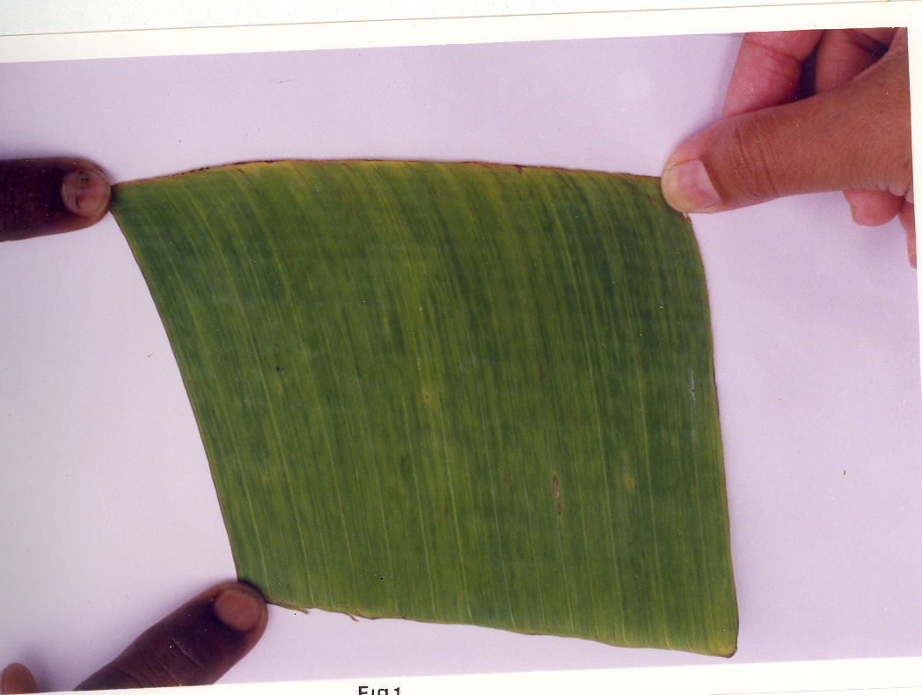
In sucker propagated banana plants interveinal chlorotic streaks of varied sizes were noticed on fully expanded leaves (Figure 1). The distribution of the chlorotic streaks is not uniform throughout the leaf in certain plants. As the leaves matured, the chlorotic streaks were less prominent and in certain leaves necrosis was initiated in chlorotic streaks. Overall the symptoms induced by BSV are comparatively less severe as comparative to the symptoms induced by CMV.

Figure 1. BSV infected banana leaf showing interveinal chlorotic streaks

The sucker propagated banana plants exhibited bright yellow chlorotic speckes spindle shaped streaks and sometimes continuous interveinal chlorotic streaks. Like BSV, the symptoms induced by CMV are also not uniformly distributed throughout the leaves in infected plants. As the leaves aged, the severity of the symptoms reduced. The lateral veins appear prominent in diseased leaves compared to healthy leaves. Banana (variety Robusta) leaf samples collected from Nellore district also exhibited interveinal chlorotic specks and streaks of varied sizes (Figure 2).

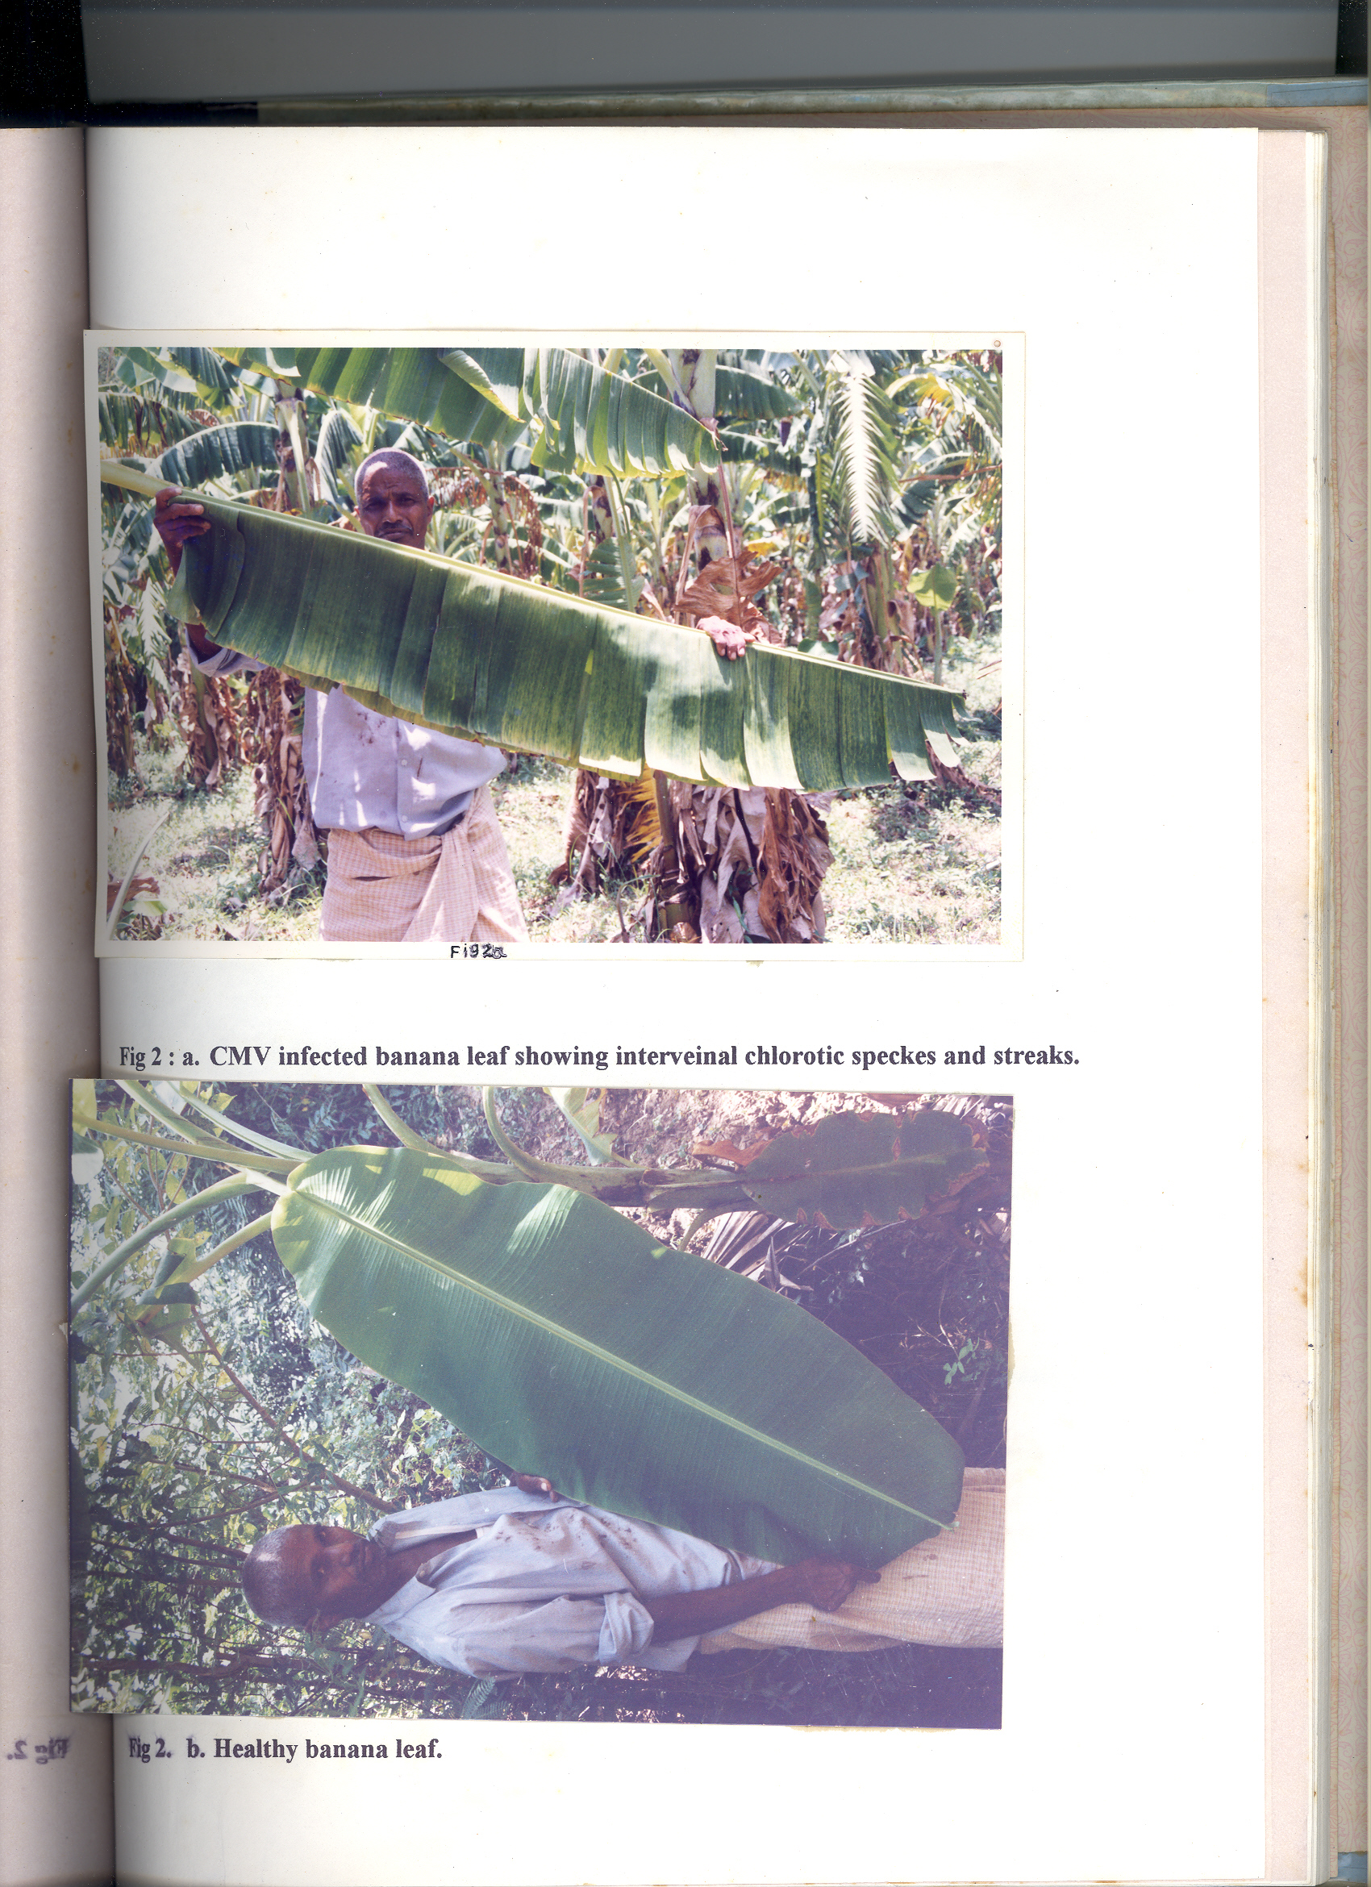

- CMV infected banana leaf showing interveinal (b) Healthy banana leaf
chlorotic specks and streaks
Figure 2. Various types of banana leaves
DAC-ELISA and Dot-blot-ELISA were performed using homologous CMV and heterologous RTBV antisera. For this, two sets were first evaluated using the BSV and CMV infected samples of banana propagated in the garden of Virology Department. In DAC-ELISA, BSV was detected up to 10⁻² dilutions in leaf samples up to 10⁻¹ dilution in pseudostem samples of infected banana using RTBV antiserum (Figure 3 and Table 2). But in Dot-blot-ELISA, BSV was detected in both leaf and pseudostem samples up to 10⁻³ dilution. However, background reaction was noticed with healthy samples in 10⁻¹ dilution (Figure 4).

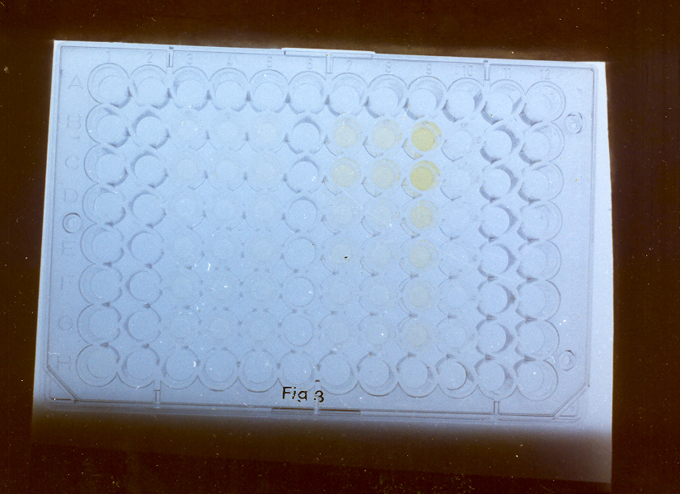

Figure 3. ELISA plate showing positive reactions (yellow colour) of BSV infected banana samples with RTBV antiserum

DAC-ELISA and Dot-blot-ELISA were used for the detection of CMV and BSV in banana (variety Robusta) collected from Duvvur area of Buchireddypalem of Nellore District. Among all the ten tested samples (with mild/faint-chlorotic streaks), none were found positively reacted with CMV-banana antiserum in DAC-ELISA. However, one sample reacted weakly with heterologus RTBV antiserum. Out of ten CMV negative samples, three samples were further tested by Dot-blot-ELISA. Three samples positively reacted with CMV antiserum up to 10⁻³ to 10⁻⁴ dilutions (Figure 5, Table 3). Light back ground reaction is also noticed in healthy samples up to 10⁻¹ dilution. However one sample positive for BSV in DAC-ELISA was turned out to be negative in Dot-blot-ELISA.

Table 2. Detection of BSV in banana samples by DAC-ELISA using heterologous RTBV polyclonal antiserum

Nature of the sample | Dilution | A₄₀₅ reading
Healthy rice leaf extract | 10⁻¹  10⁻²  10⁻³ | 0.14  -0.07  -0.02
Infected rice leaf extract | 10⁻¹  10⁻²  10⁻³ | 0.77  0.50  0.21
Healthy banana leaf extract | 10⁻¹  10⁻²  10⁻³ | 0.12  -0.04  -0.04
Infected banana leaf extract | 10⁻¹  10⁻²  10⁻³ | 0.48  0.34  0.06
Healthy banana  Pseudostem extract | 10⁻¹  10⁻²  10⁻³ | 0.12  -0.04  -0.04
Infected pseudostem extract | 10⁻¹  10⁻²  10⁻³ | 0.44  0.22  0.041
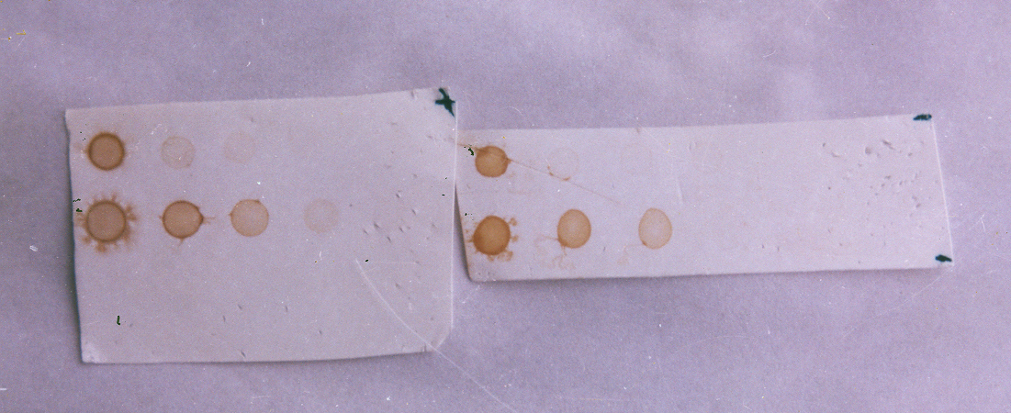

Figure 4. Detection of BSV in banana leaf and pseudostem samples using
RTBV antiserum by dot-blot-ELISA
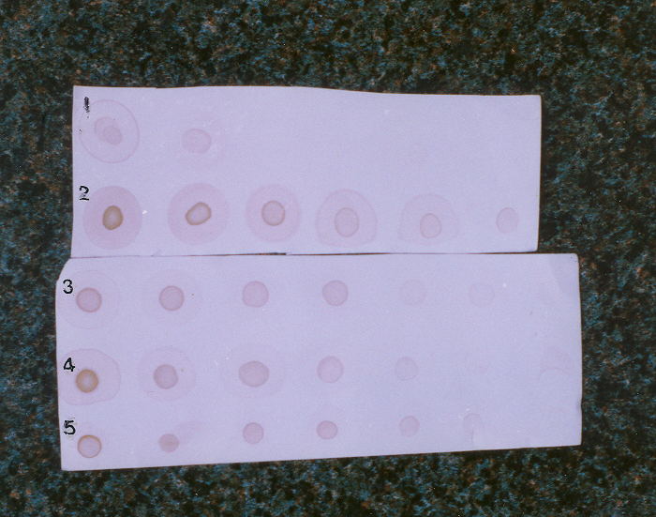

Figure 5. Detection of CMV in banana leaf samples using CMV-banana antiserum by dot-blot-ELISA
Table 3. Comparison of DAC-ELISA and dot-blot-ELISA for detection of CMV and BSV in field collected banana samples

Sample No. | Virus | DAC-ELISA | Dot-blot-ELISA
1 | CMV | 0.04 | +
2 |  | 0.33 | +
3 |  | 0.04 | +
4 |  | 0.03 | -
5 |  | 0.18 | -
6 |  | 0.11 | -
7 |  | 0.27 | -
8 |  | 0.23 | -
9 |  | 0.14 | -
10 |  | 0.27 | -
Healthy banana leaf extract |  | 0.30 | -
CMV infected banana leaf extract |  | 3.58 | +
11 |  | 0.04 | -
12 |  | 0.01 | -
13 |  | 0.04 | -
14 |  | 0.02 | -
15 |  | 0.44 | -
16 |  | 0.03 | -
17 |  | 0.25 | -
18 |  | 0.13 | -
19 |  | 0.24 | -
20 |  | 0.12 | -
Healthy banana leaf extract |  | 0.26 | -
BSV infected banana leaf extract |  | 0.48 | +
Healthy rice leaf extract |  | 0.13 | -
RTBV infected rice leaf extract |  | 1.40 | +

Summary and Concluding Remarks
An attempt was made to compare DAC-ELISA and Dot-blot-ELISA for the detection of BSV and CMV in banana leaf and pseudostem tissues. The significant observations are summarized below:
- BSV and CMV induced similar interveinal chlorotic streaks of varied sizes in banana and hence difficult to identify based on visual symptoms.
- In DAC-ELISA, BSV was detected up to 10⁻² dilutions of tissue extracts but it was detected by Dot-blot-ELISA up to 10⁻³ dilution.
- Out of ten field collected samples, none were positive for CMV in DAC-ELISA, but three samples reacted positively in Dot-blot-ELISA.
- Out ten field samples tested for BSV, only one weakly reacted. However, in Dot-blot-ELISA, none were found positive for BSV.
- Out of ten samples, none were found mixedly infected.
Above findings indicate that Dot-blot-ELISA is relatively more sensitive for the detection of BSV and CMV in banana.

References
- Anonyms. Area and production of banana in different states in India. Statistical agricultural sciences 1997; 1: 64-65.
- Banttari CE, Goodwin PH. Detection of potato viruses, S, X and Y by ELISA on nitrocellulose membranes (Dot-ELISA). Plant Dis. 1985; 69: 202.
- Brunt AA, Crabtree K, Dallwritz MJ, Gibbs AJ, Watson L. Viruses of plants. CAB International 1996; 44-46, 150-153, 477-478.
- Geering ADW, McMichael LA, Dietzgen RG, Thomas JE. 2000. Genetic diversity among banana streak virus isolates from Australia. Virology 2000; 90(8): 921-927.
- Glyn Harper, Darren Hart, Sarah Moult, Roger Hull. Banana streak virus is very diverse in Uganda. Virus Research 2004; 100: 51-56.
- Gregoire le Provost, Marie Line Iskra Caruana, Isabelle Acina, Pierre Yves Techeney. Improved detection of episomal banana streak viruses by multiplex immunocapture PCR. J. Virological methods 2006; 137: 7-13.
- Helliot B, Panis B, Frison E, De Clercq E, Swennen R, Lepoivre P, Neyts J. The acyclic nucleoside phosphonate analogues, adefovir, tenofovir and PMEDAP, efficiently eliminate banana streak virus from banana (Nusa spp.). Antiviral Research 2003; 59 : 121-126.
- Hibi, T, saito, Y. A dot immunobinding assay for the detection of tobaccomosaic virus in infected tissues. J Gen Virology 1985; 66: 1191-1194.
- Hobbs HA, Reddy DVR, Rajeshwari R, Reddy, AS. Use of direct antigen coating and protein A coating ELISA procedures for three peanut viruses. Plant Dis. 1987; 71: 747-749.
- Jeger MJ, Eden-Green S, Thresh JM, Johanson A, Waller JM, brown AE. Banana diseases In: Bananas and Plantains. Edited by Gowen, S. Published by Chapmann and Hall. 1995:317-381.
- Jones DR, Lockhart BEL. Banana streak disease Musa fact sheet No. 1.INIBAP, Montpeillier, france.1993.
- Lockhart BEL. Banana streak virus, In: Compendium of tropical plant diseases. 1994; 82: 19-20.
- Mowat WP, Dawson S. Detection and identification of plant viruses by ELISA using crude sap extracts and unfractionated antisera. j Virological Methods 1987; 15: 233-293.
- Pierre-Yves Teycheney, Isabelle Acina, Benham EL Lockhart, Thierry Candresse. Detection of banana mild mosaic virus and banana virus X by polyvalent degenerate oligonucleotide RT-PCR (PDO-RT-PCR). J. Virological methods 2007; 142: 41-49.
- Rodone BC, Ahlawat YS, Varma A, Dale JL, Harding RM. Identification and characterization of banana bract mosaic virus in India. Plant Disease 1997; 81: 669-672.
- Singh SJ. A new mosaic disease of banana. Curr Sci. 1998; 57: 1248-1249.

