MECHANICAL STRESS ANALYSIS BY EDDY CURRENT METHOD

M. Zergoug, G. Kamel, N. Boucherou

Laboratoire d’Electronique et d’Electrotechnique
Centre de soudage et de contrôle, Route de Dely Ibrahim, B.P:64, Chéraga, Alger
Tel: (213)(21) 36 18 54 à 55, Fax: (213)(21) 36 18 50

Email: m.zergoug@caramail.com

4/10/2008

A lot of progress is made in the last decade concerning the theoretical and practical aspects of eddy current testing. In addition to the defect characterization, actual studies deal with the metallurgical evaluation of materials. Surface examination allows the prediction of the material strength and consequently its life time.
In order to obtain various microstructures and to modify the mechanical and metallurgical characteristics of materials, samples made from aluminium or steels have been exposed under mechanical stress.
It was shown in this work that all microstructure modifications of the samples were detected and they can be quantified by eddy current impedance measurement.
The impedance analysis by eddy current will be correlated with the microstructure changes observed in the material because of plastic damage and fatigue.

Introduction

The ability to control the working stresses level in mechanical components and structures is an important factor in engineering industries. Evaluation and monitoring of the stress state of these elements is time consuming, because of the conventional techniques involved [4].

The characterization of microstructures, mechanical properties, deformation, damage initiation and growth by Non-Destructive Evaluation (NDE) techniques plays a vital role in various industries because of the growing awareness of the benefits that can be derived by using NDE techniques for assessing the performance of various components. Fracture mechanics based analysis of component integrity requires quantitatively characterization of microstructure defects as well as stresses.

Any alteration in the microstructure, which reduces the life or performance, should be predicted sufficiently in advance in order to ensure safe, reliable and economic operation of the components. This prediction is possible with NDE techniques, so far the interaction of the non-destructive probing energy with the material depends on the sub structural / micro structural features such as point defects, dislocations, voids, micro and macro cracks, secondary phases, texture and residual stress. The stress sensitivity plays a very important role with respect to the different material properties.

Physical approach

Various non-destructive techniques are available for the measurement of either applied and/ or residual stresses [5-10]. Eddy current testing is also sensible to changes in micro structural characteristics and the stress state of the material as well and can be used to evaluate these materials characteristics.
Eddy current testing [1, 2] allows to evaluate the state of stress in ferromagnetic material. The method can be used for determining residual stress, also named inner stress, as well as stress induced by external loads. In the study by Dybiec et al. [1] eddy current inspection is used to evaluate the state of stress in ferromagnetic material. Because a notable change in the magnetic characteristics can be observed, even at small values of strain degree, the technique has high sensitivity.
It is known that during plastic deformation microstructure irregularities, i.e. lattice defects, are generated (e.g. microspores, micro cracks, vacancies, etc). The lattice defects are observed even at very early stages of plastic deformation. The formation of discontinuities is combined with partial relaxation of elastic energy [1], which leads to changes in the magneto-elastic energy of the material in regions adjacent to the lattice defects. This phenomenon is likely to affect the magnetic and electric parameters of materials.

Experimental Procedure

A Merlin machine of traction is used for evaluating the solicitation degree of the material in the gauge length of the specific specimen. The effect of traction strain and accumulated damage on magnetic properties was studied by using standard tensile specimen subjected to elongation. The correlations obtained allowed to evaluate the traction strain and current damage, as well as to estimate the residual lifetime of the specimen under traction.
The equipment applied can be characterized by its high sensitivity to detect changes in the material microstructure. The software allows to continuously control the tensile load or stepwise. The eddy current probe is placed in the predicted zone of failure which was preliminarily determined by tests. At each specific load, five local impedance amplitude or phase values were measured in the rupture zone. ( Figure1).

Eddy current probe
Measure and analysis system
Excitation system
Force
Traction machine
Control System of Traction machine
Force
Pt1 Pt 2 e 3 Pt4 Pt5 b
. . . . .

Figure1: Principle of the measuring system (Traction and eddy current)
Measuring conditions

In order to obtain the required measuring precision the recommendation is:

- to determine the rupture load
- to select an incremental load step of 3KN in case of aluminium alloy 2024 with 3 minutes of maintain time
- to select an incremental load step of 8KN in the elastic regime and 3KN in the plastic regime in case of stainless steel 304L with 2 minutes of maintain time.

At each load step, the impedance amplitude and phase of the eddy current probe impedance in the five selected points was measured.

Results and Interpretation

The objective is to find a relationship between the electric/magnetic and the load parameters. Therefore the sample was exposed to traction while taking measurements of the phase and the amplitude of the impedance in several points of the specimen.
The curves representing these relationships typically show a transition behaviour.
This result is obtained for all of the locally selected points chosen on the sample according to Figure1, which indicates that the microstructure presents a priori the same electric and magnetic modification when the sample is exposed to traction. This fact is observed for all of the curves representing the impedance as function of mechanical properties like load, elongation and deformation, (Figure 2-Figure 7)
This result can be verified also for the phase behaviour (Figure 12- Figure 17).
The curve representing the impedance as function of the load typically shows two zones of transitions. It is to notice that in case of Aluminium a first transition in the curve is observed in the load range 9-10 kN corresponding to an impedance of 23.82 Ohm, the second is located at 22-24 kN corresponding to an impedance of 23.78 Ohm.
These transitions are observed in all of the curves representing the impedance as function of the deformation, the elongation, and the load. (Table 1).

Aluminium | Amplitude Z(Ohm) | A(%) | DI(mm) | P(kN)
transition1 | 23.82 | 2.22 | 4.82 | 9-10
transition 2 | 23.78 | 4.5 | 5.2 | 22
Table1: Alumium, amplitude of the impedance and mechanical parameters at the transition points
This significant feature is also observed in the functional representations of the phase versus various mechanical parameters (Table 2)

Aluminium | Phase (degree) | A(%) | DI(mm) | P(kN)
transition 1 | 35.32 | 2.22 | 4.82 | 9
transition 2 | 35.45 | 4.5 | 5.2 | 22

Table 2: Aluminium, phase of the impedance and mechanical parameters at the transition point
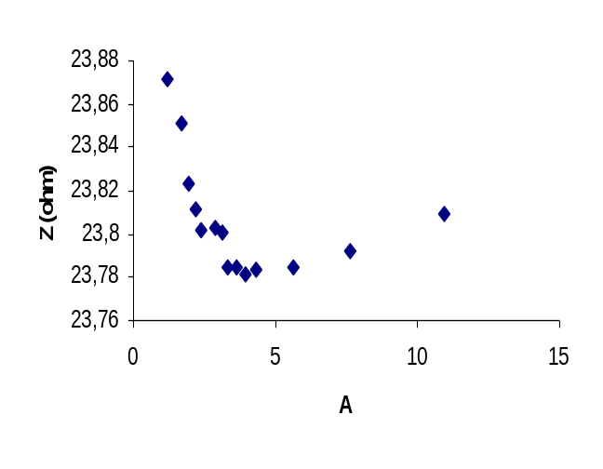
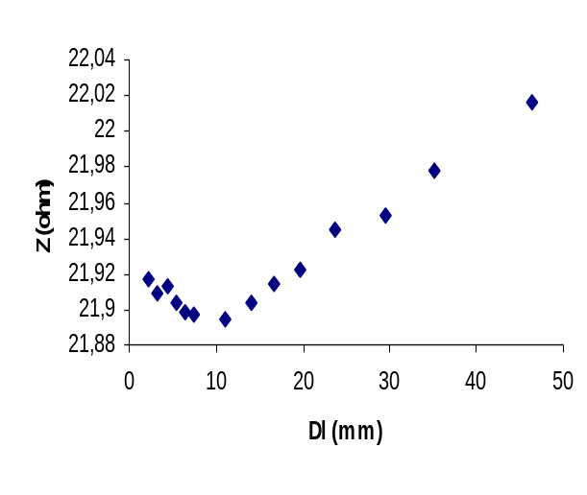
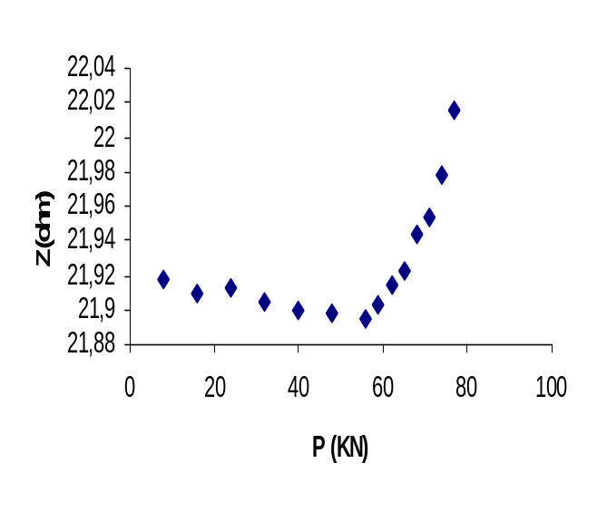
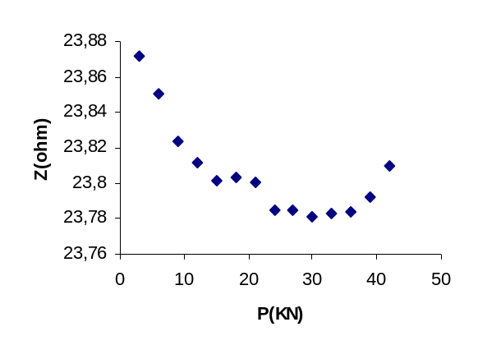
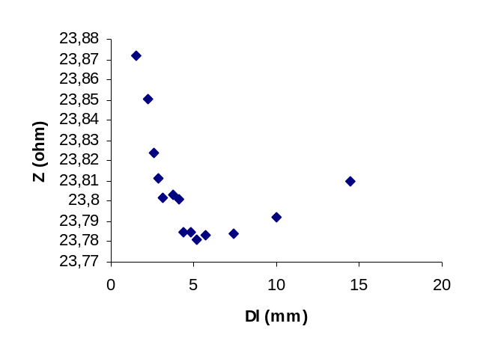
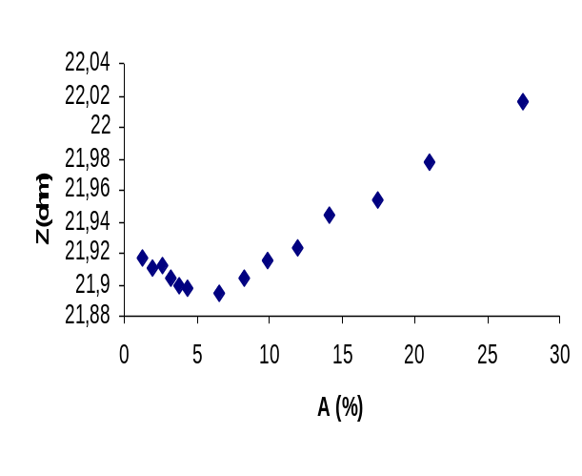
Figure2: impedance as function of the load for steel Figure3: impedance as function of the elongation for steel

Figure4: impedance as function of the deformation for steel Figure5: impedance as function of the deformation for aluminium

Figure:6 Impedance as function of the load for aluminium Figure:7 impedance as function of the elongation for aluminium steel

Figure: 8 Load as function of the deformation for aluminium Figure: 9 Load as function of the elongation for aluminium

P(KN)

50
20
30
Dl (mm)
10
0
10
20
30
40
50
0
load(kN)
P(kN)
Load (kN)
A (%)
0
5

20

40

30

10
0
10
15

Load (kN)

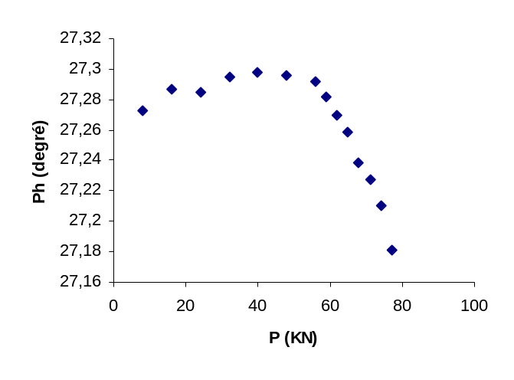
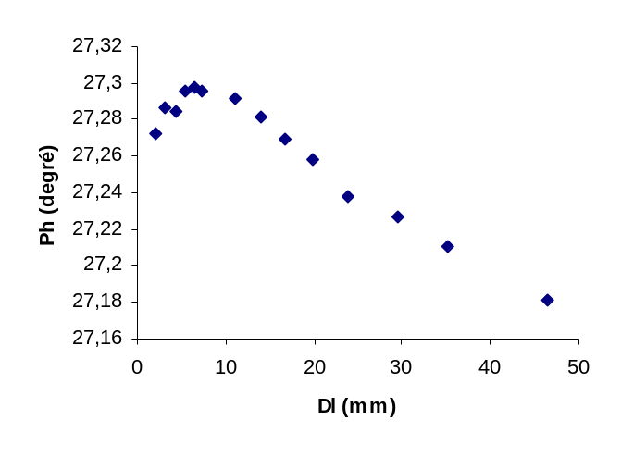
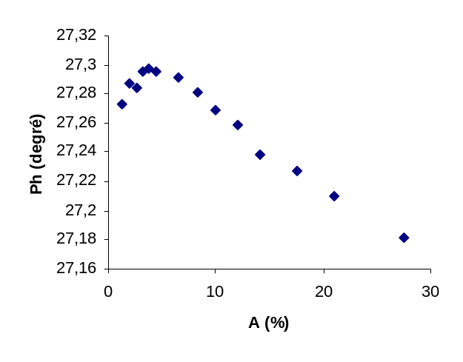
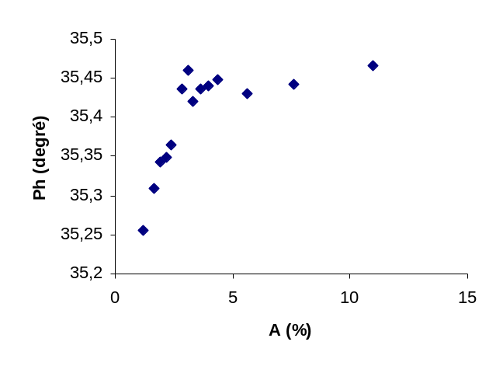
0
20
40
60
80
100
0
10
20
30
A (%)
P (KN)
Load (kN)
0
20
40
60
80
100
0
20
40
60
Dl (mm)
P (KN)
Load (kN)
Figure 10: The load as function of the deformation for the steel figure11: The load as function of the elongation for the steel
Figure:12 Phase as function of load for steel Figure:13 Phase as function of the elongation for steel

35,2
35,25
35,3
35,35
35,4
35,45
35,5
0
5
10
15
20
25
Dl (mm)
Ph (degré)
35,2
35,25
35,3
35,35
35,4
35,45
0
10
20
30
40
50
P(KN)
Figure:16 Phase as function of load for aluminum Figure: 17Phase as function of the elongation for aluminum

35,5
Ph (degré)
Figure14: Phase as function of the deformation for steel Figure15: Phase as function of the deformation for aluminum

Figure14: Phase as function of the deformation for steel Figure15: Phase as function of the deformation for aluminum

We notice that in case of the austenitic steel, the curve representing the impedance as function of the load also shows two zones of transition (figure 2-4). Table 3-4 gives the values of the impedance and the phase as function of the deformation, elongation, and the load for the two points of transitions
In comparison of table 1 and 3 and table 2 and 4 the different results obtained at austenitic steel and aluminium are visible. The differences allow to individually characterize the materials behaviour under load... The value of the impedance or the phase is different between the first and the second transition points.

Steel | Amplitude Z(Ohm) | A(%) | DI(mm) | P(kN)
transition 1 | 21.910 | 2.41 | 4 | 18
transition 2 | 21.885 | 5-6 | 9 | 55-58

Table 3: Steel, amplitude of the impedance and mechanical parameters at the transition points

Steel | Phase (degree) | A(%) | DI(mm) | P(kN)
transition1 | 27.285 | 2.4 | 4 | 18
transition2 | 27.300 | 5 | 8-9 | 55-58

Table4: Steel, phase of the impedance and mechanical parameters at the transition points

These results at Aluminium are confirmed by discussing the mechanical parameters alone where the transition points can be observed too (figure 8-9). (table5).
Whereas the impedance curve of the austenitic steel reveals two transition points, allows the observation of the mechanical measurements only the detection of the second transition (figure 10-11) (table6).

Aluminium mechanical measurements | P(kN) | A(%) | DI(mm)
transition 1 | 9 | 2.2 | 4
transition 2 | 25 | 4.5 | 5-6

Table5:

Steel mechanical measurements | P(kN) | A(%) | DI(mm)
transition 2 | 55 | 5 | 9

Table6

These results are significant in order to non-destructively detect the elastic limit and the plasticity of material. In the case of aluminium, the first transition point corresponds to the elastic limit and the second corresponds to the limit of mechanical resistance, a very useful parameter concerning the determination of the endurance against fatigue. For steel we notice two transition points which correspond to the elastic limit and the start of the plasticity. In the case of steel we also observe that the impedance increase and the phase decrease after the second transition point, corresponding to the start of the plasticity. In the austenitic stainless steel the development of a magnetization by increasing the tensile stress can be observed, according to a localized phase transformation of the fcc austenitic phase to bcc α’ cold-forming martensitic phase [9].

In case of the aluminium, we notice in the curves (figure 5 to7 and 15 to17) that the impedance and the phase have a relation with the young modulus. This fact is very important because we can measure the elastic parameter only by an impedance amplitude or/and phase measurement. Also the start of the plasticity can be detected.

Conclusion

Lifetime extension of components in technical applications is a general task with tremendous economical benefits. NDT/NDE has developed first attempts for materials characterization taking into account damage assessment as part of the in service inspection. We have shown in this work the relation between parameters obtained by eddy currents measurements and mechanical parameters.
The curve representing the impedance or the phase as function of the elongation or deformation follow a well determined trajectory where the elastic limit and the start of the plasticity of the material can be detected by the impedance amplitude or the phase measurement. In case of aluminium the relations between the impedance phase and the load as function of the elongation has the same shape.
The curve of the phase increases linearly with the load in the elastic regime and therefore it is possible to determine Young’s modulus.
This work shows the ability to determine the material behaviour exposed to external loads in the elastic as well as in the plastic regime by analysis of eddy current inspection results only. The elastic limit or the start of plasticity can be detected by the impedance measurement. In the case of aluminium, it is also possible in the future to evaluate Young’s modulus by the phase analysis.
The results are very significant for the non-destructive mechanical properties determination and useful to be applied in In Service Inspection.

References

[1] Dybiec, C., Wlodarczyk, S. and Dybiec, M., "Measurement of Own Stress Using the Eddy Current Method", proceedings of the ECNDT, Vol. 3, December 1998
[2] C.Dybiec and all “Determining Residual Austenite With Eddy Current Method”, proceedings of the ECNDT, Vol3, December 1998
[3] Baldev Raj ,V. Moorthy,T. Jayakumar and K. Bhanu Sankara Rao,”Assessment of Microstructures and Mechanical behaviour of Metallic Materials Through Non Destructive Characterisation”, International Materials Reviews, October 2003,Vol 48 ,N°5
[4] J. Lu, D. Retraint,” A review of recent development and applications in the field of X-ray diffraction for residual stress studies”, J. Strain Anal.33 (2) (1998) 127–136.
[5] K. Jassby, D. Saltoun, “Use of ultrasonic Rayleigh waves for the measurement of applied biaxial surface stresses in aluminium 2024-T351 Alloy”, Materials Evaluation 40 (1982) 198–205.
[6] N.Ye.Nikitina, L.A.Ostrovsky.”An ultrasonic method for measuring stresses in engineering materials “Ultrasonic .35. (1998).605-610.
[7] Marc Duquennoy, Mohammadi Ouaftouh, Mohamed Ourak, and Wei-Jiang Xu. “Influence of natural and initial acoustoelastic coefficients on residual stress evaluation: Theorie and experiment.”, J.App.Phys. 86(5) (1999)2490-2498 ..
[8] Yuossef Abdellahoui, Henri walaszek, Catherine Peyrac,Henri_Paul Lieurade,Mohamed Charfaoui, “ Récents développements de la mesure des contraintes résiduelles par méthode ultrasonore : Les principales sources d'erreurs”, Mec.Ind. 1 ( 2000)187-200..
[9 ] A.K. Roy , S. Bandyopadhyay , S.B. Suresh , D. Wells ,” Comparison of Residual Stress in Martensitic Alloys by Nondestructive Techniques” Materials Science and Engineering A 419 (2006) 372–380.
[10] C. C. H. Lo, J. A. Paulsen, E. R. Kinser, and D. C. Jiles,” Quantitative Evaluation of Stress Distribution in Magnetic Materials by Barkhausen Effect and Magnetic Hysteresis Measurements”, IEEE Transactions on Magnetics, vol. 40, no. 4, july 2004,pp2173-2175

