Temperature Increased for Atherosclerotic Artery after Lasing

Ma Hongbao

Brooklyn, New York 11212, The United States
hongbao@gmail.com

Abstract: Introduction: Usefulness of laser angioplasty for endovascular surgery was recognized especially for patients having short segments of severe atherosclerotic changes in vessels. Acute thrombotic occlusion of arteries and veins is the leading causes of death worldwide. Difference of temperature increasing in normal and atherosclerotic arteries after the lasing is not clearly established. Materials and Methods: NZW rabbits were induced to atherosclerosis with balloon deendothelialization and feeding a high cholesterol diet (1%) for 9 months. The thermal couple was induced to rabbit aortas (control n=9; atherosclerotic n=12) wrapped by rabbit skin and the temperature of artery was measured during lasing with different energies of 2, 3, 4, 5 W. Results: There is linear relationship between the temperature and lasing energy (r=0.99, p<0.0005). After 2, 3, 4, 5 W lasing, the temperature of atherosclerotic rabbit arteries was 2.63, 4.18, 6.98 and 9.40ºC higher than the temperature of normal rabbit arteries. Conclusions: Laser angioplasty for endovascular surgery was a useful procedure but there is a significant higher temperature increasing after lasing. Consequently, this method should be recommended especially for high-risk patients with atherosclerosis.

Keywords: artery; atherosclerosis; laser; temperature

Introduction
Over one million patients present yearly with cardiovascular events in the United States. Vulnerable plaques are responsible for development of unstable and acute cardiovascular syndromes. Extensive data from investigations in other fields have demonstrated that the laser can alter collagen structure as shown for skin resurfacing and from our recent work on thermal coagulation of collagen in the arterial wall. The problem of ischemic heart disease is widely prevalent. These patients have heart attacks and unstable angina symptoms. Although various medical and technological advances have reduced the mortality, many patients continue to die suddenly from coronary artery disease because of vulnerable plaques (Lipinski et al, 2004; Schaar et al, 2004; Vink et al, 2003).
The pathology of vulnerable plaque has demonstrated it to be composed of a rich lipid core covered by a thin collagen cap. However, recently inflammatory cell activity has been shown to participate in weakening the collagen cap by producing enzymes that digest collagen (Bhatia et al, 2003; Hartung et al, 2004). After heart attacks, vulnerable lesions are noted to have ruptured collagenous caps leading to exposure of the lipid core to the circulating blood causing thrombotic occlusion of the artery (Virmani et al, 2002). Although investigations have demonstrated that the vulnerable plaque can be detected, it is not clear what type of intervention will alter its course to rupture (Shah, 2003).
The temperature elevation is critical problem for the laser clinical practice. Temperature difference between atherosclerotic plaque and healthy vessel wall is related to clinical instability. It is correlated with systemic markers of inflammation and is a strong predictor of adverse cardiac events after percutaneous interventions. Thermography is the first in a series of novel "functional" imaging methods and is moving to clinical trials (Madjid et al, 2002). Usefulness of laser angioplasty for endovascular surgery was recognized especially for patients having short segments of severe atherosclerotic changes in vessels. Acute thrombotic occlusion of arteries and veins is the leading causes of death worldwide. Difference of temperature increasing in normal and atherosclerotic arteries after the lasing is not clearly established. The objective of this proposal is to use laser radiation to stabilize vulnerable plaques by altering their collagen structure, and detect the temperature after lasing.

Materials and Methods
Bench Studies: In this project we have established the technique that will be used in the rabbit model by in vitro testing. A 300 μm core optical fiber was placed in the flush channel of a balloon angioplasty catheter (Figure 1). The argon ion beam was noted to diffuse via the crystalloid fluid filling the balloon and lucent balloon walls. Using a single perfusion chamber, segments of both normal and atherosclerotic aorta were irradiated. Thermocouples were placed on the arterial wall surface while the balloon catheter was advanced into the perfusion chamber via a t-connection. The balloon was inflated and the argon laser activated at various powers and temperatures measured on the arterial wall surface (Figure 2).



Figure 1. A standard angioplasty balloon catheter was used with a 300 μm optical fiber centered within the balloon. Argon ion laser irradiation can be seen as a bright light diffusing around the body of the inflated balloon.
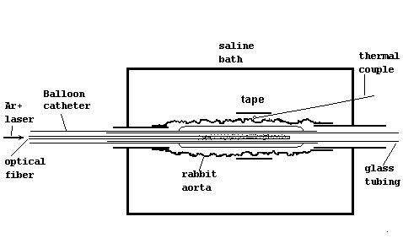
Figure 2. Sectional view of a single organ perfusion chamber. The balloon catheter is seen advanced into the lumen of the rabbit artery. Thermal couples are placed on the surface to measure temperature and these are held in place using umbilical tape.

Temperature rise on the arterial surface was proportional to the laser energy delivered via the balloon. Following irradiation the balloon material was left intact. Figure 3 is an example of the temperature rise and peak over about 60 seconds at five power levels (2, 3, 4, 5, 5.5W). After the study, the rabbit aortas are perfusion fixed and stored for histological analysis using light and electron microscopy.

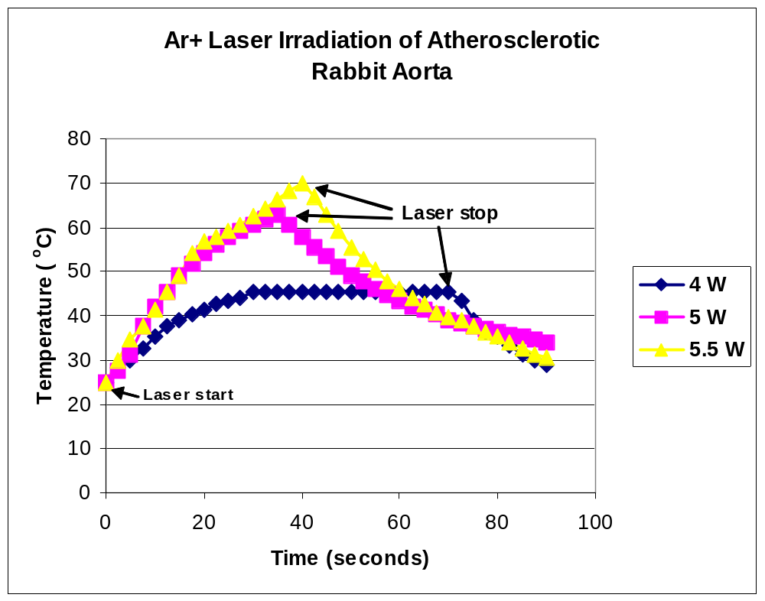

Figure 3. Temperature curves measured at the surface of the rabbit abdominal aorta during Ar⁺ laser irradiation. These measurements were performed in a bath at 23ºC.

If the bath temperature was 37ºC then there was a higher target of temperature achieved using lower laser energy. Also, the temperature profile formed a plateau with a more consistent temperature profile (Figure 4). These data will guide how we will implement the laser delivery in the rabbit experiments. While under general anesthesia, the rabbit body temperature will be monitored and a warming pad used to maintain a 37ºC body temperature.

In vivo Rabbit Studies: New Zealand white (NZW) rabbits are made atherosclerotic by feeding a high cholesterol diet (1%) and balloon deendothelialization. After maintaining the cholesterol enriched diet for 4 months, rabbits will be ready to undergo pharmacological triggering to induce myocardial infarction and platelet rich thrombus on the aorta. Presently, two rabbits were made atherosclerotic and their aortas used in the bench top studies to determine the lasing parameters for the in vivo study described above. We have already demonstrated in the above experiments that we can raise the arterial wall temperature to levels that will cause cross-linking of collagen in the arterial wall. These are the same temperatures we had used in prior reports using other laser devices (i.e. laser activated thermal probes).
Currently, ten NZW rabbits are being fed an atherogenic diet and will undergo balloon deendothelialization in two weeks according to the protocol. Prior to triggering, balloon angioplasty of the mid-abdominal aorta with associated laser irradiation will be performed in a group of five rabbits and only a sham using the balloon without irradiation will be performed in the remaining five rabbits. Another group of ten rabbits will be staggered to conduct the same study and prepared two months after the first group was begun.
The thermal couple was induced to rabbit aortas (control n=9; atherosclerotic n=12) wrapped by rabbit skin and the temperature of artery was measured during lasing with different energies of 2, 3, 4, 5 W.

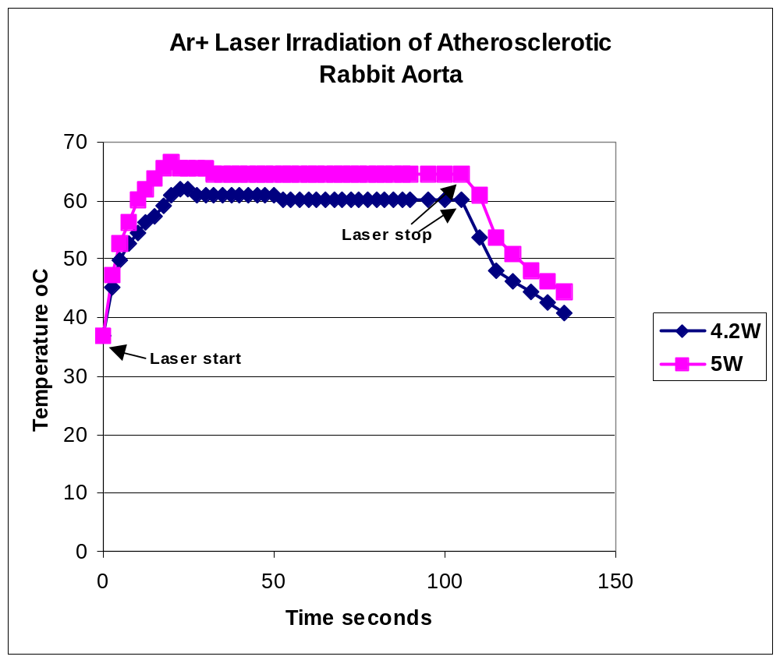

Figure 4. Temperature curves measured at the surface of the rabbit abdominal aorta during Ar⁺ laser irradiation. These measurements were performed in a bath at 37ºC to simulate the body temperature. The bath at 37ºC provides a more stable thermal environment for the arterial wall.

Results
If our hypothesis that lasing of the arterial wall that cross links the collagen to stabilize the plaques were correct we would expect to see a significantly reduced number of pharmacologically triggered thrombi in the section of the aorta that was treated. We know from earlier studies that most of the thrombus occurs in the mid abdominal aorta. Thus, we will select that section of the aorta to conduct our preliminary laser-balloon treatment sites.

1. Temperature Measurement in vitro
In this project, we measured the temperature with the thermal camera. First, the temperature of isolated aorta was measured using a thermal camera. There was a linear relationship of the energy and temperature (r=0.99; p<0.0001). After 3, 4, 5 W lasing, the temperature of atherosclerotic rabbit arteries was 1.87ºC, 2.99ºC, and 4.96ºC higher than the temperature of normal rabbit arteries (p<0.001) (Figure 5).
Second, we measured the temperature of the aortas wrapped with rabbit skin using a thermal couple. There was a linear relationship of the energy and temperature (r=0.99; p<0.001) in this measurement either. After 2, 3, 4, 5 W lasing, the temperature of atherosclerotic rabbit arteries was 2.63ºC, 4.18ºC, 6.98ºC and 9.40ºC higher than the temperature of normal rabbit arteries (Figure 6).
Third, we measured the temperature of the aortas wrapped with Nu Gauze plain packing strip using a thermal couple. There was a linear relationship of the energy and temperature (r=0.99; p<0.001) in this measurement either. There was no significant temperature difference between normal aorta and atherosclerotic aorta (Figure 7).
The temperature of the aorta with rabbit skin wrap measured by thermal camera was 8-20ºC higher than the temperature measured by thermal couple (8.05ºC, 11.58ºC and 15.00ºC after 3, 4 and 5 W lasing respectively for normal arteries; 10.37ºC, 15.57ºC and 19.45ºC after 3, 4 and 5 W lasing respectively for atherosclerotic arteries) (Figure 8).
Using the thermal couple, the temperature of aorta wrapped with rabbit skin was higher that the temperature of aorta wrapped with Nu Gauze plain packing strip (Figure 9).
The temperature distribution of rabbit aorta during 5 W argon lasing is shown in Figure 10. The temperature peak is about located in a 15 mm length of the artery during the lasing.

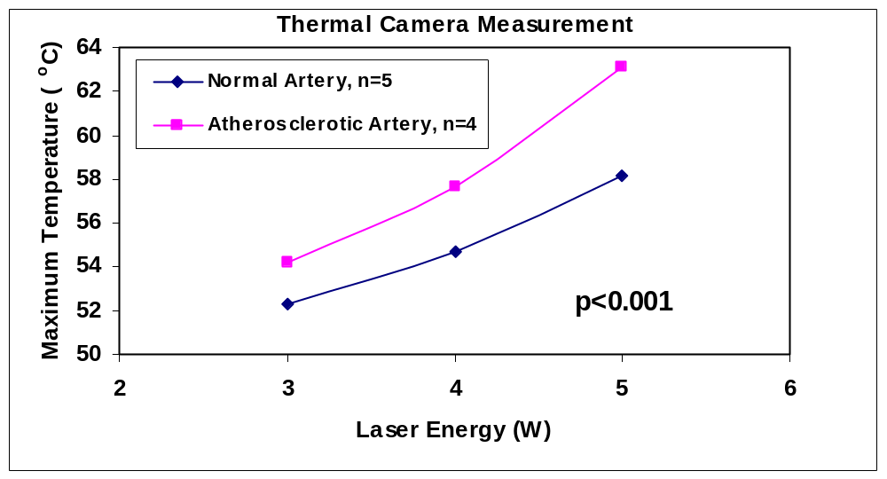

Figure 5. Temperature measurement of rabbit aorta by thermal camera.

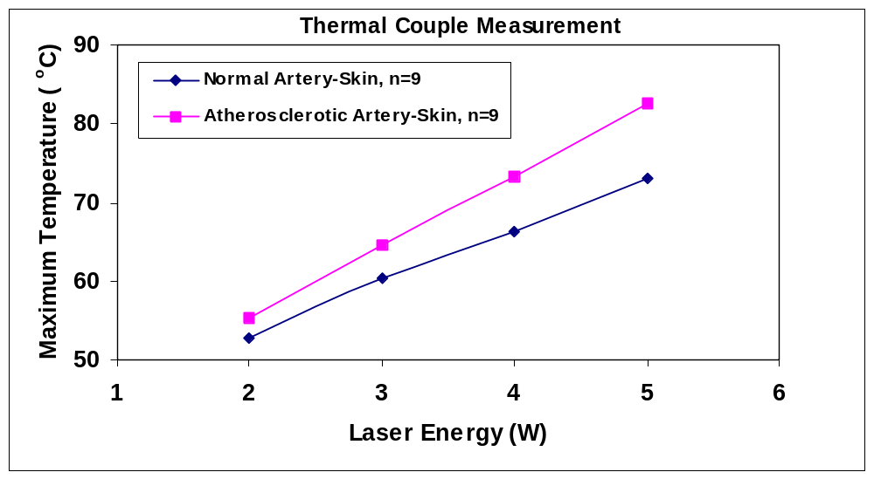

Figure 6. Temperature measurement of rabbit aorta with skin wrap.

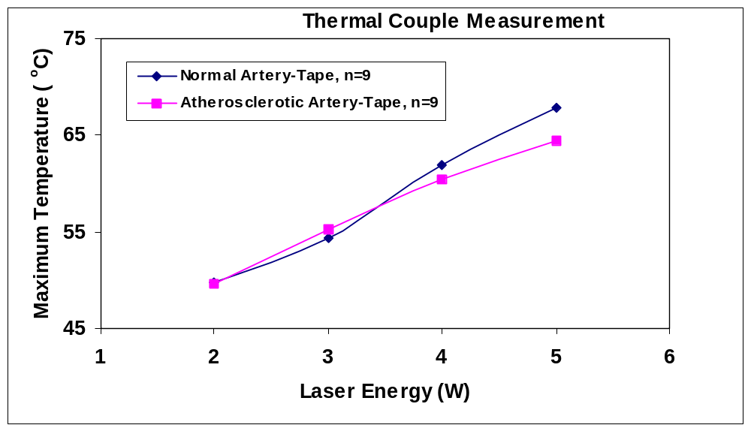

Figure 7. Temperature measurement of rabbit aorta wrapped with clothes tape.

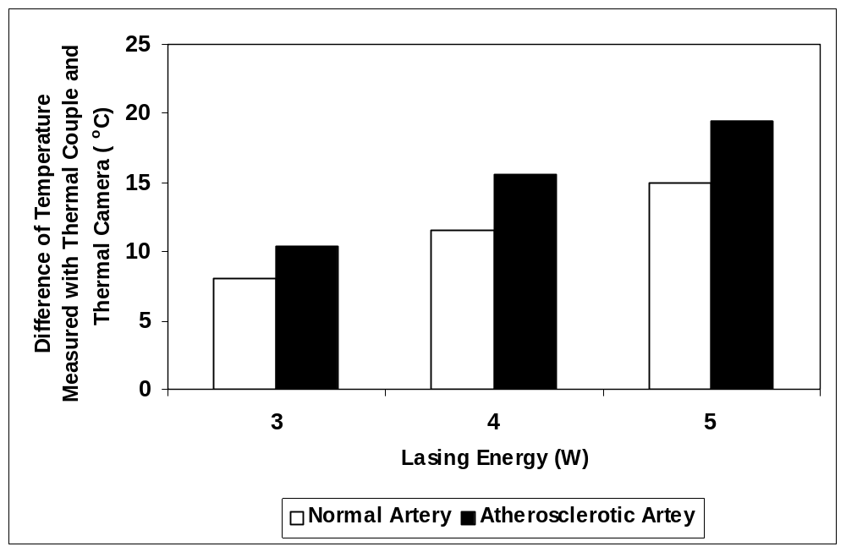

Figure 8. The temperature of the aorta with rabbit skin wrap was 8-20ºC higher than that of without rabbit skin wrap (8.05ºC, 11.58ºC and 15.00ºC after 3, 4 and 5 W lasing respectively for normal arteries; 10.37ºC, 15.57ºC and 19.45ºC after 3, 4 and 5 W lasing respectively for atherosclerotic arteries).

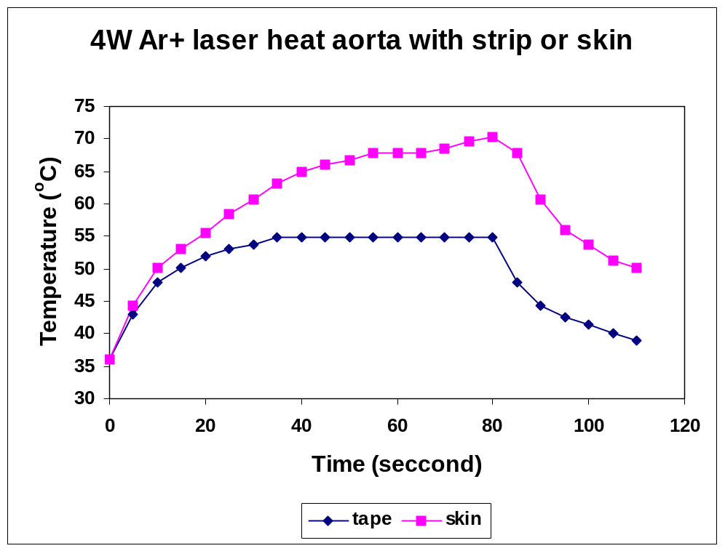

Figure 9. Comparison of the temperature of lased rabbit aortas (4 W Ar+) wrapped with Nu Gauze plain packing strip and rabbit skin. The result shows that the temperature of the artery wrapped with skin is higher than that of the artery wrapped with strip.

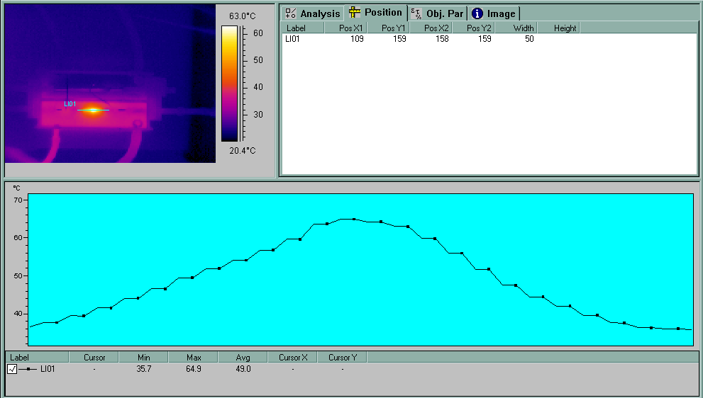

Figure 10. Temperature distribution on rabbit aorta during argon lasing by 5 W. The artery is lased for 30 sec and the total length of the cures is 30 mm.

2. Temperature Measurement in vivo
In this project, we measured the temperature in vivo with the thermal couple. The rabbit abdomen was opened under general anesthesia and rabbit aorta temperature was measured in vivo.
With 3.5 W argon lasing, the temperature will be elevated to the peak from 45 sec lasing (Figure 11). It is highly correlated between laser energy and rabbit aorta temperature (r=0.95; p<0.0001) (Figure 12).

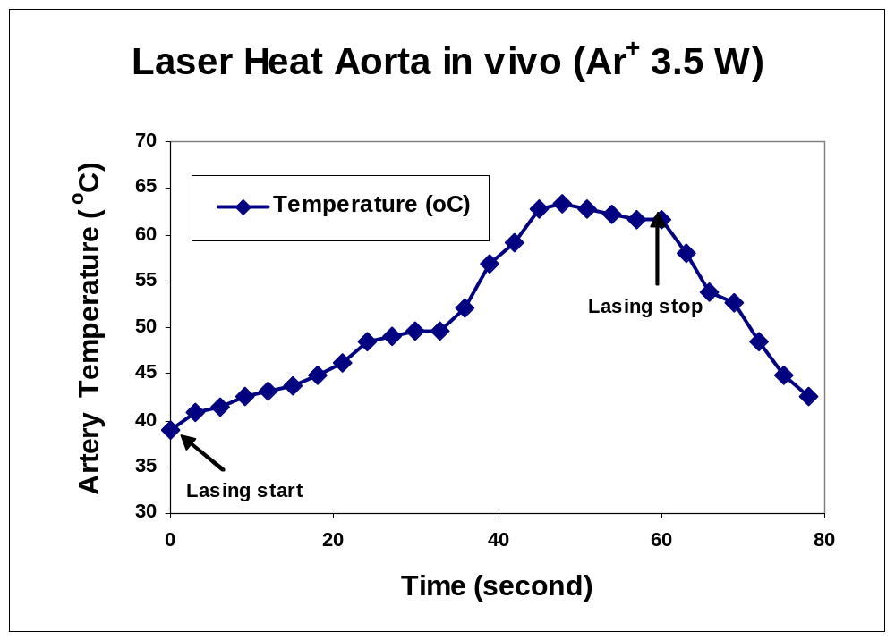
Figure 11. Temperature measurement in vivo for rabbit aorta after lasing by argon laser (3.5 W).

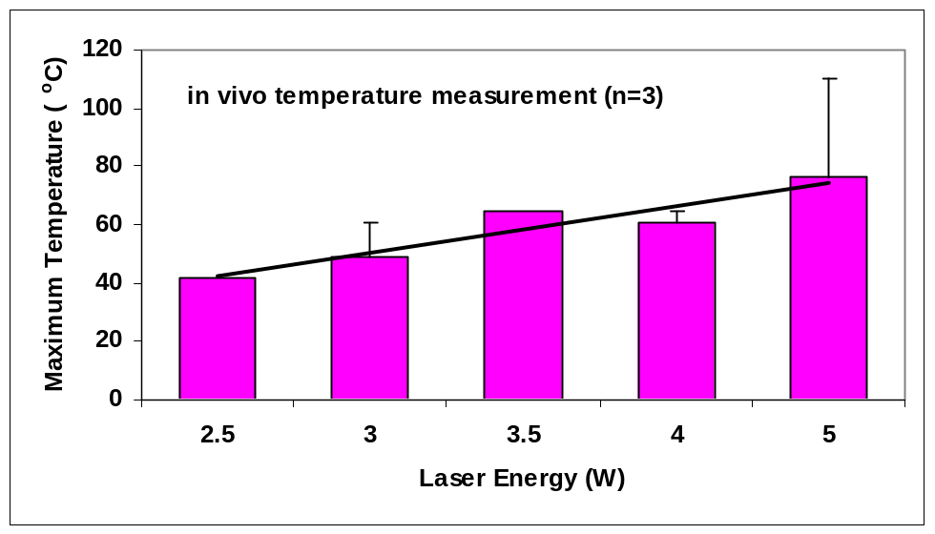

Figure 12. Temperature measurement in vivo for rabbit aorta after lasing by argon laser with different energy.

Discussion
According to the report of Madjid et al in 2002, areas with lower pH had higher temperature, and areas with a large lipid core showed lower pH with higher temperature. They also developed a thermography basket catheter and showed in vivo temperature heterogeneity in atherosclerotic lesions of atherosclerotic dogs and Watanabe rabbits. Thermal heterogeneity was later documented in human atherosclerotic coronary arteries in Madjid’s group. Temperature difference between atherosclerotic plaque and healthy vessel wall is related to clinical instability. It is correlated with systemic markers of inflammation and is a strong predictor of adverse cardiac events after percutaneous interventions. It may be useful for a variety of clinical and research purposes, such as detection of vulnerable plaques and risk stratification of vulnerable patients (Madjid et al, 2002).
Arteriosclerosis is an inflammatory disease. Inflammatory processes play a role in the initiation of plaque development and the early stages of the disease as well as in complex plaques and complications such as intraarterial thrombosis. A method to detect inflammation in coronary arteries has the potential to characterize both local and systemic activation of arteriosclerotic plaque disease. It could help to define in more detail what constitutes a vulnerable plaque or vulnerable vessel and thus improve the prediction of acute coronary syndromes. Intracoronary thermography records a cardinal sign of inflammation. Heat is probably produced by (activated) macrophages. Experimental work has suggested that thermal heterogeneity is present in arteriosclerotic plaques and that increased temperature is found at the site of inflammatory cellular-macrophage-infiltration. Preliminary experience in patients undergoing coronary angiography has demonstrated that it is safe and feasible to perform intracoronary thermography using various systems. A graded relationship between thermal heterogeneity and clinical symptoms has been reported, with the greatest temperature elevation in acute myocardial infarction. Increases in thermal heterogeneity appeared to be associated with a comparably unfavorable long-term prognosis. Intracoronary thermography has the potential to provide insights into location and extent of inflammation as well as the prognostic consequences. Currently, this novel method and the underlying concepts are extensively evaluated (Schmermund et al, 2003).
The detection of temperature during laser execution is important to monitor the laser effect. In this study, we have developed the technique with thermal couple to detect the temperature during laser angioplasty in vivo. We propose to use laser and laser-thermal techniques in an atherosclerotic rabbit model to demonstrate a reduction in the plaque disruption and thrombosis. This could be translated to applications in humans with lesions that can cause heart attacks. Laser angioplasty for endovascular surgery was a useful procedure but there is a significant higher temperature increasing after lasing. Consequently, this method should be recommended especially for high-risk patients with atherosclerosis.
Laser angioplasty for endovascular surgery was a useful procedure but there is a significant higher temperature increasing after lasing. Consequently, this method should be recommended especially for high-risk patients with atherosclerosis.

Correspondence to:
Ma Hongbao, Ph.D.
Brooklyn, New York 11212
The United States
hongbao@gmail.com

References
- Bhatia V, Bhatia R, Dhindsa S, Virk A. Vulnerable plaques, inflammation and newer imaging modalities. J Postgrad Med 2003;49(4):361-8.
- Hartung D, Narula J. Targeting the inflammatory component in atherosclerotic lesions vulnerable to rupture. Z Kardiol 2004;93(2):97-102.
- Lipinski MJ, Fearon WF, Froelicher VF, Vetrovec GW. The current and future role of percutaneous coronary intervention in patients with coronary artery disease. J Interv Cardiol 2004;17(5):283-94.
- Madjid M, Naghavi M, Malik BA, Litovsky S, Willerson JT, Casscells W. Thermal detection of vulnerable plaque. Am J Cardiol 2002;90(10C):36L-39L.
- Schaar JA, Muller JE, Falk E, Virmani R, Fuster V, Serruys PW, Colombo A, Stefanadis C, Ward Casscells S, Moreno PR, Maseri A, van der Steen AF. Terminology for high-risk and vulnerable coronary artery plaques. Eur Heart J 2004;25(12):1077-82.
- Schmermund A, Rodermann J, Erbel R. Intracoronary thermography. Herz 2003;28(6):505-12.
- Shah PK. Mechanisms of plaque vulnerability and rupture. J Am Coll Cardiol 2003;41(4 Suppl S):15S-22S.
- Vink A, Pasterkamp G. Atherosclerotic plaques: how vulnerable is the definition of "the vulnerable plaque"? J Interv Cardiol 2003;16(2):115-22.
- Virmani R, Burke AP, Kolodgie FD, Farb A. Vulnerable plaque: the pathology of unstable coronary lesions. J Interv Cardiol 2002;15(6):439-46.

