Haemoparasites Of Clarias Gariepinus And Synodontis Clarias From Lekki Lagoon, Lagos Nigeria

BY

1 2 3
Hassan A.A, Akinsanya Bamidele, and Adegbaju W.A

- Department of Zoology,University of Ibadan,Nigeria
- Department of Zoology,University of Lagos,Nigeria
- Department of Zoology,University of Ibadan,Nigeria.

akinbami2000@yahoo.com

Received: 8/26/2007

ABSTRACT

A total of 270 randomly selected fish specimens comprising of Clarias gariepinus(165) and Synodontis clarias (105) from Lekki Lagoon were examined for haemoparasites. Sampling was carried out between July to December 2006. Thin blood smear were made and both C. gariepinus and S. clarias was observed to be infected with Trypanosomes spp .S. clarias recorded a higher prevalence of trypanosome 35.24% than C. gariepinus with 10.78%. Haemoparasite of the genus Myxospora was observed only in S. clarias with a prevalence of 1.09%.There was significant difference (p<0.05)in the infection rate with trypanosome in male and female specimens of Clarias gariepinus.

Keywords : Trypanosomes,Myxospora,Synodontis clarias,Clarias gariepinus,Lekki lagoon,Lagos,Nigeria.

INTRODUCTION

Piscine haemoparasite belong to the genus Trypanosoma, Cryptobia (haemoflagellate) and Dactylosoma (haemosporidia) (Paperna, 1996). Although Trypanosoma and Cryptobia are seemingly related in morphology and in means of transmission via leeches, there are sufficient biological differences to separate the two. (Paperna, 1996). Cryptobia unlike trypanosomes are not exclusively vascular parasite and (even sometime the same species) also occur as ecto-parasites on fish body surface and in the digestive tract (Woo, 1987). Trypanosomes have been reported in all major water systems of Africa (Dias, 1952, Baker,1961), with some species apparently distributed as widely as their fish host. There are no reports on vascular cryptobia from Africa (Paperna, 1996)

Dactylosome are parasite of the circulating erythrocytes and reticulo-endothelial tissues. Data on piscine Dacytlosome is scanty, however infection in cichlids from Lake Victoria have been recorded (Baker,1960).

Clarias gariepinus BURCHELL, 1822, the African catfish is generally considered to be one of the most important tropical catfish species for aquaculture in West Africa (Clay, 1979). This African catfish is widely distributed throughout Africa, inhabiting tropical swamps, lakes and rivers, some of which are subjected to seasonal drying (Olufemi et al., 1991). C. gariepinus is considered one of the best example of an omnivore (Holden and Reed, 1972; Clay, 1979) or predator feeding mainly on aquatic insects, fish and higher plant debris (Micha, 1973). They have also been found to feed on terrestrial insects, mollusk and fruit (Bruton, 1979).

Synodontis clarias LINNAEUS, 1758 belong to the family Mochokidae and the genus Synodontis to which S. clarias belong is the most common and of great commercial importance (Reed et al, 1967). Synodontis species only occur in Africa and apart from those species present in River Nile they are restricted to water systems within the tropics (Willoughby, 1974). S. clarias (squeaker or upside-down catfish) is benthopelagic potamodroous fresh water fish (Reids, 2004). This fish is generally classified as an omnivore feeding mainly on insect larva, mollusk and detritus (Willoughby, 1974)

Publication on parasite fauna of fish in Africa is on the increase. However documentation on piscine haemoparasite is scarce. In an update on parasite of fish in Africa by Paperna (1996), C. gariepinus and S. clarias were reported to be infected with haemoflagellates. Nico et al (2004) worked in Okanvango Delta Bostwana and reported 43% and 71% prevalence of infection of Trypanosoma in C. gariepinus and S. clarias respectively.
The aim of this study is to investigate the occurrence and prevalence of Haemoparasites in C. gariepinus and S. clarias from Lekki lagoon, Lagos, Nigeria.

MATERIALS AND METHODS

The Study Area
The area of study is the Lekki lagoon which lies between longitude 4⁰ 00’ and 4⁰ 15’ E and between latitudes 6⁰ 25’ and 6⁰ 37’ N in Lagos state, Nigeria. The lagoon has a surface area of about 247km² with a maximum depth of 6.4m. A greater part of the lagoon is shallow and less than 3.0m deep.

The Lekki lagoon supports a major fishery in Nigeria and it is a part of an intricate systems of waterways made up of lagoons and creeks that are found along the coast of south-western Nigerian from the Dahomey border to the Niger Delta stretching over a distance of about 200km. It is fed by River Oni discharging into the north-eastern and the Rivers Oshun and Saga discharging into the north- western parts of the Lagoon. Lekki lagoon experiences both dry and rainy seasons typical of the southern part of Nigeria.

The vegetation around the lagoon is characterized by shrubs and raphia palms, Raphia sudanica and oil palm, Elaeis guineesis. Water hyacinth can be seen floating on the periphery of the lagoon while coconut palms Cocos nucifera are widesspread in the surrounding villages.

The rich fish fauna of the lagoon includes Heterotis niloticus, Gymnarchus niloticus, Clarias gariepinus, Chrysicthys nigrodigitatus, Channa obscura, Mormyrus rume, Tilapia zillii, Tilapia galilaea, Hemichromis fasciatus and Saratherodon melontheron (Kusemiju, 1981). Figure 1 shows map of Lekki lagoon, Lagos, Nigeria.

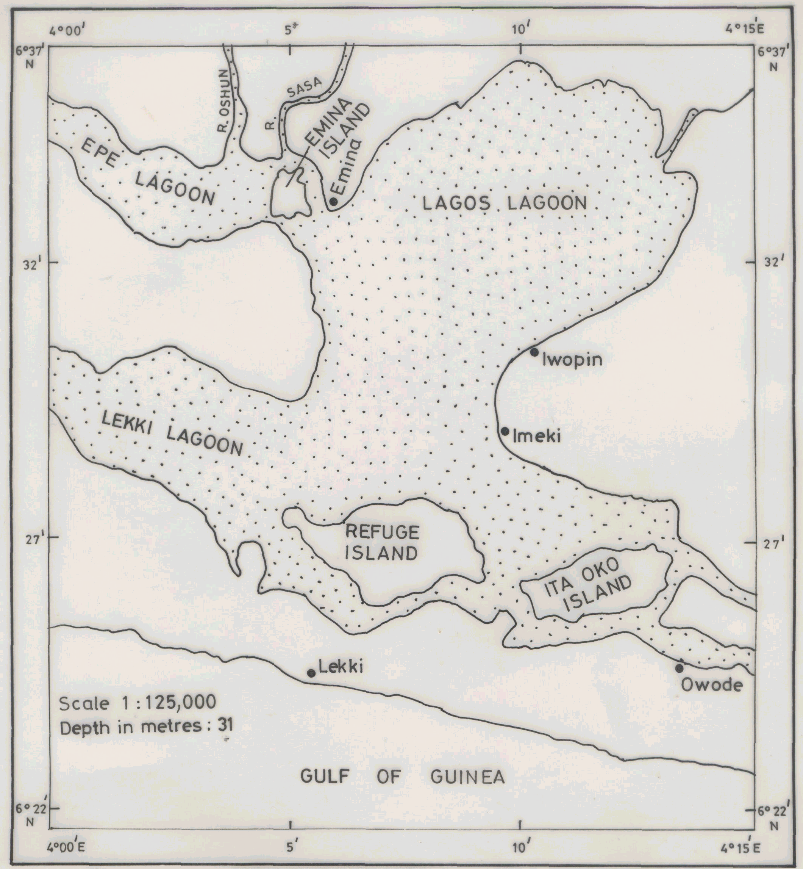

Figure 1. Map of Lekki Lagoon

Live fish from Lekki lagoon were procured from fresh fish sellers at Oluwo market Epe, Lagos, between July and December 2006. On the field, identification of fish samples and morphometrics were carried out. Also immediately blood was collected from the caudal circulation with a 23 guage plastic syringe as described by Kori-Siapere and Ake (2005). Thin blood smears were made from the blood samples collected. The blood smears were allowed to air dry and fixed in absolute methanol. The smears were then taken to the laboratory for further processing. Slides were stained with phosphate buffered Geimsa and examined under 100x objective oil immersion microscope. Images were captured by digital camera.
RESULTS

Blood smears from a total of 165 C. gariepinus and 105 S. clarias were examined for haemoparasites. S. clarias were observed to be infected with two kinds of blood parasites,Trypanosoma spp and Myxospora spp (Fig. 2 and 3) respectively. Both parasites were found co-existing in S. clarias host (Fig 4). while only trypanosome infection was observed in C gariepinus (Fig. 5 and 6).

Myxospora had an overall prevalence rate of 1.90% in S. clarias, with 0.95% prevalence each in male and female hosts

Table 1 shows the overall prevalence of Trypanosomes in S.clarias and C. gariepinus while table 2 shows the prevalence of Myxospora in Synodontis clarias. An overall prevalence of Trypanosome infection in S. clarias was 35.24%. The percentage infection of 14.29% and 20.95% was recorded for male and female respectively. In C. gariepinus, the overall prevalence of trypanosoma infection was 7.23%. Of the 12 specimen infected, 11 were males and 1 was female with a prevalence of 6.67% and 0.61% respectively.

In S. clarias, the differences in the rate of infection in male and female specimen was insignificant (χ²=0.14, p>0.05) while in C. gariepinus the difference infection rate was significant (χ²⁼ 4.88, p<0.05)

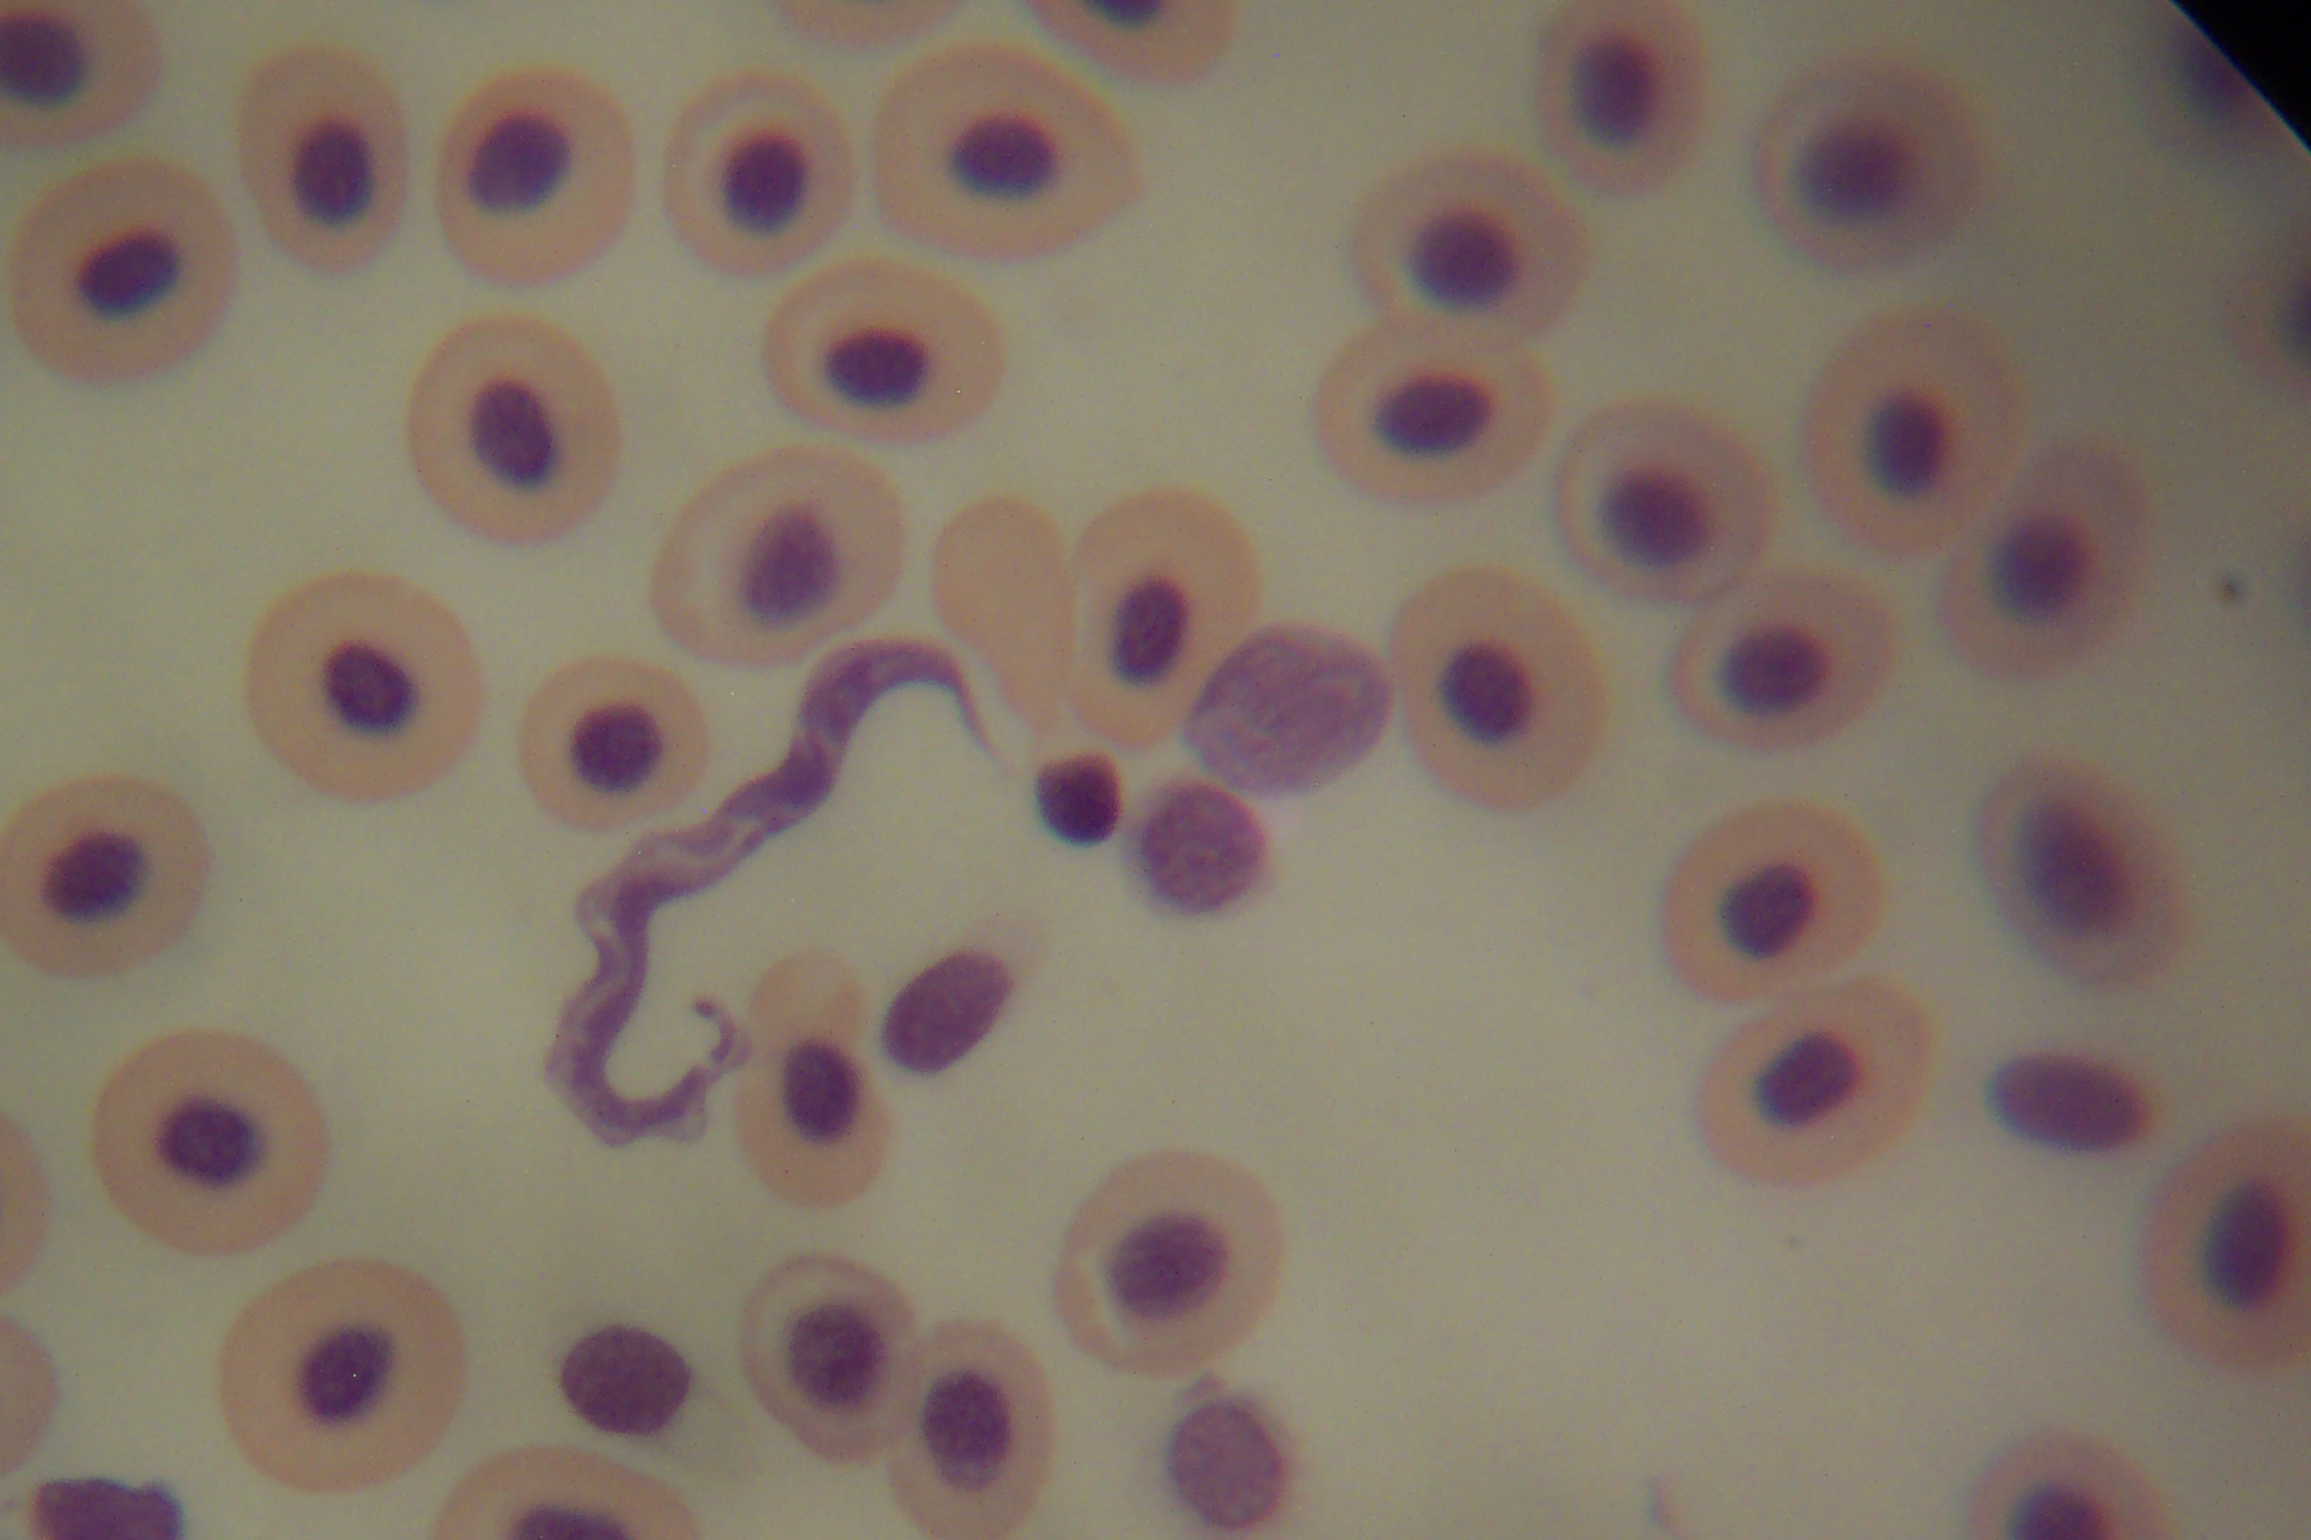

Fig 2: trypanosoma as seen in blood smear of S. clarias

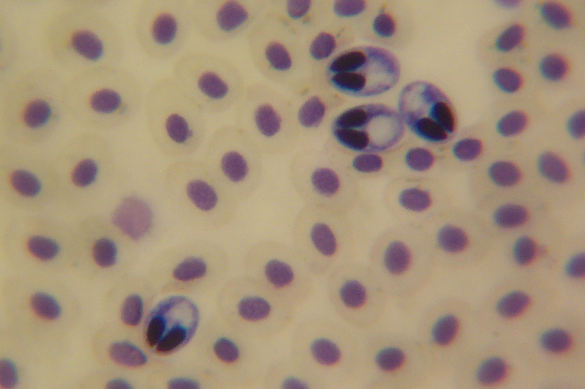

Fig 3: Myxospora as seen in blood smear S. clarias

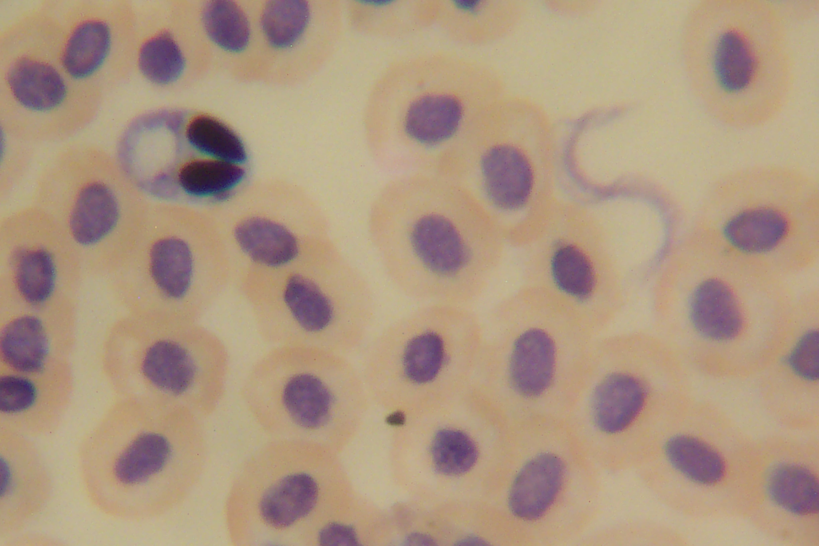

Fig 4: Both trypanosoma and myxospora occurring together in blood smear
of S.clarias

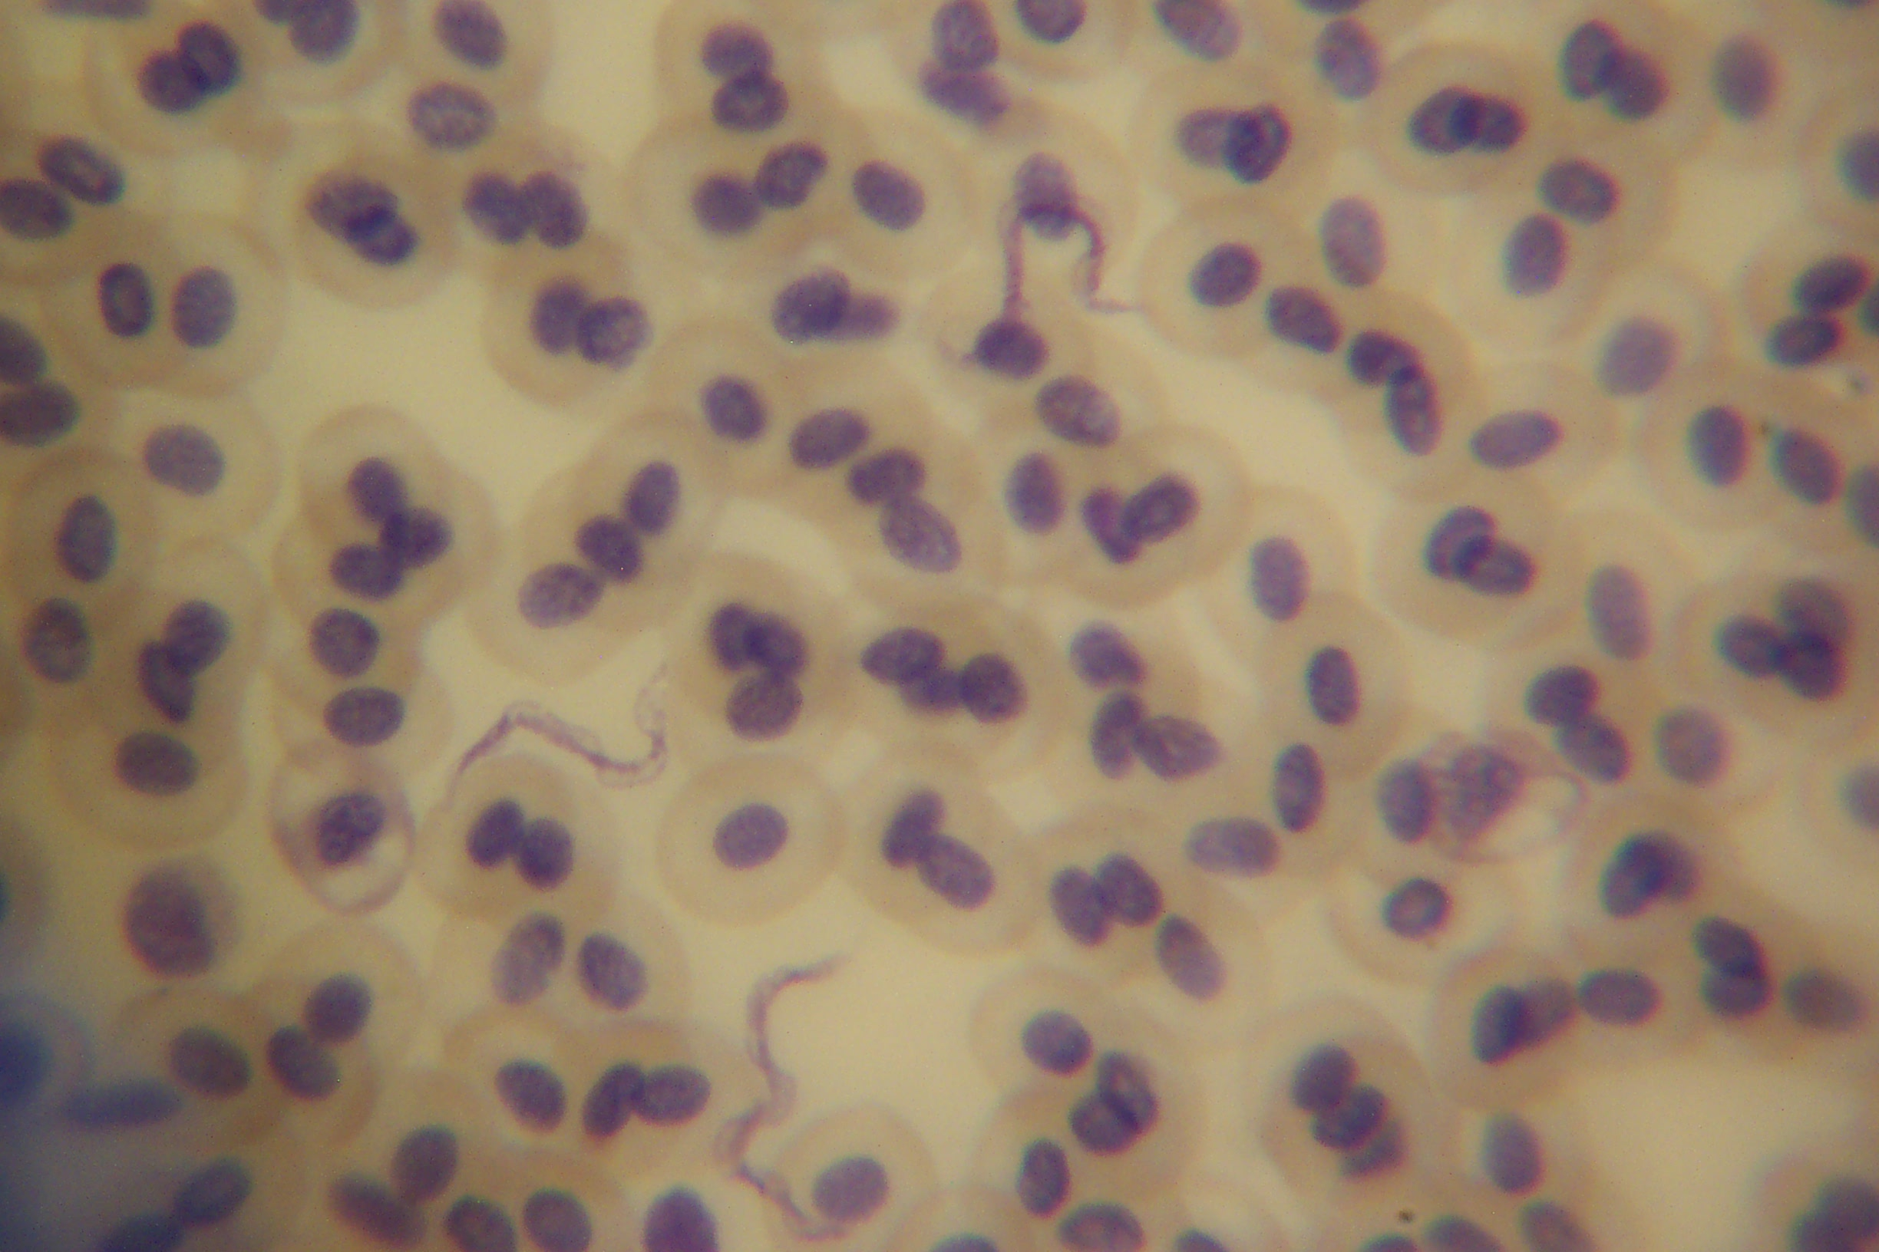

Fig 5: Trypanosoma as seen in blood smear C. gariepinus

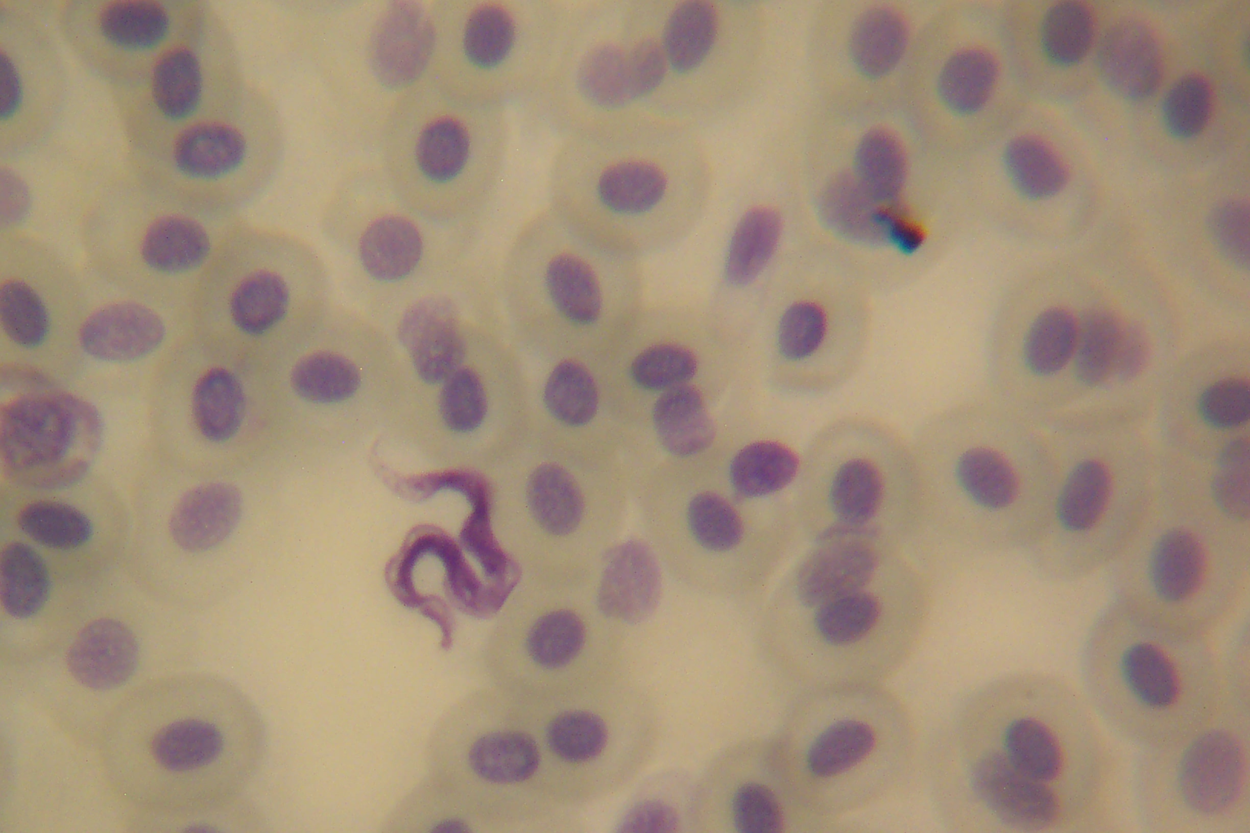

Fig 6: Trypanosoma as seen in blood smear of C. gariepinus

Table 1: Overall prevalence of trypanosomes in S. clarias and C. gariepnus

S. clarias C. gariepinus
 | No examined | No infected | Prevalence (%) | No examined | No infected | Prevalence (%)
Male | 40 | 15 | 14.29 | 102 | 11 | 6.67
Female | 65 | 22 | 20.95 | 63 | 1 | 0.61
Total | 105 | 37 | 35.24 | 165 | 12 | 7.27

DISCUSSION
Paperna (1996), reported prevalence of infection by trypanosome in catfish, C. gariepinus and Bagrus spp in Lake Victoria was about 50%. Nico et al (2004) also reported a high infection rate of trypanosome with 79% prevalence in Synodontis spp and 43% prevalence in C. gareipinus. However, low prevalences of infection (35.24% and 7.27%) observed in the present study in S. clarias and C. gariepinus respectively may probably be due to low population of the leeches in Lekki Lagoon. This assumption is based on the proposal by Thomas (1973) in the control of schistosomiasis .He suggested that the population density of the vector (Leech) must be at optimum density and that below this critical threshold transmission may cease.

The higher infection prevalence of trypanosome in S. clarias when compared with C. gariepinus can be attributed to diet and feeding habit. Araoye 1999 reported high percentage frequency of occurrence of plants debris in the gut of S. schall during the wet season, and the ability to explore the bottom habitat despite the higher pressure due to the possession of a large swim bladder, the bony shield of the head and high fat deposition. Unlike S. clarias, plant debris was found to be a minor food item consumed by C. gariepinus in Lake Sibayi (South Africa) (Bruton 1979). Leeches, once engorged with the blood of the host, detach and rest on a protected substrate in the water (under stones or in plant debris) until the next meal (Paperna 1996). Hence S. clarias are more prone to trypanosome infection than C. gareipinus. The significant high prevalence of infection in males by trypanosome in C. gariepinus may also be attributed to random selection due to the large number of males examined as compared with female.

Paperna (1996) noted that the protozoan parasite, Myxosporea are basically parasite found in the tissues where they cause histozoic infection and in the internal cavities e.g in gall and urinary bladder where the cause coelozoic infection. The cyst can be found in the gills, skin and digestive tract of their host fish. Current and Janovy, (1976) cyst is a parasite-origin plasmodium which forms a specialized membranous junction of the pinocytotic vesicle (canals) with the surrounding host cells Abolarin (1974) in Nigeria reported the presence of Myxosporea cyst in the gill filament, skin, on the fins and from the diaphram of African carp. Also in Nigeria, Obiekezie and Okaeme (1990) identified ten species of Myxosporea in cultured tilapia, where the spores where majorly found in the spleen and ovary while the cysts were found on the skin and gills. Although it is intresting in this present study that the spores of Myxosporea where found in the blood, it may be noted that the occurrence in blood may not be impossible. Lom and Dykova (1986), demonstrated that in the life cycle of the protozoan parasite, there is an early migratory proliferative phase, which precedes later sporulating plasmodia in tissues or kidney or the gills of their fish host. Such dividing plasmodia occur in blood and in the swimbladder tissues as observed in carp by Casber et al (1984). Also the occurrence of spores in the spleen as reported Obiekezie and Okaeme (1990) gives a high probability of infection in blood.

S. clarias alone recorded infection in blood by Myxospora with a prevalence of 1.09%. Although there has been reported case of infection by Myxospora in C. lazera (=C. gariepinus) by Landsberg (1986), the lack of infection in C. gariepinus in Lekki lagoon may be due to the host specificity exhibited by different species of Myxospora as reported by Paperna (1996).

Further studies are required to ascertain the existence of Myxspora in blood of fish and the pathological effect both Trypanosoma and Myxospora to their fish host.
REFERENCES

Abolarin M.O. (1974). A preliminary study of Myxospora (protozoa) from the Africa carps in Nigeria. Nigeria Journal of Science 5(1): 21-26

Araoye P.A (1999). Spatio-temporal distribution of the fish Synodontis schall (Teleostei: Mochokidae) in Asa Lake , Ilorin , Nigeria .Rev. Biol Trop 47(4)

Baker, J. R., (1961). Trypanosomes of African freshwater fish: an addendum. Parasitol.,
51:263

Bruton M.N. (1979) The food and feeding behaviour of Clarias gariepinus pisces: Claridae in lake Sibaya, South Africa, with its emphasis on its role as predator of cochlids. Trans Zool. Soc. London 35: 47-114
Casber, G., Kovac-Geyer, E., Bekesi, L., Bucsek, M. & Molnar, K., (1984). Studies into the possible aetiology of swimbladder inflammation in carp fry. J. Fish Dis., 7, 39–56.
Clay, D. (1979). Population biology, growth and feeding of the African catfish Clarias gariepinus with special reference to juveniles and their importance in fish culture. Arch. Hydrobiol. 87(4): 453-482

Current, W.L. & Janovy, J. Jr. (1976). Ultrastructure of interlamellar Henneguya exilis in the channel catfish. J. Parasitol., 62: 975–981.
Dias, J.A.T.S., 1952. Uma nova especie di tripanosoma, parasita do Clarias gariepinus (Burchell, 1822), peixe africano de agua doce. An. Inst. Med. Trop. Lisboa, 9: 167–179.
Holden M. and Reed W. (1972). West African Freshwater Fish. Longman group Ltd. Pp 67.
Ikusemiju K (1981). The hydrobiology and fishes of the Lekki Lagoon, Nigeria . Nig J. Nat. Sci 31 (1-2): 135-146
Landsberg, J.H..(1986). Myxosporean parasites of the catfish, Clarias lazera (Valenciennes). System. Parasitol., 9: 73–81.
Lom, J. & Dykova, I. (1986). Comments on myxosporean life cycles. Symposia Biol. Hung., 33: 309–318.
Micha J.C. (1973). Etude des populations piscoles de pubangui et tentative de selection et d’ adaptation de quelques especes a l’etang de piscecuture. Center Technique Forestiere Tropical, Nogent 1961
Nico S.J, Van As J.G. and Davies A.J. (2004). Fish trypanosome from the Okavango Delta, Botswana. Folia Parasitologica 51 : 299-303
Obiekezie, A.O. and Okaeme, A.N. (1990) Some emergent diseases management problems of Oreochronis niloticus, Sarotherodon gelileus and Clarias species in Nigeria. Biosci. Res. Comm. 2(2): 153-161
Olufemi B.E., Akinlabi D.A. and Agbede S.A. (1991). Aerobic bacterial pathogens isolated from the African catfish Clarias gariepinus. Trop. Vet. 9: 177-180
Paperna I. (1996). Parasite, Infections and Disease of Fishes in Africa- An update. CIFA Technical paper31, pp 1-220
Reed W, Burchan J., Hopson A.J. , Jennes J. and Yaro I (1967). Fish and fisheries of Northern Nigeria. Publ. M.A.N.R. 22p
Reid, K. 2004. Global registar of migratory species from global to regional scales. Final Report of R and D- Projet 80805081. Federal Agency of Nature conservation. Bonn Germany. 329p.
Thomas, J. D. (1973). Schistosomiais and the control of molluscan hosts of human schistosomiasis with particular refrence to possible self regulation mechanism . Adv. Parasit. .II, 307-394.
Willoughby, N. G. (1974). The ecology of Synodontis (Pisces: Siluroides) in Lake Kainji, Niger, Nigeria. Ph. D. thesis, University of Southampton. 288p
Woo, P.T.K., 1987. Cryptobia and cryptobiosis in fishes. Adv. Parasitol., 26: 199–237.

