Effect of Vascular Injury on Vasomotor Activity and Thrombosis in Diabetes

Ma Hongbao, Cherng Shen

Abstract: Diabetes mellitus is a known major risk factor for coronary artery disease. Recent multicenter clinical studies have demonstrated a significantly worse long-term outcome including a higher mortality in diabetic patients following balloon angioplasty when compared to coronary artery bypass surgery. The underlying pathogenesis for this is unknown. We hypothesize that both an abnormal vasomotor response as well as enhanced platelet adhesion occur in the setting of hyperglycemia and diabetes mellitus. The purpose of this study is to evaluate the effect of vascular injury on vasomotor activity and thrombosis in diabetes and then to investigate therapeutic approaches to inhibit these adverse events using an antioxidant and a new protease activation receptor-1 (PAR-1) inhibitor, thrombostatin.

Keywords: diabetes; effect; thrombosis; vascular injury; vasomotor activity

1. Introduction

Diabetes mellitus is a known major risk factor for coronary artery disease. Recent multicenter clinical studies have demonstrated a significantly worse long-term outcome including a higher mortality in diabetic patients following balloon angioplasty when compared to coronary artery bypass surgery (BARI, NEJM, 1996). The underlying pathogenesis for this is unknown. We recently demonstrated that vascular injury in the presence of hyperglycemia significantly attenuates normal vasomotor response (Ma, FASEB, 1999). Thus, we hypothesize that both an abnormal vasomotor response as well as enhanced platelet adhesion occur in the setting of hyperglycemia and diabetes mellitus. The purpose of this study is to evaluate the effect of vascular injury on vasomotor activity and thrombosis in diabetes and then to investigate therapeutic approaches to inhibit these adverse events using an antioxidant and a new protease activation receptor-1 (PAR-1) inhibitor, thrombostatin.
Vasomotor relaxation has been shown to be disturbed following balloon angioplasty and that this effect is enduring for several weeks despite reendothelialization (Weidinger, 1990). Diabetic patients with angiographically normal coronary arteries have been shown to have an abnormal vasorelaxation response (Nitenberg, 1993). The endothelial response of resistance vessels in the forearm of insulin-dependent diabetic patients has also been shown to be abnormal (Johnstone, 1993). Studies have demonstrated that advanced glycosylation products quench nitric oxide and alter the normal vasomotor relaxation response in diabetic rats (Bucala, 1991). Also, insulin has been shown to stimulate the production of endothelin from bovine endothelial cells in culture (Takahshi, 1990).
Studies have demonstrated that antioxidants can preserve endothelial mediated vasorelation in atherosclerotic arteries (Keaney, 1994). Vitamin C has been shown to improve endothelium-dependent vasodilation in patients with non-insulin dependent diabetes (Ting, 1996). Recent work has demonstrated that certain HMG CoA reductase inhibitor drugs (i.e. pravastatin) can activate endothelial nitric oxide synthase activity in cultured bovine endothelial cells (Kaesemeyer, 1999). Also, angiotensin-converting enzyme inhibition in non-insulin-dependent diabetes was shown to improve endothelial function (O'Driscoll, 1999). How these may influence outcomes following PTCA is unkown.
Platelet function in diabetes has been shown to be abnormal (Stubbs, 1990) and VonWillibrant Factor concentrations increased (Lanberton, 1984). A new family of antiplatelet drugs, GpIIb/IIIa receptor inhibitors have been shown to be effective in reducing the thrombus load at sites of plaque disruption and thrombosis. Large randomized clinical studies have demonstrated that in subgroup analysis diabetic patients seem to have benefited the most from the use of GpIIb/IIIa platelet inhibiting drugs (Kleiman). Also, thrombostatin a biproduct of bradykinin has been shown to be an effective platelet inhibiting drug (Luchaisi). Antioxidants such as vitamin E have been shown to have a beneficial effect on platelet function.
Antioxidants may reverse some of the adverse effects noted in DM. Antioxidants such as vitamin E and β-carotene have been shown to impact the development of atherosclerosis (Carpenter, 1997; Porkkala-Sarataho, 1996). Antioxidants can reduce the oxidized LDL and protect arterial vasomotor reactivity. Thus, the use of antioxidants may have a positive role on both the thrombosis as well as the vasomotor reactivity.

2. Materials and Methods
2.1 Experimental Model
Sixty rabbits will be utilized in this study. Forty rabbits will be made diabetic by using intraperitoneal streptozotocine (65 mg/kg). After one week, blood glucose levels will be measured and 20 rabbits started on a high cholesterol (1%) diet to induce atherosclerosis over 4 to 6 months. At this time rabbits will be sacrificed using an overdose of pentobarbital then carotid arteries will be isolated. These will then be placed in a dual organ chamber and both arteries injured with a balloon angioplasty catheter by 2 inflations for 60 sec each at 10 atms. Fresh human platelet rich plasma (PRP) from normal donors will be labeled using ¹¹¹In-tropolone according to Dewanjee et al (1982). These will be mixed with unlabeled platelets in a ratio of 10:1 and used to perfuse the vessels following balloon injury using a roller pump (Figure 2). Vasomotor relaxation will be evaluated by preconstriction with NE (1 x 10⁻⁶ M) followed by baseline response to acetylcholine (Ach; 1 x 10⁻⁵ M) and sodium nitroprusside (SN; 1 x 10⁻⁵ M). Vessel lumen changes will be measured using digitized images of the whole artery preparation by planimetry and a customized computer program.
Platelet function will be pretested by using standard aggregometery with ADP, collagen, α-thrombin and CPG. A sample of ¹¹¹In-labeled platelets will be tested in order to assess functionality. Platelet aggregation will be measured continuously by laser-light scattering technique that was developed in our laboratory. This uses a He-Ne laser beam split by a motorized chopper wheel and passed through cuvettes in the tubes draining the arteries. The scattering light from the particles in the cuvettes is spread on the diode array of a multichannel analyzer. From the angle of incidence, the ratio of scattering light at 1° to 5° represents the particle size distribution and is a measure of platelet aggregation. Radioactivity in the arterial segments represents the adhesion of ¹¹¹In-labeled platelets and will be measured in a γ-counter. This method has been verified using a dog arteries injured by balloon angioplasty. Other studies are pending to evaluate human arteries.
Measurement of nitric oxide production by the vascular cells will be performed using the NO electrode method with a A meter (ISO-NO MARK II Nitric Oxide Meter, World Precision Instruments, Sarasota, FL). The electrode will be placed at the outflow site of the artery in the organ chamber (Figure 2). This will provide constant monitoring of NO. Also, the same system will be used to measure NO production in the primary endothelial cells isolated in culture medium.

2.2 Platelet Adhesion and Aggregation Following Balloon Injury in the Presence of Hyperglycemia using Normal, Atherosclerotic and Diabetic Rabbits:
The arteries from normal or atherosclerotic rabbits will be placed in the dual perfusion chamber and treated as described above. However, in this study, glucose concentrations will be varied for each of the two arteries respectively. One artery will be immersed in physiologic buffered solution with 100 mg/dl and the other with 250 mg/dl. Baseline vasomotor relaxation will be obtained using pharmacologic challenge followed by balloon angioplasty and then rechallenged. Platelet aggregation, adhesion and vasomotor responses will be measured. Also, NO products will be monitored throughout the experiment.
¹¹¹In-labeled platelet rich plasma with or without thrombostatin (50 mM) will be perfused through the arteries separately for 60 min. To measure platelet adhesion, radioactivity counts will be measured with a γ-counter for each arterial segment. Platelet aggregation will be measured continuously with the laser-light scattering method described by us. This will also be done using a Coulter counter. Platelet aggregation and adhesion measurements will be compared to control at 100 and 250 mg/dl glucose concentrations. Other agents including an antioxidant, vitamin E (1000 IU/kg chow for 28 days) will be given to 10 rabbits and arteries isolated for evaluation in the organ chamber. Also, GpIIb/IIIa inhibitor (Integrelin) will be evaluated by addition to the perfusate in the organ chamber as described. Pravastatin can also be used in this setting since it enhances NO production and has been shown to be associated with reduce platelet thrombus in human coronary arteries.

2.3 Measurement of cAMP, cGMP, adenylyl cyclase, guanylyl cyclase, and G-proteins
The G proteins are involved in signal transduction that is responsible for both platelet aggregation and adhesion as well as arterial vascular relaxation. The nucleotides cyclic adenosine-3’, 5’-monophosphate (cAMP) and cyclic guanidine-3’, 5’-monophospohate (cGMP) serve as a secondary messenger for intracellular metabolic regulation of many hormones that cannot cross the cell membrane or can do so only with difficulty. cAMP is a secondary messenger for NE and cGMP is a secondary messenger for Ach. cAMP is synthesized by adenylyl cyclase and cGMP is synthesized by guanylyl cyclase. These are a family of membrane-bound enzymes that exhibit inactive and active configurations resulting from the actions of a variety of agents, acting indirectly and directly on the enzyme. Guanylyl cyclase catalyzes the biosynthesis cGMP from GTP. cGMP plays an important role in relaxation the endothelium-dependent and -independent vasodilators ultimately leading to its physiologic effect via a complex phosphorylation cascade. These will be measured in endothelial cells cultured in normoglycemic and hyperglycemic medium. Also, the perfusate in the organ chamber will be analyzed to measure the amount of G-proteins and cGMP, cAMP and enzymes produced by platelets and arterial wall in the presence and absence of balloon injury and hyperglycemia.
G Proteins Measurement (Ohmori, et al., 1989): G proteins are GTP-binding proteins. GTP combines with G proteins specifically. Incubate sample with radioactivity-labeled GTP and isolate free GTP then measure radioactivity in the sample is the way to measure G protein amount. Samples are incubated for 2 hours at 30°C in 40 μl of the reaction mixture containing 20 mM HEPES at pH 8.0, 1 mM EDTA, 1 mM DTT, 0.8 mM NaCl, 6 mM MgCl₂, 3 mM L-α-dimyristoylphosphatidylcholine, and 1 μM [³⁵S]GTPγS (1000-2000 cpm/pmol, Boehringer Mannheim). The reaction will be stopped by the addition of about 2 ml of the iced-cold 20 mM Tris-HCl at pH 8.0 containing 100 mM NaCl and 25 MgCl₂, followed by rapid filtration on nitrocellulose filters. Filters are washed five times with the same ice-cold buffer. After the filters are dissolved in 8 ml of scintillation mixture, the radioactivity will be counted.
GTPase Measurement (Kikuchi, et al., 1988): GTPase is the enzyme for the degradation of GTP. GTPase can be measured by the detection of ³²P from [³²P]GTP. The GTPase activity is determined by a modification of the method of Brandt et al. (Brandt et al.). 20 μl of the sample is incubated for 30 minutes at 30°C in 80 μl of the reaction mixture containing 20 mM Tris-HCl at pH 7.5, 1 mM EDTA, 1 mM DTT, 5 mM MgCl_{2,} 0.8 M NaCl, 3 mM L-α- dimyristoylphosphatidylcholine, and 1 μM [³²P]GTP (2000-3000 cpm/pmol). After the incubation, 50 μl of aliquots are added to 0.75 ml of ice-cold 5% (w/v) charcoal in 50 mM NaH₂PO₄. The mixtures are centrifuged at 1000 × g for 10 minutes at room temperature. The amount of ³²Pi released from [γ-³²P]GTP is then estimated by counting the radioactivity of 0.5 ml of the clear supernatants.
cAMP measurement (Armbruster, 1990): cAMP will be measured by standard ELISA and Western Blotting method. The cAMP antibody will be bought from Sigma (Catalogue No.: A0670).
Adenylyl cyclase catalytic activity (Johnson and Salomon, 1991): Adenylyl cyclase catalyze the synthesis of cAMP and it can be measure by cAMP formation. 250 μl of the reaction solution is incubated at 30°C for 10 minutes, which contains 20 mM Tris-HCl, pH 7.5, 1 mM [α-³²P]ATP (10 cpm/pmol), 2 mM cAMP, 5 mM MgCl₂, 1 mM EDTA, 1 mM 2-mercaptoethanol and 0.1% (w/v) BSA. After the incubation 600 μl of 120 mM zinc acetate is added as the reaction stopping reagent. Isolate cAMP with a Dowex AG-50W-X8 column (BioRad, USA) and the radio-labeled product [α-³²P]cAMP is measured by a scintillation counter. cGMP (Sambrook, 1989): cGMP will be measured by standard ELISA and Western Blotting method. cGMP antibody will be bought from Sigma (Catalogue No.: G4899).
Guanylyl cyclase catalytic activity (Domino, 1991): Guanylyl cyclase catalyze the synthesis of cGMP and it can be measured by cGMP formation. Prepare 3 ml assay buffer as the following: containing 600 μl of 200 mM 2-(N-morpholino)ethanesulfonic acid (MES), 180 μl of 100 mM MnCl₂ or MgCl₂, 600 μl of 10 mM 1-methyl-3-isobutylxanthine (MIX), 600 μl of 10 mM cGMP, 300 μl of 10 mg/ml bovine serum albumin and 720 μl of water, 1.5 mg of creatine kinase and 33.1 mg of creatine phosphate (disodium salt). Take 50 μl of the above buffer and add 25 μl of 2 mM GTP (50 nmol) containing 500,000 cpm [α-³²P]GTP, incubate at 37°C for 5 minutes. Start the assay with the addition of 25 μl of the enzyme source (perfusion solution). In time zero controls, stop the assay reactions with 500 μl of 120 mM zinc acetate before addition of enzyme. The time zero control is used to subtract background radioactivity when calculating the amount of cGMP formed. Non-enzymatic formation of cGMP will be tested by adding 25 μl of the buffer from the enzyme source or 25 μl of the enzyme boiled in a 100°C water bath for 5 minutes in separate control reaction mixtures. Stop assay reaction with the addition of 500 μl of 120 mM zinc acetate. Place samples in an ice bath. Once all of the assay reactions have been stopped, add 600 μl of 144 mM sodium carbonate to precipitate 5’-nucleotides, including unreacted [α-³²P]GTP. Centrifuge at 2000 × g for 10 minutes. Samples could be frozen and thawed prior to centrifugation. Pour the sample over a neutral alumina column (0.7 × 15 cm, Econo-Column from BioRad). Elute [³²P]GTP with 5 ml of 100 mM Tris-HCl, pH 7.5, into scintillation vials. Add 10 ml scintillation fluid or water and determine the radioactivity of the samples in a scintillation counter. Recoveries will be determined by measuring the absorbance at 252 nm of aliquots of each sample before and after column separation or with a tracer amount of cyclic. Recovery is usually between 60%-70% (Domino, 1991).

2.4 Primary Cells in Culture Medium
To compare the effect of different cell contribution to the vasomotor function under the specific conditions studied we will evaluate the effect of hyperglycemia on rabbit endothelial and smooth muscle cells. Primary cells will be used and obtained from the aorta and carotid arteries. The endothelial and smooth muscle cells will be obtained from the three groups studied (i.e. normal artery, diabetic with and without atherosclerosis) using culture techniques (Davies, 1990). Cells will be placed in a culture medium with various glucose concentrations as used in the organ chamber environment. G proteins, cAMP, adenylyl cyclase catalytic activity, cGMP, guanylyl cyclase catalytic activity and GTPase catalytic activity will be measured in culture medium. These experiments will help elucidated the various cellular contribution to the above.

2.5 Data Analysis
The data will be analyzed by Sigma Stat and Excel software. Comparisons will be made between vasomotor relaxation in normal and atherosclerotic arteries with and without diabetes using multivariate analysis. The effect of elevated glucose among the various groups will also be evaluated. The use of various antiplatelet drugs will be compared to controls within the various groups including those treated with thrombostatin, vitamin E and Gp IIb/IIIa inhibitors using Student's t-test. Intergroup analysis will be done using ANOVA. These data on aggregation and adhesion will also be correlated to NO production by regression analysis.

3. Results
Recent work by the applicant has demonstrated that hyperglycemia greatly attenuates the vasomotor relaxation response following balloon angioplasty. Also, use of the antioxidant, β-carotene was demonstrated to preserve vasomotor relaxation in atherosclerotic arteries of a rabbit model using a high cholesterol diet. Results of these investigations are presented as follows:

3.1 Effect of hyperglycemia on vasomotor relaxation following balloon angioplasty
Fourteen carotid arteries from 7 NZW rabbits were isolated and the whole artery mounted in a dual organ chamber and perfused with a physiologic buffered solution using either 100, 250 or 500 mg/dl glucose concentrations. Using norepinephrine (1 x 10⁻⁶ M) preconstriction, pharmacologic challenge was conducted with acetylcholine (1 x 10⁻⁵ M) and nitroprusside (1 x 10⁻⁵ M). Balloon angioplasty was done with a 3 mm balloon and arteries rechallanged with the same pharmacologic agents. High glucose concentrations significantly reduced vasorelaxation after balloon angioplasty. The arteries in 100 mg/dl glucose had twice as much vasomotor reactivity compared to arteries in 250 and 500 mg/dl medium (Figure 1). The exact cause for this is not well established at present. In order to determine if the mechanism was due to an osmotic stress, we conducted another study using four carotid arteries. In this study manitol was substituted for the excess glucose load used earlier. This did not result in the deterioration of vasomotor function. Two balloon treated arteries were exposed to glucose at 100 mg/dl and another two were exposed to a mixture of glucose (100mg/dl) and manitol (150 mg/dl). Thus, it seems from these preliminary data that the effect of glucose is not an osmotically mediated event but more likely the result of a biochemical process.

3.2 Effect of β-carotene on vasomotor function
Vasodilator Effects of β-carotene: Twenty rabbits were studied in a model that was developed by the principal investigator at Harvard Medical School to study plaque disruption and thrombosis (Abela, 1995). Briefly, the model utilized atherosclerotic rabbits that were triggered with histamine, a known vasoconstrictor in rabbits and Russel viper venom, a procoagulant. Eighteen of the 20 rabbits were made atherosclerotic by balloon endothelial debridement and a high cholesterol diet for six months. β-carotene was given to eight atherosclerotic rabbits (30 mg/kg) 5 days prior to triggering. In another eight rabbits no β-carotene was given and these were also triggered. Two atherosclerotic rabbits (atherosclerotic control) and two additional normal rabbits (normal control) were evaluated. Vasomotor relaxation studies were conducted using acetylcholine (Ach) and sodium nitroprusside (SN) by measuring the responses of both carotid and femoral arteries after preconstriction with norepinephrine (NE). The results demonstrated that arteries pretreated with β-carotene had a significantly greater vasodilation response when challenged with Ach when compared to arteries that had not received β-carotene. This suggests that β-carotene preserves the vasorelaxation response.

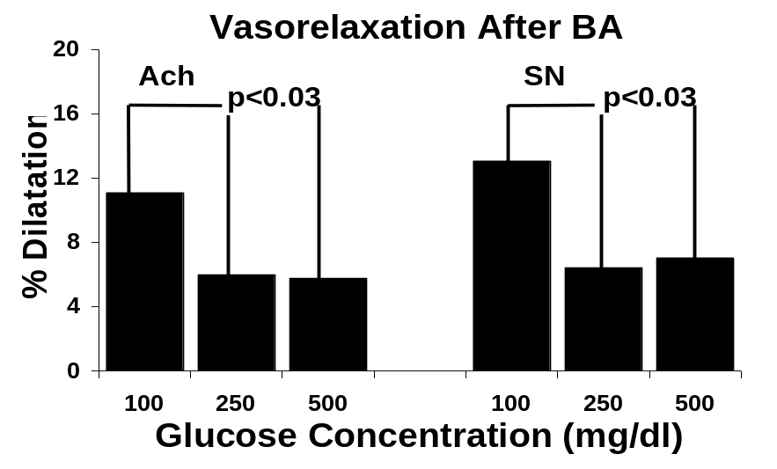

Figure 1: Effect of glucose concentration on vasomotor relaxation following balloon angioplasty

Table 1. The Diameter measurement for rabbit carotid arteries (mm)
Treatment NE Ach SN A-N (%) S-N (%)
Non-carotene 18.05±3.39 19.68±3.64 20.21±3.62 9.98±9.68* 12.43±11.84**
Carotene 16.52±3.22 18.75±3.32 19.16±3.29 14.30±10.0* 16.93±11.37**
Atherosclerotic
Control 18.56±7.16 18.94±2.98 19.88±2.96 16.80±14.91 20.30±15.22
Normal Control 13.98±2.34 18.21±2.81 18.83±2.45 35.27±29.76 39.38±26.07
NE: Diameter of artery perfused by phosphate buffer with NE (1×10⁻⁶ M); Ach: Diameter of artery perfused by phosphate; buffer with Ach (1×10⁻⁵ M); SN: Diameter of artery perfused by phosphate buffer with SN (1×10⁻⁵ M); A-N (%): (Ach perfusion-NE perfusion)/NE perfusion × 100; S-N (%): (SN perfusion-NE perfusion)/NE perfusion × 100; *p<0.001; **p<0.003.

3.3 Human Platelet - Rabbit Artery Model
A pilot study was conducted to test the feasibility of using human platelets in rabbit arteries. Fresh human platelets were obtained from collected whole blood in citrate buffer and PRP prepared by centrifugation at 200 g for 10 min. Then 10% of platelets were labeled with ¹¹¹In-Tropolone. Platelet aggregation was tested using ADP, collagen and cationic propyl gallate (CPG) to assess platelet function. Normal rabbit carotid arteries were isolated and mounted in a dual perfusion organ chamber. Balloon angioplasty was performed in one artery and the other was used as control. Both arteries were then perfused using ¹¹¹In-labeled platelets for one hour. Particle size was evaluated by sampling every five minutes using both a laser-light scattering method and a Coulter counter. Radioactive counts were measured in each artery using a γ-counter. This represented platelet adhesion to the arterial wall. In this study, the radioactive count was 48 times greater for the balloon treated artery when compared to the non-balloon treated control.
The same study was repeated after the human subject took aspirin (325 mg) 2.5 hours prior to blood retrieval. In this experiment, the platelet adhesion as represented by radioactive count was 1.7 times greater in the balloon treated artery when compared to control. However, aggregation as measured by Coulter counter and laser-light scattering was not significantly different for the balloon treated and non-treated artery. Also, the response of platelets to ADP, collagen and CPG were significantly reduced by 1.4 times when compared with and without aspirin pretreatment. This preliminary work confirms the feasibility to use rabbit arteries with human platelets. Also, it demonstrated that the effect of aspirin on platelet adhesion and aggregation was not equivalent.

3.4 The Effect of Antiplatelet Drugs on Platelet Adhesion and Aggregation after Balloon Injury
A new method was developed in our laboratory to monitor platelet aggregation continuously for evaluating the effect of various antiplatelet drugs (Huang, 1999). The intima of 10 carotid dog arteries was injured using a 3 mm balloon catheter. A He-Ne laser beam was split and passed through cuvettes in the tubes draining the carotid arteries in the organ chamber (Figure 2, 3). Laser-light scattering from the particles in the cuvetts was spread on the diode array of a multichannel analyzer. From the angle of incidence, the ratio of scattering light at 1° and 5° represented the particle size distribution. Also, particle size was measured using a Coulter counter. ¹¹¹In-labled platelets with or without aspirin were perfused through the arteries for 60 min. Radioactivity counts in the arterial segments was measured in a γ-counter. The aspirin treated platelet aggregation and adhesion were less than control by both laser-light scattering (234.2+106.4 vs. 308.8+100.3; p<0.002) and radioactive counts (331.1+251.9 vs 581.0+471.5; p<0.02) respectively. Particle size by Coulter counter and laser method were highly correlated (r=0.75). A similar study was conducted with thrombostatin, a PAR1 inhibitor. This demonstrated results comparable to aspirin.

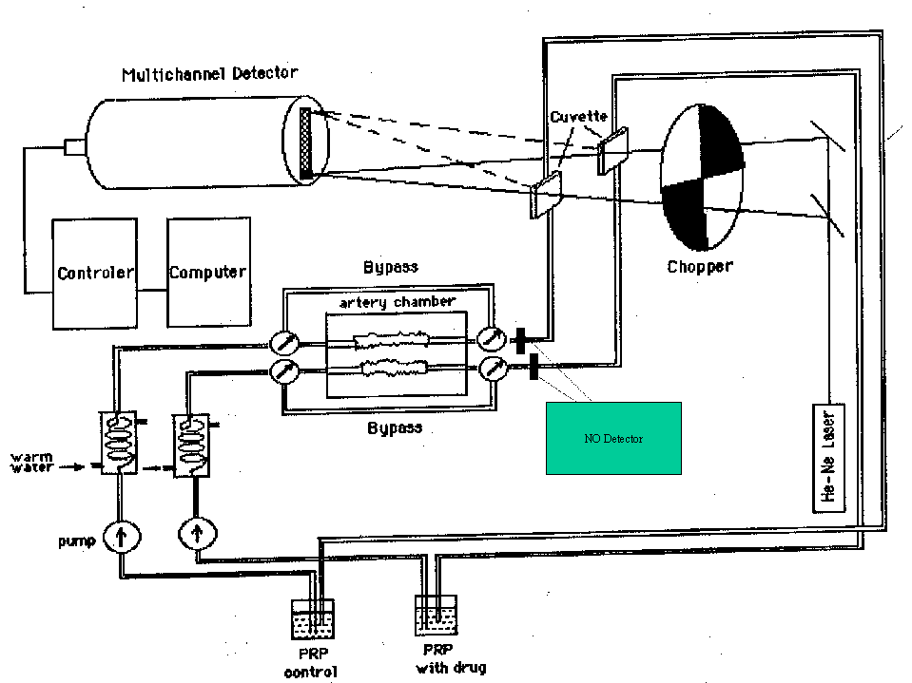
NO Detector

Figure 2. Dual Organ Chamber and Laser-light Scattering System

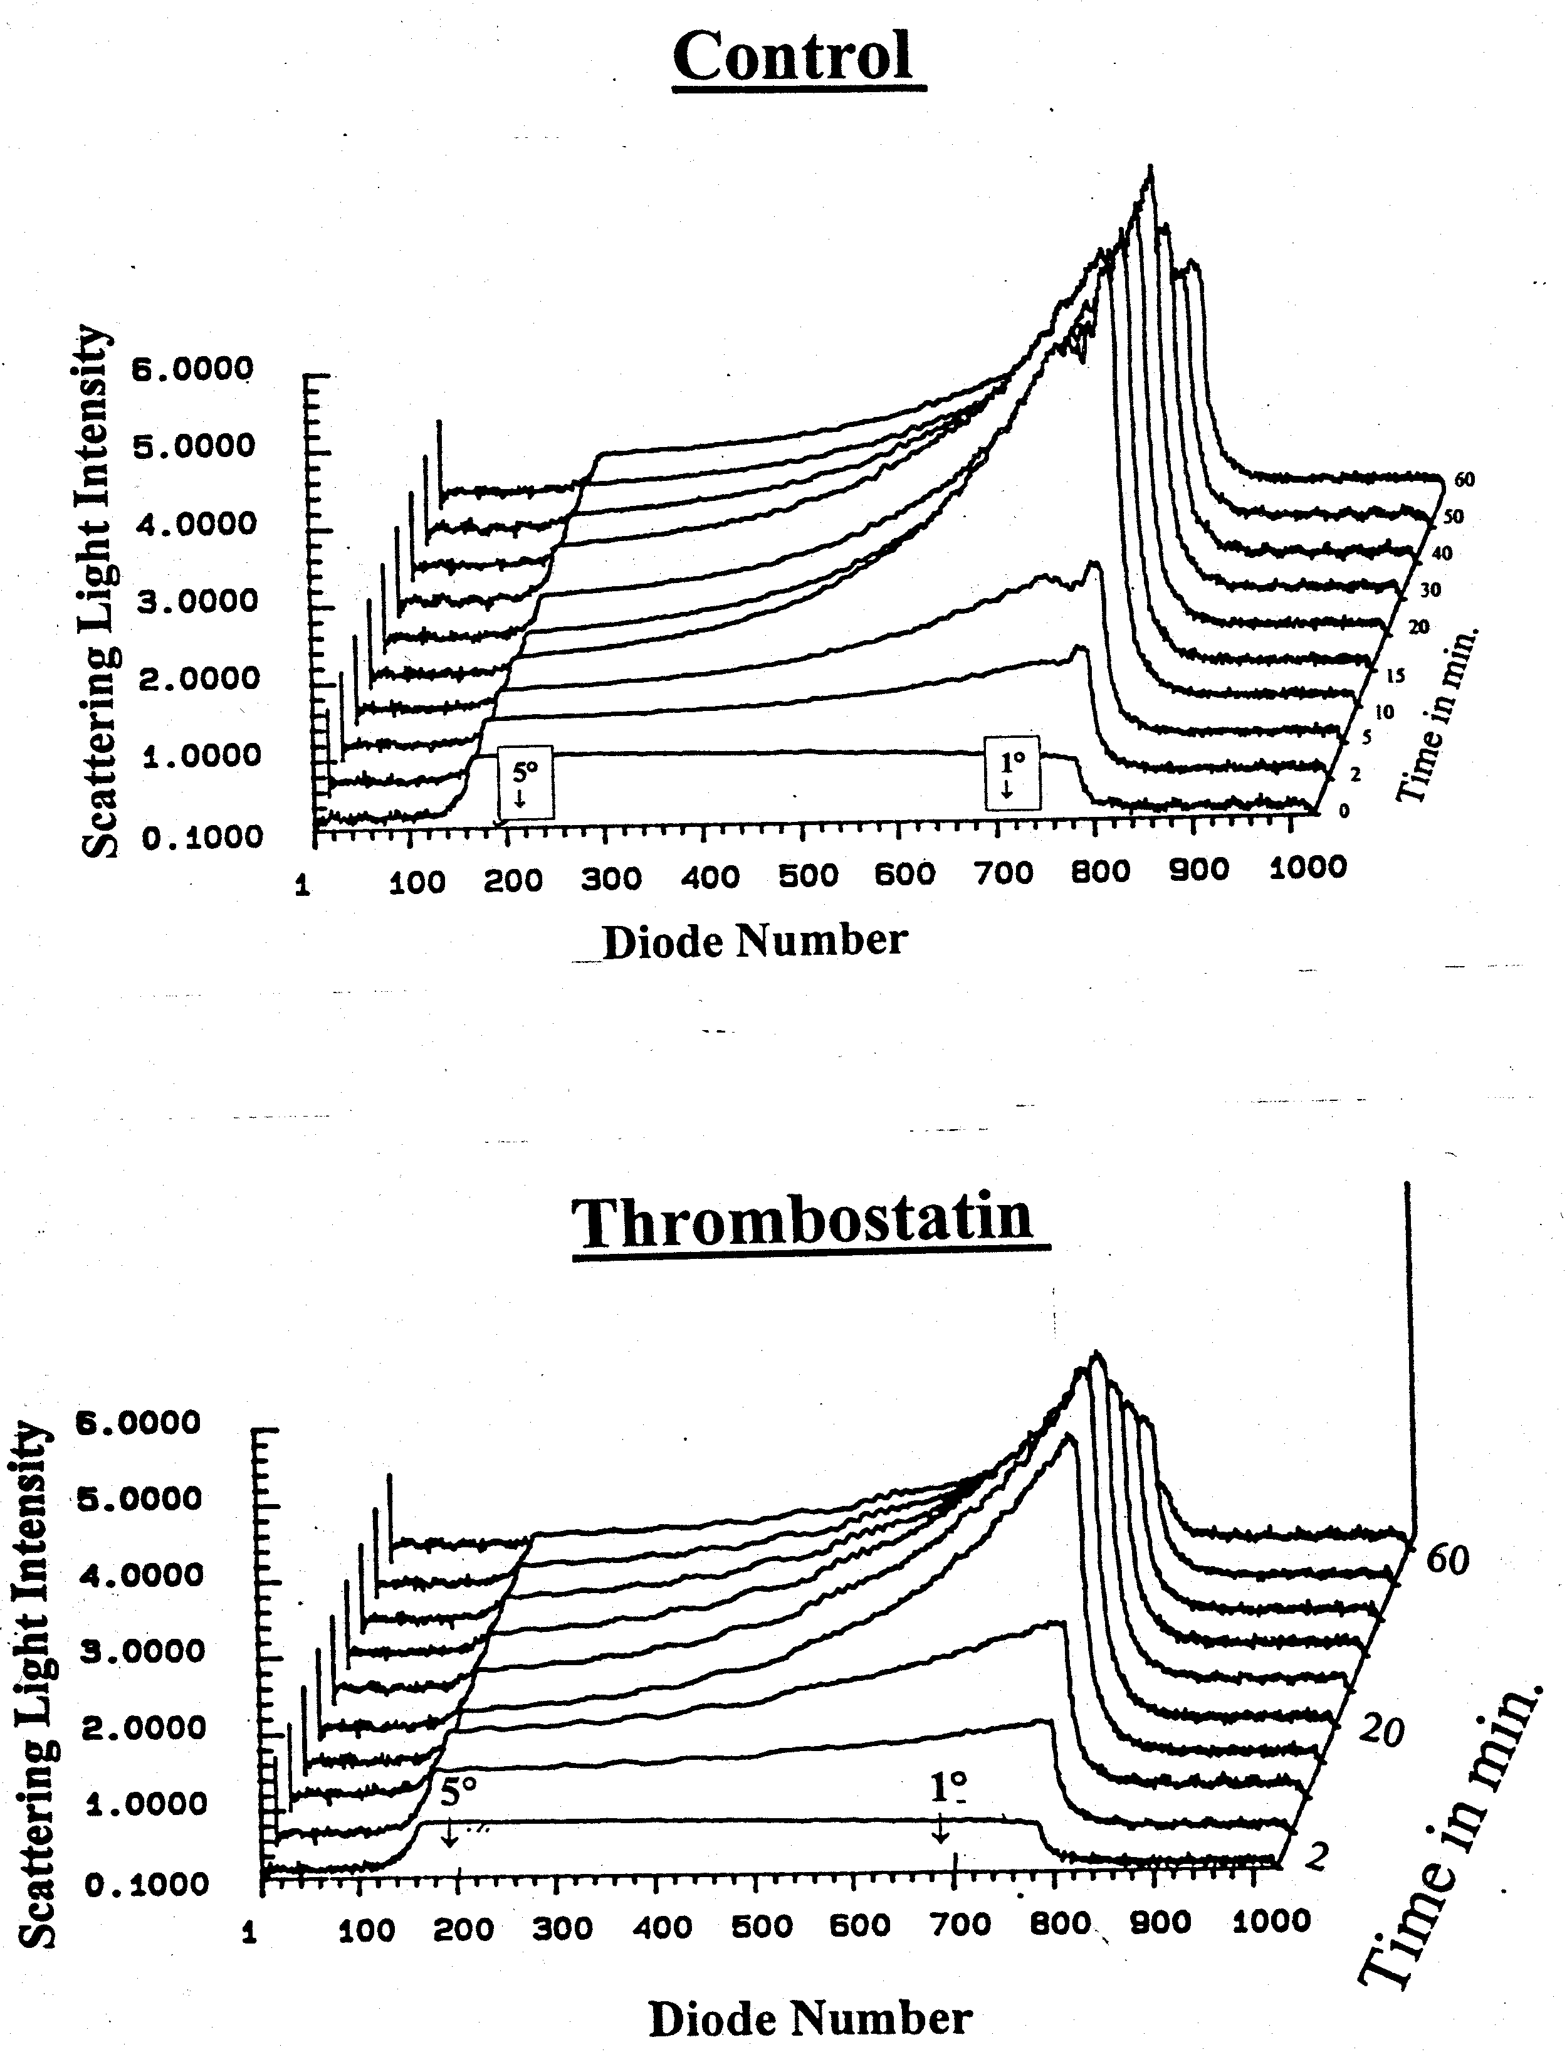

Figure 3. Laser-light Scattering at 1° to 5°

Thrombostatin, the angiotensin converting enzyme (ACE) breakdown product of bradykinin, is a selective inhibitor of α-thrombin activation of platelets. Previous work in our lab using dog carotid arteries demonstrated that thrombostatin inhibits platelet aggregation and adhesion following balloon injury. Control arteries that had balloon angioplasty when compared to thrombostatin had 2.3 times more platelet adhesion. Particle size of platelet aggregates was 1.5 times more for control when compared to thrombostatin treatment. The effect of thrombostatin as well as other antiplatelet agents (i.e. GpIIb/IIIa inhibitors and vitamin E) on platelet function following balloon injury in diabetic patients is unknown. Our hypothesis is that there is enhanced platelet aggregation during hyperglycemic states and this response can be attenuated by administration of thrombostatin.

4. Discussions
The nucleotides cyclic adenosine-3’, 5’-monophospohate (cAMP) and cyclic guanidine3’, 5’-monophospohate (cGMP) serve as a secondary messenger for intracellular metabolic regulation of many hormones that cannot cross the cell membrane or can do so only with difficulty. Primarily, cAMP is a secondary messenger for NE and cGMP is a secondary messenger for Ach. cAMP and cGMP play an important role in relaxation the endothelium-dependent and -independent vasodilators ultimately leading to its physiologic effect via a complex phosphorylation cascade. Adenylyl cyclase (ATP pyrophosphate-lyase, cyclizing, EC 4.6.1.1) is a family of membrane-bound enzymes that exhibit inactive and active configurations resulting from the actions of a variety of agents, acting indirectly and directly on the enzyme. Guanylyl cyclase (GTP pyrophosphate-lyase, cyclizing, EC 4.6.1.2) catalyzes the biosynthesis of guanosine 3', 5'-cyclic monophosphate (cGMP) from GTP. cAMP is synthesized by adenylyl cyclase and cGMP is synthesized by guanylyl cyclase. These are a family of membrane-bound enzymes that exhibit inactive and active configurations resulting from the actions of a variety of agents, acting indirectly and directly on the enzyme. Guanylyl cyclase catalyzes the biosynthesis cGMP from GTP.
The G proteins are involved in signal transduction that is responsible for both platelet aggregation and adhesion as well as arterial vascular relaxation. G proteins are heterotrimers comprised of α, β and γ subunits, each of which can exist in multiple forms. Some, but not all, of the known variants of Gα are substrates for ADP-ribosylation by pertussis toxin, a modification which disrupts the flow of information from receptor to effector. The proteins that have been identified in platelets to date are Gs, Gi₁, Gi₂, Gi₃, Gz and Gq.
Decrease in nitric oxide (NO) can lead directly to thrombosis as was demonstrated by laser-induced endothelial damage in vivo resulting in platelet aggregation (Rosenblum, 1987). The inhibition of NO synthesis in the rabbit by N^{G}-nitro-L-arginine (LNMMA) potentiates the pulmonary accumulation and prolongs disaggregation of ¹¹¹In-labeled platelets induced by sub-maximal doses of ADP, platelet activating factor and thrombin (May, 1991). Cytokine-stimulated endothelial and smooth muscle cells produce NO in amounts to vasodilate the artery and inhibit platelet adhesion and aggregation (Durante, 1991). NO is formed during platelet aggregation and L-arginine inhibits this process. Excess NO inhibits platelet aggregation and adhesion. Continuous exposure of the endothelium to low density lipoproteins also inhibits endothelium-dependent relaxation of aorta (Andrews, 1987).
Diabetic patients with coronary artery disease have more adverse outcomes including an increased mortality following balloon angioplasty when compared to coronary bypass surgery. Vasomotor relaxation and platelet reactivity are known to be altered in diabetes. Based on preliminary observations from our recent work, we hypothesise that the higher incidence of adverse events may be related to vasomotor and thrombotic dysfunction. Thus, the aims of this study are to evaluate the mechanism of vasomotor inhibition following balloon angioplasty in the presence of hyperglycemia. This will be accomplished by investigating various intracellular signaling pathways by using an organ chamber and isolated cells suspended in culture medium to determine the site of glucose inhibition of vasomotor relaxation. Also, various antiplatelet agents will be tested to evaluate the effect of hyperglycemia on platelet aggregation and adhesion. More specifically, evaluation of platelet adhesion will be compared to platelet aggregation functions as related to hyperglycemia and various drug effects. Normal, diabetic, and atherosclerotic diabetic arteries will be used in evaluating these effects. It is anticipated that the elucidation of these basic mechanisms will lead to more effective therapeutic approaches in diabetic patients.
Many studies have been performed to evaluate the risk of diabetes mellitus on the development of atherosclerosis and coronary artery disease. These include a hypercoagulable state (Ware, 1993), enhanced oxidation of LDL (Napoli, 1997), glycosylation of proteins (Brownlee, 1988) and disturbances in vasomotor relaxation (Ludmer, 1986). More recently, clinical studies have demonstrated that patients with diabetes mellitus had worse outcomes and higher mortality following PTCA when compared to coronary bypass graft surgery (CABG) (Frye, 1997). The underlying cause of this observation is unkown. Also, it is not known whether certain therapies including tight glucose control or antioxidant agents can alter these outcomes following PTCA.
Experimental problems may be encountered using the radioactive labeled platelets technique. The carotid arteries have several small side branches. These can leak into the organ chamber bath and result in ¹¹¹In-labeled platelets to adhere to the adventitial surface of the artery. This can result in an abnormally elevated radioactive count. To prevent this we test the arteries prior to circulating the platelets by injecting air and looking for bubbles in the solution bathing the medium. This is done only at the beginning of the study and at low pressures since high velocity air injection can dry out and injure the endothelium.
The laser-light scattering method to evaluate aggregation is a new technique developed in our laboratory. This technique has been evaluated in dog carotid arteries. Thus, the laser-light scattering method will always be performed together with the more established Coulter counter method. Other studies independent of this grant will be conducted on the validation of this technique.
Cells in culture do not represent the ideal environment since this is not a the same as their native environment. This limits the ability to extrapolate the behavior of the cells in situ especially after several generations of cell passes. Therefore to minimize some of this limitation we propose to use the primary cells for the studies. This will involve endothelial and smooth muscle cells freshly obtained by disaggregation from the rabbit aorta. It is expected that cells from diabetic and atherosclerotic arteries will still have responses that may be more representative of their natural state.

For the future project, three groups of 20 rabbits will be utilized in this study: Group 1, will be rabbits made diabetic with streptozodesine; Group 2, will be diabetic rabbits with atherosclerosis induced by feeding a high cholesterol (1%) diet; and Group 3, will be normal rabbit s as controls.

The following studies are designed to test the above hypothesis by:

(1) Evaluating platelet adhesion and aggregation following vascular balloon injury in the presence of hyperglycemia using normal, diabetic, and atherosclerotic diabetic rabbits.

(2) Evaluating vasomotor response to pharmacologic challenge in normal and atherosclerotic arteries from diabetic rabbits in the presence of hyperglycemia and normoglycemia.

(3) Evaluating signal transduction by cyclic GMP/AMP molecular pathways to characterize the response of the endothelial and smooth muscle cells to hyperglycemic stress following balloon injury.
(4) Evaluating therapeutic approaches using vitamin E as an antioxidant to prevent the inhibition of vasomotor relaxation with hyperglycemia and to evaluate inhibition of platelet adhesion to the injured arterial wall by using a PAR-1 inhibitor and Gp IIb/IIIa antagonists.

References
- Abela GS, Picon PD, Friedl SE, Gebara OC, Federman M, Tofler GH, Muller JE. Triggering of plaque disruption and arterial thrombosis in an artherosclerotic rabbit model. Circulation. 1995;91;776-784.
- Andrews HE, Bruckdorfer KR, Dunn RC, Jacobs M. Low-density lipoproteins inhibit endothelium-dependent relaxation in the rabbit aorta. Nature. 1987;327:237-239.
- Armbruster FP. Calcium regulating hormones, vitamin D metabolites, and Cyclic AMP: Assays and their clinic application, pp 232-243, Springer-Verlag, Berlin Heidelberg, Germany, 1990.
- Brownlee M, Cerami A, Vlassara H. Advanced glyocsylation end products in tissue and the biochemical basis of diabetic complications. N Eng J Med. 1988;318(20):1315-1321.
- Bucala R, Tracey KJ, Cerami A. Advanced glycosylation products quench nitric oxide and mediate defective endothelialium-dempendendet vasodilatation in experimental diabetes, J Clin Invest. 1991;87:432-438.
- The Bypass Angioplasty Revascularization Investigation (BARI) Investigators, Comparison of Coronary Bypass Surgery with Angioplasty in Patients with Multivessel Disease, N Eng J Med, 1996; 335:217-225.
- Carpenter KL, van-der-Veen C, Hird R, Dennis IF, Ding T, Mitchinson MJ. The carotenoids beta-carotene, canthaxanthin and zeaxanthin inhibit macrophage-mediated LDL oxidation. FEBS Lett. 1997;401(2-3):262-6.
- Davies PF. Cell Culture Techniques in Heart and Vessel Research: Coculture of Endothelial and Smooth, Muscle Cells, pp. 290-298, Springer-Verlag Berlin Heidelberg, New York, USA, 1990.
- Dewanjee MK, Rao SA, Rosemark JA, Chowdhury S, Didisheim P. Indium-111 tropolone, a new tracer for platelet labeling, Radiology. 1982;145:149-153.
- Domino SE, Tubb DJ, Garbers DL. Methods in Enzymology (Volume 195): Adenylyl Cyclase, G Protein, and Guanylyl Cyclase, pp 345-355 & 345-355, Academic Press, Inc., San Diego, USA, 1991.
- Dusting Macdonald PS. Endogenous nitric oxide in cardiovascular disease and transplantation, Ann-Med. 1995;27(3):395-406.
- Frye RL. Influence of diabetes on 5-year mortality and morbidity in a randomized trial comparing CABG and PTCA in Patients With Multivessel Disease, Circulation. 1997;96:1761-1769.
- Gaziano LM. Randomized trials of dietary antioxidants in cardiovascular disease prevention and treatment, J Cardiovasc Risk. 1996;3(4):368-71.
- Guo JP, Murohara T, Buerke M, Scalia R, Lefer AM. Direct measurement of nitric oxide release from vascular endothelial cells. J Appl Physiol. 1996;81:774-779.
- Alfred E. Harper, Measurement of Enzyme Activity: Glucose-6-phosphatase, in Methods of Enzymatic Analysis, pp 788-792, Academic Press, New York, USA, 1965.
- Harris WS. The prevention of atherosclerosis with antioxidants. Clin Cardiol. 1992;15(9):636-40.
- Hasan AK, Amenta S, Schmaire AH. Bradykinin and its metabolite, Arg-Pro-Pro-Gly-Phe, are selective inhibitors of α-thrombin-induced platelet activation. Circulation. 1996;94:517-528.
- Henriksen T, Mahoney EM, Steinberg D. Enhanced macrophage degradation of biologically modified low density lipoprotein. Arteriosclerosis. 1983;3:149-159.
- Huang R, Ma H, Prieto AR, Khan GR, Hage-Korban EE, Schwartz KA, Davis JM, Abela GS. Laser-light scattering as a new model for measuring platelet aggregate formation in arteries following balloon injury. Lasers in Surgery and Medicine. 1999(Suppl 11).
- Ignarro LJ, Buga GM, Wood KS, Byrns RE, Chaudhuri G, Endotheliumo-derived relaxing factor produced and released from artery and vein is nitric oxide. Proc Natl Acad Sci USA. 1987;84:9265-9269.
- Jialal I, Fuller CJ. Effect of vitamin E, vitamin C and beta-carotene on LDL oxidation and atherosclerosis. Can J Cardiol. 1995;11 Suppl G:97G-103G.
- Johnstone M, Creager S, Scales K, Cusco J, Lee B, Creager M. Impaired endothelium-dependent vasodilatation in patients with insulin dependent diabetes mellitus, Circulation. 1993;88:2510-2516.
- Roger A. Johnson and Yoram Salomon, Methods in Enzymology (Volume 195): Adenylyl Cyclase, G Protein, and Guanylyl Cyclase, pp 3-21, Academic Press, Inc., San Diego, USA, 1991.
- Kaesemeyer WH, Caldwell RB, Huang J, Caldwell RW. Pravastatin sodium activates endothelial nitric oxide synthase independent of its cholesterol-lowering actions. J Am Coll Card. 1999;33:234-241.
- Kasanicki MA, Plch PF. Regulation of glucose-transporter function, diabetes care, 1990;13:219-227.
- Keaney JF, Gaziano JM, Xu A, Frei B, Curran-Celentano J, Ahawaery G, Loscalzo J, Vita JA. Low-dose alpha-tocopherol improves and high-dose alpha-tocopherol worsens endothelial vasodilator function in cholesterol-fed rabbits. J Clin Invest. 1994;93:844-851.
- Kikuchi A, Yamashita T, Kawata M, Tamamoto K, Ikeda K, TanimotoT, Takai Y. Purification and characterization of a novel gtp-binding protein with a molecular weight of 24000 from bovine brain memberane. The Journal of Biological Chemistry. 1988;263(6):2897-1904.
- Klip MR. Paquet, glucose transport and glucose transporters in muscle and their metabolic regulation. Diabetes Care. 1990;13:228-243.
- Kita T, Nagano Y, Yolode M, Ishii K, Kume N, Ooshima A, Yoshida H, Kawai C. Probucol prevents the progression of atherosclerosis in Watanabe heritable hyperlipidemicrabbit, an animal model for familial hypercholesterolemia. Proc Natl Acad Sci USA, 1987;84:7725-7729.
- Kleiman MS, Lincoff AM, Kereiakes DJ, Miller DP, Aguirre FV, Anderson KM, Weisman HF, Califf RM, Topol EJ. Diabetes mellitus, glycoprotien IIb/IIIa blockade, and heparin: evidence for a complex interaction in a multicenter trial. EPILOGUE Investigators. 1998;97:1912-1920.
- Kremastinos DT, Iliodromitis EK, Markianos M, Apostolou TS, Kyriakides ZS, Karavolias GK. Interacoronary cyclic-GMP and cyclic-AMP during percutaneous transluminal coronary. Angioplasty. 1996;53:227-232.
- Lamberton RP, Goodman AD, Kassoff A, Rubin CL, Treble DH, Saba TM, Merimee TJ, Dodds WJ. Diabetes. 1984;33:125..
- Ludmer P, Selwyn A, Shook T, Wayne R, Mudge G, Alexander W, Ganz P. N Eng J Med. 1986;315:1046-1051.
- May GR, Crook P, Moore PK, Page CP, The role of nitric oxide as an endogenous regulator of platelet neutrophil within the pulmonary circulation of the rabbit. Brit J Pharmacol. 1991;102:759.
- Napoli C, Mancini F, Corso G, Malorni A, Crescenzi E, Postiglione KA, Palumbo G, A simple and rapid purification procedure minimizes spontaneous oxidative modifications of low density lipportein and lipoprotein (a), J Biochem 1997;121:1096-1101.
- Nitenberg, Valensi P, Sachs R, Dali M, Aptecar E, Attali J. Impairment of coronary vascular reserve and ach-induced coronary vasodilatation in diabetic patients with angiographically normal coronary arteries and normal left ventricular systolic function, Diabetes. 1993;42:1017-1025.
- O’Driscoll G, Green D, Maiorana A, Stanton K, Colreavy F, Taylor R. Improvement in endothelial function by angiotensin-converting enzyme inhibition in non-insulin-dependent diabetes mellitus. J Am Coll Card. 1999;33:1506-1511.
- Ohmori T, Kikuchi A, Yamamoto K, Kim S, Takai Y. Small molecular weight GTP-binding proteins in human platelet membrane. The Journal of Biological Chemistry, 1989;264 (3):1877-1881.
- Palinski W, Rosenfeld M, Yla-Herttuala S, Gurtner G, Socher S, Butler S, Parthasarathy S, Carew TE, Steinberg D, WitztumJ. Low density lipoprotein undergoes oxidative modification in vivo. Pro Natl Acad Sci USA. 1989;86:1372-1376.
- Palozza P, Krinsky NI. Antioxidant Effects of Carotenoids in Vivo and in Vitro: An Overview, in Method in Enzymology, Vol. 213, pp 404-420, Academic Press, Inc., New York, USA, 1992.
- Porkkala-Sarataho E, Nyyssonen K, Salonen JT. Increased oxidation resistance of atherogenic plasma lipoproteins at high vitamin E levels in non-vitamin E supplemented men. Atherosclerosis. 1996;124(1): 83-94.
- Quinn MT, Parthasarathy S, Fong LG, Steinberg D. Oxidatively modified low density lipoproteins: a potential role in recruitment and retention of monocyte macrophages during atherogenesis. Proc Natl Acad Sci USA. 1987;84:2995-2998.
- Rosenbblum WI, Nelson GH, Povlishock JT. Laser-induced endothelial damage inhibits endothelium-dependent relaxation in the cerebral microcirculation of the mouse. Circ Res 1987;60:169.
- Shaish; Daugherty A, O'Sullivan F, Schonfeld G, Heinecke JW. Beta-carotene inhibits atherosclerosis in hypercholesterolemic rabbits. J Clin Invest. 1995;96(4):2075-82.
- Stubbs ME, Jimenez AH, Yamane M, Maciak D, Burke B, D'Elia JA, Weinrauch LA, Tofler GH, Muller JE. Platelet hyperreactivity in diabetics: relation to time of onset of acute myocardial infarction. Circulation. 1990;15:119A.
- Takahashi K, Ghatei M, Lam H, O’Halloran D, Bloom S. Elevated plasma endothelin in patients with diabetes mellitus. Diabetologia. 1990;33:306-310.
- Ting H, Timimi F, Boles K, Creager S, Ganz P, Creager M, Vitamin C improves endothelium-dependent vasodilation in patients with non-insulin-dependent diabetes mellitus, J Clin Invest. 1996;97:22-28.
- Vassanelli C, Menegatti G, Zanolla L, Molinari J, Zanotto G, Zardini P. Coronary vasoconstriction in response to acetylcholine after balloon angioplasty: possible role of endothelial dysfunction, Coron Artery Dis. 1994;5(12):979-86.
- Ware J, Heistad D. Platelet-Endothelium Interactions. N Eng J Med. 1993;328:628-635.
- Weidinger FF, McKenachan JM, Cybulsky MI, Gordon JB, Rennke HG, Hollenber NK, Fallon JT, Ganz P, Cook JP. Persistent dysfunction of regenerated endothelium after balloon angioplasty of rabbit iliac artery. Circulation. 1990;81:1667-1676.
- Witztum JI, Steinberg D. Role of oxidized low density lipoprotein in atherogenisis. J Clin Invest. 1991;88:1785-1792.
- Yla-Herttuala S, Palinski W, Rosenfeld M, Parthasarathy S, Carew TE, Butler S, Witztum J, Steinberg D. Evidence for the presence of oxidatively modified LDL in atherosclerotic lesions of rabbit and man. J Clin Invest. 1989;184:1086-1095.

