The Comparison of the Loading Devices on
Microstrip Circuit in Patch Antenna
Shen Cherng
Graduate Institute of Electrical Engineering,
Chengshiu University, Niaosong, 833 Taiwan, ROC

Abstract

A microstrip band pass filter circuit presented can be used to regulate the characteristic of the antenna. In this article, the circuit effects to the loading devices are investigated to depict the function of the microstrip band pass filter circuit designed for patch antenna.

Key words: VSWR, microstrip circuit, patch antenna

1. Introduction
The microstrip circuit can regulate the patch antenna. Design a coupling microstrip circuit connecting the signal source to an effective loading device can control the characteristic of microstrip antenna [1]. Size and shape of the radiator in patch antenna are parameters for design and can be considered as loading impedance regulator for a microstrip circuit in a transmission line model. However, the characteristics of the distributed microstrip elements being coupled to the antenna are the problems to analysis in both Thevenin and Norton equivalents [2]. In this article, we proposed a patch antenna including a microstrip band pass filter circuit to find the circuit behavior on different radiators as the loading devices via a short connection transmission line [4]. Prototype antennas are constructed

2. Configuration
Figure 1 shows the size and shape parameters of the proposed antenna patch antenna with slot and without slot. In Figure 2, the drawing of the return loss depicts microstrip band pass filter causes the similar effect on different resonant loading devices for patch antenna. As shown in the figure, the filter circuit via path connecting to the metal radiator can be analyzed by using transmission line model.
3. Results and Discussion
The proposed antenna is depicted in Figure 3. The thickness and dielectric constant of the FR4 plate are indicated d = 0.4 mm,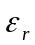= 4.4. Figure 2 depicts the return loss of the measurement of the antenna including microstrip strip circuit coupled to different metal radiators as loading devices. Figure 4 demonstrates the field-patterns of the antenna with different radiators. The presence of the forward and backward scattering current driven by filter circuit delivers the excitation power via path for the modes of resonances of the metal radiator. In Figure 5, the gains of the proposed antenna are depicted. The microstrip circuit can be designed to improve the impedance matching and selecting resonant frequencies for loading devices.

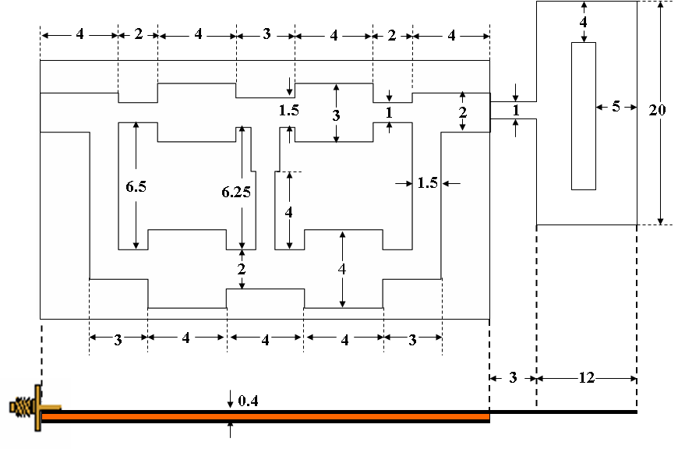

(A)
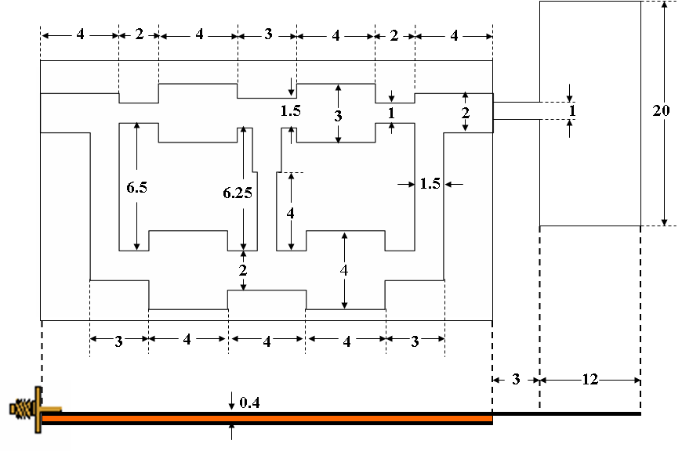
(B)

Figure 1.
Size and shape parameters of the proposed antenna patch antenna (A) with slot (B) without slot

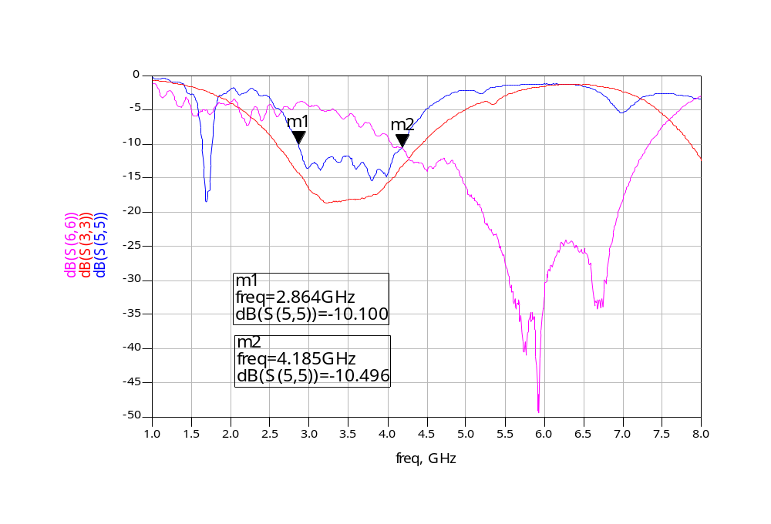

VSWR=1.3 *

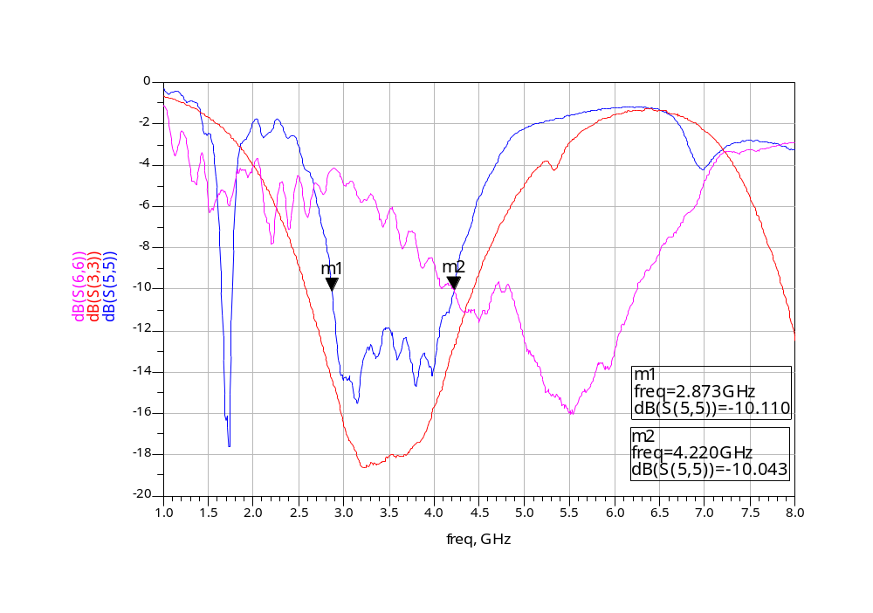
(A)



(B)

Figure 2.
Measurement of the Return Loss. The impedance matching of the metal antenna at 3.5GHz is shown being improved by coupling to microstrip circuit regulator

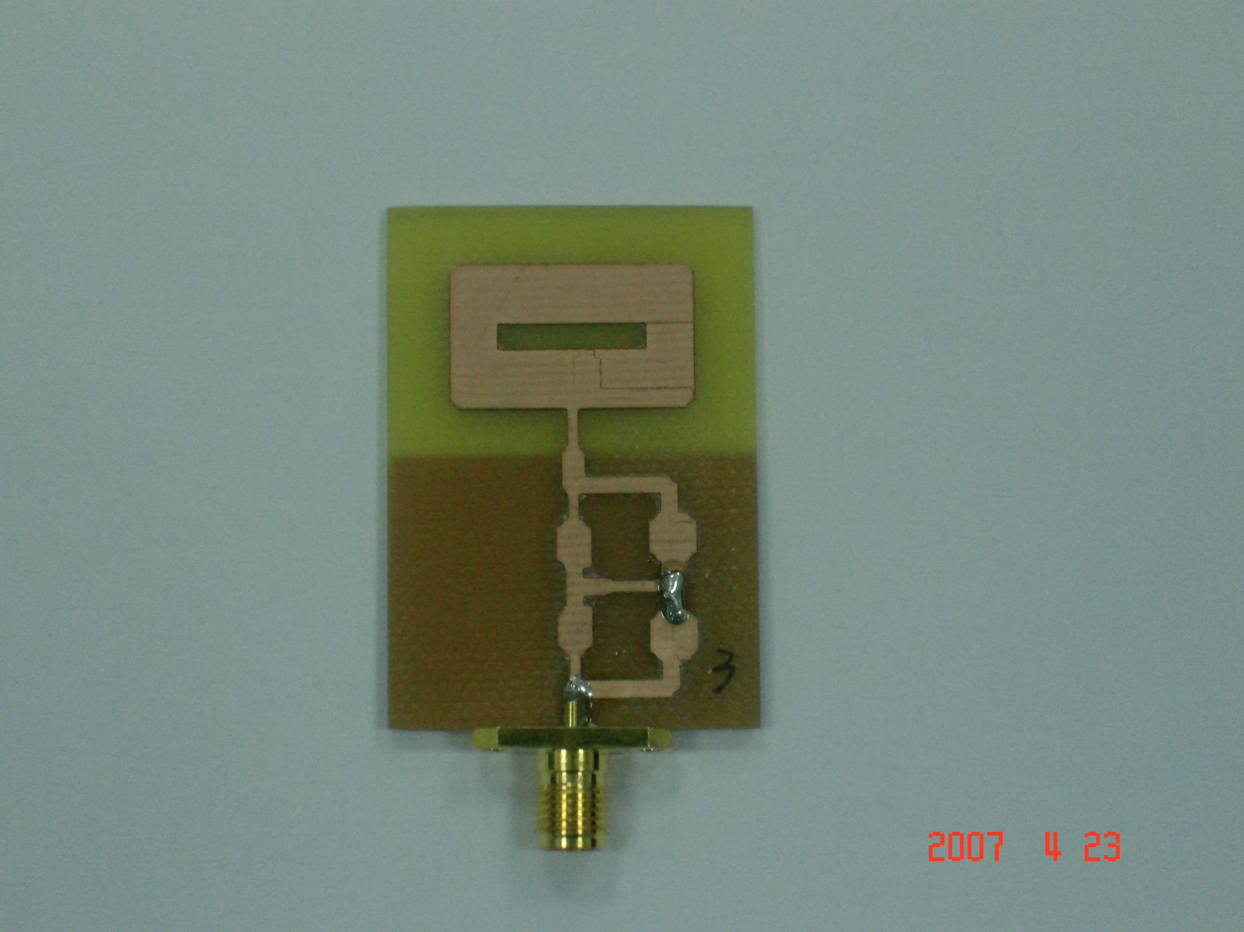
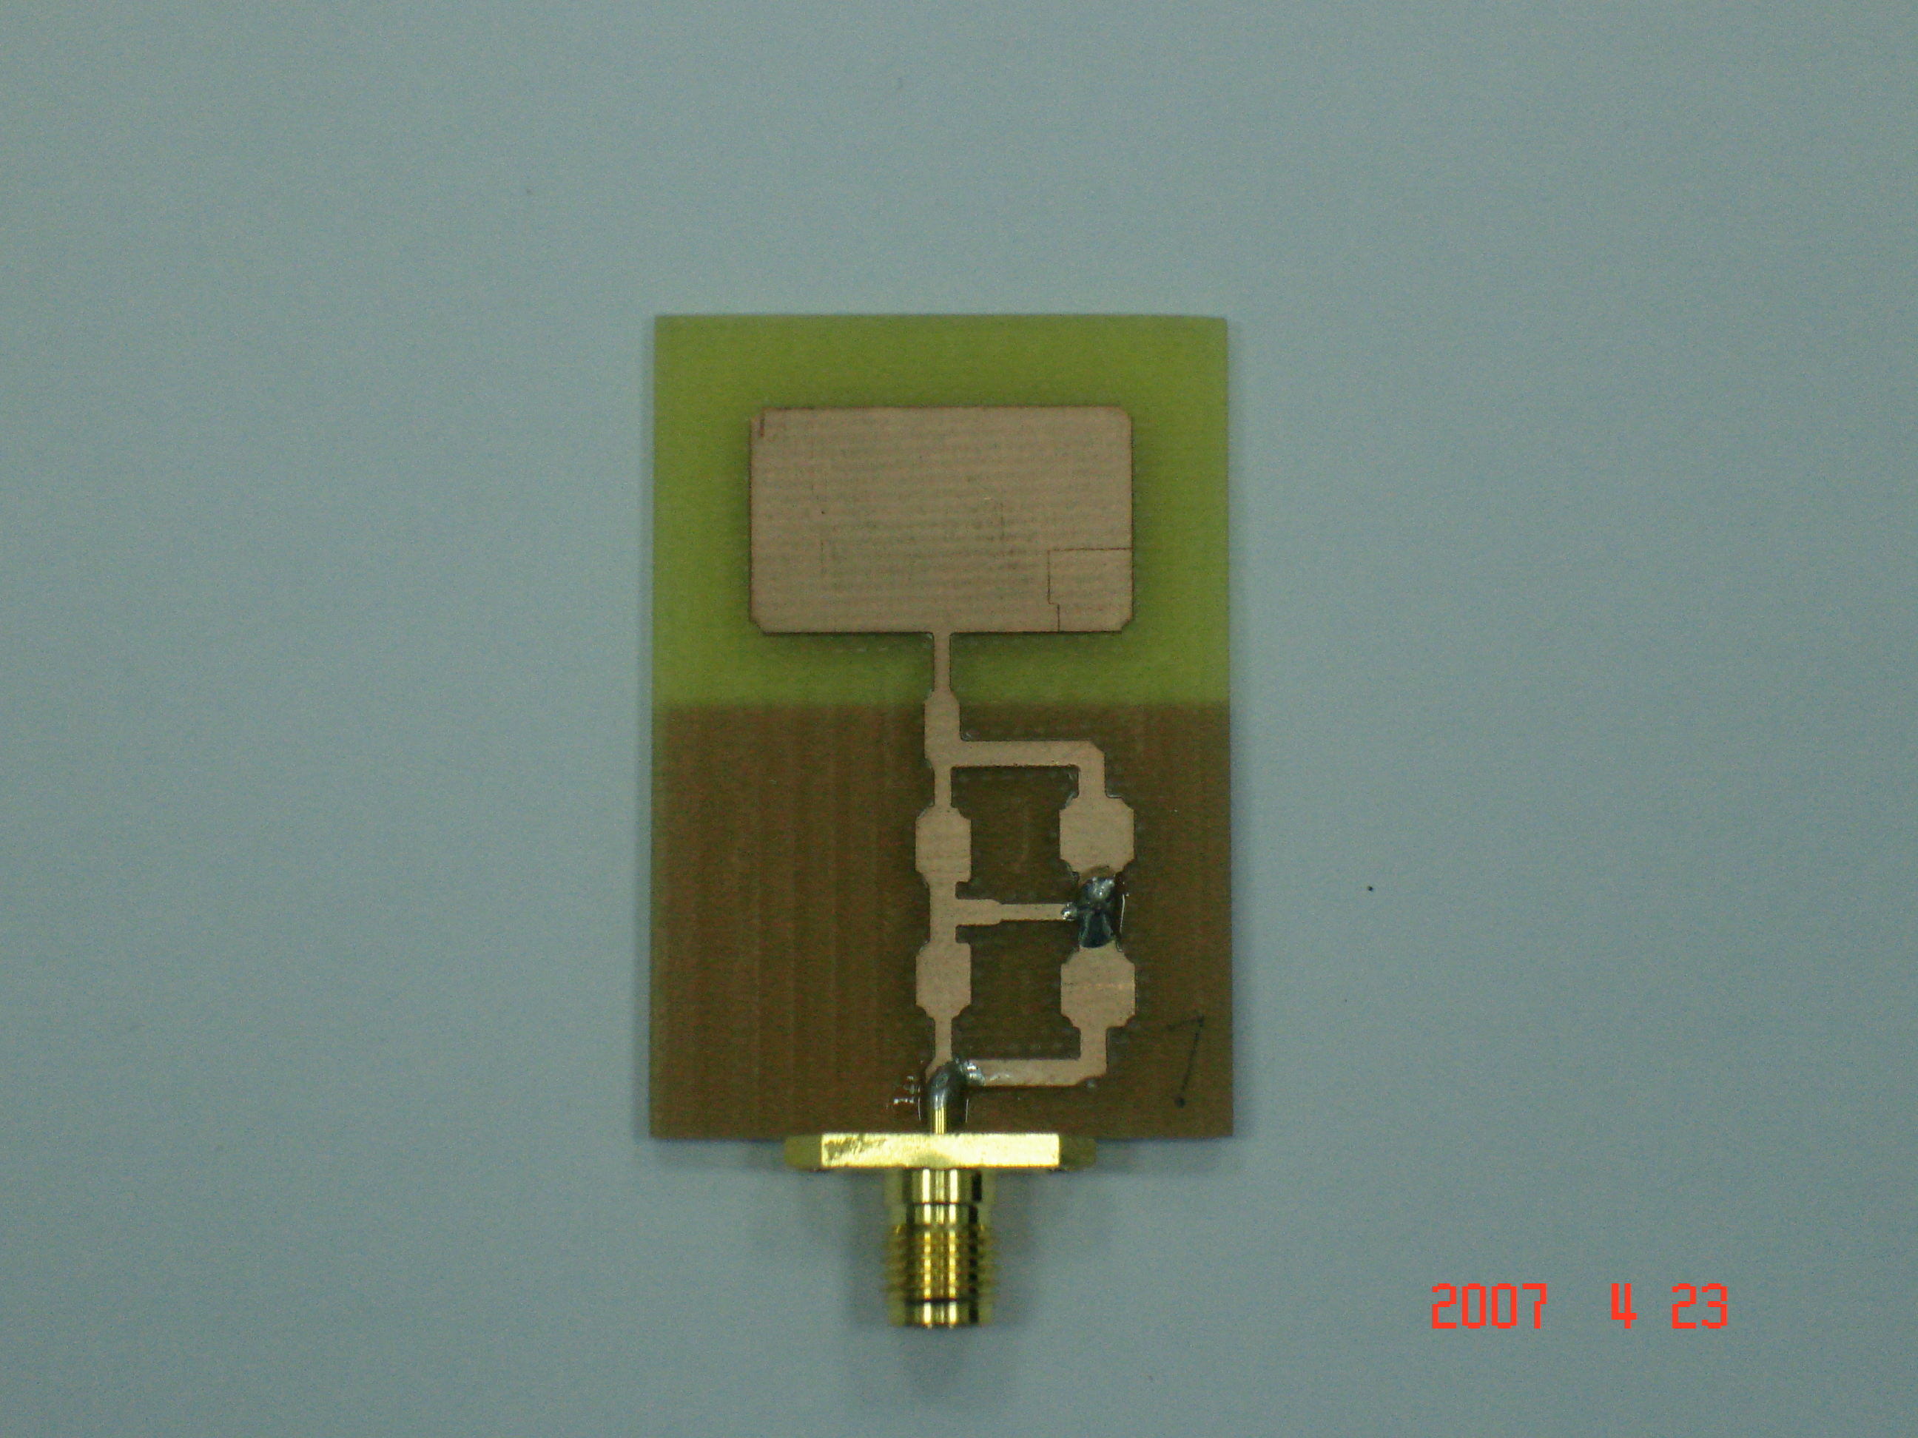

(A) (B)

Figure 3.
Prototype of the proposed antennas in design
(A) with slot (b) without slot
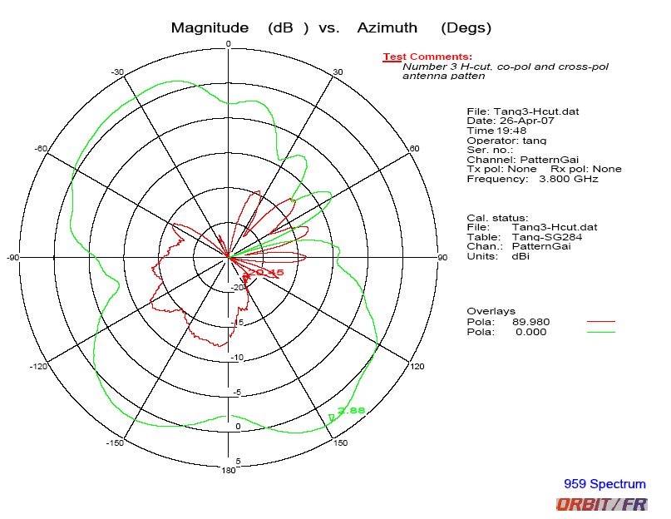
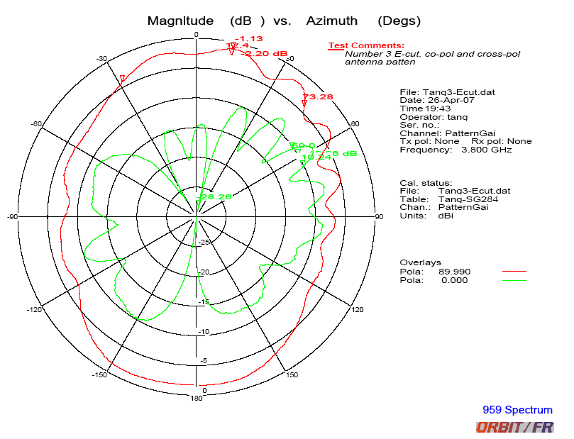

(A)
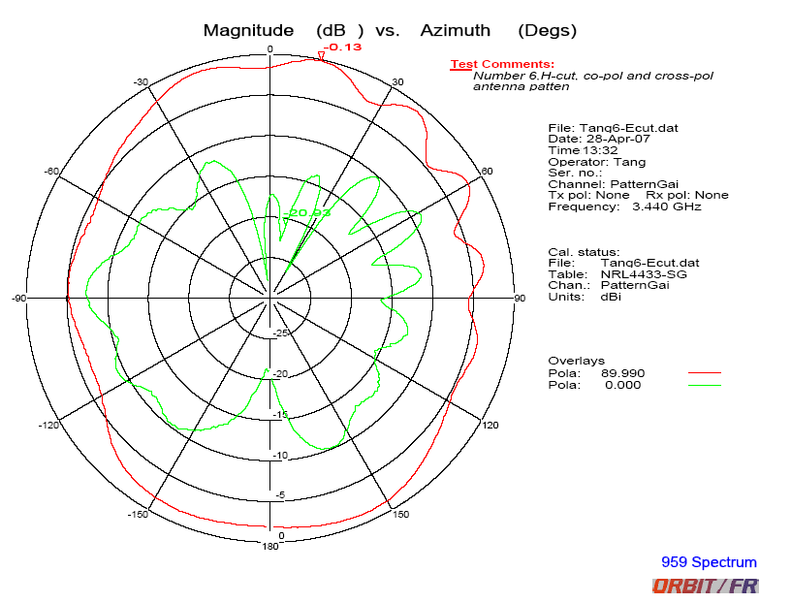
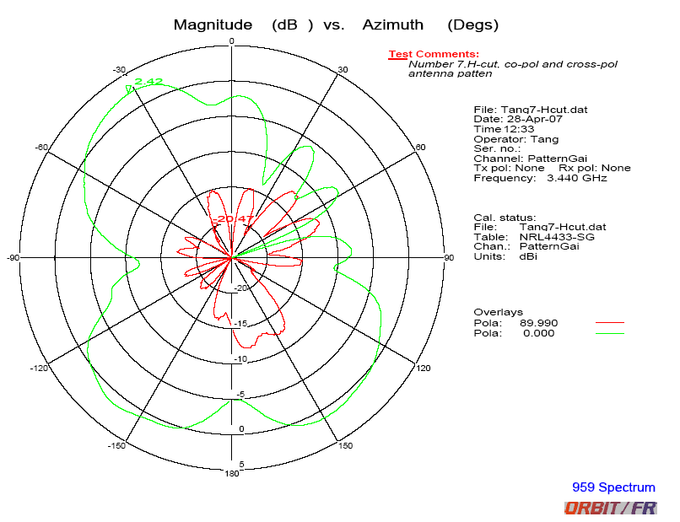

(B)

Figure 4.
The measured radiation pattern of the proposed antenna at 3.8 GHz
(A) with slot and (B) 3.44GHz without slot

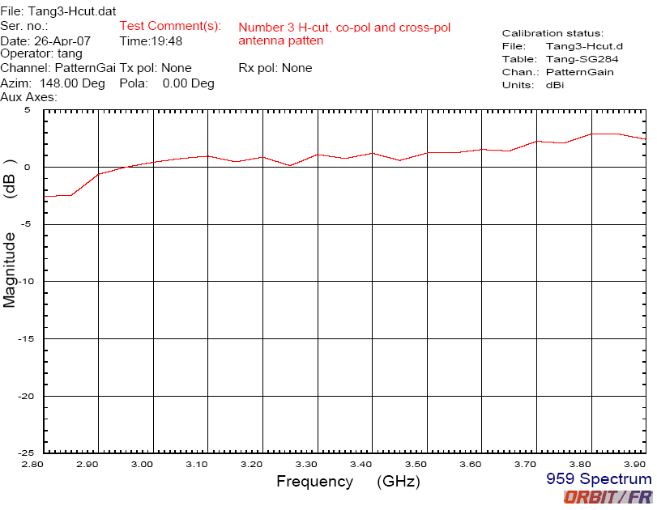

(A)

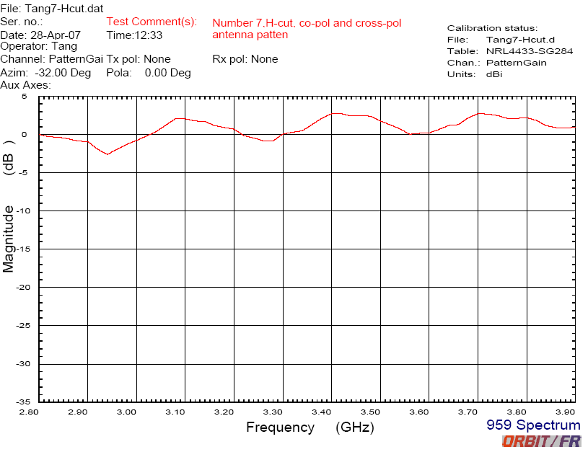

(B)

Figure 5.
Antenna Gains for the prototype designs for different resonant radiator connection
(A) with slot (B) without slot

4. Conclusion
The proposed antenna with a functional microstrip filter circuit via transmission line coupling to metal radiator can be used to select available frequency-bands for carrying out specific gains for the mobile system. The microstrip circuit functions to regulate the patch antenna with keeping the same characteristic to different loading devices. Under the conditions of different resonant radiators, the optional design of the filter circuit can be conducted to satisfy the resonant specification.

Acknowledgement: All the data and drawings were conducted by Shiue Chun Tang, Air Communication Electronic Department, Air Force Institute of Technology, Gangshan, 820 Taiwan, ROC

Correspondence to:
Shen Cherng, P.E., M.D., Ph.D.
Gradulate Institute of Electrical Engineering
Chengshiu University, Niaosong, 833 Taiwan, ROC
cherng@msu.edu
886-77310606 ext 3423 (office)
886-929370970 (cellula

References
- KL Wong, Planar antennas for wireless communications, Chapter 5~7, John Wiley & Sons, New York, NY.2003
- JV Bladel, ” On equivalent circuit of a receiving antenna ,” IEEE Antennas and Propagation Magazine, vol.44, No.1, pp164~165, February, 2002
- KL Wong, CH Wu and FS Chang, “A compact wideband omnidirectional cross plate monopole antenna,” Microwave and Optical Technology Letters, vol.44, No.6, pp492~494, March 20, 2005
- KL Wong, Compact and Broadband microstrip antennas, Chapter 7, John Wiley & Sons, New York, NY.2002

