Laser Stabilization of the Vulnerable Plaque to Prevent Heart Attacks

Ma Hongbao *, Cherng Shen **

* New Start Company, Brooklyn, New York 11212, USA; hongbao@gmail.com, 347-789-4323

** Department of Electrical Engineering, Chengshiu University, Niaosong, Taiwan 833, Republic of China; cherngs@csu.edu.tw, 011886-7731-0606 ext 3423

Abstract: Atherosclerosis is a complex disease process of the arterial system that results in the development of obstructive lesions that eventually rupture causing arterial thrombosis leading to heart attacks and strokes. Atherosclerosis is a dynamic process that evolves over long periods of time. Recent studies of human as well as rabbit plaques have demonstrated that vulnerable plaques have a higher temperature than the surround plaque and normal arterial wall. The pathology of vulnerable plaque has demonstrated it to be composed of a rich lipid core covered by a thin collagen cap. This study gives the information of the laser stabilization effects on the vulnerable plaque with the rabbit artheorsclersotic model. [The Journal of American Science. 2006;3(1):6-15].

Keywords: atherosclerosis; laser; plaque; rabbit; rupture

1. Introduction
Atherosclerosis is a complex disease process of the arterial system that results in the development of obstructive lesions that eventually rupture causing arterial thrombosis leading to heart attacks and strokes. Atherosclerosis is a dynamic process that evolves over long periods of time. Until present there has been no effective model to evaluate the dynamic behavior of atherosclerosis that leads to disruption and thrombosis. We developed a model based on the early work of Dr. Paris Constantinides in the Sixties using atheroslcerotic rabbits that could be triggered pharmacologically to develop plaque disruption and thrombosis (Contstantinides, 1961). This was performed using Russell’s viper venom as a procoagulant agent (factor V and X activator) and histamine as a vasoconstrictor agent in rabbits. The model resulted in plaque disruption and thrombosis similar to the human condition. However, the original model was cumbersome requiring one to two years of preparation. Our version of the model accelerates the atherosclerotic process by balloon endothelial debridement prior to initiating cholesterol feeding. This leads to the formation of atherosclerotic lesions within 4 - 6 months that could be triggered with a resulting 72% event rate (Abela, 1995; Christov, 2000).
Recent studies of human as well as rabbit plaques have demonstrated that vulnerable plaques have a higher temperature than the surround plaque and normal arterial wall (Verheye, 2002). Various devices have been developed to detect these vulnerable lesions. One method uses a catheter system with thermocouples at the tip that maps the artery for ‘hot spots’ (Casscells, 1996; Stephanadis, 1999).
In a recent report we evaluated the effect of lasers and thermal probes on the coagulation of collagen in the arterial wall (Abela, 2001). In this study we demonstrated that thermal coagulation gels the collagen of the internal elastic lamina of the artery and reduces the damage of balloon angioplasty. This resulted in a significant reduction in platelet deposition and thrombus formation. The concept of collagen stabilization using laser and thermal effects has been shown in other organ systems, namely in skin resurfacing (Fitzpatrick, 1996) as well as in injured tendons to enhance healing. We propose to use the laser prior to pharmacological triggering in the plaque rupture model to treat the ‘hot spots’ in order to reduce the disruption and thrombosis event rate. If successful, this could represent a major therapeutic role for the laser in cardiovascular disease.
In our preliminary data we have demonstrated that laser treatment can thermally alter mechanical and histological properties of the arterial wall. Also, we have better defined the parameters to use in the in vivo studies of the plaque disruption model. These seem to favor laser treated arteries with respect to elasticity. In this proposal we will attempt to demonstrate the hypothesis that laser treatment can actually reduce the plaque rupture and thrombosis at treated sites.
Recently, it has become clear that certain types of arterial plaques are responsible for causing heart attacks. These plaques that undergo disruption and thrombosis are referred to as “vulnerable” (Muller, 1994). While at Harvard Medical School, my laboratory developed a model to evaluate vulnerable plaque in an atherosclerotic rabbit model (Abela, 1995). In humans we used angioscopy to differentiate vulnerable from non-vulnerable lesions (Waxman, 1996). Now, several other methods have been developed to detect vulnerable plaque including thermal sensing, intravascular ultrasound, magnetic resonance and optical coherence tomography. However, the outstanding question is that even if it were possible to detect vulnerable plaques, what can be done to stabilize them. We know from the pathology of plaques that have ruptured causing heart attacks that the collagen cap that holds the structure together is weakened. Thus, the objective of this proposal is to use laser radiation to stabilize vulnerable plaques by altering the collagen structure of the fibrous plaque and surrounding artery. Extensive data from investigations in other fields have demonstrated that the laser can alter collagen structure as shown for skin resurfacing and from our recent work on thermal coagulation of collagen in the arterial wall (Fitzpatrick, 1996; Abela, 2001). Ischemic heart disease is widely prevalent with over one million patients presenting yearly with cardiovascular events in the United States. These patients have heart attacks and unstable angina symptoms. Although various medical and technological advances have reduced the mortality, many patients continue to die suddenly from coronary artery disease because of vulnerable plaques.
The pathology of vulnerable plaque has demonstrated it to be composed of a rich lipid core covered by a thin collagen cap (Davies, 1985). However, recently inflammatory cell activity has been shown to participate in weakening the collagen cap by producing enzymes that digest collagen (Lendon, 1991). After heart attacks, vulnerable lesions are noted to have ruptured collagenous caps leading to exposure of the lipid core to the circulating blood causing thrombotic occlusion of the artery. Although investigations have demonstrated that the vulnerable plaque can be detected, it is not clear what type of intervention will alter its course to rupture. We have published reports demonstrating that laser and thermal energy can alter vascular collagen structure and reduce platelet deposition at the site of vascular injury (Abela, 1991;2001). Furthermore, we had previously developed an atherosclerotic rabbit model that closely simulates the events that lead to heart attacks in humans (Abela, 1995). In our previous preliminary studies we have demonstrated that arterial sites with plaque rupture have elevated temperature. Furthermore, in the past year we demonstrated that laser delivery via a diffuser tip fiber inside an angioplasty balloon catheter could heat the arterial wall to temperatures that can alter the collagen structure (see progress report, section 6 below).
We propose to use laser and laser-thermal techniques in this atherosclerotic rabbit model to demonstrate a reduction in the plaque disruption and thrombosis. If successful, this could be translated to applications in humans with plaques that can cause heart attacks.

2. Materials and Methods
2.1 Preparation of the Model:
Twenty New Zealand White rabbits (3-4 kg) will be used in this study. Ten rabbits are currently being used as atherosclerotic control with triggering. Another 10 rabbits (requested in this study) will have laser treatment prior to triggering. Rabbits will be started on a 1% cholesterol diet for two weeks then under general anesthesia (ketamine 35 mg/kg and xylazine 5 mg/kg, i.m.), a 4F Fogarty balloon catheter is inserted via a right femoral artery cut down and advanced to the aortic arch. The balloon is inflated with 1 cc of air and withdrawn rapidly to the femoral artery. This is repeated three times and then the artery ligated. This does not cause any significant ischemia to the leg. Standard wound care is provided post operatively and the rabbits observed closely after the procedure till awake. Antibiotics and analgesics will be used post operatively. The rabbits are then kept on a 1% cholesterol diet for the next two weeks and then the diet alternated monthly with normal rabbit chow over the next four to six months.

2.2 Detecting Vulnerable Plaque:
After the preparation period, the rabbits are anesthetized again and a thermal map of the surface of the aorta obtained using a thermal catheter introduced via the left femoral artery using fluoroscopic guidance. An anatomical image is obtained by angiography. The catheter system has thermocouples that allow detection of the arterial surface temperature. A thermal map is then generated and superimposed on the anatomical map obtained by angiography of the aorta (see Appendix). ‘Hot spots’ will be localized using side branches and external radio-opaque markers.

2.3 Lasing of Vulnerable Plaque:
During the same catheterization, laser irradiation will be performed using an Argon-ion laser delivered via a 300 μm core diffuser fiber tip advanced to the aortic sites with elevated thermal recordings. The choice of this wavelength is the absorption of the 488 nm by plaque. We have previously shown enhanced absorption of plaque with β-carotene at the Argon-ion wavelengths 488 and 514 nm (Ye, 1993). Also, we have used this wavelength in human peripheral artery revascularization with thermal monitoring (Barbeau). Lasing will be at sites with elevated temperature along the proximal, mid and distal aorta and delivered using 4-5 W for 60 sec. As shown in our preliminary data this will raise the temperature in the arterial wall between 60 – 70°C. Three laser exposures will be made over a 2 cm length of artery. The rabbits are then revived and allowed to recover for 7 days. After that period, the rabbits are triggered to form thrombus using, histamine (i.v.) and Russell’s viper venom (i.p.) each in two doses over 48 hrs. Arterial wall temperature is then measured under general anesthesia as by using the special thermal sensing catheter and the rabbits are killed with an overdose by euthanasia solution.
Comparisons will be made between the number of thrombi formed at laser treatment sites and comparable non-lased sites in the control groups with similar elevated levels of temperature indicating vulnerable regions. The two groups will be compared by the presence and number of thrombi at lased and non-lased ‘hot spots’. Surface area of thrombus will be measured using surface planimetry by analysis of a digitized image of the artery on post-mortem. A customized computerized video analysis system will be used as previously reported (Abela, 1995).

2.4 Histology:
Histology will be performed on the laser treated and non-treated sites using special stains (i.e. Masons’ trichrome and picrosirous red) for collagen. This will help determine if the collagen density and structure of the arterial wall is altered. Transmission electron microscopy will be performed to confirm the thermal effects on collagen. Special staining for macrophages at ruptured arterial sites will be done using immunohistochemical techniques.

2.5 Inflammation markers:
C-reactive protein (CRP), interleuckin-6 (IL-6) and heat shock proteins (60 and 70) will be measured in the serum and aortic tissue of rabbits using ELISA. After sacrifice, one gram of lased and non-lased aorta is homogenized and CRP, IL-6 and heat shock proteins detected by the Western Blotting method.

2.6 Data analysis:
Comparisons will be made of temperature, thrombus number and thrombus surface area between lased and non-lased arteries using a Student’s t-test. The relationship between inflammation molecules including CRP, IL6 and heat shock proteins production, and the number of thrombi will be compared by regression analysis. A p value <0.05 will be considered statistically significant.
Manuscripts will be sent to peer reviewed journals, primarily to “Lasers in surgery and Medicine” for publication. All manuscripts will recognize the ASLMS/AW Ford Grant as a supporter of this research activity. Also, recognition will be made in other publications or presentations whenever applicable.
Animal research is performed and the All University Animal Care Committee has approved this. No human studies are performed.

3. Results
3.1 Bench Studies:
Currently as part of this grant we have established the technique that will be used in the rabbit model by in vitro testing. A 300 μm core optical fiber was placed in the flush channel of a balloon angioplasty catheter (Figure 1). The argon ion beam was noted to diffuse via the crystalloid fluid filling the balloon and lucent balloon walls. Using a single perfusion chamber, segments of both normal and atherosclerotic aorta were irradiated. Thermocouples were placed on the arterial wall surface while the balloon catheter was advanced into the perfusion chamber through a Y-connector. The balloon was inflated and the argon laser activated at various powers and temperatures measured on the arterial wall surface (Figure 2).
Temperature rise on the arterial surface was proportional to the laser energy delivered via the balloon. Following irradiation the balloon material was intact. Figure 3 is an example of the temperature rise and peak at three power levels (4, 5, 5.5W). After the study, the rabbit aortas were perfusion fixed and stored for histological analysis using light and electron microscopy.

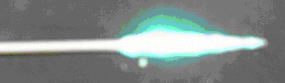

Figure 1. A standard angioplasty balloon catheter was used with a 300 μm optical fiber centered within the balloon. Argon ion laser irradiation can be seen as a bright light diffusing around the body of the inflated balloon.
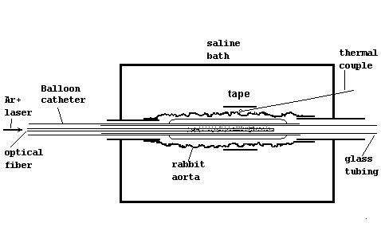
Figure 2. Sectional view of a single organ perfusion chamber. The balloon catheter is in the lumen of the rabbit artery. Thermal couples are placed on the surface to measure temperature and these are held in place using umbilical tape.

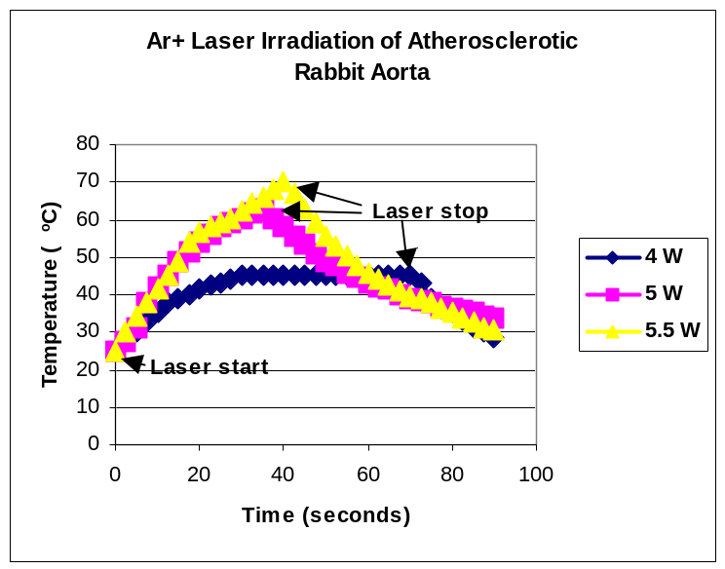

Figure 3. Temperature curves measured at the surface of the rabbit abdominal aorta during Ar⁺ laser irradiation. These measurements were performed in a bath at 23ºC.

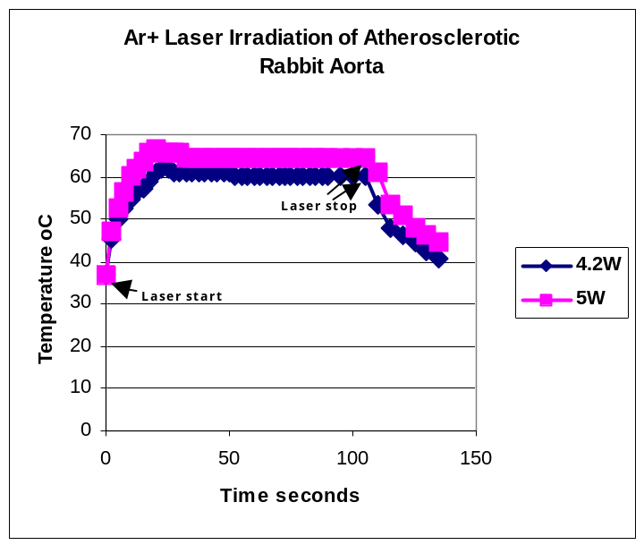
Figure 4. Temperature curves measured at the surface of the rabbit abdominal aorta during Ar⁺ laser irradiation. These measurements were performed in a bath at 37ºC to simulate the body temperature.

If the bath temperature was 37ºC then there was a higher target of temperature achieved using lower laser energy. Also, the temperature profile formed a plateau with a more consistent temperature profile (Figure 4). These data will guide how we will implement the laser delivery in the in vivo rabbit experiments. While under general anesthesia, the rabbit body temperature will be monitored and a warming pad used to maintain a 37ºC body temperature.
An important observation is that the temperature elevation was significantly greater in atherosclerotic arteries than in normal arteries. The atherosclerotic arteries were yellow in color and more dense while the normal arteries were more transparent to the laser light. The atherosclerotic arteries absorb more light and developed higher temperature (Figure 5). This study was performed using a thermal camera to measure arterial surface temperature (see Appendix for example).

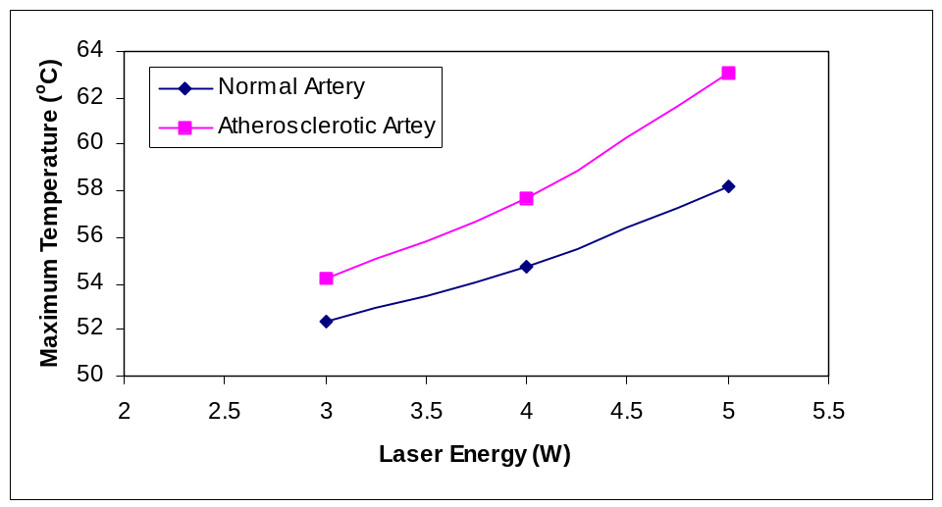

Figure 5. Temperature rise in five normal and atherosclerotic arteries at various energy levels. The data demonstrate that the temperature rise with increasing laser energy was significantly greater in atherosclerotic than normal arteries.

3.2 Mechanical Properties of the Arteries After Laser Treatment:
Stress-strain measurements were made on laser treated arteries and normal non-treated adjacent arterial segments. Examples of the stress-strain relationship were conducted in both longitudinal and circumferential directions (Figure 6). This was done using 2 cm long dumb-bell segments of arterial tissue with each end attached to a clip on a servo-controlled hydraulic testing machine system that stretched the tissue specimen until mechanical failure occurred. These preliminary data demonstrated that longitudinal stress-strain curves were shifted to the right in laser treated arteries. This suggests that the overall compliance was higher in lased arteries. Although there was a reduction in the peak stress levels to mechanical failure it is important to note that the normal level of blood pressure (i.e. 120/80) in the arteries generates a stress level below 0.2 M Pascales. Thus, the reduction of the peak stress tolerance in the laser treated arteries would almost be impossible to reach under any known physiologic condition. Similar findings were suggested by the circumferential stress-strain curves although there were some technical problems during that study. These studies were performed in the biomechanical engineering lab at Michigan State University where additional studies are being conducted to evaluate the stress-strain relationship in more arterial samples. These data are critical to the hypothesis that alteration of the collagen in the arterial wall will change the mechanical structure in favor for reducing plaque disruption and thrombosis. The histology of normal and laser treated arterial wall demonstrated that the lased tissue had a compressed and elongated cellular and connective tissue elements (Figure 7). Transmission electron microscopy is currently being processed to evaluate the collagen in the arterial wall.

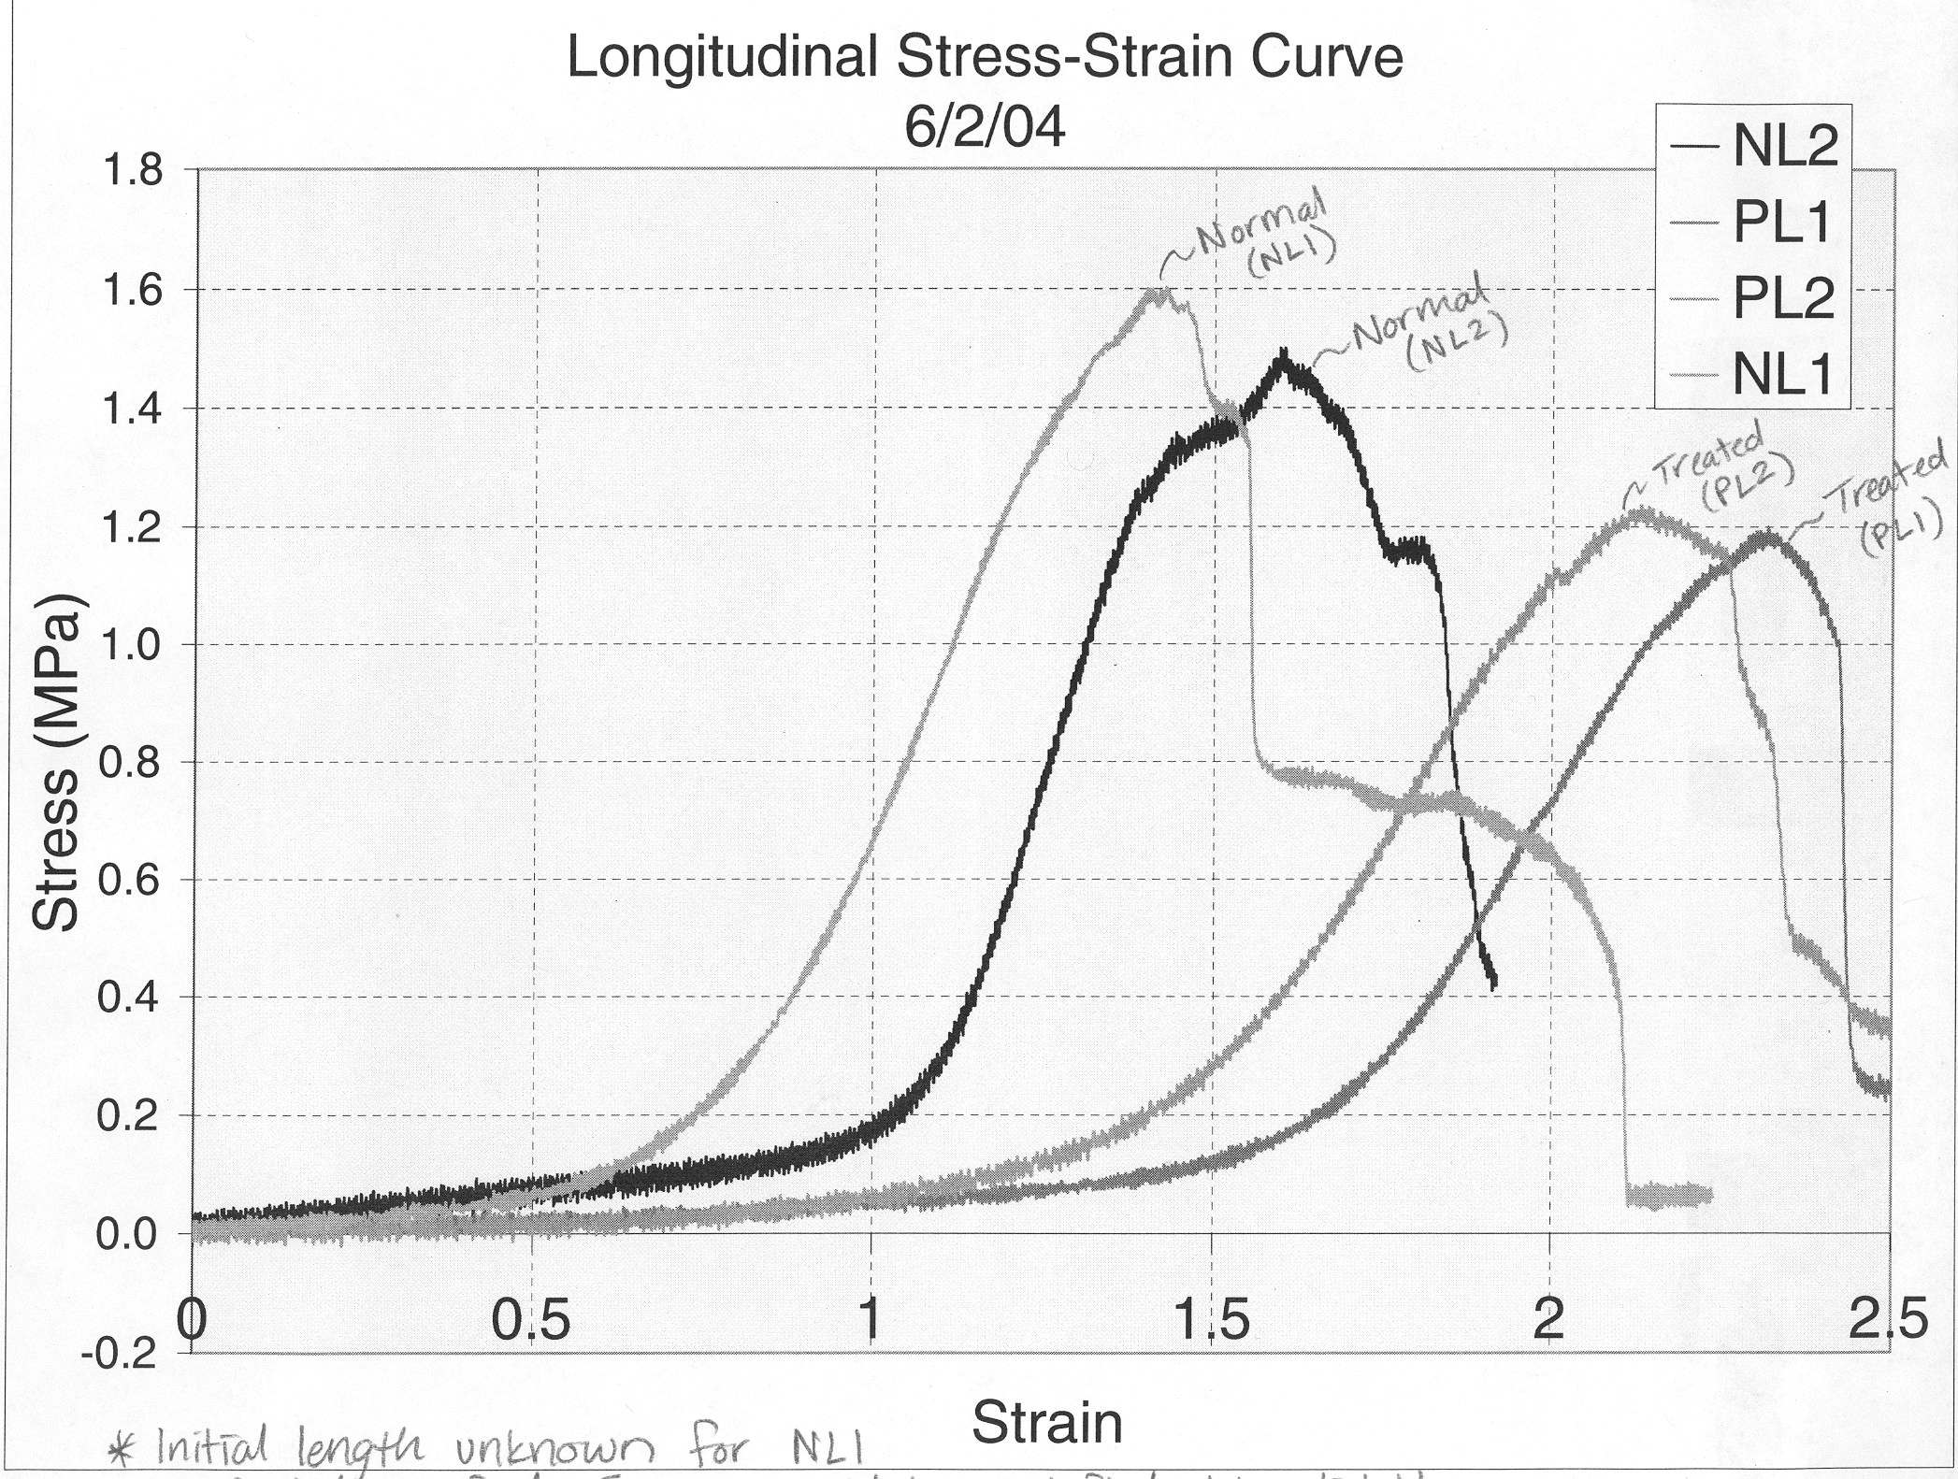

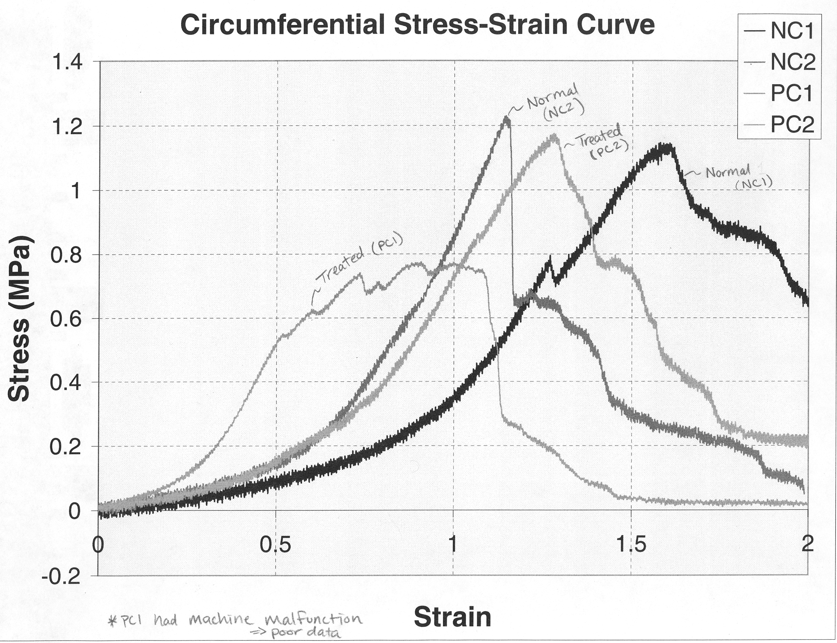

Figure 6. Stress-Strain measurement in the longitudinal direction (left graph) in the same artery above and at the site of laser treatment. Laser treatment demonstrates a shift of the curve to the right suggesting greater compliance. However, lowering of the peak stress suggests some reduction in tensile strength. The circumferential stress-strain curve (right graph) is probably similar but more data is needed to confirm the trend (the PC1 curve had a mechanical malfunction).
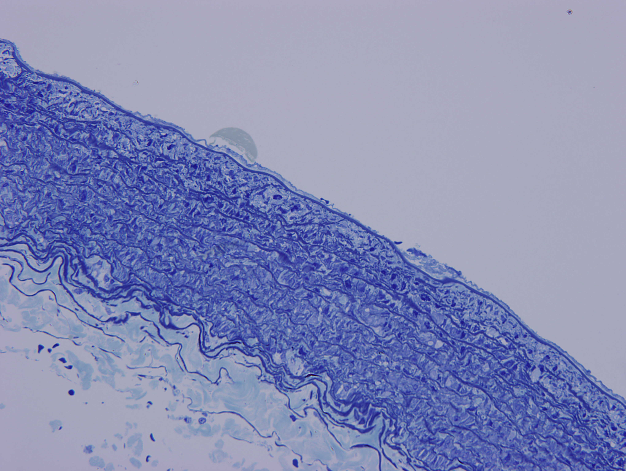
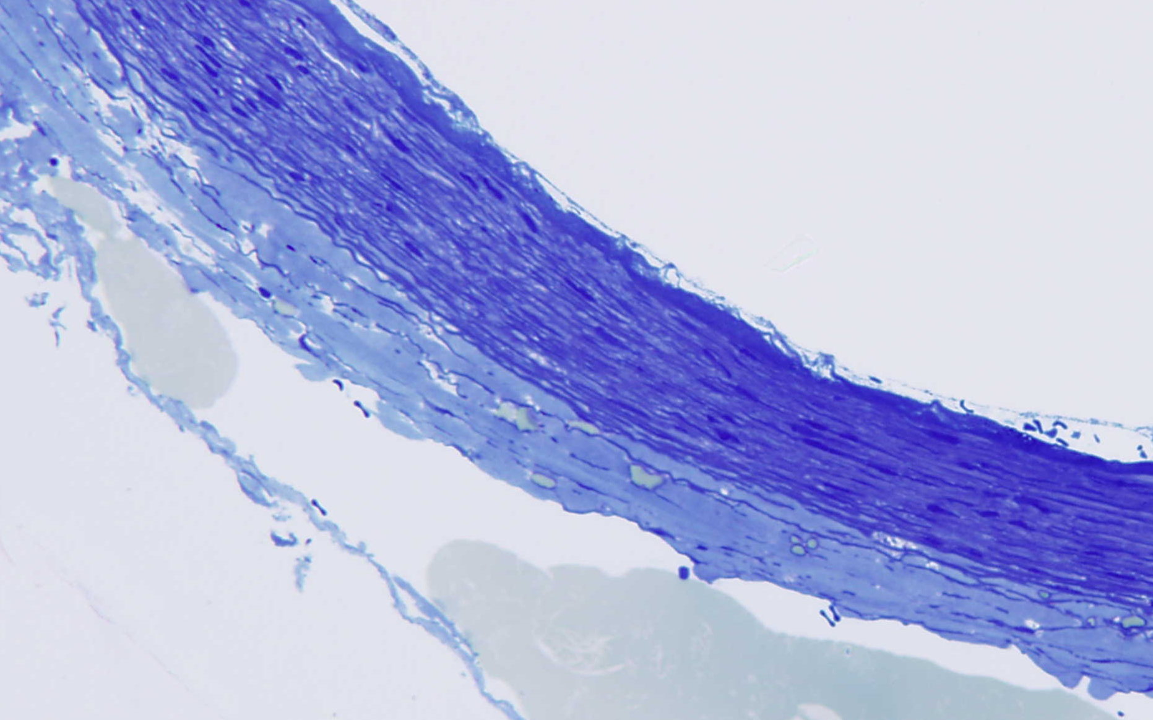
Figure 7 (Top). Light micrograph of normal arterial wall used as control for the stress-strain curves above. The cellular elements are more loosely packed when compared to the laser treated segment below.

Figure 7 (Bottom). Light micrograph of a laser thermally treated wall showing dense compression of the cellular and connective tissue elements.

3.3 In vivo Rabbit Studies:
Under general anesthesia, three NZW rabbits two normal and one atherosclerotic had the aorta exposed via an abdominal side incision to allow the placement of a thermocouple over the aorta. The balloon catheter with a diffuser laser fiber were passed via the femoral artery. Temperature measurements were made while irradiating the aorta over a period of one min. This resulted in significant temperature elevations in the range that is needed for alteration of collagen (Figure 8).
Figure 9 shows that the temperature measurement was performed on rabbit following triggering. Rectal temperature was 37°C at time of procedure. A pullback temperature history of the aorta was made from the thoracic aorta to the iliac bifurcation. The graph below is a time plot of the measured temperatures using four channels. A temperature rise is noted at the level of the 3-4th lumbar vertebra. At autopsy, there was a small thrombus at the level of the mid abdominal aorta.
Figure 10 gives the temperature measurement of arterial wall surface by thermal camera using a balloon catheter and diffuser fiber at 5W argon laser. The artery was perfused with whole blood circulating in an organ chamber.
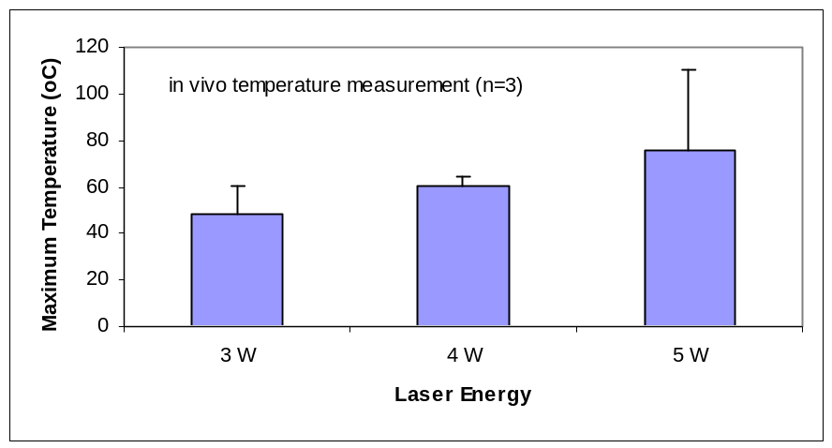
Figure 8. In vivo temperature measurement during Ar⁺ irradiation of three arteries in vivo demonstrating a similar temperature profile as shown in the in vitro studies.

4. Discussions
The proposed scientific and technological advances can help many patients suffering from ischemic cardiac conditions including heart attacks, stable and unstable angina. The prevention of future cardiovascular events after the detection of vulnerable plaque could be a major method of therapy for those patients. This investigation will utilize thermal localization of vulnerable plaques and determine if laser and thermal irradiation effects can stabilize vulnerable plaques.
This includes patients who have had heart attacks and those who have arterial lesions known to be unstable or vulnerable for future events. At present we do not have a method designed to alter the long-term behavior of atherosclerotic lesions. Although medical therapy using lipid lowering drugs has significantly impacted the outcome of patients with known coronary artery disease, it has only been relatively successful. Many patients do not take these medications and others may not tolerate them. Also, the best outcome has been approximately 30% reduction in overall death rates from cardiovascular events. This still leaves a very large number of patients who could benefit from such treatment whether in a primary or secondary prevention approach.
The benefits derived would be to reduce the morbidity and mortality in patients with coronary artery disease. This is an important endpoint. Also, the potential mechanisms related to the effects of laser on the arterial wall and collagen structure and function are important to elucidate.

References:
- Abela GS et al. Reduced Platelet Deposition With Laser Compared to Balloon Angioplasty. J Am Coll Cardiol 15(2):245A, 1990.
- Abela GS et al. Triggering of Plaque Disruption and Arterial Thrombosis in an Atherosclerotic Rabbit Model. Circulation 91:776-784,1995.
- Abela GS et al. Vascular Procedures that Thermo-coagulate Collagen Reduce Local Platelet Deposition and Thrombus Formation: Laser and Laser-thermal vs. Balloon Angioplasty. Lasers Surg Med 29:455-463,2001.
- Christov A, Abela GS and Lucas A et al. Optical Detection of Triggered Atherosclerotic Plaque Disruption by Fluorescence Emission Analysis. J. Photochem Photobiol 72: 242-252, 2000.
- Barbeau GR and Abela GS et al. Temperature Monitoring During Peripheral Thermo-Optical Laser Recanalization in Humans. Clin Cardio 13:690-697, 1990.
- Casscells W et al. Thermal Detection of Cellular Infiltrates in Living Atherosclerotic Plaques: Possible Implications for Plaque Rupture and Thrombosis. The Lancet 347:1447-1449,1996.
- Constantinides P and Chakravarti RN. Rabbit Arterial Thrombosis Production by Systemic Procedures. Arch Pathol 72:197-208, 1960.
- Davies MJ and Thomas AC. Plaque fissuring: the Cause of Acute Myocardial Infarction, sudden Ischemic Death, and Crescendo Angina. Br Heart J 53:363-73,1985.
- Fitzpatrick RE et al. Pulsed Carbon Dioxide Laser Resurfacing of Photoaged Skin. Arch Dermatol 132:395-402,1996.
- Lendon CL et al. Atherosclerotic Plaque Caps Are Locally Weakened When Macrophages Density is Increased. Athero. 87:87-90,1991.
- Muller JE and Abela GS et al. Triggers, acute risk factors, and vulnerable plaques: the lexicon of a new frontier. J Am Coll Cardio 23;809-13,1994.
- Stephanadis C et al. Thermal Heterogeneity Within Human Atherosclerotic Coronary Arteries Detected in vivo: A New Method of Detection by Application of a Special Thermography Catheter. Circulation 99;1965-1971,1999.
- Verheye S et al. In vivo Temperature Heterogeneity of Atherosclerotic Plaques is determined by plaque composition Circulation 105:1596-1601,2002.
- Waxman S and Abela GS et al. Angioscopic Predictors of Early Adverse Outcome After Coronary Angioplasty in Patients with Unstable Angina and Non-Q Wave Myocardial Infarction. Circulation 93:2106-2113,1996.
- Ye B, Abela GS. β-Carotene Enhances Plaque Detection by Fluorescence Attenuation in an Atherosclerotic Rabbit Model. Lasers Surg Med 13:393-404, 1993.

APPENDIX

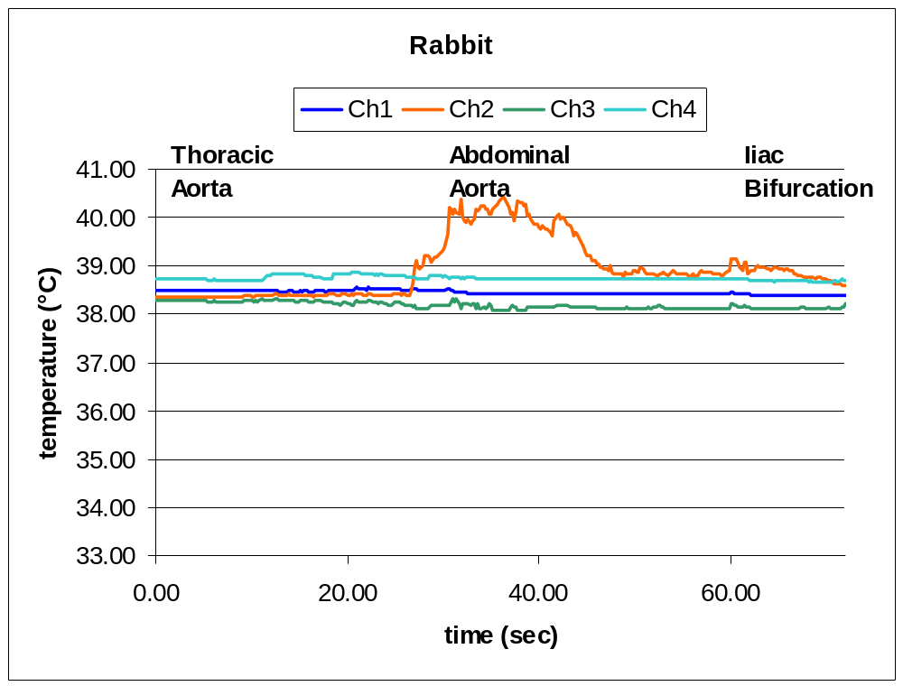
Figure 9. Temperature measurement was performed on rabbit following triggering. Rectal temperature was 37°C at time of procedure. A pullback temperature history of the aorta was made from the thoracic aorta to the iliac bifurcation. The graph below is a time plot of the measured temperatures using four channels. A temperature rise is noted at the level of the 3-4th lumbar vertebra. At autopsy, there was a small thrombus at the level of the mid abdominal aorta.

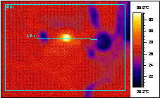

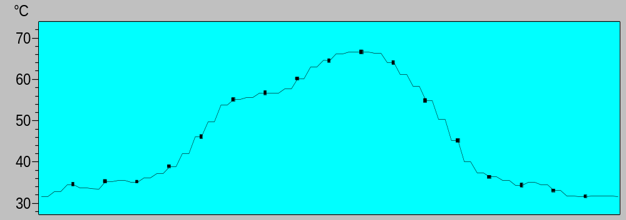

Figure 10. Temperature of arterial wall surface measured by thermal camera using a balloon catheter and diffuser fiber at 5W argon laser. The artery was perfused with whole blood circulating in an organ chamber.

