The Interaction of Excimer Laser with Blood Components and Thrombosis

Hongbao Ma ¹, Roshan Patel ¹, Ruiping Huang ¹, Charan Kantipudi ¹, Kevin Taylor ², George Abela ¹

¹ Department of Medicine, Michigan State University, East Lansing, MI, USA
² Spectranetics Corporation, Colorado Springs, CO, USA

Abstract: Vascular thrombosis is a major component leading to acute cardiovascular events. Rapid and efficient thrombolysis is critical for quick relief of symptoms and prevention of organ damage. This article describes of excimer laser ablation of thrombus and effect on blood components, by-products of excimer laser ablation and hemoglobin release into the medium. In conclusion, this background data could help the operator select catheter sizes and laser energy protocols depending on the needs of a particular case. If a situation consisted of a thrombus in an artery with poor distal run off then a smaller catheter with lower energies may be selected. On the other hand a large vessel with a large thrombus load and good distal run off may be approached with a larger catheter and higher energies. These types of decisions can be based on the basic data and implemented in a clinical situation. However, the choice of how to proceed in a case would always depend on the judgment of the operator and the presented data are meant to serve only as broad guidelines. [The Journal of American Science. 2005;1(3):80-91].

Keywords: artery; blood; excimer laser; heart; thrombosis; vascular

1. Introduction
Vascular thrombosis is a major component leading to acute cardiovascular events (1). Rapid and efficient thrombolysis is critical for quick relief of symptoms and prevention of organ damage. Many patients are not candidates for phamacological thrombolysis and could greatly from mechanical thrombolysis. Excimer laser has the potential for such an application based on preliminary data suggesting that pulsed photo energy could disrupt the thrombus fabric as well as promote endogenous thrombolysis (2). Given these observations laser interaction with thrombus and blood components were conducted to determine the potential of excimer laser thrombolysis as well as the laser parameters that can be used to optimize this effect as necessary.
The exact mechanism of excimer laser thrombolysis is a complex process with multiple effects that can be used for removal of thrombus. This white paper will attempt to incorporate these in an organized fashion to provide a guide for the end user for thrombus removal.
Experiments on whole blood and thrombus will be used as examples of the laser-blood and laser-thrombus interaction. These will also be put into perspectives of basic science studies that have been done to analyze the laser effects on tissues.

2. Mechanism of Excimer Laser Ablation of Thrombus and Effect on Blood Components

- Mechanical effects of shock wave trauma on soft tissues:
Much work has already been performed to evaluate ablation by pulsed excimer laser at 308 nm. These are primarily related to generation of bubbles and volumetric expansion when the catheter is engaged in the tissue. Thus, bond breaking as a means of surface etching is perhaps less of the mechanism in a complex tissue environment (3). In arterial tissues, bubbles can result in dissection of the arterial wall as has been demonstrated (4). However, slower pace of tissue removal or using saline flushes results in the dissipation of the gas bubbles allowing for a smother ablation process with less tissue dissection (5,6). Another approach accomplishes a similar outcome by lasing and withdrawing the catheter to allow the gas bubbles trapped between the catheter tip and the tissue to dissipate (7,8). How do these mechanisms affect thrombus removal? Several elements can affect this including the age of the thrombus (i.e. how solid or soft it is) or more specifically its water content. More water will buffer the energy from creating tissue disruption thus resulting a lesser cutting effect. Softer tissue may act more of a large absorptive medium resulting in more gas generation with expansion and thrombus break up. Interaction with the blood in direct contact with the catheter tip results in dispersion of the blood film as shown by a parting of the water type of an effect that Isner termed the “Moses” effect. Subsequent pulses would then engage the tissue or other surfaces below the initial blood film (9).

- Effect of Excimer Laser on Platelet Function:
Platelet function has been reported to be altered in a dose dependent fashion following exposure to excimer laser irradiation. This effect on reduced platelet aggregation to ADP and collagen was performed in vitro using human blood from normal patient volunteers (10). Further studies were performed in a model using continuous monitoring of platelet aggregation by a laser-light scattering technique previously reported (11,12). Using this method it is possible to monitor platelet aggregates as well as then test the effects of ADP and the reversal time of ADP aggregation. The lasing system is shown in Figuer 1.
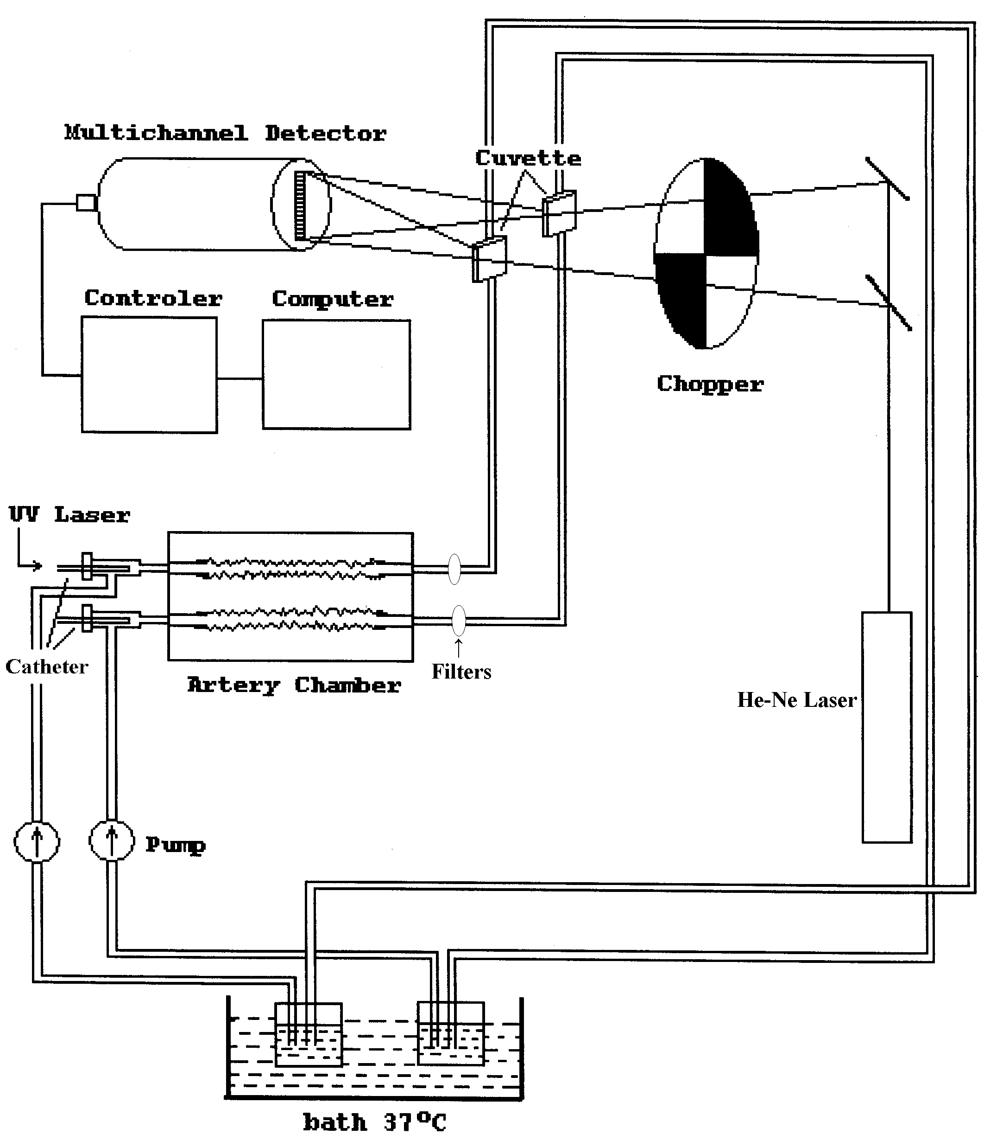
Preliminary data were obtained using platelet rich plasma (PRP) circulating in the model while applying various laser energies and catheters sizes (Figure 2). Laser parameters used at 308 nm were 45 mJ/mm²; 25 Hz and catheter diameter sizes ranging from 0.7 to 2.0 mm at a corresponding energy of 2.3 to 32 mJ respectively. The amount of PRP circulated was 30 ml in each of the dual circuits of the chamber using a roller pump. The platelet aggregate volume were determined by a laser light scattering technique using the ratio of the angle of He-Ne light scattering at 1º/5º on the detector surface of a multichannel analyzer. Particles were also evaluated using a Coulter counter.
The results of PRP lasing demonstrated that at the lower laser energy there was no significant platelet aggregation while at higher energies there was a significant increase in platelet aggregation. However, these aggregates were few in number and large in volume. Thus, these particles were not detected by the particle size range of the Coulter counter. However, these particles were readily picked up by the laser light scattering technique.
Table 1 summarizes the data comparing aggregates and energy in several experiments using multiple data collections from each study. Figure 2 illustrates that higher energies also had larger aggregates while Figure 3 shows that total platelet numbers are not significantly altered by laser irradiation perfuse.
The addition of ADP to the lased platelets resulted in a slower aggregation and disaggregation. These functions were also correlated to the energy used (i.e. more delay at higher energy exposure). Figure 4 demonstrates this phenomenon.

Figure 1. Dual Organ Chamber Experiment Set Up. The He-Ne laser beam was split by a beam chopper to enter the cuvettes and displayed the laser light scattering on the diode array at 1º/5º.

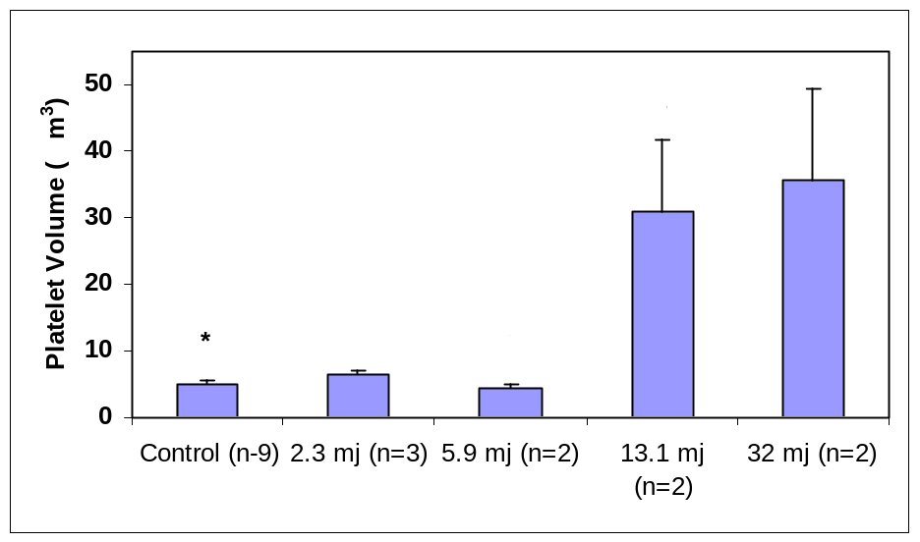

Figure 2. Peak Platelet Volume with Varying Laser Energy. PRP was circulated and platelet volume was measured with laser light scattering (μm³). Greater energy resulted in higher platelet volumes.
* to **: p<0.04; * to * and ** to **: P=ns.
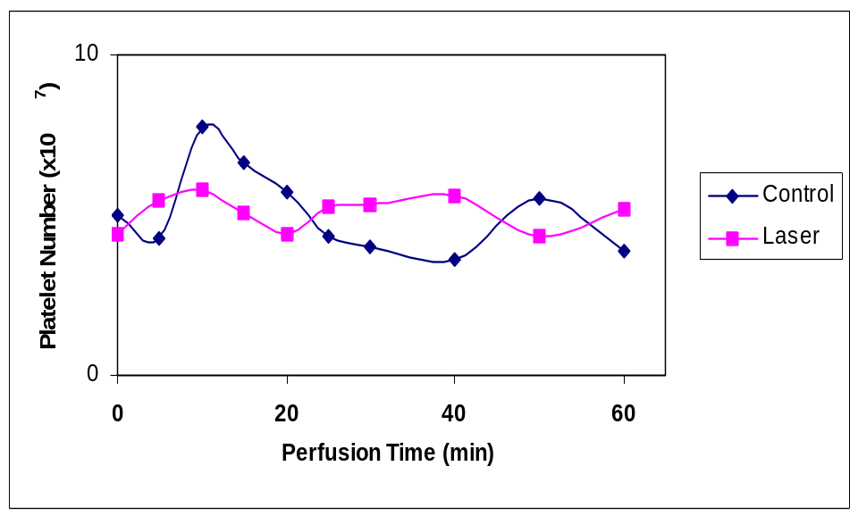

Figure 3. Platelet Number in PRP after lasing with 2.0 mm fiber at 45 mJ/mm2, 25 Hz, for 5 min. Platelet number was measured by Coulter counter and does not show as significant drop in platelet number.

Table 1. Platelet Aggregation Based on Excimer Laser Energy
Platelet Lasing | Control  (n=9) | 2.3 mJ  (n=3) | 5.9 mJ  (n=2) | 13.1 mJ  (n=2) | 32 mJ  (n=2)
Light Scattering (1º/5º) | 1.06±0.09* | 1.11±0.12* | 1.04±0.09* | 2.00±0.70** | 2.17±0.83**
CoulterCounter†μm³ | 21.5±1.2 | 21.9±1.5 | 22.4±1.5 | 21.7±1.5 | 22.4±1.5
* to **: p<0.04; * to *, ** to **, †: p=ns

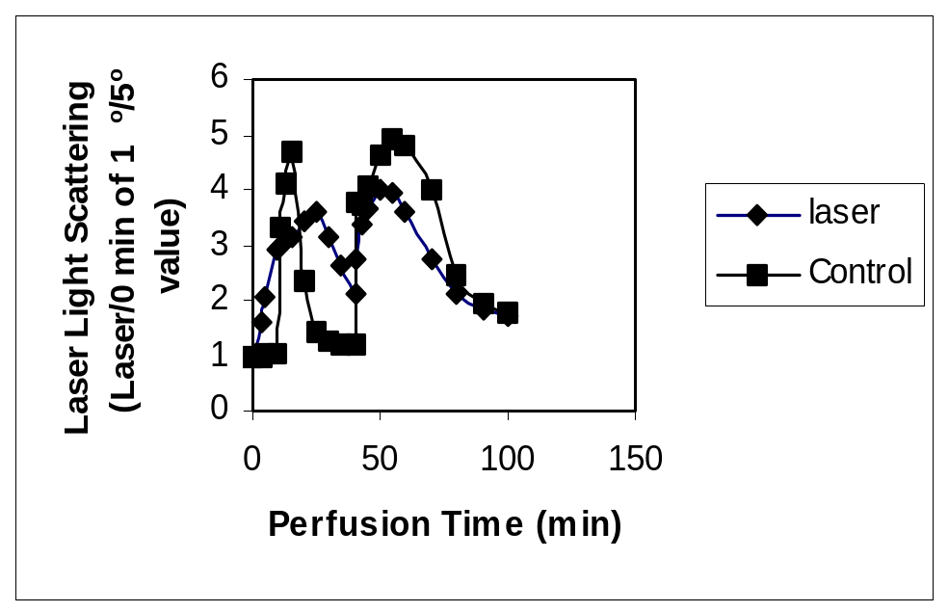
3.6 μM ADP

0.4 μM ADP

Figure 4. Typical Example of Platelet Aggregation by Laser Light Scattering in Circulating PRP. 0.4 μM and 3.6 μM ADP were added after 10 and 40 min of circulation respectively. PRP was circulated through rabbit carotid arteries and laser light scattering was used to measure platelet aggregates. PRP was lased using a 2.0 mm diameter excimer laser catheter.
3.6 μM ADP
0.4 μM ADP

- By-Products of Excimer Laser Ablation
Previous studies of laser effects on blood elements and thrombus have been reported using both continuous and pulsed laser wavelengths (13, 14). Reports have demonstrated that lasers can break up thrombus. The excimer laser has been shown to ablate thrombus occluding coronary arteries in acute cardiovascular events (7). Also, similar findings have been reported in the peripheral circulation (15). In vitro studies using excimer laser have demonstrated that energy levels, repetition rate, and catheter size all influence thrombolysis. Catheter size affects both ablation efficiency and mass removal rate while fluence and repetition rate mainly affect the mass removal rate (16). The particulate debris generated by excimer laser ablation has been reported to be mostly less than 10 to 25 microns. In order to better define the particulate materials and sizes generated by excimer laser, we pursued another approach in evaluating the products generation using gross and electron microscopic definition of particulates as well as amount of particulates generated as related to energy and speed of ablation. These data should help the clinician using the devices to gauge their procedure to obtain optimal efficiency of ablation with the least amount of debris generation.

  - Effects of aspirin on platelets during laser procedure.
The effect of aspirin was evaluated following laser irradiation in the model of circulating PRP as described above. Using the dual organ chamber, one side was treated with aspirin (0.2 mg/ml) and the other was used as control. Lasing was performed at 45 mJ/mm²; 25 Hz and catheter size of 2.0 mm for a total of 5 min. The results demonstrate a significant reduction in platelet aggregation by aspirin when measured by laser light scattering method (Figure 5).
Since platelets are very small and can pass through even 5 µm mesh we used phase contrast microscopy to evaluate the particulate debris generated by lasing the PRP. These confirm the findings made by the aggregate detection using laser light scattering (Figure 6).
Additional studies of the platelets using Coulter counter to measure the particle size distribution demonstrated that in the presence of aspirin, not only had fewer numbers of aggregates but that those aggregates were significantly smaller in size. Figure 7 shows the Coulter distribution of sizes of the aggregates.

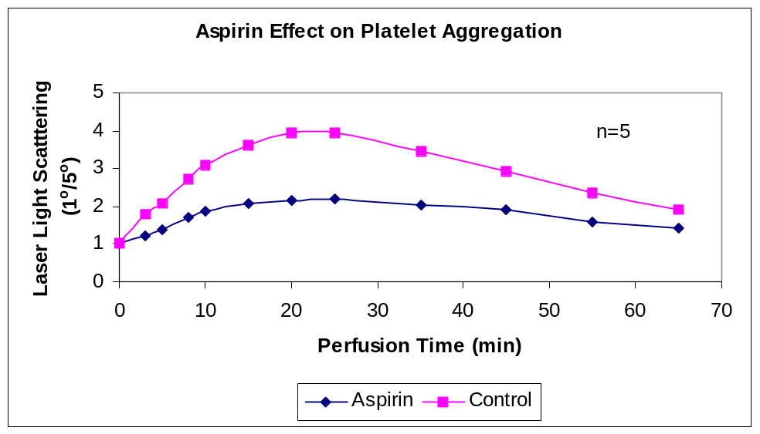

Figure 5. Platelet aggregates are shown with and without aspirin treatment after lasing. There is considerable reduction in aggregate formation with aspirin.

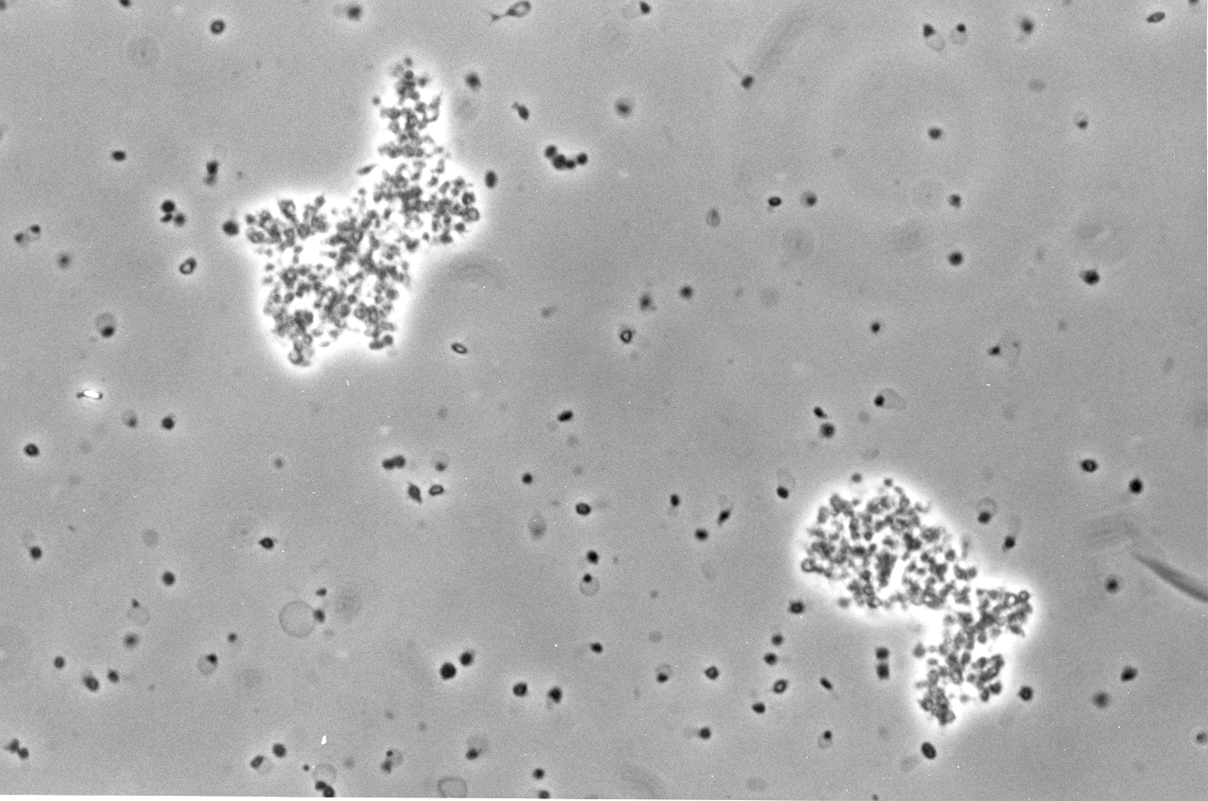
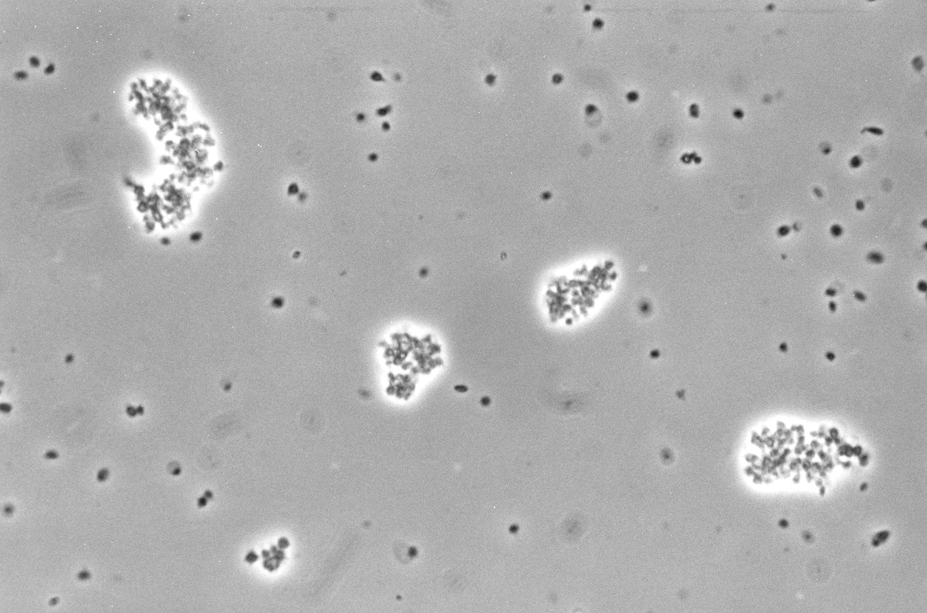
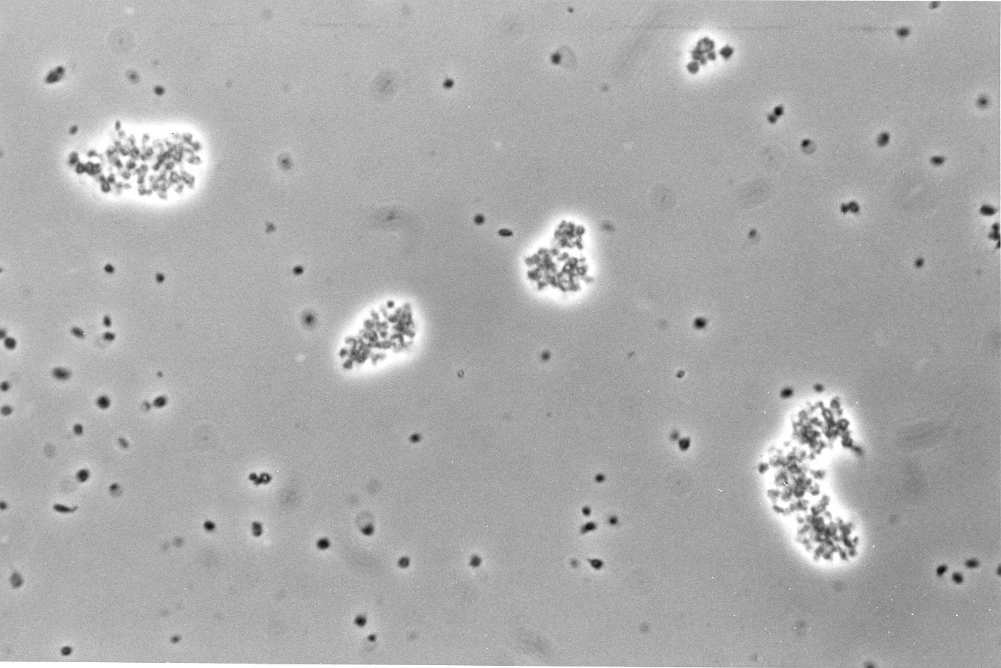
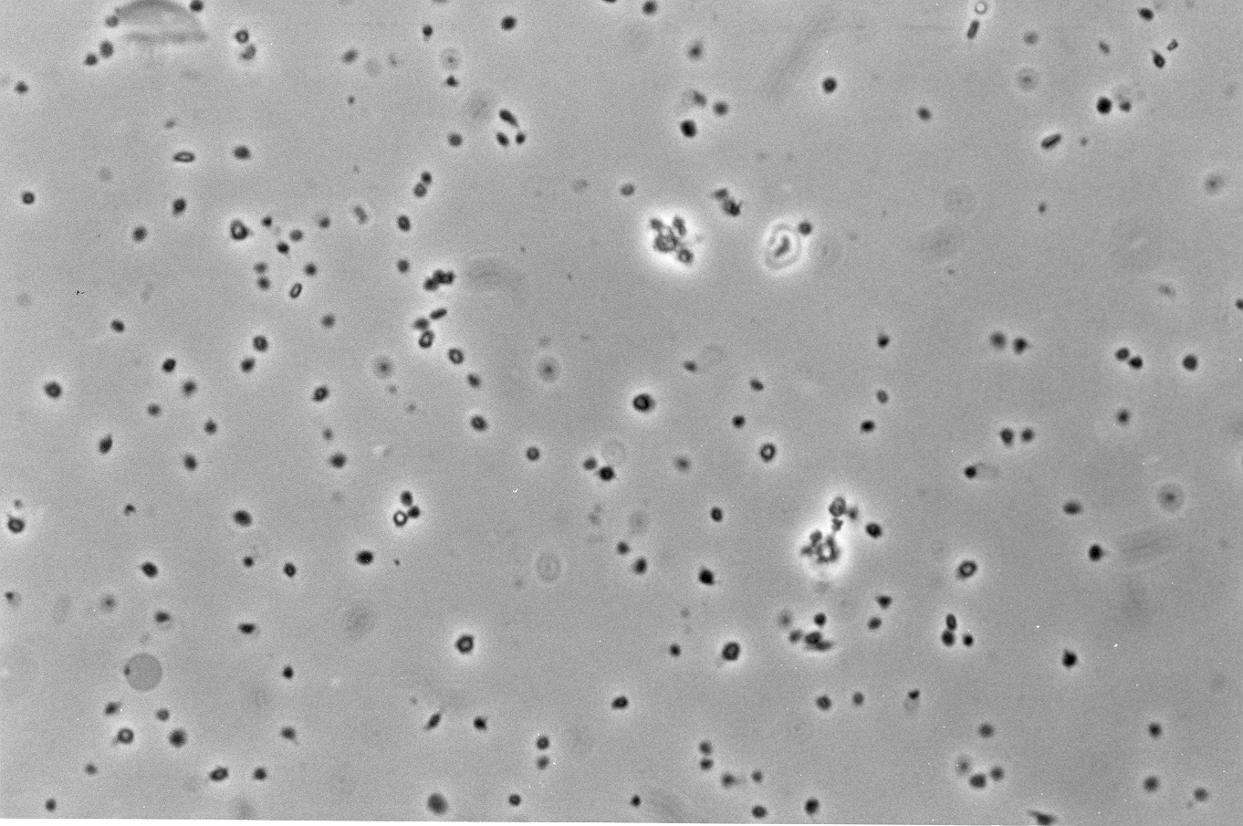
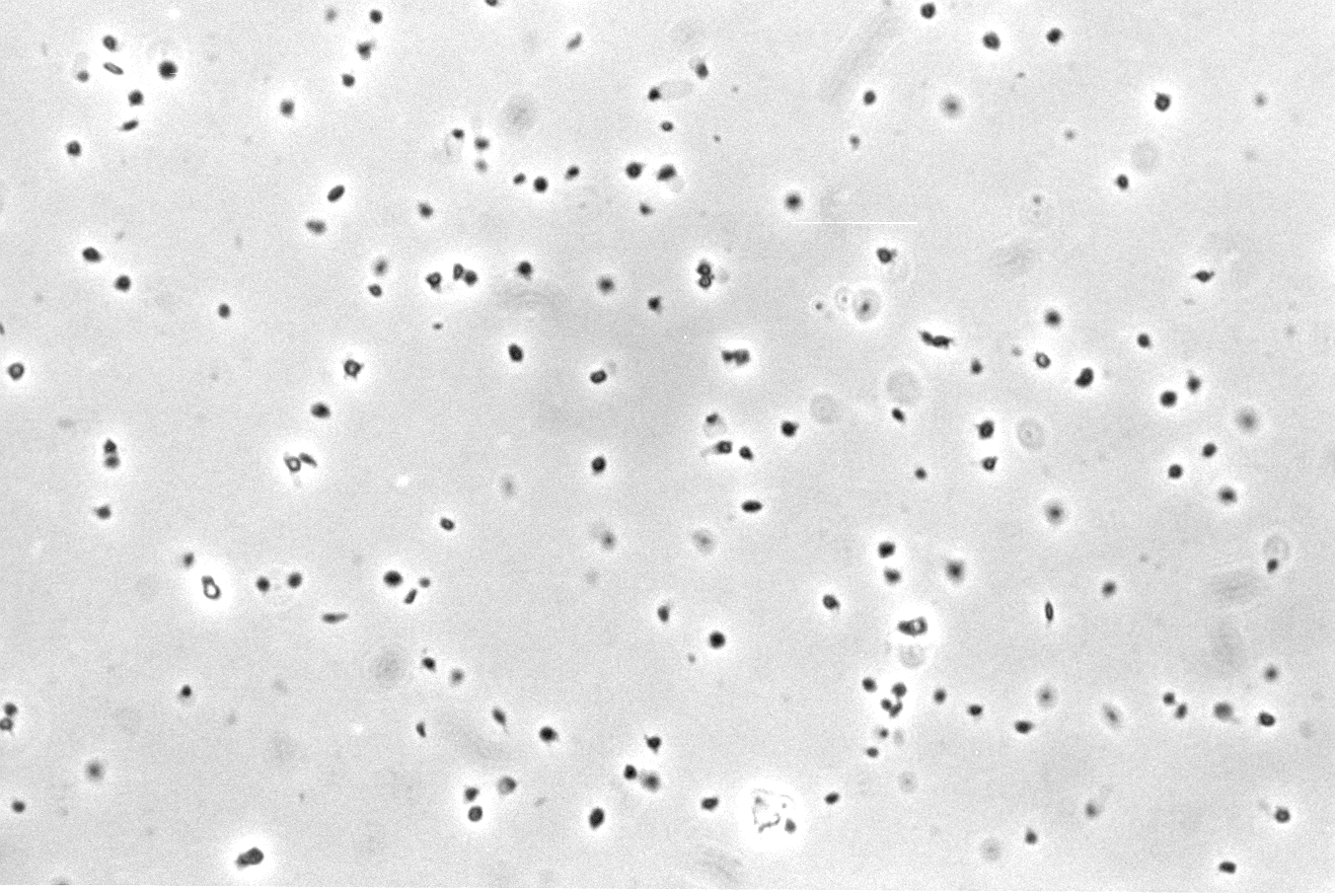
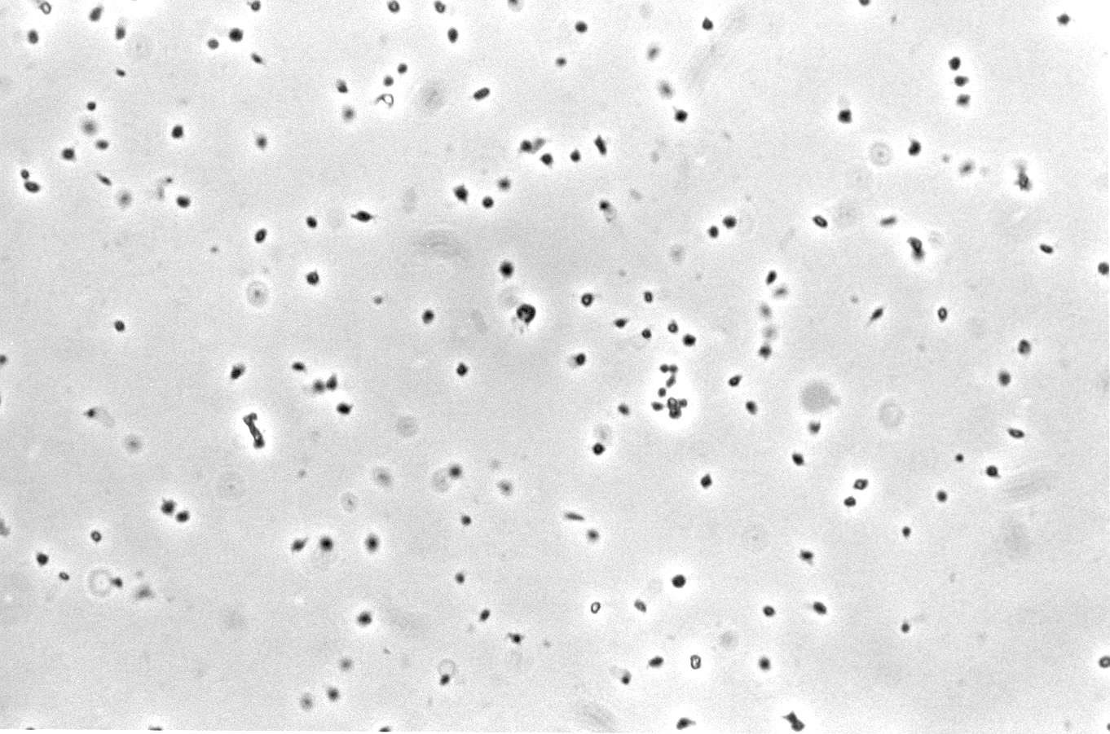
Lased without Aspirin
Lased with Aspirin

Figure 6. Samples from three experiments demonstrate that lased samples of PRP in the dual chamber circuit had many aggregates while the lased PRP pretreated with aspirin had very small to no aggregate formed.

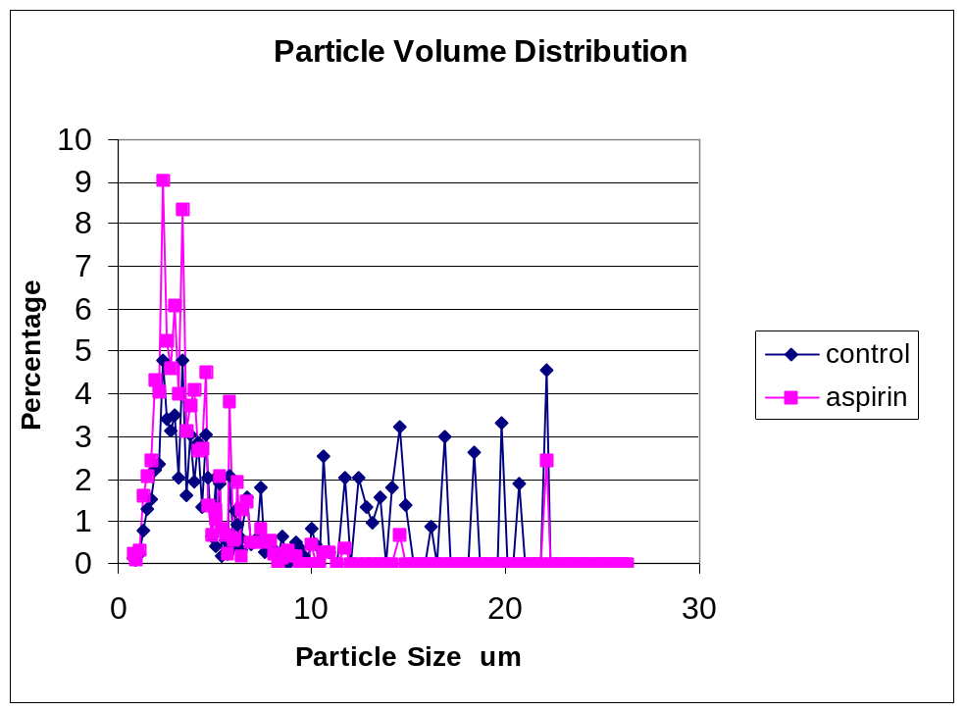

Figure 7. Particle volume distribution by Coulter counter show that with aspirin aggregates are smaller.

  - Type and amount of debris formed by laser ablation.
The experimental set up used a fresh thrombus formed at the base of a 10 mm diameter tube. The laser catheter was placed in a perpendicular fashion at the surface of the thrombus. The catheter was advanced using a hand-operated micrometer and time measured while advancing in accordance to the ablation of the thrombus and energy delivery. The thrombi were prepared by taking whole blood (10 ml) in sodium citrate and placing 0.7 ml in each tube. Then fibrinogen (mg/ml), thrombin (0.3 ui/ml) and CaCl₂ (1.5 mg/ml) were added to form the thrombus and this was allowed to consolidate over night at 4ºC. Figure 8 demonstrates the set up used. Saline was passed through the central channel of the catheter to force the ablated particulate materials to be ejected to the surface of the thrombus and then collected in the overflow of buffered solution placed in a beaker outside the tube containing the thrombus. After lasing the buffer with particulates was centrifuged and the debris dried and weighed. Also, the residual thrombus in the tube was dried and weighed.
In one group of experiments, the buffer was filtered with 53 μm filters to separate the debris larger than 53 μm. The dry weight of debris on the filter was measured by a highly sensitive balance (to 1 μg).
Most of the debris generated (~70%) measured less than 53 μm. Also, the amount of total debris generated compared to the amount removed demonstrates a variation that can be explained by the loss of water and possibly hemoglobin and other intracellular materials from the RBC core (Figure 9). The SEM demonstrates holes in the RBC membranes (see below) that could explain seepage of intra RBC content to the buffer solution. The results from this group of experiments demonstrated that at higher energies and catheter size resulted in greater amount of thrombus ablation and debris generation (Table 2) (Figure 10).

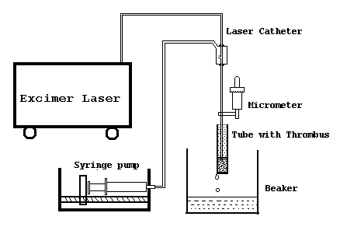

Figure 8. Set up demonstrating the technique used in irradiating thrombus and collecting the debris.

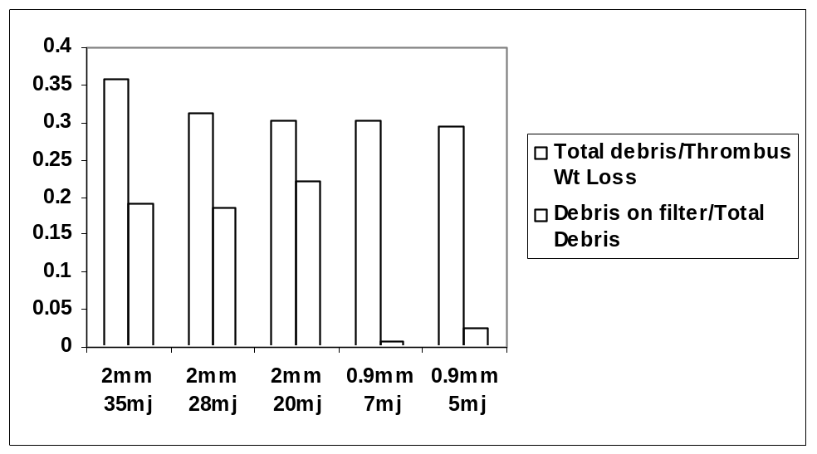

Figure 9. Debris generated by more energy and larger catheters was significantly greater than lower energy and smaller catheters.

Table 2. Energy and Catheter Size Related to Thrombus Removal
Energy (mJ/pulse) | 35 | 28 | 20 | 0 | 7 | 5 | 0
Catheter Diameter | 2 mm | 2 mm | 2 mm | 2 mm | 0.9 mm | 0.9 mm | 0.9 mm
Thrombus (g) | 0.2±0.03* | 0.18±0.04* | 0.18±0.02* | 0.12±0.04** | 0.15±0.03⁺ | 0.16±0.02 | 0.11±0.04⁺⁺
P < 0.05 * vs **; ⁺ vs ⁺⁺

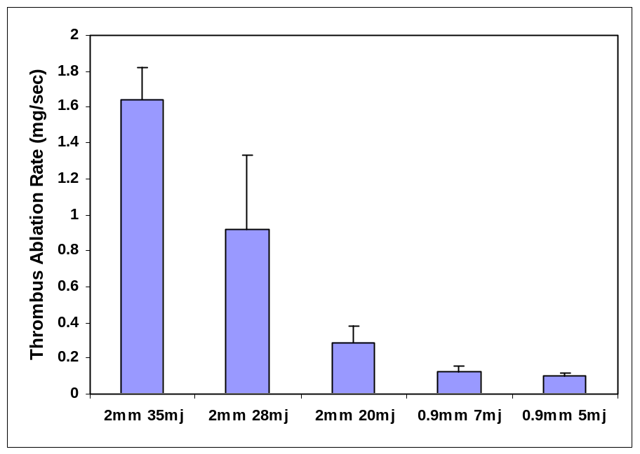

Figures 10. Greater laser power results in higher rate of thrombus ablation.

(3) Gross and SEM images demonstrated size, shape and structure of debris (Figure 11).
The gross images of collected debris on 53 μm filter pore filter demonstrated similar results to those reported by the weight measurements. Also, the SEM images demonstrate fewest amount of debris at lower energies (Figures 12, Figures 13).
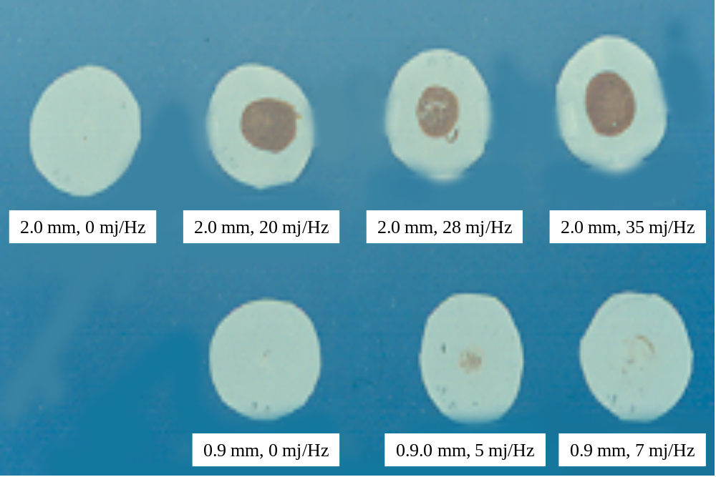

Figure 11. Debris on 53 μm filter with various laser energy. The first filter on the left top shows no debris in the non-lased thrombus. Only mechanical passage was made with minimal debris. The greatest amount of debris is shown in the right upper corner at the greater laser energy (20 to 35 mJ).

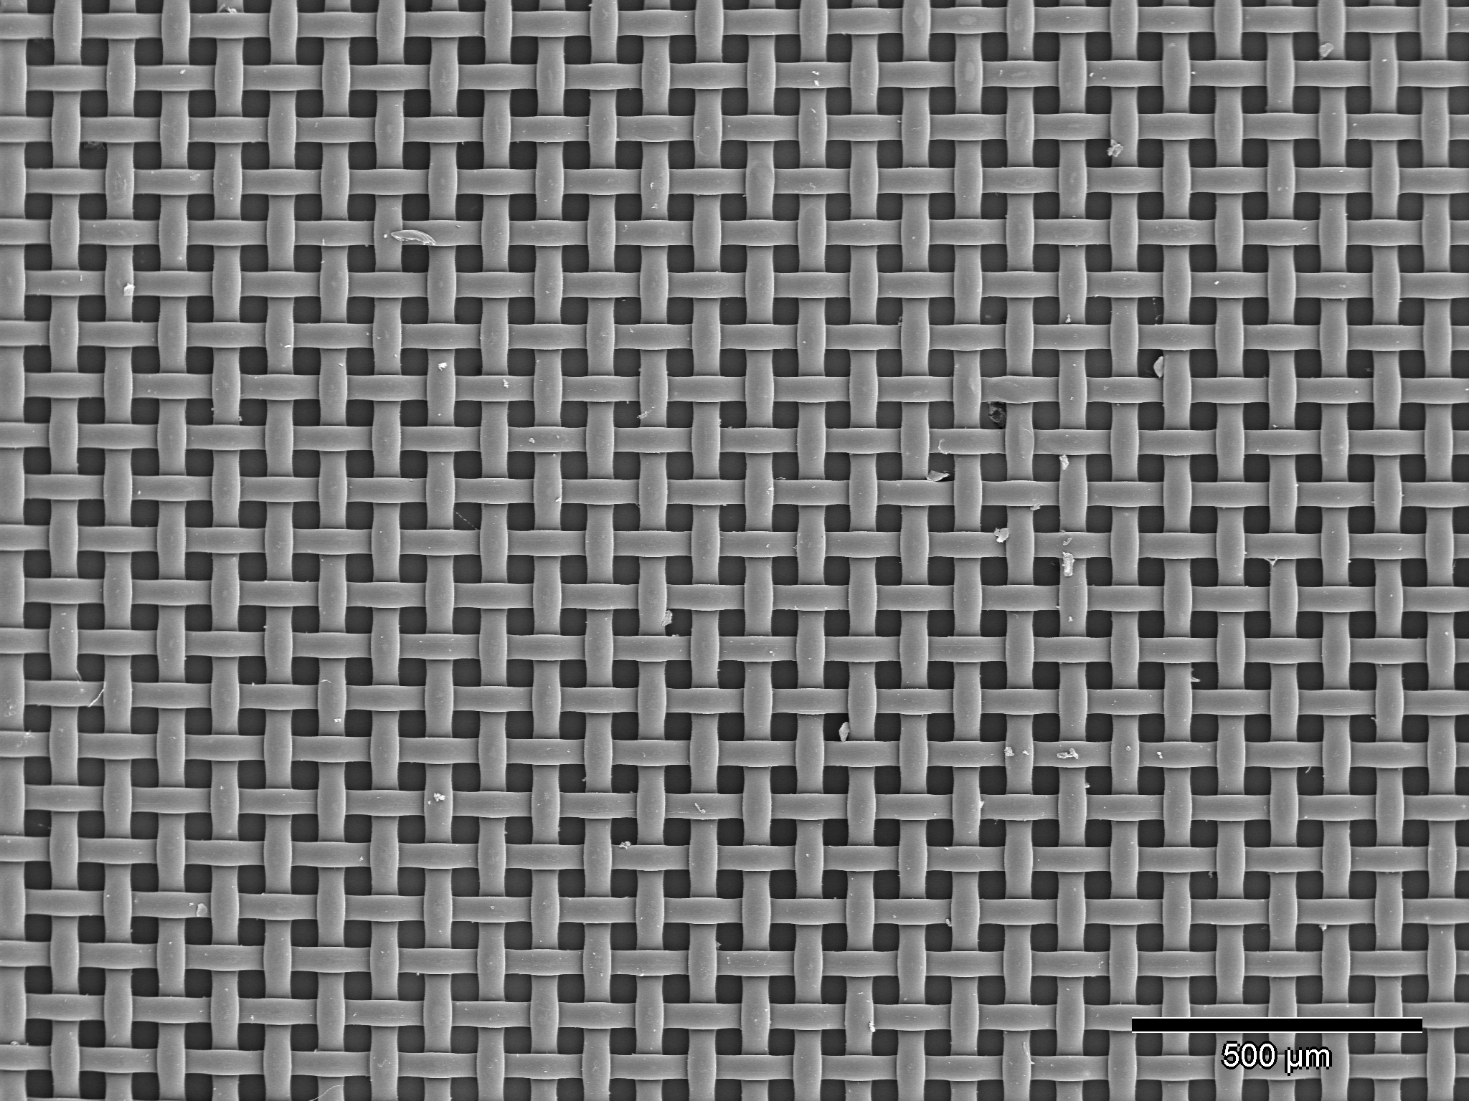

Figure 12. 45 mJ per mm sq – 2 mm f-3: At lower laser energies small amount of thrombus debris is generated and collected on the 53 μm mesh.

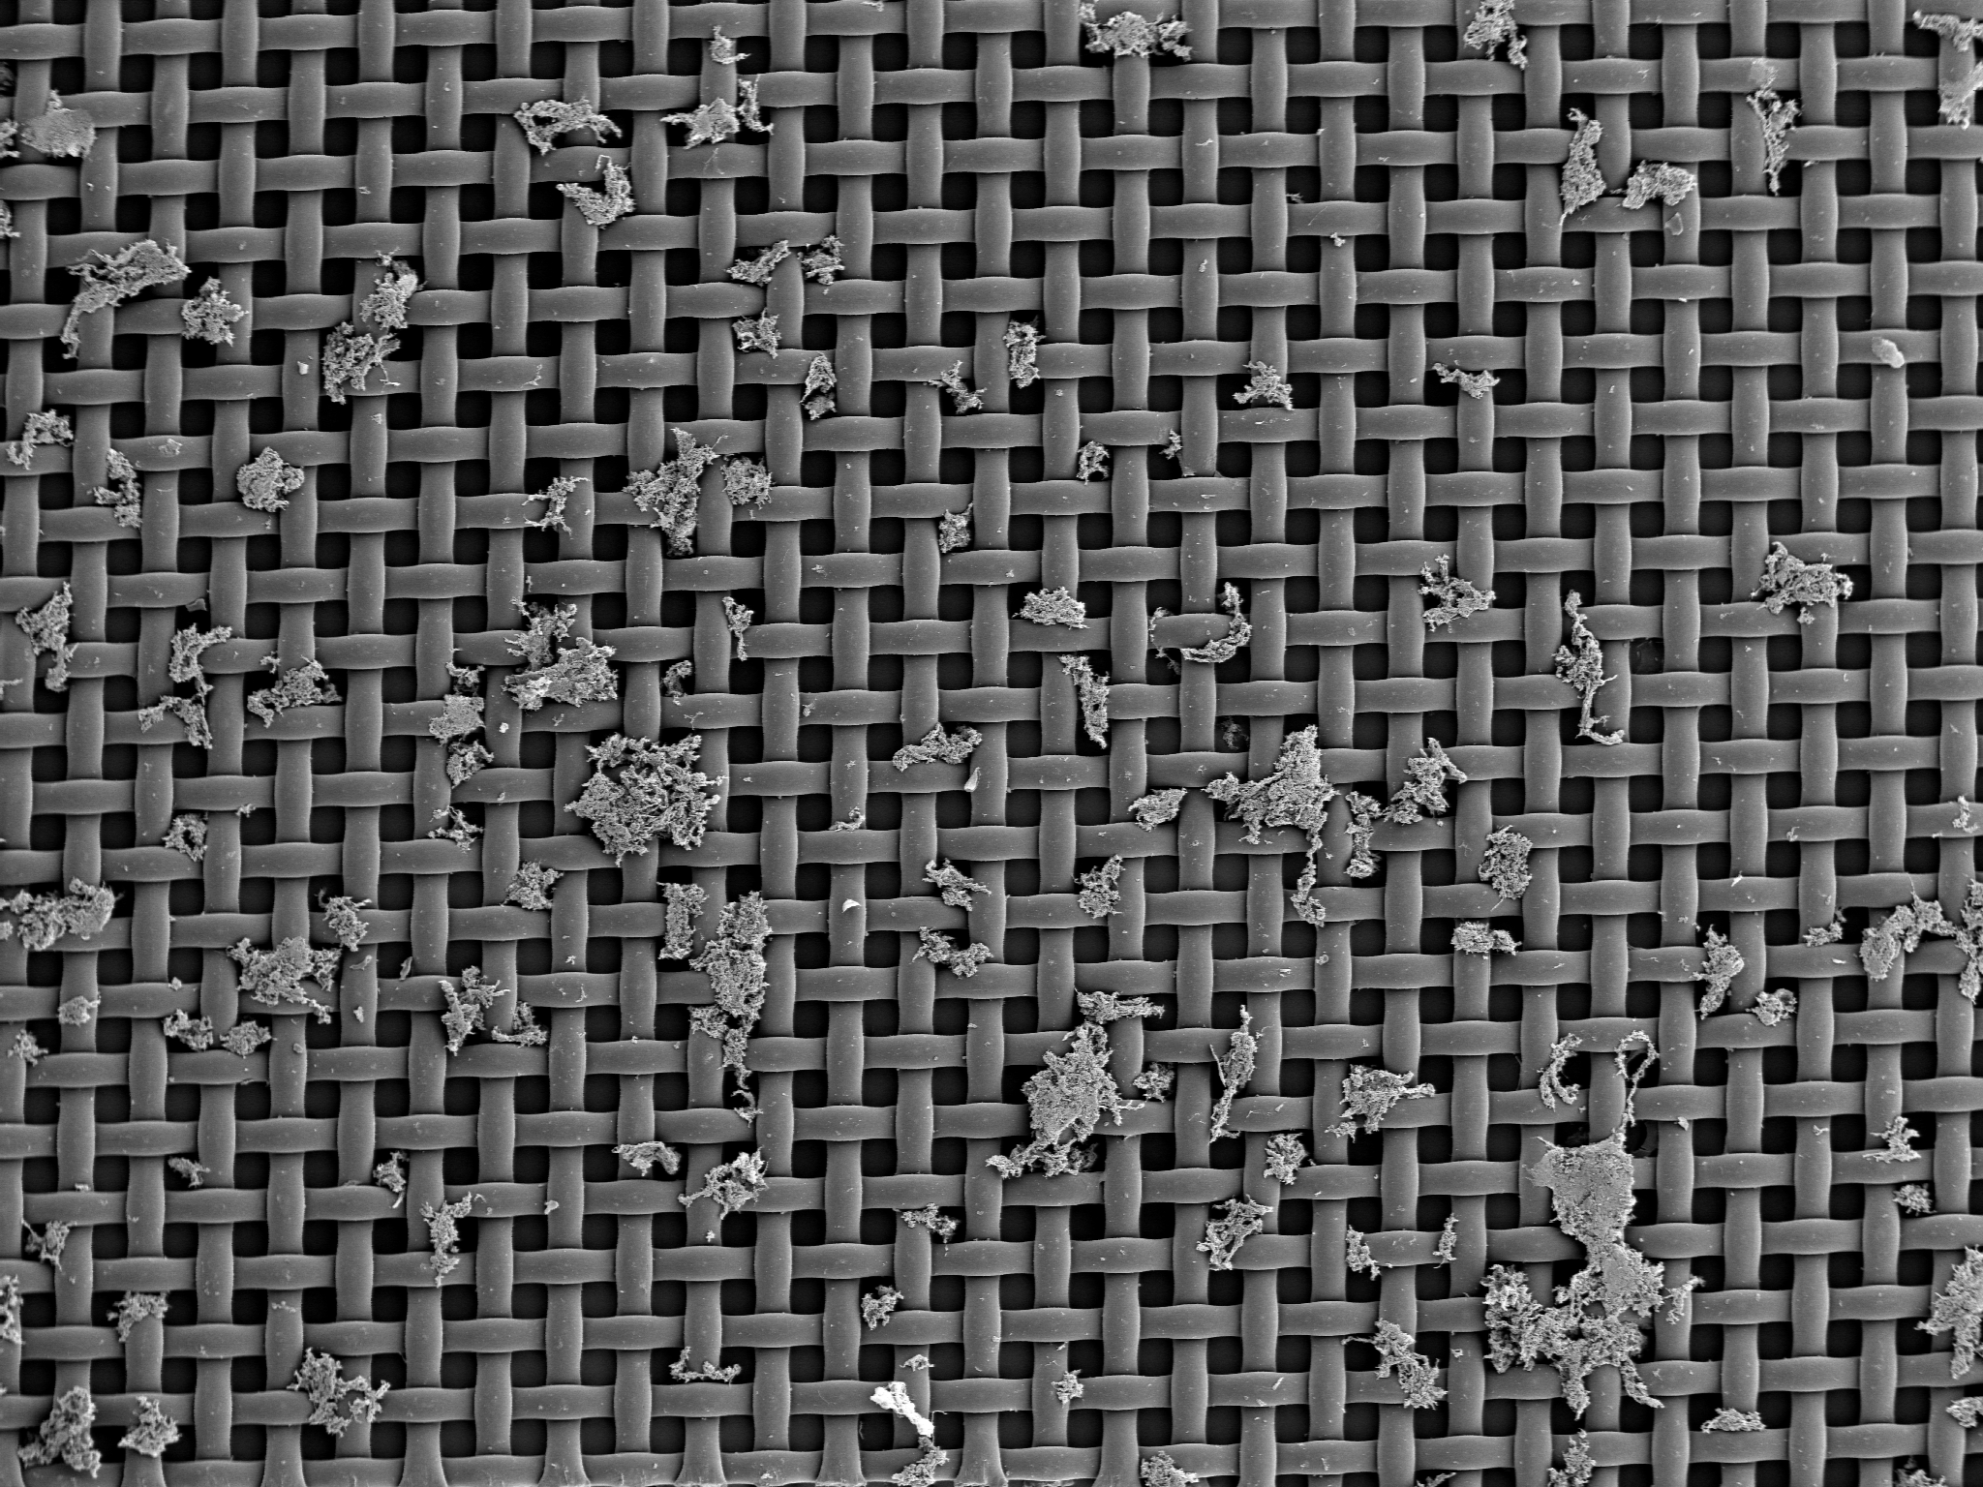

Figure 13. 60 mJ per mm sq – 2 mm f: With higher energy there is more thrombus debris by SEM on the 53 μm mesh.

4. Hemoglobin Release into the Medium
In the whole blood samples treated with laser had greater amount of hemoglobin release as measured by optical density (OD). However, the cell count in the laser treated vs. non-treated thrombus were not different. These results imply that the red cells were not disrupted by the laser, but the hemoglobin in the red cell was released into the buffer (Table 3) (Figures 14, Figures 15). We irradiated 1 ml whole blood with UV laser and 2.0 mm fiber at 35 mJ/pulse, and 10 Hz for 1 min. The particle number and the buffer OD at 413 nm were measured with and without laser treatment. The particle number did not change significantly. However, the OD at 413 nm changed significantly with the laser treatment. About 25% hemoglobin was released into the buffer by laser treatment.

Table 3. Red Blood Cell Count and Hemoglobin Measurement
 | Cell count | OD 413 nm
No Lasing | 5.0 x 10⁹ | 0
With Lasing | 5.3 x 10⁹ | 200
With total hemolysis | All cells lysed | 760

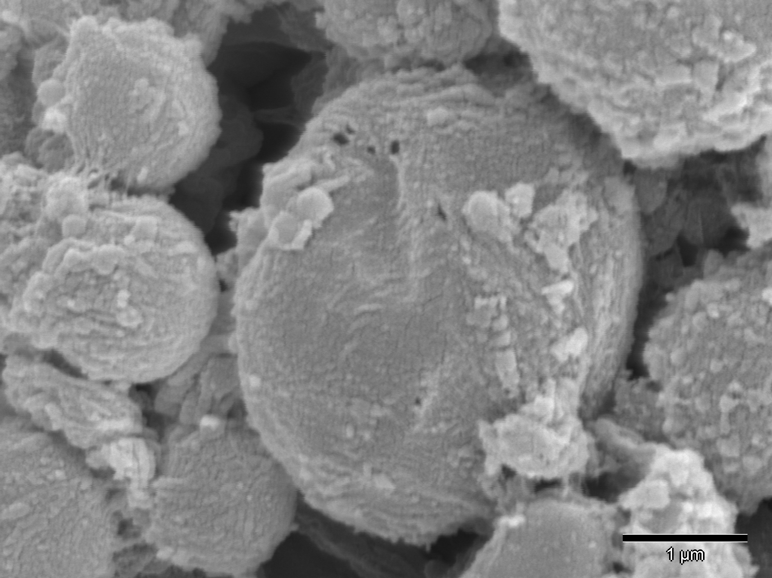

Figure 14. 45 mJ per mm sq – 09 mm f-3: Hole in RBCs were made and presumably released hemoglobin and other cell content into the bathing solution.

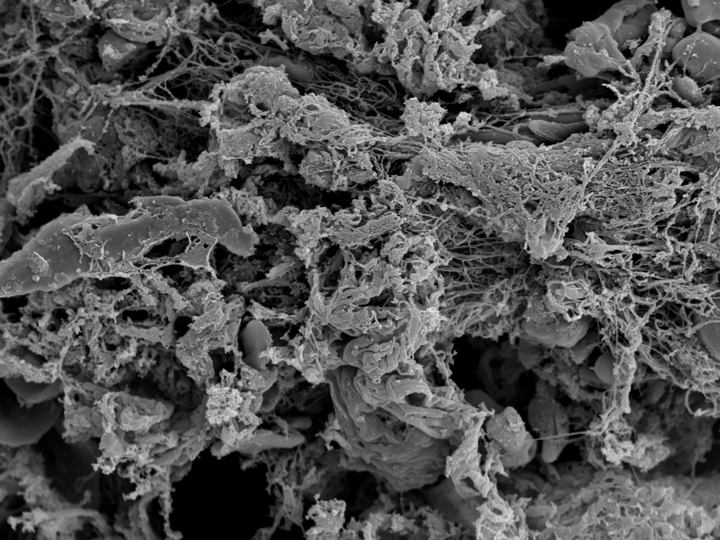

Figure 15. 60 mJ per mm sq – 2 mm f-4: Fibrin materials holding the fibers together can be seen in the thrombotic debris generated.

5. Summary and Conclusions
The data obtained by the current studies as well as the data generated by earlier work provide a broad investigation of the interaction between excimer laser and thrombus. The observations are consistent with respect to the fact that pulsed excimer laser will break up thrombus into smaller particulate debris. At higher energy and larger catheters debris generated is greater in size and number. Also, this associated with faster ablation of the thrombus. Previous work has shown that conducting laser angioplasty in the coronary circulation as treating the usual obstructions is not ideal and special attention should be made to alter lasing parameters in the presence of thrombus (17, 18).
At a cellular level perforation of the cell membranes by the laser beam allows intracellular content to leak out into the bathing solution. Also, irradiation of platelets alters their function with respect to aggregation and disaggregation and this is also related to the laser energy applied. Higher energies and larger catheters result in greater platelet aggregation.
From a clinical standpoint, the effect of aspirin in markedly reducing both the number and size of platelet aggregates is of significant relevance to patients undergoing laser procedures. Given these data, it would be highly recommended that patients be on aspirin when having laser procedures to reduce the number and size of particulate debris formation.
In conclusion, this background data could help the operator select catheter sizes and laser energy protocols depending on the needs of a particular case. If a situation consisted of a thrombus in an artery with poor distal run off then a smaller catheter with lower energies may be selected. On the other hand a large vessel with a large thrombus load and good distal run off may be approached with a larger catheter and higher energies. These type of decisions can be based on the basic data and implemented in a clinical situation. However, the choice of how to proceed in a case would always depend on the judgment of the operator and the presented data are meant to serve only as broad guidelines.

Correspondence to:
Hongbao Ma
Department of Medicine
Michigan State University
East Lansing, MI 48823, USA
Telephone: (517) 303-3990
Email: hongbao@msu.edu; hongbao@gmail.com

References
- DeWood MA, Spores J, Notske R, Mouser LT, Burroughs R, Golden MS, Lang HT. Prevalence of total coronary occlusion during the early hours of transmural myocardial infarction. N Engl J Med 1980;16:897-902.
- Pettit GH, Saidai IS, Tittle FK, et al. Thrombolysis by excimer laser photoablation. Lasers in Life Sciences 1993;5 (3):185-97.
- Gijsbers Geert. Tissue Ablation by CW Lasers and a pulsed XeCl Excimer laser as used in Excimer Laser Angioplasty. Lasercentrum, Academisch Medisch Centrum, Amsterdam. 1992.
- Abela GS. Abrupt Closure after Pulsed Laser Angioplasty: Spasm or a "Mille-Feuilles" Effect? Journal of Interventional Cardiology, 1992:5(4):259-62.
- Manzo KS, Zenni M, Shubrooks S, Byrnes C, Friedl SE, Gebara OC, Abela GS, Tcheng JE. Use of Crystalloid Infusion to Reduce Dissection During Excimer Laser Coronary Angioplasty. Lasers in Surgery and Medicin, 1993;Supplement 5:59.
- Tcheng JE. Saline infusion in excimer laser coronary angioplasty. Semi Intervent Cardiol 1996;1:135-41.
- Topaz O, Shah R, Mohanty PK, McQueen RA, Janin Y, Bernardo NL. Application of excimer laser angioplasty in acute myocardial infarction. Lasers Surg Med 2001;29(2):185-92.
- Topaz O. A new safer lasing technique for laser-facilitated coronary angioplasty. J Intervent Cardiol 1993;6:297-306.
- Isner JM, Clarke RH, Katzir A, Gal D, DeJesus ST, Halaburka KR Transmission characteristicsof individual wavelengths in blood do not predict ability to accomplish laser ablation in a blood field: inferential evidence for the “Moses effect”. Circulation 1986;74:II-361.
- Topaz O, Minisi AJ, Bernardo NL, et al. Alterations of platelet aggregation kinetics with ultraviolet laser emission: the “stunned platelet” phenomenon. Thromb Haemost 2001;86:1087-93.
- Abela GS, Huang R, Prieto AR, Ma H, Schmaier AH, Schwartz DA, Davis JM. Laser-light Scattering (LLS) as a New Method for continuous monitoring of platelet activation in circulating fluid. J Lab Clin Med 2003;141:50-7.
- Prieto AR, Ma H, Huang R, Khan G, Schwartz KA, Hage-Korban EE, Schmaier AH, Hasan AAK, Abela GS. Thrombostatin, a bradykinin metabolite, reduces platelet activation in a model of arterial wall injury. Cardiovascular Research 2002;53:984-92.
- Papaioannou T, Sorocoumov O, Taylor K, Grundfest WS. Excimer Laser Assisted Thrombolysis: The effect of fluence, repetition rate and catheter size. Lasers in Medicine: Proc SPIE 2002;4609:413-18.
- Abela GS, Crea F, Smith W, Pepine CR, Conti CR. In Vitro effects of argon laser radiation on blood: quantitative and morphologic analysis J Am Coll Cardiol 1985;5:231-37.
- Scheinert D, Laird JR Jr, Schroder M, Steinkamp H, Balzer JO, Biamino G. Excimer laser-assisted recanalization of long, chronic superficial femoral artery occlusions. J Endovasc Ther 2001;8(2):156-66.
- Papaioannou T, Levinsman J, Sorocoumov O, Taylor K, Pizer S, Grundfest WS. Particular debris analysis during excimer laser thrombolysis: An in-vitro study. Lasers in Medicine: Proc SPIE 2002;4609:404-12.
- Estella P, Ryan TJ, Landzberg JS, Bittl JA. Excimer laser-assisted coronary angioplasty for lesions containing thrombus. J Am Coll Cardiol 1993;21:1550-6.
- Dahm JB, Topaz O, Woenckhaus C, Staudt A, Mox B, Hummel A, Felix SB. Laser-facilitated thrombectomy: a new therapeutic option for treatment of thrombus-laden coronary lesions. Catheter Cardiovasc Interv 2002;56(3):365-72.

