Simultaneous Determination of Metallothionein and Thionein with Cadmium-Hemoglobin Saturation Method

Hongbao Ma

Department of Medicine, Michigan State University, East Lansing, Michigan 48824, USA, (517) 432-0623, hongbao@msu.edu

Abstract: Metallothionein (MT) has a dynamic role in cellular zinc metabolism. In order to determine the apoprotein thionein (T), an assay was developed. With this method tissue homogenates were treated with subtilisin to digest any T that might exist but MT could not be digested by subtilisin. MT was detected by cadmium-hemoglobin saturation method and T was determined as the difference of MT between samples with and without subtilisin added. With this assay the value of T/MT was found as 0.67, 0.53, 0.14 and 0.10 in four different hamster tissues brain, testis, liver and kidney, individually. This finding was confirmed by gel filtration experiments of liver homogenate supernatants. Upon addition of zinc to the homogenate, zinc in MT containing fractions increased about 2.5 fold. Since the tenet has been that the steady state concentration of T in cells is very low due to its rapid proteolytic digestion, the existence of T under normal physiological condition is a novel finding that has important implications for the function of this protein in zinc metabolism. [The Journal of American Science. 2005;1(1):28-33].

Keywords: assay; metallothionein; subtilisin; thionein

Abbreviations: BME, β-mercaptoethanol; EDTA, ethylenediaminetraacetic acid; MT, metallothionein; T, thionein; Tris, tris(Hydroxymethyl)aminomethane

1. Introduction

Mammalian metallothionein (MT) is a relatively small protein of about 60 amino acids that binds seven zinc atoms exclusively to the thiol group of cysteine side chains. Despite the fact that MT was discovered over 40 years ago (Margoshes, 1957), the exact role of the protein is not clear. Many functions have been suggested (Li, 1993). The strongest evidence points toward its participation in zinc metabolism (Vallee, 1993; 1995). MT has always been isolated in its metal bound form, because its metal content proved to be one of the few characteristics of the protein that could be followed reliably during purification. It is unknown, however, whether or not there is enough zinc available to saturate the metal binding sites of MT in the cell, and consequently, how much apoprotein is present (Calderone, 2005). The rapid proteolytic digestion of thionein (T) in vitro led to the idea that T is not stable in vivo (Feldman, 1978). When exploring MT by its metal content, the possible existence of T is neglected (Haase, 2004). Thus, it has been tacitly assumed that the amount of T is orders of magnitude lower than that of MT in most cells (Kägi, 1993). This postulate has never been tested rigorously, because there was no method to detect and measure T. Evidence for the existence of T was obtained only when cells were grown under conditions that elicit zinc deficiency (Krezowski, 1988; Kraker, 1988). In this case, release of zinc is faster than the proteolytic digestion of MT, resulting in the accumulation of T. Relatively large amounts of T were detected in some cancer cells by chromatography in combination with a radioimmunologic assay and metal determinations (Pattanaik, 1994). The possible functional significance of T was discussed repeatedly (Vallee, 1987; 1991) and it was shown that T inhibits the binding of zinc containing transcription factors to DNA, presumably by removing zinc from the latter (Zeng, 1991). Therefore, it becomes an important issue to assess the amount of T in cells with a convenient assay. To achieve this, a new method that relies on the fact that proteases digest T much more readily than MT in vitro, is described here. Accordingly, the sum of MT and T was measured before protease treatment, while MT was measured with a sensitive detection method for MT based on the binding of cadmium (Cd-hemoglobin saturation assay) after protease treatment. The amount of T was then calculated as the difference between both measurements. This assay detected relatively large amounts of T under normal physiological conditions.

2. Materials and Methods

2.1 Materials
Ten Syrian golden hamsters (Mesocricetus auratus, Sasco Inc., Omaha, NE, USA) were used in this experiment. Tris-base and bovine hemoglobin (H-2500) were purchased from Sigma Chemical Company (St. Louis, MO, USA). Subtilisin was from Boehringer Mannheim (Indianapolis, IN, USA). Cadmium chloride was from Mallinckrodt (St. Louis, MO, USA). Water was obtained from a Milli-Q water system (Millipore Corporation, Bedford, MA, USA) and buffers were treated with Chelex-100 (Bio-Rad, Hercules, CA, USA) as recommended (Holmquist, 1988). Gel filtration system and fraction collector were from LKB Pharmacia Company (Stockholm, Sweden).

2.2 Methods
Since the isolation of hamster MTs has not been reported and there were no hamster MTs available, the assays were verified with MTs from other species. The high sequence homology of mammalian MTs makes possible to verify MT of a specific species with the MT sample of another species. In this research, T was prepared from rabbit MT-II (Sigma, St. Louis, MO, USA) by acidification and gel filtration (Vasak, 1991). To get Zn₇-MTs, the T proteins were reconstituted with seven zinc atoms for each protein molecule. 10 μl of subtilisin (1 mg/ml dissolved in 20 mM NaCl) was added to 200 μl of MT and/or T solution and incubated for 30 min at 30°C. After the incubation, MT and T protein concentrations were measured immediately by optical absorption measurements (ε₂₂₀=48,000 M⁻¹cm⁻¹ at pH 2 for T, ε₂₂₀=159,000 M⁻¹cm⁻¹ at pH 8 for Zn₇-MT, Schäffer, 1991), Also, MT was determined by Cd-hemoglobin saturation method (Onosaka, 1982; Klein, 1994; Ma, 1995).
Cd-hemoglobin saturation assays were performed according to the following protocol: Brain, kidney, liver and testes (about 1 g each) from healthy Syrian golden hamsters were cut into small pieces with scissors and rinsed in ice-cold Tris-HCl buffer (50 mM, pH 8.6). Then the samples were treated with a Potter-Elvehjem homogenizer with a lose-fitting pestle attached to an overhead motor (40 rpm) in 3 volume of the Tris-HCl buffer at 4°C. The homogenate was spun at 10,000×g for 10 min at 4°C in Eppendorf tubes. For the determination of MT, 10 μl of subtilisin (1 mg/ml dissolved in 20 mM NaCl) was added to 200 μl of supernatant and the solution was incubated for 30 min at 30°C. Subtilisin was omitted in the assay for total of MT and T, but the sample was incubated under identical conditions. Then, to each sample 0.1 ml of 3.6 mM solution of cadmium chloride in water was added (final Cd concentration was 1.2 mM). The sample was incubated at room temperature for 5 min and 0.15 ml of hemoglobin (2%, w/w in water) was added. Then the solution was boiled in a water bath for 1.5 min. Samples were then spun at 10,000×g for 5 min at 4°C and the supernatant was collected. The addition of 1.5 ml of hemoglobin was added and subsequent treatment was repeated. Unless indicated otherwise the assay was performed in triplicate. The cadmium concentration in the supernatant was measured with a Zeeman atomic absorption spectrometer (model 4100 ZL, Perkin Elmer, Boston, MA, USA) and the calculated MT concentration was based on a stoichiometry of seven cadmium atoms per MT molecule (1 mg cadmium represented 8.93 mg MT) (Ma, 1994).
Gel Filtration: Hamster liver was homogenized as described above but in one volume of the same buffer and filtered through 0.45 mm Millex-HV filters (Millipore Corporation, Bedford, MA, USA). The sample was then divided into two equal parts. Zinc (zinc nitrate in water) was added to a final Zn concentration of 2.6 mM to one of the two samples. Each sample (0.3 ml) was then loaded onto a Sephadex G-50 (fine) column (1.2×120 cm) and eluted with 10 mM Tris-HCl with 5 mM NaCl (pH 8.6) at a flow-rate of 0.1 ml/min at room temperature, and OD 254 nm was detected with a UV record continuously (Pan, 1993). The MT fraction (at 254 nm) was collected by an automatic fraction-collector (5 ml/tube). Also, 280 nm was measured with a UV detector after the 254 nm was collected as the protein reference.

2.3 Results
There was a linear relationship between T added to 200 μl of the buffer and Cd-MT detected with the Cd-hemoglobin saturation method within the range of 1-10 μg of T (Figure 1). Cd-MT was no longer detected when T in the buffer had been treated with subtilisin (Figure 1). There was also a linear relationship between 1-4 μg Zn₇-MT added to the buffer and Cd-MT measured with virtually the same recovery in the presence or absence of subtilisin (Figure 2). These experiments demonstrated that subtilisin digested T completely whereas Zn₇-MT

was resistant to digestion by subtilisin in the same range of subtilisin concentrations used in the assay. These data were in agreement with reports in the literature (Nielson, 1983). In the absence of added MT or T, cadmium could not be detected above background levels (limit of detection was 0.1 ppb) in the supernatant after performing the Cd-hemoglobin saturation assay. These observations made it possible to calculate the amount of T from the difference between values measured in the assays with and without added subtilisin.
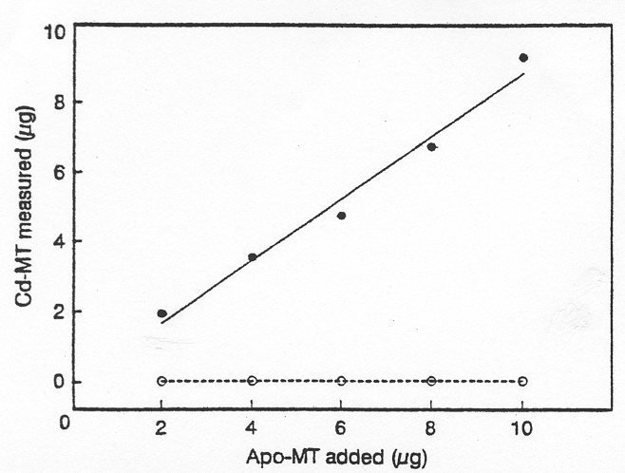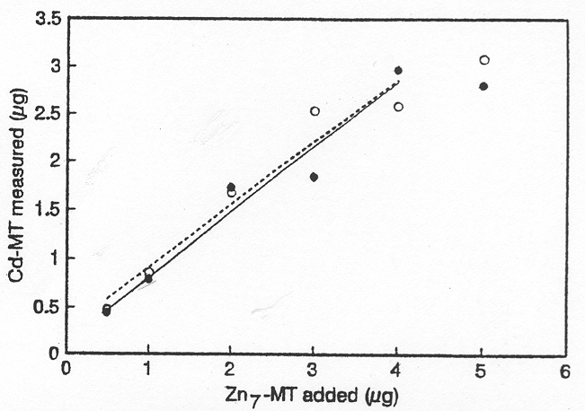Substantial amounts of T were found when the Cd-hemoglobin saturation assay was employed on different hamster tissues (brain, kidney, liver and testes, Table 1). Hamsters contained 30-150 μg MT per gram of wet tissue according to the assay with subitlisin and 50-230 μg MT plus T per gram of wet tissue according to the assay without subtilisin. The ratio T/MT was between 0.10 and 0.67 in different tissues. The error for each assay was lower than the variation of MT content between individual hamsters.

Figure 1. Thionein measured with Subtilisin-Cd-Hemoglobin Saturation Method. The experiment was performed using rabbit liver apo-MT-Ⅱ(1mg/ml) without subtilisin(—)(r=0.89) and treated subtilisin(……)(1mg protein/ml, dissolved in 20 mM NaCl, 200ml T with 10ml subtilisin) for 30 min at 30℃(r=0.94). The recovery was 80%.

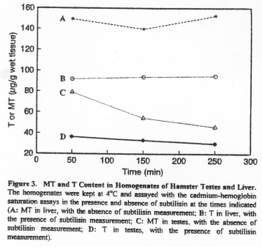
Figure 3. MT and T Content in Homogenates of Hamster Tests and Liver. The homogenates were kept at 4℃ and assayed with the cadmium-hemoglobin saturation assays in the presence and absence of subtilisin at the times indicated (A: MT in liver, with the absence of subtilisin measurement; B: T in liver, with the presence of subtilisin measurement; C: MT in testes, with the absence of subtilisin measurement; D: T in testes, with the presence of subtilisin measurement).
Figure 2. Zn-Metallothionein measured with Subtilisin-Cd-Hemoglobin Saturation. The experiment was performed using rabbit liver Zn-MT-Ⅱ(1mg/ml) without subtilisin(—)(r=0.91) and treated subtilisin(……)(1mg protein/ml, dissolved in 20 mM NaCl, 200ml T with 10ml subtilisin) for 30 min at 30℃(r=0.93). The recovery was 75%.
The concentration of MT was highest in testis, followed by liver, kidney and brain, whereas the concentration of T decreased in the order of testis, brain, liver and kidney (Table 1). The T or MT content of these tissues did not correlate with their overall zinc or copper content. Heat denaturation of the supernatant effected a considerable loss of T (Table 1). Therefore, it was crucial to perform the assay without heat denaturation of the homogenate and a step that was commonly employed in metal saturation assays and in purification of the protein.
In order to address the question of how much T was digested during homogenization and the assay, the concentration of T and MT in liver and testis homogenates was measured as a function of time at 4⁰C. While the amount of MT remained constant in both tissues, the amount of T in testis decreased by 42% within 200 minutes, much more rapidly than that in liver where there was a decrease of only 18% during the same period of time (Figure 3). Extrapolating these values to time zero, i.e., when homogenization of the tissue occurred and a linear rate of decay for T assumed (Figure 3), the amount of T was underestimated at most by 10% in testis. A correction for liver tissue seemed negligible.
It was also investigated whether or not the duration of incubation with subtilisin influences the amount of MT measured. The rationale for this experiment was that the MT/T equilibrium could be perturbed once T was digested, i.e., if the rate of zinc dissociation was fast, there would be are-equilibration with concomitant
decrease of the amount of MT. However, such a mechanism did not pertain since the amount of MT was: 159, 151, 155, and 153 mg/g wet tissue after periods of incubation with subtilisin of 5, 10, 20, and 30 minutes, respectively.
In order to test for the presence of T directly, gel filtration experiments by Sephadex G-50 column in the absence and presence of zinc added to hamster liver homogenates were performed. When zinc was added, the zinc content of metallothionein containing fractions increased 2.7 times (Figure 4A) in comparison with the control (Figure 4B) as it was judged from an integration of the areas of the zinc peaks.

Table 1. Measurement of Metallothionein and Thionein in Hamster Tissues with Subtilisin-Cd-Hemoglobin Saturation Method (μg MT or T/g wet tissue)
Tissues | MT+T | MT | T | T/(MT+T) | T/MT
Brain | 53.4±8.5 | 32.0±1.1 | 21.4±3.6 | 0.40 | 0.67
Kidney | 84.5±13.9 | 76.5±11.7 | 8.0±1.4 | 0.09 | 0.10
Liver | 168.7±3.2 | 148.1±7.5 | 20.6±4.5 | 0.12 | 0.14
Testis | 228.5±24.9 | 149.5±9.1 | 79.0±12.7 | 0.35 | 0.53

Figure 4. Gel Filtration and Zinc Determination of Hamster Liver Homogenates. A: Hamster liver homogenate without added zinc. Zinc analyses was identification of the metallothionein containing fractions(OD280 nm; ——;Zn:----); B: Hamster liver homogenate with added zinc. Zinc analyses was identification of the metallothionein and unbound zinc in a low molecular weight fraction (OD 280 nm ——;Zn:----).

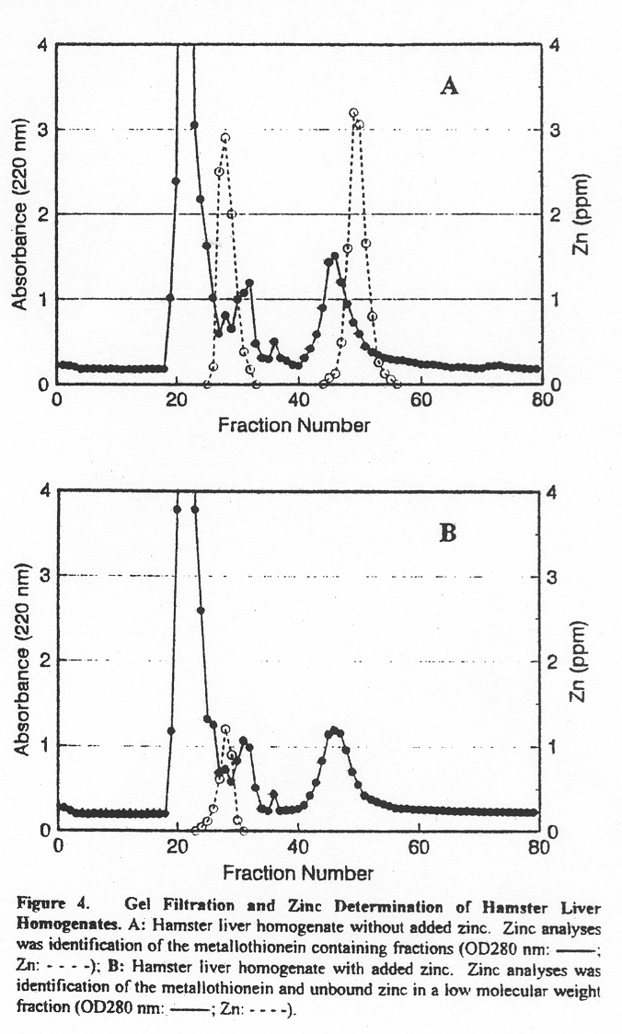3. Discussion

Metal saturation assays for MT are based on the strength of metal binding to MT, which is in the order Bi (III), Hg (II), Ag (I)>Cu (I)>Cd (II)>Pb (II)>Zn (II) (Kägi, 1987). Thus, strong binding metals that do not occur in vivo can be used to displace the native metals in MT. The newly introduced metals could be measured either by radiometrically or by atomic absorption spectroscopy. The amount of MT in a sample could be determined on the basis of its known metal/protein stoichiometry. Here, nonradioactive cadmium is employed to displace zinc in MT and to saturate any binding sites of T. The differential assay for MT and T is based on the fact that subtilisin can digest T but not MT. The resistance of MT to protease digestion in vitro was shown repeatedly (Feldman, 1978; Cousins, 1979; Klaassen, 1993).
On the basis of the expectation that any T present could be converted to MT by the addition of zinc, gel filtration experiments in the absence and presence of zinc added to the homogenate supernatant were performed. The increase of the amount of zinc in the MT containing fractions when zinc was added to the homogenate provides an independent confirmation of the presence of T in hamster liver. The 2.7 fold increase of zinc was higher than the amount of T measured with the cadmium saturation assay that was on the average 1.4 fold (n=6) for liver (Figure 4A). The reason for this is unclear. It maybe reflect an underestimation of the amount of T with the assay or an overestimation of the amount of T in the gel filtration experiment due to the presence of other zinc binding proteins in the corresponding fractions. During homogenization of tissue proteases released might digest T or that metals released might form MT from T. T was readily oxidized in vitro. In all three instances the amount of T will be underestimated. Therefore, the influence of these factors on the assay has been investigated. Omitting the step of heat denaturation of the tissue homogenate, which is commonly employed in the assay, reduces the amount of T significantly (Table 1). However, the amount of MT was not affected. This indicated that T did not sequester metals during or after homogenization. Therefore, the decrease of T must result from its oxidation or digestion. To minimize the oxidation of T, degassed, nitrogen saturated buffers at 4°C were used and the procedure was performed from the homogenization to the removal of hemoglobin in the assay in less than 50 minutes. The question of proteolytic digestion was addressed by studying the amount of T recovered from the homogenate of two tissues as a function of time. This allowed an extrapolation to time zero and demonstrated that a correction was not necessary for liver tissue.
Hamster MTs had been studied (Pine, 1987; Huang, 1993). There are two MT isoforms with the typical primary sequences of mammalian MT-1 and MT-2 in hamster. In other rodents such as the rat or mouse, the MT concentration is about 0.1-15 mg MT/g wet liver tissue (Vasak, 1991). The amount of MT found in hamster liver (Table) lies within this range of values. However, the amount of MT found in hamster tissues (testis > liver > kidney > brain) differs from that in the rat where the order is: kidney > testis > liver > brain (Nolan, 1986; Chen, 1975). The finding of substantial amounts of T in addition to MT in four selected hamster tissues raises questions about the widely applied metal saturation assay which is thought to measure endogenous MT. Apparently all measurements were interpreted under the assumptions that (i) the active principle is the metal-loaded form, i.e. MT isolated from biological material, and that (ii) the rapid proteolytic digestion of T observed in vitro reflects rapid digestion of T in vivo. However, Kraker et al. (1988) showed that T is about as stable as MT in cells and indeed is the predominant form in some cell lines.
Metal saturation assays are never validated by measuring the amount of MT isolated from tissue without a heat denaturation step. Other assays do not have the ability to distinguish between MT and T. Presumably, this is the reason why the existence of T has not been discovered earlier - with the possible exception of one report (Apostolova, 1993).
Direct methods to determine T have not been available by literatures. T is detected in various cell lines by immunological means and a comparison between native Zn-MT and Cd-MT that is produced by addition of cadmium in chromatographic fractions (Pattanaik, 1994). Furthermore, it is suggested that T exists only in states of zinc deficiency (Krezoski, 1988) and in neoplastic tissue (Kraker, 1988). Here large amounts of T are found under normal physiological conditions opening new perspectives on possible functions of T and MT. The discussion will be limited to two such functions. For example, the presence of T in the cell (micromolar concentration level) and the high cysteine content of the protein (20 cysteines) must make a significant contribution to the cellular thiol status. The high reactivity of cysteine thiols has been implicated in many functions including a role as a free radical scavenger and anti-oxidant. Substantial amounts of T also suggest that the MT/T pair plays a significant role as a redox buffer that is likely linked to redox control of other systems such as the glutathione couple (Vallee, 1987). A dynamic role of MT in cellular zinc metabolism would require the presence of T at some point in time. Kägi (1993) developed the idea that the MT/T couple acted as a zinc buffer in the cell, and postulated that the synthesis and degradation of T determined the amount of free zinc in the cell. Metal buffering capacity requires the presence of two species, the metal-loaded form and the metal-free form. It is worth noting that the amounts of T found here are exactly in the range where such a buffer would operate, and therefore, it provides strong support for this hypothesis.
The cadmium-saturation assay is problematic if there is a large portion of oxidized MT (Klein, 1994) or of copper MT (Bienengräber, 1995). In the latter case cadmium cannot displace copper, and consequently, the amount of MT is underestimated unless the assay is modified (Klein, 1990). We have measured the copper concentration in tissue of four hamsters but there was no information about how much copper there was in hamster MT. Therefore, we have no further information about this state of MT.

Correspondence to:
Hongbao Ma
B410 Clinical Center, Department of Medicine
Michigan State University
East Lansing, MI 48824, USA
Telephone: (517) 432-0623
Email: hongbao@msu.edu

References
[1] Apostolova M, Bontchev PR, Nachev C, Sirakova I. Apometallothionein in rat liver. J Chromatogr 1993;620(2):191-7.
[2] Bienengräber M, Forderkunz S, Klein D, Summer KH. Determination of Cu-containing metallothionein: comparison of Ag saturation assay, thiomolybdate assay, and enzyme-linked immunosorbent assay. Anal Biochem 1995;228(1):69-73.
[3] Calderone V, Dolderer B, Hartmann HJ, Echner H, Luchinat C, Del Bianco C, Mangani S, Weser U. The crystal structure of yeast copper thionein: the solution of a long-lasting enigma. Proc Natl Acad Sci USA 2005;102(1):51-6.
[4] Chen RW, Ganther HE. Relative cadmium-binding capacity of metallothionein and other cytosolic fractions in various tissues of the rat. Environ Physiol Biochem 1975;5(6):378-88.
[5] Cousins RJ. Synthesis and degradation of liver metallothionein. Experientia Suppl 1979;34:293-301.
[6] Feldman SL, Failla ML, Cousins RJ. Degradation of rat liver metallothioneins in vitro. Biochim Biophys Acta 1978;544(3):638-46.
[7] Haase H, Maret W. A differential assay for the reduced and oxidized states of metallothionein and thionein. Anal Biochem 2004;333(1):19-26.
[8] Holmquist B. Elimination of adventitious metals. Methods Enzymol 1988;158:6-12.
[9] Huang PC. Metallothionein structure/function interface. In Metallothionein III, Suzuki KT, Imura N, Kimura M, Eds. Birkhäuser Verlag, Basel, Switzerland. 1993:407-26.
[10] Kägi JHR. Evolution, structure and chemical activity of class I metallothioneins: an overview. In Metallothionein III, Suzuki KT, Imura N, Kimura M, Eds. Birkhäuser Verlag, Basel, Switzerland. 1993:29-55.
11] Kägi JHR, Kojima Y. Chemistry and biochemistry of metallothionein. in Metallothionein II, Kägi JHR, Kojima Y, Eds, Birkhäuser Verlag, Basel, Switzerland. 1987:25-61.
[12] Klaassen CD, Choudhuri S, McKim JM, Lehman-McKeeman LD, Kershaw WC. Degradation of metallothionein. In Metallothionein III, Suzuki KT, Imura N, Kimura M, Eds. Birkhäuser Verlag, Basel, Switzerland. 1993:207-224.
[13] Klein D, Bartsch R, Summer KH. Quantitation of Cu-containing metallothionein by a Cd-saturation method. Anal Biochem 1990;189(1):35-9.
[14] Klein D, Sato S, Summer KH. Quantification of oxidized metallothionein in biological material by a Cd saturation method. Anal Biochem 1994;221(2):405-9..
[15] Kraker AJ, Krakower G, Shaw CF 3rd, Petering DH, Garvey JS. Zinc metabolism in Ehrlich cells: properties of a metallothionein-like zinc-binding protein. Cancer Res 1988;48(12):3381-8..
[16] Krezoski SK, Villalobos J, Shaw CF 3rd, Petering DH. Kinetic lability of zinc bound to metallothionein in Ehrlich cells. Biochem J 1988;255(2):483-91.
[17] Li L, Ma H. A hot topic in biochemistry-metallothionein. World Agriculture 1993;172(8):26-7.
[18] Ma H, Xiao G, Tong X, Li L, Min G, Zhai Z, Ru B. The isolation and purification, ultraviolet absorption, fluorescence emission, circular dichroism and scanning tunneling microscopy of metallothioneins from earthworm induced by cadmium. Acta Biophsca Sinica 1994;10(4):529-36.
[19] Margoshes M, Vallee BL. J Am Chem Soc 1957;79:4813-4.
[20] Nielson KB, Winge DR. Order of metal binding in metallothionein. J Biol Chem 1983;258(21):13063-9.
[21] Nolan CV, Shaikh ZA. Determination of metallothionein in tissues by radioimmunoassay and by cadmium saturation method. Anal Biochem 1986;154(1):213-23.
[22] Onosaka S, Cherian MG. Comparison of metallothionein determination by polarographic and cadmium-saturation methods. Toxicol. Appl Pharmacol 1982;63(2):270-4.
[23] Pan A, Tie F, Duan Z, Ma H, Li L, Ru B. Purification and characterization of hedgehog liver metallothionein. Biochemical Chromatography 1993;7:94-8.
[24] Pattanaik A, Shaw CF 3rd, Petering DH, Garvey J, Kraker AJ. Basal metallothionein in tumors: widespread presence of apoprotein. J Inorg Biochem 1994;54(2):91-105.
[25] Pine R, Huang PC. An improved method to obtain a large number of mutants in a defined region of DNA. Meth Enzymol 1987;154:415-30.
[26] Schäffer A. Absorption, circular dichroism, and magnetic circular dichroism spectroscopy of metallothionein. Methods Enzymol 1991;205:529-40.
[27] Vallee BL. Implication and inferences of metallothionein structure. In Metallothionein II, Kägi JHR, Kojima Y, Eds, Birkhäuser Verlag, Basel, Switzerland. 1987;5-16.
[28] Vallee BL. Introduction to metallothionein. Methods Enzymol 1991;205:3-7.
[29] Vallee BL. The function of metallothionein. Neurochem Int 1995;27(1):23-33.
[30] Vallee BL, Maret W. The functional potential and potential functions of metallothioneins: a personal perspective. In Metallothionein III, Suzuki KT, Imura N, Kimura M, Eds. Birkhäuser Verlag, Basel, Switzerland. 1993:1-27.
[31] Vasak M. Large-scale preparation of metallothionein: biological sources. Methods Enzymol 1991;205:39-41.
[32] Zeng J, Vallee BL, Kägi JHR. Zinc transfer from transcription factor IIIA fingers to thionein clusters. Proc Natl Acad Sci USA 1991;88(22):9984-8.

