Clinicopathological Features of Non Hodgkin’s Lymphoma Patients Treated in Kasr Al-Ainy Centre of Clinical Oncology (Nemrock) from 2015 to 2020

Wedad B. Hashem, MD, Rasha Salama MD, Hadir Habib, Msc, Hamdy Zawam MD

Department of Clinical Oncology, Kasr Al-Ainy School of medicine, Cairo University, Egypt
E-mail: weedo_82@hotmail.com

Abstract: Background: Worldwide, non-Hodgkin lymphoma (NHL) is the most prevalent hematologic cancer. It has more than 40 major subtypes. The primary objective of this study is to evaluate the prevalence and clinicopathological features of different types of NHL and to study the impact of number of cycles of Rituximab on progression free survival of DLBCL patients. Our main secondary objective is to assess the incidence of CNS relapse in DLBCL.
Methods: This is a five-year retrospective (from January 2015 till January 2020) study of clinic-pathological features of NHL patients in Kasr Aini Clinical Oncology department, Cairo University. Final analysis of DLBCL patients data was done.
Results: During the period from January 2015 to January 2020 data of lymphoid malignancies retrieved were 719 cases. Meanwhile among NHL, the diffuse large B cell lymphoma (DLBCL) was the commonest subtype forming 43% (251 patients). Only 186 patients of DLBCL were eligible for the final analysis. In our cohort, the median age at diagnosis was 50 years. We have found that patients with intermediate or high CNS-IPI were more likely to develop CNS relapse with a trend toward statistical significance (p= 0.08). Complete remission (CR) also increased to 60.1% of the patients after adding rituximab to CHOP. Median PFS for patients who achieved CR after first line of treatment was 13.5 months, while those who failed to achieve a response had a median PFS of 5 months, with p value <0.0001. Overall survival was significantly affected by the response after 1st line of chemotherapy; with the median OS for those who achieved favorable response was 20.8 versus 8.1 months for those who achieved no response after completion of the first line of chemotherapy.
Conclusion: The most prevalent lymphoma subtype in our study, accounting for 43% of the patients, was DLBCL. When added to chemotherapy, rituximab improved both CR and ORR. Furthermore, Rituximab plus chemotherapy had a noticeably longer overall survival.
Regarding CNS relapse and the impact of CNS IPI, we noticed that patients with intermediate or high CNS-IPI were at a higher risk of experiencing CNS relapse.
[Wedad B. Hashem, Rasha Salama, Hadir Habib, Hamdy Zawam. Clinicopathological Features of Non Hodgkin’s Lymphoma Patients Treated in Kasr Al-Ainy Centre of Clinical Oncology (Nemrock) from 2015 to 2020. Cancer Biology 2023;13(4):86-93]. ISSN: 2150-1041 (print); ISSN: 2150-105X (online). http://www.cancerbio.net 04.doi:10.7537/marscbj130423.04.

Keyword: DLBCL, Rituximab, CNS prophylaxis.

1. Background:
Non-Hodgkin’s Lymphoma (NHL) is considered the most common hematologic malignancy all over the world. In United States, it represents around 4.3% of all cancers, being the 7th most common malignancy between males and ranked the 6th among females. NHL has several subtypes, which varies to a great extent to age, difference in gender, as well as geographic region [1].
NHL is characterized by numerous age-related distinctions in clinical picture, biology, as well as therapeutic outcome. Children under the age of 16 years are named the “pediatric” group, whereas patients between 16 to 39 years, are defined as the “adolescent and young adult (AYA)” group. The incidence of newly diagnosed patients increases in higher age. The annual incidence in the US - extracted from SEER database - is 0.5-1.2 per 100 000, 1.8-7.2 per 100 000, and 10.5- 116.4 per 100 000, for the pediatric, AYA, and older adult (>40 years) age groups respectively [2].
In Egypt between 2000 and 2011, the histopathology department in the national cancer institute (NCI) evaluated a total of 5690 cases diagnosed as malignant lymphoma; 71.84% were diagnosed as NHL, while 28.16% presented by Hodgkin lymphoma. There was a clear predominance of B-cell type NHL of around 83.7%. Diffuse large b-cell lymphoma (DLBCL) was the most frequently recorded subtype of all B-cell lymphomas, representing about half of the cases (50.17%) [3].
CNS relapse is considered a highly serious and most life threatening event in aggressive Lymphoma cases [4, 5]. Properly identifying the high-risk patients will definitely aid CNS-dedicated diagnostic work-up to early find out CNS disease and select cases that need therapeutic or maybe prophylactic measures [6].
In 1975, the trial for monoclonal antibodies (mAbs) to be used as a therapeutic treatment option began. Researchers at that time described the hybridomas formation to save and produce a limitless amount of mAbs from just one single B cell [7].
Rituximab is a mAb that has the capability of specifically binding with high affinity to the CD20 antigen. CD20 is expressed on the preponderance of malignant B cells. Binding of the fragment crystallizable (Fc) portion of the rituximab mAb to the CD20⁺ tumor cells leads to its elimination by at least 4 pathways: antibody-dependent cellular cytotoxicity (ADCC), antibody-dependent cellular phagocytosis, complement- dependent cytotoxicity (CDC), and direct antitumor effects [8, 9].

Aim of work:
The primary objective of this study is to evaluate the prevalence and clinicopathological features of different types of NHL and to study the impact of number of cycles of Rituximab on progression free survival of DLBCL patients.
Our main secondary objective in this study is to assess the incidence of CNS relapse in DLBCL.

2. Patients and Methods:
This is a five-year retrospective (from January 2015 till January 2020) study of clinic-pathological features of Non-Hodgkin’s Lymphoma in Kasr Aini Clinical Oncology department. We accessed the database to extract the file numbers of the patients. Final data analysis was done on DLBCL patients.
Data was retrieved from patient’s records including: age at diagnosis, year of diagnosis, gender, virology, ECOG performance score, LDH level, and clinical stage, size of tumor, extranodal site of involvement, number of Rituximab cycles, outcome, and survival.
Overall survival (OS) was the outcome of interest. OS was calculated as the time in months elapsed between the date of diagnosis and the date of death, date last known to be alive, or date of the study cut off. [10]
PFS was calculated as the time in months elapsed between the date of complete response until first evidence of disease relapse. Objective response rate (ORR) is the proportion of patients who had responded either partially or completely to therapy. [10]

Inclusion criteria:
- Adults’ patients with age ≥18 years diagnosed with Non-Hodgkin’s Lymphoma namely: Diffuse Large B cell Lymphoma, T cell Lymphoma, Mantle Cell lymphoma, Marginal Zone Lymphoma.
- Patients with controlled co-morbidities such as diabetes mellitus were enrolled in this study.

Exclusion criteria:
  - Patients with inadequate or incomplete data on their treatment outcomes
  - Patients with secondary active cancers.

Methods of evaluation:

Patients and staging:
Patients included in the study were newly diagnosed with no prior chemotherapy or radiotherapy. Their ages ranged from 18 to 89 years. Standard staging work up included thoracic, abdominal, and pelvic computed tomography scans, as well as bone marrow biopsy or aspiration. We used the international prognostic index (IPI) to stratify the patients into prognostic groups.
Patients baseline characteristics including ECOG performance status (PS) between grade 0 and 4, routine labs, chemistry profile, full electrolytes panel, LDH, clinical stage according to Lugano classification, international prognostic index (IPI), site and number of extra nodal involvement, CNS IPI score were recorded.

Treatment:
A total of 152 patients received CHOP (cyclophosphamide, doxorubicin, vincristine, and prednisone). Rituximab was given in 1st line treatment protocols in 144 patients R-CHOP/R-CHOP like regimens.
Response to treatment was evaluated after completing 6 or 8 cycles and prognostic factors were identified by univariate and multivariate analysis of the therapeutic response.
The results of interim assessment of chemotherapy and post chemotherapy were done based on clinical examination, laboratory assessment (CBC, kidney function tests, Liver function tests, LDH, ESR), as well as radiological evaluation (Computed tomography and PET CT scans).
Complete remission was characterized by the disappearance of all tumor sites confirmed by the results of assessment. Partial remission corresponded to a partial regression of the tumor and failure to an absence of remission. [10]

CNS Prophylaxis:
CNS involvement screening was performed if the patient had any neurological signs or symptoms or had a more accurate approach from the beginning, by incorporating with (MRI) and flow cytometry on (CSF) in the initial work up of the high risk patients. Patients were classified according to CNS IPI score, in which patients were treated with either high dose methotrexate or intrathecal methotrexate. The high risk of CNS relapse was defined by any of the following: high-risk International Prognostic
Index score (IPI) ≥ 3, elevated LDH and more than one extranodal site or specific extranodal sites being renal, testicular and breast. We also calculated CNS-IPI, consisting of the individual IPI factors and involvement of renal and/or adrenal glands for a total of six factors.

Statistical methodology:
  - Data analysis packages were by SPSS version 21.
  - Qualitative data was presented by number and percentage; quantitative data was presented by mean, standard deviation, median and interquartile range.
  - Parametric and non-parametric tests of significant were done according to data type. Student t test or Manwhitney test was deployed based on data distribution.
  - Correlations were done between the independent variables and the significant variables were selected to conduct a multivariate regression analysis. Level of significance was set at p equal to or below 0.05.

Funding and approvals:
This study was self-funded and investigators didn't receive funding from external sources during the study conduction, analysis or publishing. The study subjects were not offered any financial compensation for participation in the study. The study design and documents were approved by the institutional review board of the Kasr al Aini Centre of Clinical Oncology and nuclear medicine (NEMROCK). Faculty of Medicine ethical committee approval was received on 4/10/2020.

3. Results:

Clinico-pathological features:

Pathology:
During the period from January 2015 to January 2020 data of lymphoid malignancies retrieved were 719 cases. Non-Hodgkin’s lymphoma and plasma cell disorders constituted the largest fraction 74% (580 patients), while Hodgkin lymphoma only constitutes 26% (139 patients). Meanwhile among NHL, the diffuse large B cell lymphoma (DLBCL) was the commonest subtype forming 43% (251 patients), CLL/SLL represented 10% (60 patients), mycosis fungoids was 8% (45 patients) while follicular lymphoma & marginal zone lymphoma each represented 4% (24 patients).

Patient characteristics:
Only 186 patients of DLBCL were eligible for the final analysis.
In our cohort, the median age at diagnosis was 50 years. ECOG performance score was 0-1 in 65.6% of the patients (122 patients) .Virology screening for Hepatitis C was positive in 44 patients (23.6%). On the other hand, Hepatitis B was positive in 7 patients (3.7%). Hypertension was the commonest comorbidity reported in the included patients that was reported in 27 patients followed with Diabetes mellitus in 21 patients (Table 1).

Table (1): Patient characteristics
Variables | Number (%)
Age Mean 50
<60 | 134 (72)
≥60 | 52(28)
Gender
Male | 98 (52.7)
Female | 88 (47.3)
ECOG PS
0-1 | 122(65.6)
2-4 | 64 (34.4)

Stage and risk stratification:
Patients presented with early Ann Arbor stage (I-II) were 110 patients (59.1%), while those who presented with the advanced stage (III- IV) were 76 (40.9%). A total of 68 patients (36.6%) had bulky tumors on presentation (≥7.5cm). On the other hand, International prognostic index (IPI) score showed that the majority of cases were categorized as intermediate risk (44.6%), followed by low risk (39.9%), and high risk (15.6%) (Table 2).

Extra nodal involvement
Out of 186 patients, 41 patients (22%) had extranodal involvement on presentation. The most common site of involvement was the Gastrointestinal tract (GIT) identified in 18 patients. (Figure 1). All patients in the extranodal group showed noticeably worse performance status (ECOG PS 2-4) when compared to the nodal group.

Characteristics of patients with CNS Relapse:
Out of 184 patients not initially diagnosed with CNS disease, 11 patients (6%) developed CNS relapse. Out of 184 patients, only 18 patients (9.8%) received CNS prophylaxis (High dose intravenous Methotrexate and/or intracecal Methotrexate).

Table (2): Clinical parameters of disease characteristics
Variable | Number (%)
Stage
Early (I/II) | 110 (59.1)
Late (III/IV) | 76 (40.9)
Bulky disease
<7.5cm | 118 (63.4)
≥7.5cm | 68 (36.6)
Serum LDH
Normal | 62 (34.6)
High | 124 (65.4)
IPI Score
Low | 74 (39.8)
Intermediate | 83 (44.6)
High | 29 (15.6)

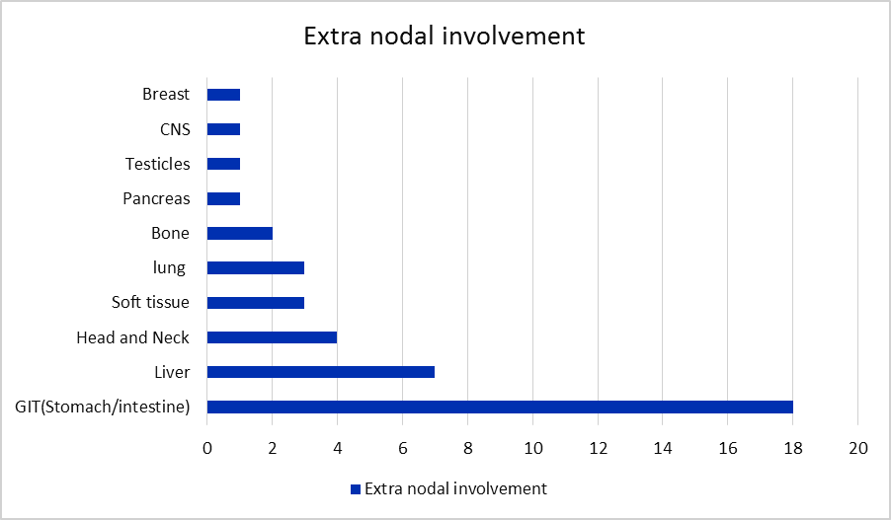
Figure (1): Bar chart for extra nodal involvement

CNS intermediate IPI score was the commonest (43.5%). CNS relapse was not significantly associated with CNS-IPI with a p-value of 0.30 (Table 3).
In a bivariate logistic regression analysis accounting for the CNS prophylaxis status, we have found that patients with intermediate or high CNS-IPI were more likely to develop CNS relapse with a trend toward statistical significance (Odds ratio: 6.2, 95% Confidence Interval: 0.80- 50, p= 0.08).

Table (3): Correlation between the CNS-IPI category and CNS relapse
 | Number (%)
 | Low | Intermediate | High | P value
CNS IPI score | 74 (40.2) | 80(43.5) | 30(16.3)
CNS prophylaxis | 2 (2.7) | 8 (11.4) | 8 (26.7) | 0.76
CNS relapse | 2 (2.7) | 6 (7.5) | 3 (10) | 0.30

Treatment outcomes:
CHOP was the most commonly used chemotherapy protocol. A total of 151 patients (81.2%) received CHOP (with and without rituximab). Rituximab was given in 1st line treatment protocols in 144 patients. It was combined with CHOP (R-CHOP) in 121 (65.1%) patients and in 23 patients with CHOP-like regimens and other regimens (Table 4).
CHOP only (without rituximab) regimen showed ORR in 35.7% of the patients, where CR was seen in 21.4%. In patients who received rituximab, ORR was up to 82%. Furthermore, complete remission also increased to 60.1% of the patients after adding rituximab to CHOP.
Furthermore, patients who received at least three cycles of Rituximab significantly experienced complete response (CR) in 65% of cases, compared to 20% of patients who received fewer than three cycles.

Table (4): Treatment protocols
Treatment regimen |  | Number (%)
First-line chemotherapy | CHOP | 30 (16.1)
 | CHOP-like regimen | 4 (2.2)
 | Others | 8 (4.3)
 | R-CHOP | 121 (65.1)
 | R-CHOP like regimens | 23 (12.3)
Number of  chemotherapy cycles | <6 cycles | 14 (7.5)
 | ≥ 6 cycles | 172 (92.5)
Rituximab plus  Chemotherapy | No | 42 (22.6)
 | Yes | 144 (77.4)

Factors affecting response of treatment:
The stage, bulky disease, and serum LDH did not have impact on the response status significantly (p-values 0.089, 0.79, and 0.50, respectively). Meanwhile, patients with good ECOG PS (0-1) achieved higher CR rates compared to those with poor PS (≥2) (p-value = 0.002).

Survival analysis:
Progression-free survival analysis (PFS):
Median PFS for patients who achieved CR after first line of treatment was 13.5 months, while those who failed to achieve a response had a median PFS of 5 months, with p value <0.0001.
Also a numerically higher PFS in patients who received at least ≥3 of Rituximab 10.5 months versus 5 months in those who didn’t complete 3 cycles (p value = 0.11) (Figure 3).
However, the IPI score did not have a significant impact on PFS with p value of 0.69 (Figure 4).

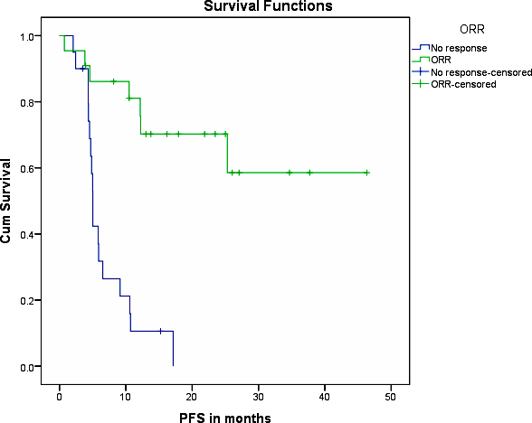
Figure (2): Kaplan Meier curve showing PFS in months based ORR

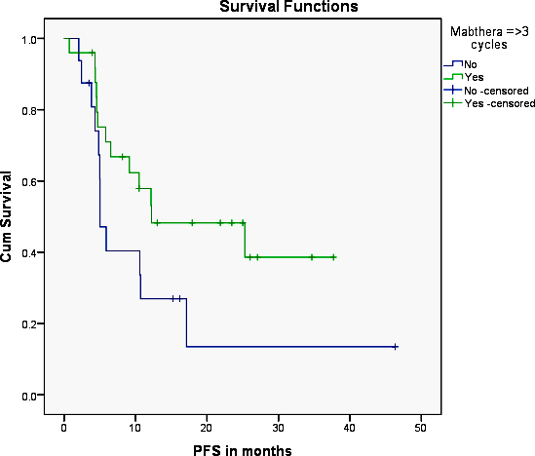
Figure (3): Kaplan Meier curve showing PFS in months based on the number of cycles

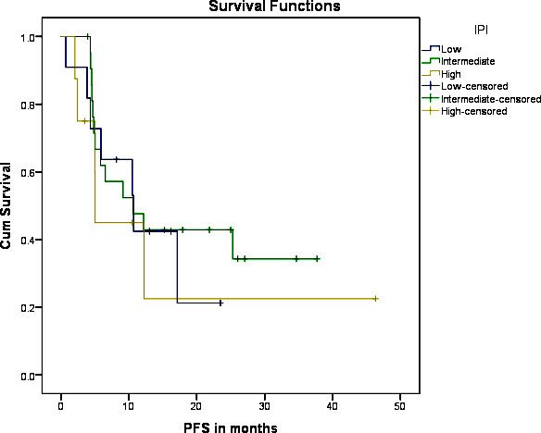
Figure (4) Kaplan Meier curve showing PFS in months based on IPI score

Overall survival analysis (OS):
Overall survival was significantly affected by the response after 1st line of chemotherapy; with the median OS for those who achieved CR was 20.8 versus 8.1 months for those who achieved no response after completion of the first line of chemotherapy (Figure 5).
In addition, rituximab plus chemotherapy had significantly longer OS with a median of 16.6 versus 13.2 months in chemotherapy alone arm with a p-value of 0.001. However, the IPI score did not significantly impact the OS with a p-value of 0.12 (Figure 6, Figure 7).
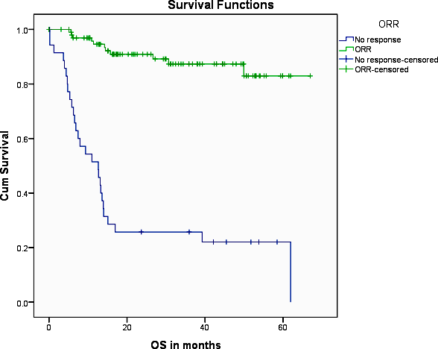
Figure (5): Kaplan Meier curve showing OS in months based on ORR

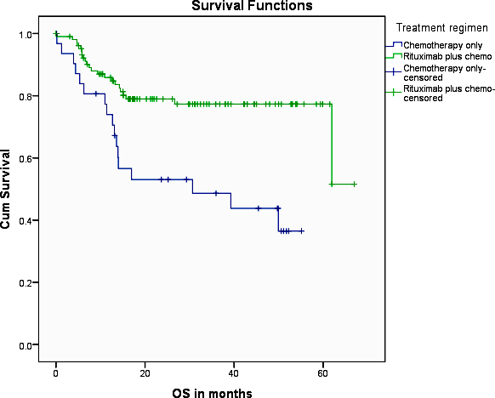
Figure (6): Kaplan Meier curve showing OS in months based on the treatment regimen
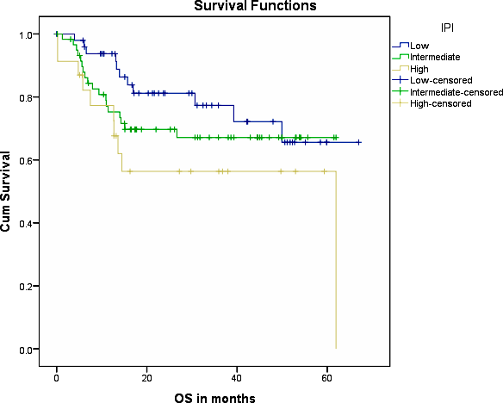
Figure (7): Kaplan Meier curve showing OS in months based on IPI score

4. Discussion:
Worldwide, non-Hodgkin lymphoma (NHL) is the most prevalent hematologic cancer. With a projected 70,800 new cases in the United States (U.S.) in 2014, it is more prevalent in industrialized nations. NHL is the seventh most frequent disease in men and the sixth most prevalent in women, making up 4.3% of all cancer cases in the United States. More than 40 primary subtypes of NHL exist, each with unique morphologic, genetic, and clinical characteristics [1].
Meanwhile, NHL is the fourth most frequent disease in Egypt, following breast, gastrointestinal, and bladder cancers, according to the National disease Institute (NCI) [3].
The current study is significant because it provides information on the relative distribution of different lymphoma types at our facility and the impact of the number of Rituximab cycles on progression-free survival.
Hodgkin lymphoma accounts for 26% of the patients in our analysis, which retrieved 719 cases of lymphoid malignancy from our medical data between 2015 and 2020; non-Hodgkin's lymphoma makes up the majority of the cases (74%).
DLBCL was the most prevalent subtype of lymphoma in our study, accounting for 43% of lymphoid malignancies, which is higher than the range seen in western countries, which is between 25% and 30%, according to the WHO Classification of Tumors of Hematopoietic and Lymphoid Tissues Health & Environmental Research Online (HERO) US EPA, n.d. [11]; While myeloma cells and plasma cell diseases represent 27% and constitute the second most common subtype. In contrast to the high rates of DLBCL, FL was shown to account for about 4% of our NHL. This is noted in contrast, the prevalence of NHL in Western research is between 28 and 32% [1].
The primary emphasis of our data's final analysis was on DLBCL patients.
In our study, the patients' median age was 50 years old, with extremes of 21 and 89 years old. This is lower than what has been shown in other research (Sant et al., 2010), where the median age at diagnosis was in the 70s. The incidence of DLBCL in patients was greater in men (53.1%). In addition, 22% of patients had extranodal involvement, which was more common in men. Most other investigations support this as well [12,13].
Our study's lower median age and higher DLBCL predominance may be related to epidemiological factors like the prevalence of viral infections. A higher risk of developing lymphomas is linked to immunosuppressive diseases such as autoimmune diseases, organ transplants, and primary or acquired immunodeficiencies, as well as chronic viral infections. Helicobacter pylori, Epstein-Barr virus (EBV), and hepatitis C virus (HCV) are among the infectious agents that have been connected to the risk of lymphoma [14].
This was noted in our study, where 23.6% of patients tested positive for HCV, a rate significantly higher in the west where a sizable epidemiological study had reinforced the association between HCV and B-NHL. The prevalence of HCV infection in B-NHL was found in 5542 patients in 48 studies, with a mean HCV infection rate of 13%, according to a systematic review published by Gisbert et al. HCV prevalence in B-NHL was 17% in another ten case-control series, while it was 1.5% in healthy controls [15].
In terms of performance status, our findings indicate that 65.6% of our patients had good ECOG performance scores (≤1), and that their CR rates were significantly higher than those of patients with poor PS (≥2).
According to numerous studies, the most common site was the GIT, and in our study, the percentage of patients with extranodal involvement accounted for 22% of all patients (12). In our study, patients in the extranodal group showed noticeably worse performance status when compared to the nodal group. This is consistent with findings from Shuna Yao et al's study (16). However, other research revealed no statistically significant difference in the performance scores of the two groups [12, 13].
The percentage of CNS relapse in our patients was 6%, which is consistent with a meta-analysis by C. Meert et al. that found that the incidence of CNS relapse ranged between 2-6% based on the results of five studies and the impact of CNS prophylaxis [17]. However, the frequency of CNS disease in DLBCL cases with MYC rearrangement varies from 9% to 45%, especially when linked to either BCL-2 or BCL-6 gene rearrangements [18].
Our research revealed a trend toward statistical significance in the likelihood of CNS relapse in patients with intermediate or high CNS-IPI. There were conflicting findings regarding the reduction of CNS relapse incidence through CNS prophylaxis. Actually, some research has not demonstrated any benefit in terms of prevention [4, 17, 18].
In our study, 21.4% of patients experienced complete remission following CHOP treatment (p-value = 0.001). Additionally, the response rate was 35.7%, which is comparable to the majority of outcomes (30–35%) reported in trials using first-generation regimens [19].
According to our findings, adding rituximab to CHOP (R-CHOP) greatly raised the CR to 60.1%. Moreover, response rates increased, with R-CHOP rising to 82%. Nearly all of the studies highlighting the impact of rituximab show this increase [20, 21, 22,23].
Furthermore, in our investigation, patients who received at least three cycles of Rituximab significantly experienced complete response (CR) in 65% of cases, compared to 20% of patients who received fewer than three cycles.
PFS data showed that patients who experienced complete remission (CR) following first line of treatment had a median PFS of 13.5 months, while patients who did not show any response had a median PFS of 5 months (p value <0.0001).
Based on our analysis, patients who received at least three cycles of Rituximab had a PFS that was numerically higher (10.5 months) compared to those who did not complete three cycles (5 months).
However, the response following the first round of chemotherapy had a significant impact on overall survival (OS); the median OS for patients who experienced a favorable response was 20.8 months, while the median OS for patients who did not experience any response was 8.1 months.
Furthermore, the OS for the Rituximab plus chemotherapy group was significantly longer, with a median of 16.6 months, compared to 13.2 months for the chemotherapy alone arm.

Conclusion:
Worldwide, non-Hodgkin lymphoma (NHL) is the most prevalent hematologic cancer. It has more than 40 major subtypes, each with unique morphological, genetic, and clinical characteristics. The most prevalent lymphoma subtype in our study, accounting for 43% of the patients, was DLBCL.
Twenty-two percent of our patients had extra nodal involvement, with the GIT being the most common site.
Patients who had received Rituximab, especially with three or more cycles, along with chemotherapy regimens had improved both CR and ORR. Furthermore, compared to chemotherapy alone, Rituximab plus chemotherapy had a noticeably longer overall survival.
Regarding CNS relapse and the impact of CNS IPI, we found that patients with intermediate or high CNS-IPI were at a higher risk of experiencing CNS relapse, with 6% of our patients experiencing CNS relapse.

References:
- Krishana C, Adam B, sandeep A, Alexander B, and Prashanth R. Epidemiology of the non-Hodgkin’s lymphomas. Med sci (Basel); 2021 Mar; 9 (1):5.
- Hochberg J, El-Mallawany N.K. & Abla O. Adolescent and young adult non-Hodgkin lymphoma. In British Journal of Haematology; 2018 (Vol. 173, Issue 4, pp. 637–650). Blackwell Publishing Ltd. https://doi.org/10.1111/bjh.14074
- Amal S., Hussein M., Nabiel M., Hoda B. and Hossam K. Cancer incidence in Egypt: results of the national population- based cancer registry program. J Cancer Epidemiol. 2014; 2014: 437971. Doi: 10.1155/2014/437971.
- Boehme V, Zeynalova S, Lengfelder E, Franke A, Reiser M, Steinhauer H, Clemens M, Nickenig C, Witt M, Loeffler M, Pfreundschuh M. & Schmitz N. (2007). CNS-Disease in elderly patients treated with modern chemotherapy (CHOP-14) with or without rituximab: an analysis of CNS events in the RICOVER-60 trial of the Gerrman high-grade non-Hodgkins lymphoma study group (DSHNHL) [Abstract No. 519]. Blood, 110(11). https://doi.org/10.1182/blood-2008-10-182253.
- Steven B, Joseph U, Michel L., Jonathan f., Thomas M. and Richer F. Natural history of CNS relapse in patients with aggressive non-hodgkin’s lymphoma: a 20-year follow up analysis SWOG 8516--- the Southwest Oncology Group: J Clin Oncol. 2009 Jan1; 27 (1): 114-9. Doi: 10.1200/jco.2008.16.8021.
- Sandra Q., Antonio P., Juan M, et al: Identification of leptomeningeal disease in aggressive B-cell non-hodgkin’s lymphoma: improve sensitivity of flow cytometry: J Clin Oncol. 2009 March; 27(9). Doi: 10.1200/JCO.2008.17.7089.
- Köhler G. & Milstein C. (1975). Continuous cultures of fused cells secreting antibody of predefined specificity. Nature, 256(5517), 495–497. https://doi.org/10.1038/256495a0
- Maloney D.G, Smith B. & Rose A. (2002). Rituximab: Mechanism of action and resistance. Seminars in Oncology, 29(1S2), 2–9. https://doi.org/10.1053/sonc.2002.30156
- Abulayha A, Bredan A, El-Enshasy H. & Daniels, I. (2014). Rituximab: Modes of action, remaining dispute and future perspective. In Future Oncology (Vol. 10, Issue 15, pp. 2481– 2492). Future Medicine Ltd. https://doi.org/10.2217/fon.14.146
- Amanda D. and Achuta K. Clinical endpointd in oncology – a primer. Am J Cancer Res. 2021; 11(4): 1121-1131.
- Rita A., Catalina A., Loannis A. et al. The fifth edition of the WHO classification of haemapoetic tumors: lymphoid neoplasms. LYMPHOMA; June 2022, 36, 1720-1748.
- Castillo J.J, Winer E.S. & Olszewsk, A.J. (2014). Sites of extranodal involvement are prognostic in patients with diffuse large B-cell lymphoma in the rituximab era : An analysis of the Surveillance, Epidemiology and End Results database. 89(3), 310–314. https://doi.org/10.1002/ajh.23638
- Takahashi H, Tomita N, Yokoyama M, Tsunoda S, Yano T, Murayama K, Hashimoto C, Tamura K, Sato K. & Ishigatsubo Y. (2012). Prognostic impact of extranodal involvement in diffuse large B-cell lymphoma in the rituximab era. Cancer. https://doi.org/10.1002/cncr.27381
- Flowers C.R, Sinha R. & Vose J.M. (2010). Improving Outcomes for Patients With Diffuse Large B-Cell Lymphoma. CA: A Cancer Journal for Clinicians, 60(6). https://doi.org/10.3322/caac.20087

Gisbert J.P, García-Buey L, Arranz R., Blas C, Pinilla I, Khorrami S, Acevedo, A., Borque, M.J, Pajares J.M, Fernândez-Rañada J.M. & Moreno-Otero, R. (2004). The prevalence of hepatitis C virus infection in patients with non-Hodgkin’s lymphoma. European Journal of Gastroenterology and Hepatology, 16(2), 135–138. https://doi.org/10. 1097/ 00042737-200402000-00003
- Yao S, Li J, Yao Z, Xu Y, Chu J, Zhang J, Jin S, Huang Y, Zhang J, Ma J, Zhao Y, Yang S. & Liu Y. (2017). Extranodal involvement in young patients with diffuse large B-cell lymphoma : distribution , prognostic value and treatment options. Chinese Journal of Cancer Research, 29(1), 57–65. https://doi.org/10.21147/j.issn.1000-9604.2017.01.07
- Meert C, Dierickx D, Vergote V, Verhoef G. & Janssens A. (2017). CNS prophylaxis in aggressive non-Hodgkin’s lymphoma. Belgian Journal of Hematology, 6, 232–238.
- Savage K.J, Slack G.W, Mottok A, Sehn L.H, Villa D, Kansara R, Kridel R, Steidl C, Ennishi D, Tan K.L, Ben-neriah S, Johnson N.A, Connors J.M, Farinha P, Scott D.W. & Gascoyne R.D. (2018). Impact of dual expression of MYC and BCL2 by immunohistochemistry on the risk of CNS relapse in DLBCL. 127(18), 2182–2189. https://doi.org/10.1182/blood- 2015-10-676700.
- Fisher R.I. (2000). Diffuse large-cell lymphoma. In Annals of Oncology (Vol. 11).
- Fang C, Xu W. & Li J. (2010). A systematic review and meta-analysis of rituximab-based immunochemotherapy for subtypes of diffuse large B cell lymphoma. Ann Hematol, 89, 1107–1113. https://doi.org/10.1007/s00277-010-0990-5
- Olszewski A.J, Winer E.S. & Castillo J.J. (2014). Improved survival with rituximab-based chemoimmunotherapy in older patients with extranodal diffuse large B-cell lymphoma. Leukemia Research, 38(8), 866–873. https://doi.org/10. 1016/j. leukres. 2014.04.009
- Pfreundschuh M, Trumper L, Osterborg A, Pettengell, R, Trneny M, Imrie K, Ma D, Gill, D, Walewski J, Zinzani P.L, Stahel R, Kvaloy S, Shpilberg O, Jaeger U, Hansen M, Lehtinen T, Lopez-Guillermo A, Corrado C, Scheliga A, oeffler M. (2006). CHOP-like chemotherapy plus rituximab versus CHOP- like chemotherapy alone in young patients with good-prognosis diffuse large-B-cell lymphoma: a randomised controlled trial by the MabThera International Trial (MInT) Group. The Lancet. Oncology, 7(5), 379–391. https://doi.org/10.1016/S1470- 2045(06)70664-7
- Pfreundshcuh M, Trümper L, Österborg A, Pettengell R, Trneny M, Imrie K, et al. (2006). CHOP-like chemotherapy plus rituximab versus CHOP-like chemo- therapy alone in young patients with good prognosis diffuse large B-cell lymphoma: a randomised controlled trial by the MabThera International Trial (MInT) Group. Lancet Oncol., 7(379), 91.

11/12/2023

