Performance of Blood culture, Beta d glucan and PCR for diagnosing Invasive Fungal Infection in Egyptian Cancer Patients

Noha El-Mashad, Amina Mostafa Abd El-Aal, Ahmed Elewa and Mohamed Elshaer

Department of Clinical Pathology, Faculty of Medicine, Mansoura, Egypt.

Abstract: Background: The incidence of invasive fungal infections (IFIs) has increased considerably in recent years. Invasive fungal infection is of greater concern because epidemiological data for fungal infections are relatively poor and they are often misdiagnosed. Methods: The study included 70 hospitalized cancer patients at the Mansoura University Oncology Center and suspected clinically to suffer from invasive fungal infections. Blood samples were obtained by venipuncture under aseptic conditions. Results: The blood samples were subjected to culture, ELISA and PCR. Considering the different methods used for diagnosis of IFIs, 19 cases (27.1%) were positive blood culture. This number increases to 38 (54.3%) by the use of Ag detection test and further increase to 45 (64.3%) cases out of the examined 70 patients by pan-fungal PCR. Conclusion: Rapid diagnostic techniques such as ELISA and PCR offer an accurate and reproducible tool for early diagnosis and identification of fungal pathogens.
[Noha El-Mashad, Amina Mostafa Abd El-Aal, Ahmed Elewa and Mohamed Elshaer . Performance of Blood culture, Beta d glucan and PCR for diagnosing Invasive Fungal Infection in Egyptian Cancer Patients.Cancer Biology 2022;12(3):1-7]. ISSN: 2150-1041 (print); ISSN: 2150-105X (online). http://www.cancerbio.net 01.doi:10.7537/marscbj120322.01.

Keywords: Blood Culture; Fungi; Invasive Fungal Infections; Enzyme-Linked Immunosorbent Assay; Polymerase Chain Reaction.

Introduction
Invasive fungal infections (IFI) are considered a major challenge for treatment in immunocompromised patients with high attributable morbidity and mortality (Krishnan, 2016). Invasive fungal infections can involve single organ or it can become disseminated. Potentially, IFI can involve most of the visceral organs in the body; however, infection of blood stream, lungs and sinuses is more common. Invasive candidiasis (IC) most frequently affects the blood stream (Hammond et al., 2010). In contrast, invasive aspergillosis (IA) is most commonly found in the lungs and sinuses (Hammond et al., 2010; Pagano et al., 2010).
Establishing a definite diagnosis of invasive fungal infection in immunocompromised patients is particularly challenging and time consuming. Therefore, there is an urgent need for immediate treatment with appropriate antifungal therapy. Novel diagnostic techniques have been developed, including fungal antigen assays, metabolite detection and molecular detection of fungal DNA from different samples which may allow early diagnosis and treatment of fungal infection (Ruhnke and Schwartz, 2016).
1,3-Beta-D-Glucan is a component of fungal cell wall that present in many fungal species and therefore it should be considered as a pan-fungal detection method and a good indicator of systemic fungal infection, if detectable in blood or other normally sterile body fluids (Cuenca-Estrella et al., 2008).
The detection of microbial deoxyribonucleic acid (DNA) by PCR is also considered one of the most powerful tools for the early diagnosis and identification of human pathogens (Azab et al., 2015).
The aim of our study was to evaluate the diagnostic utility of conventional culture based methods and advanced methods including ELISA (Enzyme linked immunosorbent assay) and PCR techniques for early diagnosis of invasive fungal infections.
Methodology

1. Study locality & duration
This study was conducted at Mansoura University Oncology Center, Egypt over a period of one year to obtain a convenience sample of patients.
2. Study population
2.1. Inclusion criteria
Cancer patients with clinically suspected invasive fungal infection (IFI) according to EORTC-MSG revised definition of IFI were enrolled in the study with one or more of these risk factors:
- Febrile with or without neutropenia.
- Presence of localized signs and symptoms of infection (oral mucositis or lower respiratory tract infection or mixed infections
- Receiving induction chemotherapy.
- Receiving steroid therapy for more than 10 days.
- Intravenous intake of antibiotic for more than 10 days.
2.2. Exclusion criteria:
A. Patients who received systemic antifungal treatment.
B. Patients with incomplete medical record.
C. Patients discharged before sampling.

3. Sampling:

Blood samples were obtained by venipuncture under aseptic conditions. The blood sample was divided into three parts that was stored as follows:

-First part consists of 5 ml of blood was immediately inoculated into special blood culture bottle BacT/Alert FA vials using the BACT-ALERT system (Biomérieux, Durham, NC, USA) to detect early microbial growth. Culture on Sabaraoud dextrose slants (Oxoid Company, UK) with subsequent automated identification of isolated organism using Vitek 2 system (biomérieux, France) was performed in microbiology laboratory, Oncology Center, Faculty of Medicine, Mansoura University, Egypt.

-Second part consists of 2 ml of blood transferred to sterile tube and left to clot then centrifuged; the serum was stored in a sterile plastic aliquot at -20°C. Serological testing was done according to manufacturer instructions.

-Third part consists of another 2 ml of blood was put in tube containing EDTA that was stored at -20°C for doing PCR.

- PCR testing of fungi in the whole blood sample.
- DNA extraction:
Genomic DNA extraction from whole blood sample inoculated on EDTA supplemented tubes was carried out using DNA extraction Qiamp UCP Pure Pathogen mini kit (QIAGEN, Germany). The kits will be used in accordance with the manufacturer’s recommendations.
- PCR amplification:
PCR was performed using Maxima SYBR Green qPCR Master Mix (2×) (Waltham, Massachusetts, USA). Pan-fungal primers targeting for amplification of the ITS1 and ITS4 regions were used to generate a PCR product of 500 bp. The used primers were 18S forward primer 5'- ATTGGAGGGCAAGTCTGGTG- 3' and 18S-reverse primer 5'- CCGATCCCTAGTCGGCAT-3' (Sigma, USA). Amplification was performed in thermocycler (Applied Biosystems StepOne, Life Technologies Corporation, USA).The cycling parameters include: hot start denaturation at 95 °C for 5 min, followed by denaturation at 95°C for 1 min, annealing at 55 °C for 1 min, extension reaction at 72 °C for 1 min and final extension at 72 °C for 7 min (Ribeiro et al., 2006). The presence of specific PCR products will be detected using electrophoresis on a 1% agarose gel and staining with ethidium bromide.

4. Ethical consideration

The ethics committee of the Faculty of Medicine, Mansoura University, Egypt, approved this study (MD/16.01.42).

5. Statistical analysis
The collected data will be analyzed using SPSS Version 21 using appropriate statistical significant test.
Results
Over a period of one year, blood samples were collected from 70 patients hospitalized in Oncology center, with suspected systemic fungal infection. The patient’s symptoms and characteristics included persistent fever unresponsiveness to broad-spectrum antibacterial therapy with possible fungal lesion on CT. 45 samples were positive for fungal infection either by culture, PCR, or both. Of these 45 samples, 19 fungal isolates were positive by blood culture. Positive samples were subculture on Sabaraoud dextrose slants and identified by Vitek 2 YST ID cards.
Table 1 presents the fungal species identified by Vitek 2 system in blood cultures. Candida albicans accounted for the majority of fungal bloodstream infection. However, the overall number of patients presented with candidemia caused by non albicans Candida species was higher (12 out of 19 patients). The most common non albicans Candida species were C. krusei followed by C. tropicalis, C. parapsilosis and C. guilliermondii.

Table 1. Distribution of fungal species identified by Vitek 2 system
C. albicans | 7
C. dubliniensis | 1
C. guilliermondii | 2
C. krusei | 3
C. lusitaniae | 1
C. parapsilosis | 2
C. tropicalis | 2
C. ciferri | 1
Total 19

Comparing the results of different methods used for diagnosis of IFIs, 19 cases (27.1%) were positive blood culture. This number increases to 38 (54.3%) by the use of Ag detection test and further increase to 45 (64.3%) cases out of the examined 70 patients by pan-fungal PCR (Table 3). Accordingly, ELISA can detect all the blood culture positive cases and 22 of the blood culture negative cases. 45 cases were diagnosed by PCR including all the blood culture and ELISA positive cases. 25 cases were negative by all three methods (Figure 1-3).

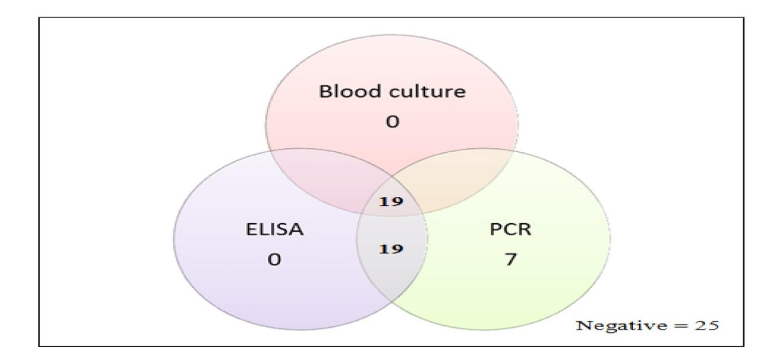
Figure 1. Venn diagram showing number of positive results in each combination of blood culture, ELISA and PCR

Figure 2. Blood culture versus ELISA and PCR in diagnosis of IFI.
Figure 3. PCR using pan-fungal primer
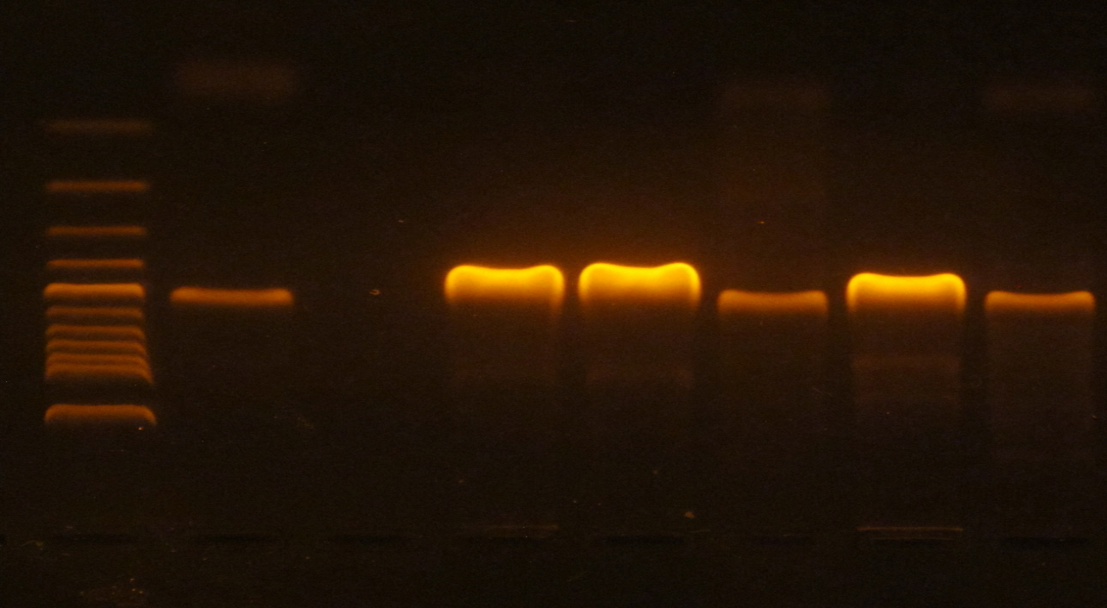
Lane 1: Molecular size marker (50-1500bp) Lane 2: Positive control
Lane 3: Negative case Lane 4: Positive case
Lane 5: Positive case Lane 6: Positive case
Lane 7: Positive case Lane 8: Positive case

Table 2. Blood culture versus ELISA and PCR in diagnosis of invasive fungal infections
 | Blood Culture | ELISA | PCR
Positive No. (%) | 19 (27.1 %) | 38 (54.3 %) | 45 (64.3 %)
Negative No. (%) | 51 (72.9 %) | 32 (45.7 %) | 25 (35.7 %)
Standard error | 0.06 | 0.033 | 0.001
CI 95 % | 0.594 – 0.829 | 0.857 – 0.988 | 1.53 – 1.76
The diagnosis of patients with IFIs in the present study revealed a good agreement between Ag detection test of fungal antigen in serum by enzyme immunoassay and pan-fungal PCR. However, there is moderate agreement between the results of blood culture and Ag detection test. Additionally there is a fair agreement between the results of blood culture and pan-fungal PCR (Table 3).
Table 3: Agreement between Blood culture, ELISA and PCR used for diagnosis of IFIs
Test | Agreement % | Kappa* | P value
Blood culture versus Ag detection test | 69.8% | 0.478 | 0.001
Blood culture versus pan-fungal PCR | 62.9% | 0.343 | 0.001
Ag detection versus pan-fungal PCR | 90% | 0.795 | 0.001
*Kappa-Value: Strength of agreement <0.2: poor 0.2-0.4: fair 0.41-0.6: moderate 0.61-0.8: good 0.81-1.0: very good.

According to EORTC/MSG, 19 patients were proven invasive fungal infection, 38 patients were probable invasive fungal infection and 32 patients were possible invasive fungal infection ( Table 4). PCR is not considered within the EORTC/MSG criteria. A lack of standardization has limited both its acceptance as a diagnostic tool and multicenter clinical evaluations, preventing its inclusion in disease-defining criteria.

Table 4: Classification of cases according to EORTC/MSG criteria
Types of IFIs | No of cases
Proven IFI: Fungemia proven by blood cultures that gave fungal growth | (19)
Probable IFI: Probable IFD needs the presence of three elements to be defined: (1) host factors (2) clinical features; and (3) mycological evidence : indirect serological tests | (38)
Possible IFI: Cases that meet host factor criteria plus a clinical criterion with no mycological evidence. | (32)

Discussion
Invasive fungal infections constitute a serious threat to an ever-growing population of immunocompromised individuals and other individuals at risk (Arvanitis et al., 2014). Blood culture remains the gold standard method for diagnosis of invasive fungal infection although; the sensitivity of blood culture is controversial. Multiple or repeated blood cultures should be performed to increase the likelihood of detecting fungemia. Fungemia is rarely present in healthy individuals, however it is commonly found in hospitalized patients, especially those with multiple risk factors such as cancer patients.
Candida albicans was the most common causative agent in 36.8% of all case. Non albicans Candida species including C. krusei, C. tropicalis, C. parapsilosis, and C. guilliermondii accounted for 63.2% of nosocomial candidemia. C. guilliermondii is rarely isolated in fungemia cases, but it is emerging as a cause of candidemia in cancer patients (De Carvalho Parahym et al., 2009). The increased rate of C. krusei, C. guilliermondii and C. ciferrii species isolation from blood culture over the recent years is of concern as serious health problem because these species are known to be drug-resistant (Aydemir et al., 2017).
Our results are consistent with the studies done by Ding et al. (2015), Sharma et al. (2017) and Akgun et al. (2018) in which non albicans Candida species have been recovered from blood cultures with increased frequency.
Serological tests for detection of fungal antibodies can be difficult to interpret. For example, circulating antibodies to Candida may occur as a result of commensal colonization of mucosal surfaces, antibody production in the immuno-compromised patient varies according to immune status and false negative results occur. However, the antigen detection tests are more significant for diagnosis because they detect active infection. Β-D-glucan (BDG) can be detected in invasive infections as a cell wall component of many pathogenic fungi. It is included as mycological criterion in the revised definitions of IFI from the EORTC/MSG consensus group (De Pauw et al., 2008).
PCR assay for the detection of fungal nucleic acids appear to be a promising diagnostic technique. Many studies show a tendency of PCR methods to detect fungal DNA in patients at high risk of IFI with negative blood culture. The detection of non-cultivable cells and circulating free fungal DNA by PCR, unlike in culture which needs viable cells. Wagner et al. (2018) mentioned that the ability of pan-fungal PCR assays to detect a wide spectrum of fungi which is clearly an advantage. Conversely, amplification of contaminating fungal nucleic acids present in the environment or laboratory can be a drawback.
Comparing the results of different methods used for diagnosis of IFIs, 19 cases (27.1%) were positive blood culture. This number increases to 38 (54.3%) by the use of Ag detection test and further increase to 45 (64.3%) cases out of the examined 70 patients by pan-fungal PCR. Accordingly, ELISA can detect all the blood culture positive cases and 22 of the blood culture negative cases. These results are coincident with the work of Azab et al. (2015) in which 24.1% of patients were positive by blood culture increased to 51.9% of cases by the use of Ag detection test and further increased to 59.5% by pan-fungal PCR, with statistically significant difference. In a similar study by Nguyen et al. (2012) BDG and PCR results were both significantly more positive than blood cultures (62% and 88% vs 17%).
The diagnosis of patients with IFIs in the present study revealed a good agreement between Ag detection test of fungal antigen in serum by enzyme immunoassay and pan-fungal PCR. However, there is moderate agreement between the results of blood culture and Ag detection test. Additionally there is a fair agreement between the results of blood culture and pan-fungal PCR. In accordance with our results A meta-Analysis by Lehrnbecher et al. (2016) detected a very good agreement between the two non-culture based methods (PCR and ELISA).
Invasive fungal infections in our study were defined using revised EORTC/MSG Consensus Group criteria, and according to these criteria we found that 19 cases were classified as proven IFI, serological tests suggested probable invasive fungal infection in 49 patients whereas 70 cases were possible invasive fungal diseases. All the 38 proven/probable cases were positive by the pan-fungal PCR assay, and of the 32 possible cases, only 7 turned to be positive by the pan-fungal PCR assay. A study by Landlinger et al. (2010) had focused on the correlation between PCR positive patients and the presence of proven, probable, and possible criteria of IFI according to the EORTCMSG criteria; in his study, all proven, probable IFI, and one case with possible IFI were PCR positive.

Invasive fungal infections are better diagnosed by molecular assay due to the presence engulfed fungi within circulating phagocytes. Also, the time factor could offer another explanation for the observed differences in the results of blood culture and PCR. Concerning time taken by each method, blood culture method took the most time (up to 2 weeks) while PCR took the least time (2- 3 hours).
Conclusion
It was concluded that conventional diagnostic tests such as histology, microscopy, and culture remain the cornerstone of proving the presence of fungal disease, however they are slow and lack the desired sensitivity and specificity. While rapid diagnostic techniques such as ELISA and PCR offer an accurate and reproducible tool for early diagnosis and identification of fungal pathogens. It is important to consider standardization of fungal PCR so it can be included in the diagnostic criteria of invasive fungal diseases.
Acknowledgments
The authors would like to thank the Clinical microbiology staff of Mansoura Oncology Center for providing facilities to this work.

Corresponding author:
Dr Mohamed Elshaer.
Lecturer assistant of Clinical Pathology
El-Gohmouria Street, Mansoura university post.
Tel: +21020480202.
Email: M_y_s_1985@outlook.com.

References
- Krishnan NS, Emerging Fungal Infections in Cancer Patients- A Brief Overview. Med Mycol Open Access. 2016; 2: 16. Doi: 10.21767/2471-8521.100016.
- Hammond SP, Marty FM, Bryar JM, DeAngelo DJ, and Baden LR, Invasive fungal disease in patients treated for newly diagnosed acute leukemia. Am J Hematol. 2010; 85(9): 695-699. Doi: 10.1002/ajh.21776.
- Pagano L, Caira M, Candoni A, Offidani M, Martino B, Specchia G, et al., Invasive aspergillosis in patients with acute myeloid leukemia: a SEIFEM-2008 registry study. Haematologica. 2010; 95(4): 644-650. Doi: 10.3324/haematol.2009.012054.
- Ruhnke M and Schwartz S, Recent developments in the management of invasive fungal infections in patients with oncohematological diseases. Ther Adv Hematol. 2016; 7(6): 345-359. Doi:10.1177/2040620716656381.
- Cuenca-Estrella M, Bernal-Martinez L, Buitrago MJ, Castelli MV, Gomez-Lopez A, Zaragoza O, et al., Update on the epidemiology and diagnosis of invasive fungal infection. International Journal of Antimicrobial Agents. 2008; 32: S143-S147. Doi: 10.1016/S0924-8579(08)70016-5.

- Azab MM, Abo Taleb AF, Mohamed NAE and Omran FH, Rapid diagnosis of invasive fungal infections. Int J Curr Microbiol App Sci. 2015; 4: 470–486.
- Ribeiro P, Costa F, Monteiro A, Caldas J, Silva M, Ferreira G, et al., Polymerase chain reaction screening for fungemia and/or invasive fungal infections in patients with hematologic malignancies.Support Care Cancer. 2006; 14(5): 469-474. Doi: 10.1007/s00520-005-0903-7.
- Arvanitis M, Anagnostou T, Fuchs BB, Caliendo AM, and Mylonakis E, Molecular and non-molecular diagnostic methods for invasive fungal infections. Clin Microbiol Rev. 2014; 27(3): 490-526. Doi: 10.1128/cmr.00091-13.
- De Carvalho Parahym, AM, LR De Melo, VL De Morais, and RP Neves, Candidiasis in pediatric patients with cancer interned in a university hospital. Braz J Microbiol. 2009; 40(2): 321-324. Doi: 10.1590/s1517-838220090002000020.
- Aydemir Ö, Demiray T, Köroglu M, Aydemir Y, and Altindi M, Emerge of non-albicans Candida species; evaluation of Candida species and antifungal susceptibilities according to years. Biomedical Research. 2017; 28(6).
- Ding X, Yan D, Sun W, Zeng Z, Su R and Su J, Epidemiology and risk factors for nosocomial Non-Candida albicans candidemia in adult patients at a tertiary care hospital in North China. Med Mycol. 2015; 53(7): 684-90. Doi: 10.1093/mmy/myv060.
- Sharma Y, Chumber SK and M Kaur, Studying the Prevalence, Species Distribution, and Detection of In vitro Production of Phospholipase from Candida Isolated from Cases of Invasive Candidiasis. J Glob Infect Dis. 2017; 9(1): 8-11. Doi: 10.4103/0974-777x.199995.
- Akgun S, Sayiner HS, and Kayali S, Distribution of Candida Species Isolated from Blood Cultures Over a Period of Four Years. Eurasian Journal of Medical Investigation. 2(1): 35-39. Doi: 10.14744/ejmi.2018.68077.
- De Pauw B, Walsh TJ, Donnelly JP, Stevens DA, Edwards JE, Calandra T, et al., Revised Definitions of Invasive Fungal Disease from the European Organization for Research and Treatment of Cancer/Invasive Fungal Infections Cooperative Group and the National Institute of Allergy and Infectious Diseases Mycoses Study Group (EORTC/MSG) Consensus Group. Clinical Infectious Diseases. 2008; 46(12): 1813-1821. Doi: 10.1086/588660.
- Wagner K, Springer B, Pires VP, and Keller PM, Molecular detection of fungal pathogens in clinical specimens by 18S rDNA high-throughput screening in comparison to ITS PCR and culture. Scientific Reports. 2018; 8(1): 6964. Doi: 10.1038/s41598-018-25129-w.
- Nguyen MH, Wissel MC, Shields RK, Salomoni MA, Hao B, Press EG, et al., Performance of Candida Real-time Polymerase Chain Reaction, β-D-Glucan Assay, and Blood Cultures in the Diagnosis of Invasive Candidiasis. Clinical Infectious Diseases. 2012; 54(9): 1240-1248. Doi: 10.1093/cid/cis200.
- Lehrnbecher T, Robinson PD, Fisher BT, Castagnola E, Groll AH, Steinbach WJ, et al., Galactomannan, beta-D-Glucan, and Polymerase Chain Reaction-Based Assays for the Diagnosis of Invasive Fungal Disease in Pediatric Cancer and Hematopoietic Stem Cell Transplantation: A Systematic Review and Meta-Analysis. Clin Infect Dis. 2016; 63(10): 1340-1348. Doi: 10.1093/cid/ciw592.
- Landlinger C, Preuner S, Baskova L, van Grotel M, Hartwig NG, Dworzak M, et al., Diagnosis of invasive fungal infections by a real-time panfungal PCR assay in immunocompromised pediatric patients. Leukemia. 2010; 24(12): 2032-2038. Doi: 10.1038/leu.2010.209.

12/15/2022

