**Performance, Serum Biochemical And Haematological Response Of Broiler Chicken Fed Mixture Of Ginger (Zingiber Officinale) And Garlic (Allium Sativum) In Diets**

1Umoru, J. I. A. and 2Agbaye F. P.

1Federal College of Education (Technical) Akoka, Lagos

2Lagos State Polytechnic, Ikorodu, Lagos.

**Abstract:** Performance, serum biochemical and haematological response of broiler chicken fed mixture of ginger (Zingiber officinale) and garlic (Allium sativum) in diets was investigated in a feeding trials using completely randomised design that lasted for eight weeks. A total of 135 1-day broiler chicks of Abor acre strain were randomly allotted to three dietary treatments of 45 chicks per treatment and replicated 15 chicks per treatment Three isocaloric and isonitrogenous diets were formulated and fed. Control diet was without mixture of ginger and garlic. The two other diets were T1 7.5g Ginger plus 7.5g Garlic mixture/25 kg diet and T2 15g Ginger plus 15g Garlic mixture/25 kg diet. The experimental diets were offered to the respective birds with water ad libitum. The body weight gain (Kg) feed intake and feed conversion ratio (FCR) of birds control, T1 and T2 respectively were similar (p> 0.05). Birds on diet. T2 recorded the highest live ability percentage (96 Mixture of ginger and garlic in ratio 1:1 up to 7.5 g each in 25 kg diets slightly but insignificantly (p>0,05) increased performance body weight gain and live ability improved feed conversion ratio (FRC) but reduced feed intake. Variation in the experimental diets had no significant (p>0.05) difference on serum biochemical and haematological indices except for Glucose and Alkaline Phosphate, and White Blood Cell count Lymphocytes and Basophil which showed significant (p<0.05) difference with the level mixture of ginger and garlic ip diets. Mixture of ginger and garlic in the diets of broiler chicken had no adverse effect on the serum biochemical and haematological indices.

[Umoru, J. I. A. and Agbaye F. P. **Performance, Serum Biochemical And Haematological Response Of Broiler Chicken Fed Mixture Of Ginger (Zingiber Officinale) And Garlic (Allium Sativum) In Diets**. Cancer Biology 2022;12(1):8-12]. ISSN: 2150-1041 (print); ISSN: 2150-105X (online). <http://www.cancerbio.net>  [2.doi](http://www.sciencepub.net/nature.%20%20x.doi):[10.7537/marscbj120122.02.](http://www.dx.doi.org/10.7537/marscbj120122.02)

**Keywords:** performance body weight, serum biochemical and haematological indices, Allium sativum, Zingiber officinale

**Introduction**

In pursuit of improved broilers health and in order to fulfill consumer expectation in relation to food quality, poultry farmers include natural herbal materials in the diet of their stock (Gardzielewska *et al*; 2003). The use of blood examination to assess physiological, Brea pathological, and nutritional and health status animals have been well documented (Muhammed *et al*. 2004). The routine collection and processing of blood samples allow the evaluation of serum biochemical and haematological response to nutrition and disease (Howlet and Jaime, 2008). Blood examination can be used to detect nutritional disorder since it provide information on animal health, nutritional deficiency and changes in growth with time. The nutritional value of diets could be a reflection through changes in performance, serum biochemical and haematological indices animal base on treatment effects. Ginger, (Z*ingiberofficinale Zingbeacea*) and Garlic, Allium sativum, (*Liliaceae)* are herbal materials with good nutritional and medicinal properties. The plants and their extract possess antioxidant, anticancer, immune-modulatory, anti-inflammatory hypoglycaemic, antifungal, antiviral, anti-dental caries and cardiovascular effects (Gbenga *et al*., 2009). Previous study has demonstrated positive effects of herbal materials on the performance, serum biochemical and haematological indices of birds (Iskiwenu *et al*. 2008). In the present study, mixture of ginger and garlic was added to broiler diets in two graded levels to evaluate effects on the performance, serum biochemical and haematological indices.

**Materials and Methods**

This study was carried out at Teaching Farm, Department of Agricultural Education, Federal College of Education (Technical) Akoka-Yaba Lagos. A total of 135 1-day broiler chicks of Abor acre strain (45 chicks per treatment and 15. chicks per replicate), reared in an open-sided deep litter pen previously cleaned, disinfected fumigated and covered with wood shavings to 5 m depth before their arrival. The chicks on arrival were allowed to adapt to their new environment for 7 days in order to reduce variation in performance due to hatchery and t high mortality due to treatment effects. The test materials, ginger and Garlic were purchased from the open markets in Lagos metropolis, rinsed using distilled water, sundried for 5 days and blended using an electric Mortal & Pestle miller (Model MR 200 Pascall) into powdered form. The "milled powdered materials was packed inside transparent polythene bags and added broiler starter and finisher diets in ration 1:1 of ginger and garlic. Dietary treatments. were T: 7.5g ginger plus 7.5g garlic/25kg diet and T.: 15g ginger plus 15g garlic/25kg diet. The gross composition of starter and finisher diets are shown in Table 1. The birds were allotted to the two treatment groups in a completely randomized design with three replicates per group containing 15 birds each. The experimental diets were made. isonitrogenous and isocaloric. Recommended vaccination and medication schedules from the hatchery were strictly observed. Starter diets was fed for 4weeks (0-4weeks) and finisher 4weeks (5-8weeks). Experimental diets water was provided ad-libitum throughout 52 days of the study. Body weight changes and feed intake were measured on weekly basis to determine body weight gain and feed conversion ratio. At the end of week 8 of feeding trials, two (2) birds from each dietary treatment per replicate were randomly sampled to determine serum biochemical and haematological responses. 5ml samples of blood were taken from the wing vein of randomly sampled birds from each dietary treatment per replicate. 2.5ml of the sampled blood was put in labeled Sterile Universal Bottles containing anti-coagulant (Ethyl Diamine-Tetra-Acetate powder (EDTA)) to determine haematological indices. aematological indices such as Packed Cell Volume (PCV) (56), Red Blood Cells (RBC) (T/L) and White Blood Cells (WBC) (G/L), Haemoglobin (g/1), Neutrophils (%), Basophils (%), Lymphocytes (9), Eosinophil (%). Monocytes (6), Mean Corpuscular Volume (MCV) (1), Mean Corpuscular Haemoglobin (MCH) (pg) and Mean Corpuscular Haemoglobin Concentration (MCHC) (g/dl) according to the procedure of Jaime and Howlett (2008). The remaining 2.5ml of the sampled blood was put in labeled Sterile Universal Bottles without anti-coagulant to: determine serum biochemical indices such as Total Protein (mg/dl), Albumin (g/dl), Alkaline Phosphate (ALP) (u/l) and Ureic acid (mg/dl) and Glucose (mg/dl). Data obtained were subjected analysis of variance and significant means were separated using statistical package ASSISTAT Version 7.7 beta (2013).

**Results and Discussion**

The composition and calculated analysis of starter and finisher diets are shown in Table 1. The crude protein and metabolizable energy content diets respectively were within the range recommended by Oluyemi and Robert (2000).

**Table 1: Gross Composition of Starter and Finisher Diets**

|  |  |  |
| --- | --- | --- |
| **Feed Ingredients** | **Starter Diet** | **Finisher Diet** |
| Maize | 46.71 | 61.00 |
| Soybean meal | 21.29 | 17.00 |
| Groundnut cake | 15.00 | 12.00 |
| Fish meal (72%) | 3.00 | 2.00 |
| Wheat offal | 10.00 | 4.00 |
| Di-calcium Phosphate | 1.70 | 1.70 |
| Limestome | 1.20 | 1.30 |
| Lysine | 0.25 | 0.25 |
| Methionine | 0.25 | 0.25 |
| Broiler Premix | 0.25 | 0.25 |
| Salt | 0.25 | 0.25 |
| **Total** | **100.00** | **100.00** |
| Calculated Analysis |  |  |
| Metabolizable Energy (kcal/kg) | 2713.41 | 2918.76 |
| Crude Protein (%) | 24.00 20.37 |  |

The effect of mixture of ginger and garlic in diets on the body weight development of broiler. chicken is presented in Table 2. The final mean body weight gain and feed intake (kg) and feed conversion ratio (FCR) values (kg)for birds on control, T1 and T2 diets respectively were similar (p>0.05). Inclusion of mixture of 7.5g ginger plus 7.5 g garlic mixture 25 kg diet slightly increased body weight gain of birds. Bird fed. 15g ginger plus 15g garlic mixture/ 25kg diets had the lowest body weight gain due to higher level the mixture. Broiler chicken fed control diets increased in weekly body weight gain rapidly between 4th and 6th week, and decline from week 7 Birds fed T1 and T2 diets steadily increase in weekly body weight gain behind those fed control diet (See Fig. 1). The differences in weekly body weight gain could be attributed probably to high fiber and some anti nutritional factor in the mixture of ginger and garlic included in the diets. The increasing positive beneficial growth potential of birds on T1 and T2 diets could possibly due to improvement in feed digestion, additive. advantage of nutrients and anti-microbial property of the mixture of ginger and garlic in the diets (Tekeli et al., 2008; Gbenga et al., 2009). Mortality was moderate and evenly spread. ranging from 9-4 percent. Birds on diet T, survived the most (96% live ability) suggestive of the advantage of the antibiotic property of mixture of ginger and garlic in the diets.

**Table 2 body weight of broiler chicken fed mixture of ginger and garlic in diet**

|  |  |  |  |  |
| --- | --- | --- | --- | --- |
| **Parameters** | **Control** | **T1** | **T2** | **SEM** |
| Initial weight (g) @ 2nd week | 0.17 | 0.16 | 0.18 | 0.01 |
| Final weight (kg) | 2.02 | 2.06 | 1.92 | 0.91 |
| Weight gain (kg) | 1.85 | 1.90 | 1.74 | 0.07 |
| Feed intake (kg) | 4.77 | 4.22 | 4.02 | 0.32 |
| Feed conversation ratio (feed/weight) | 2.70 | 2.22 | 2.31 | 0.21 |
| Live ability | 91.00 | 96.00 | 92.00 | 1.49 |

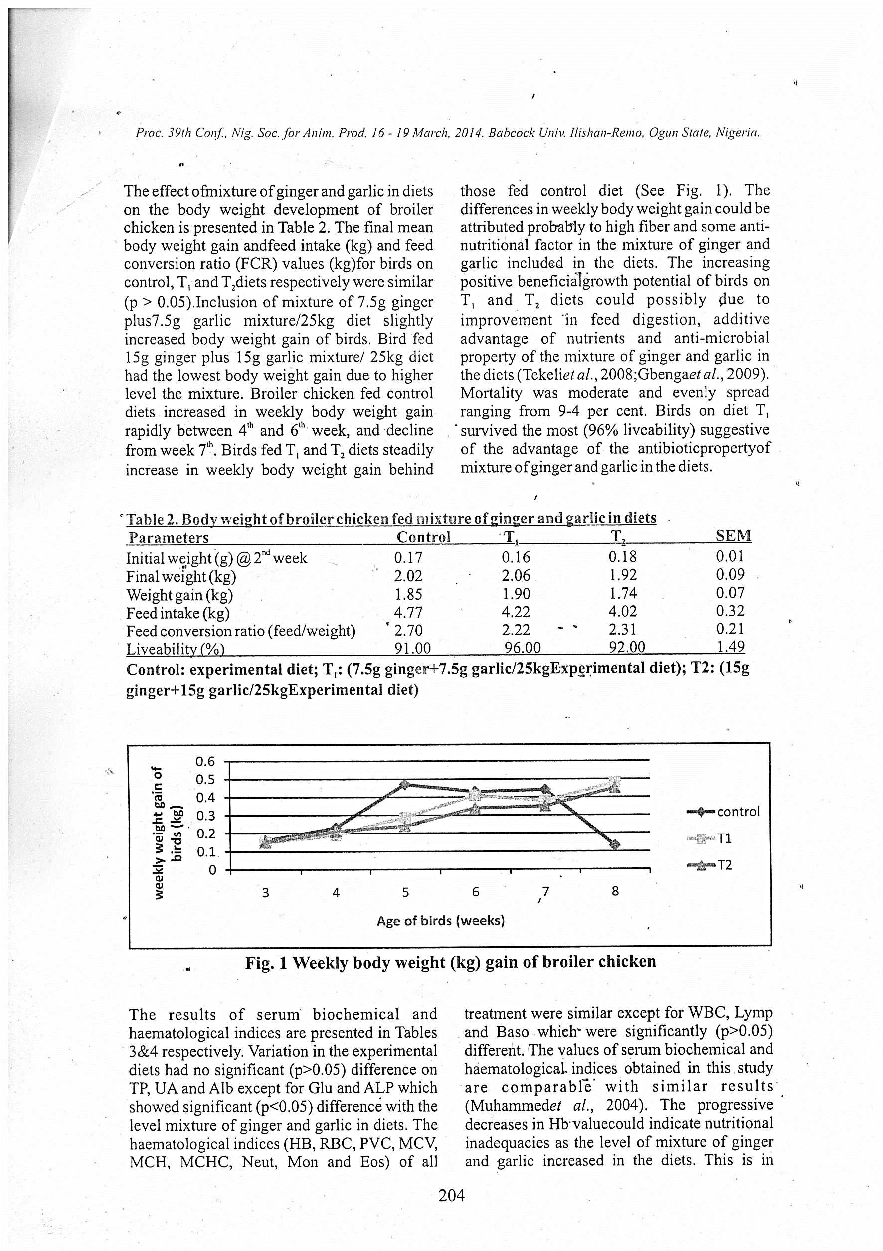**Control: experiential diet T1: (7.5g ginger + 7.5g garlic/25kg experimental diet); t2: (15g ginger+15g garlic/25kg experimental diet**

**Fig. 1 weekly body weight (kg) gain of broiler chicken**

The results of serum biochemical and haematological indices are presented in Tables 3&4 respectively. Variation in the experimental diets had no significant (p>0.05) difference on TP, UA and Alb except for Glu and ALP which showed significant (p<0.05) difference with the level mixture of ginger and garlic in diets. The haematological indices (HB, RBC, PVC, MCV, MCH. MCHC, Neut, Mon and Eos) of all treatment were similar except for WBC, Lymp and Baso which were significantly (p>0.05) different. The values of serum biochemical and haematological indices obtained in this study are comparable with similar results (Muhammed et al., 2004). The progressive decreases in Hb value could indicate nutritional inadequacies as the level of mixture of ginger and garlic increased in the diets. This is in agreement with the decreased feed intake of bird as mixture of ginger and garlic increased in the diets. the nutrient intake restriction effect of decreased voluntary feed intake may have result in the deficiency of blood nutrient composition.

**Table 3. serum biochemical indices of broiler chicken fed mixture of ginger and garlic in diet**

|  |  |  |  |  |
| --- | --- | --- | --- | --- |
| **Parameters** | **Control** | **T1** | **T2** | **SEM** |
| T P (g/dl) | 32.81 | 37.90 | 35.27 | 1.47 |
| Glu (mg/dl) | 213.93 | 290.91 | 228.85a | 23.57 |
| UA (mg/dl) | 6.27 | 5.22 | 7.00 | 0.52 |
| ALB | 2.32 | 1.59 | 1.48 | 0.26 |
| ALP (u/l) | 1134.36 | 1450.38 | 1261.32a | 91.81 |

a.b Means with different superscripts in the same row are significantly (p<0.05) different. TP-Total protein, Glu Glucose, UA-Uric Acid, Alb-Albumin, ALP-Alkaline phosphate

The similarity of the PCV values obtained indicates that the treatment had no adverse: effect on the blood level and birds were not anaemic RBC values were similar for all treatment and shows that the blood level and immunity status of birds were not negatively affected by experimental diets. However, WBC values significantly (p> 0.05) increased with increasing level of mixture of ginger and garlic in diets. The values of RBC and WBC obtained in this study are comparable with those reported by Iskiwenu et al. (2008) and are within the normal range values Variation in the level of mixture of ginger and garlic in the diets had no significant (p>0.05) on serum biochemical (TP. UA and Alb) and haematological (HB, RBC, PVC, MCV, MCH, MCHC, Neut, Mon and Eos) indices. This is an indication that mixture of ginger and garlic in diets does not contain factors that are deleterious to the normal blood formation, and does not impart negatively on the physiological, pathological and nutritional status of broiler chicken.

**Table 4 haematological indices of broiler chicken fed mixture of ginger and garlic in diets**

|  |  |  |  |  |
| --- | --- | --- | --- | --- |
| **Parameters** | **Control** | **T1** | **T2** | **SEM** |
| (Hb) gl) | 75.00 | 71.42 | 51.44 | 7.33 |
| RBC (T/L) | 2.55 | 2.45 | 1.65 | 0.29 |
| WBC (G/L) | 16.16 | 23.24 | 19.60 | 2.04 |
| PCV (%) | 22.50 | 21.50 | 15.50 | 2.19 |
| MCV (f/l) 88.19 | 87.96 | 104.50 | 5.48 |  |
| MCH (pg) 29.48 | 29.23 | 34.70 | 1.80 |  |
| MCHC (g/dl) | 333.38 | 332.213 | 32.22 | 0.39 |
| Neut (%) | 43.00 | 32.50 | 31.00 | 3.78 |
| Lymp (%) | 46.00 | 62.50 | 62.50 | 5.50 |
| Mon (%) | 6.50 | 3.50 | 4.00 | 0.93 |
| Eos (%) | 3.00 | 1.50 | 2.50 | 0.44 |
| Baso (%) | 1.50 | 0.00 | 0.00 | 0.50 |

a,b Means with different superscripts in the same row are significantly (p<0.05) different. Hb. - Haemoglobin, RBC-Red Blood Cells, WBC-White Blood Cells, PCV-Packed Cell Volume, MCV-Mean Corpuscular Volume, MCH-Mean Corpuscular Haemoglobin, MCHC-Mean Corpuscular Haemoglobin Concentration, Neut-Neutrophils, Lymp-Lymphocytes, Mon-Monocytes, Eos-Eosinophil, Baso-Basophils.

**Conclusion**

The findings from this study shows that mixture of ginger and garlic (in ratio 1:1) up to 7.5g each in 25kg broiler chicken diets slightly but I insignificantly (p>0.05) increased final body weight performance and live ability, improved feed conversion ratio (FGR) but reduced feed intake. Also, mixture of ginger and garlic at same quantity had no adverse effect on the serum biochemical and haematological indices of broiler chicken.

**REFERENCES**

1. **ASSISTAT Version 7.7 beta (2013)** - Website http://www.assistat.com by Francisco de A.S.e Silva DEAG-CTRN-UFCG Updated on 08/04/2013
2. **GARDZIELEWSKA, J., PUDYSZAK, K.; MAJEWSKA, T: JAKUBOWSKA, M. AND POMIANOWSKI, J (2003)** Effect of plant-supplemented feeding on fresh and frozen storage quality of broiler chicken meat, Electronic J. Polish Agric Univ, 6: 12-12.
3. **GBENGA, O.E.; ADEBISI, O.E.; FAJEMISIN, A.N. AND. ADETUNJI, A.V (2009)** Response of broiler chickens in terms of performance and meat quality to garlic Allium sativum supplementation. Afr J. Agric Res, 4:511-517,
4. **HOWLETT, J. C. AND JAIME, S. (2008)** Avian medicine. Mosly Elevier (2) pp. 46
5. **ISKIWENU, J. O., OMEJE, S. I... OKAGBARE, G., AND APODIETE, O. J. (2008)** Effect of replacing groundnut cake with urea fermented brewer's dried grains in broiler chicks' diets. Anim. Res. Int. 5:795 800
6. **MUHAMMED, N. O., OLOYEDE, O. B., OWOYELE, B. O. AND OLAJIDE, J. E. (2004)** Deleterious effect of defatted Terminaliacatappa seed meal-based diets on haematological and urinary parameters of Albino ratNISEPJ.4(2) 51-57
7. **OLUYEMI, J.A. AND ROBERT, F.A. (2000)** Poultry production in the warm wet climate (2Edn), Macmillan Press Ltd, London
8. **TEKELI, A., KUTLU, H.R. CELIK, L. VAR, I. YURDAKUL, E. AND AVCI, A. (2008)** The use of Propolis as an alternative to antibiotic growth promoters in broiler diets. Proceedings of 23rd World's Poultry Congress, June 30-July 4, Brisbane, Australia, pp. 482.

3/22/2022