Role of lincRNA-p21 and lncRNA-H19 in multiple sclerosis disease

Laila M. Meber¹. Olfat G. Shaker². Amr H. El-Sayed ³. Nermien E. Waly, MD, PhD ^{4,5}.

¹ Assistant lecturer, Department of Medical Biochemistry & Molecular Biology, Faculty of Medicine, Helwan University, Ain-Helwan, Cairo, Egypt.
² Professor, Department of Medical Biochemistry & Molecular Biology, Faculty of Medicine, Cairo University, Cairo, Egypt.
³ Professor, Department of Neurology, Faculty of Medicine, Cairo University, Cairo, Egypt.
⁴ Associate Professor, Department of Physiology, Faculty of Medicine, Helwan University, Ain-Helwan, Cairo, Egypt.
⁵ Department of Medical Education, Creighton School of Medicine, Creighton University, Omaha, NE, USA 68178
*Correspondence to: Laila Mahdi Mohamed Meber
Telephone: 01066615134
Email: laila.mahdi@med.helwan.edu.eg, lailamahdi15@yahoo.com

Abstract: Multiple sclerosis (MS) is a chronic immune-mediated central nervous system (CNS) disorder with several environmental and genetic factors. To participate in the regulation of immune responses, long non-coding RNAs (lncRNAs) have recently been published. As a result, aberrant expression of lncRNAs has been proposed as an underlying cause of MS. In the current research, by means of quantitative real-time polymerase chain reaction (PCR), we assessed the expression levels of two lncRNAs with putative functions in the regulation of immune response, namely lncRNA-H19 and lincRNA-p21, in serum of 74 Egyptian patients with MS relative to healthy people. Significant down regulation of lncRNA-H19 and lincRNA-P21 expression levels relative to controls in the serum of MS patients was observed (P < 0.001). Correlation analyses of lncRNA expression levels and MS patient clinical data showed a substantial moderate positive linkage among lincRNA-p21 serum expression levels and the Expanded Disability Status Scale (EDSS), a substantial moderate negative linkage among lncRNA-H19 expression levels and MS onset age and no substantial correlation among these lncRNAs and patient age. Furthermore, we showed no significant correlation among lncRNA-H19 and lincRNA-p21 serum expression levels. In brief, in MS patients, we have shown dysregulation of two lncRNAs. To explore the precise mechanisms through which lncRNAs engage in the regulation of immune responses, more studies are required.
[Laila M. Meber. Olfat G. Shaker. Amr H. El-Sayed. Nermien E. Waly, MD, PhD,. Role of lincRNA-p21 and lncRNA-H19 in multiple sclerosis disease. Cancer Biology 2020;10(4):7-15]. ISSN: 2150-1041 (print); ISSN: 2150-105X (online). http://www.cancerbio.net. 2. doi:10.7537/marscbj100420.02.

Key words: Multiple sclerosis, LncRNA-H19, LincRNA-p21.

Introduction
Complex diseases arising from the interaction among environmental and genetic factors over time are autoimmune diseases. A large variety of diseases, including rheumatoid arthritis (RA), systemic lupus erythematosus (SLE) and multiple sclerosis (MS), are autoimmune diseases (Wu et al., 2015). MS is a central nervous system (CNS) autoimmune chronic inflammatory disease. It is commonly approved that susceptibility to MS depends on a combination of genetic and environmental factors and their interactions (Koriem, 2017).
Non-protein coding RNA transcripts that are greater than 200 nucleotides in length are long non-coding RNAs (lncRNAs) (Geng and Tan, 2016; Cao et al., 2019). LncRNAs have been found to play important roles in many diseases such as cancer, Alzheimer’s disease, cardiovascular diseases, diabetes mellitus, RA and SLE (Zhang et al., 2017; Dangelmaier et al., 2019).
In MS patients, a number of lncRNAs was shown to be dysregulated (Mazdeh et al., 2019). Concerning MS as a common autoimmune disease and leading to the immune control and pathogenesis of other autoimmune diseases such as SLE and RA by lncRNAs, an increasing number of research groups have identified lncRNAs that can predict the disease activity and its progression (Geng and Tan, 2016; Yarani et al., 2018). To today, MS diagnosis is dependent on clinical evidence. However, early signs
of MS may be nonspecific in many cases. MRI will aid in the diagnosis, but the detection of MS would be much more straightforward and inexpensive with a simple specific lab test. As they are simple to acquire, stable, fast to identify by popular molecular biology techniques (e.g. real-time quantitative PCR), quantifiable, cost-effective, and tissue/disease specific, LncRNAs have proved to be useful diagnostic biomarkers of different diseases (Yang et al., 2018).
LncRNA-H19 is an imprinted gene which is expressed only by the maternal allele, located on chromosome 7 in mice and chromosome 11 in humans (Bhan and Mandal, 2014; Liu et al., 2017). Several studies showed that H19 is related to several malignancies. It is one of the lncRNAs with a putative role in regulating of immune response (Safari et al., 2019). Of interest, H19 has been found to play an important role in RA (Stuhlmüller et al., 2003).
Long RNA-p21 intergenic noncoding (lincRNA-p21) is found in mice on chromosome 17 and chromosome 6 in human. It regulates apoptosis in response to p53 signaling. It is implicated in the development and progression of human diseases, particularly in cancer (Tang et al., 2015; Chillón and Pyle, 2016). Interestingly, it was revealed that lincRNA-p21 is correlated with RA by suppressing the activation of the signaling pathway of the nuclear factor kappa-B (NF-κB) (Spurlock et al., 2014).
In the present study, we investigate serum expression levels of lncRNA-H19 and lincRNA-p21 in 74 Egyptian patients with MS to explore their role as new convenient diagnostic biomarkers and/or therapeutic targets for MS.

Materials and methods
Study Population
This case-control research was conducted on 134 participants, 74 of whom were infected with MS, selected from the Multiple Sclerosis Unit-Cairo University Hospital of Kasr Al-Ainy, and 60 age-and sex-matched healthy controls without clinical evidence, or family history of MS or any other autoimmune disorders. A written informed consent was provided by all participants (patients and controls). This research was reviewed and accepted by Ethical Committee at Faculty of Medicine, Cairo University "Ethical Code I-201016". It was accomplished in compliance with the World Medical Association Code of Ethics (Declaration of Helsinki) for human-related experiments. Inclusion criteria for both groups were age more than 18 years. Patients with RRMS and SPMS met the 2010 revised McDonald's criteria for diagnosis of MS (Polman et al., 2011). We exclude pregnant females, patients who have chronic infectious disease or recent infection within month, patients on steroid therapy, and patients with history of other autoimmune diseases or cancer.
The following steps were done for all study subjects:

Table (1): Study subjects' demographic and clinical characteristics:
Variables |  | MS patients (n=74) |  | Control (n=60)
Age [years] Mean ± standard deviation (SD) |  | 32.5±8.1 |  | 30.2±8.9
 |  | Count | % | Count | %
Gender | Female | 62 | 83.8% | 48 | 80.0%
 | Male | 12 | 16.2% | 12 | 20.0%
Family history | Yes | 4 | 5.4% | ----- | -----
 | No | 70 | 94.6% | ----- | -----
MS Type | RRMS | 54 | 73.0% | ----- | -----
 | SPMS | 20 | 27.0% | ----- | -----
Initial presentation | Optic neuritis | 24 | 32.4% | ----- | -----
 | Weakness | 30 | 40.5% | ----- | -----
 | Sensory symptoms | 10 | 13.5% | ----- | -----
 | Ataxia | 10 | 13.5% | ----- | -----
EDSS | EDSS=1-3 | 40 | 54.1% | ----- | -----
 | EDSS=3.5-5 | 14 | 18.9% | ----- | -----
 | EDSS≥5.5 | 20 | 27.0% | ----- | -----
Treatment | Interferon | 40 | 54.1% | ----- | -----
 | Azathioprine | 12 | 16.2% | ----- | -----
 | Cyclophosphamide (Endoxane) | 4 | 5.4% | ----- | -----
 | No treatment  (Drug naiive) | 18 | 24.3% | ----- | -----

(1) General clinical examination and taking full medical history. (2) Neurological examination and evaluation of the clinical disability of MS patients using the expanded disability status scale (EDSS). The patients have been ranked according to EDSS into 3groups, (EDSS= 1.0–3.0), (EDSS= 3.5–5) and (EDSS ≥ 5.5) (Kurtzke, 1983). (3) Samples of whole blood (5ml) were begun taking and the serum was separated. Table (1) shows the demographic and clinical data of the study participants.
Detection of Long Non-Coding RNA in MS Patients Serum
Total RNA was extracted using the miRNeasy mini kit (Qiagen, Valencia, CA, USA) from serum as directed by the manufacturer. Using the NanoDrop®-1000 spectrophotometer (NanoDrop Technologies, Inc. Wilmington, USA), RNA samples were subjected to RNA quantitation and purity evaluation. Extracted RNA was subjected to complementary DNA (cDNA) synthesis by reverse transcription (RT) usage of the first strand kit RT2 (Qiagen, Valencia, CA, USA) in compliance with the instructions of the manufacturer. The RT reaction was done as follows; the reverse-transcription master mix was prepared. For each tube containing the reverse-transcription master mix, template RNA was added. Gentle mixing was done with centrifugation. Incubation was done for 60 min at 37ºC using conventional PCR. Incubation for 5 min at 95ºC was done to inactivate RT² first strand reverse transcriptase using conventional PCR.
Real-time qPCR was performed using RT² qPCR Sybr Green/Master Mix kit and RT² lncRNA qPCR primer assays for lncRNA-H19, lincRNA-p21 and GAPDH (used as reference gene). All these kits were purchased from (Qiagen, Valencia, CA, USA) with catalog no. of lncRNA-H19; LPH01147A-200, catalog no. of lincRNA-p21; LPH42417A-200 and catalog no. of GAPDH; QT00079247. Reaction mix was prepared for a 20 μl per well reaction volume. The real-time thermocycler Rotor-gene Q System (Qiagen, USA) has been programmed in accordance with table (2).

Table (2): The real-time thermocycler programming:
Step | Time | Temperature | Additional Comments
Initial activation step (holding step) | 10 min | 95ºC | HotStar Taq DNA Polymerase is activated by this heating step
2-step cycling (45cycles):  Denaturation  Annealing and Extension | 15 s  60 s | 95ºC  60ºC | Perform fluorescence data collection.

To ensure the specificity of the related PCR reactions, a melt curve analysis was performed. For data analysis, the Cycle Threshold (CT) values are exported to an Excel file and submitted to the RT2 PCR Array data analysis web portal at https:/www.qiagen.com/dataanalysiscenter, indicating the fractional cycle number at which the quantity of amplified target reaches a fixed threshold. Using the data analysis of web portal, Using the 2−∆∆CT method for relative quantification, fold change was calculated in which ΔCT was calculated among the gene of interest and the average reference gene, accompanied by ΔΔCT calculations [ΔCT (patient)-ΔCT (control)]. Fold change was then calculated using 2^{-ΔΔCT} formula (Livak and Schmittgen, 2001). Values of fold change greater than 1 indicate positive or up-regulation, and fold-regulation is equal to the fold change. A negative or down-regulation is indicated by fold change values less than 1 and the fold regulation is the negative inverse of the fold-change (Santoro et al., 2016).
Statistical Analysis:
Data were coded and entered using version 25 of the Statistical Package Social Sciences (SPSS). Data was presented in quantitative data using mean, standard deviation, median, minimum and maximum, and in categorical data using frequency (count) and relative frequency (percentage). The non-parametric Kruskal-Wallis and Mann-Whitney tests were used to compare quantitative variables (Chan, 2003a). The Chi square test was carried out to compare categorical data (Chan, 2003b). Correlations among quantitative variables were achieved using the correlation coefficient of Spearman (Chan, 2003c). The ROC curve (receiver operating characteristic) was constructed with area under curve (AUC) analysis to detect the best cutoff value of case detection markers (Hoo et al., 2017). P-values of less than 0.05 have been deemed statistically substantial.
Results
Relative expression levels of lncRNA-H19 and lincRNA-P21 were found to be significantly down-regulated in serum samples of MS patients compared to control group; (p-value = 0.024 and 0.020, respectively).
The distribution of serum relative expression levels of lncRNA-H19 and lincRNA-p21 was described by box plot (Figures 1 and 2, respectively). Each box plot displays the relative expression values of each gene according to the 2^{−ΔΔCT} method (Y-axis) by group (X-axis). The data are presented as the median and inter-quartile range (IQR). The bold black line in the box reflects our data's median value. The entire box represents the IQR. The bars across the boxes show the minimum and maximum values. Circles and asterisks indicate values (outliers) falling beyond the statistical distribution of the related variables, serum lncRNA-H19 and lincRNA-p21respectively.

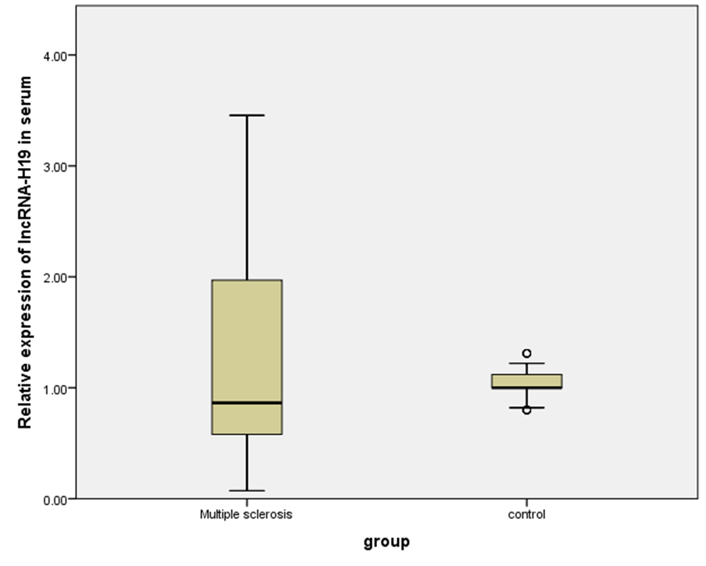
Figure (1): Box plot diagram of serum relative expression levels of lncRNA-H19 in MS patients compared to control group; circles indicate outliers.

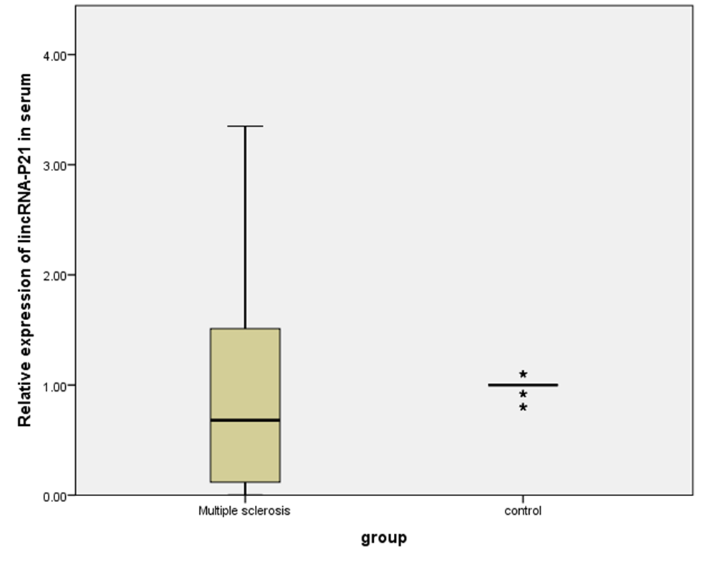

Figure (2): Box plot diagram of serum relative expression levels of lincRNA-p21 in MS patients compared to control group; asterisks indicate outliers.

When we demonstrated serum relative expression levels of lncRNA-H19 based on different variables among MS patients we found that; as regard to sex of patients, male patients had significant higher expression levels compared to female patients (p-value= 0.008). Meanwhile, no statistically significant difference was found regarding other variables.
LincRNA-p21 had significant higher serum relative expression levels in patients with EDSS ≥ 5.5 than those with EDSS=1-3 (p-value= 0.027). In addition, significant higher serum relative expression levels of lincRNA-p21 were also found in patients who received cyclophosphamide than those who received interferon (p-value= 0.005). Meanwhile, no statistically significant difference was found regarding other variables.
There was significant moderate positive correlation between lincRNA-p21 serum relative expression levels and EDSS in MS patients (P = 0.015, correlation coefficient (r) = 0.283). There was significant moderate negative correlation between lncRNA-H19 expression levels and age of onset in MS patients (P= 0.001, r = - 0.389). There was no statistically significant correlation between lncRNA-H19 and lincRNA-p21 serum relative expression levels. In addition, no statistically significant correlation was found between these two lncRNAs and age of MS patients.
ROC curve of the lncRNA-H19 serum relative expression levels was plotted between sensitivity on y-axis and (1 - specificity) on x-axis. Every point on the ROC curve reflects a chosen cut-off (Figure 3). ROC curve analysis of lncRNA-H19 serum relative expression levels with an AUC of 0.602 (95% confidence interval (CI) = 0.497– 0.706, p-value =0.043). The sensitivity and specificity of lncRNA-H19 were calculated using a cutoff value of 0.8855 for serum lncRNA-H19 relative expression levels (Table 3).

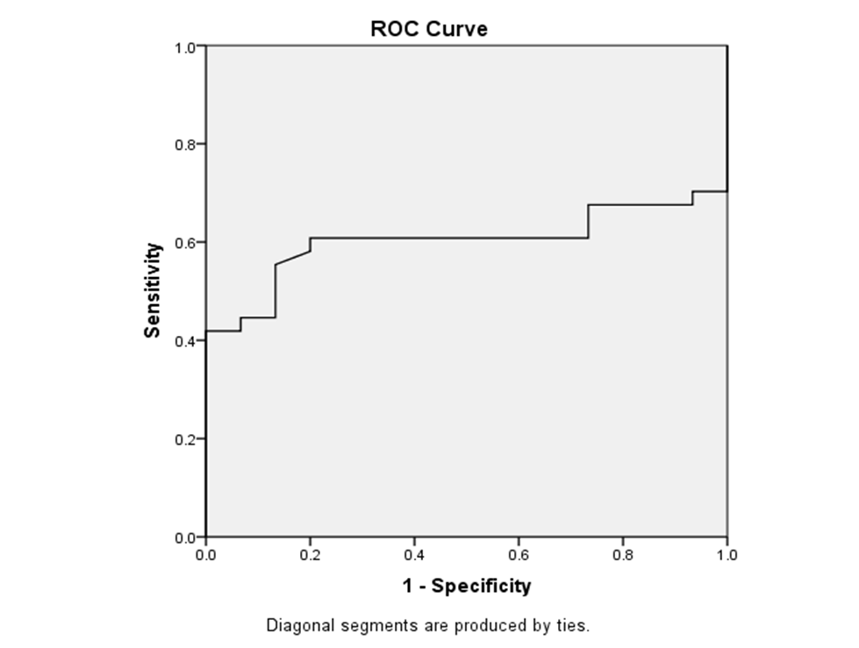
Figure (3): ROC curve for serum relative expression levels of lncRNA-H19 for MS diagnosis.

Table (3): ROC curve analysis for serum relative expression levels of lncRNA-H19 for MS diagnosis:
 | Area Under the Curve (AUC) | P value | 95% Confidence Interval (CI) |  | Cut off | Sensitivity % | Specificity %
 |  |  | Lower Bound | Upper Bound
LncRNA-H19 | 0.602 | 0.043 | 0.497 | 0.706 | 0.8855 | 52.7% | 86.7%

Table (4): ROC curve analysis for serum relative expression levels of lincRNA-p21 for MS diagnosis.
 | Area Under the Curve (AUC) | P value | 95% Confidence Interval (CI) |  | Cut off | Sensitivity % | Specificity %
 |  |  | Lower Bound | Upper Bound
LincRNA-p21 | 0.614 | 0.023 | 0.506 | 0.723 | 0.815 | 51.4% | 93.3%

ROC curve of the lincRNA-p21 expression levels was plotted between sensitivity on y-axis and (1 - specificity) on x-axis. Every point on the ROC curve reflects a chosen cut-off (Figure 4). ROC curve analysis of lincRNA-p21 serum relative expression levels with an AUC of 0.614 (95% CI= 0.506–0.723, p =0.023). The sensitivity and specificity of lincRNA-P21were calculated using a cutoff value of 0.815 for serum lincRNA-P21expression levels (Table 4).

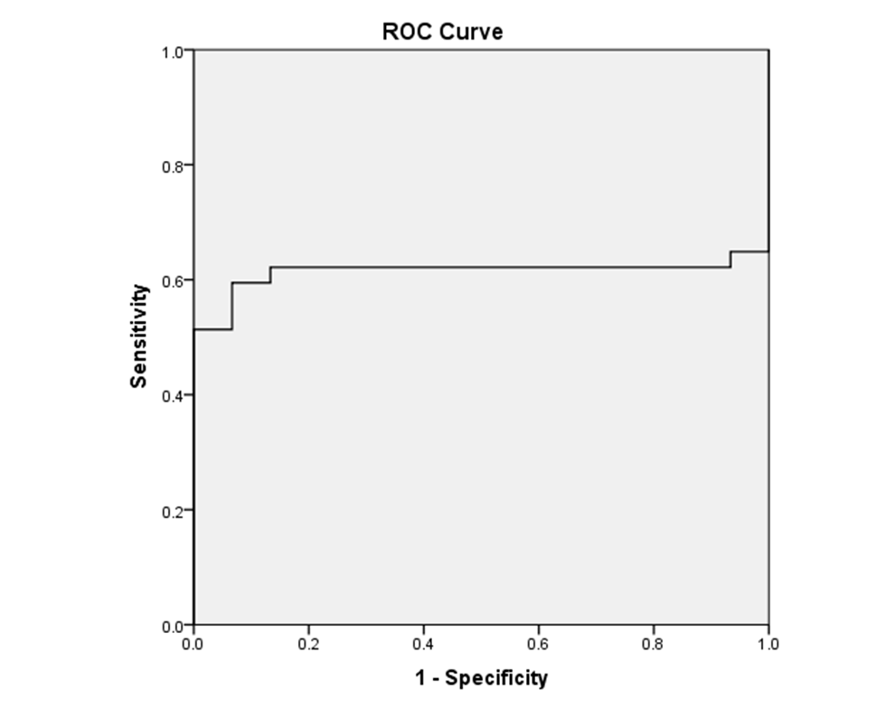
Figure (4): ROC curve for serum relative expression levels of lincRNA-p21 for MS diagnosis.

Discussion
MS is a chronic, demyelinating inflammatory CNS disease with a large degree of heterogeneity in clinical course and histopathology (Zeis et al., 2018). LncRNAs are one of the ncRNAs that suggested to be vital regulators of CNS functions and would be used in diagnosis and treatment of CNS disorders. LncRNAs were described in different autoimmune, neurodegenerative and oncologic diseases. The directive role of lncRNAs in immune response has been demonstrated by the widespread variations in their expression throughout innate immune response besides immune cells differentiation (Zhang and Cao, 2016).
Therefore, we investigated two lncRNAs; lncRNA-H19 and lincRNA-P21 which is expected to control the expression of RRMS and SPMS patients' pro-inflammatory and anti-inflammatory genes in the blood. Thus far and to the best of our knowledge, there are no studies that demonstrated the expression levels of lncRNA-H19 and lincRNA-p21 in serum of MS patients.
LncRNA-H19 is an imprinted gene expressed only from the maternal allele. Although the role of imprinted genes in development and growth is well known, their impact on immune functions and inflammatory diseases like MS is still largely unknown through molecular mechanisms (Yarani et al., 2018).
Our results showed that expression level of lncRNA-H19 was significantly down-regulated in serum samples of MS patients compared to control group (p-value = 0.024).
No previous studies investigated the expression levels of lncRNA-H19 in patients with MS. Depending on the role of the IGF system in MS pathogenesis (Chesik et al., 2007; Zeis et al., 2018) and the significance of HSCs in immune response regulation (Granick et al., 2012), H19 could lead to MS pathogenesis.
LncRNA-H19 contributes to IGFs and FOXO3 expression regulation (Venkatraman et al., 2013). FOXO3 causes FOXP3 (also known as scurfin) expression that plays a key role in distinguishing regulatory T cells and their immunosuppressive functions. (Becher et al., 2018).
The participation of HSCs in the control of immune response has been suggested by several lines of evidence. Cytokines and growth factors are produced by such cells (Granick et al., 2012). In the development and regulation of HSCs, LncRNA-H19 has a significant role. (Venkatraman et al., 2013; Zhou et al., 2019). Taking into account the role of HSCs in the therapy of MS, H19 is a putative target in this regard (Low et al., 2016).
Another mechanism could also contribute to the role of H19 in MS pathogenesis in promoter regions is the methylation of CpG islands, a common mechanism for the inactivation of imprinted genes such as H19. This mechanism has been reported in peripheral blood of patients with MS (Ewing et al., 2019).
The role of H19 in chronic inflammation is also supported by the finding that its expression level seemed to be variable in chronic inflammatory vascular diseases, including atherosclerosis, aortic aneurysm and ischemic myocardial damage. In chronic inflammatory cardiac diseases, studies have shown that the role of H19 is different and its function can be defined by specific pathological changes (Li et al., 2019).
In agreement with our study, recent study demonstrated that H19 expression was down-regulated in the ischemic hearts and H2O2-treated cardiomyocytes. H19 overexpression alleviated myocardial ischemia and H2O2-induced damage to cardiomyocytes. H19 worked for miR-877-3p as a competitive endogenous RNA. MiR-877-3p was reported to regulate the production of IL-8 and IL-1b pro-inflammatory cytokines. These data showed the anti-inflammatory role of lncRNA-H19 (Li et al., 2019). Another study revealed that lncRNA-H19 regulates inflammation response in macrophages by up-regulating miR-130b. Overexpressed miR-130b ameliorates inflammation by reducing the high translational levels of TNF-α and NF-κB (Han et al., 2018).
On the other hand, H19 expression was revealed to be substantially elevated in the plasma of atherosclerosis patients relative to healthy participants and was also highly expressed in atherosclerotic plaques. Overexpression of H19 in endothelial cells increased their proliferation by regulating the signaling pathways p38-MAPK and NF-κB (Pan, 2017). Both MAPK and NF-kB signaling pathways have been reported to be involved in regulation of MS (Lee et al., 2017; Shao, 2018; Yue et al., 2018). Furthermore, recent study demonstrated that H19 induced abdominal aortic aneurysm formation, which is recognized as a chronic inflammatory vascular disease, to cause the transcription of its target gene, IL-6, which acts as a pro-inflammatory cytokine, by acting as ceRNA for let-7a miRNA (Sun et al., 2019).
Interestingly, a previous study in sepsis, which is accepted as inflammatory disease closely correlated with dysfunction of immune system and gene expressions, concluded that H19 acted as ceRNA in regulating miR-874 and its targets. MiR-874 stimulated anti-inflammatory responses, implying that H19 may act as a protective element in inflammation, and regulating secretion of anti-inflammatory cytokines (Fang et al., 2018).
Limited studies demonstrated the expression level of lncRNA-H19 in other autoimmune diseases. The only available study in RA showed that H19 expression in synovial tissue (particularly synovial macrophages and fibroblasts) of patients with RA was up-regulated compared to healthy controls. Intriguingly, H19 expression can be highly triggered by starvation stress to a higher level in RA fibroblasts, which observed to be mediated by MAP-kinases 1/2 and the phosphatidylinositol-3 kinase pathways, with or without cytokines stress (Stuhlmüller et al., 2003). This significant increased sensitivity of H19 to starvation/cytokine regulation indicates the function of this gene in the pathogenesis of RA which is one of autoimmune chronic inflammatory diseases like MS. Indeed, cytokine stress, and/or oxidative stress are also reported to contribute to pathogenesis of MS (Adamczyk-sowa and Adamczyk, 2016).
Moreover, Chen et al., (2016) performed a study in IBD, which is a group of chronic inflammatory relapsing disorders involving the gastrointestinal tract and has two main manifestations (Crohn’s disease and UC). They investigated the role of H19 in UC development and showed that overexpression of H19 resulted in substantially reduced expression of the vitamin D receptor which plays an important role in inflammation regulation.
In the current study, as regard to sex of patients, we detected that male patients had significant higher serum expression levels of lncRNA-H19 compared to female patients (p-value= 0.008). This finding is consistent with finding that the expression level of a group of imprinted genes, including H19, was higher in male mice than female mice. Before the sexual differentiation phase, this bias was not obvious. Therefore the sexual bias found in the imprinted genes was most likely due to gonadal hormones instead of sex chromosome supplements, suggesting that unknown mechanisms related to sexual differentiation could affect the transcriptional regulation of imprinted genes (Faisal et al., 2014). As a preserved lncRNA, the H19 gene sequence stays constant with few mutations in exon areas between multiple organisms (Liu et al., 2017). Based on the low number of individuals in male subgroup in the present study (12 male patients only of 74 MS patients), such data should be interpreted with caution.
Meanwhile, in the current study, no significant difference was observed in serum expression level of lncRNA-H19 among MS patients as regard to other variables. This finding does not necessarily preclude the involvement of H19 in the MS pathogenesis and they may be due to low number of analyzed samples.
Regarding lincRNA-p21, our results demonstrated that its serum expression level was significantly down-regulated among MS patients compared to healthy controls. To our knowledge, lincRNA-p21 is of significance in regulating cellular responses to p53 that presents anti-inflammatory properties. In contrast, NF-κB is an important pro-inflammatory transcription factor, and a variety of stimulants, including cytokines, can induce its activation. Thus, lincRNA-p21 and NF-κB may be considered biologically antagonistic. Therefore, studies suggested that lincRNA-p21 may affect the inflammatory response by regulating the NF-κB signaling pathway (Cui et al., 2018).
Consistently with our results, Spurlock et al., (2014) found that subjects with RA showed decreased expression levels of lincRNA-p21 and higher basal level of phosphorylated p65 (a NF-κB subunit) when compared to control subjects. Furthermore, depressed levels of TP53 and lincRNA-p21 have been found to increase NF-κB activity in cell lines. The high levels of lincRNA-p21 are expected to play a protective role in RA in this situation.
A possible mechanism involved in this regard pertains to a research performed by Pearson and Jones (2016). They suggested that in RA patients treated with methotrexate, lincRNA-p21 has the potential to suppress NF-kB signaling by sequestrating RelA (the NF-kB subunit p65) in T cells.
As a transcriptional target of p53, an increasing body of evidence indicates that lincRNA-p21 is a novel regulator of apoptosis (Chillón and Pyle, 2016). Studies demonstrated the association of deregulated apoptosis with maintenance of auto-reactive T cells in the CNS of EAE models and MS patients (de Oliveira et al., 2017). The anti-inflammatory role of lincRNA-p21 through apoptosis modulation was supported by Wu et al., (2014) who described that lincRNA-p21 is in association with the regulation of atherosclerosis by modulating cell proliferation and apoptosis through activation of p53. They reported that lincRNA-p21 feeds back to boost p53 transcriptional activity through binding to MDM2. MDM2 repression of p53 is released by the lincRNA-p21 and MDM2 association, allowing p53 to interact with p300 and bind to the promoters/enhancers of its target genes. Thus, lincRNA-p21 may be involved in MS through many cellular processes including apoptosis.
In the current study, there was significant higher expression levels of lincRNA-p21 among patients who received cyclophosphamide than those who received interferon (p=0.005). Cyclophosphamide is a widely used cytotoxic immunosuppressive drug in cancer chemotherapy and autoimmune diseases. Previous studies have shown abnormal expression of pro-apoptotic genes in MS patients using cyclophosphamide compared to controls (de Oliveira et al., 2017). Other studies supported that cyclophosphamide significantly increased the expression levels of pro-apoptotic genes, including p53 (Asiri, 2010).
Furthermore, when we classified patients according to EDSS, we found that patients with EDSS ≥ 5.5 had significant higher expression level than those with EDSS =1-3 (p=0.027). This finding may be based on the low number of individuals in (EDSS ≥ 5.5) subgroup (20 patients only of 74 patients). Meanwhile, expression levels of lincRNA-P21 were not significantly different regarding other variables, which may be due to low number of analyzed samples.
Taking these points together, we can assume the potential role of lncRNA-H19 and lincRNA-p21 in the genetic susceptibility to MS.
Limitations still exist in this current study including the absence of analysis of these two lncRNAs' molecular mechanisms, their targets and their related signaling pathways in chronic inflammation and autoimmune diseases. Larger sample size may be needed to explore the influence of these lncRNAs in MS pathogenesis.

References
- Adamczyk-sowa M and Adamczyk B (2016): New Insights into the Role of Oxidative Stress Mechanisms in the Pathophysiology and Treatment of Multiple Sclerosis. Oxidative Medicine and Cellular Longevity; 2016: 1973834.
- Asiri Y (2010): Probucol attenuates cyclophosphamide-induced oxidative apoptosis, p53 and Bax signal expression in rat cardiac tissues. Oxidative Medicine and Cellular Longevity; 3(5): 308–316.
- Becher J, Simula L, Volpe E et al., (2018): AMBRA1 controls regulatory T-cell differentiation and homeostasis upstream of the FOXO3-FOXP3 Axis. Developmental Cell Journal; 47(5): 592-607.
- Bhan A and Mandal S (2014): Long Noncoding RNAs : Emerging Stars in Gene Regulation. Epigenetics and Human Disease Journal; 9: 1932–1956.
- Cao M, Zhao J, Hu G (2019): Genome-wide methods for investigating long noncoding RNAs. Biomedicine and Pharmacotherapy Journal; 111: 395–401.
- Chan YH (2003a): Biostatistics102: Quantitative Data – Parametric & Non-parametric Tests. Singapore Medicine Journal; 44(8): 391-396.
- Chan YH (2003b): Biostatistics 103: Qualitative Data –Tests of Independence. Singapore Medicine Journal; 44(10): 498-503.
- Chan YH (2003c): Biostatistics 104: Correlational Analysis. Singapore Medicine Journal; 44(12): 614-619.
- Chen S, Wang P, Liu Y et al., (2016): Effect of long noncoding RNA H19 overexpression on intestinal barrier function and its potential role in the pathogenesis of ulcerative colitis. Inflammatory Bowel Diseases Journal; 22 (11): 2582–2592.
- Chesik D, Wilczak N, De Keyser J (2007): The insulin-like growth factor system in multiple sclerosis. International Review of Neurobiology; 79: 203–226.
- Chillón I and Pyle A (2016): Inverted repeat Alu elements in the human lincRNA-p21 adopt a conserved secondary structure that regulates RNA function. Nucleic Acids Research Journal; 44(19): 9462–9471.
- Cui D, Zhu D, Ren H et al., (2018): LincRNA-p21 inhibits inflammatory response and angiogenesis through the NF-κB signaling pathway in rats with rheumatoid arthritis. International Journal of Clinical and Experimental Medicine; 11(2): 1217–1225.
- Dangelmaier E, Lazar S, Lal A (2019): Long noncoding RNAs: P53’s secret weapon in the fight against cancer. PLOS Biology Journal; 17(2): 1–11.
- de Oliveira G, Ferreira A, Gasparotto E et al., (2017): Defective expression of apoptosis-related molecules in multiple sclerosis patients is normalized early after autologous haematopoietic stem cell transplantation. Clinical and Experimental Immunology Journal; 187(3): 383–398.
- Ewing E, Kular L, Fernandes S et al., (2019): Combining evidence from four immune cell types identifies DNA methylation patterns that implicate functionally distinct pathways during Multiple Sclerosis progression. EBio Medicine Journal; 43: 411–423.
- Faisal M, Kim H, Kim J (2014): Sexual differences of imprinted genes’ expression levels. Gene Journal; 533(1): 434–438.
- Fang Y, Hu J, Wang Z et al., (2018): LncRNA H19 functions as an Aquaporin 1 competitive endogenous RNA to regulate microRNA-874 expression in LPS sepsis. Biomedicine and Pharmacotherapy Journal; 105(1): 1183–1191.
- Geng H and Tan XD (2016): Functional diversity of long non-coding RNAs in immune regulation. Genes and Diseases; 3(1): 72–81.
- Granick J, Simon S, Borjesson D (2012): Hematopoietic Stem and Progenitor Cells as Effectors in Innate Immunity. Bone Marrow Research; 2012: 165107.
- Han Y, Ma J, Wang J et al., (2018): Silencing of H19 inhibits the adipogenesis and inflammation response in ox-LDL-treated Raw264.7 cells by up-regulating miR-130b. Molecular Immunology; 93:107–114.
- Hoo Z, Candlish J, Teare D (2017): What is an ROC curve? Emergency Medicine Journal; 34(6): 357–359.
- Koriem K (2017): Corrigendum to ‘Multiple sclerosis: New insights and trends. Asian Pacific Journal of Tropical Biomedicine; 7(5): 493–504.
- Kurtzke J (1983): Rating neurologic impairment in multiple sclerosis : An expanded disability status scale (EDSS). Neurology Journal; 33:1444-1452.
- Lee C, Peng S, Shen L et al., (2017): The Role of N-α-acetyltransferase 10 Protein in DNA Methylation and Genomic Imprinting. Molecular Cell; 68(1): 89–103.
- Li X, Luo S, Zhang J et al., (2019): LncRNA H19 Alleviated Myocardial Ischemia Reperfusion Injury via Suppressing miR-877-3p/Bcl-2-mediated Mitochondrial Apoptosis. Molecular Therapy - Nucleic Acids Journal; 17: 297–309.
- Liu Y, Li G, Zhang J (2017): The role of long non-coding RNA H19 in musculoskeletal system: A new player in an old game. Experimental Cell Research; 360(2): 61–65.
- Livak K and Schmittgen T (2001): Analysis of Relative Gene Expression Data Using Real Time Quantitative PCR and the 2^{−∆∆Ct} Method. Methods Journal; 25 (4): 402–4080.
- Low T, Kuan T, Amini F et al., (2016): Feasibility and toxicity of hematopoietic stem cell transplant in multiple sclerosis. Iran Journal of Basic Medical Science; 20(7): 9000.
- Mazdeh M, Noroozi R, Komaki A et al., (2019): Single nucleotide polymorphisms of lncRNA H19 are not associated with risk of multiple sclerosis in Iranian population. Meta Gene; 21: 100592.
- Pan JX (2017): LncRNA H19 promotes atherosclerosis by regulating MAPK and NF-kB signaling pathway. European Review for Medical and Pharmacological Sciences; 21(2): 322–328.
- Pearson M and Jones S (2016): Long Noncoding RNAs in the Regulation of Inflammatory Pathways in Rheumatoid Arthritis and Osteoarthritis. Arithritis and rheumatology Journal;68(11): 2575–2583.
- Polman C, Reingold S, Banwell B et al., (2011): Diagnostic criteria for multiple sclerosis: 2010 revisions to the McDonald criteria. Annals of Neurology; 69: 292–302.
- Safari M, Rezaei F, Dehghan A et al., (2019): Genomic variants within the long non-coding RNA H19 confer risk of breast cancer in Iranian population. Gene Journal; 701: 121–124.
- Santoro M, Nociti V, Lucchini M et al., (2016): Expression Profile of Long Non-Coding RNAs in Serum of Patients with Multiple Sclerosis. Journal of Molecular Neuroscience; 59(1): 18–23.
- Shao X (2018): Protective Role of NF-κB in Inflammatory Demyelination. The Journal of Neuroscience; 38(10): 2416–2417.
- Spurlock C, Tossberg J, Matlock B et al., (2014): Methotrexate inhibits NF-κB activity via lincRNA-p21 induction. Arthritis and Rheumatology Journal; 66(11): 2947–2957.
- Stuhlmüller B, Kunisch E, Franz J et al., (2003): Detection of oncofetal H19 RNA in rheumatoid arthritis synovial tissue. American Journal of Pathology; 163(3): 901–911.
- Sun W, Lv J, Duan L et al., (2019): Long noncoding RNA H19 promotes vascular remodeling by sponging let-7a to upregulate the expression of cyclin D1. Biochemical and Biophysical Research Communications; 508(4): 1038–1042.
- Tang S, Zheng B, Xiong X (2015): LincRNA-p21: Implications in human diseases. International Journal of Molecular Sciences; 16(8): 18732–18740.
- Venkatraman A, He X, Thorvaldsen J et al., (2013): Maternal imprinting at the H19–Igf2 locus maintains adult haematopoietic stem cell quiescence. Nature Journal; 500: 345-349.
- Wu G, Cai J, Han Y et al., (2014): LincRNA- p21 regulates neointima formation, vascular smooth muscle cell proliferation, apoptosis, and atherosclerosis by enhancing p53 activity. Circulation Journal; 130(17): 1452–1465.
- Wu GC, Pan HF, Leng RX et al., (2015): Emerging role of long noncoding RNAs in autoimmune diseases. Autoimmunity Reviews; 14(9): 798–805.
- Yang X, Wu Y, Zhang B et al., (2018): Noncoding RNAs in multiple sclerosis. Journal of Clinical Epigenetics; 10(1): 1–12.
- Yarani R, Mirza A, Kaur S et al., (2018): The emerging role of lncRNAs in inflammatory bowel disease. Experimental and Molecular Medicine; 50(12): 01889.
- Yue Y, Stone S, Lin W (2018): Role of nuclear factor kappa-B in multiple sclerosis and experimental autoimmune encephalomyelitis. Neural Regeneration Research; 13(9): 1507–1515.
- Zeis T, Howell O, Reynolds R et al., (2018): Molecular pathology of Multiple Sclerosis lesions reveals a heterogeneous expression pattern of genes involved in oligodendrogliogenesis IdL. Experimental Neurology; 305:76–88.
- Zhang Y and Cao X (2016): Long noncoding RNAs in innate immunity. Cellular & Molecular Immunology; 13:138–147.
- Zhang Y, Zhang M, Xu W et al., (2017): The long non-coding RNA H19 promotes cardiomyocyte apoptosis in dilated cardiomyopathy. Oncotarget; 8(17): 28588–28594.
- Zhou J, Xu J, Zhang L et al., (2019): Combined Single-Cell Profiling of lncRNAs and Functional Screening Reveals that H19 Is Pivotal for Embryonic Hematopoietic Stem Cell Development. Cell Stem Cell Journal; 24(2): 285–298.

11/21/2020

