**Evaluation of the Prognostic Role of Androgen Receptors in Non-Metastatic Invasive Triple-Negative Breast Cancer Patients: A Clinicopathologic and Immunohistochemical Study**

Asmaa Raafat 1, Hanan Shawky 1, Mohamed Shareef 2, and Mohamed Sheta1

1 Department of Oncology, 2 Department of Pathology, Faculty of Medicine, Tanta University, Egypt

## Abstract: Background: Breast cancer is the second most common cause of death from cancer in females. Continuous research is therefore mandatory for new prognostic markers that will assist in therapy. The aim of this work is to study androgen receptor expression (AR) in non-metastatic TNBCs and to correlate these data with clinicopathologic findings and patient disease -free survival (DFS) and overall survival (OS) to assess its prognostic significance. Patients & Methods: Paraffin blocks were analyzed for AR immunohistochemical expression, obtained from 100 female patients with non-metastatic invasive TNBCs. All patients treated at the Department of Clinical Oncology, Faculty of Medicine, Tanta University Hospital during the period from January 2011 to December 2017. The date of this analysis was January 2020. Results: Androgen receptors showed positivity in 33 cases (33%). There was a statistical significant correlation between AR positivity and tumor grade (p= < 0.001), tumor size (p= < 0.001), Ki 67 (P=< 0.001), lympho-vascular invasion (p=< 0.001), and menopausal status (P= 0.012). However, there was no statistical significant difference when looking at the correlation between AR positivity and ECOG PS (p= 0.728), family history (p=0.902), pathological subtypes (p= 0.071), nodal status (p= 0.222), and age (p= 0. 437). Two year and 5- year DFS in AR +ve patients were 87.88% and 59.66 % respectively. While in AR – ve patients the 2 -year and 5- year DFS were 25.37% and 13.43% respectively with statistically significant difference (P < 0.001). The 2-year OS was 93.94 % versus 61.19 % for AR +ve and AR –ve tumors respectively. While the 5-year OS was 84.85% versus 16.53% for AR positive and AR-negative tumors respectively with statistically significant difference (P <0.001).Conclusion: In TNBC patients it could provide prognostic information by adding AR to the marker panel used in current clinical practice. In patients with non-metastatic invasive TNBCs, AR seems to be a potentially useful marker for good prognosis.

[ Asmaa Raafat, Hanan Shawky , Mohamed Shareef , and Mohamed Sheta **Evaluation of the Prognostic Role of Androgen Receptors in Non-Metastatic Invasive Triple-Negative Breast Cancer Patients: A Clinicopathologic and Immunohistochemical Study** Cancer Biology 2020; 10(2):6-13]. ISSN: 2150-1041 (print); ISSN: 2150-105X (online). <http://www.cancerbio.net>. 1. doi:10.7537/marscbj100220.01.

**Key words:** androgen receptors, Triple-negative breast cancer, Clinicopathologic study, Immunohistochemical Study.

**1. Introduction:**

Breast cancer is a heterogeneous disease based on different patterns of gene expression, with several subtypes. Breast carcinoma are divided into luminal A, luminal B, triple negative, HER2 positive according to status of hormonal receptor and HER2 status [1].

A relatively aggressive tumor biology is triple negative breast cancer (TNBC) that has lost expression of estrogen receptor (ER ) , progesterone receptor (PR) and HER2. TNBC patients have significantly worse prognosis due to lack of well define targeted molecular therapy and endocrinal therapy [2].

Triple negative breast cancer by gene expression micro array could be classified into seven subtypes, indicating that TNBC is a heterogeneous disease composed of subtypes with different biological behaviors and treatment response [2]. Subtypes are basal like 1 (BL1), basal like 2 (BL2), immune modulatory (IM), luminal androgen receptor (LAR), mesenchymal stem like (MLS), mesenchymal (M), unstable subtype [3].

Immunohistochemistry could detect androgen receptor (AR) to identify TNBC subset known as subtype of the luminal androgen receptor (LAR) [4]. Depending on the positivity thresholds used, AR is expressed in 10-53% of TNBC [5, 6], AR-ve TNBC, also known as quadruple negative breast cancer (QNBC), showed a different gene expression compared to AR+ve TNBC [7].

The prognostic value of AR in TNBC varies across literatures. A meta-analysis of 2826 TNBC patients suggested that the absence of AR expression in TNBC was a high risk factor for both recurrence of disease and death [8]. In contrast, some other studies have shown that AR+TNBC survive worse [9, 10, 11].

In this study, we investigate the expression of AR by immunohistochemistry in triple negative breast cancer and try to give an insight to its prognostic value.

## 2. Patients & Methods

**Patient Characteristics & Inclusion Criteria:** We included 100 patients with non- distant metastatic pathologically proven ER, PR, HER2- negative (triple receptor negative) invasive breast cancer in this retrospective study. All patients were treated at department of Clinical Oncology, Faculty of Medicine, Tanta University Hospital during the period from January 2011 to December 2017. The date of this analysis was January 2020.

The patients were chosen on the basis of availability of paraffin blocks. At the beginning of the study all patients included were free of distant metastases. Patients were between 18-70 years , ECOG performance status ≤ 2, adequate bone marrow reserve (hemoglobin >=10 gm/dL ,WBC count >=3.5 x 109/L, and platelets >=100 x 109/L,) and good renal function (creatinine clearance >=60 mL/min).

When patients had altered mental status, dementia or other medical disorder affecting understanding and impeding informed consent, they were exempt from this review. In addition, we excluded patients with bilateral breast cancer, secondary malignancy or non-malignant systemic disease that precluded them from receiving CT / RCT (e.g. uncontrolled active infection, persistent immune-compromised conditions, congestive heart failure, any clinically relevant cardiac arrhythmia). In addition, this study also excluded patients who were pregnant, male breast cancer, clinically significant pleural effusions, or ascites.

Protocol was approved by the Ethics Committee in the Faculty of Medicine, Tanta University, and all patients signed an informed consent prior to the initiation of this study. Investigational research informed consents for the using the patient's paraffin blocks were also fully obtained from all patients included in the study.

## Treatment Protocol:

**Chemotherapy:** Chemotherapy was given to all included patients in this study. The regimen of chemotherapy was applied in a sequential pattern containing anthracycline [FEC regimen which consisted of 500 mg/m2 cyclophosphamide, 100 mg/m2 epirubicin and 500 mg/m2 fluorouracil, intravenously and this cycle was repeated every 3 weeks for 4 courses, followed by 12 courses of weekly intravenous taxanes in the form of paclitaxel

{80mg/m2/qw). Supportive care was used as growth factors, blood transfusions, antiemetic administration and analgesics where appropriate, while prophylactic use of growth factors was not prescribed for any of the patients involved.

**Surgery:** All patients underwent surgical treatment with axillary dissection, either as modified radical mastectomy or breast conservative surgery (BCS).

**Radiotherapy:** Ninety-nine patients (99%) were treated with radiotherapy megavoltage equipment using linear accelerator machine. radiotherapy was delivered to the whole breast in patients with conservative breast surgery, while for patients underwent modified radical mastectomy radiotherapy was delivered to the chest wall. Individually shaped portals and daily fractions of 1.8 to 2.0 Gy were delivered on 5 consecutive days a week. Patients are given a median overall dose of 50 Gy in 25 fractions over 5 weeks (range 33-40 days). In patients submitted to conservative breast surgery, a boost of 10 Gy in 5 fractions over 1 week was applied to the bed of the tumor. Through two tangential fields the internal mammary lymph nodes if indicated and chest wall were irradiated, and immobilization techniques were used as required. Axillary and supraclavicular nodes were treated with an anterior field to a total dose of 50 Gy prescribed at 3 cm to the axillary midplane and to the supraclavicular area.

## Patient and Treatment Evaluation Assessment of Clinical Benefit

Monitoring was done pre- and on-treatment as well as every 3 months after treatment in the first 3 years and every 6 months thereafter. Evaluation included medical history, physical examination, local breast examination, bilateral mammography, CT-scan of the chest, abdomen and pelvis.

## Paraffin Blocks Collection

From the archives of the department of Pathology, Faculty of Medicine, Tanta University, Paraffin blocks of the eligible patients were retrieved.

## Immunohistochemistry

## Immunohistochemistry was performed on formalin fixed paraffin embedded tissue sections of tumor specimens using the standard AR assessment procedure.

## AR expression was evaluated using nuclear stain. If more than 10% of the nucleus of the tumor cells were stained, the tumor was considered positive.

## Study End Points

**-** Primary end point is evaluation of prevalence of AR expression in TNBC and its correlation with different prognostic factors.

- Secondary end points are correlation of AR with DFS and OS of all patients with TNBC.

## Statistical Analysis

The rates of disease free and overall survival (OS) were calculated using the Kaplan and Meier method. [12]. Data analysis was carried out using the SPSS Statistical Package (version 22.0). Estimates of quantitative data were mean and standard deviation. Chi-square / Fischer exact tests of proportion independence were used to estimate survival and log rank to compare Kaplan-Meier curves. [12]. Cox-regression analysis was used to estimate the odds of recurrence and its 95 % CI at the univariate level and to evaluate independent prognostic variables affecting OS and disease-free survival (DFS). P value is significant at ≤0.05 levels.

**3. Results**

**Patient characteristics:**

One hundred female patients with triple receptor negative non metastatic invasive carcinoma of the breast were included in this study, at the time of diagnosis, their age ranging from 28 to70 years (median 45 years). Most of our cases were of T2 or greater, node positive and grade II.

## Immunohistochemistry results:

**Table (1)** summarizes the relation of AR expression to the patient and tumor characteristics.

Androgen receptors showed positivity in 33 cases (33%) (Fig 1 (a, b), Fig 2 (a, b) and Fig 3 (a, b).Fig 3 (a, b).

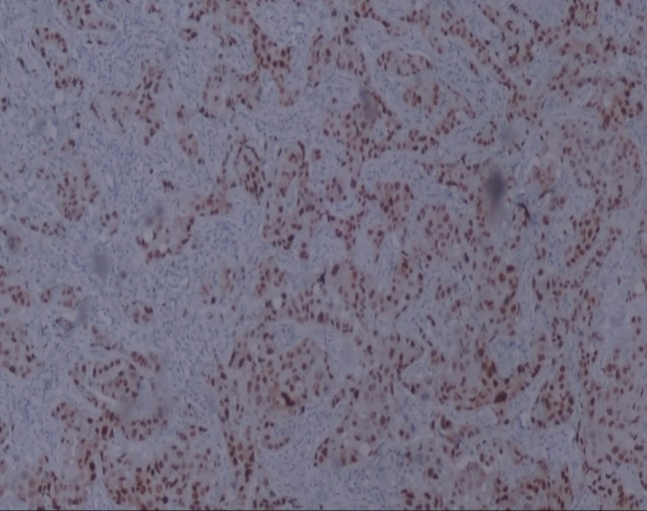

Fig 1 a

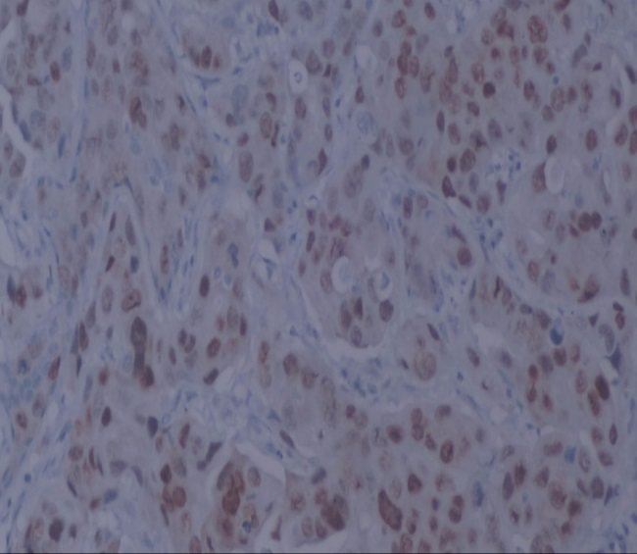

Fig 1 b

**Figure (1** a, b**):** A case of invasive ductal carcinoma showing positive immunohistochemical stain for androgen receptors

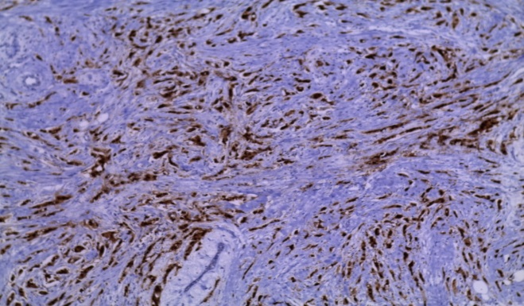

Fig 2 a

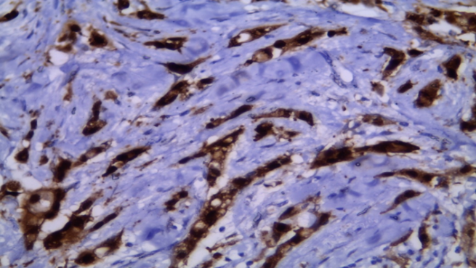

Fig 2 b

**Figure (2** a, b**):** A case of infiltrating lobular carcinoma showing positive immunohistochemical stain for androgen receptors

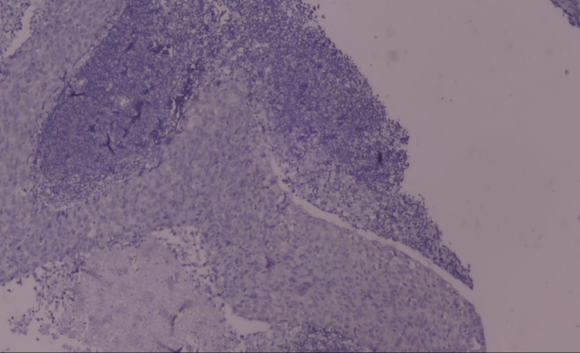

Fig 3 a

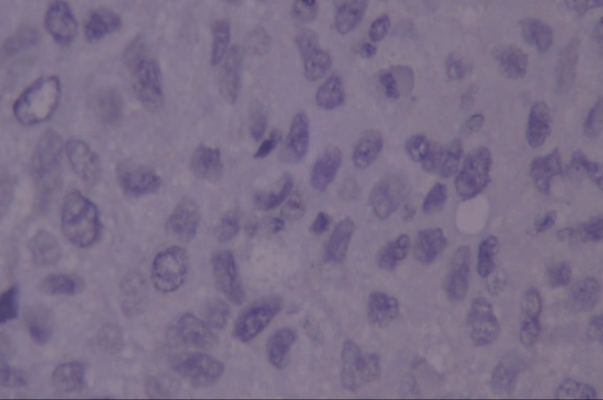

Fig 3 b

**Figure (3** a, b**):** A case of infiltrating breast carcinoma showing negative immunohistochemical stain for androgen receptors

Androgen receptors were inversely correlated with tumor grade showing a high substantial correlation with it, with a higher frequency of grade III cancers being AR negative (p=<0.001). Similarly, androgen receptors were inversely correlated with tumor size with a higher frequency of T1 cancers being AR positive (p= < 0.001). Both Ki 67<16% and negative lympho-vascular invasion had higher statistically significant direct correlation with AR positive status (P-value < 0.001). Furthermore, AR positivity was statistically significantly higher in post-menopausal patients than pre-menopausal patients **(**P-value = 0.012).

The correlation between AR positivity and ECOG PS (p=0.728), family history (p=0.902), pathological subtypes (p=0.071), nodal status (p=0.222), and age (p=0.437) was not statistically significant.

## Relationships to survival:

To evaluate the prognostic significance of AR expression, AR expression was analyzed in relation to DFS and OS in patients with triple receptor negative non metastatic invasive carcinoma of the breast.

The 2 year, and 5-year DFS for patients whose tumors were positive for AR was 87.88% and 59.66 % respectively, compared to 25.37% and 13.43 % for the women with AR negative tumors, respectively with statistically significant difference (P < 0.001) as shown in (fig4). Thus, the Kaplan–Meier survival curves demonstrate the better prognosis of AR +ve tumors.

In a univariate analysis, of different prognostic factors as regard DFS among 100 patients who had non-metastatic invasive TNBC, we found that, AR state, tumor size, LN status, tumor grade, KI 67 and lympho-vascular invasion had statistically significant correlation with DFS as illustrated in **(table 2).**

In the multivariate analysis for DFS, only AR state, lymph node infiltrations and ki-67 proliferation index retained their in-dependent prognostic values in TNBC patients as illustrated in **(table 3).**

The 2-year OS was 93.94 % versus 61.19 % for AR +ve and –ve tumors respectively. While the 5-year OS was 84.85% versus 16.53% for AR positive and AR-negative tumors respectively with statistically significant difference (P = <0.001). Thus, AR expression was significantly associated with a longer OS (P= < 0.001) (fig 5).

In univariate analysis, AR state, tumor size, LN status, tumor grade, KI 67 and lympho-vascular invasion had statistically significant correlation with OS as illustrated in **(table 4).**

In the multivariate analysis for OS, only AR state, lymph node infiltration and tumor size retained their in-dependent prognostic values in TNBC patients as illustrated in **(table 5).**

**Table (1): Androgen receptors expression in relation to patient and tumor characteristics**

|  |  |  |  |  |  |  |  |  |  |
| --- | --- | --- | --- | --- | --- | --- | --- | --- | --- |
|  | | **AR** | | | | | | **Chi-square** | |
| **Negative** | | **Positive** | | **Total** | |
| **N= 67** | **67%** | **N= 33** | **33%** | **N= 100** | **100%** | ***X*2** | ***p*-value** |
| **Age** | <45 | 38 | 56.7% | 16 | 48.5% | 54 | 54% | 0.603 | 0.437 |
| >45 | 29 | 43.3% | 17 | 51.5% | 46 | 46% |
| **Lympho-vascular invasion** | Yes | 51 | 76.1% | 9 | 27.3% | 60 | 60% | 21.981 | <0.001* |
| No | 16 | 23.9% | 24 | 72.7% | 40 | 40% |
| **Tumor Status** | T1 | 8 | 29.85% | 20 | 60.6% | 28 | 28% | 26.314 | <0.001* |
| T2 | 38 | 56.72% | 7 | 21.2% | 45 | 45% |
| T3 | 21 | 13.43% | 6 | 18.2% | 27 | 27% |
| **Tumor Grade** | Grade II | 26 | 38.8% | 27 | 81.8% | 53 | 53% | 16.421 | <0.001* |
| Grade III | 41 | 61.2% | 6 | 18.2% | 47 | 47% |
| **Nodal Status** | Negative | 8 | 11.9% | 7 | 21.2% | 15 | 15% | 1.491 | 0.222 |
| Positive | 59 | 88.1% | 26 | 78.8% | 85 | 85% |
| **Family History** | **Positive** | 17 | 25.4% | 8 | 24.2% | 25 | 27.87% | .015 | 0.902 |
| **Negative** | 50 | 74.6% | 25 | 75.8 | 75 | 75 |
| **Menopausal State** | **Pre-Menopausal** | 34 | 50.7 | 8 | 24.2 | 42 | 42 | 6.376 | 0.012* |
| **Post-Menopausal** | 33 | 49.3 | 25 | 75.8 | 58 | 58 |
| **Pathology** | **IDC** | 57 | 85.07 | 23 | 69.70 | 80 | 80 | 3.268 | 0.071 |
| **ILC** | 10 | 14.93 | 10 | 30.30 | 20 | 20 |
| **PS** | **ECOG <2** | 39 | 58.2 | 18 | 54.5 | 57 | 57 | 0.121 | 0.728 |
| **ECOG 2** | 28 | 41.8 | 15 | 45.5 | 43 | 43 |
| **Ki 67** | **<16%** | 12 | 17.9 | 25 | 75.76 | 37 | 37 | 31.74 | <0.001* |
| **>16%** | 55 | 82.1 | 8 | 24.24 | 63 | 63 |



## Figure (4): Correlation between DFS and AR expression

**Table (2): Univariate analysis of different prognostic factors as regard DFS.**

|  |  |  |  |  |  |  |
| --- | --- | --- | --- | --- | --- | --- |
| **DFS (Months)** | | **2Y** | **5Y** | **Median** | **CI95%** | **P-value** |
| **Androgen state** | **Positive** | 87.88 | 59.66 | NR | - | <0.001* |
| **Negative** | 25.37 | 13.43 | 19 | (16.81 -21.19) |
| **Age group** | **<45 Years** | 40.7 | 28.5 | 22 | (17.20 - 26.80) | 0. 574 |
| **>45 Years** | 52.17 | 30.10 | 27 | (17.03 - 36.97) |
| **Family History** | **Positive** | 40.00 | 09.6 | 22 | (19.57 – 24.43) | 0.297 |
| **Negative** | 48.00 | 34.4 | 24 | (14.58 - 33.42) |
| **Menopausal State** | **Pre-Menopausal** | 33.33 | 30.95 | 18 | (13.24 -22.76) | 0.327 |
| **Post-Menopausal** | 55.17 | 27.24 | 28 | (18.05 – 37.95) |
| **Pathological subtypes** | **IDC** | 45.00 | 28.97 | 22 | (18.49 - 25.51) | 0.951 |
| **ILC** | 50.00 | 30.00 | 24 | (8.66 – 39.34) |
| **Tumor Size** | **T1** | 92.86 | 66.94 | NR | - | <0.001* |
| **T2** | 31.11 | 20.00 | 19 | (15.71 -22.29) |
| **T3** | 22.22 | 3.70 | 20 | (16.25 -23.75) |
| **Lymph Node State** | **N-ve** | 93.33 | 77.04 | NR | - | <0.001* |
| **N+ve** | 37.65 | 20.80 | 21 | (18.75 -23.25) |
| **Tumor grade** | **Grade II** | 67.92 | 49.1 | 55 | (40.29 -52.07) | <0.001* |
| **Grade III** | 21.28 | 6.38 | 18 | (13.97 -22.03) |
| **Ki 67** | **<16 %** | 86.49 | 67.93 | NR | - | <0.001* |
| **>16 %** | 22.22 | 6.35 | 18 | (16.06 -19.94) |
| **Lympho -vascular Invasion** | **Positive** | 26.67 | 10.00 | 19 | (16.93 -21.07) | <0.001* |
| **Negative** | 75.00 | 57.59 | NR | - |
| **Surgery** | **MRM** | 46.43 | 30.56 | 22 | (14.67 – 29.33) | 0.561 |
| **BCS** | 45.45 | 27.08 | 22 | (15.50-28.50) |

**Table (3): Multivariate analysis of prognostic factors as regard DFS**

|  |  |  |  |
| --- | --- | --- | --- |
| **DFS** | **Odd's ratio** | **95.0% C.I. for Odd's ratio** | **P-value** |
| **Androgen state** | 12.9979 | 0.1377 - 4.0483 | <0.001* |
| **Tumor Size** | 0.9472 | 0.000 - 1.2682 | 0.330 |
| **Lymph Node State** | 8.8560 | 0.1087 - 7.3197 | 0.002* |
| **Grade** | 3.3402 | 0.0481 - 1.7736 | 0. 067 |
| **Ki 67** | 6.5782 | 0.0889- 3.6467 | 0.010* |
| **Lymph Vascular Invasion** | 0.4451 | 0.0000 - 1.2940 | 0.504 |



## Figure (5): Correlation between OS and AR State

**Table (4): Univariate analysis of different prognostic factors as regard OS.**

|  |  |  |  |  |  |  |
| --- | --- | --- | --- | --- | --- | --- |
| **OS (Months)** | | **2Y** | **5Y** | **Median** | **CI95%** | **P-value** |
| **Androgen state** | **Positive** | 93.94 | 84.85 | NR | - | <0.001* |
| **Negative** | 61.19 | 16.53 | 30 | (27.36 – 32.64) |
| **Age group** | **<45 Years** | 68.52 | 38.89 | 32 | (26.76 – 37.24) | 0.444 |
| **>45 Years** | 76.09 | 39.75 | 44 | (35.05 – 52.92) |
| **Family History** | **Positive** | 68.00 | 31.5 | 30 | (22.66 – 37.34) | 0.374 |
| **Negative** | 73.33 | 42.35 | 40 | (30.06 – 49.94) |
| **Menopausal State** | **Pre-Menopausal** | 64.29 | 33.33 | 30 | (22.75 – 37.25) | 0.074 |
| **Post-Menopausal** | 75.86 | 43.90 | 45 | (37.89 – 52.11) |
| **Pathology** | **IDC** | 71.25 | 39.89 | 35 | (26.25 – 43.75) | 0.832 |
| **ILC** | 75.00 | 37.50 | 40 | (28.31 – 51.69) |
| **Tumor Size** | **T1** | 96.43 | 89.29 | NR | - | <0.001* |
| **T2** | 73.33 | 23.64 | 32 | (26.75 – 37.25) |
| **T3** | 44.44 | 13.33 | 24 | (22.73 – 25.27) |
| **Lymph Node State** | **N-ve** | 93.33 | 86.67 | NR | - | <0.001* |
| **N+ve** | 68.24 | 31.26 | 32 | (27.75 – 36.25) |
| **Grade** | **Grade II** | 84.91 | 60.38 | NR | - | <0.001* |
| **Grade III** | 57.45 | 15.2 | 27 | (22.97 – 31.03) |
| **Ki 67** | **<16 %** | 94.59 | 83.78 | NR | - | <0.001* |
| **>16 %** | 66.67 | 12.38 | 30 | (26.22 – 33.78) |
| **Lympho Vascular Invasion** | **Positive** | 60.00 | 16.67 | 30 | (27.19 – 32.81) | <0.001* |
| **Negative** | 90.00 | 72.50 | NR | - |
| **Surgery** | **MRM** | 73.21 | 42.71 | 35 | (20.43 – 49.57) | 0.616 |
| **BCS** | 70.45 | 35.56 | 35 | (24.17 – 45.83) |

**Table (5): Multivariate analysis of significant prognostic factors as regard OS.**

|  |  |  |  |
| --- | --- | --- | --- |
| **OS** | **Odd's ratio** | **95.0% C.I. for Odd's ratio** | **P-value** |
| **Androgen state** | 12.7759 | .1455 - 6.3254 | <0.001* |
| **Tumor Size** | 5.4049 | .0818 - 1.8337 | 0.020* |
| **Lymph Node State** | 4.6088 | .0716 -5.2595 | 0.031* |
| **Grade** | 0.4482 | .0000 - 1.2355 | 0.503 |
| **Ki 67** | 3.0278 | .0449 -2.5592 | 0.081 |
| **Lymph Vascular Invasion** | 0.4453 | .000 0 - 1.3075 | 0.504 |

## 4. Discussion

Breast cancer is a heterogeneous tumor with variable behavior. There is a need to have definite markers that can predict whether those cancers have a better or a worse prognosis and also those which aid in the selection of appropriate therapy and predict the response to this therapy for proper management of individual patients **[13].**

TNBC patients have a significantly worse prognosis relative to other breast carcinoma subtypes due to a lack of well-defined molecular and endocrine therapy **[2]**.

Triple negative breast cancer could be classified into seven subtypes which are basal like 1, basal like 2, immune modulatory (IM), mesenchymal (M), mesenchymal stem like (MLS), luminal androgen receptor (LAR) and unstable subtype **[3].**

The immunohistochemistry could detect androgen receptors to identify the TNBC subset referred to as the luminal androgen receptor subtype **[4]**.

This study is focused on the studying AR as a biological marker that could be used in treatment to individual patients with TNBC. In this study 33 out of 100 (33%) patients with non-metastatic invasive breast carcinoma and triple receptor negative were AR +ve.

Our finding was in accordance with **Garay et al** [14] who stated that AR was expressed in 10–35% of TNBC patients [14].

In our study, AR expression was significantly associated with post- menopausal status which is in concordance to that found in **Hu et al [4]** study which reported that AR expression was significantly higher with post- menopausal state [4].

This work stated that, AR expression was significantly related to small tumor size which is comparable to that reported in **Park et al [15]** study who found that AR expression was significantly related to small tumor size [15].

In this study, AR expression was significantly related to lower tumor grade (Grade II) (p<0.001) similar to the results of **Wang et al** [16] who reported that AR expression was higher in low grade tumors (grade I-II) (P<0.001) [16].

Our research revealed that, AR expression was higher in tumors with low KI67 <16%. Similarly, **Hu et al [4]** reported that AR expression was higher in low KI67 [4].

In this work, AR expression was related to –ve LVI. These results are comparable to that reported by **Pistelli et al [17]** who found strong significant correlation between AR expression and –ve LVI [17].

**However,** in our study AR expression had no significant correlation with PS, family history, pathological subtypes, nodal status and treatment strategies, this was comparable to that found by **Hu et al [4]**.

**Zakaria et al study [18]** proved the potential importance of AR as a prognostic factor in TNBC and demonstrated that loss of AR increases the risk of treatment failure [18]. This was in an accordance with our study in which the 2- year DFS was 87.88% VS 25.37% and the 5- year DFS was 59.66% Vs 13.43% for AR +ve and AR –ve patients respectively which was statistically significant (p<0.001). Similarly, **Zakaria et al [18]** reported that the 2- year DFS was 85% vs 28% and the 5- year DFS was 78% vs 5% for AR +ve and AR –ve patients respectively (p<0.001) [18].

In our study, the multivariate analysis for DFS revealed independent prognostic value of AR. This was comparable to that stated by **Hu et al [4]** who reported that AR was also an independent prognostic factor with p value of 0.006 [4].

In this study, the Kaplan–Meier survival curves demonstrate the better prognosis of AR +ve tumors. The 2- year OS was 93.9% vs 61.1% and the 5 -year OS was 84.8% Vs 16.5% for AR +ve and AR –ve patients respectively which was statistically significant (p<0.001). This is comparable with **Zakaria et al [18]** who found a statistically significant correlation between longer OS and AR +ve status (p<0.001) [18].

The results of our study showed that AR could be a promising prognostic marker in TNBC as it had a highly significant relationship with longer duration of OS in univariate and multivariate analysis. Similar finding was reported by **Hu et al** who claimed that AR was also an independent prognostic factor with p value of 0.02 [4].

In conclusion, AR could have a prognostic significance in patients with TNBC. It appears to be a useful marker for good prognosis in TNBC and can be used to detect cases with aggressive biological behavior that may benefit from therapy that is more aggressive. So routine assessment of AR status in TNBC patients, which may refine the outcome, as a prognostic factor, is recommended. However, in large randomized trials, greater number of cases and longer follow-up periods are required to confirm their independent prognostic value.

**References**

1. **Dai X, Li T, Bai Z, et al.** Breast cancer intrinsic subtype classification, clinical use and future trends. American Journal of Cancer Research, 2015; 5(10):2929-2943.‏
2. **Lehmann BD, Jovanović B, Chen X, et al.** Refinement of triple-negative breast cancer molecular subtypes: implications for neoadjuvant chemotherapy selection. PloS One, 2016; 11(6): 1-22.
3. **Pareja F, Geyer FC, Marchiò C, et al.** Triple-negative breast cancer: the importance of molecular and histologic subtyping, and recognition of low-grade variants. NPJ Breast Cancer, 2016; 2:1-11.
4. **Hu XQ, Chen WL, Ma HG, et al.** Androgen receptor expression identifies patient with favorable outcome in operable triple negative breast cancer. Oncotarget, 2017; 8(34): 56364-56374.
5. **McNamara KM, Yoda T, Miki Y, et al.** Androgenic pathway in triple negative invasive ductal tumors: Its correlation with tumor cell proliferation. Cancer Sci, 2013; 104:639–646.
6. **Hon JD, Singh B, Sahin A, et al.** Breast cancer molecular subtypes: from TNBC to QNBC. Am J Cancer Res, 2016; 6:1864– 1872.
7. **Doane AS, Danso M, Lal P, et al.** An estrogen receptor-negative breast cancer subset characterized by a hormonally regulated transcriptional program and response to androgen. Oncogene, 2006; 25:3994–4008.
8. **Wang C, Pan B, Zhu H, et al.** Prognostic value of androgen receptor in triple negative breast cancer: A meta-analysis. Oncotarget, 2016; 7(29):46482–46491.
9. **Lehmann BD, Bauer JA, Chen X, et al.** Identification of human triple-negative breast cancer subtypes and preclinical models for selection of targeted therapies. J Clin Invest, 2011; 121:2750–2767.
10. **Choi JE, Kang SH, Lee SJ, et al.** Androgen receptor expression predicts decreased survival in early stage triple-negative breast cancer. Ann Surg Oncol, 2015;0 22:82–89.
11. **Jiang HS, Kuang XY, Sun WL, et al.** Androgen receptor expression predicts different clinical outcomes for breast cancer patients stratified by hormone receptor status. Oncotarget, 2016; 7:41285–41293.
12. **Kaplan EL & Meier P**. Nonparametric estimation from incomplete observations. Journal of the American statistical association, 1958; 53(282): 457-481.
13. **Bauer KR, Brown M, Cress RD**, **et al.** Descriptive analysis of estrogen receptor (ER)-negative, progesterone receptor (PR)-negative, and HER2-negative invasive breast cancer, the so-called triple-negative phenotype: a population-based study from the California Cancer Registry. Cancer 2007; 109 (9):1721–8.
14. [**Garay JP**](https://www.ncbi.nlm.nih.gov/pubmed/?term=Garay%20JP%5BAuthor%5D&cauthor=true&cauthor_uid=22321971)**,**[**Karakas B**](https://www.ncbi.nlm.nih.gov/pubmed/?term=Karakas%20B%5BAuthor%5D&cauthor=true&cauthor_uid=22321971)**,**[**Abukhdeir AM**](https://www.ncbi.nlm.nih.gov/pubmed/?term=Abukhdeir%20AM%5BAuthor%5D&cauthor=true&cauthor_uid=22321971)**, et al.** The growth response to AR Signaling in ERX negative human breast cancer cell is dependent on P21 and mediated by MAPK activation. Breast 2012; 14(1):1-17.
15. **Park S, Koo JS, Kim MS.** Androgen receptors expression is significantly associated with better outcomes in ER – positive breast cancer. Ann Oncol 2010; 22(8):1755–1762.
16. **Wang C, Pan B, Zhu H, et al.** Prognostic value of androgen receptor in triple negative breast cancer: A meta-analysis. Oncotarget, 2016; 7(29):46482–46491.
17. **Pistelli M, Caramanti M, Biscotti T, et al.** Androgen receptor expression in early triple-negative breast cancer: clinical significance and prognostic associations. Cancers, 2014; 6(3):1351-1362.
18. **Zakaria F, El-Mashad N, Mohamed D.** Androgen receptor expression as a prognostic and predictive marker in triple-negative breast cancer patients. Alexandria Journal of Medicine, 2016; 52(2):131-140.

## 6/16/2020