Prognostic role of MiR-497-5p as a molecular marker in papillary thyroid carcinoma in Saudi patients

Rajab Alzahrani¹, Wael H. Elsawy²

Department of Surgery, Medical College, Albaha University, SA.
Department of Clinical Oncology, Faculty of medicine Zagazig University, Zagazig, Egypt.
drrajabg@gmail.com, rasalzahrani@bu.com.sa

Abstract: Thyroid cancer constitutes a major health problem in Saudi females. We conducted this study to evaluate the role of MiR-497-5p as a possible molecular marker for prognosis and survival in Saudi patients. qRT-PCR was used to assess MiR-497-5p expression in 36 Saudi patients with papillary thyroid carcinoma (PTC) and in their nearby normal tissues. Downregulation of MiR-497-5p was noted in all malignant tumor tissues in relation to their corresponding normal tissues. Downregulation was linked with poor prognostic features and short overall and disease-free survival. MiR-497-5p function as a tumor suppressor gene in PTC. The low levels of expression were correlated with adverse prognostic clinical features and short survival in Saudi patients with PTC. It may be used as a possible molecular marker for prognosis and survival in PTC.
[Rajab Alzahrani, Wael H. Elsawy. Prognostic role of MiR-497-5p as a molecular marker in papillary thyroid carcinoma in Saudi patients. Cancer Biology 2020;10(2):1-5]. ISSN: 2150-1041 (print); ISSN: 2150-105X (online). http://www.cancerbio.net. 1. doi:10.7537/marscbj100220.01.

Keywords: Papillary thyroid cancer, MiR-497-5p, Tissues, Prognosis

1. Introduction
Thyroid cancer (TC) is the second most common malignancy among women in the Kingdom of Saudi Arabia. It constitutes 12% of all female malignancies; it is less common in Saudi males [1]. In 2015, the Saudi Cancer Registry reported 1020 new cases of TC 8.5% of TC among the Saudi population [2, 3].
Tumorigenesis and papillary thyroid cancer (PTC) development is a complex mechanism emerging from interactions between genetics and environmental factors. For most patients with thyroid cancer, surgical treatment, ablation with radioactive iodine (RAI) and suppressive therapy with TSH results in 97.7% overall 5 years survival rate [4].
MicroRNAs are 18-25 nucleotides, single-stranded non-coded RNAs. MicroRNAs regulate many biological processes and incorporated in the pathogenesis in many diseases [5]. The attachment of MicroRNAs to 3′UTR end of the controlled mRNA inhibits its degradation or protein translation [6].
MiR‐497-5p is downregulated in many malignancies such as head and neck cancer [7], pancreatic cancer [8], breast cancer [9], hepatocellular carcinoma [10], and colorectal cancer [11]. Functional analysis of MiR-497-5p revealed its tumor suppressor role [11]. The clinical significance of MiR‐497 and its functions in TC remains largely explored.
The current study aims to explore the role of Mir-497-5p in papillary thyroid cancer in Saudi patients and its relation to prognosis and survival.
2. Material and Methods
The study was conducted from group of patient from Jeddah population, between August 2015 and December 2019 and the study was approved by the hospital’s committee. 36 patients with pathologically proved PTC were included and written informed consent was obtained from each patient.
Tumor tissue biopsies were obtained from the PTC tissues and the nearby corresponding normal tissues (NCNT) without infiltration by the tumor. Tissue specimens were stored in liquid nitrogen at -80°C until analysis in separate lab facility. Patients were clinically staged according to the 8th edition of the American Joint Committee on Cancer (AJCC) [12].
RNA EXTRACTION AND QUANTITATIVE REAL-TIME RT–PCR
30-50 mg of PTC tissues and NCNT were used for the extraction of RNA and MiRNAs using the miRNeasy Mini Kit (Qiagen, Hilden, Germany) guided by the company guide. High Capacity cDNA reverse transcription Kit (Applied Biosystems, USA) was used for reverse transcription. 2μg of total RNA was used to synthesize cDNA.
Mir497-p5 expression levels were assessed by qRT-PCR using Power SYBR® Green and 7500 Sequence Detection System (Applied Biosystems, USA).
We performed all reactions in triplicate. The mir497-p5 expression level was normalized to U6 as a control. Results were expressed using the 2−ΔΔCt method [13].
Statistical analysis
Statistical analysis was performed using version 9.4 of the SAS software package (SAS Institute, Inc.; Cary, NC, USA). Data has been reported as mean ± SD. Student’s t-test and one way ANOVA were used to compare MiR-497-5p expression between groups. Receiver operating characteristic (ROC) curve analysis was used to assess the accuracy of tissue MiR-497-5p levels as an indicator of PTC prognosis. Survival was estimated by Kaplan-Meier curves and compared by the log-rank test in univariate analysis and multivariate Cox hazard regression analysis for the independency of prognostic features in PTC.

Table 1. MiR-497-5p expression and clinical features of the patients.
Parameter | n | MiR-497-5p |  | t - test | P
 |  | Mean | SD
Gender |  |  |  | 11.31 | <0.0001
Male  Female | 17  19 | 0.392  1.429 | 0.237  0.304
Age |  |  |  | 8.00 | <0.0001
< 45 years  ≥ 45 years | 23  13 | 1.293  0.3132 | 0.4095  0.2139
Grade |  |  |  | 12.70 | <0.0001
GI + GII  GIII + GIV | 18  18 | 1.47  0.26 | 0.410  0.242
T |  |  |  | 8.81* | <0.0001*
T1  T2  T3 | 12  16  8 | 1.404  0.977  0.167 | 0.2903  0.5085  0.0560
N |  |  |  | 5.86 | <0.0001
N0 | 28 | 1.160 | 0.474
N1 | 8 | 0.17 | 0.056
Stage |  |  |  | 5.86 | <0.0001
I  II | 28  8 | 1.160  0.167 | 0.474  0.056

3. Results
Patients Characteristics
Our study included 19 females and 17 male, their age ranged between 25 and 56 years, stage I tumors was the most common (Table 1).
MiR-497-5p expression level in PTC tissues and NCNT
We analyzed MiR-497-5p in papillary thyroid tissues and their nearby normal tissues obtained from 36 patients. We used the mean ± SD of 2-ΔΔCt for calculating the MiR-497-5p expression. MiR-497-5p was downregulated in the papillary thyroid carcinoma in comparison to normal tissues. The mean ± SD of MiR-497-5p level was 0.939 ± 0.591 in papillary thyroid carcinoma and 3.691 ± 0.802 in normal tissues, this difference was statistically significant (t = 16.58, P <0.0001) (Figure 1). Receiver operating characteristic (ROC) curve was generated for both groups to assess the specificity of MiR-497-5p in prediction of prognosis, it revealed area under the curve (AUC) for MiR-497-5p in malignant and normal tissues equal 1. (AUC =1; 95% CI: 1.000 to 1.000; P <0.0001) (Figure 2).
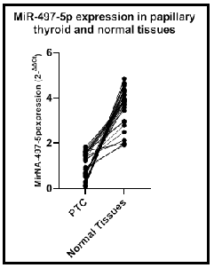
Figure 1. MiR-497-5p levels PTC and their NCNT

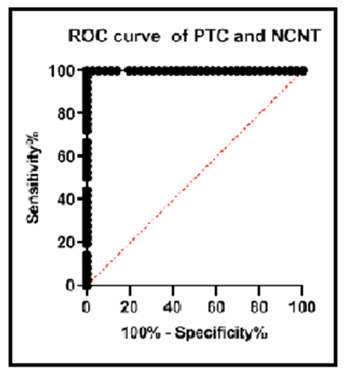
Figure 2. ROC curve for MiR-497-5p levels in PTC and their NCNT

MiR-497-5p expression in PTC with the clinical characteristics
Analysis of MiR-497-5p levels according to the clinical features of the patients revealed that downregulation of MiR-497-5p was significantly observed in male patients (P<0.0111), older patients with age ≥ 45 years (<0.0001), high-grade tumors (<0.0001), large tumor size (<0.0001), cervical lymph nodes involvement (<0.0001), and advanced tumor stage (<0.0001) (Table 1).
Multivariate analysis of clinical and pathological features MiR-497-5p expression
Multivariate analysis of the MiR-497-5p and clinical features of the patients revealed that the patient’s sex and cervical lymph nodes infiltration were related significantly to MiR-497-5p expression, the P-value was 0.001 and 0.016 respectively. (Table 2).

Table 2. Multivariate analysis of clinical features and MiR-497-5p expression
 | Coefficients | Standard Error | t Stat | P-value | Lower 95% | Upper 95%
Intercept | 0.501 | 0.529 | 0.947 | 0.351 | -0.581 | 1.583
T | 0.172 | 0.159 | 1.085 | 0.287 | -0.153 | 0.497
n | -0.459 | 0.180 | -2.548 | 0.016 | -0.828 | -0.091
grade | -0.117 | 0.123 | -0.955 | #NUM! | -0.368 | 0.134
age | -0.044 | 0.267 | -0.166 | 0.869 | -0.589 | 0.501
sex | 0.712 | 0.197 | 3.607 | 0.001 | 0.308 | 1.116
Multifocality | -0.044 | 0.280 | -0.158 | 0.875 | -0.616 | 0.528
stage | -0.459 | 0.180 | -2.548 | 0.016 | -0.828 | -0.091

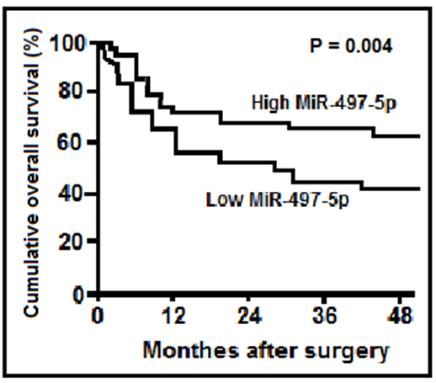
Figure 3 Kaplan-Meier overall survival curve according to MiR-497-5p expression

Survival and MiR-497-5p expression
We classified patients into high and low expression according to the mean ± SD of MiR-497-5p level. Downregulation of MiR-497-5p was associated significantly with short overall survival (42% versus 65%, P = 0.004) and disease-free survival (35% versus 58%, P = 0.041) at 48 months of follow-up (Figure 3 and 4).

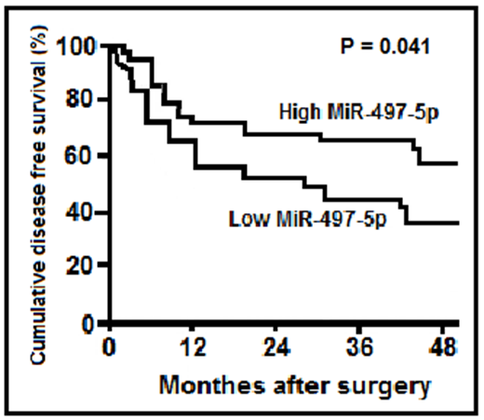
Figure 4 Kaplan-Meier disease-free survival curve according to MiR-497-5p expression.

We performed univariate survival analysis; downregulation of MiR-497-5p had a significantly worse 4 years overall survival (42% versus 65%, P = 0.004) and disease-free survival (35% versus 58%, P = 0.041) (Figure 3 and 4).
The multivariate study included patient sex and age, tumor size, infiltration of cervical lymph node, stage, histopathological tumor grade, and MiR-497-5p expression in PTC tissues by Cox regression analysis to identify independent molecular markers for PTC patients. A decreased level of MiR-497-5p was recognized as an independent risk factor for survival in PTC (P<0.01; hazard ratio, 2.63; 95% CI: 1.17–7.94), independent of the usual prognostic clinical features as tumor stage ((P<0.01; hazard ratio, 3.39; 95% CI: 1.91–8.54) and histopathological tumor grade (P = 0.01; hazard ratio, 1.34; 95% CI: 1.14–3.51).

4. Discussions
In Saudi females, thyroid cancer represents the 2nd most common malignant tumors [2]. It represents 12% of all female malignancies [3] and constitutes a major health problem in females [1]. In the current study, we aimed to study the MiR-497-5p in tumors excised from Saudi patients and its relation to the clinical and pathological features in them. We also examined its relation to their prognosis and survival, and whether we can use it as a prognostic molecular biomarker for PTC.
We observed that MiR-497-5p was downregulated in PTC to the nearby normal tissues, this downregulation means that MiR-497-5p functions as a tumor suppressor gene in PTC. In a study conducted on 36 patients with melanoma, MiR-497-5p was found to be downregulated [14]. In Hepatocellular carcinoma (HCC), Zhang et al. also reported that the MiR-497-5p level was lower in HCC tissues than in normal tissues [15]. The same observations were reported also in non-small cell lung cancer (NSCLC) [6]. In diffuse large B cell lymphoma, Troppan et al. observed that MiR-497-5p was up-regulated compared to normal germinal cells [16].
We studied the relation between MiR-497-5p expression and the clinical features of the included patients. Downregulation of MiR-497-5p was significantly associated with poor prognostic features known in PTC such as male patients, older age over 45 years, high-grade tumors, large tumors, the involvement of neck nodes and advanced clinical stage. In HCC, the data reported revealed also that low levels of MiR-497-5p were linked to adverse clinical characteristics [15]. Our observations were also reported by other authors, Chai et al. in melanoma [14], Xu et al. in pancreatic carcinoma [8], Huang et al. in NSCLC [6]. However, Chamorro-Petronacci et al. reported that no relation between MiR-497-5p downregulation and adverse prognostic parameters in oral squamous cell carcinomas (OSCC) [17]. Petronacci et al. [18] on the contrary to the results of Chamorro-Petronacci and his colleagues [17] and in line with our results reported that MiR-497-5p downregulation was related to bad clinical parameters in OSCC.
In the present study, we analyzed the MiR-497-5p downregulation with the survival of patients with PCT. Downregulation was found to be significantly associated with short overall and disease-free survival. At 4 years of follow-up, the overall survival rate in downregulated patients was 42% in comparison with those with up-regulation 65%. The same observation was also found with respect to disease-free survival, 35% versus 58%. Our observations were reported also in HCC [15], pancreatic carcinoma [8], melanoma [14], NSCLC [6], and OSCC [18].
In multivariate regression analysis using the Cox model, we found that the downregulation of MiR-497-5p is an independent risk factor to predict survival in PTC in Saudi patients and independent of the recognized prognostic clinical parameters as neck node infiltration, and male gender. In OSCC, Petronacci et al. reported no statistically significant differences between downregulated and up-regulated patients in survival [18]. In addition, Zhang et al. also reported MiR-497-5p level was an independent factor for the prediction of survival in HCC [15].
In conclusion, in the current study MiR-497-5p function as a tumor suppressor gene in PTC. The low levels of expression were correlated with adverse prognostic clinical features and short survival in Saudi patients with PTC. MiR-497-5p may be used as a possible molecular marker. Further research with a large number of patients is needed to confirm these results.

Acknowledgements:
I wish to thank professor Amal F Gharib, Professor of Medical Biochemistry and Molecular Biology, for her work which we almost depend on her efforts, experience and analysis to have the results of this study. College of Applied Medical sciences, Taif University, SA.

Corresponding Author:
Dr. Rajab Alzahrani,
Assistant Professor of Surgery, Medical College, Albaha University and Consultant Otorhinolaryngology Head and Neck Surgery.
e-mail: drrajabg@gmail.com
https://orcid.org/0000-0002-5411-0454

References
- Hussain F, Iqbal S, Mehmood A, Bazarbashi S, ElHassan T, Chaudhri N. Incidence of thyroid cancer in the Kingdom of Saudi Arabia, 2000–2010. Hematology/oncology and stem cell therapy. 2013 Jun 1;6(2):58-64.
- Bazarbashi S, Al Eid H, Minguet J. Cancer incidence in Saudi Arabia: 2012 data from the Saudi cancer registry. Asian Pacific journal of cancer prevention: APJCP. 2017;18(9):2437.
- Saudi Health Council National Health Information Center Saudi Cancer Registry, Cancer Incidence Report, 2015.
- Riesco-Eizaguirre G, Santisteban P. ENDOCRINE TUMOURS: Advances in the molecular pathogenesis of thyroid cancer: lessons from the cancer genome. European journal of endocrinology. 2016 Nov 1;175(5): R203-17.
- Ruksha TG, Komina AV, Palkina NV. MicroRNA in skin diseases. European Journal of Dermatology. 2017 Jul 1;27(4):343-52.
- Huang X, Wang L, Liu W, Li F. MicroRNA-497-5p inhibits proliferation and invasion of non-small cell lung cancer by regulating FGF2. Oncology letters. 2019 Mar 1;17(3):3425-31.
- Lajer CB, Garnaes E, Friis-Hansen L, Norrild B, Therkildsen MH, Glud M, Rossing M, Lajer H, Svane D, Skotte L, Specht L. The role of miRNAs in human papilloma virus (HPV)-associated cancers: bridging between HPV-related head and neck cancer and cervical cancer. British journal of cancer. 2012 Apr;106(9):1526.
- Xu J, Wang T, Cao Z, Huang H, Li J, Liu W, Liu S, You L, Zhou L, Zhang T, Zhao Y. MiR-497 downregulation contributes to the malignancy of pancreatic cancer and associates with a poor prognosis. Oncotarget. 2014 Aug;5(16):6983.
- Lehmann U, Streichert T, Otto B, Albat C, Hasemeier B, Christgen H, Schipper E, Hille U, Kreipe HH, Länger F. Identification of differentially expressed microRNAs in human male breast cancer. BMC cancer. 2010 Dec;10(1):109.
- He XX, Kuang SZ, Liao JZ, Xu CR, Chang Y, Wu YL, Gong J, Tian DA, Guo AY, Lin JS. The regulation of microRNA expression by DNA methylation in hepatocellular carcinoma. Molecular bioSystems. 2015;11(2):532-9.
- Guo ST, Jiang CC, Wang GP, Li YP, Wang CY, Guo XY, Yang RH, Feng Y, Wang FH, Tseng HY, Thorne RF. MicroRNA-497 targets insulin-like growth factor 1 receptor and has a tumour suppressive role in human colorectal cancer. Oncogene. 2013 Apr;32(15):1910.
- Amin MB, Greene FL, Edge SB, Compton CC, Gershenwald JE, Brookland RK, Meyer L, Gress DM, Byrd DR, Winchester DP. The Eighth Edition AJCC Cancer Staging Manual: Continuing to build a bridge from a population‐based to a more “personalized” approach to cancer staging. CA: a cancer journal for clinicians. 2017 Mar;67(2):93-9.
- Schmittgen TD, Livak KJ. Analyzing real-time PCR data by the comparative C T method. Nature protocols. 2008 Jun;3(6):1101.
- Chai L, Kang XJ, Sun ZZ, Zeng MF, Yu SR, Ding Y, Liang JQ, Li TT, Zhao J. MiR-497-5p, miR-195-5p and miR-455-3p function as tumor suppressors by targeting hTERT in melanoma A375 cells. Cancer management and research. 2018;10:989.
- Zhang L, Yu Z, Xian Y, Lin X. micro RNA‐497 inhibits cell proliferation and induces apoptosis by targeting YAP 1 in human hepatocellular carcinoma. FEBS Open Bio. 2016 Feb;6(2):155-64.
- Troppan K, Wenzl K, Pichler M, Pursche B, Schwarzenbacher D, Feichtinger J, Thallinger G, Beham-Schmid C, Neumeister P, Deutsch A. miR-199a and miR-497 are associated with better overall survival due to increased chemosensitivity in diffuse large B-cell lymphoma patients. International journal of molecular sciences. 2015 Aug;16(8):18077-95.
- Chamorro-Petronacci C, Pérez-Sayáns M, Padin-Iruegas ME, Suarez-Peñaranda JM, Lorenzo-Pouso AI, Blanco-Carrion A, Garcia-Garcia A. Association of miR-497-5p and miR-4417 Expression in Oral Squamous Cell Carcinoma and Clinical Parameters.
- Petronacci CM, Pérez-Sayáns M, Iruegas ME, Peñaranda JM, Pouso AI, Carrión AB, García AG. miRNAs expression of oral squamous cell carcinoma patients: Validation of two putative biomarkers. Medicine. 2019 Mar;98(13).

4/21/2020

