Evaluation of the Predictive and Prognostic Role of BCL2 in Non-Metastatic Locally Advanced Triple-Negative Breast Cancer Patients: A Clinicopathologic and Immunohistochemical Study

Asmaa E¹, Hanan S¹, Dareen M²

¹ Department of Oncology, Faculty of Medicine, Tanta University, Egypt
² Department of Pathology, Faculty of Medicine, Tanta University, Egypt

Abstract: Background: Breast cancer is the second most common leading cause of cancer death in females. So, continuous researches for new prognostic markers which will aid in therapy are mandatory. BCl2 has been associated with estrogen receptor positivity and good prognosis in breast cancer. However contradictory data have been reported in several studies concerning the role and the prognostic impact of this marker in triple-negative breast cancers (TNBCs). The aim of this work is to study the expression of BCl2 in locally advanced non-metastatic TNBCs and to correlate these data with clinicopathologic findings and patient disease free survival (DFS) to assess its prognostic significance. Patients & Methods: Paraffin blocks obtained from 61 female patients with non-metastatic locally advanced invasive TNBCs were analyzed for BCl2 immunohistochemical expression. All patients treated by neoadjuvant chemotherapy (NAC), with a sequential regimen containing anthracycline and taxanes -based regimen at Clinical Oncology Department, Faculty of Medicine, Tanta University Hospital during the period between January 2009 and December 2014. Results: this study included 61 female patients with non metastatic locally advanced TNBC. BCL2 was inversely correlated with response to neoadjuvant chemotherapy (P value = 0.005). Tumor grade showing a border line significant correlation with it, with a higher frequency of grade III cancers being BCL2 negative (P value= 0.0598). There was no statistical significance between BCL2 positivity and tumor size, (P value= 0.807), nodal status (P value= 0.948), age (P value= 0.933), as well as lympho-vascular invasion (P value= 0.705). The 1 year, 2 year, and 3 year DFS for patients whose tumors are positive for BCL2 without residual disease after neoadjuvant chemotherapy was 92 %, 81% and 70% compared to 91%, 80% and 65% for the women with BCL2 negative tumors, respectively. (P value = 0.799). The 1 year, 2 year, and 3 year DFS for patients whose tumors are positive for BCL2 with residual disease after neoadjuvant chemotherapy was 95 %, 79% and 70% compared to 85%, 53% and 40% for the women with BCL2 negative tumors, respectively (P value= 012). Conclusion: In TNBC patients, adding BCl2 to the panel of markers used in current clinical practice could provide prognostic and predictive information. BCl2 appears to be potentially useful marker of good prognosis in patients with non-metastatic locally advanced TNBCs who had residual disease, with a sequential regimen containing anthracycline and taxanes -based regimen.
[Asmaa E, Hanan S, Dareen M. Evaluation of the Predictive and Prognostic Role of BCL2 in Non-Metastatic Locally Advanced Triple-Negative Breast Cancer Patients: A Clinicopathologic and Immunohistochemical Study. Cancer Biology 2020;10(1):61-68]. ISSN: 2150-1041 (print); ISSN: 2150-105X (online). http://www.cancerbio.net. 8. doi:10.7537/marscbj100120.08.

Key words: BCl2, Triple-negative breast cancer, Clinicopathologic study, Immunohistochemical Study.

1. Introduction:
Breast cancer is considered as the most common cancer in women and it is the second leading cause of death (1). Breast cancers could be classified into seven molecular subtypes: luminal A, luminal B, HER2 overexpressing, basal-like (BL1 and BL2) immunomodulatory (IM), mesenchymal (M), mesenchymal stem-like (MSL) and normal breast-like tumors. Most of the triple negative breast cancer fall into basal-like subtype group (2) Triple Negative Breast Cancer (TNBC) could be defined as a subtype of breast cancer that lacks the expression of estrogens receptor (ER), progesterone receptor (PR) and human epidermal growth factor receptor 2 (HER2) (3).
Triple Negative Breast Cancer (TNBC) is very aggressive, it occurs in a younger age, high tumor size, higher grade and a higher rate of nodal metastasis (4), besides it has an early peak of recurrence especially between the first and third year after diagnosis, its metastasis is very aggressive and likely to occur in viscera particularly in the lung and brain (5). Due to inability of these tumors to respond to targeted therapeutic agents, management of this tumor remains a great challenge (6-8).

Locally advanced breast cancer is a group of breast tumors that have different clinical presentations and different biological behavior, it is characterized by large primary tumor size and or extensive regional lymph node metastasis with absence of any evidence of distant metastases (9).
Recent studies proved there are promising prognostic and predictive marker in human cancers breast cancer outcome for BCl2 protein and gene expression (10-14). It was found that high Bcl2 expression is associated with better breast cancer outcome. There are few studies that searched for the correlation between response to chemotherapeutic agents in breast cancer patients and Bcl2 status (15).
In this study, we investigate the expression of BCl2 by immunohistochemistry in locally advanced triple negative breast cancer and try to give an insight to its prognostic and predictive value.

2. Patients and Methods
Patient Characteristics & inclusion criteria:
We included 61 patients in this study, all characterized with non-distant metastatic pathologically proven ER, PR, HER2- negative (triple receptor negative) locally advanced invasive ductal breast cancer, in Clinical Oncology Department, Tanta University Hospital were enrolled. Patients were treated by neoadjuvant chemotherapy (NAC), with a sequential regimen containing anthracycline and taxanes -based regimen at Clinical Oncology Department, Faculty of Medicine, and Tanta University Hospital during the period between January 2009 and December 2014. The follow up of patients until May 2017.
Patients have age between 18-70 years, Karnofsky performance status 70, adequate bone marrow reserve (hemoglobin 10 gm/dL, WBC count 3.5 x 10⁹/L, and platelets 100 x 10⁹/L,) and good renal function (creatinine clearance 60 mL/min) (16).
Patients were excluded if they had distant metastases, altered mental status, dementia, or any psychiatric condition that affect understanding and impede informed consent. Also patients with secondary malignancy or systemic disease (e.g. uncontrolled active infection, immune-compromised disease, congestive heart failure, significant cardiac arrhythmia) were excluded.
Protocol was approved by the Ethics Committee in Faculty of Medicine, Tanta University, and before the beginning of any treatment, all patients signed an informed consent.
Treatment Protocol:
Chemotherapy:
Neoadjuvant chemotherapy was given to all included patients in this study before surgery. The regimen of chemotherapy was applied in a sequential pattern containing anthracycline [FEC 100 regimen which consisted of (500 mg/m², day 1) cyclophosphamide, (100 mg/m², day 1) epirubicin and (500 mg/m², days 1) fluorouracil, intravenously and this cycle was repeated every 3 weeks for 4 courses] and taxanes [12 courses of 80 mg/m2/qw (weekly) paclitaxel or docetaxel 75 mg/m2/ q3w, for 4 courses]. Supportive care as growth factors, blood transfusions, administration of antiemetics and analgesics were included.
Surgery:
Forty-three of our patients (70.5%) were submitted to conservative breast surgery. While 18 patients (29.5%) underwent modified radical mastectomy. all specimens were histologically evaluated to assess the pathological response for NAC of surgical specimens. When no residual invasive tumor cells, pathological complete response (pCR) were reported.

Radiotherapy:

Fifty-three of our patients (87%) received radiotherapy using linear accelerator machine. radiotherapy was delivered to the whole breast In patients with conservative breast surgery, while patients underwent modified radical mastectomy radiotherapy was delivered to the chest wall. Patients received a total dose of 50 Gy given in 25 fractions over 5 weeks (1.8 to 0.2 Gy per fraction). In patients submitted to conservative breast surgery, A boost of 10 Gy in 5 fractions over 1 week was applied to the bed of tumor. Through two tangential fields the internal mammary lymph nodes and chest wall were irradiated. Axillary and Supraclavicular nodes were treated with an anterior field.
Patient and Treatment Evaluation
Assessment of Clinical Benefit
Assessment of tumor response was done, after every three cycles of treatment. Monitoring was done Pre- and on-treatment of medical history, physical examination, local breast examination, bilateral mammography, CT-scan of the chest, abdomen and pelvis. According to the standard definitions of RECIST, criteria of complete response, partial response, stable disease and progressive disease were done.
Toxicity
Toxicity grading was based on common terminology criteria for adverse events, (NCI-CTC, version 3.0 (17).
Paraffin blocks collection
From the archives of the department of pathology, Faculty of Medicine, Tanta University, Paraffin blocks of the eligible patients were retrieved and H & E sections were prepared for review and confirmation of histopathological types, hormonal status, HER2 expression, according to the WHO classification of breast and female genital system. The tumors were classified, and graded according to modified Scarff-Bloom-Richardson grading system as well as staging was done according to the seventh edition of the American Joint Committee on Cancer (18).
Investigational research informed consents for the using the patient's paraffin blocks were fully obtained from all patients included in this study.
Immunohistochemistry
Tissue sections of four micrometers size were attached on positive charged slides then tissue was deparaffininzed in xylene and then rehydrated in descending alcohol concentration, followed by antigen retrieval by 20 minutes microwave incubation in 6.1 PH citrate buffer and using H2O2 for blocking endogenous peroxidase. After that, incubation in blocking solution for 5 min was done followed by incubation with primary antibody of BCL2 (124, 1:50; Dako, Carpinteria, USA). Slides were then washed for 5 min with PBS visualization obtained by streptavidin biotin ABC detection kit (Catalog # TA-015-HP, Lab-Vision Corporation Fremont, USA) and counterstaining with haematoxylin. Cytoplasmic and or membranous brownish staining of more than 25% of the tumor cells was reported as positive for BCL2 staining, regardless of the intensity of the stained cells (19).
Statistical analysis
Follow up of the patients was done until June 2017. The maximal follow-up for the entire group at the time of analysis was 120 months with a mean of 48.5 months. Using the method of Kaplan and Meier, Overall-survival (OS) rates were calculated from the time of initial treatment to the time of the last follow-up visit or death (20). SPSS Statistical package (version 12.0) was used for data analysis. Mean and standard deviation were estimates of quantitative data. Chi-square/ Fischer exact were tests of proportion independence. for estimating survival and log rank to compare curves Kaplan-Meier method was used (20). To estimate odds of recurrence & its 95% CI on univariate level and to evaluate independent prognostic variables affecting OS and disease-free survival (DFS), Cox-regression analysis was used. P value is significant at 0.05 levels.

3. Results
Patient characteristics:
The present study included 61 female patients with triple receptor negative locally advanced infiltrating duct carcinoma, the patients ages ranged from 30 to 70 years (mean 53.2 years; SD±12.2). Their tumors size ranged from 1.5 cm to 7 cm. Most of cases were T2 or greater, node positive and grade III. Maximal follow-up was 120 months with a mean of 48.5 months.
Immunohistochemistry results:

Table (1): BCL2 expression in relation to patient and tumor characteristics as well as to tumor response and mortality
 |  | BCL2 |  |  |  |  |  | Chi-square
 |  | Negative |  | Positive |  | Total
 |  | N= 32 | 52.46% | N= 29 | 47.54% | N= 61 | 100% | X² | p-value
Age | <60 | 18 | 56.25% | 16 | 55.17% | 34 | 55.74% | 0.012 | 0.933
 | >60 | 14 | 43.75% | 13 | 44.83% | 27 | 44.26%
Lympho-vascular invasion | Yes | 17 | 53.13% | 14 | 48.28% | 31 | 50.82% | 0.143 | 0.705
 | No | 15 | 46.87% | 15 | 51.72% | 30 | 49.18%
Tumor Status | T1 | 2 | 6.25% | 3 | 10.34% | 5 | 8.2% | 0.432 | 0.807
 | T2 | 27 | 84.38% | 24 | 82.76% | 51 | 83.6%
 | T3 | 3 | 9.38% | 2 | 6.89% | 5 | 8.2%
Tumor Grade | Grade I | 0 | 0% | 4 | 13.79% | 4 | 6.56% | 1.223 | 0.0598
 | Grade II | 3 | 9.38% | 7 | 24.14% | 10 | 16.39%
 | Grade III | 29 | 90.63% | 18 | 62.07% | 47 | 77.05%
Nodal Status | Negative | 9 | 28.12% | 9 | 31.03% | 18 | 29.51% | 0.112 | 0.948
 | 1-3 LNs | 19 | 59.38% | 17 | 58.62% | 36 | 59.02%
 | >3 LNs | 4 | 12.5% | 3 | 10.34% | 7 | 11.47%
Response to neoadjuvant chemotherapy | Complete response | 13 | 40.63% | 4 | 13.79% | 17 | 27.87% | 13.012 | 0.005*
 | Partial response | 14 | 43.75% | 10 | 34.48 | 24 | 39.34
 | Stable disease | 5 | 15.62 | 8 | 27.59 | 13 | 21.31
 | Progressive disease | 0 | 0% | 7 | 24.14% | 7 | 11.47%

Table (1) shows the correlation between BCL2 expression and the patient, tumor characteristics, as well as to response of treatment, and mortality.
BCL2 showed positivity in 29 cases (47.54%) (Fig 1, Fig 2 a, b, c and d). BCL2 was inversely correlated with tumor grade showing a border line significant correlation with it, with a higher frequency of grade III cancers being BCL2 negative (p= 0.0598). There was no statistical significance when looking at the correlation between BCL2 positivity and tumor size, (p= 0.807), nodal status (p= 0.948), age (p= 0.933), as well as lympho-vascular invasion (p= 0.705).
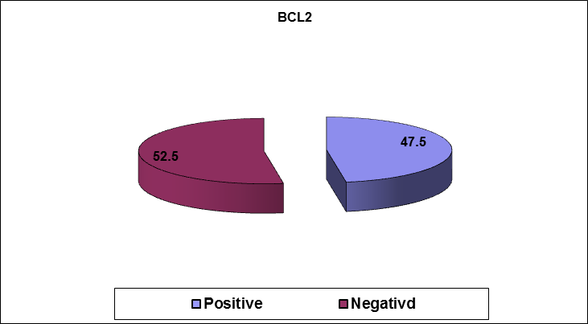
Fig 1: BCL2 showed positivity in 29 cases (47.54%).
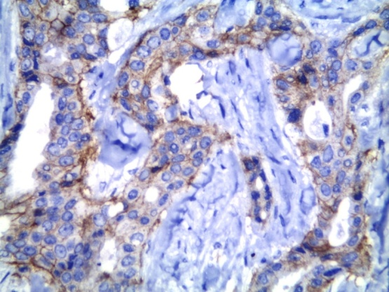
Fig2a: bcl2 positive expression in grade I infiltrating duct carcinoma breast.
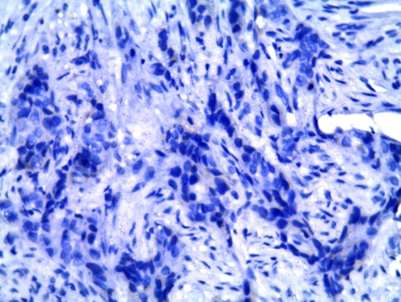
Fig2b: bcl2 positive expression in grade II infiltrating duct carcinoma breast.

BCL2 is a predictor for response in patients who receive neoadjuvant chemotherapy. There was a statistical significant correlation when looking at the effect of BCL2 positivity on the response to neoadjuvant chemotherapy (p = 0.005). Among 61 patients with triple receptor negative locally advanced infiltrating duct carcinoma treated with a sequential regimen containing anthracycline and taxanes -based regimen, 32 of 61 (52.46%) were BCL2 -ve. Thirteen of 32 (40.63%) of TNBC patients with BCL2-ve achieved complete response versus 4 of 29 (13.79%) of those with BCL2+ve (P = 0.005). In multivariate analysis, also BCL2 was independently related to this end point.

Relationships to survival:
BCL2 expression was analyzed in relation to DFS. Patients with triple receptor negative locally advanced infiltrating duct carcinoma of the breast who received neoadjuvant anthracycline and taxanes -based regimen, BCL2-ve tumors who achieved complete response had a clinical outcome similar to those with BCL2+ ve tumors. The 1 year, 2 year, and 3 year DFS for patients whose tumors are positive for BCL2 without residual disease after neoadjuvant sequential regimen containing anthracycline and taxanes -based regimen was 92 %, 81% and 70% compared to 91%, 80% and 65% for the women with BCL2 negative tumors, respectively (P = 0.799) (Fig. 3).
In a univariate analysis, among 44 patients who had residual disease after neoadjuvant anthracycline and taxanes -based regimen, 19 patients with BCL2-ve had a worse DFS (HR 0.541, 95% CI 0.298 – 0.851, P = 0.012) compared with those with BCL2 + ve expression. Thus, BCL2 expression was significantly associated with a longer DFS (P = 0.012) (Figure 4) in univariate analysis. Thus the Kaplan–Meier survival curves demonstrate the better prognosis of BCL2 +ve tumors who had residual disease after neoadjuvant sequential regimen containing anthracycline and taxanes -based regimen.
The 1 year, 2 year, and 3 year DFS for patients whose tumors are positive for BCL2 with residual disease after neoadjuvant sequential regimen containing anthracycline and taxanes -based regimen was 95 %, 79% and 70% compared to 85%, 53% and 40% for the women with BCL2 negative tumors, respectively (P = 012) as shown in (fig 4).

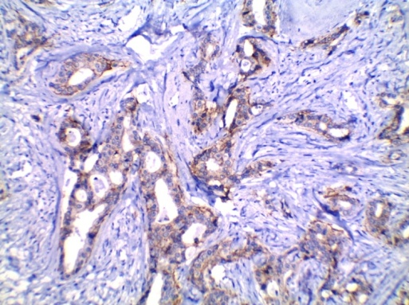
Fig 2c: bcl2 positive expression in grade III infiltrating duct carcinoma breast.
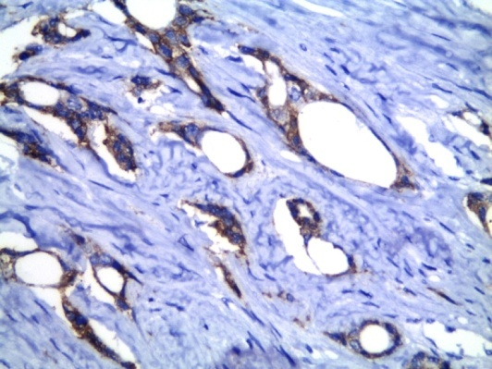
Fig 2d: bcl2 negative expression in grade III infiltrating duct carcinoma breast.
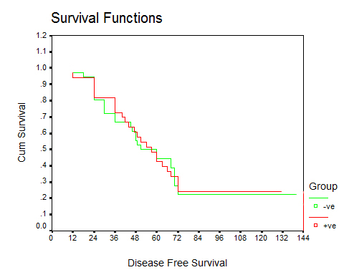
Fig 3: Disease free survival in months for patients with triple receptor negative locally advanced infiltrating duct carcinoma of the breast, who achieved complete response after neoadjuvant sequential regimen containing anthracycline and taxanes -based regimen. The 1 year, 2 year, and 3 year DFS for patients whose tumors are positive for BCL2 without residual disease after neoadjuvant sequential regimen containing anthracycline and taxanes -based regimen was 92 %, 81% and 70% compared to 91%, 80% and 65% for the women with BCL2 negative tumors, respectively. (P = 0.799).

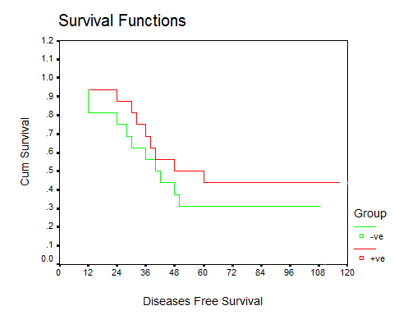
Fig 4: Disease free survival in months for patients with triple receptor negative locally advanced infiltrating duct carcinoma of the breast, who had residual disease after neoadjuvant sequential regimen containing anthracycline and taxanes -based regimen. The 1 year, 2 year, and 3 year DFS for patients whose tumors are positive for BCL2 with residual disease after neoadjuvant sequential regimen containing anthracycline and taxanes - based regimen was 95 %, 79% and 70% compared to 85%, 53% and 40% for the women with BCL2 negative tumors, respectively (P = 012).

4. Discussion
Breast cancer is a heterogeneous tumor with variable behavior. There is a need to have definite markers that can predict whether those cancers have a better or a worse prognosis and also those which aid in the selection of appropriate therapy and predict the response to this therapy. for proper management of individual patients (21).
Triple negative breast cancer (TNBC) is a subpopulation of breast cancer with aggressive behavior, characterized by a lack of expression of estrogen receptors, progesterone receptors, and human epidermal growth factor receptor 2 (HER2) (22). It is believed that prognosis of TNBC is poor (23). Several studies have shown an increased response rate to systemic chemotherapy in patients with TNBC (24-25-26), and because of rapid proliferation rates and defects in DNA repair, improvements in chemotherapy are likely to preferentially benefit TNBC. However, they have no preferred chemotherapy in treatment (27).
The current work is focused on studying BCL2 as a biological marker that could be used in treatment to individual patients with TNBC. In our study 32 out of 61 (52.46%) patients treated with anthracycline and taxanes -based regimen were BCL2 –ve.
Our results showed that the response to neoadjuvant chemotherapy had an inverse significant correlation with BCl2 expression, as 13 patients out of 32 BCL2 –ve patient (40.63%) achieved complete response. while 4 of 29 (13.79%) BCL2 +ve patient achieved complete response to chemotherapy (P = 0.005). Multivariate analysis, also showed that BCL2 was independently related to this end point. This finding showed the increasing importance of routine assessment of BCL2 status in TNBC patients, which may improve the outcome, as a predictive factor. This was agreed with Von Minckwitz et al (28), who showed that there was a relationship between lack of achievement of complete response and BCL2 over-expression in breast carcinoma.
In our study, BCL2-ve triple receptor negative locally advanced infiltrating duct carcinoma patients who received neoadjuvant sequential regimen containing anthracycline and taxanes -based regimen and who achieved complete response had no significant differences with patients with BCL2+ve tissue expression. The DFS at 1 year, 2 year, and 3 year for patients with BCL2 +ve tumor without residual disease after neoadjuvant anthracycline and taxanes -based regimen was 92 %, 81% and 70% compared to 91%, 80% and 65% for the women with BCL2 -ve tumors, respectively (P = 0.799). Thus, we found that complete response following neoadjuvant sequential anthracycline and taxanes has been proved to be associated with an improved outcome, suggesting that staining for Bcl2 status in TNBC patients could help in identifying the patients who would be ideal for neoadjuvant sequential regimen containing anthracycline and taxanes as evidenced by our results, and similar previous studies (28-29-30-31).
However, in our study, it was found that BCL2 +ve patient who had residual disease after neoadjuvant anthracycline and taxanes -based regimen, has a better prognosis than that in BCL2 –ve patients, so BCL2-ve patients are considered to have a limited response to anthracycline-based treatment and targeting alternative pathways is recommended and need further investigation.
The results of our study showed that BCL2 could be a promising prognostic marker in TNBC as it had a highly significant relationship with longer duration of DFS in univariate analysis. The Kaplan–Meier survival curves demonstrate the better prognosis of BCL2 +ve tumors that had residual disease after neoadjuvant sequential regimen containing anthracycline and taxanes -based regimen.
Several studies reported the importance of BCL2 as a prognostic factor in TNBC, and showed that loss of BCL2 increase the risk of treatment failure (32-33-34-35), these were in a agreement with our study.
Diversely Tawfik et al (36) found that TNBC BCL2+ve patients had an adverse prognostic factor and even was independent from other factors in a multivariate analysis and showed that BCL2 over expression was an independent poor prognostic factor in TNBC. This finding may be due the multiple functions of BCL2, as it acts as both an anti-apoptotic factor and also prolongs cell cycle at G0 phase; this explain why BCL2+ve cells recover earlier from damage caused by chemotherapy. However, BCL2-ve tumors has a better response to treatment, may be due to increased damage of DNA, abnormal mitoses and subsequent mitotic catastrophe which its mechanism is unknown, but it may be due to a combination of deficient cell-cycle checkpoints (especially the DNA structure checkpoints and the spindle assembly checkpoint) and cellular damage. Conversely, BCL2-ve non-responding tumors could be explained through accumulation of genetic abnormalities that would not lead to a mitotic catastrophe but rather to aneuploidy and subsequent growth advantage (29-30-31).
Interestingly, Abdel-Fatah et al (37) found that higher mitotic index was associated with loss of Bcl2 in TNBC and also accompanied with low levels of MDM4 (p53-inhibitory factor), p27 (G0/G1 check protein), and SPAG5 which is essential for cell cycle progression and fidelity of chromosomal separation.
In conclusion, our study showed that BCL2 could have a prognostic and predictive significance in patients with TNBC and it appears to be a useful marker of good prognosis in locally advanced TNBC who had residual disease after neoadjuvant anthracycline and taxanes based regimen. BCL2 also can be used to detect cases with aggressive biological behavior who can benefit from more aggressive therapy. So routine assessment of BCL2 status in triple negative breast cancer patients which may improve the outcome, as a predictive and prognostic factor is recommended. However, larger number of cases and longer follow up period are required to confirm our results in a multivariate analysis.

References
- Siegel R, Ma J, Zou Z, Jemal A. Cancer statistics, 2014. Cancer J Clin. 2014; 64(1):9–29.
- Abramson VG1, Lehmann BD, Ballinger TJ, Pietenpol JA. Subtyping of triple-negative breast cancer: implications for therapy. Cancer. 2015; 121(1):8-16.
- Cheang MC, Martin M, Nielsen TO, et al. Quantitative hormone receptors, triple-negative breast cancer (TNBC), and molecular subtypes: a collaborative effort of the BIG-NCI NABCG. J Clin Oncol. 2012; 30(Suppl) abstr 1008.
- Lehmann BD, Pietenpol JA, Tan AR. Triple-negative breast cancer: molecular subtypes and new targets for therapy. Am Soc Clin Oncol Educ Book. 2015; 35:e31-9.
- Beca F, Santos R, Vieira D, et al. Primary relapse site pattern in women with triple-negative breast cancer. Pathol Res Pract. 2014 Sep; 210(9):571-5.
- Ossovskaya V, Wang Y, Budoff A et al. Exploring molecular pathways of triple negativ breast cancer. Genes Cancer 2011; 2: 870–879.
- Brouckaert O, Wildiers H, Floris G et al. Update on triple-negative breast cancer prognosis and management strategies. Int J Womens Health 2012; 4: 511–520.
- Amos KD, Adamo B, Anders CK. Triple-negative breast cancer: an update on neoadjuvant clinical trials. Int J Breast Cancer 2012; 2012: 385978.
- FRANCESCHINI G., TERRIBILE D., MAGNO S., FABBRI C., D’ALBA P.F., CHIESA F., LEONE A. DI, MASETTI R. (2007): Update in the treatment of locally advanced breast cancer: a multidisciplinary approach. European Review for Medical and Pharmacological Sciences; 11: 283-289.
- Barrans S, Crouch S, Smith A et al. Rearrangement of MYC is associated with poor prognosis in patients with diffuse large B-cell lymphoma treated in the era of rituximab. J Clin Oncol 2010; 28: 3360–3365. 8.
- Callagy GM, Pharoah PD, Pinder SE et al. Bcl-2 is a prognostic marker in breast cancer independently of the Nottingham Prognostic Index. Clin Cancer Res 2006;12: 2468–2475.
- Dawson SJ, Makretsov N, Blows FM et al. BCL2 in breast cancer: a favourable prognostic marker across molecular subtypes and independent of adjuvant therapy received. Br J Cancer 2010; 103: 668–675.
- van Slooten HJ, van de Vijver MJ, van de Velde CJ et al. Loss of Bcl-2 in invasive breast cancer is associated with high rates of cell death, but also with increased proliferative activity. Br J Cancer 1998; 77: 789–796.
- Abdel-Fatah TM, Powe DG, Ball G et al. Proposal for a modified grading system based on mitotic index and Bcl2 provides objective determination of clinical outcome for patients with breast cancer. J Pathol 2010; 222:388–399.
- Gasparini G, Barbareschi M, Doglioni C et al. Expression of bcl-2 protein predicts efficacy of adjuvant treatments in operable node-positive breast cancer. Clin Cancer Res 1995; 1: 189–198.
- O'Toole DM and Golden AM (1991): Evaluating cancer patients for rehabilitation potential. West J Med. 155: 384-387.
- NCI Common Terminology Criteria for Adverse Events v3.0 (CTCAE) http://ctep.cancer.gov/protocoldevelopment/electronic_applications/docs/ctcaev3.pdf Cancer Therapy Evaluation Program, Common Terminology Criteria for Adverse Events, Version 3.0, DCTD, NCI, NIH, DHHS. March 31, 2003.
- Tavassoli FA and Devilee P. (2003): World Health Organization Classification of Tumors: Pathology and Genetics of Tumors of the Breast and Female Genital Organs. IARC Press: Lyon, France, 2003. 22-.
- Alis Dema1, Simona Dragan2, Elena Lazar1, Danina Munteanu3, Sorina Taban1, Codruta Lazureanu1, Traila Nicola4 (2008): BCL-2 EXPRESSION IN BREAST CARCINOMAS IN POSTMENOPAUSAL WOMEN: TMJ, Vol. 58, No. 3 - 4.
- Kaplan EL, Meier P (1958): Nonparametric estimation from incomplete observations. J Am Stat Assoc. 53: 457-481. Hinnis AR, Luckett JCA and Walker RA (2007): Survivin is an independent predictor of short-term survival in poor prognostic breast cancer patients. Br J Cancer. 96: 639 – 645.
- Bauer KR, Brown M, Cress RD, Parise CA, Caggiano V. Descriptive analysis of estrogen receptor (ER)-negative, progesterone receptor (PR)-negative, and HER2-negative invasive breast cancer, the so-called triple-negative phenotype: a population-based study from the California Cancer Registry. Cancer 2007; 109 (9):1721–8.
- Brouckaert O, Wildiers H, Floris G et al. Update on triple-negative breast cancer: prognosis and management strategies. Int J Womens Health 2012; 4: 511–520.
- Carey LA, Dees EC, Sawyer L, Gatti L, Moore DT, Collichio F, et al. The triple negative paradox: primary tumor chemosensitivity of breast cancer subtypes. Clin Cancer Res 2007; 13:2329–34.
- Metzger-Filho O, Tutt A, de Azambuja E, Saini KS, Viale G, Loi S, et al. Dissecting the heterogeneity of triple-negative breast cancer. J Clin Oncol 2012; 30 (15):1879–87.
- Rouzier R, Perou CM, Symmans WF, Ibrahim N, Cristofanilli M, Anderson K, et al. Breast cancer molecular subtypes respond differently to preoperative chemotherapy. Clin Cancer Res 2005; 11: 5678–85.
- Wang J, Shi M, Ling R, Xia Y, Luo S, Fu X, et al. Adjuvant chemotherapy and radiotherapy in triple-negative breast carcinoma: a prospective randomized controlled multi-center trial. Radiother Oncol 2011; 100 (2): 200–4.
- von Minckwitz G, Sinn HP, Raab G et al. Clinical response after two cycles compared to HER2, Ki-67, p53, and bcl-2 in independently predicting a pathological complete response after preoperative chemotherapy in patients with operable carcinoma of the breast. Breast Cancer Res 2008; 10: R30.
- Sierra A, Castellsague X, Escobedo A et al. Bcl-2 with loss of apoptosis allows accumulation of genetic alterations: a pathway to metastatic progression in human breast cancer. Int J Cancer 2000; 89: 142–147.
- O’Reilly LA, Huang DC, Strasser A. The cell death inhibitor Bcl-2 and its homologues influence control of cell cycle entry. EMBO J 1996; 15: 6979–6990.
- van Slooten HJ, van de Vijver MJ, van de Velde CJ et al. Loss of Bcl-2 in invasive breast cancer is associated with high rates of cell death, but also with increased proliferative activity. Br J Cancer 1998; 77: 789–796.
- Callagy GM, Pharoah PD, Pinder SE et al. Bcl-2 is a prognostic marker in breast cancer independently of the Nottingham Prognostic Index. Clin Cancer Res 2006; 12: 2468–2475.
- Dawson SJ, Makretsov N, Blows FM et al. BCL2 in breast cancer: a favourable prognostic marker across molecular subtypes and independent of adjuvant therapy received. Br J Cancer 2010; 103: 668–675.
- Abdel-Fatah TM, Powe DG, Ball G et al. Proposal for a modified grading system based on mitotic index and Bcl2 provides objective determination of clinical outcome for patients with breast cancer. J Pathol 2010; 222:388–399.
- Ali HR, Dawson SJ, Blows FM et al. A Ki67/BCL2 index based on immunohistochemistry is highly prognostic in ER-positive breast cancer. J Pathol 2012; 226: 97–107.
- Tawfik K, Kimler BF, Davis MK, Fan F, Tawfik O. Prognostic significance of Bcl-2 in invasive mammary carcinomas: a comparative clinicopathologic study between “triple-negative” and non-”triple-negative” tumors. Hum Pathol 2012; 43(1):23–30.
- Abdel-Fatah TMA, Perry C, Dickinson P, Ball G, Moseley P, Madhusudan S, Ellis IO & Chan SYT. Bcl2 is an independent prognostic marker of triple negative breast cancer (TNBC) and predicts response to anthracycline combination (ATC) chemotherapy (CT) in adjuvant and neoadjuvant settings. Annals of Oncology 2013: 1–7.

3/17/2020

