PDL1 Expression as a Prognostic Factor in Female Patients with Invasive Breast cancer

Walid Almorsy¹, Asmaa Elkady¹ and Dareen Mohamed²

¹Clinical Oncology Department, Faculty of Medicine, Tanta University, Gharbia, Egypt
²Pathology Department Faculty of Medicine, Tanta University, Gharbia, Egypt
walidaa1@hotmail.com

Abstract: In relation to the apoptosis program, programmed death-1 ligand 1 (PDL1) has been named as a programmed cell death1 receptor. There is growing indication of a dynamic crosstalk among the breast cancer cells and immune system. The existence of regulatory T cells in peripheral blood in addition to the breast tumors tissue are documented in many advanced studies. So, we aimed in this study to evaluate PDL1 as a prognostic factor in relation to other clinicopathological factors and survival. Patients and Methods: This retrospective study was performed at Clinical Oncology Department, Tanta University Hospital, from Jun 2011 to Jun 2016 on one hundred and sixty three (163) female breast cancer patients with histopathologically confirmed invasive ductal carcinoma. Patient's data were recorded. Specimens from affected lesions of breast tissues were fixed in formalin and processed for hisopathological examination after staining with IHC for PD-L1. Results: PDL1 expression was significantly connected with N stage, hormonal levels, lymphovascular invasion, grade of tumor (p), tumor size, molecular subtypes and menopausal status. The 5-years OS owing to PDL1 expression was 50.1% for positive expression and 72.6% for negative expression (p<0.001). The 5-years DFS according to PDL1 expression was 22.4% for positive expression and 77.9% for negative expression (p <0.001). The results revealed to a significant 5-years OS rate with PDL1 expression and age in multivariate analysis. The 5-years DFS showed significant correlation with PDL1 expression, nodal status, hormoenal status and Ki67 expression. Conclusion: PDL1 expression was significantly associated with N stage, hormonal levels, lymphovascular invasion, grade of cancer, tumor size, molecular subtypes and menopausal status.PDL1 expression was independent prognostic factors for invasive breast carcinoma and therefore can be considered as independent indicator for bad prognosis and can be used as goal for the discovery of novel treatments.
[Walid Almorsy, Asmaa Elkady and Dareen Mohamed. PDL1 Expression as a Prognostic Factor in Female Patients with Invasive Breast cancer. Cancer Biology 2020;10(1):53-60]. ISSN: 2150-1041 (print); ISSN: 2150-105X (online). http://www.cancerbio.net.7. doi:10.7537/marscbj100120.07.

Keywords: PDL1; Expression; Prognostic; Factor; Female; Patient; Invasive Breast cancer

1. Introduction
Breast cancer is the most commonly diagnosed tumor and the main etiology of cancer related mortality in women in the world [1]. In the few past decades the frequency of breast tumor has elevated progressively, as a result of the great advances achieved in the treatment of breast cancer, the mortality due to breast cancer seemed to be diminishing [2-3].
Programmed death 1 ligand 1 (PD-L1) is an immunoglobulin superfamily haplotype type I transmembrane glycoprotein, which has been named as a programmed cell death-1 receptor in relation to the apoptosis program. [1] Human PD-1 gene, also known as CD279, was located in the chromosome 2q37.35 with relative molecular weight of 55 kDa and composed of extracellular domain, transmembrane domain, and intracellular domain. [2] PD-L1 was widely expressed on the surface of B lymphocytes, monocytes, natural killer cells, macrophages, and vascular endothelial cells. It was also upregulated in human tumor cell lines, such as ovarian cancer, lymphoma, and malignant melanoma, indicating a close relationship with the occurrence and development of tumors. [3] The expression of PD-L1 in various tissue specimens has been studied, such as colon cancer, [4] malignant melanoma, [5,6] non-small cell lung cancer, renal cell carcinoma, and esophageal cancer. [7,8]
There is increasing indication of a dynamic crosstalk among the breast cancer and immune system in spite of the breast tumor is usually assumed to be less immunogenic than RCC or melanoma. Recently, regulatory T cells were recorded in the breast tumors tissue and in peripheral circulation of patients [9, 10]. Moreover, PD-L1 is expressed on breast cancer cells while, inhibitory molecules of the CD28 receptor
family are up regulated on breast tumor-specific T cells[11–13].
So, we aimed in this study to evaluate PDL1 as a prognostic factor in relation to other clinicopathological factors and survival.

2. Patients and Methods
The current work (retrospective study) was carried out at Tanta University Hospital, Department of Clinical Oncology, at the period from Jun 2011 to Jun 2016 on one hundred and sixty three (163) female breast cancer patients with diagnosed and confirmed invasive ducal carcinoma by histopathological examination. Various parameters concerning the patients were obtained involving; clinical symptoms, menopausal status, age, pathology, tumor size (T), tumor grade (G), number of previous excisions and lymphovascular invasion (LVI), invaded axillary lymph nodes (N), progesterone receptors (PR), Estrogen receptors (ER), Her-2neu expression status and Ki67 expression. Complete blood profile, blood chemistry tests (kidney and liver functions tests), Imaging studies (abdominopelvic ultrasound, Chest X-ray, MRI, CT, and scan of bone were performed.

PDL1 expression
Specimens of tissues were obtained from the breast lesion and fixed in formalin, paraffin-embedded and processed for immunohistochemical technique which done in the department of Pathology, Tanta University Hospital.

Evaluation of PDL1Immunostainin

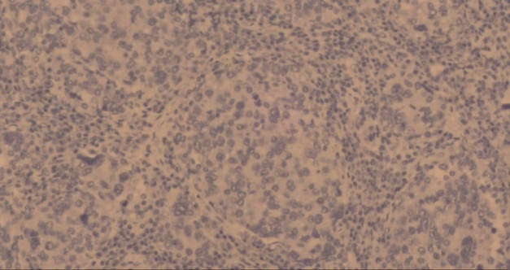
Fig A: invasive ductal carcinoma showed negative expression of PDL1[X400]

Staining for PD-L1 by using immunohistochemistry (IHC) technique was carried out in 3 μm sections from paraffin blocks. In this technique an anti-human PD-L1 rabbit monoclonal antibody was used as the primary antibody. The procedures of IHC were performed according to the instructions of manufacturers of the IHC kit. Positive (human tonsil) and negative staining were done in corresponding to the paraffin sections. Positivity for PDL-1 marker was determined depending on the following criteria: cytoplasmic and membranous staining ≥1% in tumour cells and graded according to intensity of staining of tumor cells into mild [+1] moderate [+2] and strong [+3]

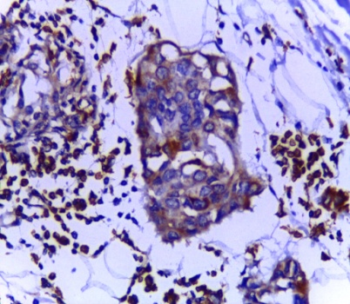
Fig B: invasive ductal carcinoma showed strong expression of PDL1[X400]

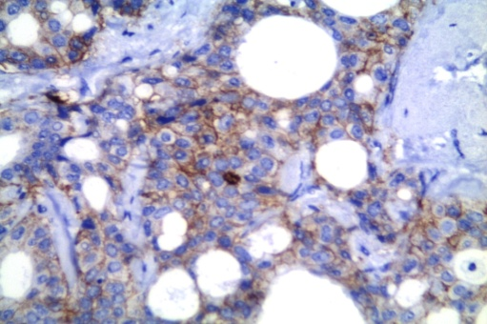
Fig C: invasive ductal carcinoma showed moderate expression of PDL1[X400]

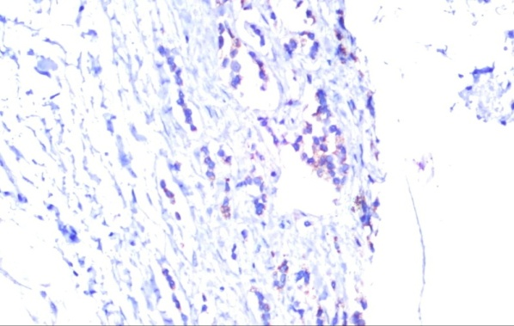
Fig D: Invasive lobular showed mild expression of PDL1[X400]

Statistical analysis
Statistical Package for the Social Sciences, version 21.0 (SPSS Inc., Chicago, IL, USA) was used for statistical analysis of all data. Chi-square test was applied for estimation of the correlation among PDL1 expression and clinicopathologicalfeatures. An independent prognostic factors for Overall survival was determined by using univariate and multivariate analyses. The Kaplan-Meier method was used for estimation of overall survival (OS), and the log-rank test was used analyzing the differences in survival rates. Pvalue less than 0.05 was considered to be significant statistically.

3. Results
The current investigation assessed an invasive ductal breast carcinoma patients (163 women), their ages averaged 50.4 ± 11.41 years, and ranged from 24 to 75 years, while the follow up period extended from 5 to 8 years. PDL1 expression was significantly correlated with N stage (p<0.02), hormonal status (p=0.005), tumor grade (p<0.005), lymphovascular invasion (p<0.007), tumor size (p<0.001), molecular subtypes (p<0.001) and menopausal status (P=0.04) as demonstrated in Table (1). Though, the statistical analysis not revealed to a significant connection with age (p=0.12), Her-2 expression (p=0.81) and tumor pathology (p=0.13). The 5-years overall survival (OS) and Disease free survival (DFS) in all cases were averaged 63.4% and 56.1%, respectively (Figs. 2 & 3). Figure (1) revealed that the 5-years OS between all patients according to PDL1 expression was 50.1% for positive expression and 72.6% for negative expression (p<0.001). The 5-years DFS between all patients rendering to PDL1 expression was 22.4% for positive expression and 77.9% for negative expression (p <0.001) (Fig. 2). By applying univariate analysis, there was significant impact on 5-year OS rate with T stage (p=0.004), PDL1 (p<0.001), hormonal status (p=0.024), N stage (p=0.038), lymphovascular invasion (p=0.007), Ki67 (p=0.001), molecular subtypes (P= 0.01) and age (p <0.001) as tabulated in table (2). Menstrual status, pathology, grade and Her/2-neu showed insignificant correlation with 5 year OS rate as P –value for them was (p=0.106), (p=0.115), (p=0.415) and (p=0.598) respectively. A significant effect on 5-year DFS rate with Tumor size (p=0.04), N stage (p<0.001), Hormonal status (p=0.012), Her-2/neu (p=0.028), lymphovascular invasion (p=0.025), Age (p=0.007), Ki67 (p<0.001) and molecular subtypes (p<0.001), while menstrual status, pathological type and grade of differentiation showed insignificant correlation with 5 year DFS rate as P –value for them was (p=0.27), (p=0.477) and (p=0.06) respectively, as estimated by the univariate analysis (Table3). In multivariate analysis, (Table 3), there was significant 5-years OS rate with PDL1 expression (p=0.014) and age (p <0.038). multivariate analysis, (Table 3) according to 5-years DFS showed significant correlation with PDL1 expression (p<0.001), Nodal status (p <0.001), hormonal status (p=0.023) and Ki67 expression (p<0.001).

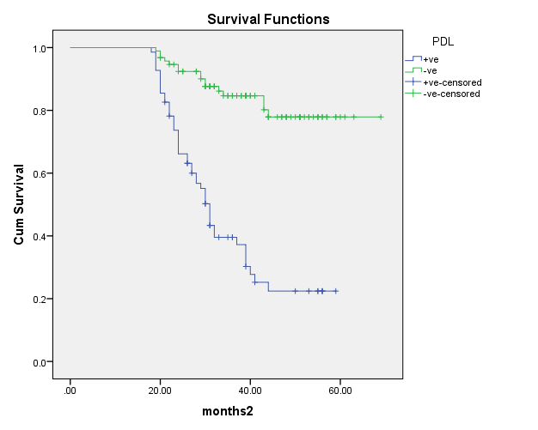
Fig. (1) Disease free survival

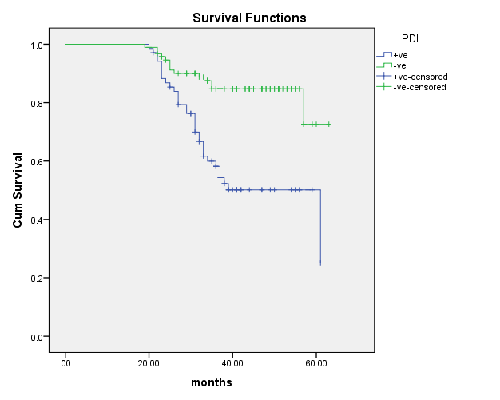
Fig. (2) Overall survival

Table (1): Patient characteristics according to PDL1 expression
 |  | PDL1-ven = 94 (57.67%) | PDL1+ven = 69 (42.33%) | P
Age
≤50 | 62(38%) | 31(33%) | 31(44.9%) | 0.12
>50 | 101(62%) | 63(67%) | 38(55.1%)
Pathology
Ductal | 144(88.3%) | 80(85.1%) | 64(92.8%) | 0.13
Lobular | 19(11.7%) | 14(14.6%) | 5(7.2%)
Menopause
Pre | 72(44.2%) | 35(37.5%) | 37(53.6%) | 0.04*
Post | 91(55.8%) | 59(62.5%) | 32(46.4%)
N  N0  N+ve | 69 (42.3%)  94 (57.7%) | 47(50%)  47(50%) | 22(31.9%)  47(68.1%) | 0.02*
Grade
G1&2 | 118(72.4%) | 76(80.9%) | 42(60.9%) | 0.005*
G3 | 45(27.6%) | 18(19.1%) | 27(39.1%)
LVI
Non | 100(61.3%) | 66(70.2%) | 34(49.3%) | 0.007*
Yes | 63(38.7%) | 28(29.8%) | 35(50.7%)
radiotherapy
Yes | 68(78.2%) | 12(52.2%) | 56(87.5%) | <0.001
No | 19(21.8%) | 11(47.8%) | 8(12.5%)
Ki67
Low | 51(31.3%) | 40(42.6%) | 11(15.9%) | <0.001*
High | 112(68.7%) | 54(57.4%) | 58(84.1%)
Her-2  Positive  Negative | 35(21.5%)  128(78.5%) | 20(20.8)76(79.2%) | 15(22.4%)  52(77.6%) | 0.81
Tumor size  <=5  >5 | 101(62%)  62(38%) | 69(73.4)  25(26.6) | 32(46.4)  37(53.6) | <0.001*
Hormonal status  +ve  -ve | 120(73.6)  43(26.4) | 77(81.9)  17(18.1) | 43(62.3)  26(37.7) | 0.005*
Luminal A  Luminal B  Her-2 +ve  Triple -ve | 47(28.8)38(40.4)  76(46.6)39(41.5)  18(11)7(7.4)  22(13.5)10(10.6 | 9(13)  37(53.6)  11(15.9)  12(17.4) |  | 0.001*

Table (2): Univariate and multivariate analysis of factors affecting Overall Survival rate
Factor | Univariate analysis according to OS | P | HR (95% CI) | p-value
Age  ≤50 years  >50 years | 53.2  79.7 | <0.001 | 0.494 (0.254-0.961) | 0.038
Pathology  Ductal Ca.  Lobular Ca. | 61.3  88.5 | 0.115
N stage  Negative  Positive | 78.2  50.9 | 0.038 | 1.231 (0.918 – 1.649) | 0.165
Menopausalstatus  Pre-  Post- | 61.3  75.8 | 0.106
LVI  -ve  +ve | 77.5  57.4 | 0.007 | 1.162 (0.575-2.349) | 0.676
Her-2/neu status  +ve  -ve | 62.2  64.5 | 0.598
Tumor size  < 5  ≥ 5 | 79.3  27.3 | 0.004 | 0.900 (0.408 – 1.986) | 0.795
Grade  1-2  3 | 58.9  66.1 | 0.415
Hormonal Status  Positive  negative | 65.9  56.0 | 0.024 | 1.531 (0.702 – 3.339) | 0.284
PD-L1  +v  -ve | 50.1  72.6 | <0.001 | 0.408 (0.200 – 0.833) | 0.014
Ki67  Low  high | 79.4  60.0 | 0.001 | 2.403 (0.803-7.189) | 0.117
Molecular subtypes  Luminal A  Luminal B  Her-2/neu +ve  Triple - ve | 77.4  64.9  53.3  57.9 | 0.01 | 0.876 (0.536 – 1.433) | 0.599

Table (3) Univariate & multivariate analysis of factors affecting Disease fee Survival rate
Factor | Univariate analysis according to DFS | P | HR (95% CI) | p-value
Age  ≤50 years  >50 years | 41.3  61.6 | 0.007 | 0.656 (0.363-1.187) | 0.164
Pathology  Ductal Ca.  Lobular Ca. | 53.0  63.2 | 0.477
N stage  Negative  Positive | 64.6  45.9 | <0.001 | 1.677 (1.282 – 2.193) | <0.001
Menopausalstatus  Pre-  Post- | 48.7  58.1 | 0.27
LVI  -ve  +ve | 58.2  48.3 | 0.025 | 0.852 (0.468-1.549) | 0.599
Her-2/neu status  +ve  -ve | 33.7  58.7 | 0.028 | 0.819 ( 0.444 – 1.513) | 0.524
Tumor size  < 5  ≥ 5 | 58.6  47.1 | 0.044 | 0.575 (0.293 – 1.126) | 0.107
Grade  1-2  3 | 60.5  41.0 | 0.06
Hormonal Status  Positive  negative | 64.3  33.4 | 0.012 | 2.260 ( 1.120 – 4.559) | 0.023
PD-L1  +v  -ve | 22.4  77.9 | <0.001 | 0.202 (0.107 – 0.384) | <0.001
Ki67  Low  high | 78.4  41.3 | <0.001 | 5.949 (2.311-15.317) | <0.001
Molecular subtypes  Luminal A  Luminal B  Her-2/neu +ve  Triple - ve | 81.9  47.9  29.6  32.4 | <0.001 | 0.734 (0.488 – 1.102 ) | 0.136

4. Discussion
In this study, one hundred and sixty three female patients with invasive ductal carcinoma of the breast were evaluated and PDL1 expression was expressed in 42.3% of all patients. Triple negative had higher incidence (12/22 patients, 54.5%). Positive expression of PDL1 was correlated significantly with N stage (p<0.02), hormonal status (p=0.005), tumor grade (p<0.005), lymphovascular invasion (p<0.007), tumor size (p<0.001), molecular subtypes (p<0.001) and menopausal status (P=0.04). Whereas, there was a non-significant association with tumor pathology (p=0.13), age (p=0.12) and Her-2 expression (p=0.81). The 5-years Disease free survival (DFS) and overall survival (OS) rates obtained from all women in the study were averaged 56.1% and 63.4%, respectively.
The 5-years OS within all diseased women depending on PDL1 expression was averaged 50.1% for positive expression and 72.6% for negative expression (p<0.001). While, the 5-years DFS within all diseased women basing on PDL1 expression was averaged 22.4% for positive expression and 77.9% for negative expression (p <0.001).
There was a significant effect by using univariate analysis, on 5-year OS rate with N stage (p=0.038), T stage (p=0.004), PDL1 (p<0.001), hormonal status (p=0.024), lymphovascular invasion (p=0.007), Ki67(p=0.001), molecular subtypes (P= 0.01)and age (p <0.001). Menstrual status, pathology, grade and Her/2-neudemonstrated a non-significant relationship with 5 year OS rate as P –value for them was (p=0.106), (p=0.115), (p=0.415) and (p=0.598) respectively. Meanwhile, univariate analysis showed a significant impact on 5-year DFS rate with Tumor size (p=0.04), N stage (p<0.001), Hormonal status (p=0.012), Her-2/neu (p=0.028), lymphovascular invasion (p=0.025), Age (p=0.007), Ki67 (p<0.001) and molecular subtypes (p<0.001), while menstrual status, pathological type and grade of differentiation presented anon-significant link with 5 year DFS rate (p=0.27, p=0.477and p=0.06 respectively).
In multivariate analysis for5-years OS ratethere was significant correlation with PDL1 expression (p=0.014) and age (p <0.038). multivariate analysis, according to 5-years DFS showed significant correlation with PDL1 expression (p<0.001), Nodal status(p <0.001), hormonal status (p=0.023) and Ki67 expression (p<0.001).
Some studies showed that patients with positive lymph node metastasis, ER- negativity and higher histological grades have a tendency to increase in the levels of expression of PD-L1 than patients without metastasis in lymph nodes, ER-positivity and lesser histological grades. Also, PD-L1 was expressed more commonly in TNBC than in non-TNBC and their findings reveal that rise inPD-L1 expression may be a prognostic marker for decreased OS (Zhang et al., 2017).
Muenst et al ^{[15]} evaluated 650 breast cancer specimens andPD-L1 was expressed in 152 (23.4 %), expression was significantly correlatedwith tumor size, age, tumor grade, AJCC primary tumor classification, high Ki-67 expression, lymph node status and absence of ER expression. PD-L1 expression was associated with a significantly worse OS by using univariate analysis. Whereas, PD-L1 expression remained an independent negative prognostic factor for OS whenmultivariate analysis was applied.Expression of PD-L1 was correlatedsignificantly with worse OS in the luminal B HER2(+ve) subtype, in the luminal B HER2(-ve) subtype, the basal-like subtype and the HER2 subtype, by applying subset analyses.
Fei et al ^{[16]} investigated 112 patients with invasive breast cancer and they found thatthe positive expression of PD-L1 was not related with the patients' age, menopause history, family history of breast cancer, tumor size, and location of the tumor (P> 0.05) while it was related with lymph node metastasis, the clinic staging, and histopathological grading (P< 0.05).

Zhou et al ^{[17]} examined 136 patients with invasive breast cancer for the expression of PD-L1. The expression of PD-1 was associated with the expression of progesterone and estrogen receptors, the histological grade and Ki-67 (P<0.05). The positive expression rates of PD-1 and PD-L1were averaged 43.5% and 47.8 in triple-negative breast cancer (TNBC), which were higher than other subtypes (P<0.05). Regarding breast invasive ductal carcinoma, the expression of PD-L1 in tumor cells was established to be an independent prognostic risk factor with the progression-free survival rate (P=0.003).

Conclusion
PDL1 expression was significantly associated with tumor grade (p), hormonal status, N stage, tumor size, lymphovascular invasion, molecular subtypes and menopausal status. For invasive breast carcinoma, PDL1 expression was not considered dependent prognostic factors. Therefore PDL1 can be applied as independent indicator for bad prognosis and can be used as target for the development of novel treatments. Additional investigate numbers of patients are required.

References:
  - Siegel RL, Miller KD, Jemal A. Cancer statistics, 2016. CA Cancer J Clin.2016; 66:7-30.
  - Early Breast Cancer Trialists’ Collaborative Group (EBCTCG). Effects of chemotherapy and hormonal therapy for early breast cancer on recurrence and 15-year survival: an overview of the randomised trials. Lancet.2005; 365:1687-1717.
  - Gradishar WJ, Anderson BO, Balassanian R et al. Invasive Breast Cancer Version 1.2016, NCCN Clinical Practice Guidelines in Oncology. J Natl Compr Canc Netw.2016; 14:324-354.
  - Grenda A, Krawczyk P. New dancing couple: PD-L1 and microRNA. Scand. J Immunol 2017;86:130-4.
  - Gianchecchi E, Delfino DV, Fierabracci A. Recent insights into the role of the PD-1/PD-L1 pathway in immunological tolerance and autoimmunity. Autoimmun Rev 2013;12:1091-100.
  - Pedoeem A, Azoulay-Alfaguter I, Strazza M et al. Programmed death-1 pathway in cancer and autoimmunity. Clin Immunol 2014;153:145-52.
  - Wang X, Yang L, Huang Fet al. Inflammatory cytokines IL-17 and TNF-α up-regulate PD-L1 expression in human prostate and colon cancer cells. Immunol Lett 2017;184:7-14.
  - Thierauf J, Veit JA, Affolter A et al. Identification and clinical relevance of PD-L1 expression in primary mucosal malignant melanoma of the head and neck. Melanoma Res 2015;25:503-9.
  - Liyanage UK, Moore TT, Joo HG et al (2002) Prevalence of regulatory T cells is increased in peripheral blood and tumor microenvironment of patients with pancreas or breast adenocarcinoma. J Immunol 169(5):2756–2761.
  - Droeser R, Zlobec I, Kilic E et al (2012) Differential pattern and prognostic significance of CD4?, FOXP3? and IL-17? tumor infiltrating lymphocytes in ductal and lobular breast cancers. BMC Cancer 12:134.
  - Czerniecki BJ, Koski GK, Koldovsky U et al (2007) Targeting HER-2/neu in early breast cancer development using dendritic cells with staged interleukin- 12 burst secretion. Cancer Res 67(4):1842–1852.
  - Ghebeh H, Barhoush E, Tulbah A et al (2008) FOXP3? Tregs and B7-H1?/PD-1? T lymphocytes co-infiltrate the tumor tissues of high-risk breast cancer patients: implication for immunotherapy. BMC Cancer 8:57.
  - Ghebeh H, Mohammed S, Al-Omair A et al (2006) The B7-H1 (PD-L1) T lymphocyte inhibitory molecule is expressed in breast cancer patients with infiltrating ductal carcinoma: correlation with important high-risk prognostic factors. Neoplasia 8(3):190–198.

Zhang M, Sun H, Zhao S et al. (2017) Expression of PD-L1 and prognosis in breast cancer: a meta-analysis. Oncotarget. 2017 May 9; 8(19): 31347–31354.
  - Muenst S, Schaerli AR, Gao F et al. (2014) Expression of programmed death ligand 1 (PD-L1) is associated with poor prognosis in human breast cancer. Breast Cancer Res Treat.2014 Jul; 146(1):15–24.
  - Li F, Ren Y, Wang Z et al. Programmed death 1 Ligand 1 expression in breast cancer and its association with patients’ clinical parameters. J Can Res Ther 2018;14:150-4).
  - Zhou T, Xu D, Tang B et al. Expression of programmed death ligand-1 and programmed death-1 in samples of invasive ductal carcinoma of the breast and its correlation with prognosis. Journal of Anti-Cancer Drugs: October 2018 - Volume 29 - Issue 9 - p 904–910.

.

2/29/2020

