Enforcing End-to-side, duct-to-mucosa pancreatico-jejunostomy with seromuscular jejunal flapsis an effective method to prevent pancreatic leakage after pancreatico-duodenectomy

Waheed Y. Gareer, Alaadin Hussein

Surgical Oncology department, National Cancer Institute, Cairo University, Egypt
alaadin.osman@yahoo.com

Abstract: Despite the improvement in perioperative outcomes over the past years and the reduction in operative mortality, pancreatic ﬁstula still represents a common complication and is still considered the main cause of mortality after pancreatico-duodenectomy (PD). The reported incidence of such fistula differed in many researches with some series defining the incidence to range from 2% to 22% 3-7while others reported the incidence to be between 5% to 40%, depending on the deﬁnition of leakage. Most of these leaks resolve with just conservative treatment and just keeping properly placed drains. But it may lead to sepsis, severe hemorrhage and may reach to mortality. In 20% to 40% and result in prolonged hospitalization and increased hospital expenses...…. and so prevention of fistula is of sure considered better than treatment of its complications. Multiple risk factors for fistula development were identified including soft pancreatic texture; size of pancreatic duct, exocrine function of the pancreatic remnant and the technique of anastomosis. Notably the anastomotic technique is the only factor that can be modified by surgeons. As alternatives to the conventional PJ anastomosis, Several techniques were tried in the search for reducing the incidence of fistula formation including isolated Roux loop pancreatico-jejunostomy, end-to-end anastomosis with invagination of the pancreatic stump in the jejunum, pancreatico-gastrostomy and the use of pancreatic stents whether internal or external stents but no technique showed clear evidence to be considered superior. Aim: To evaluate the efficiency and safety of seromuscularjejunal flap done to enforce the classic end-to-side, duct to mucosa pancreatico-jejunostomy and monitoring rate of fistula occurring with this technique. Methods: seventy-three patients underwent the classic non pylorus preserving pancreatico-duodenectomy procedure by our surgical team from May 2013 to June 2019; in all these cases we performed end-to-side duct-to-mucosa pancreatico-jejunostomy with sero-muscular jejunal flap, and stent insertion. The drain amylase was measured on 5th and 8th postoperative days. Results: There were 73 patients who underwent end-to-side, duct-to-mucosa pancreatico-jejunostomy with sero-muscular jejunal flap formation. The mean operative time was 250.3 ± 30.0 min, also, the mean time needed to perform the pancreatico-jejunostomy was 22.4 min, ranging from 17 to 26 min. drain amylase level was normal in 69 patients with only 4 patients (5.48%) developed amylase elevation that normalized on the 8th postoperative day with conservative treatment. one of them needed 12 days to normalize his drain amylase level. none of the 73 patients had any clinical symptoms. one patient developed deep venous thrombosis. There was only 1 post-operative mortality due to myocardial infarction. Conclusion: Enforcing end-to-side pancreatico-jejunostomy with Seromuscularjejunal flap is a safe and technically easy method to prevent pancreatic fistula after pancreatico-duoedenectomy.
[Waheed Y. Gareer, Alaadin Hussein. Enforcing End-to-side, duct-to-mucosa pancreatico-jejunostomy with seromuscular jejunal flapsis an effective method to prevent pancreatic leakage after pancreatico-duodenectomy. Cancer Biology 2020;10(1):31-35]. ISSN: 2150-1041 (print); ISSN: 2150-105X (online). http://www.cancerbio.net. 4. doi:10.7537/marscbj100120.04.

Key words: Whipple; Pancreatico-jejunostomy; Seromuscularjejunal flap; pancreatic fistula

1. Introduction
Since 1935 when PD was first reported by whipple et al, it has been regarded as the proper operation for peri-ampullary carcinoma and pancreatic head cancers (1, 2)
Despite the decrease in the mortality rate associated with PD recently to below 5% (3,4 5, 6). Still the incidence of overall postoperative morbidity rates remains elevated, ranging from 30% to 50% with pancreatic fistula considered the most feared and the commonest complication with a varying incidence ( according to the definition of fistula ) from 2% to 40% in some series (7, 8, 9), while other report the fistula from 2% to 22% (10-14).
The uniformly accepted definition of pancreatic fistula is the presence of amylase rich fluid in the drains from third postoperative day or after; with its concentration greater than three times the serum amylase level (10, 14).

Most of these leaks resolve with just conservative treatment and just keeping properly placed drains (15). But it may lead to sepsis, severe hemorrhage and may reach to mortality. In 20% to 40% (13, 14) and result in prolonged hospitalization and increased hospital expenses. and so prevention of fistula is of sure considered better than treatment of its complications. (16, 17).
Fistula could be classified into 2 categories; clinical and subclinical. The difference is the presence of fever, elevated white cell count, hemodynamic disturbance and collection or sepsis in the clinical type that usually need intervention whether drainage of collection or exploration, while subclinical fistula remains asymptomatic and usually resolve on conservative treatment (5, 7).
Many techniques and modifications were tried in order to decrease occurrence of pancreatic leakage such as pancreatic duct occlusion, using fibrin glue to reinforce the anastomosis, insertion of stent in pancreatic duct, and pancreatico-gastrostomy but no modification has clear evidence to be better regarding the incidence of fistulae (1, 7, 18).

2. Patients and Methods

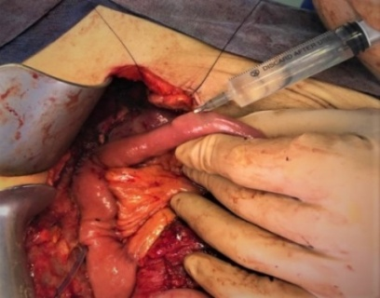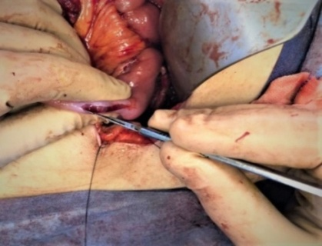
A B
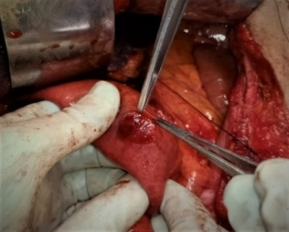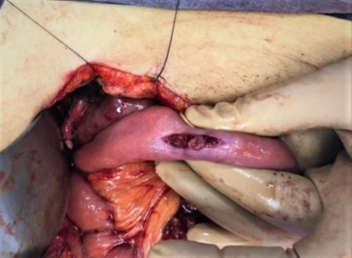
C D
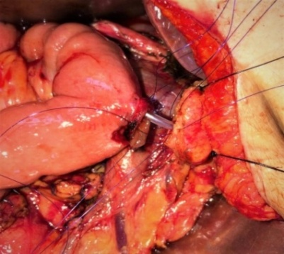
E
Fig (1) a: saline injection in sub-serous plane, b: cutting the serosa with scalpel, c: sero-muscular flaps after elevation, d: hole done in the center of the mucosa, e: stent in place with sutures taken for duct to mucosa anastomosis

During the period May 2013 to June 2019, seventy three patients underwent the classic non-pylorus preserving PD by our surgical team. The types of disease in these patients are shown in Table 1.

Table 1: Type of disease in our patients
Type of disease | Patients number
Pancreatic head carcinoma | 58
Peri-Ampullary carcinoma | 13
Distal common bile duct carcinoma | 2
Total | 73

Technique
After completing the classic PD, a single jejunal loop was used for the needed anastomoses, hepatico-jejunostomy was performed first, and then Saline was injected using insulin syringe needle in the sub-serous plane to facilitate the sero-muscular flap dissection with preserving the mucosa intact. (Fig: 1 a).
The serosa was then cut using a scalpel for a length that equals to the cut pancreatic stump (Fig: 1 b), Then seromuscular flaps are dissected by the scalpel keeping the mucosa intact. (Fig: 1 c)
A hole in the jejunal mucosa is done, with its diameter equal to the pancreatic duct (Fig: 1 d), and duct to mucosa anastomosis was done using interrupted simple sutures by PDS 3/0, first the posterior layer and then a nelaton stent is passed in the pancreatic duct (Fig: 1 e) and after that the anterior layer of duct to mucosa layer is completed in the same technique.
After completion of the duct to mucosa anastomosis; the posterior sero-muscular flap was sutured to the posterior pancreatic edge and then the anterior flap to the anterior edge, both done using interrupted vicryl 3/0 sutures.
After that the gastro-jejuonstomy was done and drains were inserted and abdomen was closed.
Sandostatin was given subcutaneously three times per day for the first 5 days electively in all of our patients. The drain ﬂuid amylase levels were measured from the drain put close to the pancreatico-jejunostomyon both 5th and 8th post-operative days (10).

3. Results
There were 73 patients who underwent end-to-side, duct-to-mucosa pancreatico-jejunostomy with sero-muscular jejunal flap formation. 48 of them were men (65.75%) and 25 were women (34.25%). The mean age was 53.3 years, ranging from 43 to 68 years. The types of disease in these patients are shown in Table 1.
The mean operative time was 250.3 ± 30.0 min, also, the mean time needed to perform the pancreatico-jejunostomy was 22.4 min, ranging from 17 to 26 min. drain amylase level was normal in 69 patients, only 4 patients (5.48%) had drain level higher than normal serum level but didn’t reach 3 times the serum level to be able to name it as a fistula, in three of these patients the amylase level normalized on the 8th postoperative day measure and only one of them whose amylase drain level on 5th day nearly doubled; needed 12 days to drop back to normal level with just conservative treatment in all these four patients.
none of all our 73 patients (either those with normal amylase level nor the 4 patients with elevated levels) had any clinical manifestations, and all started clear fluids on 4th postoperative day and started semisolids on 5th day except the patient with double amylase level who was kept on oral fluids till 8th postoperative day. One patient developed deep venous thrombosis. There was only one post-operative mortality due to myocardial infarction.

4. Discussion
Due to its high rate of failure Pancreatico-jejunostomy, it is considered the most important and challenging step in the Whipple procedure, and the leading cause of morbidity and mortality. (1, 13, 18).
The risk factors for pancreatic fistula include soft pancreas, pancreatic duct size, and the anastomosis technique. With the technique being the only modifiable risk factor; (9, 19). Several technical variations have been proposed, in the search for minimizing postoperative pancreatic fistula rates with no clear evidence indicating superiority of a single technique (1, 16, 17).
Pessaux P et al. investigated the importance of stent placement in the pancreatic duct especially in high risk patients for fistula (small duct size and soft pancreatic remnant) and concluded that pancreatic stent reduced the incidence of fistula and the overall morbidity rates (20). However another comparative study by Jordan M et al, found that fistula rates were similar in stented and non-stented patients (21).
Regarding the routine use of octreotidein the prophylaxis against fistula, some studies as Montorsi M et al. (22) and Abdullah et al. (23) concluded it is effective to significantly reduce the incidence of pancreatic fistula after PD. however other studies as Lowy A M et al denied concluded that octreotide use in prophlaxis cannot be recommended (24).
Seromuscular flap was introduced by Katsaragakis S et al in 2013, where 32 patients were treated, with only one patient developed low output fistula and so they concluded the technique to be safe and reliable. But they advised that more research is still needed because of the small number of patients in their series (15).
We presented a modification to the technique described by Katsaragakis S et al, by injecting saline in the sub-serous plane which we believe that it facilitate flap elevation and also important to keep the mucosa intact during flap elevation.
Also in our series more number of patients was done with no one developed fistula and only four patients experienced mild elevation of amylase in drain not enough to reach the universally accepted definition of fistula which is elevation to three times the serum amylase level.

Conclusion
Seromuscular jejunal flap is a safe and technically easy method to prevent pancreatic fistula after pancreatico-duoedenectomy.

References
- Abu Hilal M, Malik HZ, Hamilton-Burke W, Verbeke C, Menon KV. Modified Cattell’ spancreatic ojejunostomy, buttressing for soft pancreases and an isolated biliopancreatic loop are safety measurements that improve outcome after pancreatic oduodenectomy: a pilot study. HPB 2009; 11: 154-160.
- Whipple AO, Parsons WB, Mullins CR. Treatment of carcinoma of the ampulla of vater. Ann Surg 1935; 102: 763-779.
- Takano S, Ito Y, Watanabe Y, Yokoyama T, Kubota N, Iwai S. Pancreaticojejunostomy versus pancreaticogastrostomy in reconstruction following pancreaticoduodenectomy. Br J Surg 2000; 87: 423-427.
- Dai XW, Ma K, Wang FX, Yang FQ, Wang BS, Zhao HY, Sun W, Liu BL, Qiu F, Pu XM, Wang L, Dai Y. Prevention of pancreaticojejunal anastomotic leakage after pancreaticoduodenectomy with separate internal drainage of bile and pancreatic fluid. Hepatobiliary Pancreat Dis Int 2003; 2: 131-134.
- Poon RT, Lo SH, Fong D, Fan ST, Wong J. Prevention of pancreatic anastomotic leakage after pancreaticoduodenectomy. Am J Surg 2002; 183: 42-52.
- Bassi C, Falconi M, Molinari E, Mantovani W, Butturini G, Gumbs AA, Salvia R, Pederzoli P. Duct-to-mucosa versus end-to-side pancreaticojejunostomy reconstruction after pancreaticoduodenectomy: results of a prospective randomized trial. Surgery 2003; 134: 766-771.
- Ronnie T. P. Poon, Sheung Tat Fan, Chung Mau Lo, Kelvin K. Ng, Wai Key Yuen, Chun Yeung, and John Wong. External drainage of Pancreatic Duct with a Stent to Reduce Leakage Rate of Pancreaticojejunostomy after Pancreaticoduodenectomy. Ann Surg 2007; 246: 425–435.
- Haddad LB, Scatton O, Randone B, Andraus W, Massault PP, Dousset B, Soubrane O. Pancreatic fistula after pancreaticoduodenectomy: the conservative treatment of choice. HPB (Oxford) 2009; 11: 203-209.
- Butturini G, Daskalaki D, Molinari E, Scopelliti F, Casarotto A, Bassi C. Pancreatic fistula: definition and current problems. J Hepatobiliary Pancreat Surg 2008; 15: 247-251.
- Eric C. H. Lai, Stephanie H. Y. Lau, Wan Yee Lau. Measures to Prevent Pancreatic Fistula after Pancreatoduo denectomy. Arch Surg.2009; 144(11):1074-1080.
- Büchler MW, Friess H, Wagner M, Kulli C, Wagener V, Z’ Graggen K. Pancreatic fistula after pancreatic head resection. Br J Surg. 2000; 87(7):883-889.
- Schmidt CM, Powell ES, Yiannoutsos CT, et al. Pancreaticoduodenectomy: a 20 year experience in 516 patients. Arch Surg. 2004; 139(7):718-727.
- Cameron JL, Riall TS, Coleman J, Belcher KA. One thousand consecutive pancreaticoduodenectomies. Ann Surg 2006; 244: 10-15.
- Bassi C, Dervenis C, Butturini G, Fingerhut A, Yeo C, Izbicki J, Neoptolemos J, Sarr M, Traverso W, Buchler M. Post-operative pancreatic fistula: an international study group (ISGPF) definition. Surgery 2005; 138: 8-13.
- Cullen JJ, Sarr MG, Ilstrup D. Pancreatic anastomotic leak after pancreaticoduodenectomy: incidence, signiﬁcance and management. Am J Surg 1994; 168:295–8.
- Choon-Kiat Ho, Jorg Kleeff, Helmut Friess & Markus W. Bu chler. Complications of pancreatic surgery. HPB, 2005; 7: 99–108.
- Panousopoulos SG, Toutouzas K, Theodorou D, Stergiopoulos S, Androulakis G. A new pancreaticoje junostomy technique: A battle against postoperative pancreatic fistula. World J Gastroenterol 2013; 19(27):4351-4355.
- Rault A, Sa Cunha A, Klopfenstein D, Larroudé D, Epoy FN, Collet D, Masson B. Pancreaticojejunal anastomosis is preferable to pancreaticogastrostomy after pancreaticoduodenectomy for longterm outcomes of pancreatic exocrine function. J Am Coll Surg 2005; 201: 239-244.
- Yeh TS, Jan YY, Jeng LB, Hwang TL, Wang CS, Chen SC, Chao TC, Chen MF. Pancreaticojejunal anastomotic leak after pancreaticoduodenectomy--multivariate analysis of perioperative risk factors. J Surg Res 1997; 67: 119-125.
- Pessaux P; Sauvanet A; Mariette C; Paye F; Muscari F; Cunha A SA; Sastre B; ArnaudJ-P. External Pancreatic Duct Stent Decreases Pancreatic Fistula Rate After Pancreaticoduodenectomy: Prospective Multicenter Randomized Trial. Annals of Surgery: May 2011 - Volume 253 - Issue 5 - p 879–885.
- Jordan M, John L, Kurtis A., David C, Taylor S, Richard D, Michael A., Jo Ann C, Mary B., Patricia K., Christopher J., Christopher L., Michael R. & Charles J. Does pancreatic duct stenting decrease the rate of pancreatic fistula following pancreaticoduodenectomy? Results of a prospective randomized trial. Journal of Gastrointestinal Surgery volume 10, pages 1280–1290 (2006).
- Montorsi M, Zago M, Mosca F, Capussotti L, Zotti E, Ribotta G, Fegiz G, Fissi S, Roviaro G, Peracchia A, Pivi M, Peregom R, Pezzuoli G. Efficacy of octreotide in the prevention of pancreatic fistula after elective pancreatic resections: A prospective, controlled, randomized clinical trial. Surgery 1995; 117:26-31.
- Abdullah A. Alghamdi, Ali M. Jawas, and Richard S. Hart. use of octreotide for the prevention of pancreatic fistula after elective pancreatic surgery: a systematic review and meta-analysis. Can J Surg.2007 Dec;50(6):459-466.
- Lowy A M, Lee J E, Pisters P W, Davidson B S, Fenoglio C J, Stanford P, Jinnah R, and Evans D B. Prospective, randomized trial of octreotide to prevent pancreatic fistula after pancreaticoduodenectomy for malignant disease. Ann Surg. 1997 Nov; 226(5): 632–641.

1/22/2020

