Comparative study of radiation doses exposure to Organs at Risk between Multiple Field-In-Field and Intensity Modulated Radiation Therapy techniques in left breast
cancer

Sahar E. Abo-Neima¹, Sabbah I. Hammoury ², Eslam G. Omar ¹, Hussein A. Motaweh ¹

^{1.} Department of physics, Faculty of Science, Damanhur University, Egypt
^{2.} Department of Medical physics, Alexandria Ayadi Almostakbl Oncology Center, Alexandria, Egypt.
sahar_amr2002@yahoo.com

Abstract: The Breast cancer is the most common cancer in females worldwide. It is considered as the second diagnosed type of cancer “after non-melanoma skin cancer” in women with about 23% of total new cancer cases. Also it represents about 14% of cancer death among women. Radiation therapy should not only be directed to improve the local control, which has a survival benefit, but also should be directed to minimize the risk of complications, which may develop in critical organs. Several studies have reported that multiple field-in-fields (MFIF) radiotherapy technique improves the dose homogeneity, decreases doses to lungs, heart and contralateral breast compared with conventional wedged technique. Purpose: to compare the dosimeter for the left breast cancer radiotherapy using two different radiotherapy techniques, Segmented field (MFIF) and inverse planning IMRT (IP-IMRT). Material and Methods: Twenty patients have undergone left breast-conservative surgery and received a prescribed dose of 50 Gy/25 fractions. Results: The mean PTV receiving 107% (V107) dose was 0.0275% for MFIF, and 2.7345% for IMRT; the difference is statistically significant through paired comparison between MFIF vs. IMRT. The mean V95% was 98.366% for MFIF, and 98.513% for IMRT; the difference is statistically not significant. Better homogeneity index for FIF and IMRT, where mean of (HI) are 0.100979, 0.110807 in MFIF and IMRT respectively. The conformity index (CI) values in case of MFIF, and IMRT were 2.44, 2.11 respectively, the difference is statistically not significant (p= 0.268027). The conformity index should be equal to (one) when the ideal dose coverage or high conformity. The conformity index greater than one indicate that the irradiated volume exceeds the target to a part of the healthy tissue, but when the conformity index is less than one, it means that the target volume is partially radiated. Regarding to organs at risk, left lung and heart, they have higher Values of V5, V10, and V20 for IMRT compared to MFIF; the differences are statistically significant, for the left lung mean dose (Dmean) was (8.0105±2.1375) for MFIF compared to (10.335±1.3792) for IMRT, the differences are statistically not significant. For contralateral lung and contralateral breast the V2, V3, V4, V5, Dmean and D max values are higher for IMRT than MFIF, the difference is statistically significant (P <0.0001). Conclusion: MFIF technique is an efficient and reliable method for achieving a uniform dose throughout the whole breast resulting in improved coverage, sparing of organs at risk and reduction of acute and late toxicities.
[Sahar E. Abo-Neima, Sabbah I. Hammoury, Eslam G. Omar, Hussein A. Motaweh. Comparative study of radiation doses exposure to Organs at Risk between Multiple Field-In-Field and Intensity Modulated Radiation Therapy techniques in left breast cancer. Cancer Biology 2019;9(4):41-49]. ISSN: 2150-1041 (print); ISSN: 2150-105X (online). http://www.cancerbio.net. 6. doi:10.7537/marscbj090419.06.

Keywords: Breast Cancer, Radiation therapy, multiple Field-in-Field, Intensity Modulated Radiation Therapy

1. Introduction
According to GLOBACAN in 2012, the breast cancer is the most common cancer diagnosed in women in more and less developed regions, with more cases occurring in less developed (883,000 cases) than more developed regions (794,000 cases). In 2015, the lung cancer was the leading cause of cancer death among women in more developed regions (210,000 deaths) followed by breast cancer (198,000 deaths) which ranks as the most frequent in women in less developed regions (324,000 deaths) followed by cancers of the lung 281,000 deaths (Ferlay et al.,2015 ). The objective of RT is complete sterilization of any tumor cells present, which must be achieved without incurring an unacceptably high risk of serious injury to normal tissues, that’s mean the balance between cure and toxicity of treatment, which can be described with models on Tumor Control Probability (TCP). Radiation therapy is also associated with side-effects in the treated volume. By increasing the radiation dose to the target the probability of damage to the surrounding normal tissue will increase, which can be described with models on Normal Tissue Complication Probability (NTCP). Small difference in dose can have major biological effect. The therapeutic ratio is the ratio between the TCP and the NTCP. The radiotherapy treatment objective is to maximize the therapeutic index for each patient case (Spencer et. al., 2009).
The proportion of breast cancer patients treated with radiation therapy (RT) has increased substantially during the past two decades (Recht., 2007). Multiple, prospective, randomized trials have established the equivalence of breast conserving therapy in which radiotherapy is an integral component (considered the standard of care for early stage) to mastectomy, regarding locoregional control, disease free and overall survival (Veronesi, et al., 2001)
In patients with left breast cancer, the critical organs in radiotherapy are: ipsilatreral lung, heart, contralateral lung and contralateral breast. The most often found complications in these patients are cardiac and pulmonary function disorders and development of second malignancies (Adams., et al. 2003). Hotspots and dose in homogeneity also lead to poor cosmetic outcomes, especially in women with larger breasts. More skin reactions and desquamation, can lead to pain, fibrosis and reduced breast appearance and decreased quality of life (Cao, et al.,2009). Also cardiac complications may develop after 10 years following radiotherapy and they are most frequently observed in women with left-sided breast cancer. These complications cause a 30% increase in cardiovascular deaths after the period of 10 years following radiotherapy. Pulmonary complications are confined to anterolateral peripheral (subpleural) region of the lung on the irradiated side. They are usually divided into early and late complications. Immediately after radiotherapy, patients may develop radiation pneumonitis which later evolves into lung fibrosis (Correa et al.,2008, Hurkmans et al.,2000).
Generally, patients with breast cancer are at a higher risk for a second cancer in the contralateral breast. Moreover, radiotherapy of breast cancer is associated with a small, but significant, increased long term risk of contralateral breast cancer (CBC), particularly among women treated under the age of 45 and has strong family history (Stovall et al.,2008). Because the risk of radiation-induced second malignancy is a stochastic process with no apparent threshold dose and seems to demonstrate a dose-dependent relationship, this emphasizes the need for reduction of radiation dose to the contralateral breast using asymmetric jaws (MLC) and some form of intensity modulation, avoiding hard wedges, and Cerro band half beam blocks (Stathakis et al.,2009).
Several single-institution studies and two randomized trials for breast cancer have reported that field-in-field or forward-planned IMRT technique improves the dose homogeneity and decreases the acute skin toxicity as well as the dose to the contralateral breast and doses to lung and heart compared with conventional tangential techniques with wedges (Rongsriyam et al., 2008, Zhang et al. 2008). This improvement in dose homogeneity has been most remarkable in the treatment of large breasts. Homogeneity also becomes more important in hypofractionation schemes, this simple forward field in field planning method obtained a homogeneous dose distribution, within dose constraints similar to inverse planning IMRT which requires sophisticated technical resources and is more time consuming (Cavey et al.,2005, Xu et al., 2006).
Aim of work
The aim of this study is to compare the radiation dose received by the treatment target and organs at risk by using multiple field-in-field and intensity modulated radiotherapy techniques in left-sided breast cancer patients.

2. Material and Methods
Twenty patients with left breast cancer were randomly selected for this treatment planning study. They have undergone breast-conserving surgery. After performing a Computed Tomography (CT) scanning for every patient, a radiotherapy treatment plan was designed using the two different radiotherapy techniques (MFIF and Inverse-IMRT) on a treatment planning system (TPS) named (CMS Xio TPS) to receive a prescribed dose of 50Gy in 25 fractions. The dose distribution and the dosimeter parameters were compared for the two techniques and the data was analyzed to conclude what is the best one of the two techniques to be used for the post mastectomy left breast cancer radiotherapy.
2.1. Target and Normal Tissue Delineation
CT scan was acquired of the patient in the supine position with both arms extended above the head. The target volumes (the whole breast) and sensitive structures, such as the heart, ipsilateral lung, contralateral lung, and contralateral breast, were delineated in 5-mm-thick CT slices. The breast CTV ( Clinical Target Volume) included all visible breast parenchyma based on wired breast tissue, limited 5 mm from skin and anterior to pectoralis muscle (exclude lung/heart). The PTV was added a 7-mm expansion in all direction around the CTV (set-up margin and patient movement) except the skin surface (no CTV-PTV margin was taken), with exclusion of the heart and anterior to ribs and lung. The CTV of all the 20 cases were delineated based on CT image. The PRV contours of all the involved OARs, including contra-lateral breast, heart, and both lungs.
Delineation of the heart started at one slice below the pulmonary trunk; and extends inferiorly to the apex of the heart. Both lungs should be contoured using pulmonary windows. The right and left lungs were contoured separately but they should be considered as one structure for lung dosimetry (Fuller et al.,1992).
2.2. Plan Design
All plans were completed in three-dimensional treatment planning system. The Siemens linear accelerators with 6MV, 10MV or 15MV photon energy were used. The PTV was prescribed to 50 Gy. The field borders were clinically defined with radiopaque wires during simulation and also delineated according to the location of the tumor, extent of breast tissue, and adequate set-up margins. The field borders extended up to midline medially, lower border of clavicle superiorly, and laterally and inferiorly 2 cm beyond the palpable breast tissue.
To avoid radiation omission in the target region of the lacteal gland caused by respiratory movement, the front limit of the fields was set at 20 mm off the skin surface. The entrance and exit points of coplanar tangential fields are aligned three dimensionally on the treatment planning work station. The normalization point was defined at approximately mid-depth and 1 cm superficial to the deep edge of the chest wall in the plane of the central axis of the beams.
The MFIF plan consists of two parallel opposed tangential fields was designed. Multiple subfields for the medial and lateral beams were designed using the multileaf collimators to ensure the Dmax of PTV less than 55 Gy (<110%) and to shield lung and heart. IMRT: 7 fields were designed, with gantry set at 300˚, 330˚, 0˚, 30˚, 60˚, 90˚, and 130˚. After providing some optimizing constraints (shown in Table 1), distribution of dose curves was automatically optimized, and through repeated parameters adjustment, the ideal distribution of dose curves was achieved. (Elzawawy & Hammoury., 2015).

Table.1. The optimization objective used for IMRT planning
Structure | Planning aim
PTV | Dmax < 55 Gy; D50% = 50 Gy; V47.5 Gy ≥ 95%
Contralateral breast | Dmax ≤ 3 Gy
Lt lung | V20 Gy ≤ 20%; V30 Gy ≤ 10%
Rt lung | V5 Gy ≤ 10%
Heart | V15 Gy ≤ 20%; V20 Gy ≤ 15%; V30 Gy ≤ 5 %

2.3. Data Analysis
The conformity index (CI) and homogeneity index (HI) were defined to describe the quality of plans as follows: The conformity index (CI) can be calculated for a certain PTV, and is a measure of how conform the dose depositions is to the PTV in question. According to the RTOG, the CI is defined as (Khayaiwong., 2012)

CI = VRI / PTV

Where VRI represents all the volumes wrapped by reference iso dose curve face (95%), and PTV represents the target volume. A higher CI value, ranging from 0 –1, represents better conformity.
Homogeneity Index (HI) is an objective tool to analyze the uniformity of dose distribution in the target volume. Different formula can be used. However, we used the best formula used in this work is defined as (Pathak et al., 2013)

HI = (D2% − D98%)/ D50%

D2%, D50% and D98% mean the doses of 2%, 50% and 98% volume of the PTV, where D2 represents the dose corresponding to 2% target volume as shown in DVH and can be deemed as the maximum dose; D98 represents the dose corresponding to 98% target volume as shown in DVH, and can be deemed as the minimum dose and D50% represent the prescribed dose. Therefore, a lower HI is indicative of a more homogeneous dose distribution across the PTV (Pathak & Vashisht.,2013).
2.4. Evaluation of Plan
The treatment plans generated were compared objectively using the dose volume histograms (DVHs) for PTVs and different Organs at Risk (OARs) regions of interest. The doses delivered to: 2% (D2), 5% (D5), 50% (D50), and 95% (D95), the mean dose (Dmean), and the maximum dose (Dmax) of the PTV were estimated. Similarly, the volumes covered by: 90% (V90), 95% (V95), and 107% (V107) of the prescribed dose, homogeneity index (HI), conformity index (CI) were compared for the two techniques.
For OARs (heart, and ipsilatreral lung), the dose values of Dmean, V5, V10, V15, V20, V30, V35 and V40 were recorded. For contralateral breast and contralateral lung, the Dmean, Dmax, V2, V3, V4, V5, V10 and V15, doses were evaluated and compared for the two techniques (Khayaiwong., 2012).
2.5. Statistical Analysis
Comparison of the dosimetric characteristics for planning target volume and organs at risk for the MFiF and IMRT plans. The all results from the two plans (for the all patients under the study) were compared and analyzed considering p value ≤ 0.05 is statistically significant.

3. Results
Table 2 showed the Mean and Standard Deviation (±SD) of volume % of PTV covered with 107% of the total prescribed dose (PTV 107%), PTV 95%, PTV 90%, PTV 70%, dose % received by 98% of PTV volume (D 98%), D95%, D 50% and D 2% in Method 1 (MFiF) and Method 2 (IMRT) respectively.

Table 2. Mean and Standard Deviation (±SD) of PTV dose parameters for both MFIF and IMRT
Measured indices from DVH | Mean and ±SD |  | Estimated P values (a) vs (b)
 | MFIF (a) | IMRT (b)
V107 (%) | 0.03±0.1 | 2.7 ±2.03 | p-value is < 0.00001
V95 (%) | 98.4±1.4 | 98.5 ± 0.8 | 0.689466
V90(%) | 99.8±0.3 | 99.9 ±0.1 | 0.240691
D95(Gy) | 48.8 ±1.2 | 48.7± 0.9 | 0.630897
D50 (Gy) | 51.6 ±0.8 | 51.2± 0.7 | 0.15045
D2 (Gy) | 53.1 ± 0.7 | 53.6 ± 0.7 | 0.034121
Dmax (Gy) | 53.7±0.7 | 55.9 ±1.0 | < 0.00001
Dmean (Gy) | 51.3 ±0.8 | 51.1±0.7 | 0.435861
CI | 2.44±0.5 | 2.1±1.1 | 0.268027
HI | 0.10±0.02 | 0.11±0.01 | 0.055549

Figure 1 displays that the mean volume of PTV breast receiving 107% of the prescribed dose ( V 107) was 0.0275% for MFIF, and 2.7345% for IMRT. The difference is statistically significant through paired comparison between MFIF vs IMRT (p-value is < 0.00001), It is noted that there are big SD values in Method 2(IMRT). The mean volume of PTV covered by 95% isodose (V 95%) was 98.366% for MFIF, and 98.513% for IMRT. The difference is statistically not significant (p= 0.689466) as shown in Figure 2 (Table 2). The mean volume of PTV covered by 90% isodose (V 90%) was 99.8155% for MFIF, and 99.8995% for IMRT. The difference is statistically not significant (p=0.240691) as shown in Figure 3 (Table 2).
The mean Dose delivered to 95% 0f PTV ( D95 (Gy) ) was 48.7585% for MFiF, and 48.729% for IMRT. The difference is statistically not significant (p = 0.630897) as shown in Figure.4 & Table 2. The mean Dose delivered to 50% 0f PTV (D50 (Gy) ) was 51.5535% for MFIF, and 51.186% for IMRT. The difference is statistically not significant (p = 0.15045) as shown in Figure 5 (Table 2). The mean Dose delivered to 2% 0f PTV ( D2 (Gy) ) was 53.1345% for MFIF, and 53.649% for IMRT. The difference is statistically significant (p= 0.034121) as shown in Figure 6(Table 2). Figure 7 showed the Mean and SD for the Homogeneity Index (HI) of the all above PTV related results in all patients under the study in Method.1 & Method.2, and they are (0.100979±0.0175, 0.110807±0.0137) respectively, from which we noted that there is no significant difference between the two methods (P= 0.055549). The CI values in case of MFIF and IMRT were (2.441832±0.5267, 2.117262±1.179), respectively, illustrated in Table 2, The difference is statistically not significant (p= 0.268027), It is noted that there are some big SD values in Method 2(IMRT) as shown in Figure 8 & Table 2).

Figure 1. Comparison of mean value of PTV receive 107% of the prescribed dose for the 2 planes.

Figure 2. Comparison of mean V95% of PTV for the 2 planes.

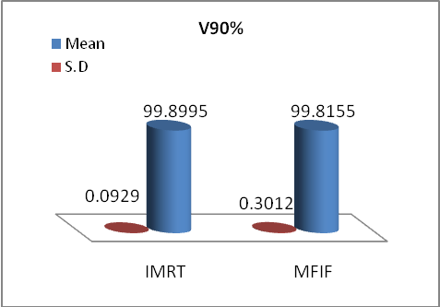
Figure 3. Comparison of mean V 90% of PTV for the 2 planes.

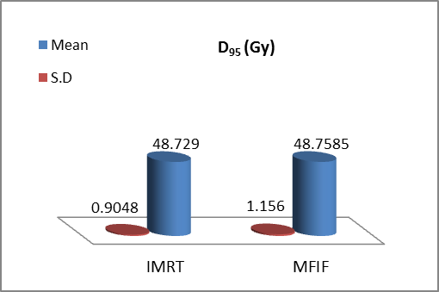
Figure 4. Comparison of mean Dose delivered to 95% of PTV for the 2 planes.

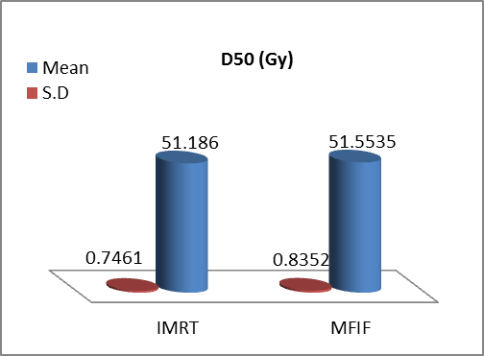
Figure 5. Comparison of mean Dose delivered to 50% 0f PTV for the 2 planes.

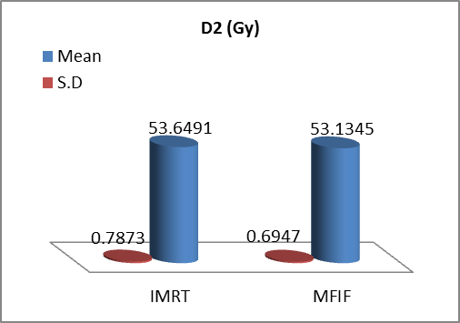
Figure 6. Comparison of mean Dose delivered to 2% 0f PTV for the 2 planes.

Figure 7. Mean and Standard Deviation (±SD) Homogeneity Index (HI) for PTV for IMRT and FIF techniques in twenty patients with left breast cancers.

Figure 8. Mean and Standard Deviation (±SD) conformity index for PTV for IMRT and MFIF techniques in twenty patients with left breast cancers.

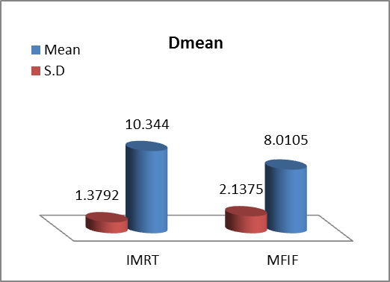
Figure 9. Comparison of Dmean of the left lung for the 2 planes.

The next Table 3 showed Mean and Standard Deviation (±SD) of Organs at Risk (LT Lung, Heart, RT Lung and RT Breast) dose parameters for both MFIF and IMRT techniques respectively in all cases.
Under the study.
For the left lung, higher values of V5, V10, and V20 for IMRT compared to MFIF. The differences are statistically significant between MFIF and IMRT (P < 0.0001) (Table 3).
Table 3 showed the Mean and SD for the values of V30 in Method 1 and Method 2 they are (17.196 ± 4.761, 19.85±3.4528) respectively, from which we noted that there is no significant difference between the two methods (p= 0.05035 ).
Figure 9 showed that the left lung mean dose (Dmean) was (8.0105±2.1375) for MFIF compared to (10.335±1.3792) for IMRT. The differences are statistically not significant observed throughout the two techniques (P = 0.05035).
For the heart, Table 3, Figure 10 revealed that V5, V10, V20 and Dmean were significantly higher for IMRT compared to MFIF (P < 0.0001), While Mean and Standard Deviation (±SD) for V30 are (6.374±4.324, 8.1825±3.2209 ) respectively for MFiF and IMRT, The differences are statistically not significant between MFIF and IMRT (P=0.141866) (Table 3).
For the right lung, as shown in Table 3, Figure 11 higher V2, V3, V4, V5, D_{mean} and D _{max} values for IMRT compared to MFIF, the difference is statistically significant (P <0.0001).
Concerning the contra lateral breast, higher V2, V3, V4, V5, D_{mean} and D _{max} values for IMRT compared to MFIF, the difference is statistically significant between two method in all above values (P <0.0001) (Figure 12 & Table 3).

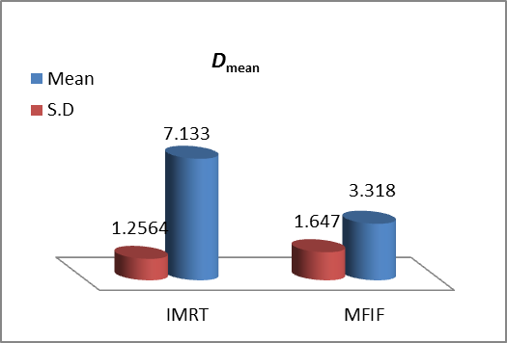
Figure 10. Comparison of Dmean of the heart for the 2 planes.

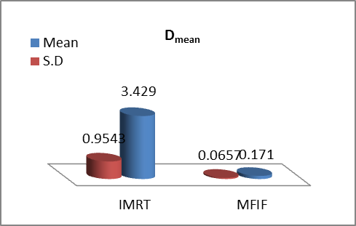
Figure 11. Comparison of Dmean of the right lung for the2 planes.

Table 3. Organs at risk dose parameters
Organ | Measured indices from DVH | Volume and doses for two breast irradiation techniques |  | Estimated P values for  compared treatment techniques
 |  | MFIF (a) | IMRT (b)
LT Lung  Heart  RT Lung  RT Breast | V5 | 30.4755±7.0744 | 82.57±11.2987 | < 0.00001
 | V10 | 23.8565±5.76 | 55.705±12.1491 | < 0.00001
 | V20 | 19.4555±5.0935 | 29.6715±5.3691 | < 0.00001
 | V30 | 17.196±4.761 | 19.85±3.4528 | 0.05035
 | Dmean | 8.0105±2.1375 | 10.335±1.3792 | 0.000208
 | V5 | 16.3855±7.8751 | 85.4345±8.4742 | < 0.00001
 | V10 | 10.5245±5.98 | 51.016±14.5038 | < 0.00001
 | V20 | 7.6685±4.889 | 19.1975±7.5992 | < 0.00001
 | V30 | 6.374±4.324 | 8.1825±3.2209 | 0.141866
 | Dmean | 1.647±3.318 | 7.133±1.2564 | < 0.00001
 | V2 | 0.4308±0.431 | 91.2945±5.3217 | < 0.00001
 | V3 | 0.0452±0.021 | 80.8475±8.0299 | < 0.00001
 | V4 | 0.0051±0.002 | 69.4905±11.1719 | < 0.00001
 | V5 | 0 | 59.5705±13.0036 | < 0.00001
 | D mean | 0.0657 ±0.171 | 3.429 ±0.9543 | < 0.00001
 | D max | 1.094 ± 1.777 | 16.6495 ± 5.5564 | < 0.00001
 | V2 | 1.1337 ±0.7085 | 67.9015±20.7464 | < 0.00001
 | V3 | 0.129±0.0675 | 51.2095±23.3489 | < 0.00001
 | V4 | 0.0562±0.024 | 35.969±20.7054 | < 0.00001
 | V5 | 0.0294±0.0115 | 23.470±16.7372 | < 0.00001
 | Dmean | 0.0653±0.172 | 1.953 ± 0.8383 | < 0.00001
 | D max | 2.0706±2.3195 | 9.7255 ± 4.4095 | < 0.00001

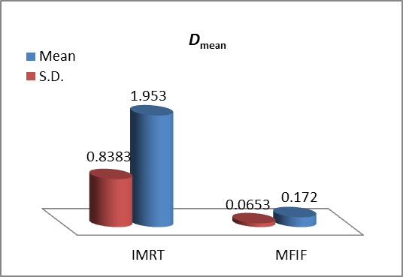
Figure 12. Comparison of Dmean of the right breast for the 2 planes.

4. Discussion
The aim of this study was to compare the radiation dose received by the treatment target and organs at risk by using multiple field-in-field and intensity modulated radiotherapy techniques in left-sided breast cancer patients.
Intensity-modulated radiation therapy (IMRT) has been described to improve the target conformity and dose homogeneity in treating breast cancer.
In the quantitative comparison, enormous parameters were taken into consideration, including: D₂, D₅₀, D₉₅, V₉₀, V₉₅, V₁₀₇, D_{mean}, D_{max}, the HI, and CI in case of the PTV. While, in case of OARs, the parameters of comparisons were: D_{mean}, V₅, V₁₀, V₂₀, and V₃₀ in case of the heart and Lt lung; D_{mean}, D_{max}, V₂, V₃, V₄, and V₅, in case of right lung, and right breast.
All data considered in this work were extracted from DVH curves, more specifically, from the data in Tables (2), it can be concluded that, in case of considering of volume of PTV covered with 107% of the total prescribed dose (PTV 107%), and the mean of the maximum dose delivered to the PTV, there is a significant difference between the two planning techniques, at the level (p ≤ < 0.00001), with lowest V₁₀₇ and lowest D_{max} in case of MFIF.
It was shown that the MFIF-results were comparable to the IMRT technique in terms of breast coverage, delivering 95% of the prescribed dose > 95% of the breast PTV, the mean dose delivered to the breast PTV, CI and HI with no statistically significant.
In fact, large frequency of data contained from the dose volume histograms, and isodose lines and curves seem to be complicated and enormous and need to be simplified to be able to make a choice in favor of a plan which provides maximum tumor coverage homogeneously and protects healthy tissues at the same time. The homogeneity index (HI) and the conformity index (CI) are two tools devoted for this purpose, i.e., simplify data treatment plan analysis in conformal radiotherapy, proposed by the RTOG, in 1993. In other words, Homogeneity Index (HI) is an objective tool to analyze the uniformity of dose distribution in the target volume. The concept of HI was developed as an extension of section-by-section dosimetric analysis of treatment plans, to compare between different plans proposed for the same patient (Kataria et al.,2012).
The mean values of homogeneity index for the MFIF, and IMRT are outlined in Table (2). The MFIF technique allowed, relatively, more homogeneity distribution when compared with the other technique with HI =0.10, 0.11, respectively, with no significant difference at the level p < 0.05.
The CI values in case of MFIF, and IMRT were 2.441832±0.5267, and 2.117262±1.179 respectively, illustrated in Table (2), with no significant difference, at the level (P = 0.268027). The conformity index equal to 1 corresponds to the ideal dose coverage or high conformity. The conformity index greater than one indicates that irradiated volume exceeds the target volume and covers part of the healthy tissue. In the case where the conformity index is less than one, it means that the target volume is partially radiated. RTOG criteria define a range of conformity index values to determine the quality of conformity since the value up to 1 can rarely be reached. If the conformity index is between 1 and 2, the treatment is in accordance with the protocol; if it is between 0.9-1 and 2-2.5 it is considered that there is a minor deviation of the protocol; if it is greater than 2.5 and less than 0.9 it is considered as a severe deviation from the protocol (Richmond et al.,2003).
In patients with left breast cancer, radiation therapy represents the most effective tool of treatment with minimum doses to the critical organs in radiotherapy. The most often found complications in these patients are cardiac and pulmonary function disorders and development of second malignancies.
For each dosimetry of the OARs, (heart, and left lung), the multiple field-in-field technique significantly reduced the volumes receiving more than 5, 10, 20Gy of the prescribed dose compared to IMRT, while the mean dose and the volumes receiving more than 30 Gy, there is no significant difference between the two methods.
The statistical parameters calculated for the either the Rt lung or Rt breast, were: the mean and maximum doses (D_{mean} and D_{max}), in addition to the volumes of the Rt lung or Rt breast covered by 2%, 3%, 4%, and 5% of prescribed dose, i.e., V₂, V₃, V₄, and V₅ calculated by the three planning techniques proved the existence of significant difference between the two plans, at the level P <0.001.
Darby S.C. et al. reported that exposure of the heart to ionizing radiation during radiotherapy for breast cancer increases the subsequent rate of ischemic heart disease (Kataria et al., 2012).
The results of our study match with other similar studies. Efficacy of FIF technique versus tangential field is clearly brought out by Sasaoka and Futami (Sasaoka & Futami.,2011)
Efficacy of FIF technique versus Tangential Wedged Fields, and IP-IMRT is clearly brought out by Elzawawy, S. and Hammoury, S.I (Elzawawy & Hammoury, 2015).
The IMRT for breast treatment is time consuming and requires advanced planning skills. In contrast to the MFiF plans, the IMRT required pretreatment verification and specific quality assurance (QA) measurements. The additional QA time must be taken into account when considering the total workload per plan. Compared with the IMRT, and MFiF-plans are likely to be generated in a shorter time without requiring a high level of planning ability (Elzawawy & Hammoury., 2015).

5. Conclusion
Multiple Field in Field technique for tangential whole breast radiotherapy is an efficient and reliable method for achieving a uniform dose throughout the whole breast. Strict dose-volume constraints can be readily achieved in most patients, resulting in improved breast coverage, potential sparing of risk organs and reduction of acute and late toxicities.

Corresponding Author:
Dr. Sahar Aboneima
Department of physics
Damanhur University, Egypt
E-mail: sahar_amr2002@yahoo.com

References
- Ferlay J, Soerjomataram I, Dikshit R, Eser S, Mathers C, Rebelo M, et al. Cancer incidence and mortality worldwide: sources, methods and major patterns in GLOBOCAN 2012. Int J Cancer 2015; 136(5): 359-86.
- Spencer SJ, Bonnin DA, Deasy JO, Bradley JD, El Naqa I. Bioinformatics methods for learning radiation-induced lung inflammation from heterogeneous retrospective and prospective data. J Biomed Biotechnol 2009; 2009: 892863.
- Recht, A. (2007) Breast Cancer: Stages T1 and T2. In: Gunderson, L.L. and Tepper, J.E., Eds., Clinical Radiation Oncology, 2nd Edition, Churchill Livingstone, London, 1475-1495.
- Veronesi, U., Marubini, E., Marian, L., Galimberti, V., Luini, A., Veronesi, P., et al. (2001) Radiotherapy after Breast Conserving Surgery in Breast Cancer: Long Term Result of Randomized Trial. Annals of Oncology, 12,997-1003.
- Adams, M.J., Hardenbergh, P.H., Constine, L.S., et al. (2003) Radiation-Associated Cardiovascular Disease. Critical Reviews in Oncology/Hematology, 45, 55-75.
- Cao, Y.D., Gao, H.D., Sun, X.C., et al. (2009) A Comparison of Doses for Conventional Radiotherapy and Intensity Modulation Radiation Therapy after Breast Conserving Operation. Journal of Medical Poster Graduates, 2, 161-164.
- Correa, C.R., Das, I.J., Litt, H.I., et al. (2008) Association between Tangential Beam Treatment Parameters and Cardiac Abnormalities after Definitive Radiation Treatment for Left-Sided Breast Cancer. International Journal of Radiation Oncology, Biology,Physics,72,508-516.
- Hurkmans, C.W., Borger, J.H., Bos, L.J., et al. (2000) Cardiac and Lung Complication Probabilities after Breast Cancer Irradiation. Radiotherapy & Oncology, 55, 145-151.
- Stovall, M., Smith, S.A., Langholz, B.M., Boice Jr., J.D., Shore, R.E., Andersson, M., et al. (2008) Dose to the Contralateral Breast from Radiotherapy and Risk of Second Primary Breast Cancer in the WECARE Study. International Journal of Radiation Oncology, Biology, Physics, 72, 1021-1030.
- Stathakis, S., Roland, T., Papanikolaou, N., Li, J.S. and Ma, C. (2009) A Prediction Study on Radiation-Induced Second Malignancies for IMRT Treatment Delivery. Technology in Cancer Research & Treatment, 8, 141-148.
- Rongsriyam, K., Rojpornpradit, P., lertbutsayanul, C., Sanghangthum, T. and Oonsiri, S. (2008) Dosimetric Study of Inverse-Planned Intensity Modulated, Forward-Planned Intensity Modulated And conventional Tangential Techniques in Breast Conserving Radiotherapy. Journal of the Medical Association of Thailand, 91, 1571-1582.
- Zhang, F.L., Wang, P. and Zhen, M.M. (2008) Dosmetric Evaluation of CR, 3DCRT and IMRT for Breast Cancer after Conserving Surgery. Chinese Clinical Oncology, 13, 354-358.
- Xu, X.-L., Wu, H. and Han, S.-K. (2006) Dosimetry Study of Intensity Modulated Radiation Therapy for Left Side Breast Cancer. Chinese Journal of Radiation Oncology, 15, 192-195.
- Cavey, M.L., Bayouth, J.E., Endres, E.J., Pena, J.M., Colman, M. and Hatch, S. (2005) Dosimetric Comparison of Conventional and Forward-Planned Intensity-Modulated Techniques for Comprehensive Locoregional Irradiation of Post-Mastectomy Left Breast Cancers. Medical Dosimetry, 30, 107-116.
- Fuller, S.A., Haybittle, J.I., Smith, R.E. and Dobbs, H.J. (1992) Cardiac Doses in Post-Operative Breast Irradiation. Radiotherapy and Oncology, 25, 19-24.
- Elzawawy, S. and Hammoury, S.I. (2015) Comparative Dosimetric Study for Treating Left Sided Breast Cancer Using Three Different Radiotherapy Techniques: Tangential Wedged Fields, Forward Planned Segmented Filed, and IP-IMRT. International Journal of Medical Physics, Clinical Engineering and Radiation Oncology,4,308-317.
- Radiation Therapy Oncology Group (RTOG). A phase iii trial of accelerated whole breast irradiation with hypofractionation plus concurrent boost versus standard whole breast irradiation plus sequential boost for early-stage breast cancer. Report 1005. Philadelphia, Radiation Therapy Oncology Group; 2014.
- Khayaiwong P. Dosimetric Comparison between Simultaneous Integrated Boost and Sequential Intensity- Modulated Radiotherapy Techniques in Nasopharyngeal Carcinoma. In: 6th Annual Scientific Meeting on Challenges of Quality Assurance in Radiation Medicine. Khayaiwong P, Tungboonduangjit P, Suriyapee S, Boonkitticharoen V, Oonsiri S, Sanghangthum T (eds), et al. Thai Medical Physicist Society, Thailand. 2012, pp.77-80.
- Pathak P1, Vashisht S. A quantitative analysis of intensity-modulated radiation therapy plans and comparison of homogeneity indices for the treatment of gynecological cancers. J Med Phys 2013; 38(2): 67-73.
- Kataria T, Sharma K, Subramani V, Karrthick KP, Bisht SS. Homogeneity Index: An objective tool for assessment of conformal radiation treatments. J Med Phys 2012; 37(4): 207-213.
- Richmond ND, Turner RN, Dawes PJ, Lambert GD, Lawrence GP. Evaluation of the dosimetric consequences of adding a single asymmetric or MLC shaped field to a tangential breast radiotherapy technique. Radiother Oncol 2003; 67(2): 165-170.
- Darby, S.C., Ewertz, M., McGale, P., Bennet, A.M., Blom-Goldman, U., Brønnum, D., et al. (2013) Risk of Ischemic Heart Disease in Women after Radiotherapy for Breast Cancer. New England Journal of Medicine, 368, 987-998.
- Sasaoka, M. and Futami, T. (2011) Dosimetric Evaluation of Whole Breast Radiotherapy Using Field-in-Field Techniquein Early-Stage Breast Cancer. International Journal of Clinical Oncology, 16, 250-256.

12/23/2019

