Prospective dosimetric study considering respiratory motion in lung cancer (NCI Experience)

Ehab Elkest, MD; Sherweif Abdel Fatah, MD and Ahmed Saeed, MSc

Radiation Department, National Cancer Institute, Cairo University, Egypt.
sherweif@yahoo.com

Abstract: Objectives: Respiratory movements not paid any attention during performing of single computed tomography (CT) scan for lung tumor during conformal radiotherapy planning. The current work in spects cancer activities to plan personalized borders to interpretation for these activities and assesses their dosimetric effects on planning capacity and organs at risk. Design: Prospective self-controlled dosimetric study of radiotherapy treatment planning for NSCLC patients presenting to the National Cancer Institute, Cairo University from March 2016 to April 2017. Methods: Thirty patients were enrolled in the study. Each patient was simulated using CT simulator and instructed to breathe normally, at full maximum inspiration and at full maximum expiration to create 2 RT plans; a reference plan and respiratory correlated plan. Target volumes in cubic centimeter along with doses to organs at risk were obtained. Evaluations of volumetric and dosimetric factors were done statistically by using paired Student t-tests. Results: The respiratory correlated plan is better than the old conventional one. There was marked reduction in PTV in all cases; Mean±SD (325.4±296.23 cc vs. 498.2±263.2 cc, p <0.001). Lung dosimetric parameters were reduced significantly; MLD (7.3±2.65 vs. 9±2.8 Gy, p = 0.04), V20 (11.6±4.9 vs. 14±5.5 %, p <0.001), V30 (8.4±3.8 vs. 10±4 %, p <0.001) and V5 (31.63±11.32 vs. 38.6±12%, p = 0.05). For heart, MD (8.27±13.5 vs. 11.24±11 Gy, p = 0.03), whereas V30 was not significantly changed. Concerning esophagus, MD (11.3±6.93 vs. 15.3±8 Gy, p = 0.03) and the V50 (7±11.3 vs. 12±14.2 %, p <0.001). Also there was significant decrease in maximum dose reaching spinal cord (20.8±13 vs. 27.9±14Gy, p <0.001). Conclusion: By applying CT scans at different phases of respiration (inhalation, exhalation and free breathing) is a good chance for estimation of respiratory motion and tumor deformation NSCLC level. Minor and more conformal design capacity was recorded obtained matched with the standard method. This created a less but constant improvement to spare the lung for a comparable treatment. In addition, respiratory correlated treatment plans can significantly reduce excessive radiation doses to the surrounding organs at risk, reducing acute & long-term radiation induced toxicities. We recommend the use of our technique in cases of NSCLC as a simple method - especially in departments where 4D CT is not available - for refining the explanation of internal target volume and tumor leveling.

[Ehab Elkest; Sherweif Abdel fatah and Ahmed Saeed. Prospective dosimetric study considering respiratory motion in lung cancer (NCI Experience). Cancer Biology 2019;9(4):21-27]. ISSN: 2150-1041 (print); ISSN: 2150-105X (online). http://www.cancerbio.net. 3. doi:10.7537/marscbj090419.03.

Keywords: Lung Cancer, Target volume, Radiation dose, Critical organs.

1. Introduction
Globally, the tumor in the lung is considered the main etiology of tumor-related death. Application of thoracic radiation (TRT) is an essential element for management of small-cell lung cancer and non–small-cell lung cancer (NSCLC). Conversely, regardless of greatest efforts, several of patients remain to have local-regional disappointment post TRT (Hayman et al., 2001; Komaki et al., 2002). Subsequently, methods to increase the precision and quality of radiation supply are being aggressively studied.
A serious topic in lung cancer radiation is the exact localization of the target size. The scientists classified this subject into 3 main parts.1. The precise anatomic description of the cancer, and this can be achieved through applying of recent techniques like CT and PET-CT, 2. Ensuring that the daily position of patient for RT is analogous to that at the time of simulation, 3. defining how best to account for movement of the GTVs as a result of breathing when creating the PTVs.
The radiotherapy of lung tumor facing many obstacles, one of them is transferring the dose of radiation to the target organ due to the movement of tumor/organ and the need to protect neighboring vital organs. Developing radiotherapy tools, such as daily on-board imaging, adaptive radiotherapy and 4-D image-based motion management, have allowed the researchers to advance the therapeutic index of radiation treatment for lung tumor by allowing the proposal of individual treatments for each patient sporadically that convey sufficient doses transforming to the specific site, in the same time protecting the neighboring vital organs or tissues.
We must put on our consideration during planning for therapy, that the margins must be large enough in size to confirm that most of the treatment reaches the target site. Commonly, for CT-planned lung tumor therapy, GTV is bounded, and the margin is added to comprise the doubted microscopic spread which when added to the GTV generates the clinical target volume (CTV). Therefore, using ICRU 6242 terminology, to get the planning target volume (PTV) from the CTV includes margins to account for both intrafraction, and interfraction movement and make an error and this upsurges the radiation field volume and subsequently the area of healthy tissues exposed to high doses of radiation.

2. Patients and methods
Thirty Patients with NSCLC presented to the Radiation Oncology Department, National Cancer Institute, Cairo University - from March 2016 to April 2017 -and candidate for radical treatment were included. The aim of study was to evaluate and compare dosimetric difference between conventional RT planning and RT planning related to respiratory motion regarding PTV and organs at risk (OAR). In the present study, conventional plan was used to treat patients. Eligibility criteria included: 1) Histologically or cytologically proven NSCLC (from stage I to stage III), 2) Candidates for curative thoracic radiotherapy, 3) PS: up to 2 and 4) Ability to follow instructions, perform voluntary breath-holds at the end of full inspiration and expiration and willing participants in the study before proceeding with the scans. Patients who did not meet these criteria were ineligible.
Patients were simulated using CT simulator (General Electric CT simulator, light speed 1017CT02) in which the patient lied down in supine position with his arms behind his head. Midline & lateral lasers guided the placement of lead markers in midline and on lateral sides of patient and marked on skin by tattoos. CT cuts were obtained every 5mm after contrast injection from the cricoid cartilage to mid abdomen.
Each Patient was instructed to; a) breath normally, b) under assisted breath hold at full maximum inspiration and c) expiration during the scanning procedure. Quiet free breathing, was defined as normal, unlabored breathing devoid of sighing, yawning, gasping, or deep inspiratory or expiratory efforts. To familiarize the patient with the procedure, a training session was given a few days before the planned simulation. During this training session the patient was placed in the recumbent position and taught the breath hold techniques. The patient was then instructed to repeat the maneuver three to four times. If the patient was unable to reproduce and maintain the deep inspiration, more coaching was given. If the patient was still unable to reproduce and maintain the deep inspiratory level, the patient was excluded from our study. All scans were performed on the basis of patient maximum comfortable effort without spirometry to be as simple as possible, and the length of each breath-hold was approximately 15 s. The 3 phases CT datasets for each patient were imported to focal planning system for contouring target volumes and OARs.
Delineation
Using lung window, 2 sets of plans will be done for each case. The 1st includes the images of free breathing, GTVs were outlined, conformal expansion on each GTV was used as CTV to encompass microscopic invasion (6mm for SCC and 8mm for adenocarcinoma), and PTV is created using an expansion of 15-20 mm of the CTV which accounts for tumor mobility and set-up errors. CTV was edited over normal structures (e.g. vertebral body) to respect anatomical boundaries. The 2nd one in which the images of free breathing, breath hold at full inspiration and full expiration were used, CT fusion was done with contouring of GTV on all scans allowing a visual approximation of the excursion of the tumor and the associated volumes through the respiratory cycle so that a new volume is created "sum volume", which represent an estimation of tumor motion associated with all the CT scans performed. CTV is added as usual and also PTV (5mm) which accounts for set up errors only. The vertebral spine was used as a reference for alignment between all scans. Lymph nodes delineation was not included in the study. Critical organs (lungs, heart, spinal cord and esophagus) were also delineated.

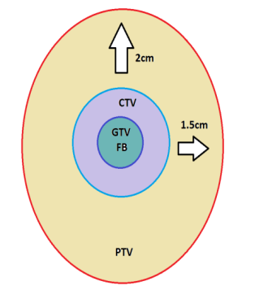
Plan B Plan A

Figure (1): comparison between plan A (the conventional) and plan B (the experimental
GTV=Gross Target Volume; IGTV=Internal Gross Target Volume; PTV=Planning Target Volume; IPTV=Internal Planning Target Volume; CTV=clinical Target Volume; FB=free breathing

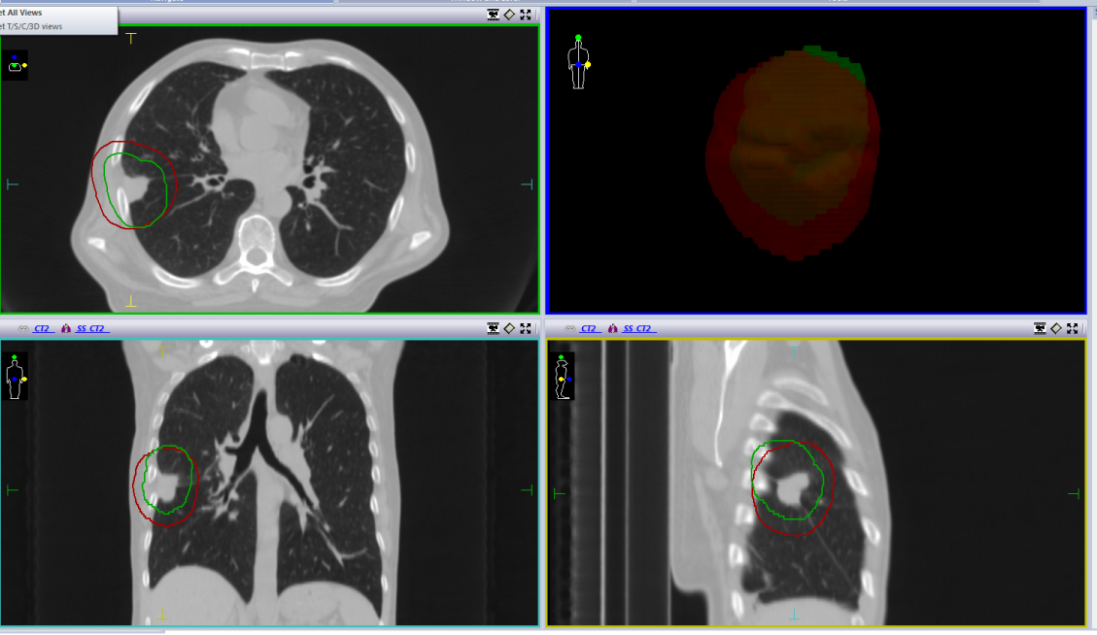
Figure (2): comparison between PTV (red) and IPTV (green)
PTV=Planning Target Volume; IPTV=Internal Planning Target Volume

Planning
Contouring plans for each patient were then transferred to the treatment planning system (Xio, CMS, Elekta, version 5.1). Two plans were designed for each patient, one to cover PTV & the other to cover IPTV. The same beam arrangement with the same beam energy was used in both plans for the same patient, 3D conformal plan by three to five fields. The prescribed radiation dose was 60 Gy in 30 fractions at 2 Gy per fraction delivered to the PTVs. Doses to organs at risk were obtained from dose volume histogram (DVH) when 95% of the prescribed dose covered 95% of PTV & 95% of IPTV or more, based on The Quantitative Analysis of Normal Tissue Effects in the Clinic “QUANTEC” review which provides normal tissue dose/volume tolerance guidelines They included: Lung (volume calculated by subtracting PTV from the bilateral lung volume): Mean lung dose (MLD): <15 Gy, V20 (volume of lungs receiving 20 Gy): <35-40%, Heart: V30 (volume of heart receiving 30 Gy) <46%, Mean heart dose should be less than 26 Gy, Spinal cord: maximum point dose <45 Gy, Esophagus: V50 <40%; mean esophagus dose <34 Gy. (Søren et al., 2010).

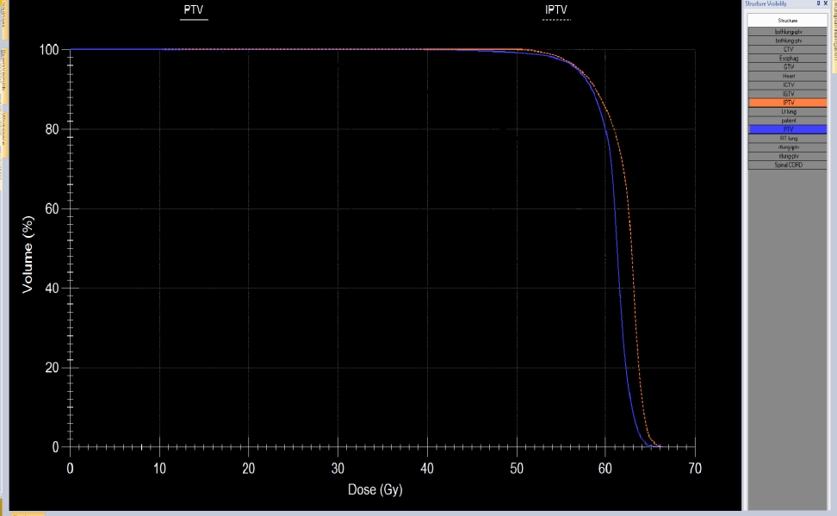
Figure (3): DVH of PTV (blue) and IPTV (orange)
PTV=Planning Target Volume; IPTV=Internal Planning Target Volume

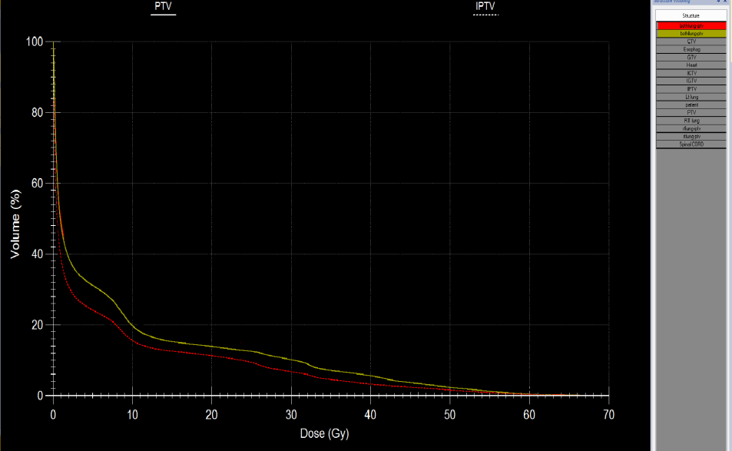
Figure (4): DVH of bilateral lung-PTV as organs at risk

Both lungs-PTV (yellow); both lungs-IPTV (red)

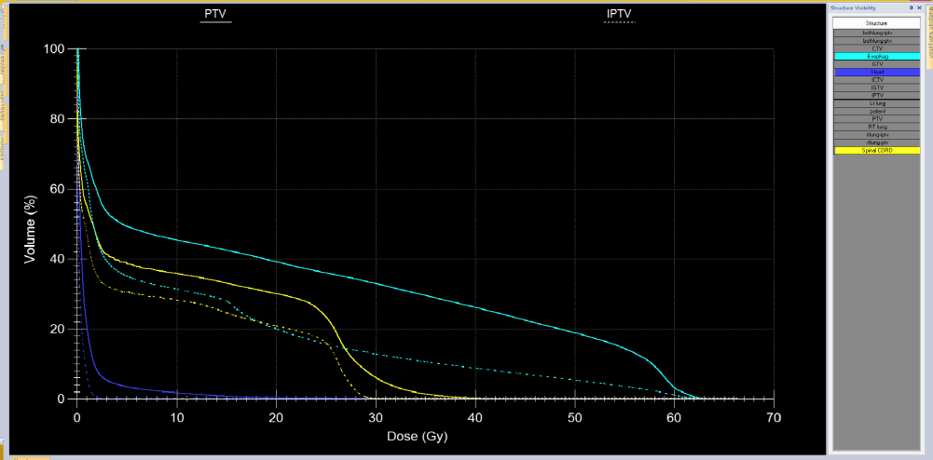
Figure (5): DVH of spinal cord, esophagus and heart as organ at risk

Statistical methods
Statistical analysis was performed using Statistical Package for Social Sciences, Version 23 (SPSS Inc., Chicago, USA) for Windows. Categorical data were presented as number and percentage and numerical data were presented as mean and standard deviation or median and range. To measure association between variables: McNemar test was done, to compare between two dependent percentages, continuous variable were tested by Wilcoxon test to compare between two dependent means. All tests were two tailed & Probability (p-value) equal or less than 0.05 is considered significant.

3. Results
Patient's age ranged from 50-84 years with a mean age of 65.27±9.04 years. Males constituted 27 out of the 30 patients (90%). 13 patients (43%) were diabetic and 10 patients (33.3%) were hypertensive. 26 patients were smokers (86.66%). Median years of smoking were 30 years. Mean number of cigarettes smoked per day was 15±1.
Out of the 30 patients, 14 patients (46.66%) had a pathological diagnosis of adeno carcinoma, 13 patients squmaous cell carcinoma and 3 patients large type. Most of cases were Stage III 17 patients. Tumors were classified in relation to site into central and peripheral ones, where 18 patients with peripheral tumors and 12 with central ones.
Target volumes
Target volumes, measured in cubic centimeters (cc), were obtained for each patient in both conventional and our experimental plans. IGTV was larger than GTV in all patients. IPTV was much smaller in comparison to PTV in the all patients, Mean±SD (325.4±296.23 cc vs. 498.2±263.2 cc, p <0.001).
Coverage and organs at risk
Coverage and doses to organs at risk were obtained from dose volume histograms (DVH’s) for each patient in both conventional and our experimental plans. Taking into consideration that in our protocol minimum acceptance criteria 95% of the prescribed dose covered 95% of target volumes in each patient, there was no significant change in coverage between both methods Mean±SD (96.9±0.885 vs. 96.3±0.844, p value =0.1). Regarding OAR there was a highly statistically significant decrease in lungs dose, heart dose, esophageal dose and maximum dose to the spinal cord in experimental plans when compared with conventional plans. Lung dosimetric parameters were reduced significantly; MLD (7.3±2.65 vs. 9±2.8 Gy, p = 0.04), V20 (11.6±4.9 vs. 14±5.5 %, p <0.001), V30 (8.4±3.8 vs. 10±4 %, p <0.001) and V5 (31.63±11.32 vs. 38.6±12%, p = 0.05). For heart, MD (8.27±13.5 vs. 11.24±11 Gy, p = 0.03), whereas V30 was not significantly changed. Concerning esophagus, MD (11.3±6.93 vs. 15.3±8 Gy, p = 0.03) and the V50 (7±11.3 vs. 12±14.2 %, p <0.001). Also there was significant decrease in maximum dose reaching spinal cord (20.8±13 vs. 27.9±14Gy, p <0.001). There was significant benefit from our experimental plan in both peripherally located and small tumor (less than 100 cc).

4. Discussion
Some investigators (Allen et al., 2004) reported that to take on the account the movement of tumor during respiration, the using of margin as an index during extension of the outlined sizes resulted in an extreme healthy lung parenchyma and to pographical failures, which will lead to increase in the toxicity due to overdoses without improvement in the confined control. Many previous investigations were assessed in order to increase the value of estimation and attachment of cardio respiratory movement in therapy design and transport for lung tumor (Giraud et al., 2001). These improvements in the technique comprised respiratory interrelated designing information achievement and systems to track cancer movement during radiation.
In our study we taken serial CT scans to inspect physiologic movement and personalize margins of 30 individuals to create a therapy a design with a lessening of the risk of geographic divergence at maximum inhale, exhale, and free breathing. The goal from the current research was not to meet the requirements of each constituent of motion but to extract the overall effect on the volume of therapy. The intensity of inhalation and exhalation play an important role in the movement extent of cancer, where severe respiratory movements suggests exciting evidence about the complete potential movement of cancer but does not associate with the average tumor movement for the entire regimen of treatment. It contains additional amplitude of movement than could be required.
Several methods have been applied to assess cancer motion, such as Fluoroscopy, not a recent technique but most widely applied for assessing lung tumor movement and many medical and clinical centers still used it for assessing of respiratory movement for lung cancers.
Ekberg et al (1998) assessed cancer movement by using 2D fluoroscopic scanning. They reported that the mediolateral movement during quiet respiration was averaged 2.4 mm dorsal-ventral, and the craniocaudal movement was averaged 3.9 mm. The extreme movement of cancer craniocaudal was averaged 12 mm, whereas, it averaged 5.0 mm dorso-ventral and mediolateral.
Some investigators (Stevens et al., 2001) used double-exposed radiographs to estimate cancer movement in patients subjected for radiation. They reported that CT was more accurate than using of fluoroscopy and radiographs, where CT is more accurate at target volume demarcation in lung tumor.
Shih et al (2004) used series of sequential CT scans in 13 patients for assessing internal margins outside GTV to description for its predictable physiologic motion and all differences in volume and form during the exposure to radiation. At free inhalation, the GTV of a single fast helical scan needed the largest internal margin (3.5±4.2 mm) to compare the merged GTV, in comparison with those of the 4-s slow scan (2.7±3.5 mm) or combined breath-hold scans (Mean±SD 1.1±1.9 mm). Internal margins (expansion margins) required to approximate the composite GTV in 95% of cases were 13 mm for the GTVs of a single fast scan, 10 mm for 4-s slow scan, and 5 mm for breath-hold scans at the end of tidal volume inspiration and expiration.
In our study, all plans were evaluated and considered suitable for treating patients, although no patients were actually treated with either conventional Plan or the experimental one. Planexp provided more advantages in organ preservation than Planconv. Significant reductions were found in Planexp in the volumetric and dosimetric parameters, there was marked reduction in PTV in all cases Mean±SD (325.4±296.23 cc vs. 498.2±263.2 cc, p <0.001). Lung dosimetric parameters were reduced significantly, MLD (7.3±2.65 vs. 9±2.8 Gy, p = 0.04), V20 (11.6±4.9 vs. 14±5.5 %, p <0.001), V30 (8.4±3.8 vs. 10±4 %, p <0.001) and V5 (31.63±11.32 vs. 38.6±12%, p = 0.05). For heart, MD (8.27±13.5 vs. 11.24±11 Gy, p = 0.03), whereas V30 was not significantly changed. Concerning esophagus MD (11.3±6.93 vs. 15.3±8 Gy, p = 0.03) and the V50 (7±11.3 vs. 12±14.2 %, p <0.001), also there was significant decrease in maximum dose reaching spinal cord (20.8±13 vs. 27.9±14 p <0.001).
Francois et al. (2008) studied 15 patients simulated with CT scan -based planning for radical radiotherapy for localized lung cancer. A standard design was created depending on standard morphology, clinical, and scheduling target sizes (rGTV, rCTV, and rPTV, respectively). Ten designs for each individual were created and (DVHs) were estimated. Comparative to the rGTV, the total size engaged by the covered GTVs elevated significantly with each further CT scans. The mean increase in GTV was 52.1% in all 5 scans. For the design with nearby dosimetric exposure, target size was reduced (iPTV/rPTV ratio 0.808) but lung irradiation was reduced relatively. Decrease (V20) was noticed for 23-MV plans (−0.65%, p = 0.04) and 6-MV plans (−0.73%, p = 0.02).
In the present study, we evaluated the effect of change in tumor site and tumor size on the deferent dosimetric parameters. Peripheral tumors showed significant reduction than central located ones, also smaller tumors (<100 cc) showed significant changes than larger ones. Some authors found that the size or volume of cancer influenced greatly on the cancer movement, where in the lower lung region cancers diameter<5 cm presenting a lower movement than cancers >3 cm (Plathow et al., 2004). Starkschall et al., 2004 in their study, they used computed tomography scan. Two groups of therapy design were created: one depended on an internal target size obviously made from calculation of the expedition of CTV via the respiratory cycle, demonstrating an ungated therapy, and the other depended on the 0% tidal size CTV, demonstrating a gated therapy with lesser margin for enduring movement. They reported that the dose-size were associated statistically to the extent of the movement of the center of the GTV throughout respiration. Individuals having GTVs size of >100 cc demonstrated slight decline in lung dose under gating, and the remaining movement elevated, the profits of respiratory gating raised.
Ahmed et al., 2017, recently carried out several investigations for the purposes of comparing 4D-CT-based plan target size definition with predictable PTV definition, free-inhalation CT and 4D-CT data sets were attained at the same simulation sitting and with the same immobilization. PTV_3D was averaged 530.0 cm³ and PTV_4D was averaged 499.8 cm³. In case of applying the 3D- and the 4D-based plans, the lung V20 was averaged 24.0% and 22.7%, P =.057), respectively. Whereas, the heart V40 was averaged 12.1% and 12.7%, P =0.53for the 3D- and 4D-based plans, respectively. In the same time the spinal cord Dmax was 25.17Gyfor 3D-based plans and 24.35 Gy for 4D-based plans (P =.019). Also, the esophageal dose was averaged 15.8 Gy for 3D-plans and 14.35 Gy for 4D- plans, (P = 0.13).
The current investigation, and many other works estimating association between the influence of respiratory movements and treatment planning on the precision of therapy of tumor lung, have some restrictions. One is due to the sample size, where it was in between 20to 30 participants of patients. In addition to the scanning settings may not be similar. Therefore, the quality of image and distinguish ability of the cancer and normal constructions among the two scans may be varied, which may consequently lead to differences in the target size and the volume of the OARs among the two designs. Hypothetically, a decrease in the dimention of PTVs could effect in a reduced risk of radiation-induced inflammation in the bronchi, in the current work, the differences in the frequency of complications linked with RT (comprising radiation-induced pneumonitis) among the two methods were not accessible. This was another restriction of the current work.
In addition, the degree of improvement in protecting lung tissues with the specialized methods were influenced by the clinical circumstances. The maximum of individuals with medically impracticable Stages I and II lung tumor, which usually present in the area of the lung with widespread bullae and scarce residual function, may have severe chronic obstructive pulmonary disease (COPD). The primary lung cancer in regionally advanced-stage, the movement was relatively slight in like with respiration in case of attachment or embedded in the neighboring normal tissues or organs (T3 or T4 lesion), like a chest wall, vertebrae, ormediastinum, which moves slightly with the respiratory motion. Population-depended margins for movement of cancer and system errors can be also big for a number of participating subjects if they are designed for the treatment. Hence, a good protection for the normal tissues and organs might be attained if the internal margins are reduced and adjusted for specific patients.

Conclusion:
There are a significant change of movement of cancer was established in relationship with cardiac and respiratory motion. During application of CT images during inhalation, exhalation and free breathing stages of respiration permits a best chance to measure the degree of respiratory movement and tumor abnormalities in NSCLC. Smaller and more conformal designing diameter was gained matched to the standard method. This produced a little but constant benefit to protect the lung for a similar coverage. In addition, respiratory correlated treatment plans can significantly reduce excessive radiation doses to the surrounding organs at risk, reducing acute & long-term radiation induced toxicities.
We recommend the use of our technique in cases of NSCLC as a simple method - especially in departments where 4D CT is not available - for improving the definition of internal target volume and tumor targeting.

References
- Søren M, Louis S, Joseph O, et al. Quantitative Analyses of Normal Tissue Effects in the Clinic (QUANTEC): An Introduction to the Scientific Issues. Int J Radiat Oncol BiolPhys 2010;76(Suppl 3): S3-S9.
- Allen A, Siracuse M, Hayman J, et al. Evaluation of the influence of breathing on the movement and modeling of lung tumors. Int J Radiat Oncol Biol Phys 2004;58(4):1251-7.
- Giraud P, Rycke Y, Dubray B, et al. Conformal radiotherapy (CRT) planning for lung cancer: analysis of intrathoracic organ motion during extreme phases of breathing. Int J Radiat Oncol Biol Phys2001;51(4):1081-92.
- Ekberg L, Holmberg O, Wittgren L, et al. What margins should be added to the clinical target volume in radiotherapy treatment planning for lung cancer. RadiotherOncol 1998;48(1):71-7.
- Stevens C, Munden R, Forster K, et al. Respiratory driven lung tumor motion is independent of tumor size, tumor location, and pulmonary function. Int J Radiat Oncol Biol Phys 2001;51(1):62-68.
- Shih H, Jiang B, Aljarrah M, et al. Internal target volume determined with expansion margins beyond composite gross tumor volume in three-dimensional conformal radiotherapy for lung cancer. Int J Radiat Oncol Biol Phys2004;60(2):613-22.
- Francois G, Luc B, Andre F, et al. Individualized Margins in 3D Conformal Radiotherapy Planning for Lung Cancer: Analysis of Physiological Movements and Their Dosimetric Impacts. Med Dosimetry 2008;33(1)48-54.
- Plathow C, Fink C, Ley S, et al. Measurement of tumor diameter-dependent mobility of lung tumors by dynamic MRI. RadiotherOncol 2004;73(3):349-54.
- Ahmed N, Venkataraman S, Johanson K, et al. Does Motion Assessment With 4-Dimensional Computed Tomographic Imaging for Non–Small Cell Lung Cancer Radiotherapy Improve Target Volume Coverage? Clin Med Insights Oncol 2017;11(4)123-6.

9/20/2019

