Neoadjuvant Rectal Cancer (NAR) Score as a Prognostic Factor in Locally Advanced Cancer Rectum

Rehab F Mohamed, Mariam Mohsen Khalil, Samir Eid.

Department of Clinical Oncology and Nuclear Medicine, Faculty of Medicine, Assiut University, Assiut, Egypt.
faroukrehab@yahoo.com

Abstract: Background: The aim of this study is determination of NAR score for locally advanced rectal cancer patients and its relation with disease free survival (DFS) and overall survival (OS). Methods: A total number of 70 patients with locally advanced rectal cancer who had received neo-adjuvant concurrent chemo-radiotherapy followed by surgery were included in our study. NAR scores were calculated using the following formula: . The constant 12 assures that all scores are positive inside the outer brackets. Squaring the numerator transforms the score to more uniform measure per unit change. The scaling factor 9.61 in the denominator ensures that the final scores range from 0 to 100. It was divided into low risk (less than 8) - intermediate risk (from 8 to 16) - high risk (more than 16). Results: The median value of NAR score was 22.62, 23 patients (32.9%) with low NAR score, 21 patients (30.0%) with intermediate score and 26 patients (37.1%) with high score. The patients showed variable response to neo-adjuvant therapy as 17 patients (24.3%) had pCR, 21 patients (30.0%) had PR, and 32 patients (45.7%) had SD. The inverse relation between the score and response was proven in our study as patients with high NAR score had the worst prognosis. The median NAR score was 0.90 in patients with pCR, 8.43 in patients with PR, and 30.07 in patients with SD, with statistically significant P value (P value<0.003). There were a negative correlation between NAR score and DFS, OS with statistically significant P value (P value=0.003). The statistical significant relation between NAR score and DFS & OS were shown in patients with high, intermediate and low NAR score, as the median free survival times were 12.0, 24.0 and 36.0 respectively. 5-year survival rate of all patients was 75.1%. Patients with low NAR score showed 5-year OS rate 100.0%. Patients with intermediate and high score showed 5-year OS rate were not reached (NR) with statistically significant P value (P value<0.001). Conclusion: NAR score use a simple data available such as cT, pT and pN. There was a negative correlation between NAR score and DFS & OS as with the increase of NAR score, there was decrease in DFS and OS.
[Rehab F Mohamed, Mariam Mohsen Khalil, Samir Eid. Neoadjuvant Rectal Cancer (NAR) Score as a Prognostic Factor in Locally Advanced Cancer Rectum. Cancer Biology 2019;9(3):52-60]. ISSN: 2150-1041 (print); ISSN: 2150-105X (online). http://www.cancerbio.net. 7. doi:10.7537/marscbj090319.07.

Key words: NAR score, locally, neoadjuvant, rectal, advanced, cancer.

1. Introduction

Colorectal cancer (CRC) is the third most commonly occurring cancer in men and the second most commonly occurring cancer in women and the fourth leading cause of cancer-related deaths worldwide [1]. Management of locally advanced rectal cancer is complex because curative treatment routinely involves administration of surgery, chemotherapy, and radiation. Also, there is considerable heterogeneity in risk based on rectal tumor location, extent, and nodal involvement [2].

In the era of multimodality treatment for cancers, neo-adjuvant chemo-radiotherapy followed by radical surgery with total meso-rectal excision (TME) has become the standard of care for patients with locally advanced rectal cancer [3, 4]. This modern modality offer a higher probability to downsize and downstage tumors, enhance tumor respectability, sphincteric preservation and to improve local tumor control [5]. Nevertheless, locally advanced patients exhibit heterogeneity in responses to neo-adjuvant treatment, which can result in very difficult long term results. Additionally, adjuvant treatment and surveillance need to be given based in individual patient prognostication. Patients at high risk of disease progression will require additional interventions and tailored decision making with the help of physician [6]. Therefore, identification of more reliable clinic-pathological determinants of survival could improve postoperative prognosis evaluation and help to plan tailored postoperative treatment for patients with rectal cancer after neo-adjuvant therapy.

The neo-adjuvant rectal cancer (NAR) score is a short term endpoint to serve as a surrogate for disease free survival (DFS) and overall survival (OS) which facilitate the scientific research work and rapid progress in the clinical practice. The NAR score scores from 0 to 100 with higher scores representing a poorer prognosis.

2. Patients and Methods
Study Population

This retrospective cohort is observational study investigate NAR score in locally advanced rectal cancer patients and its relation to DFS and OS. We reviewed the clinical data of 70 patients with locally advanced rectal cancer treated at Clinical Oncology Department, Assiut University Hospital between January 2009 and December 2013. The protocol of the study was approved by the ethics committee of Assiut University before data collection. Patients eligible for the study were between 18 and 85 years of age, rectal cancer confirmed pathologically, with T3, T4/N +ve rectal cancer, received neo-adjuvant treatment, and underwent surgery.
Study design
All included patients received neo-adjuvant concurrent chemo-radiotherapy followed by radical surgery (according to the site of tumor) and completed the adjuvant treatment. 2D planning system by conventional X-ray simulation was used with radiation delivered by linear accelerator (SIEMENS PRIMUS Linear Accelerator) with energy 15Mev. With use of total radiation dose 5040 cGy and fraction size of 180 cGy, 5 times per week for 6 weeks. Concurrent use of 5FU 400mg/m² IV bolus + leucovorin 20mg/m2 IV bolus from day 1-4 during weeks 1 and 5 of radiotherapy. Or use of capecitabine 825mg/m² twice daily concurrently with radiation from day1-5 and repeat cycle weekly for 5 weeks. Surgery was carried out 6‐8 weeks after completion of neo-adjuvant therapy. Approximately 3 to 4 weeks after surgery, patients received adjuvant chemotherapy for 6 months including FOLFOX or CAPEOX.

NAR score (low, intermediate, high) and its correlation with DFS and OS was calculated.
NAR score was calculated using the following formula:

As cT: 1-4, pT: 0-4, and pN: 0-2 [7].
It divided into:
Low (less than 8), intermediate (from 8 to 16), and high risk (more than 16).
The constant 12 assures that all scores are positive inside the outer brackets. Squaring the numerator transforms the score to more uniform measure per unit change. The scaling factor 9.61 in the denominator ensures that the final scores range from 0 to 100.
The primary end point was DFS, defined as the time from randomization to the date of clinical relapse. Second end point was OS, defined as the time from randomization until death.
Evaluation
Follow up of patients started 1month after concurrent chemo-radiotherapy then after completion of adjuvant treatment every 3 months for the first 3 years, and then every 6 months for the next 2 years by physical examination, CEA level, CT chest and MRI (pelvis and abdomen).
Statistics
SPSS (Statistical package for Social sciences) version 24.0 was used for data management. The categorical variables were calculated by Chi-square test or Fisher`s exact test. Continuous variables with a parametric data correlation were calculated by Pearson correlation, but those with non-parametric data correlation were calculated by Spearman correlation. Survival was estimated using Kaplan-Meier method. Comparison of NAR score groups was done using Log Rank (Mantel-Cox) test. P value is considered significant if <=0.05.

3. Results
A total number of seventy patients with locally advanced rectal cancer who had received neo-adjuvant concurrent chemo-radiotherapy followed by surgery were enrolled in our study. The baseline demographic data of our patients were summarized in Table 1. The study included 40 males (57.1%) and 30 females (42.9%) patients, the mean age was 43.24±13.55 years. The most common site of tumor was the lower rectum 39 patients (55.7%). Adenocarcinoma was the most common type presented in56 patients (80.0%). After termination of neo-adjuvant chemo-radiotherapy, 17 patients (24.29%) had pCR (pT0), 8 patients (11.43%) had pT1, 12 patients (17.14%) had pT2, 14 patients (20.0%) had pT3, and 19 patients (27.14%) had pT4. Forty patients (57.14%) had pN0, 15 patients (21.43%) had pN1, and 15 patients (21.43%) had pN2.
As regard the NAR score, the median value of NAR score was 12.59. There were 23 patients (32.9%) with low score, 21 patients (30.0%) with intermediate score and 26 patients (37.1%) with high score Table (2).
On evaluation of the relation between NAR score and clinico-pathological factors (age, sex, histo-pathology, cT, pT, and pN), there was a statistical significant correlation between NAR score and histo-pathology, all stages of pT and pN with P value 0.014, 0.003, and 0.003 respectively Table (3).
As regarding the response 17 patients (24.3%) had pCR, 21 patients (30.0%) had PR, and 32 patients (45.7%) had SD Table (4)
Regarding the relation between NAR score and response, there was inverse relation between the score and response as patients with high NAR score had the worst prognosis. The median NAR score was 0.90 in patients with CR with a range of 0-3.75, 8.43 in patients with PR with a range of 3.70-20.40, and 30.07 in patients with SD with a range of 0-50.36 with statistically significant P value (P value<0.003) Table (5).
The 5-year DFS rate of all patients was 5.4%. Patients with low NAR score showed 5-year DFS rate 16.3%. Patients with intermediate and high NAR score showed 5-year DFS rate 0.0% with statistically significant P value (P value<0.001) Figure (1).
The median free survival time was 22.00 (95%CI 17.080-26.920). In patients with high NAR score it was 12.0(95%CI 10.766-13.234), in patients with intermediate NAR score was 24.0 (95%CI 16.380-31.620) and in patients with low NAR score was 36.0 (95%CI 30.955-41.045) with statistically significant P value (P value<0.001) Figure (2).
There was a negative correlation between NAR score and DFS with statistically significant P value (P value=0.003) Table (6) Figure (3).
As DFS decrease with increase NAR score, Pairwise Comparison between DFS and NAR score showed a significant difference between high, intermediate NAR score and between high, low NAR score with P value<0.001. Also, there were a significant difference between intermediate, high NAR score with P value<0.001 and between intermediate, low NAR score with P value=0.012. Furthermore, there were a significant difference between low, high NAR score with P value<0.001 and between low, intermediate NAR score with P value=0.012 Table (7).
5-year survival rate of all patients was 75.1%. Patients with low NAR score showed 5-year OS rate 100.0% with statistically significant P value (P value<0.001). The mean survival time was 49.976 (95%CI 45.785-54.166). Patients with intermediate and high NAR score showed 5-year OS rate not reached (NR) with statistically significant P value (P value<0.001).
Median survival was not reached as more than 50% of patients were censored (did not experience the event or death) Figure (4, 5).
There was a negative correlation between NAR score and OS with statistically significant P value (P value=0.003) Table (6) and figure (6).
As OS decrease with increase NAR score, Pairwise Comparison between OS and NAR score showed a significant difference between high, intermediate NAR score with P value=0.033 and between high, low NAR score with P value<0.001. Also, there was a significant difference between intermediate, high NAR score with P value=0.033 and between intermediate, low NAR score insignificant relation with P value=0.087. Furthermore, there was a significant difference between low, high NAR score with P value<0.001 but between low, intermediate NAR score, there was insignificant difference with P value=0.087 Table (8).

Table (1): Demographic characteristics of the patients in the study group
 | Number (%)
- Age mean±SD  - Sex:  Male  Female  - Site:  - Lower  - Middle  - Upper  - Histology:  - Adenocarcinoma  - Mucoid  - Signet ring  - Grade:  - G1  - G2  - G3  - G4  6- Clinical T:  - cT1  - cT2  - cT3  - cT4  7- Stage:  - Stage I  - Stage II  - Stage III  - Stage IV  8- Pathological T (after treatment):  - pT0  - pT1  - pT2  - pT3  - pT4  9- Pathological N (after treatment):  - pN0  - pN1  - pN2 | 43.24±13.55  40(57.1%)  30(42.9%)  39(55.7%)  20(28.6%)  11(15.7%)  56(80.0%)  8(11.4%)  6(8.6%)  8(11.43%)  29(41.43%)  14(20.0%)  19(27.14%)  0(0.0%)  8(11.43%)  32(45.71%)  30(42.86%)  0(0.0%)  24(34.29%)  46(65.71%)  0(0.0%)  17(24.29%)  8(11.43%)  12(17.14%)  14(20.0%)  19(27.14%)  40(57.14%)  15(21.43%)  15(21.43%)

Table (2): NAR score in study group.
 | Number (%)
Median  Range  NAR score  - Low  - Intermediate  - High | 12.59  0-50.36  23(32.9%)  21(30.0%)  26(37.1%)

Table (3): Relation between NAR score and clinico-pathological factors
 | Low  Number (%)  “n=23” | Intermediate  Number (%)  “n=21” | High  Number (%)  “n=26” | P-value
1-Age (mean±SD)  2-Sex:  - Male  - Female  3-Histopathology:  - Adenocarcinoma  - Mucoid  - Signet ring  4- Clinical T  - cT2  - cT3  - cT4  - Pathological T:  - pT0  - pT1  - pT2  - pT3  - pT4  - Pathological N  - pN 0  - pN1  - pN2 | 47.30±14.09  12(52.2%)  11(47.8%)  23(100.0%)  0(0.0%)  0(0.0%)  3(13.0%)  14(61.0%)  6(27.0%)  17(73.92%)  3(13.04%)  3(13.04%)  0(0.0%)  0(0.0%)  23(100%)  0(0.0%)  0(0.0%) | 44.29±13.72  12(57.1%)  9(42.9%)  16(76.2%)  2(9.5%)  3(14.3%)  3(14.2%)  9(42.9%)  9(43.9%)  0(0.0%)  4(19.05%)  8(38.1%)  4(19.05%)  5(23.8%)  17(81.0%)  4(19.0%)  0(0.0%) | 38.81±12.04  16(61.5%)  10(38.5%)  17(65.4%)  6(23.1%)  3(11.5%)  2(7.7%)  9(34.6%)  15(57.7%)  0(0.0%)  1(3.84%)  1(3.84%)  10(38.47%)  14(53.85%)  0(0.0%)  11(422.3%)  15(57.7%) | P=0.81$  P=0.804*  P=0.014**  P=0.253  P=0.003**  P=0.003**
P value is significant ≤0.05, p value is adjusted.
*Chi-square test.** Fisher's Exact test.$One-way ANOVA test.

Table (4): Response in the study group at the end of treatment.
Response | Number (%)
- CR  - PR  - SD | 17(24.3%)  21(30.0%)  32(45.7%)

Table (5): Relation between NAR score and response in study group.
Response | Median of NAR score | Range | P-value
CR  PR  SD | 0.90  8.43  30.07 | 0-3.75  3.70-20.40  0-50.36 | P<0.003

Table (6): Correlation between NAR score, DFS and OS in study group.
Item | NAR score
 | r- value | p- value
OS | -0.806 | 0.003*
DFS | -0.699 | 0.003*

Table (7): Pairwise Comparisons of DFS according to NAR score.
 | NAR score | High |  | Intermediate |  | Low
 |  | Chi-Square | P value | Chi-Square | P value | Chi-Square | P value
Log Rank (Mantel-Cox) | High |  |  | 13.000 | <0.001 | 35.922 | <0.001
 | Intermediate | 13.000 | <0.001 |  |  | 8.440 | 0.012
 | Low | 35.922 | <0.001 | 8.440 | 0.012

Table (8): Pairwise Comparisons of OS according to NAR score.
 | NAR score | High |  | Intermediate |  | Low
 |  | Chi-Square | P value | Chi-Square | P value | Chi-Square | P value
Log Rank (Mantel-Cox) | High |  |  | 6.439 | 0.033 | 16.550 | <0.001
 | Intermediate | 6.439 | 0.033 |  |  | 4.796 | 0.087
 | Low | 16.550 | <0.001 | 4.796 | 0.087

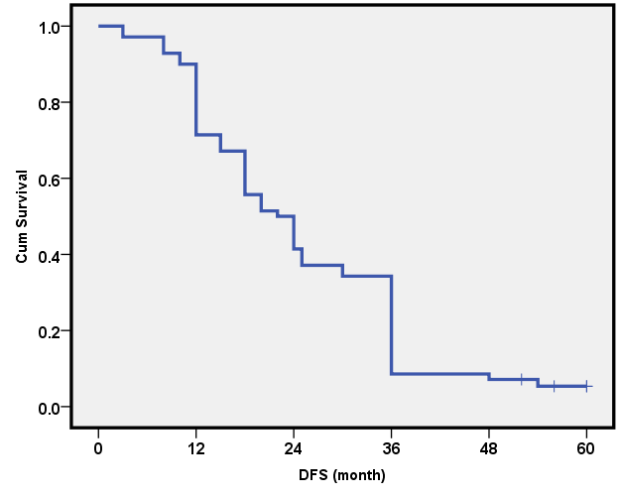
Figure (1): DFS in the study group.

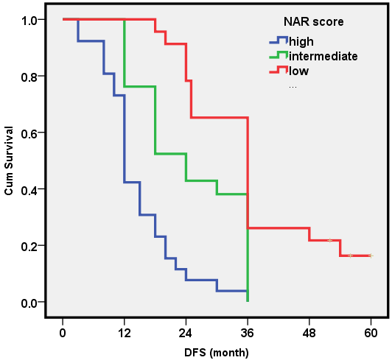
Figure (2): DFS according to NAR score

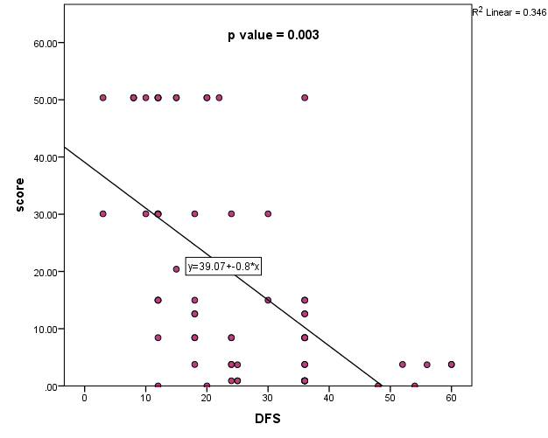
Figure (3): Correlation between NAR score & DFS.

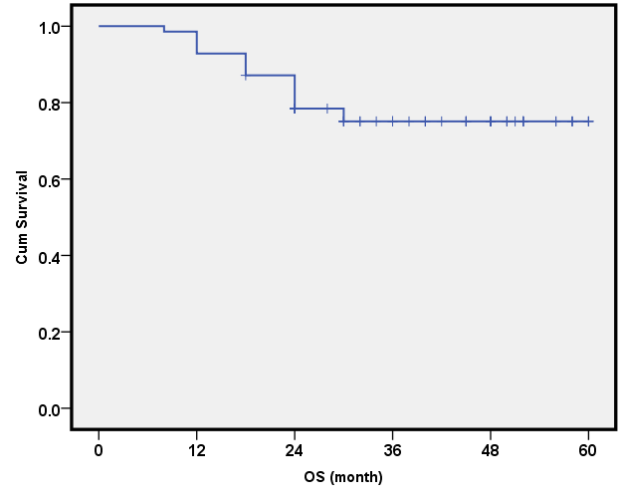
Figure (4): OS in the study group.

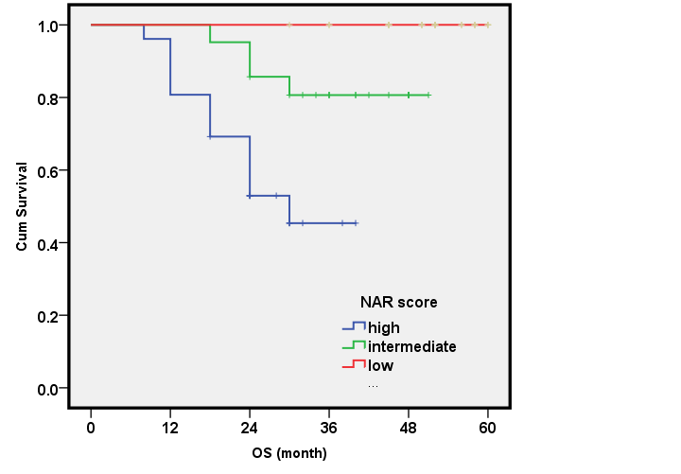
Figure (5): OS according to NAR score.

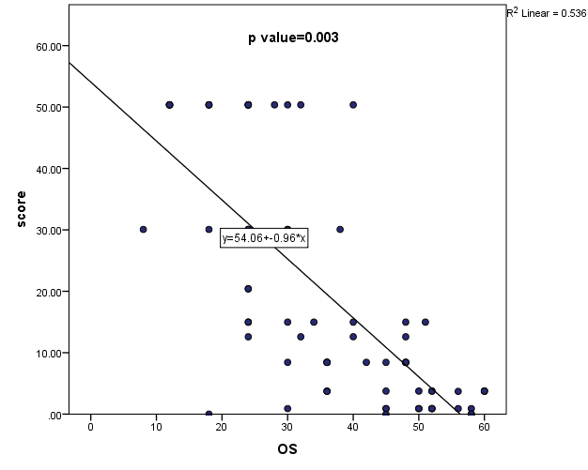
Figure (6): Correlation between NAR score & OS.

4. Discussion
Improvements in rectal cancer patient care have come as the result of clinical trials testing new treatments options. These pragmatic trials have provided significant improvement in disease staging, local disease control, patient survival, quality of life and sphincter preservation [8]. The loco-regional relapse was a primary form of treatment failure in CRC. However, with the introduction of TME and neo-adjuvant chemo-radiotherapy, local failure is far exceeded by systemic metastatic development which influences DFS and OS. These two benchmarks have been the primary endpoints of most major rectal cancer clinical trials in the past three decades. While ideal, these endpoints require long term follow-up, thus contributing to a slow pace of scientific progress in clinical research [9].
There is a tremendous desire to use the initial clinical and pathological features as surrogate endpoint for longer term outcomes, both for individual patients and also as a validated endpoint for the next generation of clinical trials. Identifying a valid surrogate short term endpoint will allow determination of treatment efficacy in clinical trials in a shorter period of time, resolving hypotheses and allowing clinical progress to be carried in more rapid fashion [10]. With the widespread use of TME, pathologic standardization has become increasingly critical for accurate assessment of nodal involvement, margin status and pathological staging [11].
Attempts to identify surrogate endpoint for DFS and OS have proven more challenging. However the introduction of neo-adjuvant chemo-radiotherapy has offered the opportunity to assess the degree of treatment effect and down-staging as a potential surrogate for longer term outcomes. So, pCR as an endpoint represent the ultimate degree of tumor down-staging defined as no histo-pathologic residual tumor remaining after neo-adjuvant therapy [12]. However, despite increasing the pCR, there was no improved local control and OS as pCR after chemo-radiotherapy is dependent upon the inherent chemo-radio sensitivity of cancer, bulk of the original tumor and interval after completion of treatment [13]. So, pCR has not been endorsed as a validated endpoint in part due to this limitation. Furthermore TRG requires standardization [14]. So the NAR score was developed as a short term clinical trial surrogate endpoint to take variables associated with treatment effect beyond pCR into consideration yet simple enough to support a diversity of clinical trial designs.
In this study, rectal cancer was common in males rather than females. This result was similar to that of Gao et al and White et al where men had higher CRC rates than females. The lower rates for rectal cancer in females are based on a degree of hormonal protection based on oral contraceptive and hormone replacement therapy [15, 16].
As regards the histo-pathological type, adenocarcinoma was the commonest type, which was similar to that of Fleming et al, and Marley et al where adenocarcinoma represented 90% and over 95% of cases respectively [17,18].
By calculating NAR score, Weiner et al, reported a median NAR score of 12.8 comparable to that of our study [19]. Conversely, the median score of Raissouni et al and You et al were 17.36 and 15.0 respectively which were higher than median score in our study [20,21].
Most of the patients in our study showed high NAR score followed by low and intermediate score. On contrary, in the study of Raissouni et al, and You et al, intermediate, high and low NAR score were 42.6% versus 49.4%, 34.9% versus 32.3% and 22.6% versus 18.3% respectively [20,21].
Considering response, pCR was comparable to that of Klautke et al and Winter et al where they reported a pCR of 22% and 28% respectively [22,23]. Meanwhile, pCR was higher than that of Kim et al, Roh et al, Raissouni et al, and You et al where pCR were 8.8%, 15%, 16.6%, and12.6% respectively [24,25], [20,21]. Conversely pCR of the current study was lower than that of Barbachano et al where it was 89% [26]. The PR was lower than that of Kim et al, Klautke et al, and Winter et al where they were 64.29%, 67% and 78% respectively [22-24].
The 5-year DFS rates in our study was lower than that of Kim et al, Roh et al, and Gérard et al where they were 52%, 65% and 72.7% respectively [24,25,27]. Also, Barbachano et al reported a higher 3-year DFS rate (68%) [26].
Roh et al reported OS rate similar to ours where it was 75% [25]. Conversely Barbachano et al reported higher OS rate (83%). This may be attributed to the different neo-adjuvant strategy as patients received 12 weeks of neo-adjuvant chemotherapy (oxaliplatin with capecitabine) followed by chemo-radiotherapy with capecitabine, TME and 12 weeks of adjuvant capecitabine [26]. Also Aschele et al, and Gerard et al, had a higher OS where5-year OS rates were 80.4 % and 88.3% respectively may be due to adding oxaliplatin to neo-adjuvant chemo-radiotherapy [27,28].
There was a statistical significant relation between NAR score and OS in our study which was matched with the study of Raissouni et al, You et al and George et al where the 5-year OS rate in the low NAR score were 88.1%, 88% & 92% and in intermediate NAR score were 82%, 81% & 89% and in high NAR score were 59.5%, 64.6% & 68% respectively [20,21,29].

Conclusion

The management of rectal cancer is challenging that requires a lot of scientific researches to decrease local recurrence, improve survival, allow sphincteric preservation and improves the quality of life of the patients. As a result, the researchers start to use a short term end points such as NAR score as a surrogate for survival in rectal cancer patients to facilitate the rapid scientific progress. There was a negative correlation between NAR score and DFS & OS as with the increase of NAR score, there was decrease in DFS and OS.

References
  - Smith D, Ballal M, Hodder R, Soin G, Selvachandran SN, Cade D. Symptomatic presentation of early colorectal cancer. Annals of the Royal College of Surgeons of England. 2006;88(2):185-90.
  - Schrag D. Evolving role of neoadjuvant therapy in rectal cancer. Curr Treat Options Oncol. 2013;14(3):350-64.
  - Sauer R, Becker H, Hohenberger W, Rodel C, Wittekind C, Fietkau R, et al. Preoperative versus postoperative chemoradiotherapy for rectal cancer. The New England journal of medicine. 2004;351(17):1731-40.
  - Bosset JF, Collette L, Calais G, Mineur L, Maingon P, Radosevic-Jelic L, et al. Chemotherapy with preoperative radiotherapy in rectal cancer. The New England journal of medicine. 2006;355(11):1114-23.
  - Sauer R, Liersch T, Merkel S, Fietkau R, Hohenberger W, Hess C, et al. Preoperative Versus Postoperative Chemoradiotherapy for Locally Advanced Rectal Cancer: Results of the German CAO/ARO/AIO-94 Randomized Phase III Trial After a Median Follow-Up of 11 Years. Journal of Clinical Oncology. 2012;30(16):1926-33.
  - Brenner H, Kloor M, Pox CP. Colorectal cancer. Lancet (London, England). 2014; 383(9927):1490-502.
  - Bray F, Ferlay J, Soerjomataram I, Siegel RL, Torre LA, Jemal A. Global cancer statistics 2018: GLOBOCAN estimates of incidence and mortality worldwide for 36 cancers in 185 countries. CA: a cancer journal for clinicians. 2018;68(6):394-424.
  - Plummer JM, Leake P-A, Albert MR. Recent advances in the management of rectal cancer: No surgery, minimal surgery or minimally invasive surgery. World journal of gastrointestinal surgery. 2017;9(6):139-48.
  - Birgisson H, Wallin U, Holmberg L, Glimelius B. Survival endpoints in colorectal cancer and the effect of second primary other cancer on disease free survival. BMC cancer. 2011;11:438.
  - Fleming TR, Powers JH. Biomarkers and surrogate endpoints in clinical trials. Statistics in medicine. 2012;31(25):2973-84.
  - Campa-Thompson M, Weir R, Calcetera N, Quirke P, Carmack S. Pathologic processing of the total mesorectal excision. Clinics in colon and rectal surgery. 2015;28(1):43-52.
  - Glynne-Jones R, Mawdsley S, Pearce T, Buyse M. Alternative clinical end points in rectal cancer—are we getting closer? Annals of Oncology. 2006;17(8):1239-48.
  - Petrelli F, Borgonovo K, Cabiddu M, Ghilardi M, Lonati V, Barni S. Pathologic complete response and disease-free survival are not surrogate endpoints for 5-year survival in rectal cancer: an analysis of 22 randomized trials. Journal of gastrointestinal oncology. 2017;8(1):39-48.
  - Kim SH, Chang HJ, Kim DY, Park JW, Baek JY, Kim SY, et al. What Is the Ideal Tumor Regression Grading System in Rectal Cancer Patients after Preoperative Chemoradiotherapy? Cancer research and treatment: official journal of Korean Cancer Association. 2016;48(3):998-1009.
  - Gao RN, Neutel CI, Wai E. Gender differences in colorectal cancer incidence, mortality, hospitalizations and surgical procedures in Canada. Journal of public health (Oxford, England). 2008;30(2):194-201.
  - White A, Ironmonger L, Steele RJC, Ormiston-Smith N, Crawford C, Seims A. A review of sex-related differences in colorectal cancer incidence, screening uptake, routes to diagnosis, cancer stage and survival in the UK. BMC Cancer. 2018;18(1):906.
  - Fleming M, Ravula S, Tatishchev SF, Wang HL. Colorectal carcinoma: Pathologic aspects. Journal of gastrointestinal oncology. 2012;3(3):153-73.
  - Marley AR, Nan H. Epidemiology of colorectal cancer. International journal of molecular epidemiology and genetics. 2016;7(3):105-14.
  - Weiner A, Markovina S, Khwaja S, DeWees TA, Hunt S, Myerson RJ, et al. Neoadjuvant Rectal Cancer (NAR) Score Applied to Phase 2 Trial of Short Course Radiation (RT) and FOLFOX as Preoperative Therapy for Rectal Cancer Supports a Total Neoadjuvant Approach. International Journal of Radiation Oncology • Biology • Physics. 2014;90(1):S389.
  - Raissouni S, Mercer J, Gresham G, Kumar A, Goodwin RA, Jiang M, et al. External validation of the neoadjuvant rectal (NAR) score and Valentini prediction nomogram (VPN): A multicenter study. Journal of Clinical Oncology. 2014;32(15_suppl):3532-.
  - You YN, George TJ, Chiang Y-J, Eng C, Das P, Chang GJ, et al. Validation of neoadjuvant rectal cancer (NAR) score as a surrogate endpoint for overall survival in real-life practice settings. Journal of Clinical Oncology. 2018; 36(15_suppl):3517-.
  - Klautke G, Feyerherd P, Ludwig K, Prall F, Foitzik T, Fietkau R. Intensified concurrent chemoradiotherapy with 5-fluorouracil and irinotecan as neoadjuvant treatment in patients with locally advanced rectal cancer. British Journal Of Cancer. 2005;92:1215.
  - Mohammed Mohiuddin KW, Edith Mitchell, Nader Hanna, Albert Yunen, Charles Nichols, Robert Shane, Cherie Hayostek, Christopher Willett. Randomized phase 2 study of Neoadjuvant Comined-Modality Chemoradiation for Distal Rectal Cancer: Radiation Therapy Oncology Group Trial 0012. 2005.
  - Kim NK, Baik SH, Seong JS, Kim H, Roh JK, Lee KY, et al. Oncologic outcomes after neoadjuvant chemoradiation followed by curative resection with tumor-specific mesorectal excision for fixed locally advanced rectal cancer: Impact of postirradiated pathologic downstaging on local recurrence and survival. Annals of surgery. 2006;244(6):1024-30.
  - Roh MS, Colangelo LH, O'Connell MJ, Yothers G, Deutsch M, Allegra CJ, et al. Preoperative multimodality therapy improves disease-free survival in patients with carcinoma of the rectum: NSABP R-03. Journal of clinical oncology: official journal of the American Society of Clinical Oncology. 2009;27(31):5124-30.
  - Yu Jo Chua YB, David Cunningham, Jacqui R Oates, Gina Brown, Andrew Wotherspoon, Diana Tait, Alison Massey, Niall C Tebbutt, Ian Chau Neoadjuvant capecitabine and oxaliplatin before chemoradiotherapy and total mesorectal excision in MRI defined poor-risk rectal cancer. 2010.
  - Gerard JP, Azria D, Gourgou-Bourgade S, Martel-Lafay I, Hennequin C, Etienne PL, et al. Clinical outcome of the ACCORD 12/0405 PRODIGE 2 randomized trial in rectal cancer. Journal of clinical oncology: official journal of the American Society of Clinical Oncology. 2012;30(36):4558-65.
  - Aschele C, Lonardi S, Cionini L, Pinto C, Cordio SS, Rosati G, et al. Final results of STAR-01: A randomized phase III trial comparing preoperative chemoradiation with or without oxaliplatin in locally advanced rectal cancer. Journal of Clinical Oncology. 2016;34(15_suppl):3521.
  - George TJ, Jr., Allegra CJ, Yothers G. Neoadjuvant Rectal (NAR) Score: a New Surrogate Endpoint in Rectal Cancer Clinical Trials. Current colorectal cancer reports. 2015;11(5):275-80.

7/22/2019

