The application of Clathrin Heavy Chain and Leukemia Inhibitory Factor Receptor in the differential diagnosis of benign and malignant hepatic lesions

Aliaa Atef Shams Eldeen, and Rania Elsayed Wasfy

Pathology Department, Faculty of Medicine, Tanta University, Egypt
Email: dr-aliaaatef@hotmail.com

Abstract: Background: Hepatic focal lesions include a heterogeneous group of lesions ranging from benign regenerative cirrhotic nodules to low and high grade dysplastic nodules to HCC. Hepatocellular carcinoma (HCC) is the most common type of all primary liver tumors. Liver cell dysplasia particularly high-grade dysplasia (HGD) has a high risk for malignant transformation. It is mandatory to find more accurate and comprehensive novel markers for diagnosis of HCC. Aim: To study the diagnostic role of clathrin heavy chain (CHC) and leukaemia inhibitory factor receptor (LIFR) in malignant and non-malignant liver lesions and correlation with the clinico-pathological parameters of studied cases. Results: CHC immunopositvity was highly specific and sensitive indicator for hepatocellular carcinoma unlike LIFR which cannot be used as reliable indicator of liver malignancy. Most of cases of HCC were positive for CHC (31 out of 33) (93.9%). Most of cases of cirrhosis (17 out of 25) (68.0%) were negative for CHC. In liver cell dysplasia, 14 cases were positive (70.0%) (P<0.001). LIFR was more expressed in non-malignant than in HCC. 92% of cases of cirrhosis were positive for LIFR. 95% of cases of dyspalsia were positive for LIFR; only 30.3% of HCC showed positivity for LIFR. This inverse relation was statistically highly significant (p<0.001). Conclusion: CHC can be a promising diagnostic immunomarker for the diagnosis of HCC unlike LIFR which can’t be a reliable diagnostic marker alone. However, a combination of both markers (CHC and LIFR) represents a valuable diagnostic tool in workout of hepatic lesions uncertain for malignancy rather than individual markers.
[Aliaa Atef Shams Eldeen, and Rania Elsayed Wasfy. The application of Clathrin Heavy Chain and Leukemia Inhibitory Factor Receptor in the differential diagnosis of benign and malignant hepatic lesions. Cancer Biology 2019;9(3):32-38]. ISSN: 2150-1041 (print); ISSN: 2150-105X (online). http://www.cancerbio.net. 5. doi:10.7537/marscbj090319.05.

Key words: Clathrin heavy chain, Leukaemia inhibitory factor receptor, hepatocellular carcinoma.

1. Introduction:
Hepatic focal lesions include a heterogeneous group of lesions ranging from benign regenerative cirrhotic nodules to low and high grade dysplastic nodules to hepatocellular carcinoma. Hepatocellular carcinoma (HCC) is the most common type of all primary liver tumors, the fifth most common cancer and the third cause of cancer-related deaths all over the world. It shows marked geographic variations with the most of cases occurring in the developing countries [Anatelli et al., 2008].
HCC is more prevalent in males than females with the peak incidence occuring in the 5th to 6th decades. Multiple factors are involved in the etiology of HCC with HBV and HCV infection being the most important in association with cirrhosis [Mohan, 2010].
Liver cell dysplasia particularly high-grade dysplasia (HGD) has a high risk for malignant transformation. The detection of dysplasia, especially HGD, or its differentiation from cirrhotic nodules or early HCC are often very challenging on the basis of histopathological features alone especially in tiny core biopsies. Despite the recent advances in imaging techniques and the increased frequency of early detection of small lesions, the low specificity of their identification has not been resolved [Jin et al., 2013].
HCC can remain undetected for awhile because in a large number of cases it occurs on top of cirrhosis. This late detection of HCC is a main cause for tumor rapid progression and increased HCC related mortality rates. So, improvement of survival of HCC patients depends on the early detection of HCCs by discovering new sensitive and specific markers for early HCC [Fanni et al., 2012].
The commonly applied diagnostic markers for HCC are not sensitive or specific enough and are incapable for identification of early well differentiated HCC making it mandatory to find more accurate and comprehensive novel proteins for diagnosis of HCC [Yan et al., 2011].
Clathrin is a protein having important roles in membrane trafficking and, mitosis. The clathrin protein is a trimeric assembly, comprising of three heavy chains with an associated light chain. Two clathrin heavy chain genes are found in humans: CHC17 and CHC22. CHC17, commonly known as CHC, is highly expressed in all cells while CHC22 expression is very low in most of cells but mainly present in skeletal muscle. In non-dividing cells, clathrin forms coated vesicles transported from the cell membrane to endosomes or between endosomes and the Golgi apparatus [Royle, 2006].
When the cell becomes mitotically active, membrane trafficking is inhibited and clathrin becomes localized to the mitotic spindle but resumes in late telophase. This shows the possibility of clathrin having a separate function different from membrane trafficking occuring during mitosis. Two different gene fusions involving CHC have been identified in human cancers: anaplastic lymphoma kinase (ALK) and transcription factor binding to IGHM enhancer 3 (TFE3). This altered clathrin function due to the presence of these fusion proteins could contribute to oncogenesis [Blixt & Royle, 2011].
CHC in liver is an endothelial marker that is overexpressed in malignant cells of HCC and showed promising results especially in combination with other diagnostic markers as glypican-3, HSP70 and glutamine synthase [Seimiya et al., 2008].
Leukemia inhibitory factor receptor (LIFR) is a multifunctional glycoprotein involved in signal transduction through interleukin-6 (IL-6) cytokine family. LIFR has variable diverse functions ranging from glucose uptake, maintaining of stem cells in a pluripotent state, liver protective actions, to alteration of cell proliferation either stimulation or inhibition. LIFR was also identified as a suppressor of metastasis through Hippo-YAP pathway [Chen et al., 2012]. LIFR was also reported as a tumor suppressor gene in HCC [Okamura et al., 2010].
However, whether CHC or LIFR, their roles as immunomarkers for differentiation between benign and malignant hepatic lesions have not been thoroughly investigated.
Aim of the work
To study the diagnostic role of clathrin heavy chain (CHC) and leukaemia inhibitory factor receptor (LIFR) in malignant and non-malignant liver lesions. Their expression was also correlated with the clinico-pathological parameters of studied cases such as age, gender, tumor size and tumor grade.

2. Materials and methods:
The study comprised of 78 formalin fixed paraffin embedded hepatic tissue blocks (25 cirrhosis, 20 dyspalsia and 33 of HCC). Paraffin Blocks were collected from the archives of the pathology department, tanta university hospital, and private laboratories, with their clinic-pathological data.
Immunohistochemicalstaining:
For immunostaining, 4 μm sections were deparaffinized in xylene, and then become rehydrated in decreasing concentrations of ethanol. Blockage of endogenous peroxidases (by incubation in 0.3% H2O2 for 30 min) followed by microwave incubation (15 min in 10 mM sodium citrate buffer pH 6.0) for antigen retrieval. Slides were then incubated with the primary antibodies CHC (Rabbit / IgG polyclonal Antibody, Catalog Number PA5-50514, Thermofisher scientific, dilution 1:25-1:100 overnight at 4°C) and LIFR (Mouse / IgG1 Monoclonal Antibody, Catalog Number MA1-065, Thermofisher scientific, dilution: 1:100). Slides were rinsed by phosphate buffered saline after every step. Phosphate Slides were examined blindly (without knowledge of the clinical data). Counting of positive cells was done using LEICA image analysis system (LEICA DFC290 HD, Leica Microsystems Ltd., Heerbrugg, Switzerland). Five high power fields (x400 fields) were counted in each slide. Cells with cytoplasmic positivity for CHC and LIFR were counted. The counts were statistically analyzed using SPSS version 16 (SPSS Inc., Chicago, Illinois, USA).
Interpretation of immunostaining:
Immunostaining scores were independently evaluated by two pathologists who were blinded to the clinical outcome. The most 3 representative fields were selected under low power magnification (×100). For LIFR, positivity was detected by brown cytoplasmic staining. The immunostaining was scored according to the percentage of positive cells: 0 (0–10%), 1 (11–50%), and 2 (> 51%) and the intensity of the staining: 0 (no staining), 1 (light brown), 2 (brown), and 3 (dark brown). The end scores were calculated with the following formula: overall scores = percentage score × intensity score. Overall scores of ≤ 1, 1–3, and ≥ 3 were defined as –, +, and ++, respectively [Luo et al., 2015]. CHC was also detected by cytoplasmic staining. Protein expression was scored as negative (0), weak (1), moderate (2), and strong (3) [Seimiya et al., 2008].
Statistical analysis was performed by using the Kruskal Wallis test, 2-tailed Fisher exact test or the χ2 test with Yates continuity correction. A P value of less than 0.05 was considered statistically significant.

3. Results:
Clinicopathological data:
The study included 78 cases of hepatic lesions, including 25 of cirrhosis (18 males and 7 females) with a mean age of 60.64 ± 12.77, 20 cases of dysplasia (13 males and 7 females) with a mean age of 58.40 ± 15.22 and 33 cases of HCC (20 males and 13 females with a mean age of 62.66 ± 11.58.
For HCC, the size was classified into small and large (17 and 16 cases respectively). The grade was classified into well, moderate and poorly differentiated (14, 8 and 11 cases respectively).
CHC immunohistochemical staining results:
CHC was detected as cytoplasmic staining of tumor cells. CHC expression was present in most of cases of HCC, decrease slightly with dysplasia with marked decrease in cirrhosis. Most of cases of HCC were positive to CHC (31 out of 33) (93.9%), only 2 cases of HCC were negative to CHC (6.1%). Most of cases of cirrhosis (17 out of 25) (68.0%) were negative to CHC. While only 8 cases of cirrhosis (32.0%) were positive to CHC. In liver cell dysplasia, 14 cases were positive (70.0%) and 6 cases (30%) were negative to CHC (Fig 1).

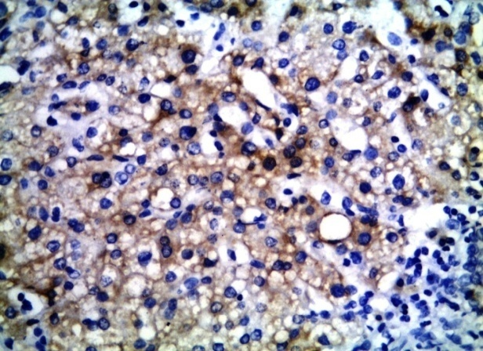
Fig 1. A case of liver cell dysplasia with moderate cytoplasmic staining (+2) of CHC

This relation was highly significant statistically (P<0.001) (Table 3). Statistical analysis revealed significant association between tumor size and cytoplasmic expression of CHC where most of large size carcinoma cases (14 out of 16) showed strong positivity to CHC (Table 2)
Studying the relation with tumor grade also revealed significant relation with advancing grade and strong CHC expression. Strong CHC expression of +3 was detected in most of moderate and poorly differentiated cases (7 out of 8 and 9 out of 11 respectively) (Table 2) (Fig 2,3).

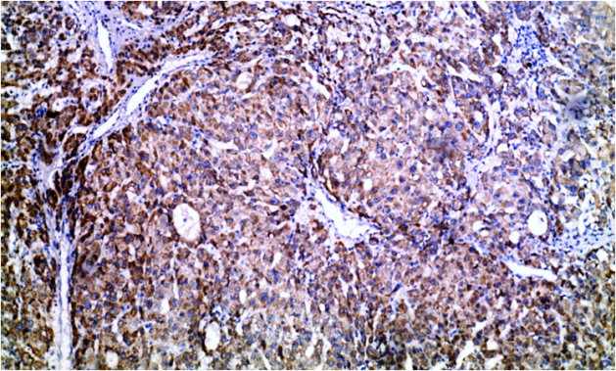
Fig 2. A case of moderately differentiated HCC with strong cytoplasmic expression (+3) of CHC

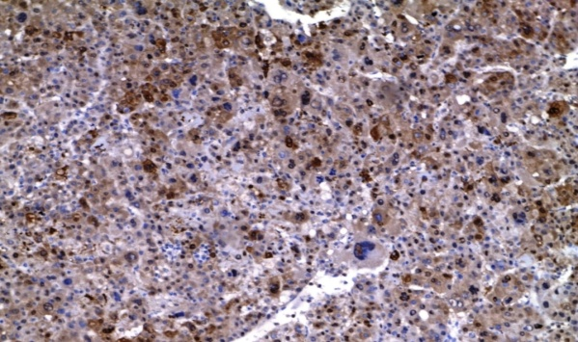
Fig 3. A case of poorly differentiated HCC with strong cytoplasmic expression (+3) of CHC

Table 1. The relation between CHC expression with tumor size and grade.
HCC |  |  | CHC |  |  |  | FE (p value)
 |  |  | Negative  (n=2) | +1  (n=1) | +2  (n=8) | +3  (n=22)
 | size | Small n=17 | 1 (50) | 1(100) | 7 (87.5) | 8 (36.4) | 7.23  (0.01)*
 |  | Large n=16 | 1 (50) | 0 | 1 (12.5) | 14 (63.6)
 | grade | Well n=14 | 0 | 1(100) | 7 (87.5) | 6 (27.3) | 11.02  (0.007)*
 |  | Moderate n=8 | 1 (50) | 0 | 0 | 7 (31.8)
 |  | Poor n=11 | 1 (50) | 0 | 1 (12.5) | 9 (40.9)
*Statistically significant (P<0.05).

LIFR immunohistochemical staining results:
LIFR was detected by cytoplasmic staining of tumor cells. The expression of LIFR was more expressed in non-malignant (cirrhosis and dyspalsia) than in HCC. 92% of cases of cirrhosis were positive to LIFR. (Fig 4). 95% of cases of dyspalsia were positive to LIFR. (Fig 5). On the other hand, only 30.3% of HCC showed positivity to LIFR (Fig 6). This inverse relation was statistically highly significant (p<0.001) (Table 3).
As a result of low expression of LIFR in cases of HCC, no significant association was found between LIFR positivity and either the size or grade of HCC cases.
Concerning the age and gender, no statistical significant relation was found between CHC and LIFR on one hand and patient’s age or gender on the other hand in all studied cases.

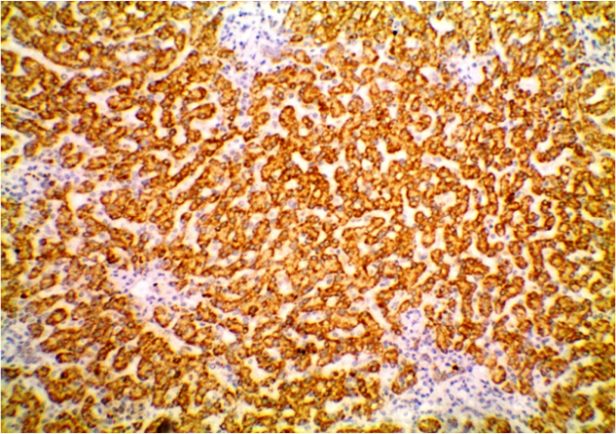
Fig 4. A case of cirrhosis with strongly positive cytoplasmic staining (++) to LIFR

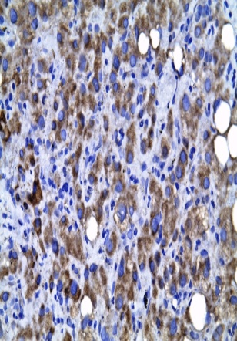
Fig 5. A case of liver cell dysplasia with strongly positive cytoplasmic expression (++) of LIFR

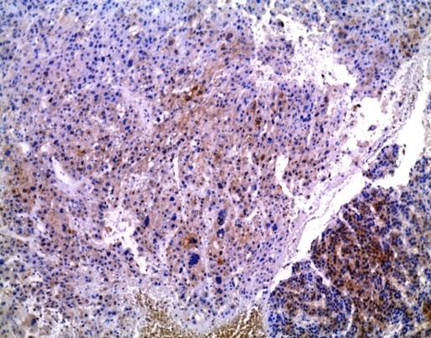
Fig 6. A case of poorly differentiated HCC with positive cytoplasmic expression (+) of LIFR

Table 2. The relation between LIFR expression with tumor size and grade
HCC |  |  | LIFR |  |  | p value
 |  |  | Negative  (n=23) | +  (n=8) | ++  (n=2)
 | size | Small n=17 | 11 (47.8) | 4 (50.0) | 2 (100.0) | 1.71  (0.59)
 |  | Large n=16 | 12 (52.2) | 4 (50.0) | 0 (0.0)
 | grade | Well n=14 | 8 (34.8) | 4 (50.0) | 2 (100.0) | 2.76 (0.64)
 |  | Moderate n= 8 | 6 (26.1) | 2 (25.0) | 0 (0.0)
 |  | Poor n=11 | 9 (39.1) | 2 (25.0) | 0 (0.0)

Table 3: CHC and LIFR expression in dysplasia, cirrhosis, and HCC
 | HCC (n=33)  No. % | Dysplasia (n=20)  No. % | Cirrhosis (n=25)  No. % | x² | P value
Age (mean ± SD) | 62.66 ± 11.58 | 58.40 ± 15.22 | 60.64 ± 12.77 | F=0.68 | 0.50
Gender:  Male:  Female: | 20 (60.0)  13 (39.4) | 13 (65.0)  7 (35.0) | 18 (72.0)  7 (28.0) | 0.81 | 0.66
CHC:  -ve:  +ve: | 2 (6.1)  31 (93.9) | 6 (30.0)  14 (70.0) | 17 (68.0)  8 (32.0) | 25.10 | <0.001*
LIFR:  -ve:  +ve: | 23 (69.7)  10 (30.3) | 1 (5.0)  19 (95.0) | 2 (8.0)  23 (92.0) | 34.08 | <0.001*
*Statistically significant (P<0.05).

Regarding statistical relations, CHC immunopositvity was highly specific and sensitive indicator for hepatocellular carcinoma unlike LIFR which cannot be used as reliable indicator of liver malignancy. (Table 4)

Table 4: sensitivity and specificity of CHC and LIFR
AUC | Sensitivity | Specificity | PPV | NPV | Accuracy
CHC | 93.9 | 95.0 | 69 | 75 | 70
LIFR | 69.7 | 30.0 | 96 | 66 | 79

4. Discussion:
The differentiation between various hepatic focal lesions can be one of the most common and confusing problems encountered by pathologists who are asked nowadays to provide conclusive diagnosis for adequate management and therapy. To support the provisional diagnosis made on the basis of morphological criteria, the finding of new immunomarkers for the early detection of HCC and for successful management, became a necessity. [Gamal et al., 2017].
In the present study, we intended to study the usefulness of both CHC and LIFR in the differential diagnosis between benign and malignant liver lesions precisely liver cirrhosis, liver cell dysplasia and HCC.
Concerning the study of CHC immunostaining; CHC was chosen for being an endothelial marker, it works well as an internal control for non parenchymal hepatocytes and, was found to be overexpressed in the cytoplasm of malignant hepatocytes [Fanni et al., 2012].
In our study, CHC was detected as cytoplasmic staining of hepatocytes in most of cases of HCC, decreased slightly with dysplasia with marked decrease in cirrhosis. 93.9% of HCC cases were positive, 68% of liver cirrhosis were negative to CHC while 70% of liver cell dysplasia cases were positive to CHC.
In approval with our results, Di Tommaso et al. (2011) assessed CHC with other markers as GPC-3 and HSP70 immunoreactivity in 15 neoplastic liver lesions (8 HCCs and 7 HGDNs). They noted that CHC is the most overexpressed immunomarker in this panel. Only one HGDN case showed focal weak positivity where HCC hepatocytes showed diffuse strong staining in five of eight cases and with focal staining in three of eight cases. 26 out of 30 cases of cirrhosis were negative for CHC immunostaining.
Supporting our results, Schaeffer et al. (2011), discovered CHC strong immunostaining in HCC while being absent in non-malignant lesions.
In 2008, Seimiya et al. reached similar results. They stated that immunostaining of CHC can contribute to the early diagnosis of HCC. They found that CHC expression was surprisingly different between tumorous and nontumorous liver tissues. CHC was useful in distinguishing HCC from benign liver lesions such as regenerative nodules.
Lately, Gamal et al. (2017) also studied CHC expression in 30 HCC specimens and 18 cirrhotic liver tissues near HCC They noted significant upregulation of CHC in hepatocellular carcinomas compared to cirrhotic liver tissue suggesting their role in hepatocarcinogenesis.
Statistical analysis of our data revealed significant relation between tumor size and positive expression of CHC where most of large size HCCs showed strong positivity to CHC. In the same time, there was significant relation between advancing grade and strong CHC expression.
Gamal et al. (2017), similarly found positive correlation between CHC and histological grade of HCC but no significant relation with tumor size.
Concerning Sensitivity and specificity of CHC in this study, CHC was highly specific and sensitive indicator for hepatocellular carcinoma with 93.9% sensitivity, 95% specificity and 70% diagnostic accuracy.
Similarly, Seimiya et al. (2008), found that the sensitivity and specificity of CHC for the detection of HCC were 51.8% and 95.6%.
Schaeffer et al. (2011), stated that the addition of CHC to a panel of other four markers increased the diagnostic accuracy for HCCs (from 76.9 to 84.3%), and there was an important gain in sensitivity (from 46.8 to 63.8%).
Interestingly, Di Tommaso et al. (2011), found that a four‐marker panel with CHC was superior to a three‐marker panel without CHC with a gain in sensitivity and accuracy with four markers staining (63.8% and 84.3% respectively) versus three markers staining (46.8% and 76.9% respectively).
The biological roles of interleukin-6 cytokine family including LIFR, are widely variable, In the present study we aimed to discuss the role of LIFR in liver carcinogenesis and its efficacy as diagnostic marker for HCC. The role of LIFR in HCC was analysed in several tumors including breast, nasopharyngeal carcinoma, choriocarcinoma and leukaemia [Shin et al., 2011, Hergovich, 2012, Liu & Chang, 2014, Fitzgerald et al., 2005 and Yue et al., 2015]. Very few studies discussed the expression of LIFR in liver lesions and the results were controversial.
In our study, we found that LIFR was more expressed in non-malignant than in HCC. 92% of cases of cirrhosis were positive to LIFR. 95% of cases of dyspalsia were positive to LIFR. On the other hand, only 30.3% of HCC showed positivity to LIFR. This inverse relation was statistically highly significant (p<0.001).
The same results were reached by Luo et al. in 2015. They analysed the expression of LIFR in 64 cirrhotic nodules, 62 dysplastic nodules, and 71 HCCs. They noticed that LIFR expression was decreased along with stepwise progression of hepatocarcinogenesis from dysplastic nodules to HCC. Their results were significantly different between well differentiated HCC and HGDNs.
In the same year, Luo et al., in another study, also revealed decreased expression of LIFR in HCC, and even lower in HCC with metastasis. They demonstrated as well that downregulated LIFR expression indicated poor prognosis for HCC patients.
In addition, Okamura et al. (2010), attempted to identify the suppressor genes of HCC as LIFR. They found that only 23 of 48 (47.9%) tumor tissues showed positivity for LIFR gene, and the expression level was clearly decreased in HCCs (P<0.0001). They also considered LIFR gene as a new tumor suppressor gene of HCC.
On the other hand, several studies discussed the expression of LIFR in different tumors as breast cancer. Shin et al. (2011) showed LIFR overexpression with breast cancer progression although the molecular mechanisms responsible are still largely unknown. In contrast, Hergovichin2012, noted that LIFR over-expression in breast cancer cells suppressed tumour growth, suggesting that LIFR is an important breast tumour suppressor. Similarly, Chen et al. (2012) also found that LIFR is downregulated in breast cancer.
In nasopharyngeal carcinoma, Liu & Chang (2014), stated that LIFR, as a cytokine, is thought to protect tumor cells from immune surveillance and form an important component of the tumor microenvironment. LIFR affects tumor growth and survival.
In 2005, Fitzgerald et al. found a connection between LIFR activity and invasiveness of choriocarcinoma and trophoblastic cells. As for leukemia cells, Yue et al. (2015) found that LIFR plays an important role in inducing differentiation of leukemia cells.
Unlike CHC, we found that LIFR cannot be used as reliable indicator of liver malignancy with specificity 30% and sensitivity 69.7%.
Lou et al. (2015), noticed lower sensitivity for LIFR (58.1%) and 90.5 specificity. The combination of LIFR with CD34 improved sensitivity to 93.5%. They stated that combination, Not LIFR alone, may be used as a differential diagnostic model for HCC from HGDNs in clinical practice.

Conclusion
Our results suggest that CHC can be a promising diagnostic immunomarker for the diagnosis of HCC unlike LIFR which can’t be a reliable diagnostic marker alone. A combination of both markers (CHC and LIFR) can represent a valuable diagnostic tool in workout of hepatic lesions uncertain for malignancy rather than individual markers. Furthermore, we think that the diagnostic and therapeutic ramifications of our results await future investigations.

Acknowledgment:
We wish to thank the department of pathology of faculty of medicine, Tanta university, for providing us with a large part of the cases from the archive of the department and making our work much easier.

Conflicts of interest:
Author Aliaa Atef declares that she has no conflict of interest. Author Rania Elsayedwasfy declares that she has no conflict of interest.

References:
- Anatelli F, Chuang S, Yang X et al. (2008). Value of Glypican 3 Immunostaining in the Diagnosis of Hepatocellular Carcinoma on Needle Biopsy. Am J ClinPathol, 130, 219-223.
- Blixt M and Royle S (2011). Clathrin heavy chain gene fusions expressed in human cancers: analysis of cellular functions, 12(6), 754-61.
- Chen D, Sun Y, Wei Y et al. (2012). LIFR is a breast cancer metastasis suppressor upstream of the Hippo-YAP pathway and a prognostic marker. Nat Med,18, 1511–1517.

Di Tommaso L, Destro A, Fabbris V et al. (2011). Diagnostic accuracy of clathrin heavy chain staining in a marker panel for the diagnosis of small hepatocellular carcinoma. Hepatology, 53(5), 1549-57.
- Fanni D, Gerosa C and Faa G (2012). The Histomorphological and Immunohistochemical Diagnosis of Hepatocellular Carcinoma, Hepatocellular Carcinoma - Clinical Research, 65-88.

Fitzgerald J, Tsareva S, Poehlmann T et al. (2005). Leukemia inhibitory factor triggers activation of signal transducer and activator of transcription 3, proliferation, invasiveness, and altered protease expression in choriocarcinoma cells. Int J Biochem Cell Biol, 37(11), 2284-96.

Gamal Y, Ahmed A, Hassan H et al. (2017). Glypican-3, heat shock protein-70, and clathrin heavy chain in hepatitis C virus-related hepatocellular carcinoma. Egyptian Journal of Pathology,37(2), 236–243.
- Hergovich A (2012). YAP-Hippo signalling downstream of leukemia inhibitory factor receptor: implications for breast cancer. Breast Cancer Research, 14, 326.
- Jin G, Dong H, Yu W bet al. (2013). A novel panel of biomarkers in distinction of small well-differentiated HCC from dysplastic nodules and outcome values. BMC Cancer, 13, 161.

Liu S and Chang Y (2014). Role of leukemia inhibitory factor in nasopharyngeal carcinogenesis. Mol Cell Oncol, 1(1), e29900.
- Luo Q, Zhang Y, Wang N et al. (2015). Leukemia inhibitory factor receptor is a novel immunomarker in distinction of well-differentiated HCC from dysplastic nodules. Oncotarget, 6(9), 6989-6999.
- Luo Q, Wang C, Jin G, et al. (2015). LIFR functions as a metastasis suppressor in hepatocellular carcinoma by negatively regulating phosphoinositide 3-kinase/AKT pathway. Carcinogenesis, 36(10), 1201-12.
- Mohan H (2010). Text book of pathology: The Liver, Biliary Tract and Exocrine Pancreas. CH. 21, 6th Ed. Pub. Jaypeebrothers medical publishers (p) ltd. P. 633.
- Okamura Y, Nomoto S, Kanda M, et al. (2010). Leukemia inhibitory factor receptor (LIFR) is detected as a novel suppressor gene of hepatocellular carcinoma using double-combination array. Cancer Lett.,289, 170–177.
- Royle SJ. (2006). The cellular functions of clathrin. Cell Mol Life Sci, 63(16), 1823-1832.
- Schaeffer D and Nahum Méndez-Sánchez N (2011). Clathrin heavy chain (CHC) staining for the diagnosis of small hepatocellular carcinoma. Annals of hepatology, 10 (3), 374-375.
- Seimiya M, Tomonaga T, Matsushita K et al. (2008). Identification of Novel Immunohistochemical Tumorm Markers for Primary Hepatocellular Carcinoma; Clathrin Heavy Chain and Formiminotransferase Cyclodeaminase Hepatology, 48, 519-530.
- Shin J, Park S and Jang Y (2011). Epigenetic Up-Regulation of Leukemia Inhibitory Factor (LIF) Gene During the Progression to Breast Cancer. Mol. Cells, 31, 181-189.
- Yan B, Wei J, Qian Y et al. (2011). Expression and clinicopathologic significance of glypican 3 in hepatocellular carcinoma. Annals of Diagnostic Pathology, 15, 162–169.
- Yue X, Wu L and Hu W (2015). The regulation of leukemia inhibitory factor. Cancer Cell Microenviron, 2(3), e877.

7/6/2019

