Spontaneous Rupture of Hepatocellular Carcinoma; Middle-Eastern Experience

Mohammad Burhan Khan ¹ MBBS; Ahmed Elaffandi^{1, 2} MD; Walid Elmoghazy^{1,3} PhD; Samah Mohamed ^{4,5}FRCR, MD; Alshimaa Alaboudy⁶ MD; Hatem Khalaf¹ MD

¹Department of Hepato-Pancreatobiliary and Liver Transplantation, Liver Unit-Organ Transplantation, Hamad General Hospital, Doha, Qatar
²Department of Surgical Oncology, National Cancer Institute, Cairo University, Cairo, Egypt
³Department of Surgery, Sohag University, Egypt
⁴Diagnostic Radiology, Hamad Medical Corporation, Doha, Qatar
⁵Diagnostic Radiology, National Cancer Institute, Cairo, Egypt
⁶Department of Tropical Medicine and Gastroenterology, Faculty of Medicine, Sohag University, Sohag, Egypt
ahmedaffandy@gmail.com

Abstract: Background: Hepatocellular carcinoma (HCC) is among the top five most common cancers in the world. However, spontaneously ruptured hepatocellular carcinoma (HCC) is a rare and potentially fatal condition. The aim of the present study is to compare the outcomes and survival between patients presenting with ruptured HCC and those presenting without a rupture. Our secondary objectives are to determine factors predisposing patients to a spontaneous rupture. Methods: In this retrospective study, all patients presenting with HCC between January 2006 and December 2015 were included. They were grouped based on findings of ruptured HCC at presentation. Treatment plans for patients were decided by a multidisciplinary team of physicians and surgeons. Outcomes were calculated, which included Kaplan-Meier survival curves and log-rank test was used for comparison. Cox proportional hazards regression was used in identifying prognostic factors in relation to mortality, and long-term survival. Patient and tumor factors predisposing to rupture were compared to the control group. Results: 324 patients were diagnosed with HCC during the study period. 14 of them presented with a spontaneous rupture. Majority of patients (54.9%) had Hepatitis C virus as the underlying etiology for cirrhosis and HCC. The overall mortality rate was 59.3%, (64.3% in ruptured HCC group versus 59% in HCC group). Median survival in the ruptured group was 370 days, compared to 400 days in HCC group. 5 out 14 (36%) patients with ruptured HCC died within the initial 30 days. Initial survival rates were found to be statistically different at 1 and 3 months; however, the overall survival found to be similar for the rest of the follow-up period. Poorer liver function, a lower hemoglobin level, higher creatinine level, larger maximal tumor diameter, and higher total tumor volume was associated with ruptured HCC. Conclusions: While the survival benefit of patient’s with ruptured HCC is inferior to those who present with HCC, there are a few important observations. Poor liver function, low hemoglobin, high createnine, larger tumor maximum diameter and higher total volume at presentation is associated with a high 30-day mortality for patients presenting with ruptured HCC compared to those with HCC. However, long term overall survival is no different between the two groups of patients once past the initial 30 - day period. Tumor related factors such as maximum tumor diameter and total tumor volume may play an important role as predictors for spontaneous rupture.
[Mohammad Burhan Khan; Ahmed Elaffandi; WalidElmoghazy; Samah Mohamed; Alshimaa Alaboudy; Hatem Khalaf. Spontaneous Rupture of Hepatocellular Carcinoma; Middle-Eastern Experience. Cancer Biology 2019;9(3):24-31]. ISSN: 2150-1041 (print); ISSN: 2150-105X (online). http://www.cancerbio.net. 4. doi:10.7537/marscbj090319.04.

Keywords: Spontaneous; Rupture; Hepatocellular; Carcinoma; Middle-Eastern; Experience

1. Introduction
Hepatocellular carcinoma (HCC) is among the top five most common cancers in the world and the commonest primary malignant tumor of the liver. ^{[1, 2, 3, 4]} The incidence of HCC is gradually increasing. ^{[1, 2, 3]}Per year, the number of new cases is estimated to exceed 500,000. ^{[5, 6, 7]}Treatment of choice depends on many criteria such as performance status, staging at the time of detection and evidence of portal hypertension ^{[2]}. Spontaneous rupture of HCC is a life-threatening complication that is not only clinically challenging but remarkably affects the patient survival ^{[7- 11]}. Rupture of the tumor occurs in 3 – 26% of patients with HCC. ^{[1, 2, 11- 24]} In-hospital or 30-day mortality rates are as high as 25– 75% due to commonest presentation being hemorrhagic shock. ^{[8, 9, 10, 5, 11]} Although its incidence is difficult to assess, it is the third leading cause of death overall behind liver failure and tumor progression in patients with HCC ^{[1, 2, 12]}. The seventh edition of AJCC/UICC (American Joint Committee on Cancer/Union for International Cancer Control) TNM staging system assigns all ruptured HCC tumors to T4. ^{[13, 14]} Treatment approach at the time of presentation is limited by both patient and tumor related factors, however; the scale of which ranges from surgery to conservative management. ^{[2, 11, 15 - 16]} Intraabdominal bleeding following spontaneous rupture is associated with intraperitoneal dissemination of tumor, upstaging of HCC and hence pooreroutcome ^{[7, 15]}. On the contrary, other reports have shown no change in patient outcome following similar events. ^{[7]}
The aim of the present study is to compare the outcomes and survival between patients presenting with ruptured hepatocellular carcinoma and those presenting without a rupture. Our primary objective was to compare outcomes in patients with ruptured HCC versus all patients who presented with HCC during the same time frame to our institution. Our secondary objectives includestudying factors which may predispose patients to spontaneous rupture.

2. Materials And Methods
From January 2006 to December 2015, a total of 324 patients with HCC presented to Hamad General Hospital (HGH), the tertiary care and referral center in the State of Qatar. 14 of these patients presented with spontaneous rupture, at which time they were referred to Department of Hepato-Pancreato-Biliary (HPB) surgery [Liver Unit, Hamad General Hospital – Hamad Medical Corporation (HMC)]. All patients were included in the study.
It was following approval from HMC institutional research board (IRB) and ethical committee that data was extracted from our database records and hospital charts. The clinical records of both groups were retrospectively reviewed and compared with a particular focus on factors predisposing to spontaneous rupture. The studied group, ruptured hepatocellular carcinoma (RHCC) included 14 patients who presented with spontaneous rupture and the control group, non-ruptured hepatocellular carcinoma (NHCC) included 310 patients who were diagnosed with HCC during the same time. There were no set exclusion criteria.
Diagnosis of rupture and liver cirrhosis was made on the basis of clinical, biochemical and abdominal imaging [ (ultrasonography (US), computed tomography (CT) and magnetic resonant imaging-(MRI)]. Aspartate aminotransferase (AST)-to-platelet ratio index (APRI) score is a simple calculation of two laboratory variables, namely AST and platelets which estimates the degree of fibrosis in patients with chronic liver disease and is useful for predicting post hepatectomy failure in such patients.^{[9]}The APRI score was calculated for all patients to assess the degree of liver fibrosis as it may be one of several etiologies for rupture. The Child Pugh and Model for End-Stage Liver Disease (MELD) scores were calculated using both laboratory values and clinical findings for all patients. Management plan for patients with ruptured HCC was formulated in a multidisciplinary approach between gastroenterologist, interventional radiologists, oncologists, HPB anesthetists and HPB surgeons. Factors influencing treatment of choice can be categorized as such:
2. Patients related factors included
Age, general condition, performance status, etiology of chronic liver disease, history of variceal bleeding, comorbidities (diabetes, hypertension, coronary artery disease-CAD, chronic kidney disease-CKD), biochemical tests (liver functions tests-LFTs, kidney functions, blood picture), Child Pugh and MELD score.
Tumor related factors included
Number of lesions (single or multiple), location of disease (unilobar or bilobar), maximum tumor diameter, total tumor volume, vascular involvement and presence or absence of metastatic disease at the time of presentation.
Maximum tumor diameter was defined as the largest diameter of the largest tumor; however total tumor volume was calculated using the spherical volume formula ([4/3] πr³ where r is the maximum tumor radius)
All of the above-mentioned factors were discussed in a multidisciplinary fashion to decide on the best approach for each patient. Patients with ruptured HCC were considered either surgical or non-surgical candidates. The intent of surgery was initial control of bleeding followed by resection. Staged hepatectomy (which comprises of an initial non-surgical, interventional radiology guided procedure for control of bleeding, followed by a delayed surgical resection) was not encountered in our studied group. The non-surgical group was either treated conservatively or by interventional control of bleeding.
The primary endpoint measure was patient survival. Complete data was available for a median follow-up period of 468 days. Both patient related and tumor related factors were compared between the two groups. Univariate analysis and multivariate analysis were measured against the primary endpoint to define factors influencing spontaneous rupture among the study group.
Statistical Analysis
Data were summarized as mean ± standard deviation for continuous variables and frequency (percentage) for categorical variables. Univariate analysis was done using Chi-square or Fischer’s exact test when appropriate for non-parametric variables, and Mann-Whitney U test for parametric variables. Survival curves were drawn using Kaplan-Meier method and log-rank test was used for comparison. Cox proportional hazards regression was used in identifying prognostic facts in relation to patient survival. Patients at the end of the study who were still alive were considered censored.
Missing data at follow-up in each group was dealt with as case control analysis considering an intention to treat principle.
A P-value of <0.05 was considered statistically significant.
SPSS software (SPSS Inc., Chicago, USA, version 22) was used for statistical analysis.

3. Results
Patient Demographics and Clinical Parameters
A total of 324 patients with HCC presented to our institution between January 2006 and December 2015 with a median follow-up period of 209 days (1-4766). The median age was 59 years (23-87) including 263 males and 61 females. Etiology of chronic liver disease was hepatitis C in 178 patients (54.9%), hepatitis B in 79 patients (24.4%), cryptogenic in 29 patients (9%), alcoholic liver disease in 5 patients (1.5%) and both hepatitis B and C in remaining patients (10.2%).
Median MELD score and Child Pugh scores for all patients were 10 (2-32) and 7 (5-12) respectively. Calculated median APRI score was 1.9 (0.13-13.88). Tumor related measurements included maximum tumor diameter and total tumor volume for which the median values were 4cm (0.7-30) and 33.5 (0.2-e9000). The rest of the biochemical values are tabulated below in Table 1.

Table 1. Demographics and Clinical Parameters
Variable Median (range)
Age 59(23-87)
Hemoglobin (gm/dl) 12.9(6-18.1)
Creatinine (mg/dl) 74 (23-379)
Total bilirubin (mg/dl) 23 (1-646)
Albumin (gm/dl) 33 (14-46)
INR 1.2 (0.9-4.8)
WBC (10³/ul) 5.9 (2-27.3)
Platelets 130 (22-494)
AST (U/L) 74 (14-682)
ALT (U/L) 54 (5-445)
ALP (U/L) 123 (46-637)
AFP 58 (0.8-726250)

Patient demographic and biochemical parameters
The details of the variables included in the comparative analysis between the two groups are all listed below in Table 2. It shows that the studied group of ruptured HCC had significantly lower hemoglobin and higher creatinine levels (P value 0.028 & 0.022 respectively) when compared with the rest of the patients diagnosed with HCC during the same study period.

Table 2 Demographic and biochemical parameters
Patients (n=324) RHCC (n=14) NHCC (n=310) P value
Age 59 (31-71) 59 (23-87) 0.705
Sex
Male 13 250 0.253
Female 160
Hemoglobin (gm/dl) 10.5(6-18) 13(7.8-18.1) 0.028
Creatinine (mg/dl) 104(66-283) 74(23-379) 0.022
Total bilirubin (mg/dl) 25(5-259) 23(1-646) 0.912
Albumin (g/dl) 33(16-41) 33(14-46) 0.971
INR 1.2(1-2.3) 1.2(0.9-4.8) 0.910
WBC (10³/ul) 5.7(2.2-14) 6(2-27.3) 0.700
Platelets 170(43-271) 130(22-494) 0.576
AST (U/L) 97(24-667) 73(14-682) 0.240
ALT (U/L) 62(18-299) 53(5-445) 0.258
ALP (U/L) 91(48-210) 123(46-637) 0.068
GGT 68(46-129) 126(15-2426) 0.320
AFP 92(7-145250) 57(0.8-726250) 0.759

Patient clinical parameters
The two groups showed no difference when background of liver disease, BMI or Child Pugh classes were compared. Similarly, clinical scores such as the MELD score, the APRI score or the Child Pugh scores showed no significant differences between the two groups.

Table 3 Clinical parameters
Patients RHCC NHCC P value
(n=324) (n-14) (n=310)
Etiology
HCV 8 168 0.205
HBV 4 75 0.709
Alcohol 0 5 0.570
Cryptogenic 2 52 0.807
HBV & HCV 0 10 0.495
BMI 25.75(25.5-26) 28.1(20-36)
Child class
A 5 114 0.630
B 5 129
C 4 55
MELD score 13.5(6-28) 10 (6-32) 0.059
APRI score 1.5(0.88-10.19) 1.95(0.13-13.88) 0.700
Child Pugh score 8 (5-11) 7(5-12) 0.345

Tumor related characteristics
Table 4 shows the difference in number of HCC detected, location of HCC and presence of either portal vein thrombosis or vascular involvement between the two groups. Only the maximum tumor diameter and total tumor volume were significantly higher (P value 0.018 & 0.002 respectively) among the ruptured HCC group.

Table 4 Tumor related factors
Patients RHCC NHCC P value
(n=324) (n-14) (n=310)
Number of HCC
Single 8 152 0.69
Multiple 6 142
Location of HCC
Unilobar 3 109 0.234
Bilobar 11 185
Portal vein thrombosis
Yes 2 83 0.251
No 12 210
Vascular invasion
Yes 1 70 0.126
No 13 209
Maximum tumor diameter 25.7 (25.5-26) 7.3 (3.5-15) 0.018
Total tumor volume 400(28.7-1840) 28.8 (0.2-9000) 0.002

Survival Analysis and outcome
The overall mortality rate was 59.3% (64.3% RHCC versus 59% in NHCC). The median survival for RHCC was 370 days (95% CI: 1-814 days) and 400 days for NHCC (95% CI: 291-508 days)
The cumulative survival rates at 30 days, 3 months, 6 months, 1 year, 2 years and 3 years were 71.4%, 64.3%, 64.3%, 53.6%, 42.9%, 28.6% in group A and 97.4%, 81.3%, 70.7%, 52.6%, 34%, 25.7%in group B. Overall survival rates were initially found to be statistically different at one and three months (Figures 1 and 2) period; however, the outcome was found to be similar for the rest of the follow-up period. (Figure 3,4, & 5)
4. Discussion
Spontaneous rupture of HCC is a life-threatening complication with a high mortality rate. ^{[11]} The incidence and outcome of which varies geographically, with higher incidence reaching 26% in Asia, compared to a near 3% in the West.^{[7]} The outcome of treating those patients depends on patient and tumor related factors.^{[7]} Initial presentation is mainly hemorrhagic shock characterized by hemodynamic instability and anemia. The incidence of HCC rupture is higher in Asia than in Western countries, ranging from 2.3% to 26% in Asia compared with less than 3% in the West. ^{[7]}The current study showed an incidence of 4% rupture in patients presenting with HCC; comparable to the Western Countries. The most common presentation for ruptured HCC was sudden onset abdominal pain (66%-100%) and shock (33%-90%)^{[5]}, which may well explain the significantly lower hemoglobin and high creatinine in these patients compared to the patient in the non-ruptured group.

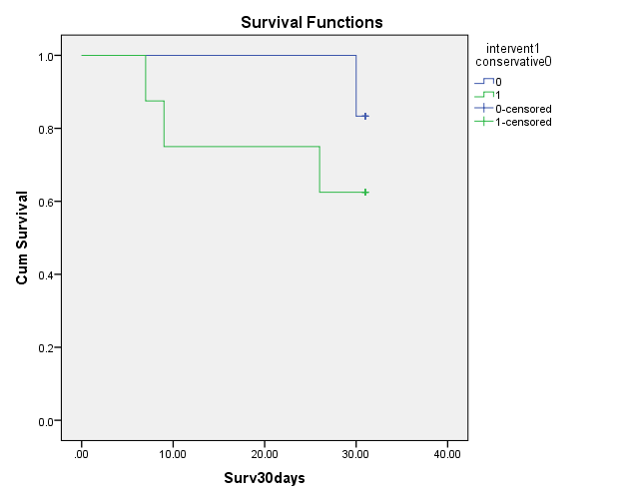
Figure 1: 30 Day Survival

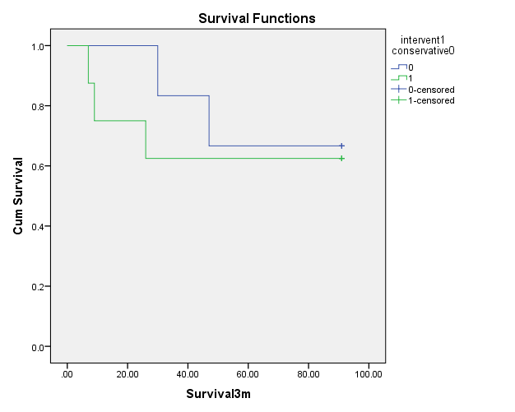
Figure 2: 3 Month Survival

The mechanism of spontaneous rupture is not clear. Trauma and TACE have been reported as external factors precipitating rupture.^{[16, 17]}Other mechanisms have been mentioned such as the positive influence of identified portal hypertension and vascular dysfunction within tumor tissue which are considered as tumor related factors.^{[18]} Furthermore, others have concluded that tumor growth rate is more important than size in predicting the incidence of rupture in patients with HCC which is well explained by necrosis within the tumor associated with splitting of the overlying normal hepatic parenchyma and erosion of nearby vessels.^{[19]} Tumor related factors strongly influenced the incidence of rupture in the current study, which included both total tumor volume and maximum tumor diameter. These factors may play an important role to be used as potential predictors in future studies.

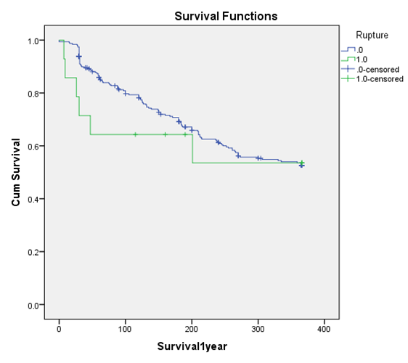
Figure 3: 1 Year Survival

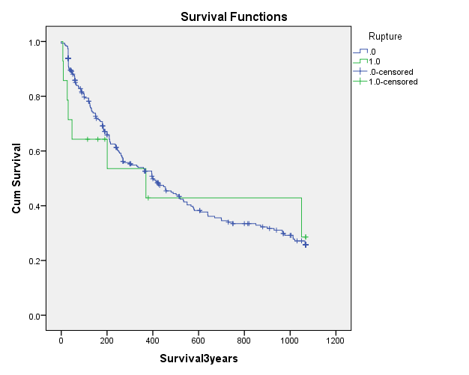
Figure 4: 3 Year Survival

Demographic changes and biochemical changes along with their explanation.

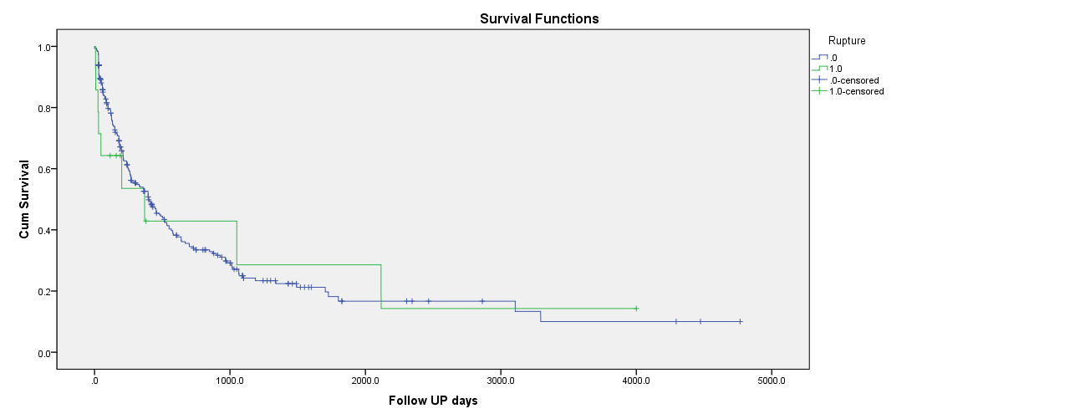
Figure 5: Overall Survival

Outcomes of the treatment within the studied group
Six patients were treated with TAE; two of them (33%) died within 24 hours, 3 patients (50%) died within 30 days of presentation, and the last one survived beyond 30 days but lost follow up. Therefore 5 out of total 14 patients presenting with a ruptured HCC had mortality within 30 days, (36%). These patients had poorer liver function (Child B and C, Child score 8-11), and lower hemoglobin levels at presentation (8.4 gm/dl), along with a larger tumor size. Previous studies haveshownthat trans-arterial embolization is the best non-surgical modality to achieve hemostasis, moreover, super-selective TAE is able to preserve liver function and has the dual outcome of being a definitive treatment or a bridge to resectable HCC.^{[1]}
Emergency surgery was undertaken for 2 patients out of the 14 patients (14%) and was successful in controlling the bleeding, and achieving hemostasis, both patients are alive and well.
In most circumstances, patients with ruptured HCC have diminished functional liver reserve along with abnormal coagulation profile. Emergency hepatectomy may, therefore, compromise the outcome of patients with ruptured HCC due to the high incidence of associated postoperative bleeding and liver failure. ^{[10, 25, 26 ]} Similarly, Lai and his colleagues ^{[27 ]} have shown high incidence of mortality associated with both emergency hepatectomy (71.4%) and hepatic artery ligation (76.6%) in the same group of patients which could be related to the general status and functional liver reserve at the time of presentation. On the other hand, Vergara et al ^{[28 ]} reported considerably low rates of both mortality (16.5%) and morbidity (50%) and contributed the poor overall survival rate associated with TACE-alone to both poor functional liver reserve and larger tumor volume. It is clear from previous studies that patients with better functional liver reserve and acceptable future liver remaining post resection may benefit from emergency hepatectomy.
The comparative analysis and potential predictors of rupture
Many factors have been linked with predicting the incidence of rupture in patients with HCC.^{[2] [11] [5]}As in previous studies, tumor related factors strongly influenced the incidence of rupture. ^{[2] [7]} In the current study, total tumor volume and maximum tumor diameter were spotted as potential predictors; however, the interpretation may be limited due to the absence of multivariate analysis that remains a standard statistical method to spot independent factors associated with ruptured HCC.
Survival outcome between the two groups and initial difference
Ruptured HCC is associated with a high in hospital mortality rate ranging between 25-100%. Liver failure occurs in 12-42% of patients during the acute phase. Previous reviewsof patients with ruptured HCC, the average 30 day mortality rates among patients who received conservative treatment, emergency liver resection and TAE were 71%, 50%, 48% respectively ^{[11]}.
The cumulative survival rates in our study, at 30 days, 3 months, 6 months, 1 year, 2 years and 3 years were 71.4%, 64.3%, 64.3%, 53.6%, 42.9%, 28.6% in the RHCC group and 97.4%, 81.3%, 70.7%, 52.6%, 34%, 25.7%in NHCC group.
Limitation of the Study
The current study was limited by its retrospective nature. The relatively small number of patients who presented with ruptured HCC is also a limiting factor, despite being the only tertiary care center with specialized hepato-pancreato-biliary service in the state. However, our results are more in line with those of other international centers. Even though we have found that tumor related factors such as the volume of HCC affecting the liver may play a role as a potential predictor for rupture; greater numbers are perhaps required with a larger sample size to elucidate a cut off value that clinicians can use to predict rupture in those presenting with HCC.

Conclusion
Our study showed that outcomes of ruptured HCC depended on many factors. Low hemoglobin levels, larger maximal tumor diameters, and greater tumor volumes were all associated with spontaneous rupture of HCC. Management of the patient required a multidisciplinary approach, however, through careful selection of patients, a single stage surgery seemed to offer a survival benefit.
During our study, we found that the survival of patients with ruptured HCC is significantly inferior to those who presentwith HCC without rupture. It was clear from the survival analysis that patients presenting with rupture had similar long term survival rates once they survived the initial the 30 day to 3 month period post rupture. Further studies would be required to replicate our findings in view of the limitations of our study.

Conflicts Of Interest
No conflicts of interest for any of the authors.

References
- N. Bassi, E. Caratozzolo, L. Bonariol, C. Ruffolo, A. Bridda, L. Padoan, M. Antoniutti and M. Massani, "Management of Ruptured Hepatocellular Carcinoma: Implications for Therapy," World J Gastroenterol, vol. 16, no. 10, pp. 1221-1225, 14 March 2010.
- J. Amarjothi, V. Ramasamy, J. Jesudason and N. B. OL, "Ruptured HCC and Variables in Management-Case Series and Literature Review," Journal of Surgery [Jurnalul de Chirurgie], vol. 14, no. 3, pp. 117 - 121, 2018.
- J. Llovet, B. A and B. J, "Hepatocellular Carcinoma," Lancet, vol. 362, pp. 1907 - 1917, 2003.
- M. Rathor, A. Lal and R. K. Dhiman, "Spontaneous Rupture of Hepatocellular Carcinoma," Journal of Clinical and Experimental Hepatology, vol. 4, no. 2, pp. 188 - 189, June 2014.
- E. C. H. Lai and W. Y. Lau, "Spontaneous Rupture of Hepatocellular Carcinoma: A Systemic Review," Archives of Surgery, vol. 141, pp. 191 - 198, February 2006.
- F. Bosch, J. Ribes, M. Diaz and R. Cleries, "Primary Liver Cancer: Worldwide incidence and trends," Gastroenterology, vol. 127, pp. S5 - S16, 2004.
- H. Yoshida, Y. Mamada, N. Taniai and E. Uchida, "Spontaneous ruptured hepatocellular carcinoma: Review Article," Hepatology Research, vol. 46, pp. 13 - 21, 2016.
- V. Vergara, A. Muratore, H. Bouzar, R. Polastri, A. Ferrero, G. Galatola and L. Capussott, "Spontaneous rupture of hepatocelluar carcinoma: surgical resection and long-term survival," European Journal of Surgical Oncology, vol. 26, pp. 770 - 772, 2000.
- K.-C. Hsueh, H.-L. Fan, T.-W. Chen, D.-C. Chan, J.-C. Yu, S.-S. Tsou, T.-M. Chang and C.-B. Hsie, "Management of Spontaneously Ruptured Hepatocellular Carcinoma and Hemoperitoneum Manifested as Acute Abdomen in the Emergency Room," World Journal of Surgery, vol. 36, pp. 2670 - 2676, 3 August 2012.
- C. Y. Chen, X. Z. Lin, J. S. Shin, C. Y. Lin, T. C. Leow and T. T. Chang, "Sponatenous rupture of hepatocellular carcinoma: A review of 141 Taiwanese cases and comparison with nonrupture cases.," Journal of Clinical Gastroenterology, vol. 21, pp. 238 - 242, 1995.
- W.-k. Chen, Y.-T. Chang, Y.-t. Chung and H.-r. Yang, "Outcomes of emergency treatment in ruptured hepatocellular carcinoma in the ED," The American Journal of Emergency Medicine, vol. 23, pp. 730 - 736, 2005.
- A. Tanaka, R. Takeda, S. Mukaihara, K. Hayakawa and T. Shibata, "Treatment of ruptured hepatocellular carcinoma," International Journal of Clinical Oncology, vol. 6, pp. 291 - 295, 2001.
- S. Subramaniam, R. K. Kelley and A. P. Venook, "A review of hepatocellular carcinoma (HCC) staging systems: Review Article," Chinese Clinical Oncology, vol. 2, no. 4, 2013.
- R. T. Poon and S. T. Fan, "Evaluation of the new AJCC/UICC staging system for hepatocellular carcinoma after hepatic resection in Chinese patients," Surgical Oncology Clinics of North America, vol. 12, pp. 35 - 50, 2003.
- T. Aoki, N. Kokudo and Y. Matsuyama, "Prognostic impact of spontaneous tumor rupture in patients with hepatocellular carcinoma: an analysis of 1160 cases from a nationwide survey.," Annals of Surgery, vol. 259, pp. 532 - 542, 2014.
- C. L. Liu, H. Ngan., C. M. Lo and S. T. FAN, "Ruptured hepatocellular carcinoma as a complication of transarterial oily chemoembolization," British Journal of Surgery, vol. 85, pp. 512 - 514, 1998.
- O. OKEZIE and G. DeANGELIS, "Spontaneous Rupture of Hepatoma: A Misdiagnosed Surgical Emergency," Annals of Surgery, vol. 179, no. 2, pp. 133 - 135, February 1974.
- L.-X. Zhua, X.-L. Menga and S.-T. Fan, "Elasticity of small artery in patient with spontaneous rupture of hepatocellular carcinoma," Hepatology Research, vol. 29, pp. 13 - 17, 2004.
- G. B. Ong and J. L. Taw, "Sponatenous Rupture of hepatocellular carcinoma," British Medical Journal, vol. 4, pp. 146 - 149, 1972.
- A.-W. Meshikhes, H. Wani and M. Tinguria, "Ruptured Hepatocellular Carcinoma," Annals of Saudi Medicine, vol. 18, no. 5, pp. 476 - 478, 1998.
- E. C. LAI, K. WU, M. T. CHOI, S. FAN and J. WONG, "Spontaneous Ruptured Hepatocellular Carcinoma: An Appraisal of Surgical Treatment," Annals of Surgery, vol. 210, no. 1, pp. 24 - 28, July 1989.
- K. Nishida, A. K. Lefor and T. Funabiki, "Rupture of Hepatocellular Carcinoma after Transarterial Chemoembolization followed by Massive Gastric Bleeding: Case Report," Case Reports in Hepatology, pp. 1 - 5, 2018.
- G. B. Ong, E. P. H. Chu, F. Y. K. Yu and T. C. Lee, "Spontaneous rupture of hepatocellular carcinoma," British Journal of Surgery, vol. 52, pp. 123 - 129, 1965.
- N. Nagasue and K. Inokuchi, "Spontaneous and traumatic rupture of hepatoma," British Journal of Surgery, vol. 66, pp. 248 - 250, 1979.
- O. Chearanai, U. Plengvanit, C. Asavanich, D. Damrongsak, K. Sindhvananda and S. Boonyapisit, "Spontaneous rupture of primary hepatoma: report of 63 cases with particular reference to the pathogenesis and rationale of treatment by hepatic artery ligation," Cancer, vol. 51, pp. 1532-1536, 1983.
- M. F. Chen, T. L. Hwang, L. B. Jeng, Y. Y. Jan and C. S. Wang, "Surgical treatment for spontaneous rupture of hepatocellular carcinoma," Surgical Gynecology & Obstetrics, vol. 167, pp. 99 - 102, 1988.
- G. A. Dewar, S. M. Griffin, K. W. Ku, W. Y. Lau and A. K. C. Li, "Management of bleeding liver tumours in Hong Kong," British Journal of Surgery, vol. 78, pp. 463 - 466, 1991.
- M. Miyamoto, T. Sudo and T. Kuyama, "Spontaneous rupture of hepatocellular carcinoma: a review of 172 Japanese cases," American Journal of Gastroenterology, vol. 86, pp. 67 - 71, 1991.
- M. Yamagata, T. Maeda and Y. Ikeda, "Surgical results of spontaneously ruptured hepatocellular carcinoma," Hepatogastroenterology, vol. 42, pp. 461 - 464, 1995.

6/25/2019

