Assessment of low anterior resection syndrome in patients who underwent low anterior resection for cancer rectum

Tarek Youssef, Ahmed Aly Khalil, Magdy Moustafa Eldahma.

General Surgery Department, Faculty of Medicine Ain Shams University, Egypt
maismile92@yahoo.com

Abstract: Background and aim: Rectal Cancer is the third most common form of cancer and the second leading cause of cancer related deaths in the western world. It occurs due to abnormal growth of the lining cells of the rectum that have the ability to invade and spread to other parts of the body. Surgery is the only curative therapy for rectal cancer. Transabdominal surgery can be performed with either sphincter sparing techniques i.e. (anterior resection) or an abdominal perineal resection. Historically, abdominal perineal resection was the gold standard for treating low-lying rectal cancers. With the advent of better surgical techniques and equipments e.g. (staplers) as well as neo-adjuvant therapy abdominal perineal resection has been gradually replaced by sphincter sparing procedures. For patients in whom negative distal margin can be achieved sphincter sparing procedures are preferred because they maintain bowel continence and avoid a permanent colostomy. However, functional disturbances constitute a major problem for many surviving rectal cancer patients following a sphincter saving procedure with symptoms ranging from daily episodes of incontinence to obstructed defecation, constipation & low anterior resection syndrome (LARS). LARS is used to describe a variety of symptoms: bowel, urinary and sexual dysfunction. The bowel dysfunction may be categorized into storage dysfunction (which includes bowel frequency, Fecal urgency and incontinence).And the evacuatory dysfunction (which includes stool fragmentation, gas stool discrimination, tenesmus and anal pain). Low anterior resection is common and has been reported in 10% to 90% of post-rectal resection patients. Aim of the work: We assessed the low anterior resection syndrome in patients with rectal cancer who underwent low anterior resection as regards incidence, timing & its fate or improvement. Methods: This was a retrospective observational study included 52 patients with low rectal cancer who underwent low anterior resection at Tanta Cancer Center (TCC) and Ain Shams University Hospital between (January 2015 - January 2017). Each patient will fill four questionnaires to cover the following periods after restoration of their bowel continuity (1 month, 6 month, 1year and 2 years). Results: The overall incidence of LARS in our study varied from 88.5% at one month point to decline to 79.1% at 24 months point also there was a decrease in the percentage of patients with major LARS and increase in the percentage of patients with minor or no LARS across the different follow-up time points. However, this notable change in LARS status across time points was not statistically significant. The average overall LARS score showed a gradual and statistically significant decrease over the 24-month follow-up period (from 30.92 to 27.04). The major decline occurred from the 6-month to the 12-month scores. Conclusion: Rectal surgeries contributed to increase of survival rates of rectal cancer patients. Yet bowel dysfunction may result thus affects the quality of life of rectal cancer survivors. LARS is an important consequence that affects a large number of rectal cancer survivors. However, it is reported that the severity of LARS decreases with time for these patients. Therefore, it is important that clinicians and researchers focus on LARS and conduct further studies to determine its contributing factors and improve the prevention and treatment strategies.
[Tarek Youssef, Ahmed Aly Khalil, Magdy Moustafa Eldahma. Assessment of low anterior resection syndrome in patients who underwent low anterior resection for cancer rectum. Cancer Biology 2019;9(3):8-13]. ISSN: 2150-1041 (print); ISSN: 2150-105X (online). http://www.cancerbio.net. 2. doi:10.7537/marscbj090319.02.

Keywords: Low anterior resection syndrome (LARS), colorectal cancer (CRC), low anterior resection, bowel dysfunction.

1. Introduction:
Oncologic outcomes for rectal adenocarcinoma have improved secondary to increased surveillance, improved chemotherapy, radiation and surgical techniques. Low anterior resection (LAR) with total mesorectal excision (TME) for rectal cancer has allowed patients to avoid the permanent colostomy associated with abdominoperineal resection. As a result, an increasing number of patients are being managed with sphincter-sparing surgery. In general, surgeons assume that patients would like to avoid a permanent colostomy and patients likely assume that in preserving their sphincter, their bowel function will not change significantly following rectal resection or effects will be short term. However, more and more data suggest that a large number (up to 90%) of patients experience long-term changes in quality of life fromsymptoms following LAR (1).
Low anterior resection syndrome (LARS) is difficult to define. Patients may have a combination of symptoms including frequency, urgency, incontinence and constipation which may last longer than an initial adaptive period. Patients typically fall into two categories: those with incontinence, frequency and urgency & those with constipation. But, some patients report features of both either occurring simultaneously or vacillating between these two constellations of symptoms (2).
Aim of work:
Assessment of the anterior resection syndrome in patients with rectal cancer who underwent low anterior resection as regards incidence, timing & its fate or improvement.
Patients and methods:
This was a retrospective observational study conducted in the surgery department at Tanta Cancer Center and Ain Shams University Hospital after ethical committee approval of (Faculty of medicine, Ain Shams University) in the period between (October 2018- March 2019). This study included 52 patients with low rectal cancer who underwent low anterior resection at Tanta Cancer Center and Ain Shams University Hospital between (January 2015 - January 2017).
Inclusion Criteria: Patients who underwent low anterior resection for rectal cancer with or without covering ileostomy who restored bowel continuity. Records of the recruited patients until at least 2 years post operatively were available.
Exclusion Criteria: Patients with metastatic rectal cancer, Patients who underwent previous rectal surgery, Patients with no available data after surgery, Patients that already have chronic gastro-intestinal disturbances before the surgery and Patients who had permanent stoma.

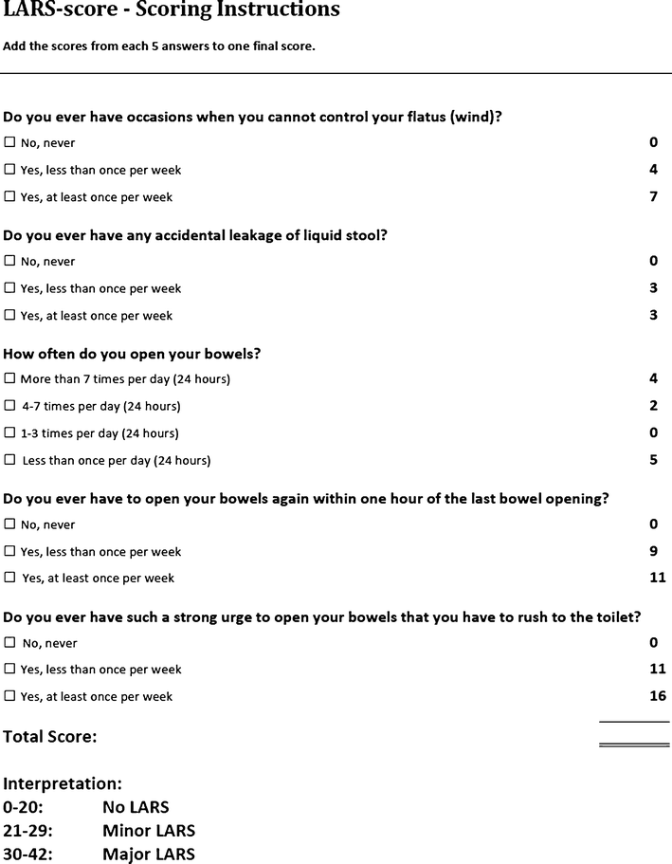

Data was obtained by interviewing the study participants (either by phone call or face to face during the patient`s follow up visit) using the validated low anterior resection syndrome (LARS) scoring questionnaire by Emmertsen et al., 201(3)
This is a questionnaire for assessing bowel function after sphincter-preserving surgery with or without chemo-irradiation for rectal cancer. It includes five sections (Symptoms), each of them assesses a certain bowl function. The five symptoms included in LARS are incontinence for flatus, incontinence for liquid stool, frequency (number of daily bowel movements), clustering (having to open bowels again within 1 h of the last opening) and urgency.
The items and scoring algorithm of the LARS, are shown in the figure.
Data analysis was done using SPSS 24 and significant results were considered at P-value less than 0.05.

3. Results:
The mean patients’ age was 51.1 years old (± 9.6) and it ranged from 34 to 76 years. The highest age group in this study was 40 – 49 years age-group, followed by the 50 – 59 years age-group (Figure 1).

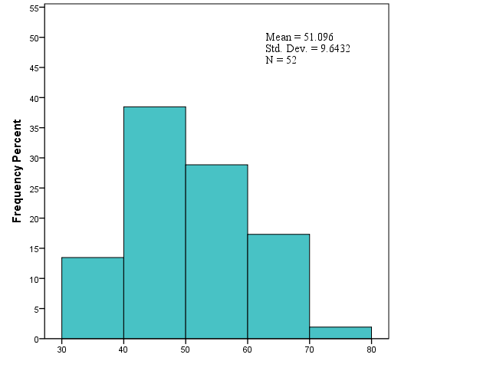

There was a statistically significant decrease in the percentage of patients who cannot control their flatus from one-month (53.8%) to 24-month (36.5%) follow-up time. (table 1)

Table (1). Do you have occasions when you cannot control your flatus?
Patient response | Time of Assessment |  |  |  |  |  |  |  | p-value
 | One month |  | 6 months |  | 12 months |  | 24 months
 | No. | % | No. | % | No. | % | No. | %
Never | 8 | 15.4 | 5 | 9.6 | 9 | 17.3 | 11 | 21.2 | 0.043*
Less than once/week | 16 | 30.8 | 32 | 61.5 | 27 | 51.9 | 22 | 42.3
At least once/week | 28 | 53.8 | 15 | 28.8 | 16 | 30.8 | 19 | 36.5

There was no significant change in the percentage of patients who had any accidental liquid stool leakage. However, there was a notable decrease in the percentage of those patients from 69.2% at one-month to 59.6% at 24-month follow-up time. ( table 2)

Table ( 2). Do you ever have any accidental leakages of liquid stool?
Patient response | Time of Assessment |  |  |  |  |  |  |  | p-value
 | One month |  | 6 months |  | 12 months |  | 24 months
 | No. | % | No. | % | No. | % | No. | %
Never | 16 | 30.8 | 12 | 23.1 | 16 | 30.8 | 21 | 40.4 | 0.089
Yes | 36 | 69.2 | 40 | 76.9 | 36 | 69.2 | 31 | 59.6
Cochran's Q Test

There was a notable increase in the frequency of bowel habits among patients over the follow-up period, this change in the bowel habit was not statistically significant. (table 3)

Table 3. How often do you open your bowel?
Patient response | Time of Assessment |  |  |  |  |  |  |  | p-value
 | One month |  | 6 months |  | 12 months |  | 24 months
 | No. | % | No. | % | No. | % | No. | %
1-3 times/day | 7 | 13.5 | 5 | 9.6 | 7 | 13.5 | 7 | 13.5 | 0.141
4-7 times/day | 11 | 21.2 | 13 | 25.0 | 12 | 23.1 | 17 | 32.7
More than 7 times/day | 13 | 25.0 | 20 | 38.5 | 23 | 44.2 | 16 | 30.8
Less than once/day | 21 | 40.4 | 14 | 26.9 | 10 | 19.2 | 12 | 23.1
Kendall's W Test

There was a statistically significant decrease in the percentage of patients who experience a bowel opening within one-hour of the last act (from 46.2% at one-month to 30.8% at 24-month follow-up time). (table 4)

Table 4. Do you ever have to open your bowel again within one hour of the last bowel opening?
Patient response | Time of Assessment |  |  |  |  |  |  |  | p-value
 | One month |  | 6 months |  | 12 months |  | 24 months
 | No. | % | No. | % | No. | % | No. | %
Never | 8 | 15.4 | 9 | 17.3 | 14 | 26.9 | 11 | 21.2 | 0.030*
Less than once/week | 20 | 38.5 | 27 | 51.9 | 23 | 44.2 | 25 | 48.1
At least once/week | 24 | 46.2 | 16 | 30.8 | 15 | 28.8 | 16 | 30.8

There was a statistically significant decrease in the percentage of patients who experience a strong urge to open their bowel that they have rush to the toilet (from 50% at one-month to 34.6% at 24-month follow-up time). (table 5)

Table 5: Do you ever have such a strong urge to open your bowel that you have rush to the toilet?
Patient response | Time of Assessment |  |  |  |  |  |  |  | p-value
 | One month |  | 6 months |  | 12 months |  | 24 months
 | No. | % | No. | % | No. | % | No. | %
Never | 7 | 13.5 | 5 | 9.6 | 9 | 17.3 | 7 | 13.5 | 0.040*
Less than once/week | 19 | 36.5 | 29 | 55.8 | 28 | 53.8 | 27 | 51.9
At least once/week | 26 | 50.0 | 18 | 34.6 | 15 | 28.8 | 18 | 34.6
*. Statistically significant p-value, Kendall's W Test.

The average overall LARS score showed a gradual and statistically significant decrease over the 24-month follow-up period (from 30.92 to27.04). The major decline occurred from the 6-month to the 12-month scores. Among male patients, the average LARS score showed a similar significant decrease from 31.91 to 26.86. However, female patients did not show significant change in their LARS score over the follow-up time. (table 6)

Table 6. The average LARS score at different time points of follow-up period (overall, and by gender)
 | Time of Assessment |  |  |  | p-value
 | One month | 6 months | 12 months | 24 months
Overall LARS Score, Mean ± SD | 30.92 ± 8.42 | 29.83 ± 8.34 | 27.54 ± 10.14 | 27.04 ± 10.51 | 0.006*
Overall LARS Score in male patients | 31.91 ± 6.89 | 30.11 ± 7.22 | 28.14 ± 9.41 | 26.86 ± 10.87 | 0.013*
Overall LARS Score in female patients | 28.88 ± 10.89 | 29.24 ± 10.49 | 26.29 ± 11.72 | 27.41 ± 10.05 | 0.151
*. Statistically significant p-value, Friedman Test.

There was a decrease in the percentage of patients with major LARS and increase in the percentage of patients with minor or no LARS across the different follow-up time points. However, this notable change in LARS status across time points was not statistically significant. (figure 2)

There were direct moderate correlations between age and LARS scores at different time points (i.e. older patients had higher LARS Scores). However, they were not statistically significant except at 6-month time point (p-value = 0.044). (Figure 3)

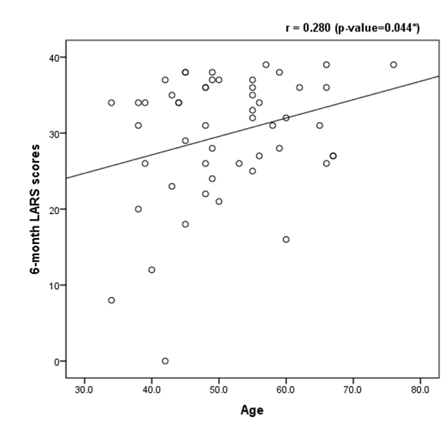
Figure 3. Correlation between and LARS score at 6-month

4. Discussion:
This study aimed to assess the low anterior resection syndrome in patients with rectal cancer who underwent low anterior resection as regards the incidence, its timing, severity & its fate or improvement.
The study of Davis et al., 2011. (4) revealed that CRC is uncommon among people aged 40 or younger; the incidence begins to raise significantly between the ages of 40 and 50 and age-specific incidence rates further increase in each succeeding decade thereafter. In our study, The mean patients’ age was 51.1 years old (± 9.6) and it ranged from 34 to76 years. The highest age group in our study was 40 – 49 years age-group, followed by the 50 – 59 years age-group.
The study of Wells, et al. (2015). (5) showed that flatus incontinence prevalence was reported to range from 9 to 76%, among postoperative rectal cancer survivors. In our study there was a statistically significant decrease in the percentage of patients who cannot control their flatus from one-month (53.8%) to 24-month (36.5%) follow-up time.
The study of Lange et al., 2007. (6) showed that 61.5% of patients were incontinent at 5 years. It was also observed in their study that from 3 to 24 months, the percentage of patients with faecal in continence declined significantly postoperatively. In our study there was no significant change in the percentage of patients who had any accidental liquid stool leakage. However, there was a notable decrease in the percentage of those patients from 69.2% at one-month to 59.6% at 24-month follow-up time. Although there was a notable increase in the frequency of bowel habits among patients over the follow-up period, this change in the bowel habit was not statistically significant.
Alavi et al., 2017. (7) in their study showed that 20% of the patients reported 6 or more bowel movements in 24 h and 10% reported never being able to wait 15 min before using the toilet, 41% reported having soilage during the day at least sometimes. Also there was 19% always used pads in case of stool leakage. In our study There is a statistically significant decrease in the percentage of patients who experience a bowel opening within one-hour of the last act (from 46.2% at one-month to 30.8% at 24-month follow-up time). There was a statistically significant decrease in the percentage of patients who experience a strong urge to open their bowel that they have rush to the toilet (from 50% at one-month to 34.6% at 24-month follow-up time).
The overall incidence of LARS in our study varied from 88.5% at one month point, to decline to 79.1% at 24 months point; however this was higher than what was reported by Wells et al., 2015(5). that the incidence of LARS decreased progressively from 61 % at 1 year to 43 % at 5 years post-operatively.
The percentage of patients with major LARS decreased over time in our study from 67.3 at one month point to reach 53.8 at 24 months point and increase in the percentage of patients who had minor or no LARS across the different follow-up time points (from 11.5% at one month to reach 21.2% at 24 months) this is higher than what was observed by Bregendahl et al., 2013(8) in their study at all the time point.
The overall LARS score in our study showeda gradual and statistically significant decrease over the 24-month follow-up period (from 30.92 to 27.04). The major decline occurred from the 6-month to the 12-month. This is consistent with previous literature, that suggested that the functional outcome for patients undergoing restorative low anterior resection could be improved temporarily for 1–2 years after surgery by the utilization of a neorectal reservoir Ho et al., 2002. (9).
There were direct moderate correlations between age and LARS scores at different time points (i.e. older patients had higher LARS Scores). However, they are not statistically significant except at 6-month time point (p-value = 0.044). On the other hand there was in disagreement with Lange et al., 2007 (10) in their study, Surprisingly, younger patients (≤ 64 years of age at surgery) reported a higher prevalence of bowel dysfunction compared with older patients (> 64 years of age at surgery).
The current study had some limitations as the relatively small number of patients in the study group. Moreover, we did not go through the details of other risk factors as dietary habits, life style, smoking, post operative chemo or radiotherapy, history of post operative rehabilitation, incidence of complications or specific type of operation done.

Conclusions and recommendations:
Rectal surgeries contributed to increase of survival rates of rectal cancer patients, yet bowel dysfunctions may result, thus affects the quality of life of rectal cancer survivors. Therefore, it is important that clinicians and researchers focus on this syndrome to improve the prevention and the treatment of bowel dysfunction and the information given to patients. LARS is an important consequence that affects a large number of rectal cancer survivors. However, it is reported that the severity of LARS decrease with time for these patients.

References:
- Monson J, Weiser M, Buie W, et al. Practice parameters for the management of rectal cancer. 2013;56(5):535-550.
- Juul T, Ahlberg M, Biondo S, et al. Low anterior resection syndrome and quality of life. 2014; 57(5):585-591.
- Emmertsen K, Bregendahl S, Fassov J, et al. The clue to low anterior resection syndrome after total mesorectal excision surgery. 2013; 15(2), 350-359.
- Davis D, Marcet J, Frattini J, et al. the recommended screening age for colorectal cancer. 2009;213(3):352-361.
- Wells H, Vather, R., Chu M, et al. Risk factor analysis Anterior resection syndrome.2015; 19(2), 350-359.
- Lange M, Den D, Bossema E, et al. Risk factors for faecal incontinence after rectal cancer treatment. British Journal of Surgery. 2009;94(10), 1278-1284.
- Alavi M, Wendel c, Krouse R, et al. Predictors of bowel function in long-term rectal cancer survivors with anastomosis 2017;24(12), 3596-3603.
- Bregendahl S, Emmertsen K Lous J, etal. Bowel dysfunction after low anterior resection with and without neoadjuvant therapy for rectal cancer.2013;15(9), 1130-1139.
- Ho Y, Yu S, Ang E, et al. Small colonic J-pouch improves colonic retention of liquids. 2002;45(3):76–82.
- Lange M, Den D, Bossema E, et al. Risk factors for faecal incontinence after rectal cancer treatment.2007;94(10), 1278-1284.

6/23/2019

