**Immunohistochemical Expression of Epidermal Growth Factor Receptor And Androgen Receptor in Triple Negative Breast Carcinoma**

Mosad Mohamed El-lithy1, Ahlam Abo Elenain2, Hassan Sheir2, Asmaa E Bedeer2

1Pathology Department, Tanta Cancer Center, Tanta, Egypt

2Pathology Department, Faculty of Medicine, Tanta University, Tanta, Egypt

[mosadelity@gmail.com](mailto:mosadelity@gmail.com)

**Abstract: Background:** Triple negative breast cancer (TNBC) is a heterogeneous group of breast cancer, this mandates thorough search for a variety of biological markers that might serve as possible predictors for the biological behavior of the tumors and targets for possible therapeutic agents. **Materials & Methods:** The present study included 60 cases of TNBC that were obtained as paraffin blocks from the department of Pathology, Tanta cancer center, in the period from December 2011 to December 2015. Cases were stained by hematoxylin and eosin staining to estimate their histological type, grade, DCIS component, necrosis and vascular invasion and also by EGFR and AR for immunohistochemical study. Data concerning with age, size and number of invaded LN were taken from archive of Tanta cancer center. **Results:** EGFR expression was associated with high tumor grade, nodal metastasis and large tumor sizes (P value 0.02, 0.01, 0.01 respectively). These findings prove the bad prognostic impact of EGFR in TNBC. AR expression was inversely correlated with necrosis, vascular invasion and tumor sizes (P value 0.004, 0.007, 0.05 respectively). These findings prove the good prognostic impact of AR in TNBC. Correlative study, to evaluate the expression of AR and EGFR immunostaining in different clinicopathological prognostic factors revealed a statistical significant inverse correlation between AR and EGFR expression regarding tumor size, vascular invasion, axillary L.N metastasis and necrosis (p value 0.02, 0.02, 0.05, 0.001 respectively). **Conclusion:** Our study proved that EGFR expression in TNBC was associated with bad prognostic impact while AR expression was associated with good prognostic impact and there is a statistical significant inverse correlation between AR and EGFR expression regarding tumor size, vascular invasion, axillary L.N metastasis and necrosis. Eventually, proper subtyping of TNBC using basal markers as well as AR receptor expression in different subtypes of TNBC will provide proper diagnosis and prognosis of cases with TNBC as well as a potential therapeutic target. However, large scale studies are needed to verify these results.

**[**Mosad Mohamed El-lithy, Ahlam Abo Elenain, Hassan Sheir, Asmaa E Bedee. **Immunohistochemical Expression of Epidermal Growth Factor Receptor And Androgen Receptor in Triple Negative Breast Carcinoma.** *Cancer Biology* 2019;9(2):96-105]. ISSN: 2150-1041 (print); ISSN: 2150-105X (online). <http://www.cancerbio.net>. 14. doi:[10.7537/marscbj090219.14](http://www.dx.doi.org/10.7537/marscbj090219.14).

**Keywords:** TNBC, Epidermal growth factor receptor (EGFR), Androgen Receptor (AR).

**1. Introduction**

Breast carcinoma constitutes a heterogenous group of tumors that are diverse in behavior, outcome and response to therapy. WHO 2013 reported that, over 508000 women died in 2011 due to breast carcinoma. In Egypt, the peak incidence of breast carcinoma occurs in the age group of 40-60years and it is estimated to be the most common cancer among females accounting for 38%. It is also the leading cause of cancer related mortality accounting for 20% (**Abd El-Bar I and Ismail K.**, **2013**). These estimates are confirmed in many regional Egyption cancer registries (The National Cancer Registry Program of Egypt and the Gharbia Population based cancer 2013).

Triple negative breast carcinoma (TNBC) is a molecular subtype of breast carcinoma characterized by negative expression of ER, PR and HER2 that approximately represents 15 – 25 % of all breast carcinoma. It is a heterogenous disease not only on the molecular level but also on the pathologic and clinical aspects **(Gauchotte et al., 2011).** The majority of TNBC are basal like constituting about 71 – 91 % of TNBC**.** TNBC usually have more aggressive clinical behavior on the short term, high tumor grade, high stage, high possibility of increasing nodal and distant metastases and poorer outcome compared with Non TNBC and lack molecular targets commonly used in targeted endocrine or HER2 positive therapy making this group very difficult to treat. Several studies have developed different novel treatments in treating TNBC, all of them rely on immunohistochemical subclassification of TNBC into basal type and five negative phenotype **(Cheang and Isola, 2010).** Two of these researches are the importance of EGFR expression and androgen receptor expression as novel treatments in TNBC and their role in improving new therapies that targeting EGFR and AR that may improve the clinical outcome of TNBC treatment **(Pierluigi and Gasparini, 2014).**

Androgen receptor has been proved to be associated with Triple negative breast carcinoma pathogenesis but its role in the different subtypes has not been clearly defined**.** Several studies assumed that AR expression improve TNBC patients’ prognosis and is associated with good overall patient survival and low risk of tumor recurrence**. (**[**Thike**](http://www.ncbi.nlm.nih.gov/pubmed/?term=Thike%20AA%5BAuthor%5D&cauthor=true&cauthor_uid=23929266) **et al., 2014).**

Subclassification of TNBC using EGFR may also playa significant role in diagnosis and prognosis of breast carcinoma as it has been proved in several studies that expression of EGFR is associated with low survival rate compared with other TNBC that do not express EGFR. However the expression of EGFR may play an important role in treatment of patients with basal type as using medicines that target epidermal growth factor receptors will haveanessentialrole in the prognosis and overall survival rate. Eventually, proper subtyping of TNBC using basal markers as well as AR receptor expression in different subtypes of TNBC will provide proper diagnosis and prognosis of cases with TNBC **(Pistelliet al., 2014).**

Table (1): EGFR expression in relation to different clinicopathological parameters

|  |  |  |  |  |
| --- | --- | --- | --- | --- |
| **EGFR expression in relation to clinicopathological parameters** | | | | |
| **Variables** | **EGFR-ve** | **EGFR +ve** | **X2** | **P-value** |
| **Age**  <50  >50 | 10  17 | 30  3 | 19.39 | 0.01**s** |
| **Size**  0-5 cm (T1 & T2)  >5cm (T3 & T4) | 21  6 | 15  18 | 6.46 | 0.011**s** |
| **Histological subtypes**  NOS  Medullary  Metaplastic | 19  5  3 | 19  10  4 | 1.22 | 0.542 |
| **DCIS component**  Absent  Present | 21  6 | 19  14 | 2.727 | 0.09 |
| **L.N involvement**  NO LN  Positive LN | 12  15 | 5  28 | 6.275 | 0.012**s** |
| **Necrosis**  Absent  Present | 19  8 | 17  16 | 2.199 | 0.138 |
| **Vascular invasion**  Absent  Present | 24  3 | 27  6 | 0.5823 | 0.44 |
| **Grade**  Two  Three | 15  12 | 9  24 | 4.949 | 0.02**s** |
| **TOTAL** | 27 | 33 |
| P value less than 0.05 is statistically significant | | |

**2. Materials & Methods**

This study was carried out on 60 cases of TNBC received by Tanta Cancer Centre during the period from December 2011 to December 2015. All the 60 specimens were paraffin blocks of modified radical mastectomy cases and immunostained slides for ER, PR and HER2. Data concerning with age, tumor size and number of invaded L.N were taken from archive of Tanta Cancer Centre. **Regarding the t**umor size **cases were** classified into two groups, Tumors with size 0-5 cm including T1 (0-1.9) & T2 (2-5), Tumors with size > 5 cm including T3 (> 5 cm) & T4 (>5 cm with metastasis) according to TNM classification (**Amin et al**., 2017). Median age was made then, **cases were** classified into **two** groups, less than 50 years and more than 50 years. L.N status was classified into, cases without LN metastasis (N0), and cases with LN metastasis (N1, N2 & N3).

## *For histopathological study*, sections were prepared from paraffin blocks of breast carcinoma cases, 5 μm slices were stained with hematoxylin & eosin (H & E) and examined by a light microscope to asses histopathological typeaccording to WHO classification 2013 *(Sin and Kriepe., 2013)*, histological gradeaccording to Nottingham modification of the Bloom–Richardson system *(Rosai., 2011)*, carcinoma associated with insitu component, vascular invasion, necrosis.

## *Hormone receptor status*: Collected immunostained slides for ER, PR and, HER2 were reexamined and *reevaluated.*

***For immunohistochemicalstudy,*** 4 μm thick sections were formed. The tissue sections were deparaffinized and rehydrated. Slides were incubated in 3% H2O2 for 10 minutes to reduce nonspecific background staining arising due to endogenous peroxides. For antigen retrieval, specimens were heated for 20 min in 10 mmol/l citrate buffer (pH 6.0) in a microwave oven (700 W). Following incubation with Ultra V Block (Cell Marque Corporation, Rocklin, CA95677, USA.916-746-8900) for 7 min at room temperature to block background staining, slides were incubated with EGFR (rabbit monoclonal, SP84) and AR (rabbit monoclonal, SP107) overnight at room temperature in a humid chamber. Antibody binding was detected using the Ultra Vision LP Detection System (Cell Marque Corporation) according to the manufacturer’s recommendations. Color development was performed with 3, 30-diaminobenzidine and counterstained with hematoxylin. a case of squamous cell carcinoma andnormal breast tissue served as positive control for EGFR and AR respectively ***(Parikh et al., 2008) (Tischkowitz et al., 2007)****.*, whereas negative controls were obtained by replacing the primary antibody with non-immune immunoglobulin G.

* **Interpretation of EGFR immunostaining:**

Sectionswere examined and scored under the microscope at high power magnification, for the presence of membrane or cytoplasmic immunostaining. Staining intensity was evaluated as follows: 0 negative; 1+ weak; 2+ moderate; 3+ strong.

* **Interpretation of AR immunostaining:**

Sections were carefully examined at high power magnification for the presence of tumor cell nuclei immunostaining. The AR immunostaining was evaluatedquantitatively as specimens considered positive if, more than 1% if the tumor cells nuclei were stained.

**3. Results**

Table (1).

A statistical significant positive correlation between EGFR expression and younger age group, large tumor size, axillary LN metastasis and tumors with grade III was found.

Table (2): AR expression in relation to different clinicopathological parameters

|  |  |  |  |  |
| --- | --- | --- | --- | --- |
| **AR expression in relation to clinicopathological parameters** | | | | |
| **Variables** | **AR**  **-ve** | **AR**  **+ve** | **X2** | **P-value** |
| **Age**  <50  >50 | 22  14 | 18  6 | 1.25 | 0.26 |
| **Size**  0-5 cm (T1 & T2)  >5cm (T3 & T4) | 18  18 | 18  6 | 3.75 | 0.05**s** |
| **Histological subtypes**  NOS  Medullary  Metaplastic | 24  8  4 | 14  7  3 | 0.459 | 0.79 |
| **DCIS component**  Absent  Present | 24  12 | 16  8 | 0.0 | 1.0 |
| **L. N involvement**  NO LN  Positive LN | 8  28 | 9  15 | 1.65 | 0.1 |
| **Necrosis**  Absent  Present | 14  22 | 22  2 | 16.73 | 0.0004**s** |
| **Vascular invasion**  Absent  Present | 27  9 | 24  0 | 7.0588 | 0.0078**s** |
| **Grade**  Two  Three | 15  21 | 9  15 | 0.104 | 0.746 |
| **TOTAL** | 27 | 33 |
| P value less than 0.05 is statistically significant | | |

A statistical significant inverse correlation was found between AR expression and large tumor size, vascular invasion and necrosis.

Correlative study between AR and EGFR in relation to the studied variables in the present study revealed a statistically significant inverse correlation between AR and EGFR immunoexpression regarding tumor size, vascular invasion and necrosis. Statistical analysis between AR & EGF Rimmunoexpression with axillary LN metastasis was very close to significant value (0.05). While, there was no significant correlation between them in other variables.

Table (3): Correlative study between EGFR and AR immunoexpression indifferent clinicopathological parameters of breast carcinoma

|  |  |  |  |  |  |
| --- | --- | --- | --- | --- | --- |
| **Correlative study between EGFR and ARimmunoexpression.** | | | | | |
| **Variables** | **AR +ve** | **N%** | **EGFR +ve** | **N%** | **P-value** |
| Age  <50  >50 | 18  6 | 75  25 | 30  3 | 90.9  9.1 | 0.1 |
| Size  0-5 cm (T1 & T2)  >5cm (T3 & T4) | 18  6 | 75  25 | 15  18 | 45.4  54.5 | 0.02**s** |
| Histological subtypes  NOS  Medullary  Metaplastic | 14  7  3 | 58.3  29.1  12.5 | 19  10  4 | 57.5  30.3  12.1 | 0.9 |
| IDC component  Absent  Present | 16  8 | 66.6  33.3 | 19  14 | 57.5  42.5 | 0.4 |
| L.N involvement  NO LN  Positive LN | 9  15 | 37.5  62.5 | 5  28 | 15.1  84.8 | 0.05 |
| Necrosis  Absent  Present | 22  2 | 91.6  8.4 | 17  16 | 51.5  48.4 | 0.001**s** |
| Vascular invasion  Absent  Present | 24  0 | 100  0 | 27  6 | 81.8  18.1 | 0.02**s** |
| Grade  Two  Three | 9  15 | 37.5  62.5 | 9  24 | 27.2  72.8 | 0.4 |
| TOTAL | 24 | 100% | 33 | 100% |

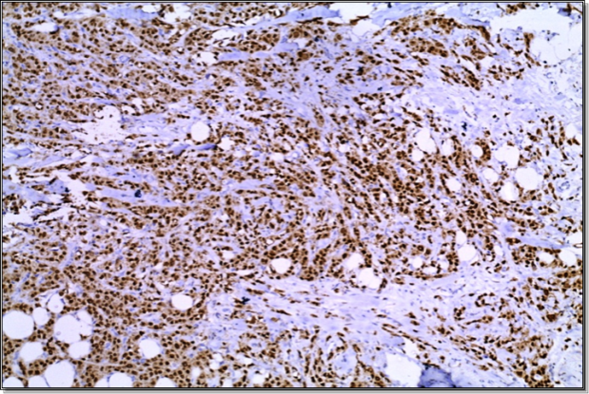

**Photo (1):** A case of IDC GII showing positive nuclear Immunostaining of AR- (Immunoperoxidase X100).

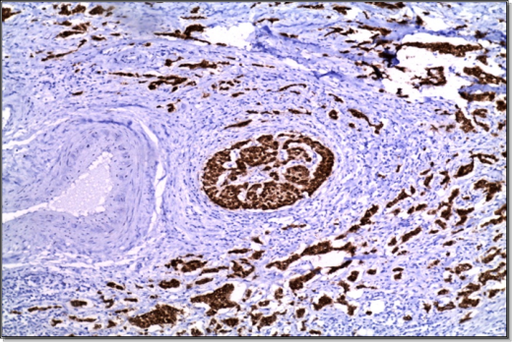

**Photo (2):** A case of IDC GII with intra ductal component showing positive nuclear Immunostaining of AR- (Immunoperoxidase X100).

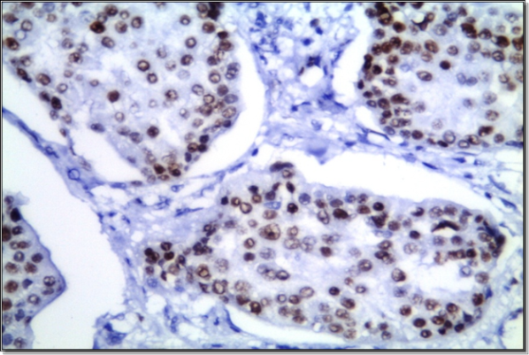

**Photo (3):** A case of IDC GIII with medullary features showing positive nuclear Immunostaining of AR- (Immunoperoxidase X400).

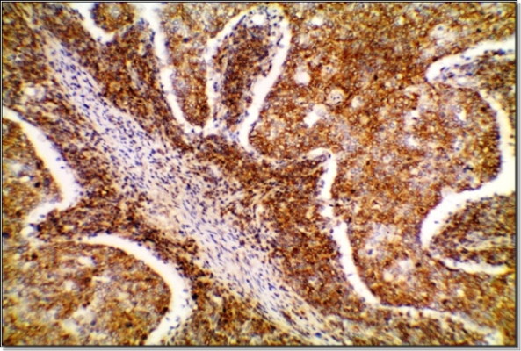

**Photo (4):** A case of medullary carcinoma showing strong positive EGFR cytoplasmic immunoreactivity (Score 3) (Immunoperoxidase x200).

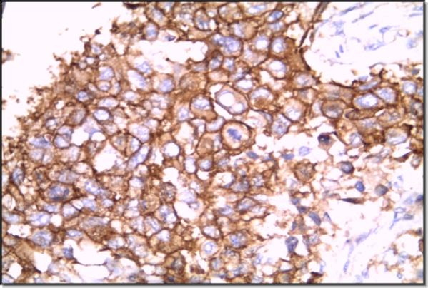

**Photo (5):** A case of metaplastic carcinoma showing strong positive EGFR membranous and cytoplasmic immunoreactivity (Score 3) (Immunoperoxidase x400)**.**

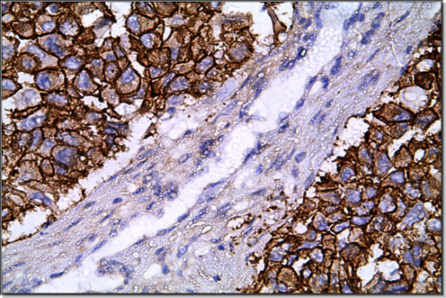

**Photo (6):** A higher magnification of EGFR strong positive membranous immunoreactivity in the cells of intraductal component (Score 3) (Immunoperoxidase x400).

**4. Discussion**

The present study included 60 cases of triple negative breast cancer. The ages of the patients ranged from 38 to 71 years with a mean age of 50 years. These results were close to the results recorded by ***Anderson et al., (2006)*** with a mean age of 50 years. ***Salomon et al., (2007),*** reported an older age of patients with a mean age of 60 years. This discrepancy may be attributed to small sample size or to racial and geographic differences.

In the current work, forty cases (representing 66.6% of the study group) were less than 50 years. This finding agreed with the results of ***Dolle et al., (2009).***

Regarding EGFR expression in different age groups, 75% of cases with age group less than 50 years were positive for EGFR while, only 15 % of the cases with age group more than 50 years were positive and these results are close to results reported by ***Rakha et al., (2008)*** who mentioned that EGFR positivity is overexpressed in TNBC with age group less than 50 years and decrease with age group more than 50 years. Similarly, ***Choccalingam et al., (2012)*** found that EGFR positivity was significantly high in age group less than 50 years.

Concerning AR expression, 30% of cases were positive in in age group >50 and 45% of cases were positive in age group <50 and these results were close to [***Pistelli***](http://www.ncbi.nlm.nih.gov/pubmed/?term=Pistelli%20M%5Bauth%5D) ***et al., (2014)*** who found that there is no significance between expression of AR and age groups.

In the current work, Statistical analysis for a possible correlation between EGFR expression and age groups had revealed a significant statistical correlation between both groups (Number of cases with positive EGFR expression increase with age group < 50 & decrease with age group > 50).

Regarding tumor size, the majority of cases were found to be T2 (25 cases representing 41.6%), 18 cases T3 (representing 30%), 11 cases were in T1 (representing 17.5%), and only 6 cases were T4 (representing 10%). This agreed with the study made by ***Rakha et al., (2007),*** which stated that the majority of cases presented at T2 and attributed the large tumor size to the rapid rate of growth of these tumors.

In the present study, Imuunohistochemical expression of EGFR was decreased in T1 cases (18.2%) and increased in T2 (52%), T3 (66.7%) and all T4 cases show positive EGFR expression. These results were close to results reported by ***Toyama et al., (2008),*** who mentioned that EGFR expression is increased with larger tumor size and decreased with smaller tumor size. On the other hand, it was noticed that AR expression was increased in T1 (54.5%) and decreased in T2 cases (48%), T3 cases (33.3%) and all T4 cases were negative for AR expression. Statistical analysis for a possible correlation between EGFR expression and different tumor sizes revealed a significant statisticalproportional correlation with larger tumor sizes more than 5cm including T3 and T4 cases. Also there was a significant correlation between androgen expression and smallertumor sizes less than 5 cm. and these results agree with ***Giannos et al., (2015)*** who mentioned that AR expression was associated with smaller tumor size.

Regarding the histological subtypes, invasive duct carcinoma (NOS) represented the majority of cases. This subtype accounted for 63.3% of all cases included in this study, close results were reported by ***Kumar et al., (2005),*** where invasive ductal carcinoma (NOS) constituting 61.9% of the cases. ***Chen et al., (2007),*** reported that invasive ductal carcinoma (NOS) constituted 97% of their study cases. Medullary variant represented 25% and the rest of cases were metaplastic (11.7%). The percentage of metaplastic carcinoma was lower than that stated by ***Livasy et al., (2006),*** where it constitutes 20.7% of the cases.

Regarding correlation of the staining results to different histopathological variables, in the current work, we found that 49.8% of invasive ductal carcinoma (NOS), showed positive EGFR immunostaining. These results were close to the results of ***Korsching et al (2014),*** who found 64.4% of invasive ductal carcinoma to be EGFR positive.

Most patients with medullary carcinoma, 10 cases (66.7%) showed positive immunostaining for EGFR. This finding is agreed with that of ***Bhargava et al., (2009),*** who described positivity for EGFR in 70% of medullary breast cancers.

Four cases of metaplastic carcinoma (60%) of the group showed positive immunostaining for EGFR. This finding is agreed with that of ***Reis-Fulford et al., (2007),*** who described positivity for EGFR in 51.2% of metaplastic breast cancers. Statistical analysis for a possible correlation between EGFR and histological subtypes in our studied cases revealed no significant correlation.

Concerning AR positivity in different histological subtypes, our study found that 36.8% of invasive ductal carcinoma (NOS), showed positive AR, 46.7% of medullary variant showed positive AR and 42.8 of metaplastic variant showed positive AR.

In the present study, statistical analysis for a possible correlation between AR immunostaining and different histological subtypes revealed no statistically significant correlation and these results close to results reported by ***perez et al., (2010) and Isola et al., (2011)***, who mentioned that there is no significant correlation between AR immunostaining and different histological subtypes.

As regarding ductal carcinoma in situ, the majority of the cases (66.7%) showed no intra duct component (40 cases), whereas (33.3%), showed associated intraductal in situ changes (20 cases). As regards the histological types of the in situ component detected, it was of high grade, varied between cribriform, comedo and solid patterns. Close results were reported by ***Lermaand Peiro., (2007),*** where they found DCIS component in 45% of the cases. ***Livasy et al., (2006)*** pointed out that the prevalence of high grade DCIS including comedo type suggest a probable precursor lesion for the associated invasive component.

In the current study, there were relative increase in number of cases expressing EGFR in cases with DCIS component (70%) and these results disagree with results reported by ***Hwangboet al (2013),*** who reported that only 17 % of cases with DCIS express EGFR and this conflicting may be attributed to the degree of DCIS component in our cases which ranging between 10 to 40% but in their study the percent of DCIS component was not specified, Statistical analysis for a possible correlation between EGFR and DCIS revealed no significant correlation.

Concerning AR expression in cases with DCIS component, 40% of cases with and without DCIS showed positive AR expression and statistical analysis showed no statistical significance between both, these results were close to results reported by ***Thike et al., (2014),*** who found no significance between expression of AR and DCIS component among TNBC patients

As regarding axillary lymph nodes status, 17 cases (28.3%), showed negative axillary node deposits, 16 cases (26.7%), showed deposits in 1-3 lymph nodes; 21 cases (35.0%) showed 4-9 nodal deposits and only 6 cases (10.0%) showed more than 9 nodes. Thus cases with axillary lymph nodes deposits represented 71.7% of the study cases; this disagreed with ***Nielsen et al., (2004)***, who detected regional nodal metastasis in only 39% of the cases.

Moreover, ***Bhargava et al., (2009),*** stated that triple negative tumors show a low tendency for lymph nodes metastasis. Also, ***Nim et al., (2011),*** in their study, mentioned that triple negative carcinomas have a low incidence of axillary lymph node involvement (accounted for 15% of their study group). Thus, data concerning lymph node metastasis are conflicting. ***Dent et al., (2007),*** found that in the triple-negative group of breast cancers, there was no correlation between tumor size and node status among women with tumors smaller than 5 cm. It is interesting to note that ***Foulkes et al. (2004),*** found the same discrepancy between tumor size and lymph node status in women with BRCA1-related breast carcinomas.

In the present study, 84.9% of cases with nodal metastases (N1, N2 & N3) show positive EGFR expression while, only 29.4% of cases without L.N metastasis (N0) showed EGFR expression with statistically significant correlation (p.value=0.01) and these results agree with ***Lisa et al., (2010)*,** who mentioned in their study that, among 78 cases of TNBC with nodal metastasis (78.6%) of cases were positive for EGFR expression. Also, [*Arathi*](http://www.ncbi.nlm.nih.gov/pubmed/?term=Changavi%20AA%5Bauth%5D) ***et al., (2015)*** found a proportional correlation between EGFR Expression in cases with nodal metastasis compared to cases without L.N involvement.

Regarding AR expression in cases without LN involvement (N0), 52.9% of cases express AR and 34.8% of cases with LN involvement express AR but there were no significant correlation and these results disagree with results reported by ***Kuenen et al., (2011),*** who found that 82% of cases without LN involvement express AR and only 15% of cases with LN involvement express AR and this conflict may be due to different methods of evaluation of AR positivity.

Concerning tumor necrosis, 36 cases (60%) were negative for tumor necrosis, while the other 24 (40%) cases showed necrosis. These results disagreed with the results reported by ***Livasy et al., (2006),*** who found tumor necrosis in 74% of cases. Again this discrepancy may be attributed to small sample size. Triple negative tumors have a poor prognosis and extensive necrosis as a common feature of these aggressive tumors ***(Foulkes et al., 2004).***

In the present study, 66.6%of cases with tumor necrosis were associated with positive EGFR expression. These results were in agreement with study reported by ***Moinfar et al., (2010)***, who found positive EGFR expression in 60% of cases with tumor necrosis.

Regarding AR expression in relation to necrosis, 91.6% of cases with tumor necrosis show negative AR expression and these results were close to results reported by ***Bryan et al., (2006),*** who found 80% negative AR expression in cases with tumor necrosis among TNBC patients.

Statistical analysis for a possible correlation between EGFR expression and tumor necrosis did not reach the statistical significance. While, there was an inverse correlation between AR expression and tumor necrosis and these results also agreed with results reported by ***Choi et al., (2015)*,** who reported that there is an inverse relationship between positive AR expression and tumor necrosis.

In the current study, only 9 cases (15%) showed vascular invasion and 51 cases (85%) were negative for invasion. Close results were reported by ***Bryan et al., (2006),*** where they found vascular invasion in 18% of the cases. However ***Gauchotte et al., (2011),*** reported vascular emboli in 30% of metaplastic carcinomas.

Among cases with vascular invasion, EGFR was expressed in 66.7% of cases and these results disagree with results reported by ***Mohammedet al., (2011)*,** who mentioned that only 27% of TNBC cases with positive vascular invasion express EGFR and this conflicting may be due to the method of evaluation of vascular invasion in their studied cases as they used CD34 for confirmation of vascular invasion. Statistical analysis for a possible correlation between EGFR positive expression and angio-invasion had revealed no significant correlation.

Concerning AR expression, all cases with vascular invasion were negative for AR expression with high statistical significance (p.value=.007) and these results were in agreement with results mentioned by ***Pistelli et al., (2014)*,** who reported a statistically significant correlation between AR expression and vascular invasion with (p.value 0.01).

Regarding tumor grade, 36 cases were poorly differentiated, constituting (60%) of the cases, and 24 were moderately differentiated (40%); the poorly differentiated cases ranged between invasive ductal carcinoma (NOS), medullary andmetaplastic histological subtypes. Thus all cases included in this study were high grade (none of the cases was grade I). This agreed with ***Choccalingam et al., (2012),*** who found that the majority (77%) of their triple negative cases were high grade. Also ***Lund et al., (2009)*** and ***Yin et al., (2009),*** stated that the majority of their triple negative cases were high grade tumors (grade III).

In the studied cases, 66.7% of cases with grade III showed EGFR expression and 37.5% of cases with grade II showed EGFR expression. Similar finding were found by [*Arathi*](http://www.ncbi.nlm.nih.gov/pubmed/?term=Changavi%20AA%5Bauth%5D) ***et al., (2015)*,** who found that EGFR showed positive expression in 77% of grade III cases. Statistical analysis for a possible correlation between EGFR expression and grade revealed a significant correlation between EGFR positive expression and higher tumor grade.

Among cases with grade II, 37.5% of cases were positive for AR immunostaining. While, in cases with grade III, 41.7% were positive for AR immunostaining. Statistical analysis revealed no significant correlation between AR positivity and tumor grade.

These results are in agree with ***Giannos et al., (2015),*** who mentioned that there is no relative difference in AR positivity between grade II and III cases and disagree with ***Kuenen et al., (2015)*,** who reported that positive AR immunostaining was higher in grade II cases reaching (68%).

High expression of EGFR has been associated with advanced stage, poor prognosis and high metastatic potential in many human tumors. Consideringthe set of therapeutic tools targeting EGFR, there are atpresent two well-identified emerging categories of drugs, withmonoclonal antibodies on one hand and tyrosine kinaseinhibitors (TKIs) on the other. Both treatment tools have reachedan advanced stage of clinical development ***(Castillo et al., 2004).***

In the current work, 33 cases (55% of total cases) were positive for EGFRand 27 cases were negative (45% of total cases). Close results were reported by ***Andersand Carey., (2009),*** where 51% of their study triple negative group showed EGFR positive immunostaining. ***Fox., (2008),*** found that 47 % of their triple negative breast cancers were positive for EGFR. Another study of ***Baselga et al., (2007),*** found a 45% positive rate.

On the other hand, 24 cases (40% of total cases) were positive for AR and 36 (60%) cases were negative. These results were close to results reported by ***Pierluigiand Gasparini., (2014),*** who found that 25 – 35 % of TNBC are positive for AR expression and ***Giannos et al., (2015),*** who reported that 38% of TNBC cases are positive for AR but disagree with ***Pistelli et al., (2014),*** who stated a lower positivity rate (17%).

The results of the current work confirm the observation found by ***Tan et al., (2008)*** and ***Kreike., (2014),*** that EGFR positivity is high in TNBC. The lack of a proven targeted therapy for TNBC, together with the availability of a number of approved EGFR & AR inhibitors, provides a powerful rationale for the study of these agents, alone and in combination with chemotherapy in TNBC.

***Anders et al., (2009),*** reported that approximately 85% of TNBC is of the basal-like subtype, and approximately 60% of basal-like tumors overexpress EGFR. ***Nielsen et al., (2004)*** detected EGFR positivity in 57.1% of the basal tumors, ***Livasy et al., (2006)*** reported a higher percentage of EGFR overexpression (72%).

The current study disagreed with the results of ***Toyamaa et al., (2008),*** who found 31% of TNBCs express EGFR.

They mentioned that EGFR status appeared to be associated with an increased risk of early recurrence and death whatever the histological sub-type of the breast cancer while they mentioned that AR expression was associated with higher 5 year disease free survival in a study made on 250 triple negative breast cancer cases ***(Lund et al., (2009).***

The histological heterogeneity of breast cancer and the different methods of immunohistochemical evaluation of EGFR and AR expression might have led to these different results, strengthening the need for standardization, especially against a background of rapidly evolving EGFR & AR targeted cancer treatment strategies. The small sample size in the current study and the possible racial, genetic and geographic characteristics of Arabs may be an important factor.

***Hwangbo et al., (2013),*** reported a tendency toward a shortened survival for EGFR positive tumors and showed that tumor growth fraction (Ki-67 labeling index) was significantly higher in EGFR positive tumors than in EGFR negative tumors, suggesting that rapid tumor proliferation might be responsible for poor prognosis associated with EGFR positive.

On the other hand, ***Deruijter et al., (2011)* & *Yu et al., (2011)*,** mentioned that tumor growth fraction (Ki-67 labeling index) was significantly lower in AR positive tumors than in AR negative tumors proving that AR is a good prognostic factor in survival rate.

* In the present study, Correlative study, to evaluate the expression of AR and EGFR positive immunostaining in different clinicopathological prognostic factors revealed a statistical significant inverse correlation regarding tumor size, vascular invasion, axillary L.N metastasis and necrosis so our study confirms that AR positivity is associated with better outcome while EGFR associated with bad outcome. Since AR & EGFR expression has important consequences on the prognosis and treatment of breast cancer, its presence should be precisely determined and the development of new strategies and drugs that can suppress AR & EGFR signaling will probably result in important clinical benefits.

**References**

1. Abd El-Bar I and Ismail K. (2013): Breast tumors. In: triennial report of 2009-2011. Gharbeia population based cancer registry.
2. Amin M, Edge S, Greene F., et al. (2017): AJCC Cancer Staging Manual. Ed.8. New York: Springer.
3. Anders CK and Carey LA. (2009): Biology, metastatic patterns, and treatment of patients with triple-negative breast cancer. Clin Breast Cancer;9(2): S73–S81.
4. Anderson W, Chatterjee N, Ershler W., et al. (2006): Estrogen receptor breast cancer phenotypes in the surveillance, epidemiology, and end results database. Breast Res Treat; 76:27-36.
5. Arathi A, Changavi, and Ashwini S Ramji. (2015): Epidermal Growth Factor Receptor Expression in Triple Negative and Nontriple Negative Breast Carcinomas. J Lab Physicians. 2015 Jul-Dec; 7(2): 79–83.
6. Baselga J and Hammond L. (2007): HER-targeted tyrosine-kinase inhibitors. Oncology; 63 (1): 6-16.
7. Bhargava R, Striebel J and Beriwal S. (2009): Prevalence, morphologic features and proliferation indices of breast caecinoma molecular classes using immunohistochemical surrogate markers. Int Clin Exp Pathol.;2:444-445.
8. Bryan b, Schnitt S, Collins L., et al. (2006): Ductal carcinoma in situ with basal-like phenotype: a possible precursor to invasive basal-like beast cancer. Mod Pathol; 19:617-621.
9. **Castillo L, Etienne-Grimaldi M., Fischel JL., et al. (2004):** Pharmacological background of EGFR targeting. Annals of Oncology: 15:1007.
10. Cheang and Isola JJ. (2010): Immunohistochemical demonstration of androgen receptor in breast cancer and its relationship to other prognostic factors. J Pathol. 170:31–5.
11. Chen CL, Weiss NS, Newcomb P., et al. (2007): Hormone replacement therapy in relation to breast cancer. JAMA; 287:734-741.
12. Choccalingam C, Rao L and Rao S. (2012): Clinico-pathological characteristics of triple negative and non triple negative high grade breast carcinomas with and without basal marker (CK5/6 and EGFR) Expression at a Rural Tertiary Hospital in India. Breast Cancer (Auckl); 6:21–9.
13. De Ruijter, Miller WR, Telford J., et al. (2011): Androgen receptor activity in human breast cancer and its relationship with oestrogen and progestogen receptor activity. Eur J Cancer Clin Oncol. 21:539– 42.
14. Dent R, Trudeau M, Pritchard K., et al. (2007): Triple-negative breast cancer: clinical features and patterns of recurrence. Clin Cancer Res; 13:4429–4434.
15. Dolle JM, Daling JR, White E., et al. (2009): Risk factors for triple-negative breast cancer in women under the age of 45 years. Cancer Epidemiol Biomarkers Prev;18:1157–1166.
16. Foulkes W, Brunet J, Stefansson I., et al. (2004): Advances in breif the prognostic implication of the basal-like phenotype of BRCA1-related breat cancer. Cancer Res.; 64:830-835.
17. Fox S. B. (2008): The epidermal growth factor receptor as a prognostic marker: results of 370 patients and review of 3009 patients. Breast Cancer Res Treat. 29(1): p. 41-9.
18. Fulford LG, Reis-Filho JS, Ryder K., et al. (2007): Basal-like grade III invasive ductal carcinoma of the breast: patterns of metastasis and long-term survival. Breast Cancer Res; 9(1):1-11.
19. Gauchotte G, Bressenot A, Verhaeghe JL., et al. (2011): Metaplastic carcinomas of the breast: a morphological and immuno-histochemical study. Ann Pathol.; 31(1):18-27.
20. Giannos A, Filipits M, Zagouri F., et al (2015): Expression of ARs in triple negative breast cancer tumors: a potential prognostic factor? Onco Targets Ther.2015; 8: 1843–1847. Published online 2015 Jul 23. doi: 10.2147/OTT. S78254
21. Hwangbo W, Lee JH, Ahn S., et al (2013): EGFR Gene Amplification and Protein Expression in triple negative breast cancer of the Breast with DCIS, korean J Pathol.; 47(2): 107–115.
22. Isola JJ (2011): Immunohistochemical demonstration of androgen receptor in breast cancer and its relationship to other prognostic factors. J, Pathol, 170(1): 31-35.
23. Korsching E, Jeffrey SS, Meinerz W., et al. (2014): Basal carcinoma of the breast revisited: an old entity with new interpretations. J Clin Pathol; 61:553–560.
24. Kreike B. (2014): Gene expression profiling and histopathological characterization of triple-negative/basal-like breast carcinomas. Breast Cancer Res, 9(5): p. R65.
25. Kuenen Boumeester V, Van der Kwast TH, Claassen CC., et a l. (2011): The clinical significance of androgen receptors in breast cancer and their relation to histological and cell biological parameters [ J ]. Eur J Cancer, 3 2A (9): 15 60-1565.
26. Kumar VL, Srivastava A, Singhal R., et al. (2005): Immunoreactive estrogen receptor in breast tumor and adjacent tissue: association with clinicopathological characteristics in Indian population. J Surg Oncol; 89(4):251-255.
27. Lerma E and Peiro G. (2007): Immunohistochemical heterogeneity of breast carcinomas negative for estrogen receptors, progesterone receptors and Her-2-neu (basal-like breast carcinomas). Modern Pathology;20:1200-1207.

## Lisa M. Sutton, Jeong S. Han, Kyle H. Molberg., et al (2010): Intratumoral Expression Level of Epidermal Growth Factor Receptor and Cytokeratin 5/6 Is Significantly Associated with Nodal and Distant Metastases in Patients With Basal-like Triple-Negative Breast Carcinoma. DOI: AJCPRMD3ARUO5WPN 782-787 First published online: 1 November 2010.

1. Livasy C, Karaca,. Nanda R., et al. (2006): Phenotypicevaluation of the basal-likephenotype of invasive breastcarcinoma. Modern Pathology;19, 264-271.
2. Lund MJ, Trivers KF, Porter PL., et al. (2009): Race and triple negativethreats to breast cancer survival: a population-basedstudy in Atlanta, GA. Breast Cancer Res Treat, 113:357-370.
3. Mohammed RA, Ellis IO, Mahmmod AM., et al (2011): Lymphatic and blood vessels in basal and triple-negative breast cancers: characteristics and prognostic significance. Modern Pathology; 24, 774–785.
4. Moinfar F. (2010): Is basal-like carcinoma of the breast a distinctclinico-pathological entity? A critical review with cautionary notes. Pathobiology: 75:119-131.
5. Nielsen TO, Hsu FD, Jensen K., et al. (2004): Immunohistochemical and clinical characterization of the basal-like subtype of invasive breast carcinoma. Clin Cancer Res;10:5367-5374.
6. Nim Moinfar F, Okcu M., et al. (2011): Androgen receptors frequently are expressed in breast carcinomas: potential relevance to new therapeutic strategies. Cancer.98:703–11.
7. Parikh RR, Yang Q, Higgins SA., et al. (2008): Outcomes in young women with breast cancer of triple-negative phenotype: the prognostic significance of CK19 expression. Int J Radiat Oncol Biol Phys; 70:35–42.
8. Perez, Moinfar F, Okcu M., et al. (2010): Androgen receptors frequently are expressed in breast carcinomas: potential relevance to new therapeutic strategies. Cancer; 98:703–11.
9. Pierluigi KI and Gaspirini LA (2014): Adjuvant therapy for breast cancer: we are solving the puzzle, but pieces are still missing. JNCI.;99:494–5.
10. Pistelli M, Caramanti M, Biscotti T., et al. (2014): Androgen Receptor Expression in Early Triple-Negative Breast Cancer: Clinical Significance and Prognostic Associations. Cancers (Basel).; 6(3): 1351–1362.
11. Rakha E, Ellis I and Reis-Filho J. (2008): Are triple- negative and basal-like breast cancer synonymous? Clin Cancer Res;14:618; author reply 618–619.
12. Rakha EA, El-Sayed ME, Green AR., et al. (2007): Prognostic markers in triple-negative breast cancer. Cancer;109:25–32.
13. Rosai J. (2011): Ackerman surgical pathology, female breasr chapter, page Nottingham modification of the Bloom–Richardson system: (Rosai., 2011).
14. Salomon A, Gruel N, Lucchesi C., et al. (2007): Identification of typical medullary breast carcinomas as a genomic subgroup of basal-like carcinomas, a heterogenous new molecular entity. Breast Cancer Res 9: R24.
15. Sin H and Kriepe H. (2013): A Brief Overview of the WHO Classification of Breast Tumors, 4th Edition, Focusing on Issues and Updates from the 3rd Edition.
16. Tan DS, Marchio´ C and Jones RL. (2008): Triple negative breast cancer: molecular profiling and prognostic impact in adjuvant anthracycline-treated patients. Breast Cancer Res Treat; 111:27–44.

## Thike AA, Yong-Zheng Chong L, Cheok PY et al. (2014): Loss of androgen receptor expression predicts early recurrence in triple-negative and basal-like breast cancer. Modern Pathology. 27, 352–360.

1. Tischkowitz M, Brunet J, Bẻgin L., et al. (2007): Use of immuno-histochemical markers can refine prognosis in triple negative breast cancer. BMC Cancer 7:134.
2. **Toyama T**, **Yamashita H**, **Kondo N.**, **et al.** (2008): Frequently increased epidermal growth factor receptor (EGFR) copy numbers and decreased BRCA1 mRNA expression in Japanese triple-negative breast cancers. BMC Cancer; **8**:309.
3. Yin WJ, Lu JS, Di GH., et al. (2009): Clinicopathological features of the triple-negative tumors in Chinese breast cancer patients. Breast Cancer Res Treat,115:325-333.
4. Yu SN, Swanson PE, Linden H., et al. (2011): Androgen receptor expression in estrogen receptor-negative breast cancer. Immuno-histochemical, clinical, and prognostic associations. Am J Clin Pathol;120:725– 31.

5/25/2019