**Role of Radiological Surveillance as a Mode of Detecting Recurrence in Children with Hodgkin Lymphoma**

Nesreen Ali1, Amr Abdalla1, Marwa Romeih2, Engy Mohamed3, Emad Moussa4.

**1**Pediatric Oncology and Hematology Department, National Cancer Institute, Cairo University, Egypt**,** Children

Cancer Hospital, Egypt.

**2**Radiodiagnosis Department, Helwan University, Egypt, Children Cancer Hospital, Egypt.

**3**Clinical Research Department, Children Cancer Hospital, Egypt.

**4**Clinical Oncology Department, Menofya University, Egypt, Children Cancer Hospital, Egypt.

[nesreenalinci@hotmail.com](mailto:nesreenalinci@hotmail.com)

**Abstract: Background**: The treatment outcome for pediatric patients with Hodgkin lymphoma (HL) is excellent with combined modality therapy. Although post-therapy imaging is justified to manage patients with early disease recurrence using salvage therapy, there are concerns regarding cumulative radiation exposure and the potential risks. Our aim was to study the value of periodic radiologic surveillance in the detection of relapse in pediatric patients with HL. **Patients and method**: This retrospective study included all patients under age of 18 years initially, diagnosed as HL, treated at children cancer hospital Egypt from July 2007 to July 2017 with a unified multidisciplinary approach and who developed relapse at any time point during follow up period. **Results**: Among 1197 patients who were treated with combined modality treatment and were evaluated for disease recurrence, 131 patients developed relapse. Thirteen patients were excluded, 8 patients were excluded due to refractory or progressive disease, 3 due to second malignancy and 2 patients due to missing data. The median age was 11 years (1.2-17.9 years). Relapse was detected by radiological surveillance in 42(35%) patients and detected clinically in 76 (65%) patients. The most common clinical presentation at time of relapse was enlarged LN in 49 patients (64%), fever in 10 patients (13%), uncommon complains in 10 patients (13%) in the form of stridor, anemia, disseminated rash, itching, cough and pain and multiple complains in 7 patients (10%). Most of our relapses occurred in the first two years after end of therapy (65%) 76 /118. Routine periodic surveillance imaging performed beyond two years after the end of therapy detected relapses in only 11patients. The early stage of disease at relapse was detected with surveillance imaging in 11/42patients (26%) and detected clinically in 24/76patients (31%). The 5 year overall survival (OS) for relapsed patients diagnosed by radiological surveillance and clinically was 75.4%, and 85% respectively with P = 0.011%. **Conclusion**: Most of relapses in pediatric patients with HL are detected clinically by history and physical examination. No survival advantage was associated with routine surveillance imaging for

pediatric patients with HL. The combination of history taking and physical examination gave the highest rate of relapse detection and decreased the hazard of radiation exposure and the risk of developing second malignancies, Patients with high-risk criteria and slow responder may benefit from routine surveillance especially in the first two years off-treatment.

**[**Nesreen Ali, Amr Abdalla, Marwa Romeih, Engy Mohamed, Emad Moussa. **Role of Radiological Surveillance as a Mode of Detecting Recurrence in Children with Hodgkin Lymphoma.** *Cancer Biology* 2019;9(1):100-107]. ISSN: 2150-1041 (print); ISSN: 2150-105X (online). [http://www.cancerbio.net.](http://www.cancerbio.net/) 13. doi:[10.7537/marscbj090219.13](http://www.dx.doi.org/10.7537/marscbj090219.13)

**Keywords:** Hodgkin lymphoma, pediatric, follow up, radiologic surveillance.

**1. Introduction**

Children with Hodgkin lymphoma (HL) have excellent overall survival (OS) rates, exceeding 90%.1Relapses after treatment are uncommon, and there is a reasonable survival rate for those patients who do experience a relapse. Patients frequently undergo routine surveillance imaging for up to 5 years after the end of therapy. Most patients with Hodgkin lymphoma who developed relapse do so within the first two years after the end of therapy.2-3

The optimal radiological surveillance for detection of relapse after the end of therapy has not been well defined; concurrently, there has been increasing concern that off-treatment routine surveillance imaging exposes a large number of patients to unnecessary, harmful radiation to detect a small number of relapses.4

The 2009 guidelines from the National Comprehensive Cancer Network (NCCN) recommend routine regular surveillance imaging for patients in the remission after the first line of treatment.5However, three retrospective analyses study argue against surveillance imaging in the absence of symptoms. The risks of excessive surveillance radiography include an increased risk of developing a second malignancy later in life that could be related to multiple CT scans, high costs and radiation exposures, in addition to unnecessary invasive procedures from equivocal lesions, and patient anxiety.**6**

Reports about adult patients with HL have suggested that most relapses are clinically detected and that routine CT images, has poor specificity, being expensive and provides minimal OS benefit.**7** There have been no studies for pediatric HL in developing countries investigating the role of routine surveillance imaging for detection of relapse, and there were only two articles published for pediatrics with a low number of relapsed patients.

The aim of this study is to investigate the role of routine radiologic surveillance in detecting relapse in asymptomatic pediatric patients with HL treated with ABVD (Doxorubicin, Bleomycin, Vinblastine, and Dacarbazine) ± radiotherapy in first complete remission and their impact on survival after relapse aiming to reduce cumulative radiation exposure, health care costs and risk of secondary malignancies in a predominantly young patient population and to decrease morbidity related to radiation exposure from diagnostic imaging.

**2. Patients and method**

This is a retrospective study including all patients under age of 18 years initially diagnosed as Hodgkin lymphoma and treated at children cancer hospital Egypt from July 2007 to July 2017who developed relapse at any time point during follow up period. All patients were treated with ABVD which was approved by the ethics committee from4-8 cycles ± involved field radiotherapy (RT) based on their risk stratification and having achieved complete remission (CR). All patients underwent a staging PET scan before treatment and interim PET (post two cycles of chemotherapy) ± post-treatment PET. Patients were classified into three risk stratifications, and staging was defined according to Ann Arbor staging **8**, low risk (LR) included stages IA, IIA without bulky disease, intermediate risk (IR) included stages IA, IIA with bulky disease or stages IB, IIB IIIA and high risk (HR) included stages IIIB and IV. B symptoms (B) considered positive if the patient had at least one of the following, (1) unexplained fever above 38.0°C orally, (2) unexplained weight loss of 10% within the last six months preceding diagnosis, (3) drenching night sweats, (A) means no B symptoms. The bulky mediastinal disease was defined when the maximum diameter of the mediastinal lymph node to the maximal transverse diameter of the rib cage on an upright chest radiograph higher than 33%, and bulky peripheral Lymph node defined as greater than 6 cm, with aggregates measured transversely. An informed consent was taken from all patients or guardians before starting treatment. After the end of treatment, patients were followed regularly according to a recommended protocol schedule every 3months for the first year, every 4 months for the next 2 years, every 6 months for the 4th and 5th years. Follow-up included physical examination, plain X-ray chest, and abdominal ultrasound alternating with CT scan of the initially involved sites and routine laboratory studies (complete blood count, erythrocyte sedimentation rate, and lactate dehydrogenase). Routine surveillance strategy did not differ according to patient risk group or stage and was done even when patients show no clinical signs of relapse, and the imaging is being performed purely based on protocol requirement. Clinically indicated surveillance, in contrast, refers to imaging that is undertaken after the patient has completed therapy in order to investigate further new symptoms or signs that have raised concern for disease relapse.

All patients who developed a relapse were included in this study. The records were reviewed to determine details of initial disease (date of diagnosis, stage, risk stratification, treatment received chemotherapy and RT), time to relapse, presentation at time of relapse, method of diagnosis of relapse (routine images or clinically detected), symptoms and signs at time relapse and site of relapse. Patients who were either refractory or who experienced progressive disease on treatment were excluded. Also patients who had relapse with other histology and those with incomplete data were excluded from the study.

**Statistical analysis**

Statistical analysis was done using IBM© SPSS© Statistics, version 22 (IBM© Corp., Armonk, NY, USA). Numerical data were expressed as a mean and standard deviation or median and range as appropriate. Qualitative data were expressed as frequency and percentage. Chi-square test or Fisher's exact test was used to examine the relationship between categorical variables. For non-normal distributed quantitative data, the comparison between the means of two groups was made using the Mann-Whitney test (non-parametric t-test). Survival analysis was done by using the Kaplan-Meier method. Log-rank test is used to compare two survival curves.

Overall survival rates calculated from the date of diagnosis to date death from any cause, living patients or patients lost to follow-up were considered to be censored on last known alive date. All p-values are two-sided. P-values < 0.05 will be considered significant.

**3. Results**

**Outcome and characteristic of relapsed patients** From July 2007 to July 2017, 1197 patients were diagnosed as Hodgkin lymphoma and were treated with combined modality treatment and evaluated for disease recurrence, One hundred thirty-one patients developed relapse. Thirteen patients were excluded, 8 patients were excluded as they did not achieve remission with first-line therapy, 3 patients developed second malignancy (Thyroid carcinoma, Non-Hodgkin lymphoma and Acute Myeloid leukemia) and 2 patients had incomplete data. The remaining 118 patients were amenable for analysis (Figure 1). The characteristics of those patients as compared to total patients are depicted in the (Table 1).

One hundred patients underwent biopsy and confirmed relapse, the remaining patients, received salvage chemotherapy without biopsy as their relapses were inaccessible for biopsy and they had bad general condition due to disease progression. Relapses occurred across all of the histologic Hodgkin lymphoma subtypes, with the same frequency represented by the initial presentation and in the same percentage of gender and age distribution in the study population. However we found that there is an increase in the percentage of relapsed patients among those who did not receive radiotherapy at upfront treatment, Out of 234 patients who didn’t receive upfront RT, 53 patients (22.5%) developed relapse as compared to only 63 relapsed patients (6.5%) out of 961 patients who received upfront RT. Relapse occurred in 63% of the patients with high-risk criteria at initial presentation and in 19 % of low-risk criteria. Most patients who developed a relapse received salvage therapy. Median follow-up time was 4.451 years (53.41 in months). While the median time to relapse for the whole cohort was18.66 months (0.6-105 months), the median time to relapse was 33.0 months for LR patients, 17.76 months for IR patients and 10.025 months for HR patients. At the time of relapse 35 patients developed early stage HL (stage I and II) while 83 developed advanced stage (III and IV).

All relapsed patients received salvage treatment, 98 patients received 2nd line as ICE (Ifosfamide, Carboplatin and Etoposide), 17 patients received gemcitabine and vinorelbine, one patient relapsed by nodular lymphocyte predominant HL (NLPHL) and received R-CHOP (Rituximab, cyclophosphamide, doxorubicin, vincristine, and prednisone), one patient received RT only due to relapse with localized disease, and one patient did not receive salvage due to leuco-encephalopathy as a complication post first line ABVD. Sixty-eight patients underwent autologous hematopoietic stem cell transplantation.

By the end of this study, 78 patients were alive, 37 patients died (31 died out of disease progression, and 6 patients died in complete remission secondary to infection and toxicity) and 3 patients were lost to follow up.

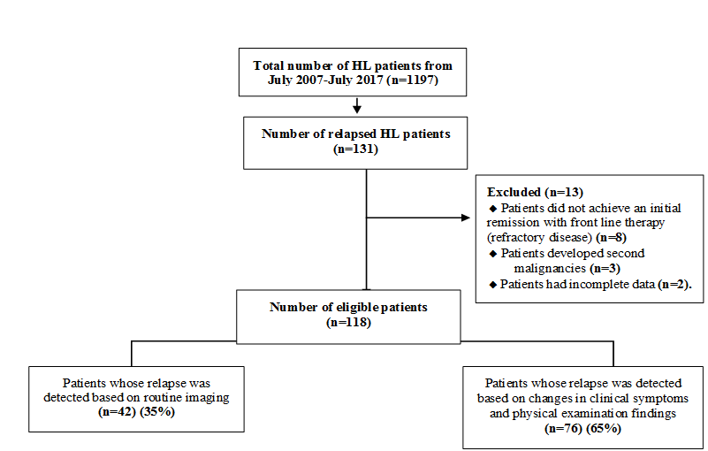

**Figure 1 Consort diagram of patients in the study.**

**Characteristic of patients and their outcome according to the method of relapse detection**

Seventy six out of the 118 relapsed patients (65%) had disease recurrence detected by changes in clinical symptoms and physical findings which included palpable lymphadenopathy in 49 patients (64%), B symptoms in 10 patients (13%), uncommon complain in 10 patients (13%) in the form of stridor, anemia, disseminated rash, itching, cough, bony pains and multiple complains in 7 patients (10%). We had42asymptomatic patients **(**35%) at the time of recurrence and had their disease detected based on routine imaging. The median time to relapse for patients detected by radiologic surveillance was 10 months and for patients who had recurrence based on changes in clinical symptoms was 20 months. Characteristics of patients whose relapse were detected by radiological surveillance and those relapsed clinically are shown in the (Table 2). The stage of disease at the time of relapse did not differ for patients whose relapse were detected clinically versus by imaging (for early stage 31 % versus 26% respectively) and (for advanced stage 69% disease versus 74% respectively).

Most of our relapses76 /118 (65%) occurred in the first 2 years, 52 patients developed relapse in the first year and 24 patients in the second year. Routine surveillance imaging performed within the first year after the end of therapy detected relapses in only 19 patients and beyond two years detected relapses in only11 patients who did not have clinical symptoms or physical findings to give rise suspicion for relapse. The 5 year OS for relapsed patients detected by radiological surveillance and those detected clinically was 75.4%, and 85% respectively with P =0.011% (Figure 2). It was better for patients who relapsed by clinical symptoms which reflected no impact for radiological surveillance on the outcome of relapsed patients. Deaths as a result of the recurrent disease occurred in 20 patients whose relapse detected by surveillance imaging and in 17 patients whose relapse detected clinically.

**Table (1): Comparison of characteristicsof Relapsed patients withtotal patients**

|  |  |  |
| --- | --- | --- |
|  | **All patients N (%)** | **Relapsed patients N (%)** |
| **Number** | 1197 | 118 |
| **Sex**   * Male * Female | 870 (72.7)  327 (27.3) | 80 (68)  38 (32) |
| **Age (years)**   * Median * Range | 9.3  1.2 – 19 | 11  1.2 – 17.9 |
| **Risk and stage at diagnosis**   * Low risk * IA * IIA * Intermediate risk * IB * IIB * IIIA * High risk * IIIB * IVA * IVB | 180 (15)  388 (32.4)  18 (1.5)  105 (8.8)  151 (12.6)  146 (12.2)  92 (7.7)  117 (9.8) | 6 (5)  17 (14.5)  1 (0.8)  7 (6)  13 (11)  26 (22)  18 (15.2)  30 (25.5) |
| **Radiation therapy**   * Given * Not given * Unknown | 961 (80.3)  234 (19.6)  2 (0.1) | 63 (53.5)  53 (45)  2 (1.5) |
| **Histology**   * Nodular sclerosis * Mixed cellularity * Lymphocyte rich * Lymphocyte depletion * Nodular lymphocyte predominance * Interfollicular * NOS | 632 (52)  446 (37)  28 (2.3)  10 (1)  48 (4)  18 (1.5)  15 (1.2) | 58 (50)  33 (28)  5 (4)  3 (2.5)  14 (11.5)  2 (1.5)  3 (2.5) |

**Table (2): Comparison of characteristics of patients whose relapse were detected by radiological surveillance and those relapsed clinically**

|  |  |  |  |
| --- | --- | --- | --- |
|  | **Radiological Relapse** | **Clinical relapse** | **P-value** |
| **Number** | 42 | 76 |  |
| **Sex**   * Male * Female | 27  15 | 52  24 | 0.69 |
| **Age (years)**   * Median * Range | 11.8  4.6 – 17.4 | 10.7  1.2 – 17.9 | 0.841 |
| **Initial risk stratification**   * Low * Intermediate * High | 4  5  33 | 19  17  40 | 0.026 |
| **Radiation therapy before relapse**   * Given * Not given | 18  24 | 46  30 | 0.126 |
| **PET-CT at time of relapse**   * Positive * Negative * Not done | 32  0  10 | 68  2  6 | 0.09 |
| **Stage at relapse**   * Early stage * Advanced stage | 11  31 | 24  52 | 0.677 |
| **5-year OS (%)** | 75.4 | 85 | 0.011 |

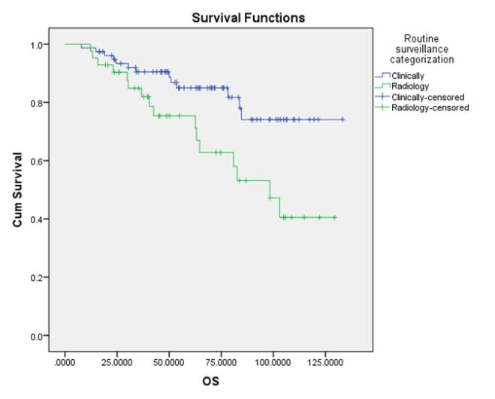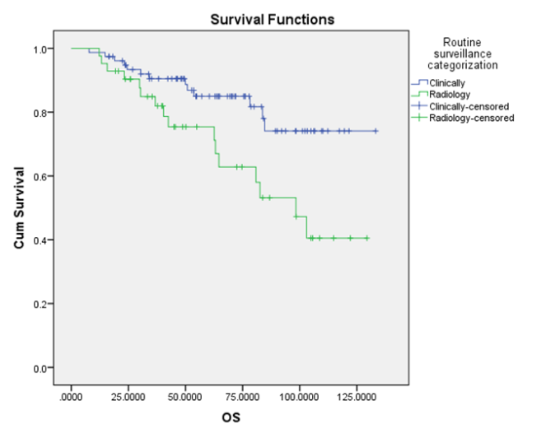

**Figure (2): 5 year OS for relapse detected by radiological surveillance versus clinical findings.**

**4. Discussion**

Our study focused specifically on the relapse of pediatric patients with HL treated with combined modality treatment ABVD ± involved field radiotherapy (RT) and we investigated the role of routine surveillance imaging in early detection of relapse. Our aim was to explore the feasibility of reducing or eliminating the toxicity of radiation exposure form frequent routine imaging studies, In addition, to reduce the costs from unnecessary images. The latest National Comprehensive Cancer Network (NCCN) guidance recommends that follow-up imaging should focus on sites of initial involvement in addition to general surveillance of the chest and abdomen every 6 months for 2–5 or 2–3 years, respectively5. This is despite evidence to suggest that surveillance imaging may be of limited value two years after end of treatment, Moreover, if relapse does occur, it is often identified clinically by the patient or physician, rather than imaging, with an argument that there is no benefit of radiological evaluation in asymptomatic patients 9, 10. This is acknowledged in European guidance that advocates the use of history taking, physical examination and blood work to supplant the use of imaging for routine follow-up unless suspicious clinical symptoms occur 11. This was in agreement with our study as we found that the majority of the patients 76(65%) had recurrence detected clinically due to changes in clinical symptoms or physical findings and 42patients (35%) were asymptomatic at the time of relapse and had their recurrence detected by routine imaging. The 5 year OS for relapsed patients detected by radiological surveillance and by clinical assessment was 75.4%, and 85% respectively with P value0.011%, and deaths as a result of the recurrent disease occurred in 20 patients whose relapse detected radiologically and in 17 patients whose relapse were detected clinically, there was no impact from radiological surveillance in the outcome of relapsed patients and the survival outcome was not affected by the mode of detection of relapse. Torrey et al., 1997did a study to investigate how relapse was detected in adult patients with HL treated with RT alone and focused on the method for detection of relapse in an earlier stage as well as examined the costs of various tests12.

They reported that good history taking combined with physical examination gave the highest rate for relapse detection and considered more cost-effective than surveillance imaging and labs12. Friedmann et al., 2013 reported that there is no evidence that earlier relapse detection occurs with surveillance imaging and the percentage of patients with advanced stage at time of relapse (stages III or IV disease) did not differ for patients whose relapse was detected by routine surveillance compared to those detected clinically (55% advanced stage disease for recurrence detected by image versus 48% advanced stage for recurrence detected clinically) 13. In our study, early disease stage at relapse was observed in 11/42 (26%) patients whose relapses were detected by routine surveillance as compared to 24/76(31%) patients whose relapses were detected based on symptoms. Advanced stage at relapse was observed in (74% versus 69%, respectively), which is considered non-significant percentage. Voss et al., 2012 examined how relapse was detected in 25 pediatric patients with intermediated and advanced-stage HL. Relapse was detected in 76% of the patients due to changes in clinical symptoms, physical examination, or laboratory tests. Relapse was detected by surveillance imaging only in two patients (8%) within the first year after the end of treatment, and four (16%) after the first year off-treatment. The authors recommended that the use of routine surveillance CT scans should be limited to the first year after the end of therapy. Their ability to detect an impact of routine surveillance imaging on overall survival was limited due to the smaller sample size14. This was in agreement with our results as most of our relapses occurred in the first 2 years 65% (76 /118), 52 patients developed relapse in the first year and 24 in the second year. Routine surveillance imaging performed within the first year after the end of treatment detected recurrence in only 19 patients and within two years detected relapses in only 11 patients who did not have any clinical findings lead to suspicion for relapse. This results may give limited value for routine images in the first 1-2 years after of end of treatment which is supported by other studies reported that most relapses occur within the first two years after end of treatment and periodic surveillance imaging performed after the first year of end of treatment detected relapses in few numbers of the patients2, 15. Current protocol of 1196 patients required a total 6-7 off-therapy CT scans and 6-7plain X-rayper patient with at least five CT scans and five plain X-ray after first year. Therefore, approximately 5,985 CT scans and plain X-ray were obtained to detect 19 asymptomatic relapses after the first year of completing treatment, and approximately 4,788CT scans and plain X-ray were obtained to detect 11 asymptomatic relapses after 2nd year of completing treatment. So those huge numbers of CT scans and plain X-ray are being performed after 1 year off-therapy to detect what we anticipate will be a small number of late relapses. Beyond one year off-treatment we found 19 patients whose relapse were detected by routine surveillance in which, deaths occurred in 7 patients (37%) and 47 patients whose relapses detected clinically with deaths occurred in 10 patients (21%), Furthermore, as we showed the use of routine surveillance imaging to detect asymptomatic late relapses did not have any impact on OS. In our opinion, this approach needs reconsideration because most of our patients who developed relapse can be successfully treated with salvage therapy with no survival benefit for patients who experience relapse by radiological surveillance beyond one-year off-treatment. In addition the risk of radiation exposure, increased incidences of second malignancies and other late effects. Modification of surveillance protocols in the pediatric HL population has also been recommended on the back of two recent studies that warned of over-scanning based on routine surveillance and detection rate 14, 16. The reassurance of a negative scan can also not be underestimated. However, its value is transient. Conversely, abnormalities identified with CT can also be equivocal and misrepresentative of relapse, thereby providing a radiologic conundrum as some patients may experience reactive lymphadenopathy with a routine illness, or to develop thymic rebound or sarcoidosis after treatment and feel otherwise well. However, in the context of lymphoma, radiologists and oncologists can be forgiven for sometimes pursuing further, sometimes invasive, tests to definitively rule out relapse.

The new response-based treatment protocols for pediatric patients with HL were designed according to the early response to chemotherapy, as a mean to stratifying or identifying patients with high sensitivity to chemotherapy and low-risk disease in whom treatment could be de-escalated or reduced. Extending this approach to surveillance imaging after the end of treatment, patients with early rapid response, higher sensitivity to chemotherapy and a lower risk for relapse may require much less follow up imaging.

Slow early responders to therapy or high-risk patients, in contrast, may benefit from more intensive surveillance early on, with a reduction in imaging as the risk of relapse decreases over time7, 18. Our results support that concept as we found that 74 out of 118 relapsed patients (63%) were high-risk patients at initial presentation with 52% of these relapse occurred at the first year follow up, and 70%of the dead patients (26/37) were high risk at initial presentation, Conversely the percentage of low-risk patients who experienced relapse was 19 %(23/118) and only 4 patients (12%) died out of disease, so for patients with high risk group and those with slow early responders, they may benefit from surveillance specifically in the first year from end of treatment.

**5. Conclusion**

Most of the pediatric Hodgkin lymphoma patients relapses are detected clinically by history and physical examination. No survival benefit associated with periodic routine surveillance imaging for pediatric patients with Hodgkin lymphoma. History taking combined with physical examination presented the highest rate of relapse detection and anticipated to decrease the hazard of radiation exposure, the risk of developing a second malignancy later in life, in addition to unnecessary invasive procedures from equivocal lesions, and patient anxiety. Patients with high risk group and those with slow early responders may benefit from routine surveillance, especially in the first 1-2 years off-treatment. However, the choice of imaging modality for disease surveillance can be reasonably debated. For HL patients with low risk of relapse, high sensitivity to chemotherapy and favorable prognosis, where relapse is approached with systemic therapy, we do not currently believe there is a rationale for frequent excessive surveillance radiography, for whom clinical follow-up combined with patients’ education on their symptoms appears to be an adequate surveillance strategy.

**References**

1. Freed J, Kelly KM: Current approaches to the management of pediatric Hodgkin lymphoma. Paediatr Drugs 12:85-98, 2010.
2. Dhakal S, Biswas T, Liesveld JL, et al: Patterns and timing of initial relapse in patients subsequently undergoing transplantation for Hodgkin’s lymphoma. Int J Radiat Oncol Biol Phys 75:188-192, 2009.
3. Ahmed BA, Connolly BL, Shroff P, et al: Cumulative effective doses from radiologic procedures for pediatric oncology patients. Pediatrics 126:e851–e858, 2010.
4. El-Galaly, T.C, Mylam, K.J., Brown, P., et al: Positron emission tomography/ computed tomography surveillance in patients with Hodgkin lymphoma in first remission has a low positive predictive value and high costs. Haematologica, 97, 931–936, 2012.
5. Wagner–Johnston ND, Bartlett NL. Role of routine imaging in lymphoma. J. Natl Compr. Canc. Netw. 9, 575–584; quiz 585, 2011.
6. Thompson, C.A., Charlson, M.E., Schenkein, E., et al: Surveillance CT scans are a source of anxiety and fear of recurrence in long-term lymphoma survivors. Ann Oncol, 21, 2262– 2266, 2010.
7. Guadagnolo BA, Punglia RS, Kuntz KM, et al: Cost-effectiveness analysis of computerized tomography in the routine follow-up of patients after primary treatment for Hodgkin’s disease. J ClinOncol 24:4116-4122, 2006.
8. Rosenberg SA: Validity of the Ann Arbor staging classification for the non-Hodgkin’s lymphomas. Cancer Treat Rep 61:1023-1027, 1977.
9. Lee AI, Zuckerman DS, van den Abbeele AD et al: Surveillance imaging of Hodgkin lymphoma patients in first remission: a clinical and economic analysis. Cancer 116, 3835–3842, 2010.
10. Bestawros A, Foltz L, Srour N, et al: Patients’ and physicians’ roles in detecting recurrent Hodgkin lymphoma following complete remission. Ann. Oncol. 24, 1359– 1363, 2012.
11. DA, Engert A, Dreyling M. Hodgkin’s lymphoma: ESMO clinical practice guidelines for diagnosis, treatment and follow-up. Ann. Oncol. 22, vi55–vi58, 2011.
12. Torrey MJ, Poen JC, Hoppe RT. Detection of relapse in early-stage Hodgkin’s disease: Role of routine follow-up studies. J ClinOncol 15:1123–1130, 1997.
13. Alison M. Friedmann, Julie A. Wolfson, Melissa M. Hudson et al: Relapse After Treatment of Pediatric Hodgkin Lymphoma: Outcome and Role of Surveillance After End of Therapy, Pediatr Blood Cancer 60:1458– 1463, 2013.
14. Voss SD, Lu C, Constine LS, et al. Surveillance computed tomography imaging and detection of relapse in intermediate- and advanced-stage pediatric Hodgkin lymphoma: A report from the Children’s Oncology Group. J ClinOncol 30:2635–2640, 2012.
15. Das P, Ng A, Constine LS, et al: ACR appropriateness criteria on Hodgkin’s lymphoma: Favorable prognosis stage I and II. J Am Coll Radiol 5:1054-1066, 2008.
16. Rathore N, Eissa HM, Margolin JF et al. Pediatric Hodgkin lymphoma: are we over-scanning our patients? Pediatr. Hematol. Oncol. 29, 415–423, 2012.
17. Hartridge-Lambert, S.K., Scheoder, H., Lim, R.C., Maragulia, J.C et al: ABVD alone and a PET scan complete remission negates the need for radiologic surveillance in early-stage, non-bulky Hodgkin lymphoma. Cancer 119, 1203–1209, 2013.

3/25/2019