Prognostic impact of immunohistochemical expression of PD-1 and PD-L1 on outcomes in classic Hodgkin lymphoma patients

Omnia Abd Elfattah¹, Tamer A. Elbedewy², Heba F. Harras³, Ayman Elsaka³ and Mohamed Elrashidy³

Departments of Clinical Oncology¹, Internal Medicine² and Pathology³, Tanta University, Tanta, Egypt

omniaabdelfattah@yahoo.com

Abstract: Objective: Hodgkin lymphoma (HL) constitutes for about 11% of all lymphoma and 0.5% of all cancers worldwide. Conventional treatment of newly recognized HL involves a combination of multi-agent therapy, tailored to the stage of disease and the hazard of relapse; this treatment help about 80% of patients to be recovered. Unfortunately, approximately 20% of HL patients developed relapse or still refractory, thus one effective treatment choice are restricted. So, substitutional treatment, such as immune checkpoint blockade drugs (anti-PD-1 and anti-PD-L1) may be needed. Our aim is to investigate the immunohistochemical (IHC) expression of PD-1and PD-L1 in the classic HL (cHL) microenvironment along with their correlation with clinicopathological characteristics and focus on their prognostic impact on survival. Patients and Methods: Sixty nine histologically confirmed newly diagnosed adult patients with cHL were enrolled in this study. Histological examination of tissue biopsy was reviewed followed by IHC staining of tissue biopsy specimens using rabbit monoclonal antibody Anti- PD1 antibody and rabbit monoclonal antibody Anti- PD-L1 antibody. Results: Out of 69 patients, 18.8% had high PD-1 ≥10% and 40.6 % had high PD-L1 ≥5. The patients with tumors with high proportions of PD-1 and PD-L1 had shorter PFS and shorter OS compared with patients with low proportions of PD-1 and PD-L1. Conclusion: PD1 and PDL1 have a prognostic value in cHL and this provides opportunities for novel targeted therapies, targeting these agents in earlier lines of therapy may improve the overall outcome of patients with cHL.
[Omnia Abd Elfattah, Tamer A. Elbedewy, Heba F. Harras, Ayman Elsaka and Mohamed Elrashid. Prognostic impact of immunohistochemical expression of PD-1 and PD-L1 on outcomes in classic Hodgkin lymphoma patients. Cancer Biology 2018;8(4):159-166]. ISSN: 2150-1041 (print); ISSN: 2150-105X (online). http://www.cancerbio.net. 14. doi:10.7537/marscbj080418.14.

Keywords: Prognostic impact; immunohistochemical expression; PD-1; PD-L1; outcome; classic Hodgkin; lymphoma patient

1. Introduction:
Hodgkin lymphoma (HL) constitutes for about 11% of all lymphoma and 0.5% of all cancers worldwide. ⁽¹⁾ Conventional treatment of newly diagnosed HL involves a combination of multi-agent therapy and, tailored to the stage of disease and the hazard of relapse; this treatment helps about eighty percent of patients to be recovered. ⁽²⁾ Unfortunately, approximately 20% of HL patients developed relapse or still refractory, thus one effective treatment choice are restricted. ⁽³⁾ So, substitutional treatment, such as immune checkpoint blockade drugs ⁽⁴⁾ may be needed.
Moreover, recognition of patients with hazard of relapse is critical in management of HL.
The immune system plays an important double function in carcinogenesis by an effective procedure called immunoediting. ⁽⁵⁾ Immune responses damage cancer cells through elimination phase. However, tumors pass to an escape phase through different ways that encouraging immunosuppressive cells, producing immunosuppressive cytokines producing defects in tumor antigen presentation to T-cells or by expressing negative co-stimulatory molecules named T-cell checkpoint regulators, like cytotoxic T-lymphocyte-associated antigen-4, programmed cell death-1 (PD-1) and programmed cell death ligand-1 (PD-L1).⁽⁶⁾ The genes encoding the PD-1 ligands, PDL1 (CD274), are targets of chromosome 9p24.1 amplification, genetic abnormality in the nodular-sclerosis HL.⁽⁷⁾ The 9p24.1 amplicon includes gene dose–dependent JAK-STAT activity moreover prompt PD-1 ligand transcription. These copy-number–dependent mechanisms and chromosomal rearrangements⁽⁸⁾ lead to overexpression of the PD-1 ligands in HL.
The mechanisms of PD-1 ligand overexpression in HL suggest that this disease may have genetically determined vulnerability to PD-1 blockade. Coamplification of PDL1 on chromosome 9p24.1 indicates receptor rather than selective ligand blockade as a therapy design.⁽⁷⁾ Immune checkpoint inhibitors targeting the PD-1 pathway have shown encouraging results for management of such patients.⁽⁹⁾ These drugs herald a novel therapeutic era in which the microenvironment is the primary goal. The patients may benefit from more intensive therapy at the time of diagnosis if they are at especially high risk of treatment failure, including immune checkpoint inhibitors as front-line treatment. Recognition of microenvironment-associated risk factors in cHL might allow for more perfect prediction of outcome in contrast to traditional prognostic factors such as the International Prognostic Score. ⁽¹⁰⁾
Our aim is to investigate the immunohistochemical expression of PD-1 and PD-L1 in the cHL microenvironment along with their correlation with clinicopathological characteristics and focus on their prognostic impact on survival

2. Patients and Methods
This prospective study had been conducted in Tanta University Hospitals from September 2014 to June 2018. Sixty nine histologically confirmed newly diagnosed adult patients with cHL were enrolled in this study.
All patients provided written informed consent prior to enrollment into the study. The Ethics Committee at our Faculty of Medicine, Tanta University granted protocol approval. To be eligible for participation in this study patients had to be greater than 18 years of age, have histologically confirmed evidence of classic Hodgkin's lymphoma, not received pervious chemotherapy or radiotherapy with normal cardiac functions, and adequate liver and kidney functions without comorbidity. Patients experiencing other malignancies were excluded from the study. The histological diagnosis was based on the currently used criteria defined by the World Health Organization 2008 classification. ⁽¹¹⁾
Patients were staged according to Cotswolds modified Ann Arbor staging system for Hodgkin lymphoma. ⁽¹²⁾ Patients’ performance status was assessed using Eastern Cooperative Oncology Group performance status.⁽¹³⁾ International Prognostic score (IPS) was used for determining the prognosis.⁽¹⁴⁾ Radiological assessment, including computed tomography (CT) scan of the neck, thorax, abdomen, and pelvis according to the site of involvement and echocardiography.
Tissue preparation
Formalin fixed paraffin embedded blocks of tumor tissue, taken from lymphoma cases. Histological examination of tissue biopsy was done with selection of 69 Hodgkin lymphoma cases. They were classified histopathologically into nodular sclerosis, mixed cellularity, lymphocyte depleted and lymphocyte rich followed by IHC staining of tissue biopsy specimens using rabbit monoclonal antibody Anti- PD1 antibody [EPR4877(2)] (ab 137132); Abcam and rabbit monoclonal antibody Anti- PD-L1 antibody [clone 28-8] (ab205921) ;
Abcam. Written consent was taken from the patients for use of the samples and publication.

PD-1 immunohistochemical expression:
Tumor microenvironment showing brown membranous PD-1 immunohistochemical staining was evaluated as positive. Lymphocytes and monocytes were included in the estimates while reed sternberg (RS) cells, granulocytes, and macrophages were excluded in the PD-1 analysis. Expression of PD-1 immunostain in follicular T helper lymphocytes of the germinal centers were excluded. ⁽¹⁵⁾
PDL-1 immunohistochemical expression:
RS cells and tumor microenvironment showing brown membranous PDL-1 staining were evaluated as positive. All cells were included in the PD-L1 analyses.
PD1 and PDL1 immunostaining interpretation:
Proportions of PD1 and PDL1 were calculated by dividing the number of positive cells by combined number of positive and negative cells
The proportions of PD-1, PD-L1 were calculated by using imageJ software [Java image processing program inspired by National institute of health (NIH), USA]. Counting was performed in two fields at X200 magnification. The mean of the two counts was calculated for each case.
High vs low proportion of PD-1 was evaluated as ≥10% vs <10% PD-1. High vs low proportion of PD-L1 leukocytes was evaluated as ≥5% vs <5% PD-L1 .⁽¹⁰⁾
Follow-up period ranged between 3 and 36 months, with a median of 14 months.
Patients were treated according to national guidelines. ⁽¹⁶⁾
Before every cycle of chemotherapy complete clinical examination and complete hematological work up were done and toxicity was evaluated according to NCI toxicity criteria. ⁽¹⁷⁾
All the investigations done during the pretreatment period were repeated at mid and end of treatment and properly assessed.
The response to treatment and evaluation of end point {overall survival (OS) and progression free survival (PFS)} were assessed according to the International Workshop criteria. ⁽¹⁸⁾
Overall-survival was defined as the time from diagnosis to the date of death from any cause or last follow-up. Progression-free survival, which was defined as the time from study to documented disease progression or death.
Statistical analysis
The data were analyzed using SPSS 21.0 software package. The correlation of PD-1 and PDL-1 expression with different clinicopathologic characteristics was analyzed with chi-square test. The Kaplan–Meier method and Log-rank test were used to analyze the correlation of patient survival with PD-1 and PDL-1 expression. A significance level of P < 0.05 was used.

3. Results
Clinicopathological characteristics of the patients: Table (1).
This study includes Sixty nine histologically confirmed newly diagnosed adult patients with cHL, the age ranged between 18-73 years, most patients were males (62.32%). Performance status 0-1 by ECOG scale represented the majority of the patients. Nodular sclerosis constituted 60.86% of all patients followed by mixed cellularity,38 patients developed relapse and 28.9% of patients were died.
Out of 69 patients, 81.2% had low PD-1 <10% and 41 patients (59.4%) had low PD-L1 <5% while 13 patients (18.8%) had high PD-1 ≥10% and 28 patients (40.6 %) had high PD-L1 ≥5 (Figure 1, 2).

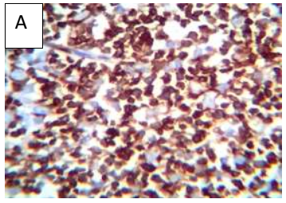

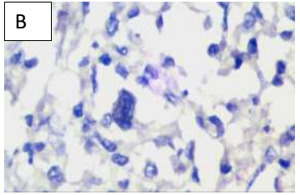
Figure (1): (A) Hodgkin lymphoma showing high PD-1 immunohistochemical expression (Streptavidin Biotin× 200). (B) Hodgkin lymphoma showing low PD-1 immunohistochemical expression (Streptavidin Biotin× 400).

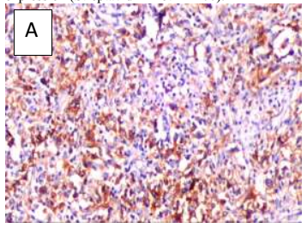

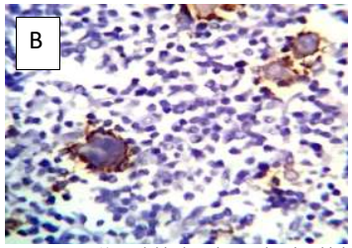
Figure (2): (A) Hodgkin lymphoma showing high PDL-1 immunohistochmical expression (Streptavidin Biotin× 100). (B) Another case of Hodgkin lymphoma showing expression of PDL-1 on RS cells (Streptavidin Biotin× 200).

PD1 and PDL1 high expression was significantly related to nodular sclerosis as a histopathological type, lymphocyte count, bone marrow involvement, advanced tumor stage and IPI score.

Survival analysis: Table (2, 3)
Kaplan-Meier analyzes were conducted the progression free survival and overall survival curves for high vs. low proportion of PD-1 and high vs. low proportion of PD-L1, both presented in Figure 3,4 and 5,6 respectively.
Thirteen patients (100%) with high proportions of PD-1 had progression of the disease compared with 6 patients (10.7%) with low proportions of PD-1. Seventeen patients (60.7%) with high proportions of PD-L1 had progression of the disease compared with 2 patients (4.9%) with low proportions of PD-L1. So the patients with tumors with high proportions of PD-1 and PD-L1 had shorter PFS compared with patients with low proportions of PD-1 and PD-L1.
Also, six patients (46.1%) with high proportions of PD-1 died compared with 4 patients (7.1%) with low proportions of PD-1. Ten patients (35.7%) with high proportions of PD-L1 died compared with no death recorded among patients with lowPD-L1 proportions. patients with tumors with high proportions of PD-1 and PD-L1 had shorter OS compared with patients with low proportions of PD-1 and PD-L1.
The PFS and OS both show statistical significant difference between high vs. low proportion of PD-1 and high vs. low proportion of PD-L1 (P =0.000*).

Table (1): Comparison between low and high (PD-1 and PD-L1)
P-value | High PD-L1 ≥5% |  | Low PD-L1 <5% |  | P-value | High PD-1 ≥10% |  | Low PD-1 <10% |  | All patients |  | Variables
 | % | N | % | N |  | % | N | % | N | % | N
0.6977 | 28.57 | 2 | 24.39 | 10 | 0.2594 | 38.46 | 5 | 23.21 | 13 | 26.09 | 51 | < 45 | Age (years)
 | 71.43 | 20 | 75.61 | 31 |  | 61.54 | 8 | 76.79 | 43 | 73.91 | 18 | ≥ 45
0.8202 | 60.71 | 17 | 63.41 | 26 | 0.5681 | 69.23 | 9 | 60.71 | 34 | 62.33 | 43 | Male | Sex
 | 39.29 | 11 | 36.59 | 15 |  | 30.77 | 4 | 39.29 | 22 | 37.68 | 26 | Female
0.047* | 3.57 | 1 | 7.34 | 3 | 0.0203* | 0 | 0 | 7.14 | 4 | 5.8 | 4 | Lymphocyte rich | Histological type
 | 64.29 | 18 | 58.54 | 24 |  | 46.15 | 6 | 64.29 | 36 | 60.86 | 42 | Nodular sclerosis
 | 17.86 | 5 | 34.17 | 14 |  | 30.77 | 4 | 26.79 | 15 | 27.54 | 19 | Mixed cellularity
 | 14.29 | 4 | 0 | 0 |  | 23.08 | 3 | 1.79 | 1 | 5.8 | 4 | Lymphocyte depleted
0.5406 | 53.57 | 15 | 60.98 | 25 | 0.338 | 46.15 | 6 | 60.71 | 34 | 57.97 | 20 | Absent | B-symptoms
 | 46.43 | 13 | 39.02 | 16 |  | 53.85 | 7 | 39.29 | 22 | 42.03 | 29 | Present
0.6967 | 75 | 21 | 70.73 | 29 | 0.0754 | 92.31 | 2 | 67.86 | 38 | 72.46 | 50 | < 4 | Serum albumin (gm/dL)
 | 25 | 7 | 29.27 | 12 |  | 7.69 | 1 | 32.14 | 18 | 27.54 | 19 | ≥ 4
0.781 | 71.43 | 20 | 68.29 | 28 | 0.4851 | 61.54 | 8 | 71.43 | 40 | 69.57 | 48 | < 10.5 | Hemoglobin level (gm/dl)
 | 28.57 | 8 | 31.71 | 13 |  | 38.46 | 5 | 28.57 | 16 | 30.43 | 21 | ≥ 10.5
0.106 | 42.86 | 12 | 24.39 | 10 | 0.5722 | 38.46 | 5 | 30.36 | 17 | 31.88 | 22 | > 15 | Total WBCs count (x 10⁹/L)
 | 57.14 | 16 | 75.61 | 31 |  | 61.54 | 8 | 69.64 | 39 | 68.12 | 47 | ≤ 15
0.0059* | 67.86 | 19 | 34.15 | 14 | 0.0032* | 84.62 | 11 | 39.29 | 22 | 47.83 | 33 | < 0.6 | Lymphocyte count (x 10⁹/L)
 | 32.14 | 9 | 65.85 | 27 |  | 15.38 | 2 | 60.71 | 34 | 52.17 | 36 | ≥ 0.6
0.9943 | 46.43 | 13 | 46.34 | 19 | 0.2104 | 30.77 | 4 | 50 | 28 | 46.38 | 33 | Normal | LDH
 | 53.57 | 15 | 53.66 | 22 |  | 69.23 | 9 | 50 | 28 | 53.62 | 37 | High
0.75.2 | 57.14 | 16 | 60.98 | 25 | 0.2796 | 46.15 | 6 | 62.5 | 35 | 59.42 | 41 | < 50 | ESR (mm/hour)
 | 42.86 | 12 | 39.02 | 16 |  | 53.83 | 7 | 37.5 | 21 | 40.58 | 28 | ≥ 50
0.4612 | 89.29 | 25 | 82.93 | 34 | 0.0994 | 100 | 13 | 82.14 | 46 | 58.51 | 59 | Absent | Extra nodal involvement
 | 10.71 | 3 | 17.07 | 7 |  | 0 | 0 | 17.86 | 10 | 14.49 | 10 | Present
0.0405* | 75 | 21 | 92.68 | 38 | 0.002* | 60 | 9 | 92.59 | 50 | 85.51 | 59 | Absent | Bone marrow involvement
 | 25 | 7 | 7.32 | 3 |  | 40 | 6 | 7.40 | 4 | 14.49 | 10 | Present
0.738 | 85.71 | 24 | 80.49 | 33 | 0.8322 | 84.62 | 11 | 82.14 | 46 | 82.61 | 57 | Absent | Bulky disease
 | 14.29 | 4 | 19.51 | 8 |  | 15.38 | 2 | 17.86 | 10 | 17.39 | 12 | Present
0.0299* | 21.43 | 6 | 39.02 | 16 | 0.0006* | 0 | 0 | 39.28 | 22 | 31.88 | 22 | I | Stage
 | 28.57 | 8 | 43.9 | 18 |  | 23.08 | 3 | 41.07 | 23 | 37.68 | 26 | II
 | 21.43 | 6 | 4.88 | 2 |  | 30.77 | 4 | 7.14 | 4 | 11.59 | 8 | III
 | 28.57 | 8 | 12.2 | 5 |  | 46.15 | 6 | 12.5 | 7 | 18.85 | 13 | IV
0.0031* | 64.29 | 18 | 92.68 | 38 | 0.0052* | 53.85 | 7 | 87.5 | 49 | 81.16 | 56 | 0,1,2 | IPI
 | 35.71 | 10 | 7.32 | 3 |  | 46.15 | 6 | 12.5 | 7 | 18.84 | 13 | 3,4
*, significant; ESR, Erythrocyte sedimentation rate; IPI, International prognostic index; LDH, Lactate dehydrogenase; N, Number; PD-1, Programmed death receptor-1; PD-L1, Programmed death ligand-1

Table (2): Progression free survival probability for different groups of patients.
 | Number of patients | Events  (N) | Censored (N) (%) | Median Survival  (Months) | Range  (Months) | Statistic test for equality of survival distributions (Log Rank)
 |  |  |  |  |  | Statistic | Df | P-value (Significance)
Low PD-1 (<10%) | 56 | 6 | 50(89.29%) | 11 | 3-32 | 59.447 | 1 | 0.000*
High PD-1 (≥10%) | 13 | 13 | Zero (0%) | 3 | 3-16
Low PD-L1 (<5%) | 41 | 2 | 39(95.12%) | 11 | 3-32 | 21.54 | 1 | 0.000*
High PD-L1 (≥5%) | 28 | 17 | 11 (39.29%) | 7 | 3-31
*, significant; N, Number; PD-1, Programmed death receptor-1; PD-L1, Programmed death ligand-1

Table (3): Overall survival probability for different groups of patients.
 | Number of patients | Events  (N) | Censored (N) (%) | Median Survival (Months) | Range  (Months) | Statistic test for equality of survival distributions (Log Rank)
 |  |  |  |  |  | Statistic | Df | P-value (Significance)
Low PD-1 (<10%) | 56 | 4 | 52(92.86%) | 16 | 7-36 | 28.104 | 1 | 0.000*
High PD-1 (≥10%) | 13 | 6 | 7 (53.85%) | 8 | 6-20
Low PD-L1 (<5%) | 41 | Zero | 41(100%) | 15 | 7-36 | 15.549 | 1 | 0.000*
High PD-L1 (≥5%) | 28 | 10 | 18 (64.29%) | 10.5 | 6-36
*, significant; N, Number; PD-1, Programmed death receptor-1; PD-L1, Programmed death ligand-1

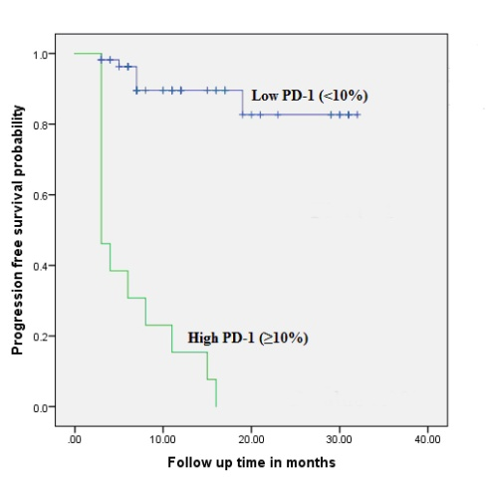
Figure (3): Kaplan–Meier analysis of the progression free survival probability for low and high PD-1 groups.

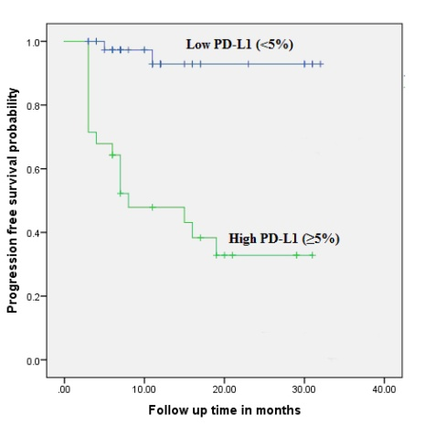
Figure (4): Kaplan–Meier analysis of the progression free survival probability for low and high PD-L1 groups.

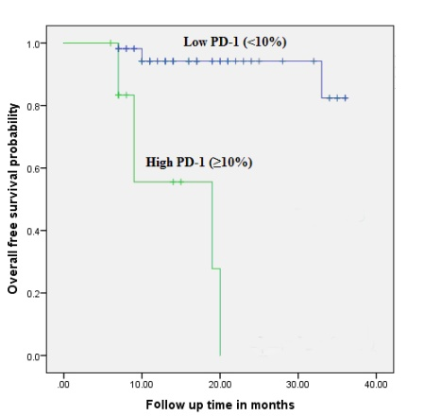
Figure (5): Kaplan–Meier analysis of the overall survival probability for low and high PD-1 groups.

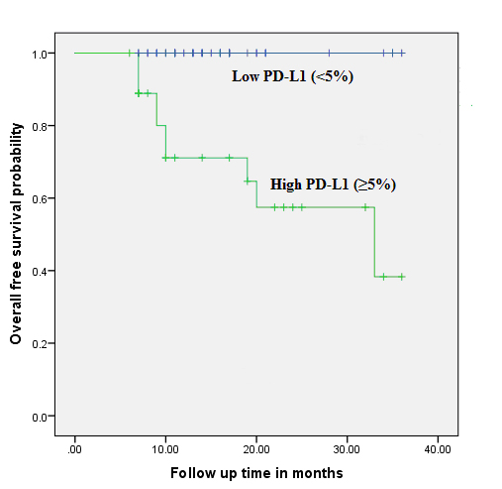
Figure (6): Kaplan–Meier analysis of the overall survival probability for low and high PD-L1 groups.

4. Discussion
Classical HL is a unique tumor with malignant cells making up only a small portion of the overall tumor cellularity. ⁽¹⁹⁾ Reed-Sternberg cells are encompassed by dense, mixed inflammatory infiltrate. However, even with the recruitment of many immune cells to the tumor site, there is an insufficient antitumoral response.⁽²⁰⁾ 9p24.1 was characterized in classical HL tumor lines contains the locus for the PD-L1. Studies utilizing fluorescence in situ hybridization detected 9p24.1 abnormalities in almost all tumors collected from a group of patients with recently diagnosed cHL.^{(21,22)} At the protein level, it can also be revealed that most cHL tumors show increased PD-L1 expression on the cell surface and on tumor-infiltrating macrophages.⁽²³⁾
The importance of the PD-1 and PD-L1 in cHL has previously been shown five studies reported.
The first study by Muenst et al, ⁽²⁴⁾ who correlated the number of PD-1+ lymphocytes in HL with the remaining background lymphocyte populations using tissue microarray. Amount of PD-1+ tumor-infiltrating lymphocytes above the prognostic cutoff score (23 cells/mm²) was a prognostic factor of OS.
The second study by Greaves et al, ⁽²⁵⁾ IHC analysis was done using tissue microarrays from 122 previously untreated cHL patients. Outcomes of freedom from first-line treatment failure, disease-specific survival (DSS) and OS were assessed. PD-1 expression was strikingly low or absent in the microenvironment of the majority of patients. The rare patients with high expression of PD-1 had adverse outcomes. In contrast, PD-L1 was expressed at a high level in both HRS and the microenvironment in the majority of cases. Level of PD-L1 expression in the microenvironment was not associated with any clinical outcome.
The third study by Paydas et al, ⁽²⁶⁾ who used IHC staining to detect the PD-1 and PD-L1 expressions. Their expressions were found in 20 % of the cases. It has been found that co-expression of PD-1 and PD-L1 was associated with shorter OS and disease-free survival.
The fourth study by Koh et al, ⁽²⁷⁾ who used IHC for PD-L1, and PD-1 expressions from 109 classical HL patients, PD-1 protein expressed in the peritumoral microenvironment in thirteen patients and was associated with OS while PD-L1 expression was not associated with OS. Multivariate analysis identified PD-1 protein as an independent prognostic factor for OS.
The fifth study by Hollander et al, ⁽¹⁰⁾ who used IHC to detect PD-1, and PD-L1expression from 387 classical HL patients. Event-free survival (EFS) and OS were analyzed, their expression in the microenvironment were associated with poor EFS in a multivariate analysis. A high proportion of PD-L1⁺ leukocytes were also associated with inferior OS in a multivariate analysis.
Different results may be due to different cutoffs to predict outcome, different methods of statistical analysis, different pathological analysis for different tumor microenvironment cells (HRS, or leukocytes), and different number of patients with different clinical and pathological characters and variations of follow up periods ^{(28, 29)} PD-L1 is probably the main inducer of immunosuppression in malignant conditions because of its inducible capacity. ⁽²⁸⁾
Macrophages have been associated with inferior prognosis in cHL in several studies,^{(30,31)} whereas other studies found no association with outcome.^{(32,33)} Macrophages are able to express PD-L1.⁽²⁹⁾ However, other leukocytes are also able to express PD-L1⁽³⁴⁾ and this probably contributes to making an immunologically crippled tumor milieu in cases with a high proportion of PD-L1⁺ leukocytes.
PD-1 is expressed by regulatory T lymphocytes (Tregs) and induces signals for proliferation rather than apoptosis ⁽³⁵⁾ in these cells. Tregs are able to down regulate the actions of different leukocytes (including cytotoxic T lymphocytes, NK cells, and B lymphocytes) that may aid in tumor cell eradication.⁽³⁴⁾ In line with this, blockade of Tregs might contribute to some extent to the success of treatment with PD-1–inhibiting drugs in various malignancies^{(35,36)} by unblocking leukocytes with tumor eradicating capabilities.

Conclusion
PD1 and PDL1 high expression was significantly related to advanced tumor stage and bone marrow involvement and was associated with shorter PFS and shorter OS suggesting that they have a prognostic value in classical HL patients. This may provide opportunities for novel targeted therapies.
Increasing the cure rates of frontline treatment by utilizing combinations that merge novel agents will improve disease outcome generally and spare patients from long-term toxicity from conventional therapy.

References
1. Perez-Callejo D, Zurutuza L, Royuela A, Torrente M, Núñez B, Calvo V, Méndez M, Franco F, Brenes MA, Sánchez JC, Provencio M. Long-term follow up of Hodgkin lymphoma. Oncotarget. 2018 Feb 3;9(14):11638-11645.
2. Ali S, Basit A, Kazmi AS, Sidhu A, Badar F, Hameed A. Chemotherapy alone or combined chemotherapy and involved field radiotherapy in favorable risk early-stage classical Hodgkin lymphoma-a 10 years experience. Pak J Med Sci. 2016 Nov-Dec;32(6):1408-1413.
3. Nikolaenko L, Chen R, Herrera AF. Current strategies for salvage treatment for relapsed classical Hodgkin lymphoma. Ther Adv Hematol. 2017 Oct;8(10):293-302.
4. Ventola CL. Cancer Immunotherapy, Part 2: Efficacy, Safety, and Other Clinical Considerations. P T. 2017 Jul;42(7):452-463.
5. Chen DS, Mellman I. Elements of cancer immunity and the cancer-immune set point. Nature. 2017 Jan 18; 541(7637):321-330.
6. Teixidó C, Vilariño N, Reyes R, Reguart N. PD-L1 expression testing in non-small cell lung cancer. Ther Adv Med Oncol. 2018 Apr 11; 10: 1758835918763493.

7. Ansell SM, Lesokhin AM, Borrello I, Halwani A, Scott EC, Gutierrez M, Schuster SJ, Millenson MM, Cattry D, Freeman GJ, Rodig SJ, Chapuy B, Ligon AH, Zhu L, Grosso JF, Kim SY, Timmerman JM, Shipp MA, Armand P. PD-1 blockade with nivolumab in relapsed or refractory Hodgkin's lymphoma. N Engl J Med. 2015 Jan 22; 372(4):311-9.
8. Steidl C, Shah SP, Woolcock BW, et al. MHC class II transactivator CIITA is a recurrent gene fusion partner in lymphoid cancers. Nature. 2011; 471:377–81.
9. Glimelius I, Diepstra A. Novel treatment concepts in Hodgkin lymphoma. J Intern Med. 2017; 281(3):247-260
10. Hollander P, Kamper P, Smedby KE, Enblad G, Ludvigsen M, Mortensen J, Amini RM, Hamilton-Dutoit S, d'Amore F, Molin D, Glimelius I. High proportions of PD-1(+) and PD-L1(+) leukocytes in classical Hodgkin lymphoma microenvironment are associated with inferior outcome. Blood Adv. 2017; 1(18):1427-1439.
11. Harris NL, Campo E, Jaffe ES, et al. Introduction to the WHO classification of tumours of haematopoietic and lymphoid tissues. In: Swerdlow SH, Campo E, Harris NL, et al., editors. WHO Classification of Tumours of Haematopoietic and Lymphoid Tissues. Lyon, France: IARC; 2008. p. 14-15.
12. Lister TA, Crowther D, Sutcliffe SB, Glatstein E, Canellos GP, Young RC, et al. Report of a committee convened to discuss the evaluation and staging of patients with Hodgkin’s disease: cotswolds meeting. J Clin Oncol 1989; 7:1630–1636.
13. Oken MM, Creech RH, Tormey DC, Horton J, Davis TE, McFadden ET, Carbone PP. Toxicity and response criteria of the Eastern Cooperative Oncology Group. Am J Clin Oncol 1982; 5:649–655.
14. Hasenclever D, Diehl V. A prognostic score for advanced Hodgkin's disease .International Prognostic Factors Project on Advanced Hodgkin's Disease. N Engl J Med. 1998 Nov 19; 339(21): 1506-14.
15. Crotty S. Follicular helper CD4 T cells (TFH). Annu Rev Immunol. 2011; 29:621-663.
16. National Comprehensive Cancer Network. Clinical practices guidelines in oncology, V.1. 2014. Available at: https://www.nccn.org/professionals/ physician_gls/pdf/b-cell.pdf. (Accessed 15 January 2014).
17. National Cancer Institute. Common terminology criteria for adverse) events index.version3.0). Available at: http://ctep.cancer.gov/forms/CTCAE_Index. pdf. (Accessed 15 June 2006).
18. Cheson BD, Horning SJ, Coiffier B, Shipp MA, et al. Report of an international workshop to standardize response criteria for non-Hodgkin's lymphomas. NCI Sponsored International Working Group. J Clin Oncol., 2000; 18(11):2351.
19. Küppers R. The biology of Hodgkin’s lymphoma. Nat Rev Cancer. 2009; 9(1): 15-27.
20. Xing W, Mai N, Dresser K, Chen BJ. PD-L1 Immunohistochemistry Highlights Bone Marrow Involvement by Classic Hodgkin Lymphoma in Staging Biopsies: Implications for Diagnosis and Tumor Microenvironment Alterations. Appl Immunohistochem Mol Morphol. 2017 Dec 21.
21. Green MR, Monti S, Rodig SJ, et al. Integrative analysis reveals selective 9p24.1 amplification, increased PD-1 ligand expression, and further induction via JAK2 in nodular sclerosing Hodgkin lymphoma and primary mediastinal large B-cell lymphoma. Blood. 2010; 116(17): 3268-3277.
22. Roemer MGM, Advani RH, Ligon AH, et al. PD-L1 and PD-L2 Genetic Alterations Define Classical Hodgkin Lymphoma and Predict Outcome. J Clin Oncol. 2016; 34(23):2690-2697.
23. Chen BJ, Chapuy B, Ouyang J, et al. PD-L1 expression is characteristic of a subset of aggressive B-cell lymphomas and virus-associated malignancies. Clin Cancer Res. 2013; 19(13): 3462-3473.
24. Muenst S, Hoeller S, Dirnhofer S, Tzankov A. Increased programmed death-1+ tumor-infiltrating lymphocytes in classical Hodgkin lymphoma substantiate reduced overall survival. Hum Pathol. 2009; 40(12):1715-1722.
25. Greaves P, Clear A, Owen A, et al. Defining characteristics of classical Hodgkin lymphoma microenvironment T-helper cells. Blood. 2013; 122(16): 2856-2863.
26. Paydas S, Bağır E, Seydaoglu G, Ercolak V, Ergin M. Programmed death-1 (PD-1), programmed death-ligand 1 (PD-L1), and EBV-encoded RNA (EBER) expression in Hodgkin lymphoma. Ann Hematol. 2015; 94(9): 1545-1552.
27. Koh YW, Jeon YK, Yoon DH, Suh C, Huh J. Programmed death 1 expression in the peritumoral microenvironment is associated with a poorer prognosis in classical Hodgkin lymphoma. Tumour Biol. 2016; 37(6):7507-7514.
28. Yao S, Chen L. PD-1 as an immune modulatory receptor. Cancer J. 2014;20(4):262-264.
29. Bardhan K, Anagnostou T, Boussiotis VA. The PD1:PD-L1/2 pathway from discovery to clinical implementation. Front Immunol. 2016;7:550.
30. Steidl C, Lee T, Shah SP, et al. Tumor-associated macrophages and survival in classic Hodgkin’s lymphoma. N Engl J Med. 2010; 362(10):875-885.
31. Kamper P, Bendix K, Hamilton-Dutoit S, Honor´e B, Nyengaard JR, d’Amore F. Tumor-infiltrating macrophages correlate with adverse prognosis and Epstein-Barr virus status in classical Hodgkin’s lymphoma. Haematologica. 2011; 96(2):269-276.
32. Azambuja D, Natkunam Y, Biasoli I, et al. Lack of association of tumor-associated macrophages with clinical outcome in patients with classical Hodgkin’s lymphoma. Ann Oncol. 2012; 23(3):736-742.
33. Kayal S, Mathur S, Karak AK, et al. CD68 tumor-associated macrophage marker is not prognostic of clinical outcome in classical Hodgkin lymphoma. Leuk Lymphoma. 2014; 55(5): 1031-1037.
34. Rodrıguez-Perea AL, Arcia ED, Rueda CM, Velilla PA. Phenotypical characterization of regulatory T cells in human sand rodents. Clin Exp Immunol. 2016; 185(3):281-291.
35. Buchbinder EI, Desai A. CTLA-4 and PD-1 pathways: similarities, differences, and implications of their inhibition. Am J Clin Oncol. 2016; 39(1): 98-106.
36. Chaudhary B, Elkord E, Regulatory T. Regulatory T cells in the tumor microenvironment and cancer progression: role and therapeutic targeting. Vaccines (Basel). 2016; 4(3): E28.

