Comparison of Clinicopathological Characteristics and Survival Outcome between Right and Left Sided Colon Cancer Patients

Amr Ghannam and Rasha Abd El-Ghany Khedr

Clinical Oncology Department, Faculty of Medicine, Tanta University, Egypt
Amro_ghannam@yahoo.com

Abstract: Aim: The purpose of our study was the evaluation of the difference in clinicopathological characteristics and survival between primary stage I-III right-sided colon (RCC) and left-sided colon (LCC) cancer. Patients and methods: A retrospective analysis of 375 Egyptian patients with pathological stage I-III colon cancer who underwent curative colectomy from January 2012 and December 2016 was performed. Our objective was to explore if there was any difference in clinicopathological characteristics and survival outcome of colon cancer based on tumor side. Results: A total of 375 patients were analyzed with 160 (42.7%) had RCC and 215 (75.3%) had LCC. RCC had higher grade with poor differentiation (p=0.01) while signet ring type was more common in left side (p=0.08). the Mucinous adenocarcinoma (MAC) were more common in RCC than LCC. The mean number of lymph node ratio for RCC was higher than that for LCC (0.15±0.27 vs. 0.10±0.24; p=0.02). The median survival was not reached. The mean overall survival (OS) for the RCC and LCC patient groups was 54.5 and 59.5months, respectively (p=0.02). The mean disease free survival (DFS) was 46.2and 54.9months, for the RCC and LCC respectively (p=0.03). Multivariate analysis revealed that tumor location, tumor stage and the lymph node ratio (LNR) are independent prognostic factors. Conclusion: Tumor located at right side, higher stage and higher positive LNR were significantly associated with worse survival.
[Amr Ghannam and Rasha Abd El-Ghany Khedr. Comparison of Clinicopathological Characteristics and Survival Outcome between Right and Left Sided Colon Cancer Patients. Cancer Biology 2018;8(4):152-158]. ISSN: 2150-1041 (print); ISSN: 2150-105X (online). http://www.cancerbio.net. 13. doi:10.7537/marscbj080418.13.

Key Words: colon cancer; tumor location, prognosis.

1. Introduction
Colorectal cancer (CRC) is a serious health problem and is the 3rd most common cancer worldwide[1]. In the United States, in 2018, approximately one hundred thousands of new cases of colorectal cancer will occur.[2]
Colonic carcinoma arising from different sites of the colon are distinct both in clinical and molecular characteristics. Right-sided tumors (defined as those arising from the appendix, cecum, ascending colon, hepatic flexure, or proximal two-thirds of the transverse colon) originate from the embryonic midgut. In contrast, Left sided tumors (those arising in the distal one-third of the transverse colon, splenic flexure, descending colon, sigmoid colon, or rectum) originate from the embryonic hindgut. [3]
As a result of different embryological origin, both RCC and LCC have different genetic profiles. Right-sided tumors are more frequently characterized by a number of negative prognostic factors, including positive BRAF mutation, microsatellite instability (MSI), positive serrated pathway signature, hypermutation, and mucinous adenocarcinoma histology. On the other hand, tumors located at left side more frequently has gene expression profiles characterized by an EGFR (epidermal growth factor receptor) inhibitor–sensitive phenotype (ie, EGFR/ERBB2[formerlyHER2orHER2/neu] amplified, epiregulin high, and possessing classic chromosomal instability).[4-7]
Earlier trials have concluded that the prognosis and biology of colorectal cancer is different based on the location of the primary tumor whether it is right or left-sided[8, 9]. There is still no consensus that tumor site itself represents an independent prognostic factor.
Many trials proved that RCC have an inferior prognosis compared to left sided tumors[10, 11]. Suttie et al. [12] demonstrated that RCC has an inferior prognosis, the possible cause may be more advanced stage at diagnosis with subsequent more non curative resections. However, Weiss et al. [13] and Kwaan et al. [14] reported no overall survival (OS) difference between RCC and LCC. On the other hand, Warschkow et al. [15]reported the reverse; they concluded that the outcome of non-metastatic RCC is relatively better than LCC.
The difference in survival between RCC and LCC is still a matter of debate in patients with localized colon cancer. Most current clinical trials are based on population databases from Europe or the United States [8, 10, 11, 16, 17]. In a systematic review and meta-analysis, Yahagi, et al. reported a statistically significant difference in outcome between RCC and LCC was found only in Western countries, while it was unreliable in Eastern countries [18].
Therefore, we underwent our clinical study with the objective of performing a retrospective analysis of Egyptian patients with non-metastatic colon cancer stage I-III after curative resection. Ouraim was the exploration of any differences in clinicopathologic characteristics and survival outcome based on tumor location.

2. Patients and Methods
A retrospective analysis of consecutive patients who underwent curative resection for histologically proven TNM stage I-III colon cancer and treated at Tanta University Hospital, clinical oncology department between January 2012 and December 2016 was conducted. Patients eligible for this study met the following criteria: had TNM stage I-III colon cancer on final pathologic examination, age over 18 years, underwent curative resection, and had complete follow-up databases.
All patients were included in a follow-up oncological program for at least 5 years after curative resection or until death in cases of relapse.
The clinical outcomes and survival status of the patients were followed up regularly. Available variables included age at diagnosis, gender, tumor size, histological subtype, presence or absence of mucinous adenocarcinoma (MAC), TNM classification, lymph node ratio (LNR), lymphovascular invasion (LVI), and surgical approach. The LNR was calculated by dividing the number positive lymph nodes by the number of dissected lymph nodes [19].
Primary tumors originating in the cecum, ascending colon, hepatic flexure, or transverse colon were classified as RCC. Primary tumors originating in the splenic flexure, descending orsigmoid colon were classified as LCC. If tumors in an individual patient were located in both sides and the origin could not be attributed to either side, the patient was excluded from the study. The TNM classification was defined according to the criteria of the (Union for International Cancer Control Tumor, Node, Metastasis classification, Seventh Edition)[20]. The date of the final analysis was October, 2018.
Statistical analysis
Data for all categorical variables were summarized as frequencies, and data for all continuous variables were presented as medians and ranges. The correlation was calculated using the Student’s t-test (for continuous variables) and chi-square test (for categorical variables). The OS and DFS were calculated using the Kaplan-Meier method. Cox proportional-hazards model was used for univariate and multivariate analysis to identify the independent prognostic factors for OS and disease-free survival (DFS). Differences were considered statistically significant for p-values <0.05. All statistical analyses were performed using SPSS version 21.0 (IBM Corporation, Armonk, NY, USA).

3. Results
Patient characteristics
Patients with pathological stage I-III colon cancer who underwent curative surgery were eligible to our study.375 out of 510recorded patients between January 2012 and December 2016who have a complete follow up data were selected for final analysis. The clinicopathologic characteristics of all patients are showed in Table 1. Of the 375 patients, 160 (42.7%) were RCC and 215 (57.3%) were LCC. RCC was poorly differentiated (p=0.01) than LCC. Signet ring type was less common in right side (p=0.08). The mean number of lymph node ratio of LCC was lower than that for RCC (0.15±0.27vs. 0.10±0.24; p=0.02). Regarding tumor depth, T3 and T4were significantly higher in right sided cancer than left sided (84% versus 56%, p=0.002). Both stage I and III were more common in left sided tumors (p=0.002). The number of LN examined was significantly different between both sides, higher number of LNs were retrieved from right side than the left side (p=0.001). However, no statistically significant differences were found between RCC and LCC regarding patient age, size of the tumor, sex, lymphovascular invasion (LVI), or number of positive nodes.
The Kaplan Myer statistical analysis of survival showed that both Overall and DFS rates were higher in patients with LCC than patients with RCC (Figures 1-4). The median survival was not reached. The mean OS was 54.54±1.81 and 59.54±1.54 months, for patients with right and left side respectively (95% CI, 50.98–58.11 and 56.52–62.56 respectively; p=0.02). The overall survival rates at 5-year were 61.2% and 76.9%for patients with right and left side respectively. The mean DFS was 46.28±2.03 and 54.90±1.77 months, for patients with right and left side respectively (95% CI, 42.29–50.26 and 51.34–58.37; p=0.03). The disease free survival rates at 5-year were 62.5% and 63.9%for patients with right and left side respectively.
Univariate and multivariate analysis were performed using the Cox proportional-hazards model to investigate the independent prognostic factors for overall and disease free survival, (Tables 2 and 3). Tumors located at right side, (HR, 0.475; 95% CI, 0.249–0.933; p=0.03) higher stage (HR, 1.73; 95% CI, 1.01–2.97; p=0.04) and lymph node ratio (HR, 5.57; 95% CI, 1.52–21.68; p=0.01) were found to be an independent negative prognostic factors for OS as well as DFS {Right-sided (HR,.436; 95% CI, 0.244–0.780; p=0.005), higher stage (HR, 2.04; 95% CI, 1.31–3.18; p=0.001), LNR (HR, 3.69; 95% CI, 1.28–10.66; p=0.016)}[15]

Table (1): Patients and tumor characteristics
Characteristics | All patients  No (%)  375 (100) | RCC  No (%)  160(42.7) | LCC  No (%)  215(57.3) | p
Age (years)  Range  Mean±SD | 26-83  54.35±12.29 | 28-80  54.43±12.26 | 26-83  53.76±12.45 | 0.81
Gender  Male  Female | 170(45.3)  205 (54.7) | 65  95 | 105  110 | 0.07
Tumor size (cm),  Range  Mean±SD | 2-12  5.72±2.69 | 3-12  6.86±2.83 | 2-10  4.86±2.60 | 0.18
Grade  1  2  3 | 45 (12)  300 (80)  30 (8) | 20  120  20 | 25  180  10 | 0.01
Histolpathology  Adenocarcinoma  Mucinous  Signet ring | 275 (73.3)  85 (22.7)  15 (4) | 110  45  5 | 165  40  10 | 0.08
LVI  Yes  No  unknown | 136 (36.3)  161 (42.9)  78 (20.8) | 65  62  33 | 71  99  45 | 0.27
T stage  1  2  3  4 | 15 (4)  105 (28)  220 (58.7)  35 (9.3) | 5  30  105  20 | 10  75  115  15 | <0.001
N stage  0  1  2 | 235 (62.7)  75 (20)  65 (17.3) | 105  35  20 | 130  40  45 | 0.09
LNR  Mean ± SD | 0.15±0.27 | 0.15±0.24 | 0.10±0.27 | 0.02
Positive nodes  Range  Mean ± SD | 0-15  1.9±3.56 | 0-11  1.04±2.46 | 0-15  2.06±3.93 | 0.14
AJCC stage  I  II  III | 85 (22.7)  150 (40)  140 (37.3) | 25  80  55 | 60  70  85 | 0.002
Examined LNs  0–12  ˃12 | 205(54.7)  170(45.3) | 55  105 | 150  65 | 0.001
LVI; lymphovascular invasion, LNR; lymph node ratio, T tumor depth, N; lymph nodes

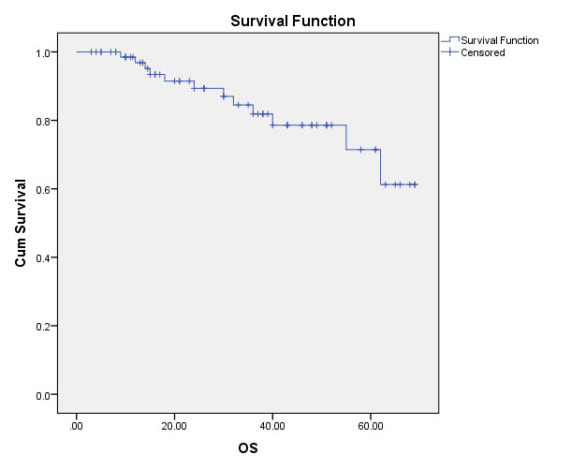 | 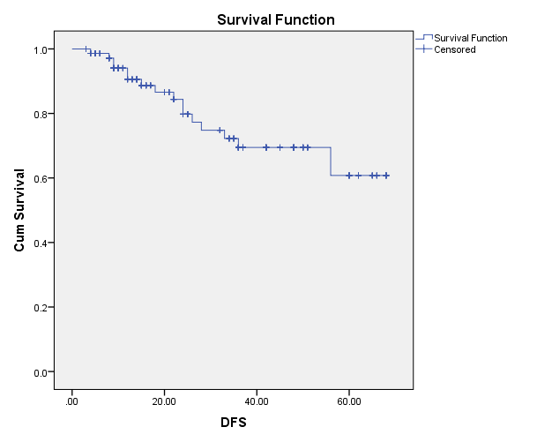
Figure 1: Overall survival curves for all patients. | Figure 2: Disease free survival curves for all patients.

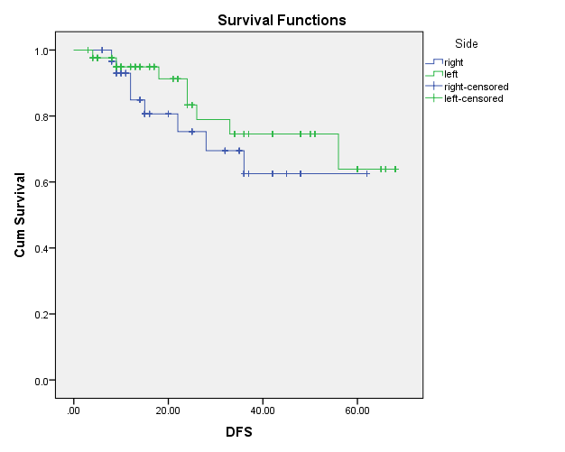 | 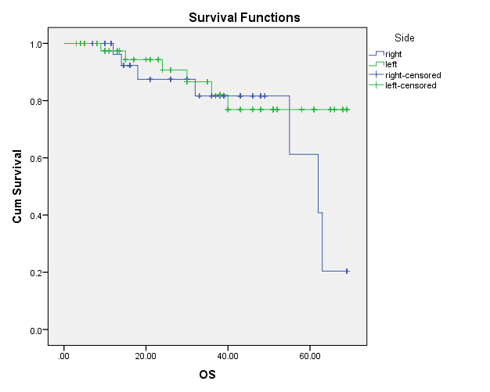
Figure 3: DFS curves for patients with right-sided and left-sided colon cancer. | Figure 4: OS curves for patients with right-sided and left-sided colon cancer.

Table 2: Univariate and multivariate analysis of prognostic indicators of OS for the 375 colon cancer patients
 | Univariate analysis |  |  | Multivariate analysis
 | HR | 95% CI | p | HR | 95% CI | p
Gender | 1.166 | 0.704-1.930 | 0.551 | 1.267 | 0.706-2.271 | 0.428
Side | .579 | 0.355-0.943 | 0.028 | 0.489 | 0.256-0.933 | 0.030
Histology | .963 | 0.632-1.468 | 0.862 | 0.632 | 0.366-1.092 | 0.100
grade | 2.443 | 1.421-4.201 | 0.001 | 1.511 | 0.826-2.765 | 0.181
stage | 2.284 | 1.550-3.363 | <0.001 | 1.736 | 1.015-2.970 | 0.044
LVI | .906 | 0.607-1.352 | 0.629 | 0.803 | 0.509-1.268 | 0.347
LNR | 4.347 | 2.166-8.726 | <0.001 | 5.753 | 1.527-21.682 | 0.010
LNs examined | 1.480 | 0.896-2.445 | 0.126 | 1.015 | 0.548-1.881 | 0.962

Table 3: Univariate and multivariate analysis of prognostic indicators of DFS for the 375 colon cancer patients
 | Univariate analysis |  |  | Multivariate analysis
 | HR | 95 % CI | p | HR | 95 % CI | p
Gender | 0.792 | 0.511-1.228 | 0.298 | 0.737 | 0.456-1.190 | 0.211
Side | 0.627 | 0.402-0.979 | 0.040 | 0.436 | 0.244-0.780 | 0.005
Histology | 1.139 | 0.793-1.636 | 0.482 | 0.722 | 0.474-1.098 | 0.127
grade | 1.340 | 0.802-2.240 | 0.264 | 0.922 | 0.528-1.610 | 0.775
stage | 2.893 | 2.018-4.148 | <0.001 | 2.048 | 1.316-3.187 | 0.001
LVI | 0.863 | 0.624-1.195 | 0.376 | 0.839 | 0.602-1.170 | 0.302
LNR | 4.261 | 2.321-7.820 | <0.001 | 3.694 | 1.280-10.664 | 0.016
LNs examined | 1.731 | 1.101-2.724 | 0.018 | 1.456 | 0.861-2.464 | 0.161

4. Discussion
Many studies investigated the prognosis of colon cancer in relation to the tumor location. There is ongoing debate and different conclusions of studies regarding the inferior survival of non-metastatic RCC than LCC[11, 12, 15]. Increasing numbers of researches demonstrated a poorer survival in RCC [11, 15]. Petrelli et al.[21] found that RCC was associated with a significant increase in the risk of death, which was independent of stage, race, year of study, number of participants, adjuvant chemotherapy, and quality of the studies included in the analysis through interrogating 1,437,846 patients from published available data.
In our study, we excluded the rectum from the definition of left sided tumors. Some studies excluded the rectum from the analysis of left sided tumors[15, 22-25] while others include it[3, 26, 27]. After analysis of the data of near 400 patients in our series, we found a difference in both clinicopathologic features and survival between RCC and LCC. In our study, RCC has significantly higher grade than LCC. This is consistent with several previous studies which concluded that tumors arising in right colon are poorly differentiated than left sided tumors[11, 28]. We investigated an increasing number of clinical and pathologic characteristics in our series and we assessed the LNR, that was proved to be an independent prognostic factor of survival in a large studies of colorectal cancer patients [19,24,29]. Patients with LCC have a lower value of LNR in our study. However, no statistically significant differences were found between RCC and LCC regarding patient age, size of the tumor, sex, lymph vascular invasion (LVI), or number of positive nodes.
The age at diagnosis was not different between patients with RCC and LCC. This is inconsistent with previous trials, which demonstrated a younger age at diagnosis for left sided colon cancer patients who underwent curative colectomy [14, 30].
After analysis of survival outcome in our trial, tumors arise in the right side showed significantly inferior overall and disease free survival than left sided tumors. The results of Cox regression analysis showed that gender, histological subtype, differentiation, LVI and the total number of the examined LNs did not have an impact on the DFS or OS rates, whereas right-sided tumor location, higher stage and an increasing positive lymph node ratio were significant negative predictors of the overall and disease free survival rates associated with high mortality rates.
Our results are consistent with the majority of the previous trials which have demonstrated that LCC would lead to a superior prognosis than RCC [8, 10-12, 28, 30]. However, Weiss et al and Kwaan et al. [13, 14]reported no significant OS difference between RCC and LCC.
In the study of Weiss et al. [13]a total of 53,801 patients with colon cancer were analyzed. The age of the patients was equal to or more than 65 years. They collected the data from the Surveillance, Epidemiology, and End Results (SEER) database (1992–2005). Weiss et al. [13]concluded that there was no 5-year OS difference between RCC and LCC after adjusting for multiple variables. Interestingly, a lower mortality was found in stage II RCC compared with patients with a LCC (HR: 0.92;95 % CI: 0.87–0.97, p=0.001), while stage III RCC was associated with a significant higher mortality than those with LCC (HR: 1.12; 95 % CI: 1.06 to1.18; p<0.001).
On the other hand, Warschkow et al. [15] reached to the opposite conclusion of our study, he demonstrated that localized RCC has superior prognosis than LCC. The clinic-pathological data for patients who underwent curative resection for localized stage I-III colon cancer were identified from the SEER-Medicare database from 2004 to 2012. Overall, 91,416 patients (51,937 [56.8 %] with RCC, 39,479 [43.2 %] with LCC) were included in final analysis. In univariate analysis, after matching of propensity score, the right sided colon cancer had superior prognosis regarding OS (HR: 0.92; 95 % CI: 0.89 − 0.94, p<0.001) and cancer-specific survival (CSS) (HR: 0.90; 95% CI: 0.87−0.93, p<0.001) than left sided tumors. The prognosis of RCC was better for OS and CSS in stage I and II. In stage III, the prognosis of both sides were similar.
The frequently asked question now is whether we should consider right and left sided colon cancer as two different tumors based on different clinicopathologic characteristics and survival and if they should be treated differently. Also, is tumor biology the only cause for the difference in prognosis between right and left colon cancer?
The blood supply and the embryological origin are different between both sides. The right colon arises from the midgut and the left colon develops from the hindgut. Moreover, these two embroyological origins are physiologically dissimilar [3, 31]. In our study, there is a trend towards an increase in mucinous adenocarcinoma histology (MAC) in RCC. It is an infrequent histopathological subtype of CRC. Previous studies have revealed that mucinous adenocarcinoma have aggressive clinical behavior; in a retrospective analysis of the data of more than five thousand patients, Hungen et al.[32] found a more frequent metastatic disease in tumors with MAC histology. In another studies, MAC was found to be an independent prognostic factor associated with worse survival in colorectal cancer [33, 34].
Regarding LNR, a considerable difference was observed between right and left sided tumors. The lymph node ratio has recently found to be an important prognostic factor in colon cancer, because a lower value of lymph node ratio was significantly associated with an improved overall and disease free survival [35]. This inconsistency leads to different outcomes. Consequently, different treatment should be administered for these two different entities.
Former studies have proposed that the molecular characteristics of the microsatellite stable phenotype was different in both sides of the colon[36]. Microsatellite instability (MSI) is a significant carcinogenesis mechanism of colorectal cancer. It prevails in approximately 12–18% in sporadic colon cancers [37].
Sinicrope and colleagues underwent a randomized study involving patients with stage III colon cancer who received adjuvant chemotherapy FOLFOX after curative resection.[38] they reported that MSI was significantly higher in patients with right sided tumors. Several trials have reported that MSI is associated with a superior outcome in patients with colon cancer[36, 39]. However, Shin et al. [37]reported that MSI is not an independent negative prognostic factor in stage colon cancer.
Our study has some limitations. At first, the number of eligible patients is small compared to the other studies which may affect the statistical significance of the different variables. Secondly, our study was a retrospective analysis of databases carried out at a single-center. Thirdly, the analysis for MSI protein expression was not done at our center due to high cost and so, we couldn't investigate the association between MSI and survival in relation to tumor location. Additional clinical studies are required to spot more light on the relationship between tumor side and prognosis in colon cancer.

Conflict of Interest
The authors declare no conflict of interest.

References
- Ferlay, J., et al., Cancer incidence and mortality worldwide: sources, methods and major patterns in GLOBOCAN 2012. International journal of cancer, 2015. 136(5): p. E359-E386.
- Siegel, R., K. Miller, and A. Jemal, Cancer statistics, 2018 CA: a cancer. J Clin 68: 7–30. 2018.
- Tejpar, S., et al., Prognostic and predictive relevance of primary tumor location in patients with RAS wild-type metastatic colorectal cancer: retrospective analyses of the CRYSTAL and FIRE-3 trials. JAMA oncology, 2017. 3(2): p. 194-201.
- Guinney, J., et al., The consensus molecular subtypes of colorectal cancer. Nature medicine, 2015. 21(11): p. 1350.
- La Pointe, L.C., et al., Map of differential transcript expression in the normal human large intestine. Physiological genomics, 2008. 33(1): p. 50-64.
- Missiaglia, E., et al., Distal and proximal colon cancers differ in terms of molecular, pathological, and clinical features. Annals of oncology, 2014. 25(10): p. 1995-2001.
- Dienstmann, R., et al., Colorectal Cancer Subtyping Consortium (CRCSC) identification of a consensus of molecular subtypes. 2014, American Society of Clinical Oncology.
- Christodoulidis, G., et al., Clinicopathological differences between right-and left-sided colonic tumors and impact upon survival. Techniques in coloproctology, 2010. 14(1): p. 45-47.
- Komuro, K., et al., Right-and left-sided colorectal cancers display distinct expression profiles and the anatomical stratification allows a high accuracy prediction of lymph node metastasis. Journal of Surgical Research, 2005. 124(2): p. 216-224.
- Masoomi, H., et al., Outcomes of right vs. left colectomy for colon cancer. Journal of Gastrointestinal Surgery, 2011. 15(11): p. 2023.
- Meguid, R.A., et al., Is there a difference in survival between right-versus left-sided colon cancers? Annals of surgical oncology, 2008. 15(9): p. 2388.
- Suttie, S., et al., Outcome of right‐and left‐sided colonic and rectal cancer following surgical resection. Colorectal Disease, 2011. 13(8): p. 884-889.
- Weiss, J.M., et al., Mortality by stage for right-versus left-sided colon cancer: analysis of surveillance, epidemiology, and end results–Medicare data. Journal of Clinical Oncology, 2011. 29(33): p. 4401.
- Kwaan, M.R., et al., Are right-sided colectomy outcomes different from left-sided colectomy outcomes?: study of patients with colon cancer in the ACS NSQIP database. JAMA surgery, 2013. 148(6): p. 504-510.
- Warschkow, R., et al., Better survival in right-sided versus left-sided stage I-III colon cancer patients. BMC cancer, 2016. 16(1): p. 554.
- Arnold, D., et al., Prognostic and predictive value of primary tumour side in patients with RAS wild-type metastatic colorectal cancer treated with chemotherapy and EGFR directed antibodies in six randomized trials. Annals of oncology, 2017. 28(8): p. 1713-1729.
- Benedix, F., et al., Colon carcinoma–Classification into right and left sided cancer or according to colonic subsite?–Analysis of 29 568 patients. European Journal of Surgical Oncology (EJSO), 2011. 37(2): p. 134-139.
- Yahagi, M., et al., The worse prognosis of right-sided compared with left-sided colon cancers: a systematic review and meta-analysis. Journal of Gastrointestinal Surgery, 2016. 20(3): p. 648-655.
- Garcia, B., et al., Trends in lymph node excision and impact of positive lymph node ratio in patients with colectomy for primary colon adenocarcinoma: population based study 1988 to 2011. Surgical oncology, 2016. 25(3): p. 158-163.
- Edge, S.B. and C.C. Compton, The American Joint Committee on Cancer: the 7th edition of the AJCC cancer staging manual and the future of TNM. Annals of surgical oncology, 2010. 17(6): p. 1471-1474.
- Petrelli, F., et al., Prognostic survival associated with left-sided vs right-sided colon cancer: a systematic review and meta-analysis. JAMA oncology, 2017. 3(2): p. 211-219.
- Hu, W., et al., Multi-omics approach reveals distinct differences in left-and right-sided colon cancer. Molecular Cancer Research, 2018. 16(3): p. 476-485.
- Wang, Y., et al., Disparities in survival for right-sided vs. left-sided colon cancers in young patients: a study based on the Surveillance, Epidemiology, and End Results database (1990–2014). Cancer management and research, 2018. 10: p. 1735.
- Zhong, M.-E., et al., Comparison of clinicopathologic features and survival between patients with right-sided and left-sided stage III colon cancer. Translational Cancer Research, 2017. 6(1): p. 254-260.
- Ishihara, S., et al., Impact of primary tumor location on postoperative recurrence and subsequent prognosis in nonmetastatic colon cancers: a multicenter retrospective study using a propensity score analysis. Annals of surgery, 2018. 267(5): p. 917-921.
- Loupakis, F., et al., Primary tumor location as a prognostic factor in metastatic colorectal cancer. JNCI: Journal of the National Cancer Institute, 2015. 107(3).
- Taieb, J., et al., Association of prognostic value of primary tumor location in stage III colon cancer with RAS and BRAF mutational status. JAMA oncology, 2018. 4(7): p. e173695-e173695.
- Huang, C.-W., et al., Different clinicopathologic features and favorable outcomes of patients with stage III left-sided colon cancer. World journal of surgical oncology, 2015. 13(1): p. 257.
- Amri, R., et al., The prognostic value of lymph node ratio in colon cancer is independent of resection length. The American Journal of Surgery, 2016. 212(2): p. 251-257.
- Benedix, F., et al., Comparison of 17,641 patients with right-and left-sided colon cancer: differences in epidemiology, perioperative course, histology, and survival. Diseases of the Colon & Rectum, 2010. 53(1): p. 57-64.
- Van der Post, S. and G.C. Hansson, Membrane protein profiling of human colon reveals distinct regional differences. Molecular & Cellular Proteomics, 2014: p. mcp. M114. 040204.
- Hugen, N., et al., Metastatic pattern in colorectal cancer is strongly influenced by histological subtype. Annals of oncology, 2014. 25(3): p. 651-657.
- Park, J.S., et al., Prognostic comparison between mucinous and nonmucinous adenocarcinoma in colorectal cancer. Medicine, 2015. 94(15).
- Nitsche, U., et al., Prognosis of mucinous and signet-ring cell colorectal cancer in a population-based cohort. Journal of cancer research and clinical oncology, 2016. 142(11): p. 2357-2366.
- Zhang, M.-R., et al., Prognostic role of the lymph node ratio in node positive colorectal cancer: a meta-analysis. Oncotarget, 2016. 7(45): p. 72898.
- Takahashi, Y., et al., Molecular differences in the microsatellite stable phenotype between left‐sided and right‐sided colorectal cancer. International journal of cancer, 2016. 139(11): p. 2493-2501.
- Shin, U.S., et al., Is microsatellite instability really a good prognostic factor of colorectal cancer? Annals of coloproctology, 2014. 30(1): p. 28-34.
- Sinicrope, F.A., et al., Prognostic impact of deficient DNA mismatch repair in patients with stage III colon cancer from a randomized trial of FOLFOX-based adjuvant chemotherapy. Journal of Clinical Oncology, 2013. 31(29): p. 3664.
- Popat, S., R. Hubner, and R. Houlston, Systematic review of microsatellite instability and colorectal cancer prognosis. Journal of clinical oncology, 2005. 23(3): p. 609-618.

12/25/2018

