Impacts of Climate Change on Fishes and Aquatic Organisms

Prof. Dr. Mona S. Zaki

Hydrobiology Department, National Research Center, Dokki, Giza, Egypt
drmonazaki@yahoo.com

Abstract: The world has seen an unprecedented rise in global temperature, and the number of those concerned is more than ever, and the coming years may have more global action to confront a phenomenon that threatens everyone, and we in Egypt should take care of this phenomenon As our coastal and low-lying, and our shores on the Mediterranean and Red Bahrain. And the thermal decline affects us in the medium and long term. There are threats of erosion of the beaches and up to the threat of delta, and we receive the Nile from its African sources and our sources of water threatened by drought in the case of climate change and global warming, which means more desertification. Hence we need Has led to a real revolution in the management of our high-value water resources in a densely populated country, which is blinded or seen in many ways, threatening us with great risks.
[Mona S. Zaki. Impacts of Climate Change on Fishes and Aquatic Organisms. Cancer Biology 2018;8(4):71-74]. ISSN: 2150-1041 (print); ISSN: 2150-105X (online). http://www.cancerbio.net. 9. doi:10.7537/marscbj080418.09.

Keywords：Impact; Climate; Change; Fishes; Aquatic; Organism

Introduction

Coral Reefs

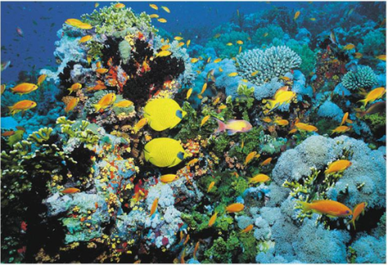

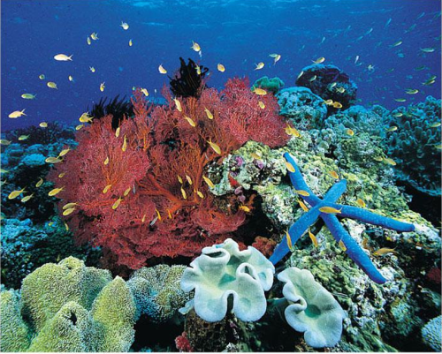

- Altered biochemical conditions: protein, lipid, nucleic acids and hormonal activities.
- Loss of habitat
- Increase in disease (Pathogens and parasite).
- Growth rates have slowed or stopped .
- Slow maturation
- Low fecundity
- Sex ratio or mode (asexuality, hermaphrodism) can change.
- Altered distributions of species, including phytoplankton, zooplankton (migration, mortality and breeding).
- Increases in direct mortality as a result of thermal stress, especially salmonids and freshwater mollusks.
- Increases in primary productivity that will alter the species composition of plants and animals.
- Food web disruptions: breakdown of certain parts of the phytoplankton-zooplankton food web.
- There are very severe effects on some sensitive systems e.g. coral reefs and these will also affect fish.
- Reefs around the world are being destroyed.
- Loss of coral reefs in the Red Sea to the distinctive colours and turned into a white colour.
The climate change impacts.

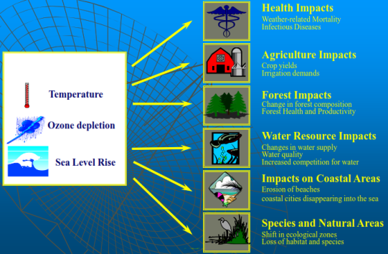
Pathological effect of heavy metals
- Circulatory changes: Copper cadmium Hg and Ld.
- Degenerative changes: Ld, Cd, Hg.
- Inflammatory reaction: Al, Cr, Vn.
- Necrosis: Hg, Cd, Ld, Vn.
- Carcinogenesis: Cr, Vn, Hg.
Cancer in fish due to global warm.
Genetic toxicology exists because of the concern that environmental agents can cause genetic damage.
This genetic damage may be manifested both in germ cells and in somatic cells.
An increase in mutational events in germ cells will lead to an increase in the incidence of inherited disease and disability in future generations.
In somatic cells, mutations play an important role in cancer.
Fish tumors from toxic chemicals.

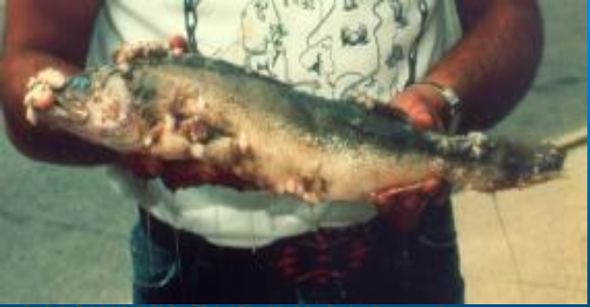
Oral papilloma

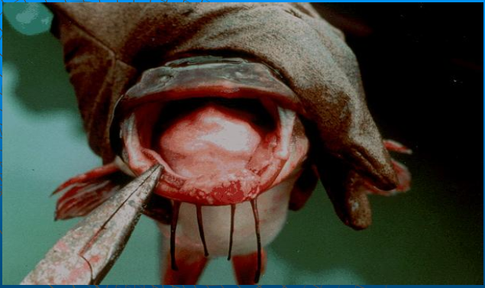
Oral Tumors

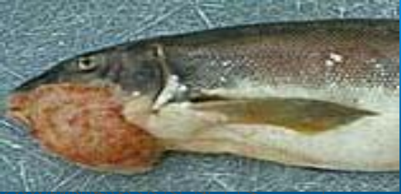
Hepatocellular Tumor
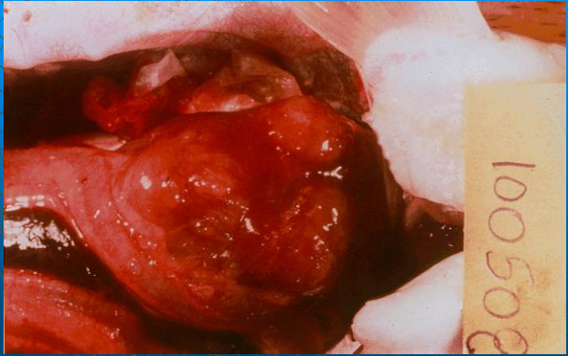
Granulomas on the Liver

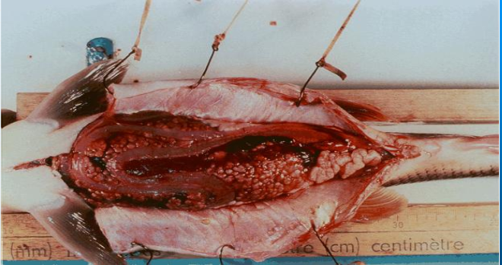
Multiple granulomas in the liver

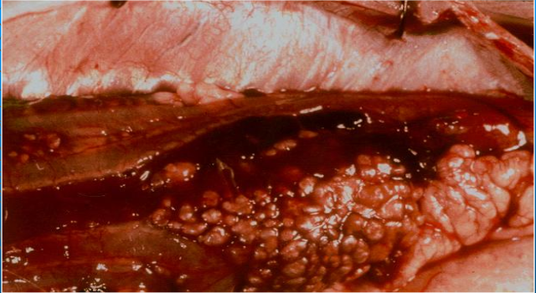
Melanoma on brown bullhead

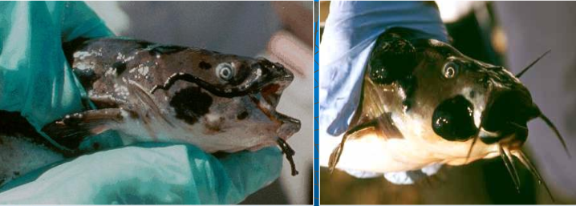
Epidermal hyperplasia and squamous cell carcinoma

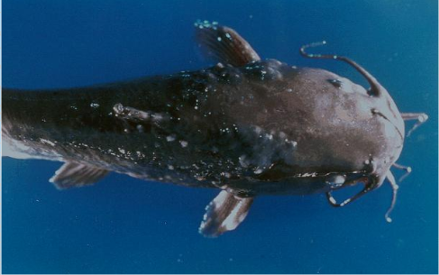
A fibroma on a white sucker
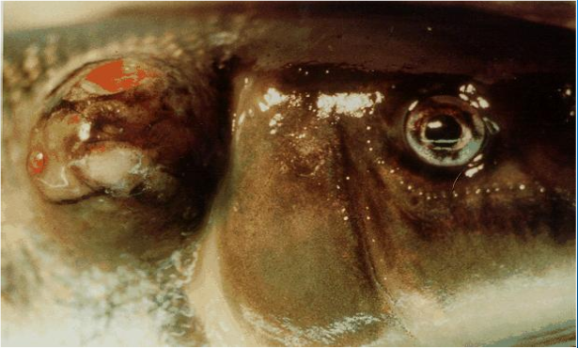
Dermal Ossifying Fibroma

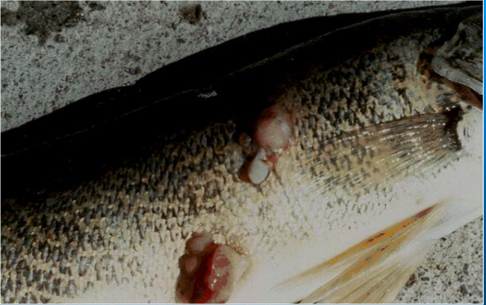
Dermal neoplasms in freshwater drum

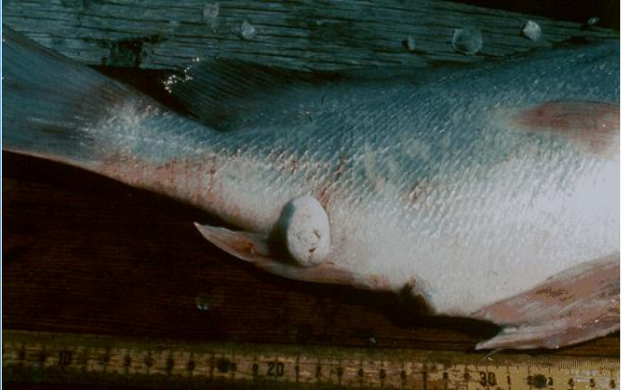
Dermal Neoplasm

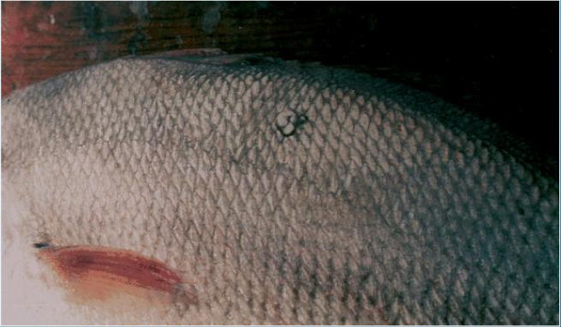
Dermal Neoplasm
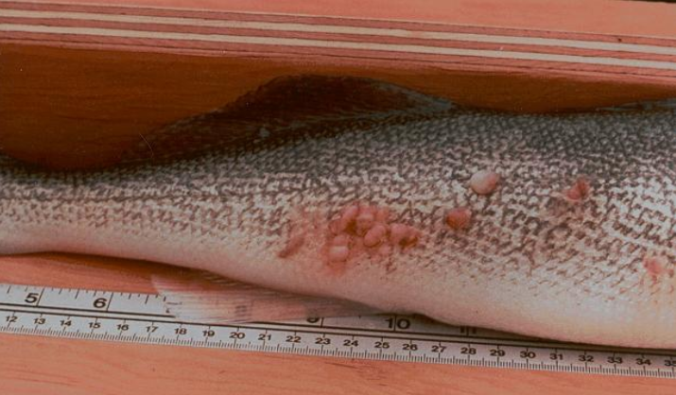
Gonadal Neoplasm

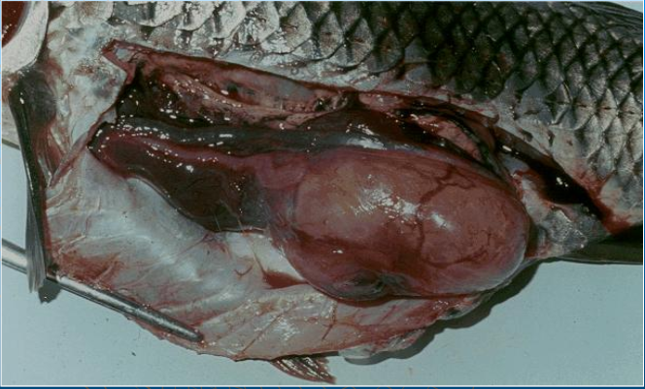
Testicular tumors

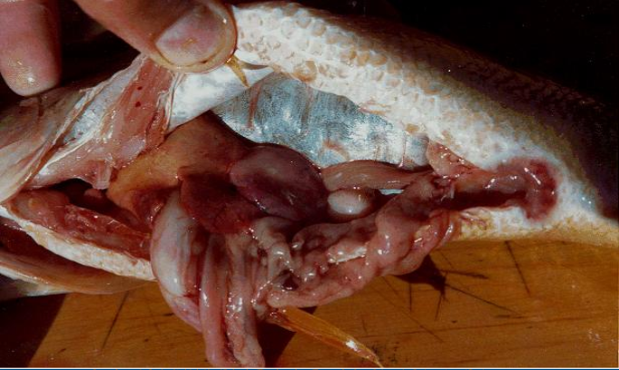
Thyroid Hyperplasia

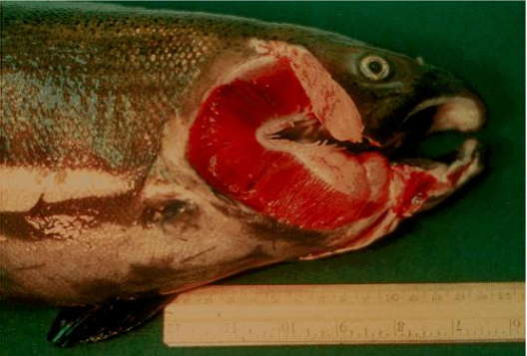
Operculum tumors
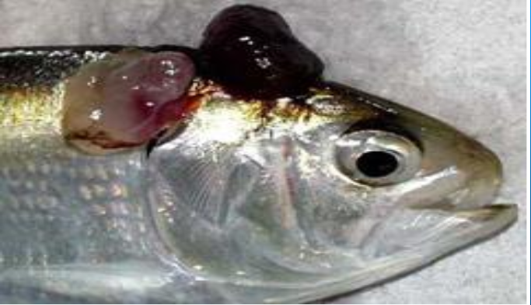
Lymphosarcoma

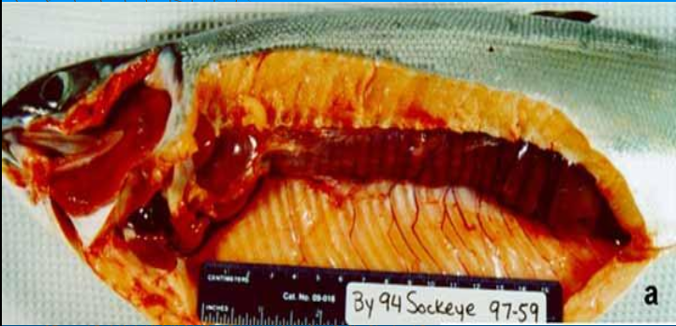
Lymphocystis

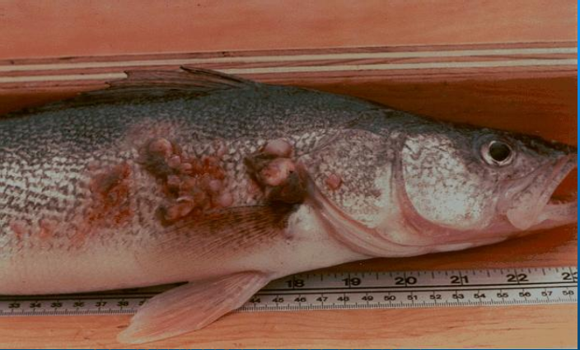
Lymphocystis
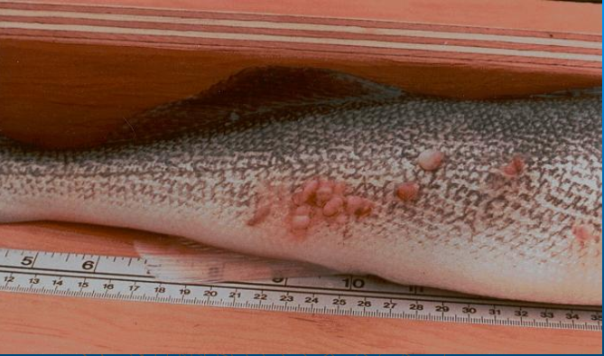

References
- Gad, S.C. and C.S., Weil, 1986. Statistics for Toxicologists. In Hayes. A. W. 2nd.
- Matsubara, A., S. Mihara, and R., Kusuda, 1985. Bull Japan Sac, Sic. Fish. 51m 921.
- Nomiyama, K., 1988. "Bacteriological Test Book ". Vol. 2 pp. 15-23. Pergamon.
- O'Neill, J.G., 1981. Bull. Env. Contam. Toxico!., 27: 42-48.
- Reitman, S.,and S. A., Frankel, 1957. Am. J. Clin. Pathol. 28, 56.
- Stephen, W.I. 2004. Zinc, cadmium, mercury and lead. Stephen, W.I. Ed.; Blackwell Scientific Publications.
- Stostiof, M.K. 1993. "Fish Medicine" W.B. Saunders Company, Philadelphia, Lonion, Toronto, Montreal, Sydney, Tokyo (1993). 23 Trinder, P., 1960. Ann. CUn Brioche. 6,24.
- Vinodhini, R., and M. Narayanan, 2008. Bioaccumulation of heavy metals in organs of fresh water fish Cyprinus carpio (Common Carp). Int. J. Environ. Sci. Tech., 5 (2):179-182.
- Vosyliene, M. Z. and A. Jankaite, 2006. Effect of heavy metal model mixture on rainbow trout biological parameters. Ekologija., 4:12-17.
- Zaki, M.S., and A.H. Osman, 2003. Clinicopathological and pathological studies on Tilapia nilotica exposed to cadmium chloride (0.25 ppm) Bull. NRC, Egypt., 28 (1): 87-100.
- Carleton H., "Carleton's; Histopathological Technique" 4th Ed. London, Oxford University, Press, New York, Toronto. (1979).
- Balah, A.M., El-Bouhy, Z.M. and Easa, M.E.I.S., Histopathlogical studies in the gills of Tilipia nilotica "Oreochromis niloticus" under the effect of some heavy metals. Zagazig Vet. J., Vol. 21, No. 3 pp 351-364. (1993).
- Randi, A.S., Monserrat J. M., Rodrigue E. M and Romano L. A., J. of fish diseases 19, 311 (1996).
- Pascoe, D., Evans, S. A. and Woodworth, J., Arch. Env. Contam. Toxicol., 15:481. (1986).
- Stostiof, M.K. "Fish Medicine". W.B Saunders Company, Philadelphia, London, Toronto, Montreal, Sydney, Tokyo (1993).

12/25/2018

