Reactive Bone Lesions in Postchemotherapy Pediatric Bone Tumor Specimens: Implications on Surgical Planning by Preoperative MRI

Iman Gouda¹, Iman Zaki², Ahmed El Ghoneimy³^{,4}, Magdy El Sherbiny³, Ranin Soliman⁵, Manal Zamzam^{6,7}

¹Department of Pathology, Children’s Cancer Hospital 57357- Egypt (CCHE); ²Department of Radiology, CCHE; ³Division of Orthopedic Oncology, CCHE;⁴ Department of Surgery, Kasr Elainy, Cairo University, Egypt; ⁵Department of Health Economics & Value, CCHE; ⁶Department of Pediatric Oncology; CCHE, ⁷Department of Pediatric Oncology, National Cancer Institute, Cairo University, Egypt. manal.zamzam@gmail.com

Abstract: Background: Therapy-associated changes in the specimens of bone tumor comprise alterations in the size of tumor and reactive changes liked with tumor necrosis in addition to bone marrow changes and periosteal effect. Aim: This work was aimed to assess the precise of pre-operative MRI images in estimating the degree of local cancer before operation in patients having high-grade osteosarcoma (OS) and Ewing sarcoma (ES) post neo-adjuvant chemotherapy. Patients and Methods: We conducted a prospective study from January 2009 till January 2011 on 75 children patients admitted at the Children Cancer Hospital Egypt diagnosed as malignant cancers in long bones; 56 High- grade OS and 19 ES were administered neo-adjuvant chemotherapy and definitive operation. The precision of the intra-osseous degree of the cancer as measured by pre-operative MRI were compared with traditional gross and histopathological methods of the biopsy samples. Variation in intra-osseous tumor extent measurements between MRI and pathology specimen of more than 1 cm was determined as inconsistency. Results: The degree of intra-osseous cancer was distinct precisely by preoperative MRI in 50 (89%) OS patients and in 15 (78%) ES patients. The average overestimation among traditional histopathological technique and MRI extents was 3.2 cm (median=2.5) in OS, while it averaged 2 cm (median=2.5) in ES. The correlation coefficient among maximum tumor size measurement estimated by pre-operative MRI and by histopathology was 0.967 and 0.973 (p< 0.001) in OS and ES, respectively. Erroneous in dimensions from MRI were caused by periosteal reactive changes, bone marrow alterations such as false positive epiphyseal infiltration and focal infarction or edema. Conclusion: Preoperative assessment of extent of cancer using MRI is a dependable tool to evaluate the local extent of bone cancers in children. The obtained data are valuable in scheduling surgical limb rescue processes and stress the incompetence of reactive alterations in bone biopsy samples on preoperative radiological assessment of cancer extent.

[Iman Gouda, Iman Zaki, Ahmed El Ghoneimy, Magdy El Sherbiny, Ranin Soliman, Manal Zamzam. Reactive Bone Lesions in Postchemotherapy Pediatric Bone Tumor Specimens: Implications on Surgical Planning by Preoperative MRI. Cancer Biology 2018;8(4):32-39]. ISSN: 2150-1041 (print); ISSN: 2150-105X (online). http://www.cancerbio.net. 4. doi:10.7537/marscbj080418.04.

Keywords: Reactive; Bone Lesion; Postchemotherapy Pediatric Bone; Tumor Specimen; Surgical Planning; Preoperative MRI

1. Introduction:
The objective from parenteral multi-agent neo-adjuvant chemotherapy is the elimination of prospective micrometastases and at declining in size of the primary tumor with enhanced tumor differentiation to get better surgical situations [1-2]. Significant challenges are encountered in post-therapy bone tumor specimens, particularly when there are reactive alterations liked with cancer necrosis, changes in tumor volume and marrow changes as well as periosteal reaction [3].
Accurate pre-operative local staging of bone sarcomas is best performed by MRI. 8 Where, MRI is principally important in calculating the longitudinal intraosseous degree of the cancer, and its association with muscle compartments, the physis, neurovascular bundles and joint [1,4,5]. In a study carried by Pan et al. by using the MR imaging of osteosarcoma patients pretreated with chemotherapy before the operation and showed an improvement in the recovery and remarkable reduction in the soft tissue edema around the tumor and edema within the intramedullary space post chemotherapy [6]. At demonstration, if a sarcoma is bounded by edema in bone marrow, it may be hard to create its original edges. It is of interest to contrast the preliminary MRI imaging with that after chemotherapy to permitting more accurate surgical management as the inflammatory reaction which may be diminished [7].
At present, post treatment specimens of both osteosarcoma and EWS/PNET are examined according to similar standardized approaches. The gross features of treated osseous EWS/PNET may pointed to mostly reparative structures, comprising hemorrhage, bony widening and sclerosis, cystic degeneration and necrosis, with no macroscopically observable residual [8]. Sites of predilection of feasible tumor in Ewing’s sarcomas include the soft tissues, the intramedullary compartment and the subperiosteal area. Isolated, rapidly enhancing, solid viable tumor nodules of at least 3-5 mm² could be detected. While in classic osteosarcomas, areas of residual viable tumor are predominantly found in the soft tissues, in the cortex and endosteal surface, near ligaments, and in zones adjacent to articular cartilage and lacunae [9].
The evaluation of changes between pre-chemotherapy and post-chemotherapy MRIs has been universally used by surgeons to plan local control resections [10-11]. The MRI imaging, especially after initial chemotherapy, is very important for planning and decisions for the patient’s definitive local treatment [4-5]. The current investigation aimed to evaluate the precision of pre-operative MRI scan in calculating the extent of local tumor before operation insubjects with high-grade osteosarcoma and Ewings sarcoma pretreated with neo-adjuvant chemotherapy.

2. Patients and Methods
We conducted a prospective study from January 2009 till January 2011. A total number of 75 pediatric patients presented at the Children Cancer Hospital Egypt with malignant tumors in long bones; High-grade osteosarcoma (n=56) and Ewing sarcoma (n=19) patients treated with neo-adjuvant chemotherapy and definitive surgery were analyzed.
In Osteosarcoma patients, the protocol consisted of 18 cycles of standard MAP chemotherapy over 29 weeks. Pre-operatively, chemotherapy comprised 2 cycles of cisplatin (60 mg/m² day 1 & 2 over 6-h continuous infusion) and doxorubicin (37.5 mg/m² day 1 & 2 in a 4-h continuous infusion) given at weeks 1 and 6, and 4 cycles of high-dose methotraxate (MTX) at weeks 4, 5, 9 & 10 in a 4-h infusion at a dose of 12 g/m² with Leucovorin rescue (15 mg every 6 h, for 11 cycles), guided by MTX serum level). Hydration during and after MTX infusion followed the standard guidelines. Patients underwent surgery at week 11. Postoperative chemotherapy was given as 8 cycles of high-dose MTX as described above, 2 cycles of cisplatin/doxorubicin, and 2 cycles of doxorubicin.
In Ewing sarcoma, our treatment protocol was adopted from POG #9354/CCG #7942 – Regimen.
A. All patients received vincristine, cyclophosphamide, and doxorubicin alternating with ifosfamide and etoposide for 48 weeks. The neo-adjuvant chemotherapy was administered as 3 cycles of VDC: Vincristine (1.5mg/m² IV push), Doxorubicin (37.5 mg/m² over 4 hours, days 1 and 2) and Cyclophosphamide (1.2 gm/m² over 30 minute) at weeks 0, 6 and 12, alternating with 2 cycles of IE: Ifosfamide (1.8 gm/ m² over 12 hours for 5 days) and Etoposide (100 mg/ m² /day over 1 hour for 5 days)] at weeks 3 and 9. Then definitive surgery for primary tumors was performed within 3 weeks following the completion of preoperative chemotherapy. Post- operatively, patients continued the same regimen of chemotherapy for another 12 cycles.

MRI assessment
All pre-operative MRI examinations were performed on a 1.5-Tesla superconductive Magnetic Resonance MR system (Magnetom Espree equipped with Syngo MR B17 software; Siemens Healthcare, Erlangen, Germany), with high-gradient performance (amplitude 40 mT/m; slow rate, 170 [mT.m⁻¹]/ms). A combination of sagittal T1, sagittal STIR, coronal T1, coronal STIR and axial T1sequences was used in all patients. Contrast injection of 0.1 mmol/Kg body weight of Gadolinium was followed by a saline flush. Post-contrast series include sagittal, axial and coronal T1. During the assessment of them edullary extent of the tumor, only sagittal & coronalpost-contrast images were evaluated. Patients were positioned supine and head first in the magnet zone. MR protocol consisted of: first Coronal T1 spine echo-weighted images obtained with the following parameters: TR/TE 490/11 matrix 192x256, and FOV 320x320 mm, section thickness 4 mm. Second, Coronal T2 weight margins with short time inversion recovery STIR sequence obtained with the following parameter 7020/87 inversion time, 150 ms; echo train length, 15, matrix 192x256, FOV 320x320 mm section thickness 4 mm. We compared the accuracy of the intra-osseous extent of the tumor as measured by pre-operative MRI, with the actual extent of the tumor as assessed by gross and microscopic examination of the resected specimens.

Pathological assessment
The specimens were dissected along coronal plane and the maximal distance from the articular surface to the gross margin was measured. Slabs of 5-to 10-mm thickness were cut along the largest tumor diameter in the resected bone tumor specimen, based on anatomic reference points on the MR images. The slice that corresponded best with the section of the MR study was selected for correlation. Paraffin-embedded sections were microscopically examined from medullary tissue at the upper and lower limits of the tumor to determine the histological extent of the tumor. Difference in intraosseous tumor extent measurements between MRI and pathology specimen of more than 1 cm was considered as discrepancy. Intraoperative marrow margin evaluation was done as a routine in all cases to rule out occult intramedullary tumor extension followed by definite assessment of paraffin embedded sections of the margins previously evaluated intra-operatively.
Statistical analysis
Categorical data were described using frequencies and percentages, and continuous data were described using mean, median and range. Statistical analysis was conducted using SPSS version 20.0 (IBM Corp. Released 2011. IBM SPSS Statistics for Windows, Version 20.0. Armonk, NY: IBM Corp.). Correlation between two continuous variables was done using Pearson’s Correlation test depending on Pearson’s Correlation coefficient (r²) to measure the strength of the association between the two variables. Fischer’s exact test was used to examine independence between categorical variables. Results were considered significant if p-value was less than 0.05. All tests were two-tailed.

3. Results
The current study comprised 75 pediatric patients admitted at the Children Cancer Hospital Egypt complained from malignant tumors in long bones; High-grade osteosarcoma (n=56, 29 were males and 27 females, male to female ratio = 1:1.2) and Ewing sarcoma (n=19, 11 were males and 8 females, female to male ratio = 1:1.4). Median age was 12 years (Range: 4 to 18 years). The location of the primary bone tumors were the femur in 44 patients, tibia in 14, Fibula in 9, humerus in 4, radius in 3, and ulna in 1 patient (Table 1).

Table [1]: Patient and Tumor characteristics
 | Osteosarcoma (n=56) | Ewings Sarcoma (n=19)
Gender  - Male  - Female | n=29(52%)  n=27(48%) | n=11 (58%)  n=8 (42%)
Age (years)  - Median  - Range | 13 years  8 - 18 years | 12 years  4 – 18 years
Primary Tumor Site:  - Femur:  - Tibia:  - Fibula:  - Humerus:  - Radius:  - Ulna: | n=34(61%)  n=14(25%)  n=5 (9%)  n=2 (4%)  n=1 (1%)  --- | n=10 (50%)  --- n=4(21%)  n=2(12%)  n=2(12%)  n=1 (5%)
Extent of Disease  - Localized  - Metastatic | n=37(66%)  n=19(34%) | n=4 (21%)  n=15 (79%)
Type of Surgery  - LSS  - Amputation  - Rotationplasty | n=39(70%)  n=13(23%)  n=4 (7%) | n= 17 (96%)  n=1 (2%)  n=1 (2%)
Histological Response:  - Goodresponse  - Poorresponse  - N/A | n=21(38%)  n=33(59%)  n=2 (3%) | n=14 (74%)  n=5 (26%)

In Osteosarcoma (n=56), response to pre-operative chemotherapy was as follows: SD in 30 patients, PR in 16 patients, and PD in 10 patients. Limb Salvage surgery was performed in 39 patients; reconsrtuction was either as metallic prosthesis (n=24), vascularized fibular graft (n=12), or fibulectomy (n=3). Amputation was done in 13 patients, and rotation plasty in 4 patients. Patients’ outcomes were as follows: 3 patients had local relapse, and 21 patients died out of disease. In Ewing sarcoma (n=19), response to pre-operative chemotherapy was as follows: SD in 2 patients, PR in 16 patients, and PD in 1 patients. Limb Salvage surgery was performed in 17 patients; reconsrtuction was either as metallic prosthesis (n=3), vascularized fibular graft (n=8), or fibulectomy (n=4). Tumor resection was done in 2 patients, amputation in 1 patient, and rotationplasty in 1 patient. Patients’ outcomes were as follows: only 1 patient had local relapse, and 7 patients died of disease.
The precision of preoperative MRI in diagnosis of intra-osseous cancer was well-defined in 50 (89%) patients with osteosarcoma and 15 (78%) patients with Ewings sarcoma. Inaccurate MRI assessments led to overestimation in 6 cases of OS and 4 cases of ES.

Table [2]: The distribution of changes leading to inaccurate preoperative MRI measurement in Osteosarcoma and Ewing Sarcoma
 | Periosteal  New Bone | Bone Marrow  Edema | Bone Infarcts | False Epiphyseal  infiltration | Other
Osteosarcoma | n=2 | n=1 | n=1 | n=2 | ---
Ewing Sarcoma | n=1 | n=1 | n=1 | --- | n=1

Periosteal New Bone
In two osteosarcomas and one Ewing’s sarcoma, periosteal new bone deposition was found in the bone considerably outside the edges of the tumor and related to uninvaded parts of the bone. The reactive bone was mostly woven, with focal remodeling to lamellar bone. In the 2 osteosarcoma patients, the overestimation was 6 cm and 2.5 cm while the overestimation in the Ewing’s sarcoma case was 2 cm.

Bone Marrow Edema
In two patients, bone marrow edema overestimated the extent of the tumor. In the osteosarcoma patient, the overestimation was 2 cm while in the Ewing’s sarcoma patient, the overestimation was 2.5 cm. In both patients, no tumor tissue was found within the area with abnormal intramedullary signals by MRI. The marrow adjacent to the tumor typically showed an edematous appearance with limited numbers of hematopoietic cells. Large dilated blood vessels were present in the osteosarcomacase.

Bone Infarcts
Necrotic and degenerative changes caused overestimation of the tumor extent by MRI in one osteosarcoma patient (overestimation by 5 cm) and one Ewing sarcoma patient (overestimation by 2 cm). There was loss of osteocyte nuclei from lacunae. In the osteosarcoma case, reparative well-vascularized fibrous tissue extended into marrow spaces inside the bone infarct with associated hyperplasia of stromal osteoprogenitor cells, differentiating into osteoblasts and laying downosteoid.

False MRI impression of Epiphyseal infiltration
Two osteosarcoma cases showed overestimated tumor extent by MRI. Histological sections in the first (overestimation by 3 cm) demonstrated diffuse areas of bone marrow proliferation as the cause of the abnormal signal change. Epiphyseal skip lesion rather than direct infiltration as noted by MRI was the cause of overestimation of tumor extent in the other case.

Other
Histopathological examination of one case of Ewing sarcoma with overestimation of tumor extent by 2 cm revealed bone deformity as a consequence of pathological fracture.

Relation to Tumor Type
The average definitive estimation among traditional histopathology and MRI parameters in Osteosarcomas was 3.2 (median = 2.5). While, in Ewings sarcoma, the mean estimation by MRI was 2 cm (median = 2.5). In osteosarcoma, the correlation coefficient between maximum radiological size estimated by pre-operative MRI and by pathological method was 0.967 (p< 0.001). Whereas, in Ewing's sarcoma, the correlation coefficient among maximum radiological size and pathological method was 0.973 (p< 0.001). There was no relation between accuracy of MRI measurement and tumor type (Fig. 1 and Fig. 2). On correlating the tumor type (Osteosarcoma or Ewings Sarcoma) with groups of patients who showed or did not show discrepancy between pathologic and radiological measurements, no correlation was found (p- value=0.268).

Relation to Tumor Histologic Response
Furthermore, on correlating histologic response to neo-adjuvant chemotherapy (Good responders who show tumor necrosis >90%, and poor responders who tumor necrosis <90%) with groups of patients who showed or did not show discrepancy between pathologic and radiological measurements, no correlation was found (p-value =0.175). No relation was detected between histologic response and accuracy of MRI measurement.

Value of Intraoperative Frozen Section Examination
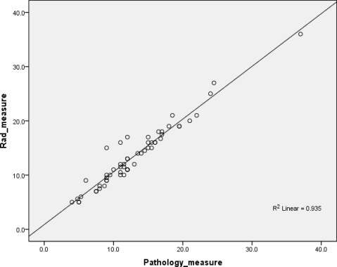
Fig. 1: Pearson’s correlation coefficient (r²= 0.935) showing positive correlation between MRI and pathologic measurements in the studied Osteosarcoma cases (n=56).

Bone margins ranged from 1 cm to 6.5 cm in resected specimens with an average of 3 cm. Only 3 cases had positive bone marrow margins in definite pathologic assessment of the specimens. In these 3 cases, intraoperative frozen section examination of the margins was not done. Two of the 3 cases were osteosarcomas where the aim of the surgery was palliative fibular resection in one while the other showed trans-articular skip metastasis in the tibia with positive margin. The third case was a Ewing sarcoma in the femur with complete histologic response and markedly thickened cortex with poor delineation of the margins of the tumor but no evidence of viable tumor cells. Margins estimated by intraoperative assessment were concordant with definite pathologic assessment in allcases.

Illustration of Cases
Case1: A case of Osteosarcoma show Inga small area of hyperemiadistal to the tumor [Figure (3.A)], proved to be bone marrow oedema [Figure (3.B)] by pathology examination.
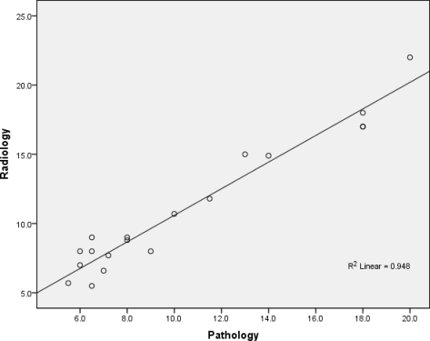
Fig. 2: Pearson’s correlation coefficient (r²= 0.948) showing positive correlation between MRI and pathologic measurements in the studied Ewing sarcoma cases (n=19).

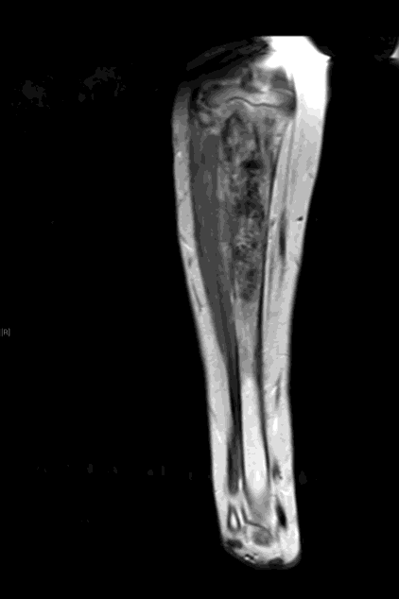 | 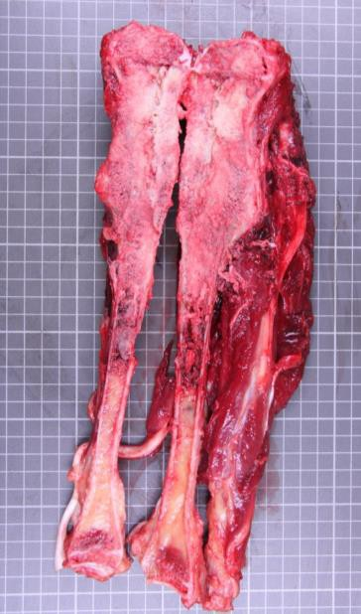
Figure (3.A) | Figure (3.B)

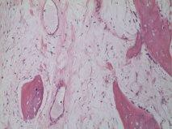
Figure (3.C) Medullary cavity showing edema with dilated blood vessels, Hematoxylin and Eosin (x100)

Case2: A case of Ewing’s Sarcoma showing thickened cortex with proximal periosteal elevation which is more evident in pathology (Figure4.B) and not note din MRI (Figure 4. A).

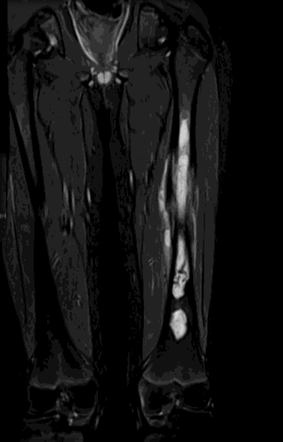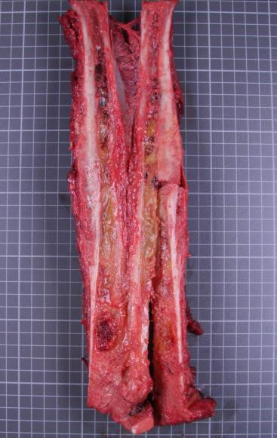

Figure (4.A) Figure (4.B)
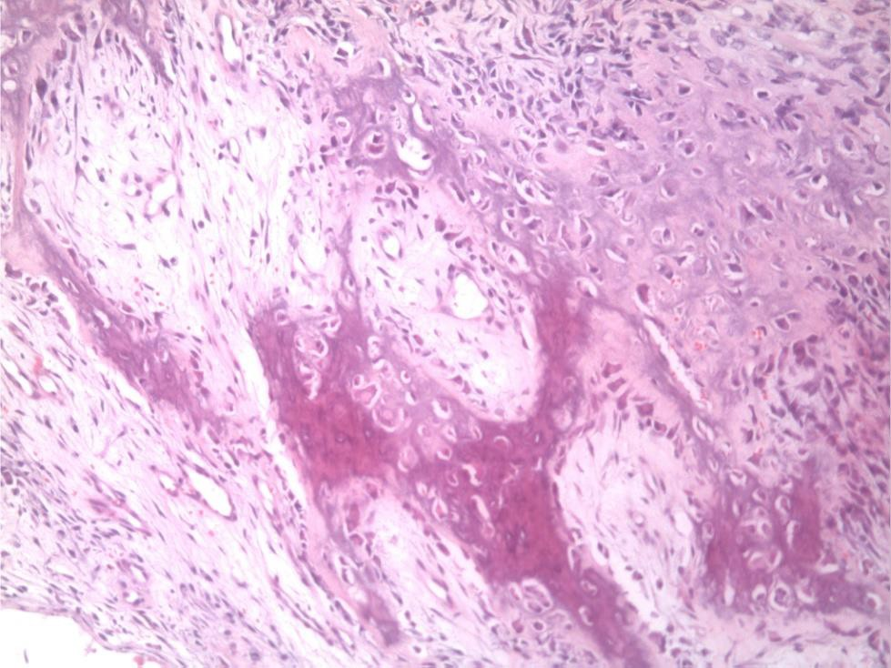
Figure (4.C) showing reactive new bone formation by osteoblasts

4. Discussion
Previous studies have tried to investigate the importance MR imaging in determining the extent of bone tumor after chemotherapy and in distinguishing it from peritumoral edema feature, or peritumoral reaction, and liking the results with histopathological data [12-15]. Most of these studies focused mainly on osteosarcoma using relatively few numbers of patients. Our study revealed that the extent of intra-osseous cancer was determined precisely by pre-operative MRI in 50 (89%) osteosarcoma and 15 (78%) Ewings sarcoma patients. No significant difference was found between the intramedullary extension as assessed by preoperative MRI and the real level of the cancer as estimated by histopathologic inspection of the bone tumorspecimen.
Based on a study conducted on 36 patients at Children Cancer Hospital of Egypt, it was found that following chemotherapy for Ewing sarcoma of long bones, MRI measurements of intraosseous extent do not change much when comparing the initial to the pre-operative MRI [16]. This study also revealed that you can with a certain degree of security depend on the pre-operative MRI to measure your safety limits before dissecting the tumor. The application of the pre-operative MRI did not increase the prospective of positive edges and local failure.
In our study, no specific reactive changes seem to be attributable to administered chemotherapy in either osteosarcoma or Ewing sarcoma. The discrepancy in measurements between MRI and pathology specimen were caused by periosteal reactive changes, bone marrow changes as false positive epiphyseal infiltration, focal infarction or edema and as well as bone deformity. In a previous study, the difference was returned to the divergence of estimating planes on MRI and the histopathological specimen, and to the edema adjoining the osteosarcoma being took as part of the cancer due to the edema corrupted the signal of the normal bone marrow [17].
Decisions regarding extent of surgical resection in our patients were based on preoperative MRI assessment and the frozen section examination of the bone tumor specimen. Examination of frozen-section established negative final bone marrow edges in all patients who underwent limb salvage procedures except for a single case of Ewing sarcoma of the femur shaft in which intraoperative frozen section examination was not done. On the other hand, Meyer et al. [18] applied preoperative MRI to detect the place of bone resection in individuals complains from osteosarcoma of the limbs. They decided that MRI could be applied safely to define the resection boundaries without the necessity for histopathological examination of frozen sections. Others advocated inspection of split gross specimens as an acceptable assistant to clinic-radiographic valuation to accomplish negative boundaries in the present period of modern imaging and surgical procedures [19]. Intra-operative frozen section examination of the boundaries might be of value in limb-sparing measures especially in cases with equivocal marrow changes and extraosseous extension. Currently there is no constant standard between orthopaedic oncologists as to the minimal safe margin for bone resection. The prevailing trend has been a decrease in acceptable margin size while sustaining good oncologic outcomes, yet there are currently no published benchmark data on the rates of positive intraoperative margins requiring recuts and the rates of positive final margins in bone sarcoma resection specimens [19-20].

Conclusion

Preoperative assessment of extent of tumor by MRI is a dependable tool to evaluate the local degree of bone cancers in children. These results are encouraged in preparation for surgical limb salvage measures and stress the incompetence of reactive alterations in bone specimens on preoperative radiological valuation of tumor extent.

References
    - n der Woude HJ, Bloem JL, and Hogendoorn PC: Preoperative evaluation and monitoring chemotherapy in patients with high-grade osteogenic and Ewing's sarcoma: review of current imaging modalities. Skeletal Radiol. 1998;27:57-71.
    - Min HS, Kang HG, and Ro JY: Therapy Related Changes in Osteosarcoma and Ewing Sarcoma of Bone. The Open Pathology Journal. 2009; 3:99-105.
    - Lowchik A, Zhou H, Pysher TJ, Smith L, Lemons R, and Coffin CM: Therapy Associated Changes in Childhood Tumors. Advances in Anatomic Pathology. 2000; 7(6):341-359.
    - Meyer JS, Nadel HR, Marina N, Womer RB, Brown KL, Eary JF et al.: Imaging guidelines for children with Ewing sarcoma and osteosarcoma: A report from the Children's Oncology Group Bone Tumor Committee. Pediatric Blood and Cancer. 2008; 51(2):163-170.
    - Silva FD, Pinheiro L, Cristofano C, Schiavon JL, Lederman HM.: Magnetic Resonance Imaging in Pediatric Bone Tumors. Current Radiology Reports. 2014; 2 (77):1-11.
    - Pan GP, Raymond AK, Carrasco CH, Wallace S, Kim EE, Shirkhoda A et al. Osteosarcoma: MR imaging after preoperative chemotherapy. Radiology. 1990;174:517–26.
    - James SL, Panicek DM, and Davies AM: Bone marrow oedema associated with benign and malignant bone tumours. European Journal of Radiology. 2008; 67:11–21.
    - Coffin CM, Lowchik A, and Zhou H.: Treatment Effects in Pediatric Soft Tissue and Bone Tumors. Practical considerations for the pathologist. Am J Clin Pathol.2005;123:75-90.
    - van der Woude HJ, Bloem JL, Verstraete KL, Taminiau AH, Nooy MA and Hogendoorn PC: Osteosarcoma and Ewing's sarcoma after neoadjuvant chemotherapy: Value of dynamic MR imaging in detecting viable tumor before surgery. AJR. 1995;165:593-598.
    - Eftekhari F.: Imaging assessment of osteosarcoma in childhood and adolescence: diagnosis, staging, and evaluating response to chemotherapy. Cancer Treat. Res. 2010; 152:33-62.
    - Jones KB, Ferguson PC, Lam B, Biau DJ, Hopyan S, Deheshi Bet al.: Effects of Neoadjuvant Chemotherapy on Image-Directed Planning of Surgical Resection for Distal Femoral Osteosarcoma J Bone Joint Surg Am. 2012; 94:1399-1405.
    - Masrouha KZ, Musallam KM, Samra AB, Tawil A, Haider R, Chakhachiro Z et al.: Correlation of non-mass-like abnormal MR signal intensity with pathological findings surrounding pediatric osteosarcoma and Ewing’s sarcoma. Skeletal Radiol. 2012; 41:1453–1461.
    - Saifuddin A. The accuracy of imaging in the local staging of appendicular osteosarcoma. Skeletal Radiol. 2002;31(4):191-201.
    - Wallack ST, Wisner ER, Werner JA, Walsh PJ, Kent MS, Fairley RA et al.: Accuracy of magnetic resonance imaging for estimating intramedullary osteosarcoma extentin pre-operative planning of canine limb-salvage procedures. Vet Radiol Ultrasound. 2002;43(5):432-441.
    - Hao YK, Zhang YK, Yang ZP, Li X, Yang Q, Li JM: The accuracy of magnetic resonance imaging in determining the osteotomy plane in osteosarcoma. Orthopedics. 2008;31(6):544.
    - El Ghoneimy AM, El Sherbiny M, Refaat A, Zaky I, Amin M, Taha H, Gouda I, et al.: Retrospective assessment of the change in intra-osseous involvement in Ewing sarcoma of long bones after neo-adjuvant chemotherapy; its impact on surgical planning and local control. European Musculoskeletal Oncology Society Meeting, Bologna2012.
    - Schima W, Amann G, Stiglbauer R, Winhager R, Kramer J, Nicolakis M et al.: Preoperative staging of osteosarcoma: efficacy of MR imaging in detecting joint involvement. AJR Am J Roentgenol. 1994;163(5):1171-1175.
    - Meyer MS, Spanier SS, Moser M, and Scarborough MT: Evaluating marrow margins for resection of osteosarcoma: a modern approach. Clin Orthop Relat Res. 1999; (363):170-175.
    - Anderson ME, Miller PE, van Nostrand K, and Vargas SO: Frozen section versus gross examination for bone marrow margin assessment during sarcoma resection. Clinical Orthopaedics and Related Research 2014;472(3):836-841.
    - Reddy K, Wafa H, Gaston CL, Grimer RJ, Abudu AT, Jeys LM, Carter SR, Tillman RM. Does amputation offer any survival benefit over limb salvage in osteosarcoma patients with poor chemonecrosis and close margins? Bone Joint J.2015;97-B (1):115-20.

12/1/2018

