**Chemoprotective Efficacy of Curcumin and Flax Seed Oil in 1, 2-Dimethylhydrazine Induced Rat Colon Cancer**

Diaa B. Al-Azahary, Nagy S. Tawfik, Hanaa F. Hassan and Shimaa A. Kamal

Zoology Department, Faculty of Science, Minia University, Egypt

[shimaa_ahmed_89@yahoo.com](mailto:shimaa_ahmed_89@yahoo.com)

**Abstract: The Aim:** The study was carried out to examine the protective roles of curcumin and flax seed oil against 1,2-dimethylhydrazine (DMH) induced colon carcinogenesis in albino rats. **Methods:** Rats were injected by DMH (20 mg/kg b. wt.) once a week for a duration period of 15 weeks. Animals were treated by oral administration of curcumin (100 mg/kg b. wt.) and / or flax seed oil (2 ml/kg b. wt.) each alternate day along the duration period of DMH- treatment. At the end of experimental period, all rats were sacrificed to obtain samples of blood and colon for biochemical, histopathological and immunohistochemical investigations. Malanodialdehyde (MDA), glutathione peroxidase (GPx), alakaline phosphatase (ALP), alpha fetoprotein (AFP) and carcinoemberyonic antigen (CEA) were estimated. Cellular alternations and expression of P53 in colon tissue of different groups were also examined. **Results**: The results revealed an increase of serum MDA, ALP, AFP and CEA and a decrease of GPx levels in DMH-treated rats as compared to control. On the other hand, separate or co-treatment of DMH-treated rats by curcumin and flax seed oil reduced the changes of these parameters. Moreover, they show obvious reduction and amelioration of necrotic areas, dysplastic zones and loss of acinar patterns of colon glands and abnormalities of P53 expression which appeared in DMH-treated group. **Conclusion**: It could be therefore concluded that inhibition of oxidative stress, enhancement of antioxidant status and amelioration of colon tissue by curcumin and flax seed oil suggest their potential efficacy as protective naturally occurring agents against colon carcinogenesis.

**[**Diaa B. Al-Azahary, Nagy S. Tawfik, Hanaa F. Hassan and Shimaa A. Kamal. **Chemoprotective Efficacy of Curcumin and Flax Seed Oil in 1, 2-Dimethylhydrazine Induced Rat Colon Cancer.** *Cancer Biology* 2018;8(4):21-31]. ISSN: 2150-1041 (print); ISSN: 2150-105X (online). <http://www.cancerbio.net>. 3. doi:[10.7537/marscbj080418.03](http://www.dx.doi.org/10.7537/marscbj080418.03).

**Key words:** Colon cancer, Curcumin, Dimethylhydrazine, Flax seed oil, Oxidative stress.

**1. Introduction:**

Colon cancer is a malignant tumor with high morbidity and mortality. It is not only the fourth most common form of cancer but also the third leading cause of cancer-related death worldwide [1]. Colon cancer incidence is increasing in the developing countries including the Middle East and North Africa [2]. It results from both genetic and environmental factors and their interaction. Genetic disposition is the most important risk factor for some individuals; conversely, environmental factors and dietary habits are the confounding factors in the induction of colon cancer [3]. More than 80% of patients with colon cancer were exposed to a number of risk factors, such as male gender, older age, high intake of red meat or fat, smoking and obesity. The risk of alcohol increases at more than a drink per day [4]. It is recognized that colon carcinogenesis is a multistep process that includes sequential selection and propagation of preneoplastic lesions. Aberrant crypt foci (ACF) are preneoplastic lesions present in humans at high risk for colon cancer development and in patients with colon cancer as well as in carcinogen-treated rodent colons [5].

Oxidative stress is considered one of the main mechanisms in the initial stages of colon carcinogenesis [6]. It refers to elevated intracellular levels of reactive oxygen species (ROS) including the superoxide anion (O2−), hydrogen peroxide (H2O2) and hydroxyl radicals (OH·); all of which have inherent chemical properties that confer reactivity to different biological targets [7]. Free radicals including reactive oxygen ROS are thought to underline the progress of numerous diseases including cancer [8]. Exposure to reactive oxygen species (ROS) can induce DNA damage, leading to genetic lesions that initiate tumourigenicity and subsequent tumor progression [9].

1,2-Dimethyl hydrazine (DMH), is a potent carcinogen inducing colon tumors in experimental animals and is the most widely used model of chemically induced colon carcinogenesis. It induces colon cancer in a multistep process involving a series of pathological alterations [10]. DMH has been reported to form active intermediates in the liver, which are subsequently transported into the colon through bile [11, 12]. An intermediate of DMH in liver elicits oxidative stress by methylating biomolecules of colonic epithelial cells leading to inflammation and tumor promotion [10].

On the other hand, many therapies including surgery, radiation and chemotherapeutic drugs, are still limited for the advanced stages of colon carcinogenesis. Chemoprevention remains an effective and promising additional strategy for controlling the incidence of colon cancer [11,13]. Extensive clinical research is warranted to evaluate further safety and chemopreventive efficacy of natural products either alone or in combination with chemotherapeutic agents against cancer [14].

Curcumin (diferuloylmethane), a polyphenolic antioxidant compound of Curcuma longa L., is efficient in chemoprevention and cancer therapy where curcumin inhibits the initiation and promotion stages of chemically induced carcinogenesis in skin, stomach and colon [11,15]. The tumor suppression is due to down regulation of a variety of transcription factors, enzymes and growth signal transducers [11,16].

Flaxseed oil was also suggested to contribute to the reduction of several diseases because of the beneficial physiological effects of its components. It is one of the richest dietary sources of α-linolenic acid which is a ω-3 polyunsaturated fatty acid (ω-3 PUFA). The consumption of purified ω-3 PUFA was found to reduce colon cancer risk in humans and experimental animal models [17]. Therefore, the overall objective of this study was to examine DMH-induced oxidative stress biomarkers, cellular alternations and carcinogenesis in rat colon and to investigate the chemo-preventive efficacy of curcumin and flaxseed oil, alone or both together, against colon carcinogenesis.

**2. Material and Methods**

**1- Experimental Animals:**

Forty two adult male Sprague Dawely white albino rats with average weight 120–150 g were obtained from the Laboratory of Animal House of Faculty of Agriculture, El- Minia, Egypt and housed in separated metal cages and kept at constant environmental and nutritional conditions throughout the period of experiment.

**2- Materials:**

1,2dimethylhydrazinewas used for induction of colon cancer, It has been purchased from Sigma Company for Trading Chemicals Medicines and Medical Application, Egypt. It was dissolved in 0.001M EDTA and buffered to pH 6.5 with sodium bicarbonate. DMH was injected in rats subcutaneously, in a dose of 20 mg/kg per week for 15 weeks [18]. Curcumin was purchased from Elgoumhouria Co. for Trading Chemicals, Medicines and Medical Appliances, Egypt. It was dissolved in distilled water and administered orallyeach other day at a dose of 100 mg/ kg b.wt. [19]. Flaxseed oil (purity ~99%) prepared from olive group for food industrial in hyper market was administered orally, day by day at a dose of 2ml/ kg [20]. The chemical composition of flaxseed oil is: 30-40 % fixed oil includes linoleic, linolenic, oleic, palmitic and stearic acids, mucilage (6%), protein (25%), the cyanogenic glycoside linamarine, bitter, and also contains vitamins A, B, D and E, minerals and amino acids [21].

**3- Experimental Design:**

Rats were divided randomly into seven groups (n=6 in each group) as follows:

***Group1*** *(control group)* in which rats fed on balanced diet without any treatments.

***Group2*** *(Curcumin treated group):* which administered curcumin orally at dose of 100 mg/kg b. wt. each alternate day.

***Group 3*** *(Flax seed oil treated group)*: that administrated flax seed oil orally at a dose of 2ml /kg b. wt. each alternate day.

***Group 4*** *(DMH-treated group)*: in which rats were injected by DMH 20mg/kg b. wt. once a week subcutaneously.

***Group 5*** *(DMH+ curcumin treated group)*: receiving DMH and curcumin treatments at the same doses described above.

***Group 6*** *(DMH+ flax seed oil treated group)*: in which rats were injected by DMH and administered flax seed oil.

***Group 7*** *(DMH+ curcumin + flax seed oil treated group)*: in which the rats injected by DMH were co-administrated by both curcumin and flax seed oil. All treatments were applied regularly under the same conditions along a period of 15 weeks.

At the end of experimental period, rats were fasted overnight and sacrificed by cervical decapitation. Two blood samples were immediately collected. The first sample was collected in EDTA for preparation of hemolysate while the second one was used for serum preparation. Samples were immediately stored at -85°c until use for biochemical analysis. After animal dissection, specimens of colon were obtained and fixed in 10 % formalin solution for histopathological and immunohistochemical investigations.

**4- Biochemical Analysis:**

Lipid peroxide level in the term of malondialdehyde concentration (MDA) was determined in serum according to the method described by [22] using kit purchased from Bio- diagnostic Company, Egypt. Hemolysateglutathione peroxidase level was determined according to the method described by [23]. Alkaline phosphatase level was determined in serum according to methods described by [24] using kit purchased from Biomed Diagnostic Company, Egypt. Alpha-fetoprotein quantitative measurement was performed in serum according to reference [25] using enzyme immunoassay kit (purchased from USCN life science Inc. Co.). CEA EIA kit was intended for the quantitative determination of the carcinoemberyonic antigen (CEA) in serum according to [26].

**5- Statistical Analysis:**

Data were analyzed using the statistical package for social science program (SPSS) according to [27]. The statistical differences between the groups involved in the study were assessed by one-way analysis of variance (ANOVA) to analyze specific difference between means.

**6- Histopathological and Immunohistochemical Studies:**

The colon was excised, flushed with saline. colonic sections were fixed in 10%buffered formalin for at least 24 h. after fixation, specimens were dehydrated in ascending grades of ethanol, cleared in benzene, and embedded in paraffin wax. Blocks were made and 5 µm thick sections. the slides were stained with hematoxylin and eosin (H & E) according to the method described by reference [28]. These sections were investigated under light microscope to evaluate the histopathological alternation of colonic tissue of all treated animals as compared to control. Immunohistochemical investigation of p53 in formalin-fixed, paraffin-embedded colon tissue specimens was applied according to the procedure of immunohistochemical staining previously described by [29].

**3. Results**

The results of the present study revealed adverse changes in different oxidative and antioxidant parameters in serum of treated groups as compared to control ones (table 1). Data presented revealed non-significant change in curcumin or flax seed oil treated rats, not receiving DMH, as compared to those of control group. On the other hand, rats in DMH-treated group showed a very highly significant increase in lipid peroxide (MDA) (fig.1) and decrease in GPx activity (fig. 2) as compared to control group. Furthermore, curcumin and/or flax seed oil administration caused very highly significant decrease in MDA and very highly significant increase in GPx activity when compared to DMH-treated animals.

Alkaline phosphatase level showed also an observed increase in DMH–treated group when compared to control one, while treatment by curcumin and/or flax seed oil induced a modulatory effect by causing a significant decrease when compared to DMH-treated group (fig.3). Because AFP and CEA have been extensively used in diagnosis of cancer tumors, their levels in all animal groups were investigated. DMH caused high elevation in the levels of AFP (fig. 4) and CEA (fig. 5) as comparedto control group. Administration of curcumin and/or flax seed oil caused a variable significant decrease in AFP and CEA compared to DMH-treated group (table 1).

Hematoxylin and Eosin stained colon sections of control and treated animals were examined. Mucosa, submucosa, muscularisinterna, muscularisexterna, and serosa were investigated. The mucosal layer comprising simple columnar epithelium and lamina propria forms deep cavities, the crypts of Lieberkühn. The epithelium has many oval mucous goblet cells while lamina propria showed normal content of inflammatory cells and no existence of epithelial or irregular cells (fig. 6A). Sections of colon tissue of rats treated by DMH showed dysplastic aberrant crypts of colonic mucosa with reduction of the intercryptic spaces. Crypts with severe dysplasia were observed. The crypts appeared as thickened epithelia which stained darker than normal crypts. There was a marked reduction in goblet cells density throughout the cryptsand existence of damaged cells and necrotic areas (fig. 6B). In this group, mucosal tissue disarrangement and variable cellular appearance revealed hyperplastic and dysplastic epithelium. Moreover, packed or scattered inflammatory cells were observed (fig. 6C).

Sections of colon of rats treated with DMH and curcumin showed clear improvement in mucosal layer with mild infiltration of inflammatory cells in the lamina propria, normal submucosa, intact basement membrane and muscularis mucosa and lower degree of hyperplasia as compared to rats treated with DMH alone (fig. 6D). In H & E stained sections of colon of rats treated with DMH and flax seed oil showed an evident reduction of the crypt dysplasia. The mucosal crypts, lamina propria and muscularis mucosa were well oriented, with few inflammatory cells infiltration. The basement membrane and muscularis mucosa were intact. The size and shape of the cells were also uniform (fig. 6E). Also, sections of colon rats treated with DMH, curcumin and flax seed oil, showed colonic structure more or less similar to the control, normal mucosal layer with regular crypts. The mucosa was obviously regenerated with no inflammatory reaction (fig. 6F).

Immunohistochemical investigation of P53 in colon of different groups showed different expressions and reactions for p53 immunostaining. In this analysis, the brown color indicates specific staining of p53. The colon section of control rats showed a very low expression for p53 (Fig. 7A). In contrast, a large number of strong positive stained nuclei were observed in colon sections of rats treated with DMH (Fig. 7B, C), indicating strong expression for p53 protein. However, treatment with curcumin (fig. 7D) or flax seed oil (fig.7E) showed less expression for p53 protein, while co-treatment with both curcumin and flax seed oil showed the most modulatory effect on p53expressionas compared to DMH group (fig.7F).

Table 1: Effect of curcumin and/or flax seed oil treatments on serum MDA, GPx, ALP, AFP and CEA levels in control and DMH-induced colon carcinogenesis.

|  |  |  |  |  |  |  |  |
| --- | --- | --- | --- | --- | --- | --- | --- |
|  | Control | Curcumin | Flax seed oil | DMH | DMH +  Curcumin | DMH +  Flaxseed oil | DMH +  Curcumin+ flaxseed oil |
| Lipid peroxide (MDA) (nmol/ml) | 0.71  ± 0.05 | 0.61  ± 0.05 | 0.72  ± 0.05 | 1.73  ± 0.20 *** | 0.82  ± 0.01 ### | 0.81  ± 0.08 ### | 0.50  ± 0.06 ### |
| Glutathione peroxidase (GPx) (u/gHb) | 2.30  ± 0.17 | 1.96  ± 0.19 | 2.50  ± 0.40 | 0.82  ±0.10 *** | 1.90  ± 0.1 ### | 2.01  ± 0.20 ### | 3.10  ± 0.3 ### |
| Alkaline phosphatase (ALP) (U/L) | 128  ±1.80 | 159  ± 7.10 | 186  ± 4.30 | 270  ±2.70 *** | 180  ±5.60 ### | 191  ± 7.30 ### | 168  ± 5.90 ### |
| Alpha feto protein (AFP) (ng/ml) | 0.143  ± 0.01 | 0.148  ± 0.003 | 0.151  ± 0.01 | 0.426  ±0.007 *** | 0.220  ±0.003 ### | 0.228  ±0.002 ### | 0.192  ± 0.003 ### |
| Carcinoemb-eryonic antigen (CEA) (µg/ml) | 1.66  ± 0.10 | 1.77  ± 0.07 | 1.80  ± 0.09 | 6.23  ± 0.20 *** | 3.05  ± 0.15 ### | 3.26  ± 0.20 ### | 2.70  ± 0.14 ### |

Data are presented as (mean ± S.E.).*indicates significant change vs. control group (*P<0.05, **P<0.01, ***P<0.001). # indicates significant change vs. DMH group (#P<0.05, ##P<0.01,###P<0.001).

|  |  |
| --- | --- |
| Figure 1: Mean levels of lipid peroxide (nmol /ml) ± SE in serum of control (G1), curcumin (G2), flax seed oil (G3), DMH (G4), DMH + curcumin (G5), DMH + flaxseed oil (G6) and DMH + curcumin + flax seed oil (G7) treated group. | Figure 2: Mean levels of glutathione peroxidase (u/g Hb) in hemolysate ± SE of control (G1), curcumin (G2), flax seed oil (G3), DMH (G4), DMH + curcumin (G5), DMH + flaxseed oil (G6) and DMH +curcumin+ flaxseed oil (G7) treated group. |
| Figure 3: Mean level of Alkaline phosphatase (U/L) ± SE in serum of control (G1), curcumin (G2), flax seed oil (G3), DMH (G4), DMH+ curcumin (G5), DMH+ flax seed oil (G6), and DMH + curcumin +flaxseed oil (G7) treated groups. | Figure 4: Alpha fetoprotein level (mg/mL) ± SE in serum of control (G1), curcumin (G2), flax seed oil (G3), DMH (G4), DMH+ curcumin (G5), DMH+ flax seed oil (G6), and DMH + curcumin + flaxseed oil (G7) treated groups |



Figure 5: Mean level of CEA (μg/ml) ± SE in serum of control (G1), curcumin (G2), flax seed oil (G3), DMH (G4), DMH+ curcumin (G5), DMH+ flaxseed oil (G6), and DMH + curcumin +flaxseed oil (G7) treated group.

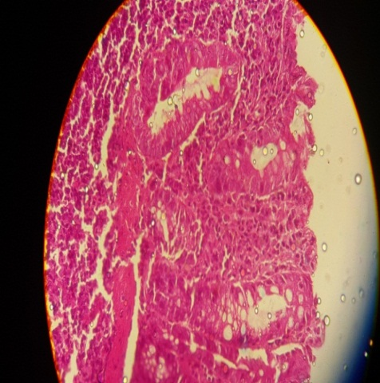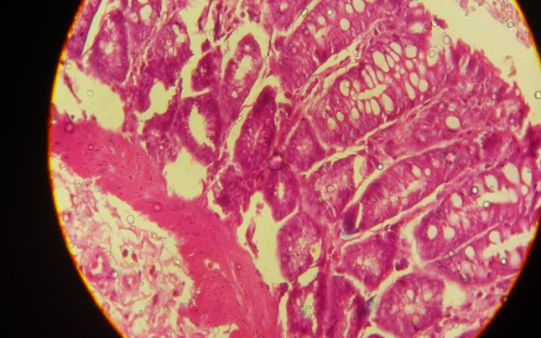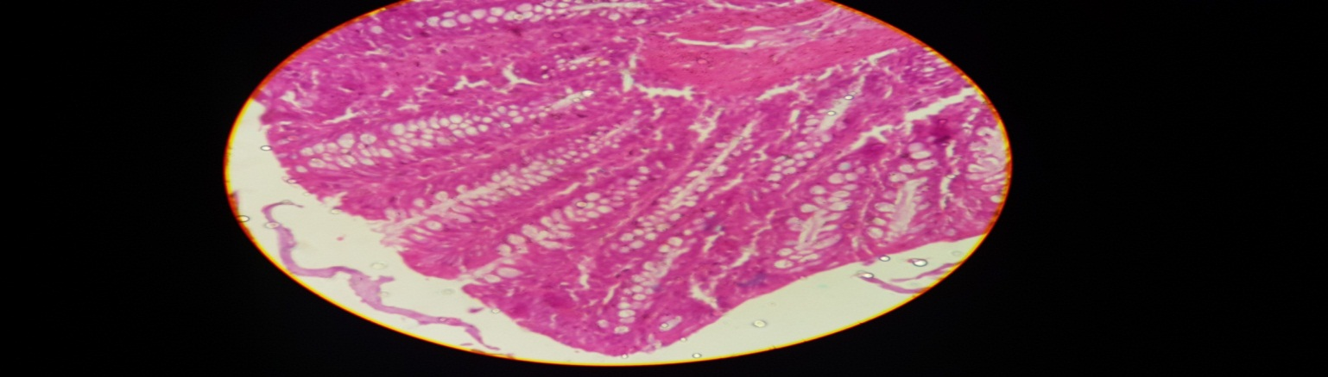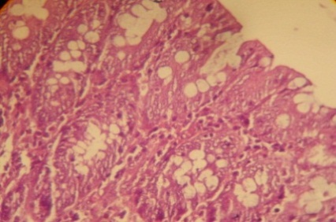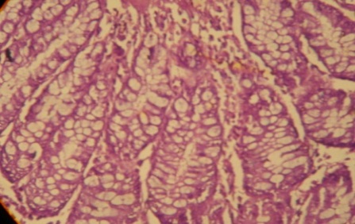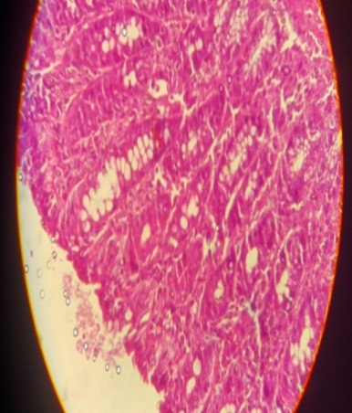

C**C**

B**hhBB**

A**hhhhbbAaaAAA**

F**F**

EE

DD

Figure 6: Photomicrograph of colon section from rats of A: control group showing colon tissue with normal mucosal glands and regular lining of cells. B and C: DMH – treated group showing some damaged cells, dysplastic zones, loss of acinar patterns of colon glands and inflammatory cells in mucosa and lamina propria. D: DMH and curcumin treated group showing less inflitration of inflammatory cells with lower degree of hyperplasia. E: DMH and flax seed oil treated group showing reduction of the crypt dysplasia and few inflammatory cells infiltration. F: DMH, curcumin and flax seed oil treated group showing colonic structure nearly similar to the control (H & E x 40).

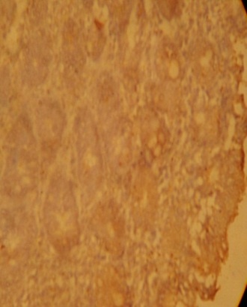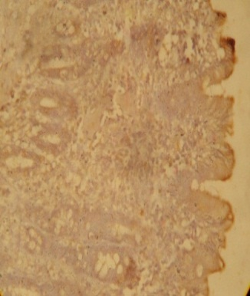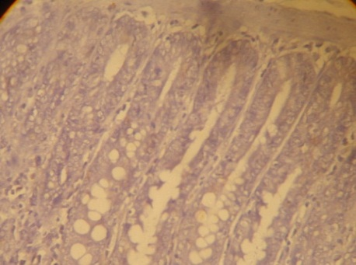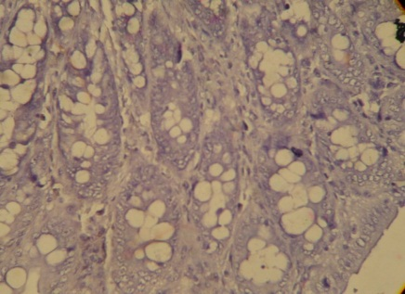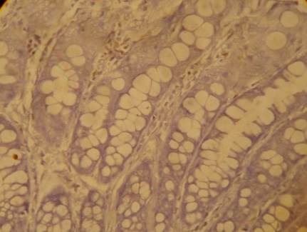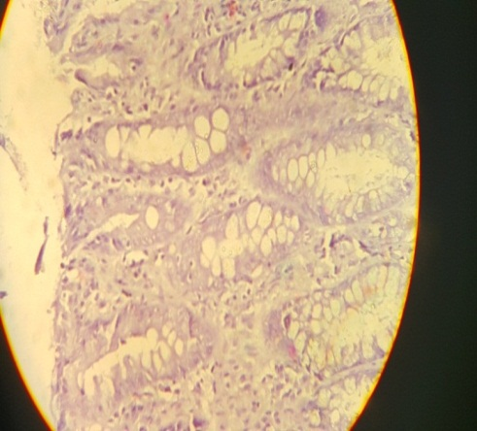

**AAA**

**BB**

**DD**

**FF**

**CC**

**EE**

Figure 7: Photomicrograph of colon section from rats of A: control group showing negative P53 experssion. B and C: DMH – treated group showing strong experssion of P53. D: DMH and curcumin treated group showing less experssion of P53. E: DMH and flax seed oil treated group showing less experssion for P53. F: DMH, curcumin and flax seed oil treated group showing experssion for P53 more or less similar to the control (P53 immunostain x 40).

**4. Discussion:**

1,2-Dimethyl hydrazine (DMH) is a toxic environmental pollutant that is well-established to be car­cinogenic with selectivity for colon. DMH undergoes metabolism in the liver, resulting in the production of active intermediates including azoxymethane and methylazoxymethanol [11,12] electrophilic diazoniumions [30] and methyl free radicals which are known to induce oxidative stress are suggested to leadfinally to tumor incidence, particularly colon tumors [31]. Data of the present study revealed also oxidative stress enhancement in rats treated with DMH (table 1). Levels of MDA, the major product of lipid peroxidation, showed highly increase over control levels (fig.1) On the other hand, the activity of the antioxidant enzyme GPx, which is considered to be more sensitive to oxidative stress [30], decreased significantly in DMH-treated animals (fig. 2). These findings may agree with previous studies indicating elevation of MDA and H2O2 content [31] and an increase in plasma and colonic MDA, while a decrease of antioxidant potential after DMH injection in rats [32].

It has been reported that MDA acts as a mutagen and tumor promoter and contribute to cancer development [31]. GPx plays a significant role in the peroxyl scavenging mechanism and in maintaining functional integration of the cell membranes [11]. If sufficient amounts of GPx are not available to decompose H2O2, the generated OH radicals are capable of attacking DNA. So, the decreased capacity of a variety of tumors to detoxify H2O2 is linked to the decreased levels of GPx [11,33,34].

Oxidative stress causes increase of free radicals which may result in injury to all the important cellular macromolecules cause the cellular death [8] and may modulate gene expression [35]. This may also be reflected in cellular alterations in colon tissue of DMH-treated rats as revealed by histopathological investigation in the present study, where both damaged cells and dysplastic zones were observed (figs. 6B and C). It has been reported that ROS have the ability to oxidize polyunsaturated fatty acids (PUFAs), which take part in cell membrane constitution. This reaction initiates lipid peroxidation, a chain reaction that produces other free radicals and substances such as MDA, conjugated dienes, hydroperoxides, lipoperoxides, and toxic aldehydes, implicating in human cancer [35].

Lipid peroxidation was also suggested to change the fluidity of cell membranes, reduce the capacity to maintain an equilibrated gradient of concentration, and increase membrane permeability and inflammation [36]. Enhanced concentrations of circulating lipid peroxidation associated with antioxidant depletion were observed in DMH-induced colon carcinogenesis [32,37]. Inflammation represented by finding of packed and scattered inflammatory cell infiltrations as well as epithelial hyperplasia and dysplasia with complete loss of polarity in different zones of clonal mucosa were also observed in this study.

Histopathological results on DMH – treated group (figs. 6B, 6C) coincide with [38] who reported that administration with DMH increased the proliferation of the colon crypts in the test animals during early carcinogenesis, and altered the distribution of proliferating and apoptotic cells in the colon. It was suggested that after metabolization in the liver the intermediates such as azoxymethane and methylazoxymethanol (MAM) are transported to the colon via bile or the blood [39]. So, the decomposition of MAM results in the formation of methyldiazonium ions, which generate reactive carbonium ions capable of methylating DNA, RNA, or the protein of colonic epithelial cells [39]. All these findings may confirm that DMH-induced oxidative stress and inflammation may be linked to the pathogenesis of colon cancer.

Many studies concerning the incidence of cancer observed elevated serum levels of ALP, AFP and CEA in human and experimental animals. Examination of these markers in the present study showed also their highly significant increase in DMH-treated rats (Table 1 and Figs. 3,4,5) indicating colon carcinogenesis. It has been reported that ALP increases in colonic inflammations [40] and colon carcinogenesis [41]. The reason of ALP elevation may be attributed to excessive dephoshphorylation of various proteins involved in the regulation of cell division which apparently is high during DMH induced colon carcinogenesis [41]. Also, elevation in the enzyme activity of ALP has been directly linked to increased DNA synthesis [41]. AFP was reported to be an indicative of colorectal cancer [42]. The results of this study on AFP of DMH induced colon cancer group is similar to [43] who recorded a highly elevation of AFP in DMH treated animals. CEA is the best marker in colorectal cancer patients and also most thoroughly characterized tumor associated antigens, in both biochemical and clinical aspects [44]. Results of this study revealed that administration of DMH to normal rats exhibited a significant increase in serum CEA concentration when compared to control group (table 1 fig. 5). This agrees with [45] who suggested that elevation in CEA concentration was observed in DMH induced colon cancer in rats.

Tumor suppressor genes, including P53, act as checkpoint in the cell replication cycle for cells with abnormal DNA [46]. Also, immunohistochemical evaluation of p53 staining has been considered as a complementary test for dysplasia in ulcerative colorectal cancer [47]. Immunohistochemical investigation of p53 in the present study showed positively p53 stained mucosal cells in colon of DMH-treated group, which may appear as a result of inactive mutants of p53. This agrees with [48] who reported that P53 positivity, both in dysplasias and carcinomas, indicates the fact that p53 gene mutations are involved in neoplastic progression. Therefore, accumulation of the p53 protein products in colon cells in DMH-treated rats indicates existence of p53 mutations and colon carcinogenesis.

Science increasing evidence indicates that natural products can modulate various molecular pathways involved in cancer initiation and progression, this study examined the potential role of curcumin and flaxseed oil in alleviating DMH- induced colon cancer in rats. The results showed that curcumin treatment decreased MDA and increased GPx activity (table 1, figs. 1,2). The obtained results are nearly similar with those of [49] who reported that oral administration of curcumin decreased the levels of plasma (MDA) and hydroperoxides. It has been reported that curcumin restores the antioxidant status by its ability to scavenge or neutralize free radicals, inhibits peroxidation of membrane lipids and maintains cell membrane integrity and their function [49].

Treatment with curcumin decreased the level of ALP induced by DMH (table 1: fig. 3). This results is also similar to [49] who reported that oral administration of curcumin decreased plasma AST, GGT and ALP activities in rats exposed to CCl4-hepatotoxicity. So, curcumin was suggested to have a potential against various diseases including cancer as a result of its antioxidant, anti-inflammatory and anticancer activities [50]. The serum levels of AFP was significantly decreased in the curcumin‑treated rats when compared to DMH treated group (table 1: fig. 4). This finding may have been due to the immuno­modulatory effect of curcumin, since previous studies have reported that curcumin is a safe and useful immunomodu­lator and also thus suggesting a potential protective role of this natural agent against hepatocarcinogenesis. This finding is consistent with a previous study, in which the serum levels of AFP and AFU were significantly decreased in the groups treated with curcumin and/or taurine [51]. In addition, data demonstrated in tables (1) revealed that, treatment with curcumin to DMH-induced colon cancer in rats significantly reduced elevated serum CEA concentration when compared with DMH-treated group. The decreased levels of these markers indicate a potential effect of curcumin in tumor suppression. The tumor suppression may be due to down regulation of a variety of transcription factors, enzymes and growth signal transducers such as nuclear factor kabba-B (NF- KB), early growth receptor-1 (EGR1) andcyclooxygenase-2 (COX-2) as previously described by [16].

The histopathological and immunohistochemical results of the present study showed also less hyperplasia, approximate normal crypts and reduction of P53 abnormalities in DMH-curcumin treated group (fig. 6D and 7D). These results may agree with [52] who reported that administration of curcumin results in an apparent amelioration of colonic crypt structure and with the suggestion that curcumin impairs changes of p53 in colon cancer cells [53]. Recently, it has been reported that the mechanism of action of this natural compound is based on the secretion of various cytokines that function via the following pathway: Stimulation of antitumor immune responses, followed by induction of tumor cell apoptosis, inhibition of the uncontrolled proliferation of cancer cells and suppression of angiogenesis [51].

Antioxidant potential of flaxseed oil (FSO) against DMH induced oxidative stress and carcinogenesis was also observed in this study. It decreased the level of MDA and increased the level of GPxas compared to DMH treated animals (figs. 1, 2). These results agree with [54] who reported that treatment with FSO increased the levels of enzymatic (SOD, CAT, GPx) and nonenzymatic antioxidants (GSH) in both skin and liver, which were noted to be decreased in the carcinogen-treated control group. It has been reported that FSO is rich in PUFA and can protect the cellular membranes scavenge free radicals and inhibit lipid peroxidation in experimental animals. α-linolenic acid, flavanoids, phenolic acid, and tocopherols in FSO are causes of elevated cellular antioxidants and reduced oxidative damage induced by carcinogen.

The obtained result in this study indicates that flaxseed oil treatment decreased level of ALP when compared to DMH treated group (table 1: fig. 3). Previous studies indicate a hepatotoxicity role of DMH during the event of colon cancer. The hepatic cell membrane damage releases ALP and other enzymes into circulation as a result of DMH toxicity, which can be measured in serum [55]. Also in hepatitis, the increased activitiesofthese enzymesindicated changes in the membrane functions and permeability leading to a destruction of hepatic cells and cellular leakage [56]. Flaxseed oil supplementation increased cell membrane contents of omega-3 fatty acids and in contrast decreased the content of omega-6 fatty acids leading to a reduction of arachidonic acid liberation and in turn reduction of prostaglandins and pro-inflammatory cytokines and also free oxygen species, the important factors in liver inflammation [57]. Therefore, flaxseed oil was suggested to be a powerful effect in protecting against injury through inhibition of inflammation as well as oxidative stress.

Data of this study showed that administration of flaxseed oil reduced levels of AFP significantly when compared to DMH-treated group (table 1; fig. 4). This may agree with [58] who reported that administration of flaxseed and corn oils significantly reduced levels of AFP. As previously mentioned [59] flaxseed or its extracted oil play an important dietary role in various biological activities in the body and exert anti-carcinogenic effects. Flaxseed oil treatment reduced also the level of CEA when compared to DMH-treated group (table 1; fig. 5). This result may also agree with [60] whonoticed increased levels of CEA in cell line induced lung cancer in mice when compared to normal control mice. The animals treated with flaxseed oil group showed significant decrease in levels of CEA in the serum when compared to cell line induced control groups.

Tissues of colon rats treated with DMH and flax seed oil showed improvement including a reduction of the crypt dysplasia (fig. 6E), the results which agree with [17] who reported that flaxseed oil demonstrated modulating effects on DMH-induced cellular proliferation of rats colonic cells in a dose-dependent manner. The immunohistochemical results of p53 showed also less positively p53 stained colon cells (fig. 7E) indicating reduction of its abnormalities and mutant forms induced by DMH treatment. As previously mentioned, mutations of the p53 gene not only loses its original growth‐suppressive function but also gains the capacity for promoting cancer cell growth [61]. Concerning flax seed oil effects on P53 mutants, it has been reported that flaxseed oil is one of the richest dietary sources of ω-3 polyunsaturated fatty acid (17) which have an inhibitory effect on the mt‐p53 [62].

Flaxseed oil has been reported to have antioxidant and antitumor properties by inducing apoptosis and thereby indicating the chemopreventive nature of natural products. α-linolenic acid acts as a precursor of the inhibitory effects of flaxseed oil on rat colon carcinogenesis. The mechanism proposed here is likely to be through the antiproliferative properties of ω-3 polyunsaturated fatty acid found in α-linolenic acid found in flaxseed oil [17]. Finally, data presented in this study confirm the protective role of both curcumin and flax seed oil against oxidative stress and carcinogenesis. This was more clearly appeared in animal group treated with both natural components than other treated groups, exhibiting synergistic preventive and modulatory effects.

**Conclusions:**

The results of the present study give more evidence of the potential antioxidant, anti-inflammatory and anti-carcinogenic effects of both curcumin and flaxseed oil. Their addition to diet and various food products is strongly recommended for people at risk or exposed to colon carcinogenesis.

**References:**

1. World Health Organization, 2009. Cancer, Fact sheet, pp: 297.
2. Ferlay J, Shin HR, Bray F, Forman D, Mathers CD, and Parkin DM. Estimates of worldwide burden of cancer in 2008. International Journal of cancer 2010;127(12): 2893–2917.
3. Hamiza OO, Rehman MU, Khan R, Tahir M, Khan AQ, Lateef A, and Sultana S. Chemopreventive effects of aloin against 1,2-dimethylhydrazineinduced preneoplastic lesions in the colon of Wistar rats. Human and Experimental Toxicology 2013;33(2): 148-163.
4. Nasrallah A, and El- Sibai M. Colorectal Cancer Causes and Treatments A Minireview. The Open Colorectal Cancer Journal 2014;7: 1876-8202.
5. Jia XD, and Han C. Chemoprevention of tea on colorectal cancer induced by dimethylhydrazine in Wistar rats. World Journal of Gastroenterology 2000; 6(5): 699-703.
6. Glei M, Latunde-Dada GO, Klinder A, Becker TW, Hermann U, Voigt k, and Pool-Zobel BL. Iron-overload induces oxidative DNA damage in thehuman colon carcinoma cell line HT29 clone 19A. Mutation Reserche/Genetic Toxocology and Environmental Mutagenesis 2002;519: 151-161.
7. Schieber M and Chandel NS. ROS Function in Redox Signaling and Oxidative Stress. Current Biology 2014; 24(10): 453–462.
8. Sharma J, Singh S, Singh R and Goyal PK. chemopreventitive and anti-oxidative effect of flaxseed oil against DMBA/CROTON oil induced two stages skin carcinogensis in mice. International Journal of Pharmaceutical Science And Research 2014; 5(8): 3383-3392.
9. Venkatachalam K, Gunasekaran S, Jesudoss VAS, and Namasivayam N. The effect of rosmarinic acid on 1, 2-dimethylhydrazine induced colon carcinogenesis. Experimental and Toxicologic Pathology 2013; 65(4): 409-18.
10. [Hamiza OO,](https://www.ncbi.nlm.nih.gov/pubmed/?term=Hamiza%20OO%5BAuthor%5D&cauthor=true&cauthor_uid=23167349) [Rehman MU ,](https://www.ncbi.nlm.nih.gov/pubmed/?term=Rehman%20MU%5BAuthor%5D&cauthor=true&cauthor_uid=23167349) [Tahir M,](https://www.ncbi.nlm.nih.gov/pubmed/?term=Tahir%20M%5BAuthor%5D&cauthor=true&cauthor_uid=23167349)  [Khan R,](https://www.ncbi.nlm.nih.gov/pubmed/?term=Khan%20R%5BAuthor%5D&cauthor=true&cauthor_uid=23167349) [Khan AQ,](https://www.ncbi.nlm.nih.gov/pubmed/?term=Khan%20AQ%5BAuthor%5D&cauthor=true&cauthor_uid=23167349) [Lateef A,](https://www.ncbi.nlm.nih.gov/pubmed/?term=Lateef%20A%5BAuthor%5D&cauthor=true&cauthor_uid=23167349) [Ali F](https://www.ncbi.nlm.nih.gov/pubmed/?term=Ali%20F%5BAuthor%5D&cauthor=true&cauthor_uid=23167349) and [Sultana S.](https://www.ncbi.nlm.nih.gov/pubmed/?term=Sultana%20S%5BAuthor%5D&cauthor=true&cauthor_uid=23167349)Amelioration of 1,2 Dimethylhydrazine (DMH) Induced Colon Oxidative Stress, Inflammation and Tumor Promotion Response by Tannic Acid in Wistar Rats. Asian Pacific Journal of Cancer Prevention 2012; 13(9): 4393-4402.
11. Hussein SA, Abdel-Aal SA and Mady HA 2013. Chemopreventitive effect of curcumin on oxidative stress, antioxidant status, and fragmentation and caspase -9 gene expression in 1, 2-Dimethylhydrazine-induced colon cancer in rats. Benha veterinary medical journal2013; 25[2]: 125 ‐138.
12. Sengottuvelan M, Senthilkumar R, and Nalini N. Modulatory influence of dietary resveratrol during different phases of 1, 2-dihmehtylhydrazine induced mucosal lipid-per oxidation, antioxidant status and aberrant crypt foci development in rat colon carcinogenesis. Biochima et Biophysica Acta 2006; 1760: 1175–1183.
13. Guruswamy S, and Rao CV. Multi-target approaches in colon cancer chemoprevention based on systems biology of tumor cell signaling. Gene Regulation and Systems Biology2008; 2: 163–176.
14. Rajamanickam S, and Agarwal R. Natural products and colon cancer: current status and future prospects. Drug Development Research 2008; 69: 460- 471.
15. Sandur SK, Deorukhkar A, Pandey MK, Pabón AM, Shentu S, Guha S, Aggarwal BB and Krishnan S. Curcumin modulates the radiosensitivity of colorectal cancer cells by suppressing constitutive and inducible NF-kappa activity. International Journal Radiation Oncology Biology Physics 2009; 75: 534–542.
16. Lee YK, Park SY, Kim YM, and Park OJ. Regulatory effect of the AMPK-COX-2 signaling pathway in curcumin-induced apoptosis in HT-29 colon cancer cells. Annals of the New York. Academy of sciences 2009; 1171: 489–494.
17. Salim EI, Abou-Shafey AE, Masoud AA and Elgendy SA. Cancer Chemopreventive Potential of the Egyptian Flaxseed Oil in a Rat Colon Carcinogenesis Bioassay -- Implications for its Mechanism of Action. Asian Pacific Journal of Cancer Prevention 2011; 12: 2385-2392.
18. Nalini N, Manju V and Menon VP. Effect of coconut cake on the bacterial enzyme activity in 1,2-dimethylhydrazine induced colon cancer. Clinica Chimica Acta2004; 342(1-2): 203–210.
19. Aggarwal BB, kumar AR, and Baharti AC. Anticancer potential of curcumin: Preclinical and clinical studies. Anticancer Reserch2003; 23:363-398.
20. Bhatia AL, Sharma AV, Patni S., and Sharma A. L. Prophylatic Effect of Flaxseed Oil against Radiation-induced Hepatotoxicity in Mice. Phytotherapy Research 2007; 21(9): 852-859.
21. Campbell AP. Flax facts. A grain for good health. Diabetes Self Manage 2003; 20(6):18, 20-2.
22. Ohkawa H, Ohishi W and Yagi K. Assay for lipid peroxides in animal tissues by thiobarbituric acid reaction. Analytical Biochemistry. 1979; 95 (2): 351-358.
23. Weinhold LC, Ahmad Sand Pardini RS. Insect glutathione Stransferase: A predictor of allelochemical and oxidative stress. Comparative Biochemistry and Physiology1990; 95(2): 355-363.
24. Tietz NW. Fundamentals of Clinical Chemistery. W. B. Saunders Co., Philadelphia, 1976.
25. Balistreri W and Shaw L. Liver function. In: Tietz NW ed. Fundamentals of Clinical Chemistry. W. B. Saunders Company, Philadelphia1987; 729-760.
26. Bormer OP. Thesis Immunoassays for Carcinoembryonic antigen, Specificity and Interferences. Scandinavian Journal of Clinical and Laboratory Investigation 1992; 53(1), 1–9.
27. Artimage GY and Berry WG. Statistical Methods. 7th Ed. Ames, Iowa Stata University Press.1987; 39-63.
28. Harris NS. Anatomy and physiology. (5ed), St. Houis: 65, 1992.
29. Ando K, Oki E, Zhao Y, Ikawa-Yoshida A, Kitao H and Saeki H. Mortalin is a prognostic factor of gastric cancer with normal p53 function. Gastric Cancer, 2013; 17: 255–262.
30. Devasena T, Menon VP and Rajasekharan KN. Prevention of 1,2-dimethylhydrazine-induced circulatory oxidative stress by bis-1,7-(2-hydroxyphenyl)- hepta-1,6-diene-3,5-dione during colon carcinogenesis. pharmalogical reports 2006; 58(2): 229_235.
31. Khan R. and Sultana S. Farnesol attenuates 1, 2- dimethylhydrazine induced oxidative stress, inflammation and apoptotic responses in the colon of Wistar rats. Chemico-Biological Interactions 2011; 192(3): 193–200.
32. Ashokkumar P. and Sudhandiran G. Protective role of luteolin on the status of lipid peroxidation and antioxidant defense against azoxymethane-induced experimental colon carcinogenesis. Biomedicine Pharmacotherapy 2008; 62(9): 590-597.
33. Cheeseman KH and Slater TF. An introduction to free radical biochemistry. British Medical Bulletin 1993; 49(3): 481–493.
34. Valko MH and Morris MT. Cronin, Metals, toxicity and oxidative stress. Current Medicinal Chemistry 2005; 12(10): 1161–1208.
35. Cejas P, Casado E, Belda-Iniesta C, [De Castro J,](https://www.ncbi.nlm.nih.gov/pubmed/?term=De%20Castro%20J%5BAuthor%5D&cauthor=true&cauthor_uid=15280629) [Espinosa E,](https://www.ncbi.nlm.nih.gov/pubmed/?term=Espinosa%20E%5BAuthor%5D&cauthor=true&cauthor_uid=15280629)  [Redondo A,](https://www.ncbi.nlm.nih.gov/pubmed/?term=Redondo%20A%5BAuthor%5D&cauthor=true&cauthor_uid=15280629) [Sereno M,](https://www.ncbi.nlm.nih.gov/pubmed/?term=Sereno%20M%5BAuthor%5D&cauthor=true&cauthor_uid=15280629) [García-Cabezas MV,](https://www.ncbi.nlm.nih.gov/pubmed/?term=Garc%C3%ADa-Cabezas%20MA%5BAuthor%5D&cauthor=true&cauthor_uid=15280629)  [Vara JA,](https://www.ncbi.nlm.nih.gov/pubmed/?term=Vara%20JA%5BAuthor%5D&cauthor=true&cauthor_uid=15280629)  [Domínguez-Cáceres A,](https://www.ncbi.nlm.nih.gov/pubmed/?term=Dom%C3%ADnguez-C%C3%A1ceres%20A%5BAuthor%5D&cauthor=true&cauthor_uid=15280629) [Perona R](https://www.ncbi.nlm.nih.gov/pubmed/?term=Perona%20R%5BAuthor%5D&cauthor=true&cauthor_uid=15280629)and [González-Barón M.](https://www.ncbi.nlm.nih.gov/pubmed/?term=Gonz%C3%A1lez-Bar%C3%B3n%20M%5BAuthor%5D&cauthor=true&cauthor_uid=15280629) Implications of oxidative stress and cell membrane lipid peroxidation in human cancer (Spain). Cancer Causes and Control 2004; 15(7): 707–719.
36. Finaud J, Lac G and Filaire E. Oxidative stress: relationship with exercise and training. Sports Medicine2006; 36( 4): 327–358.
37. Perše M. Oxidative Stress in the Pathogenesis of Colorectal Cancer. Cause or Consequence?. Bio Med Research International 2013; 725710, 9.
38. Barnes CJ, Cameron IL, Hardman WE and Lee M. Nonsteroidolanti-inflammatory drug effect on crypt cell proliferation and apoptosis during initiation of rat colon carcinogenesis. British Journal of Cancer 1998; 77(4): 573–580.
39. Arul AB, Alsaif MA and Numair KSA. Multivitamin and mineral supplementation in 1,2- dimethylhydrazine induced experimental colon carcinogenesis and evaluation of free radical status, antioxidant potential, and incidence of ACF. Canadian Journal of Physiology and Pharmacology2012;90(1): 45–54.
40. Gonzalez R, Sanchez F, Golvez J, Rodriguez M, Duarte J and Zarzuelo A. Dietary vitamin E supplementation protects the rat large intestine from experimental inflammation. Int J Vitam Nutr Res.2001; 71(4): 243-250.
41. Ghadi FE, Malhotra A, Ghara A. R, Dhawan DK. Chemopreventive Effects of Selenium on Cancer Marker Indices and Ultrastructural Changes During 1,2Dimethylhydrazine-Induced Colon Carcinogenesis in Rats. Journal of Gastrointestinal Cancer2013; 44(1): 54–59.
42. Yachida S, Fukushima N, Nakanishi Y, Akasu T, Kitamura H, Sakamoto M and [Shimoda T.](https://www.ncbi.nlm.nih.gov/pubmed/?term=Shimoda%20T%5BAuthor%5D&cauthor=true&cauthor_uid=12794586) Alpha-fetoprotein-producing carcinoma of the colon: report of a case and review of the literature. Diseases of the Colon & Rectum 2003;46(6): 826-831.
43. Karthick K and Arul Kumaran KSG. Formation and preclinical evaluation of niosomes co-loaded with 5-fluorouracil and evaluation. International Journal of Research in Pharmaceutical and Nano Sciences 20165(5): 283 – 292.
44. Ogata Y, Murakami H, Sasatomi T, Ishibashi N, Mori S and Ushijima M. Elevated preoperative serum carcinoembrionic antigen level may be an effective indicator for needing adjuvant chemotherapy after potentially curative resection of stage II colon cancer. Journal of Surgical Oncology 2009; 99(1): 65-70.
45. Kalpana C. and Menon VP. Curcumin ameliorates oxidative stress during nicotine-induced lung toxicity in Wistar rats. Italian Journal of Biochemistry 2004; 53(2): 82–86.
46. Carson DA and Lois A. Cancer progression and p53. Lancet 1995; 346:1009–11.
47. Lashner BA, Bauer WM, Rybicki L A and Goldblum JR. Abnormal p53 Immunohistochemistry Is Associated With an Increased Colorectal Cancer–Related Mortality in Patients With Ulcerative Colitis. The American Journal of Gastroenterology 2003; 98(6): 1423–1427.
48. Rivlin N, Brosh R, Oren M and Rotter V. Mutations in the p53 Tumor Suppressor Gene: Important Milestones at the Various Steps of Tumorigenesis. Genes & Cancer 2011; 2(4) 466–474.
49. Kamalakkannan N, Rukkumani R, Varma PS, Viswanathan P, Rajasekharan KN and Menon VP. comparative effects of curcumin and an analogue of curcumin in carbon tetrachloride-induced hepatotoxicity in rats. Basic & Clinical Pharmacology & Toxicology 2005; 97(1): 15– 21.
50. Campbell F and Collett G. Chemopreventive properties of curcumin. Future Oncolgy2005; 1(3): 405-414.
51. El‑Houseini ME, EL‑Agoza IA, Sakrmm and EL‑MALKYGM. Novel protective role of curcumin and taurine combination against experimental hepatocarcinogenesis. Experimental and Therapeutic Medicine 2017; 13(1): 29-36.
52. Hafez MN. Inhibitory Effect of Dietary Curcumin on 1, 2-Dimethylhydrazine-Induced Colon Preneoplasia in Irradiated Rats. The Egyptian Journal of Hospital Medicine 2007; 26: 1–21.
53. Moos PJ, Edes K, Mullally JE, Fitzpatrick FA. Curcumin impairs tumor suppressor p53 function in colon cancer cells. Carcinogenesis.2004; 25(9):1611–1617.
54. Sharma J, Singh R and Goyal PK. Chemomodulatory Potential of Flaxseed Oil Against DMBA/Croton Oil–Induced Skin Carcinogenesis in Mice. Integrative Cancer Therapies 2016; 15(3): 358–367.
55. Sengottuvelan M and Nalini N. Resveratrol, a Phytoalexin Enhances Hepatic Antioxidant Defense in 1, 2-dimethylhydrazine-induced Colon Carcinogenesis. International journal of pharmacology 2006; 2(3): 335-340.
56. Sheriff A and Thiruvengadam D. Lycopene stabilizes liver function during d-galactosamine/lipopolysaccharide induced hepatitis in rats. Journal of Taibah University for Science 2013; 7(1): 8–16.
57. Hussein J, Elmatty DA, Medhat D, Mesbah N, Farrag A and Fahmy H. Flaxseed oil attenuates experimental liver hepatitis. Der Pharmacia Lettre2016; 8(8):142-150.
58. El-khayat Z, Abas OA, Medhat D, Elghreeb M, Farrag A and Mostafa N. Biochemical studies on the effect of flaxseed and corn oils on cell membrane phospholipids in Ehrlich ascites carcinoma and solid tumor in mice. Der Pharmacia Lettre 2016; 8 (9): 90-101.
59. Basch S, Bent E, Collins J, [Dacey C,](https://www.ncbi.nlm.nih.gov/pubmed/?term=Dacey%20C%5BAuthor%5D&cauthor=true&cauthor_uid=17761128) [Hammerness P,](https://www.ncbi.nlm.nih.gov/pubmed/?term=Hammerness%20P%5BAuthor%5D&cauthor=true&cauthor_uid=17761128) [Harrison M,](https://www.ncbi.nlm.nih.gov/pubmed/?term=Harrison%20M%5BAuthor%5D&cauthor=true&cauthor_uid=17761128) [Smith M,](https://www.ncbi.nlm.nih.gov/pubmed/?term=Smith%20M%5BAuthor%5D&cauthor=true&cauthor_uid=17761128) [Szapary P,](https://www.ncbi.nlm.nih.gov/pubmed/?term=Szapary%20P%5BAuthor%5D&cauthor=true&cauthor_uid=17761128) [Ulbricht C,](https://www.ncbi.nlm.nih.gov/pubmed/?term=Ulbricht%20C%5BAuthor%5D&cauthor=true&cauthor_uid=17761128) [Vora M](https://www.ncbi.nlm.nih.gov/pubmed/?term=Vora%20M%5BAuthor%5D&cauthor=true&cauthor_uid=17761128) and Weissner W. Flax and flaxseeds Oil (*Linum usitatissimum*): A Review by the Natural Standard Research Collaboration. Journal of society for integrative oncology 2007; 5(3): 92-105.
60. Khan RG, Jabbar LL, Mushan S, Hasan SM and Abdulrahaman S. Antitumor Activity of Flaxseed Oil Cold Pressed Extract against Lung Cancer. Human Journals. Research Article 2018; 11(4): 2349-7203.
61. Alderson LM, Castleberg RL, Harsh GR, Louis DN and Henson JW. Human gliomas with wild‐type p53 express bcl‐2. Cancer Research 1995; 55(5): 999–1001.
62. Tan Y, Huang W, Chen F, Li J, Zhou J, Wang L, Chen L and Zhu H. n-3 Polyunsaturated fatty acids enhance the antitumor effect of fluorouracil by inhibiting bcl-2 and mutant-p53. European Journal of Lipid Science and Technology 2013; 115(12); 1483–1491.

11/6/2018