Intra-operative Ultrasound Vs multiparametric Magnetic Resonance Imaging for assessment of resectability of Liver tumors: Prospective Comparative Study.

Mostafa M. Sayed¹, MD, Gehan S Seifeldein², MD, Mohamed Zidan², MD, and Mohamed G. Taher, Murad A Jabir³, MD

¹General Surgery Department, Faculty of Medicine, Assiut University, Egypt
²Diagnostic Radiology Department, Faculty of Medicine, Assiut University, Egypt
³Surgical Oncology Department, Assuit University, Egypt
mostafa.sayed1974@gmail.com; gehanseifeldein@yahoo.com; mzidan74@yahoo.com mohamedamin022@aun.edu.eg; muradjab2010@gmail.com

Abstract: Background: Intra-operative ultrasound (IOUS) provides real-time tagging of liver lesions, especially those that lie deep within the liver during surgery. It also, detects relation of liver lesion (s) to major hepatic vessels and bile ducts and their segmental distribution according to Couinaud’s liver segmentation. Thus, it is very useful during liver surgery. Additionally, it may detect occult lesions, not identified by pre-operative imaging, thus it may change the decision of completing the liver resection. However, IOUS is operator dependent. It should have high sensitivity and specificity to liver lesions at least similar to those offered by advanced preoperative imaging like dynamic MRI with DWI. Otherwise, its use could cause false safety and adequacy of liver resection. Purpose: Comparison between intra-operative ultrasound (IOUS) and pre-operative dynamic magnetic resonance imaging (MRI) with diffusion-weighted imaging (DWI) for assessment of liver tumors resectability. Materials and Methods: This study included 74 patients (43 females and 31 males; mean age 47.2±12.66 years (19–70 years) who have been explored for liver resection with curative intent for liver tumors. All patients had pre-operative dynamic MRI with DWI, done within 2 weeks of planned surgery, to assess resectability. IOUS of the liver was performed by the surgeon, supervised by a radiologist with interest in hepatobiliary imaging. Ultrasound was done by a T-shape 7.5-MHz linear-array transducer. All focal hepatic tumors identified in preoperative MRI or IOUS were resected. The gold standard for final diagnosis was histopathological analysis. Results: The sensitivity of pre-operative dynamic MRI with DWI on one hand and the IOUS on the other hand for liver lesion depiction were 81.6% and 94.4%, respectively. Of the 74 patients considered to have resectable liver tumor (s) on pre-operative dynamic MRI, IOUS helped change the decision in 4 (5.4%). Two (2.7%) patients deemed to have irresectable liver tumors after the use of IOUS. These patients were saved potentially hazardous, non-beneficial liver resections. In the other 2 (2.7%) patients, IOUS helped modify the planned resection by adding more segments to be resected to achieve potentially curative liver resection. Conclusion: The use of IOUS before proceeding into liver resection for liver tumors is beneficial. It can detect new lesions and major vessel invasion that, in some cases preclude proceeding into non-beneficial liver resection. Moreover, it may change the designed hepatectomy, by either more or less segments to be involved into the resection process. Meanwhile, IOUS carries no harm and doesn’t add much to the time of surgery.
[Mostafa M. Sayed, Gehan S Seifeldein, Mohamed Zidan, and Mohamed G. Taher, Murad A Jabir. Intra-operative Ultrasound Vs multiparametric Magnetic Resonance Imaging for assessment of resectability of Liver tumors: Prospective Comparative Study. Cancer Biology 2018;8(4):1-8]. ISSN: 2150-1041 (print); ISSN: 2150-105X (online). http://www.cancerbio.net. 1. doi:10.7537/marscbj080418.01.

Key words: IOUS, MRI-DWI, pathology, hepatic focal lesion

Introduction:
Liver resection for both 1ry and 2ry malignant liver tumors is the only treatment that provides a potential for cure. To be so, the resection must be complete that means resection of the tumor with a safety margin of liver tissue around. Moreover, liver resection must be safe that means functionally sufficient liver tissue, that is well supplied and drained with blood and has good bile drainage, is left behind. Otherwise, hepatocellular failure would occur. (1)
The potential completeness and safety of a planned liver resection should be assessed before surgery. This is done through the use of advanced imaging techniques that include triphasic contrast-enhanced multislice CT and dynamic MRI together with the diffusion-weighted imaging (DWI) study. These techniques accurately assess tumor location, in relation to major vessels and bile ducts, segmental distribution within the liver and tumor (s) distribution, whether limited to a safely resectable segment (s) of the liver or not. (2)
The intra-operative US (IOUS), when done correctly, gives real-time identification of liver lesions already identified by pre-operative imaging and sometimes it identifies other ones not detected before. It also accurately determines their relation to major intrahepatic vessels and their segmental distribution and the safety margin to be left beyond the lesions at resection. Hence, it facilitates tailoring sufficient and safe tumor resection. (3,4)
Detection of new lesions not identified before surgery can change both the decision to proceed with liver resection or not and also, the extent of the resection to be both sufficient and safe. (4,5)
However, the impact of IOUS on liver surgery needs to be studied regarding its actual efficacy and its drawbacks as cost, and time consumption. (6-8)
The purpose of the current study was comparison between intra-operative ultrasound and pre-operative dynamic MRI with DWI for assessment of liver tumors resectability.

Patients and Methods:
2.1. Patient Population
This prospective study included patients who had primary or metastatic liver lesions who had undergone laparotomy for a potentially curative liver resection, as well as IOUS and bimanual palpation of the liver. All patients were admitted and operated upon in Assiut University hospitals (AUH), surgery department, between the 1st of July 2014 and the 30th of June 2017. All patients had had dynamic MRI with DWI as the final imaging assessment for resectability of their liver lesion (s) in radiodiagnosis department, AUH. Imaging was done within 2 weeks before surgery. The reference to surgery and decision-making was consulted in accordance with a multidisciplinary team meeting. (MDT). Exclusion criteria included contraindication to MRI examination and those unfit for surgery.
The study was approved by the research ethics committee and all patients gave written consent.
The study included 74 patients, 43 females and 31 males. Age of the patients ranged from 19 to 70 years, with a mean age of 47.2±12.66 years. Diagnosis of the nature of the liver lesions was based on the postoperative pathologic examination of biopsies taken from the resected and non-resected lesions.
2.2. multiparametric Magnetic Resonance Imaging (MRI):
All patients underwent preoperative MR imaging performed with a 1.5-T system (Achieva MRI scanner, Philips Medical Systems, Best, The Netherlands) using a phased-array coil. The following conventional sequences were obtained: axial T2-weighted turbo spin-echo MRI (repetition time (TR)1500 ms; echo time (TE), 100 ms; turbo factor, 28; slice thickness, 7 mm; slice gap, 1 mm; field of view (FOV), 315-350 mm; 400 × 512 matrix) and axial T1-weighted fast field-echo MRI (TR, 150–225 ms; TE, 5 ms; flip angle, 80°; slice thickness, 6 mm; slice gap, 1 mm; FOV, 315-350 mm; 256 × 400 matrix) and axial T2 fat suppression (SPAIR) (TR,560 ms, TE,28 ms, FOV,315-350mm). Diffusion-weighted-MR images were obtained using respiratory triggering fat suppressed single shot spin-echo echo-planar imaging sequence (TR, 1700 ms; TE, 76 ms; EPI factor, 60; slice thickness, 7 mm; slice gap, 1 mm; FOV, 400–450 mm; 256 × 256 matrix). b-values of 0, 50, 400, 800 s/ mm² were applied in three orthogonal directions and trace images were synthesised for each b-value using the mean of three orthogonal directions. Apparent diffusion coefficient (ADC) maps were calculated. Followed by dynamic contrast-enhanced (DCE) MRI to avoid the effect of contrast agents on ADC value. DCE-MRI study was performed after bolus injection of 0.1 mmol/kg body weight of Gadolinium diethylenetriaminepenta-acetic acid (Gd-DTPA) (magnavist; Schering, Berlin, Germany) flushed with 20 ml sterile 0.9% saline at 2ml/sec via the antecubital vein. Dynamic breath hold imaging technique was performed before and after the administration of contrast agents. fat-suppressed gradient-echo T1-weighted acquisitions in the axial plane (TR, 4 ms; TE, 1.9 ms; flip angle, 10°; slice thickness, 6 mm; slice gap, 1 mm; FOV, 300-400 mm; 2 signal averages; 256 × 256 matrix) consisting of late arterial (delay time 20–25 seconds), portal (70–90 seconds), and equilibrium (180 seconds) phases. Patients were examined in end expiration to limit the possibility of image misregistration.
Image analysis:
MR images were analysed using workstation (Philips Extended Workspace) by a single radiologist as following: The conventional sequences were analysed for morphological features of each lesion regarding its size, margin, signal characteristics at T1 and T2. Diffusion-weighted-MR images were analyzed using ADC maps that generated on the workstation. The three b values (50, 400, 800sec/mm2) were used for ADC value calculation. The ROI was drawn on hepatic lesion without contamination from adjacent tissues. Mean ADC values were calculated. The criteria for HCC on CE‐MRI were defined as a nodule showing enhancement foci during late arterial phases and washout during the portal venous and equilibrium phases. In addition, the following lesions were regarded as HCCs: nodule showing no enhancement during all dynamic phases but with a mosaic pattern, peritumoral capsule, or fatty metamorphosis. Nodules that demonstrated arterial phase enhancement but were occult on unenhanced T1WI, T2WI, and portal and/or equilibrium phase images were defined as hepatic artery phase enhancement–only (HAPE‐only) lesions. The criteria for HCC on combined DWI/conventional DCE‐MRI images were defined as a nodule showing hyperintensity on DWI and with almost equivalent or lower ADCs compared with surrounding liver parenchyma, also excluding the metastases, cyst, hemangioma, and other lesions such as focal nodular hyperplasia based on findings of conventional DCE‐MRI images. (9)
2.3. Intraoperative US
At laparotomy, all patients underwent thorough exploration before hepatic resection. The extent of hepatic disease was assessed by means of full inspection of the peritoneal cavity and bimanual liver palpation. Intraoperative US was then done before hepatic mobilization. Sometimes IOUS was repeated after liver mobilization as needed.
Each intraoperative US examination was performed by the surgeon supervised by an experienced radiologist with special interest in liver US. A 7.5-MHz T-shaped linear-array transducer (Toshiba Medical Systems, Japan) was used with a sterile way. The acoustic coupling for contact between transducer and the organ to be examined was established by utilizing sterile saline solution. The transducer was first applied for the anterior surface of the liver in a zigzag manner starting at the left lateral segment II and finishing at right segment VII of the liver. Then the transducer was applied to the visceral surface of the liver and lastly to the caudate lobe. Whenever superficial liver lesions were suspected, water-standoff technique for examining superficial liver parenchyma was applied. Ultrasound examination was repeated after finishing the needed liver mobilization.
Ultrasound image interpretation:
Liver lesions were re-evaluated, as compared to MRI findings, for the number of lesions, hepatic segmental localization, and the relation of the lesions to the hepatic veins, inferior vena cava (IVC), portal vein branches, and hepatic hilum.
2.4. Surgery
Liver resections are planned to be anatomical, liver segmentation dependent, or non-anatomical resections according to liver lesions distribution within the liver as detected by pre-operative dynamic MRI with Diffusion weighed images so that resections are tailored to be sufficient and safe. The planned surgery was assigned “modified” if IOUS examination for tumor extent and distribution within the liver has changed or precluded the planned liver resection.
2.5. Statistical Analysis
All the statistical analyses were performed using Statistical Package for the Social Sciences (SPSS) version 20. The gold standard was histopathological results. Quantitative data were expressed as means and ranges. Comparison between IOUS and findings of preoperative multiparametric MRI for same patients using Mc-Nemar test (paired comparison). The sensitivity was calculated. Cohen's kappa (k) statistic was run to determine if there was agreement between MRI and IOUS. P < 0.05 was considered to indicate a significant difference.

Results:
3.1. Demographic data:
The characteristics of the patients, number and histopathological analysis of hepatic focal lesions and type of surgical procedures summarized in table (1).

Characteristics | All patients (n=74)
Age, yrs±SD. (range) | 47.2±12.66(19-70)
Sex-men/women | 31/43
No of hepatic focal lesions | 125
Histopathological results
Hepatocellular carcinoma (HCC) | 65
Colorectal cancer liver metastases (CRC-LM) | 39
Cholangiocarcinoma | 6
Focal nodular hyperplasia | 3
Haemangioma | 8
Biliary hamartoma | 4
Total | 125
Hepatic surgical procedure
Rthepatectomy | 35
Lt hepatectomy | 13
Extended Rthepatectomy | 5
Extended Lt hepatectomy | 4
Bisegementectomy 2 and 3 | 7
Nonanatomical | 8
Surgery precluded | 2
Total | 74

3.2. Preoperative MRI and IOUS results:
At pathologic examination, 125 lesions were found in the 74 patients. Pre-operative multiparametric MRI detected 102, while IOUS detected all the 102 lesions detected by MRI. (Fig1), and (Fig2).
In addition, 16 lesions in 9 patients were identified only at IOUS, including 11 malignant lesions (9 HCCs, one metastasis, and one cholangiocarcinoma lesion) and 5 benign lesions (3 hemangiomas and 2 biliary hamartoma).
The size of the lesions detected by IOUS only, ranged from 3 to 12 mm (mean 5.4±1.71). (Fig 3)
Seven lesions were not detected by IOUS (4 HCCs, 2 metastases and one cholangiocarcinoma) and were detected only at pathologic analysis of the resected specimens. The size of these 7 lesions ranged from 2 to 7 mms (mean 3.85±1.59 mm). it is summarized in table (2) and flow chart. (Fig 4)
Based on the histopathologic findings, the sensitivities of MR imaging and intraoperative US for liver lesion depiction were 81.6% (102/125) and 94.4% (118/125) respectively.
There was a moderate significant agreement between preoperative MRI and IOUS regrading diagnostic ability of identification of hepatic focal lesions (k=0.417, p=.000). A significant difference was found between them and histopathologic analysis (p=.000, p=.016) respectively.
3.3. IOUS and its impact on surgical strategy:
The additional lesions detected at IOUS changed the planned liver resection in 4 of the 9 patients. In two patients originally scheduled for right hepatectomy for HCC, additional HCC lesions beyond the limits of tolerable resection resulted in abandoning hepatectomy. In the other 2 patients, resection of segment VI was performed in addition to the planned left lobe resection (one HCC and one metastasis).

Discussion
Intraoperative ultrasonography (IOUS) is a real-time imaging modality and it has been widely utilized in hepatic surgery both as a diagnostic technique and during treatment. (3) In the current study, IOUS have had a higher sensitivity compared to preoperative MRI for liver lesion. This was supported by previous studies that reported that IOUS is superior to preoperative cross imaging modalities in identifying hepatic lesions in patients with primary hepatic tumors or colorectal metastases. (3), (10-13) In our study IOUS depicted more lesions than did preoperative MRI (94. 4% vs 81.6%).

Tumors | Total | MRI and IOUS lesions | Additional IOUS detected lesions | Additional Path. Detected lesions
HCC | 65 | 52 | 9 | 4
CRC Liver mets | 39 | 36 | 1 | 2
Cholangiocarcinoma | 6 | 4 | 1 | 1
FNH | 3 | 3 | 0 | 0
Hemangioma | 8 | 5 | 3 | 0
BilHamartoma | 4 | 2 | 2 | 0
Total | 125 | 102 | 16 | 7

Fig (1) a 70 -year male patients presented by HFL in right hepatic lobe (segment VII). multiparametric MRI revealed a 6x5cm right hepatic focal lesion on T2WI and it shows restricted diffusion on DWI and ADC value (1.2x10⁻³mm²/s) and on DCE-MRI, it show early arterial enhancement and rapid washout in portal and equilibrium phases

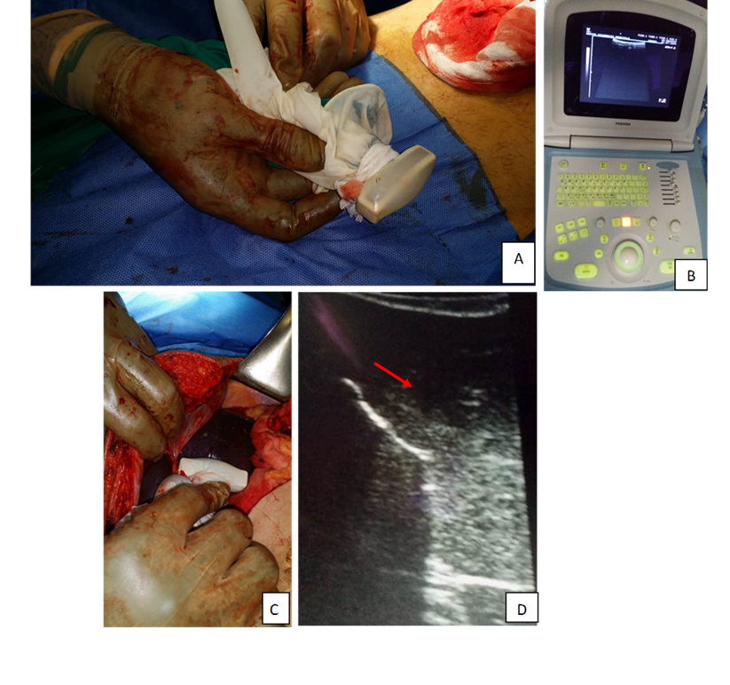
Fig (2) IOUS of the same patient. T-shape transducer in operative theater (A). Ultrasound machine (B). IOUS transducer was applied to liver surface (C) and 11X8 mm focal hepatic lesion was observed (red arrowed) (D)

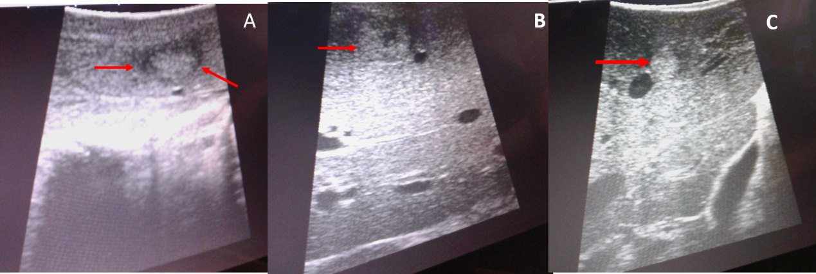
Fig (3) transverse plane gray-scale intraoperative US in three different patients scheduled for hepatic surgical resection. (A) a 1cm isoechoic hepatic focal lesionin left lateral liver segment (seg. 2-3) (red arrowed). (B) a 15 mm isoechoic lesion with central breakdown in segment IV (red arrowed) (C) a 4 mm focal lesion in left lobe segment II newly identified by IOUS (red arrowed) near the left hepatic vein (black arrow)

Pre-operative diagnostic imaging studies are required during the evaluation of patients considered for hepatic resection. MRI has been revolutionized by the addition of contrast agents and diffusion sequences. (6) Diffusion is a physical property known as Brownian motion that may be affected by the biophysical properties of tissues such as cell organization, density, microstructure, and microcirculation. Areas of restricted water diffusion are displayed as areas of high signal intensity. DWI can provide additional information in lesion detection when added to conventional MRI in the oncology patient. (14-16) In the present study, the DWI was added to the conventional Gd‐DTPA DCE‐MRI and a comparison study was conducted between DWI/DCE MRI and intraoperative US on histopathological basis.
In the current study, both MRI and IOUS detected 102 lesions. But IOUS detected an additional 16 lesions. In 2012; a meta-analysis done by van Kessel and his colleges et al. (17) described sensitivity of 84.5% (range: 69.7–94.0%) for MRI and 69.9% (range: 65.6–73.2%) for abdominal CT. This low sensitivity could be explained by several studies that shown that the accuracy of preoperative imaging decreases for liver lesions of <15 mm in size. (18) Often due to there was a time-lapse between the study and the surgery leading to surprising results during IOUS (19) and lastly technical factors of preoperative MRI that cause failure to depict these lesions like lesions that are small or located in areas vulnerable to the cardiac motion-related artifacts such as the liver dome and the left subphrenic region cannot be evaluated precisely by visual assessment or by using ADC measurements. (19,20) HCCs are also more difficult to identify in the background of cirrhosis because the cirrhotic liver may show diffusion restriction; and, DWI alone is therefore insufficient for accurate HCC detection and characterization. (21-23).
In our study, 16 additional lesions detected with IOUS in nine patients, but the planned surgical management was altered only in four patients (5.4%) out of 74 patients. The results of other studies have shown that IOUS findings modified surgical management in 11%–51% of patients. (18,19) Our results were similar to Sahani et al. (24) and Wagnetz et al. (25) who reported that the surgical management was altered after IOUS in less than 3% of patients.
The substantial advantages of intraoperative US are identification of hepatic vasculature, segmental localization, and demonstration of the proximity of hepatic lesions to hepatic or portal vessels. The drawbacks of intraoperative US include its lack of specificity, increased surgical procedure time, and cost. (24) In the current study, although IOUS depicted additional 16 lesions, it did not reveal seven lesions (5.6%) out of 125 lesions. These lesions were found at histopathologic analysis.
There were a few benign lesions were identified on histopathological basis in the resected specimens. Both preoperative MRI and IOUS performed poorly in correctly classifying them as benign concerning the clinical context at which they were interpreted like a dysplastic nodule, and focal nodular hyperplasia in a cirrhotic liver that was indistinguishable from HCC. This was like previous study (26).
Several limitations were found in the current study; first, IOUS was performed with prior knowledge of the MRI findings resulted in nonblinded image reading. Second, impossible precise comparison between IOUS and MRI cannot be done due to unavailability of ultrasound contrast medium in our locality.

Conclusion
IOUS is an essential and sensitive tool in hepatic surgical resection for primary hepatic tumors and CRLM. It has role in alteration of the planned surgical management in few patients and aiding in defining the nearby hepatic vasculature. Preoperative combined DWI/conventional DCE‐MRI is as sensitive as intraoperative US in depicting liver lesions before hepatic resection.

References
- Tarasik, A., Jaroszewicz, J., & Januszkiewicz, M. Surgical treatment of liver tumors – own experience and literature review. Clinical and Experimental Hepatology. 2017;1, 1–8. https://doi.org/10.5114/ceh.2017.65498
- You, M.-W., Kim, S. Y., Kim, K. W., Lee, S. J., Shin, Y. M., Kim, J. H., & Lee, M.-G. Recent advances in the imaging of hepatocellular carcinoma. Clinical and Molecular Hepatology. 2018; 21(1), 95–103. https://doi.org/10.3350/cmh.2015.21.1.95
- IjinJoo.The role of intraoperative ultrasonography in the diagnosis and management of focal hepatic lesions. Ultrasonography 2015; 34(4): 246-257. https://doi.org/10.14366/usg.15014.
- Sietses, C., Meijerink, M. R., Meijer, S., & van den Tol, M. P. The impact of intraoperative ultrasonography on the surgical treatment of patients with colorectal liver metastases. Surgical Endoscopy. 2010; 24(8), 1917–22. https://doi.org/10.1007/s00464-009-0874-8
- Damian, C.-D., Rednic, N., Munteanu, D., & Cazacu, M. (2014). The role of intraoperative ultrasound for the assessment of the focal liver lesions in patients with colorectal cancer. Medical Ultrasonography. 2014;6(2), 114–8. Retrieved from http://www.ncbi.nlm.nih.gov/pubmed/24791842
- Hoch, G., Croise-Laurent, V., Germain, A., Brunaud, L., Bresler, L., & Ayav, A. (2015). Is intraoperative ultrasound still useful for the detection of colorectal cancer liver metastases? HPB : The Official Journal of the International Hepato Pancreato Biliary Association, 17(6), 514–9. https://doi.org/10.1111/hpb.12393
- Ellebæk, S. B., Fristrup, C. W., & Mortensen, M. B. (2017). Intraoperative Ultrasound as a Screening Modality for the Detection of Liver Metastases during Resection of Primary Colorectal Cancer - A Systematic Review. Ultrasound International Open, 3(2), E60–E68. https://doi.org/10.1055/s-0043-100503
- Jrearz, R., Hart, R., & Jayaraman, S. (2015). Intraoperative ultrasonography and surgical strategy in hepatic resection: What difference does it make? Canadian Journal of Surgery. Journal Canadien de Chirurgie, 58(5), 318–22. https://doi.org/10.1503/CJS.016914
- Xu, P.-J., Yan, F.-H., Wang, J.-H., Lin, J., & Ji, Y. Added value of breath hold diffusion-weighted MRI in detection of small hepatocellular carcinoma lesions compared with dynamic contrast-enhanced MRI alone using receiver operating characteristic curve analysis. Journal of Magnetic Resonance Imaging. 2009; 29(2), 341–349. https://doi.org/10.1002/jmri.21650
- D'Onofrio M, Gallotti A, Martone E, Nicoli L, Mautone S, Ruzzenente A, et al. Is intraoperative ultrasound (IOUS) still useful for the detection of liver metastases? J Ultrasound. 2009; 12:144–147.
- Jarnagin WR, Bach AM, Winston CB, Hann LE, Heffernan N, Loumeau T, et al. What is the yield of intraoperative ultrasonography during partial hepatectomy for malignant disease? J Am Coll Surg. 2001; 192:577–583.
- Conlon R, Jacobs M, Dasgupta D, Lodge J. The value of intraoperative ultrasound during hepatic resection compared with improved preoperative magnetic resonance imaging. Eur J Ultrasound 2003; 16:211–216.
- Awad SS, Fagan S, Abudayyeh S, Karim N, Berger DH, Ayub K. Preoperative evaluation of hepatic lesions for the staging of hepatocellular and metastatic liver carcinoma using endoscopic ultrasonography. Am J Surg 2002; 184:601–604.
- Naganawa S, Sato C, Nakamura T, et al. Diffusion-weighted images of the liver: comparison of tumor detection before and after contrast enhancement with superparamagnetic iron oxide. J MagnReson Imaging 2005; 21:836–840.
- Ichikawa T, Haradome H, Hachiya J, Nitatori T, Araki T. Diffusion weighted MR imaging with a single-shot echoplanar sequence: detection and characterization of focal hepatic lesions. AJR Am J Roentgenol 1998; 170:397–402.
- Low RN, Gurney J. Diffusion-weighted MRI (DWI) in the oncology patient: value of breath hold DWI compared to unenhanced and gadolinium-enhanced MRI. J Magn Reson Imaging 2007; 25:848–858.
- van Kessel CS, Buckens CFM, van den Bosch MAAJ, van Leeuwen MS, van Hillegersberg R, Verkooijen HM. Preoperative imaging of colorectal liver metastases after neoadjuvant chemotherapy: a metaanalysis. Ann SurgOncol 2012; 19:2805–2813.
- Lordan JT, Stenson KM, Karanjia ND. The value of intraoperative ultrasound and preoperative imaging, individually and in combination, in liver resection for metastatic colorectal cancer. Ann R CollSurg Eng. 2011; l93:246–249.
- Cervone A, Sardi A, Conaway GL. Intraoperative ultrasound (IOUS) is essential in the management of metastatic colorectal liver lesions. Am Surg 2000; 66:611-61545.
- Nasu K, Kuroki Y, Sekiquchi R, Kazama T, Nakajima H Measurement of the apparent diffusion coefficient in the liver: is it a reliable index for hepatic disease diagnosis? Radiat Med. 2006; 24: 438–444.
- Schmid-Tannwald C, Jiang Y, Dahi F, Rist C, Sethi I, et al. Diffusion-weighted MR imaging of focal liver lesions in the left and right lobes: is there a difference in ADC values? AcadRadiol. 2013; 20: 440–445.
- Sandrasegaran K, Akisik FM, Lin C, Tahir B, Rajan J, Aisen AM. The value of diffusion-weighted imaging in characterizing focal liver masses. AcadRadiol 2009; 16:1208–1214.
- Lewis, S., Kamath, A., Chatterji, M., Patel, A., Shyknevsky, I., Dyvorne, H. A.,… Taouli, B. Diffusion-Weighted Imaging of the Liver in Patients With Chronic Liver Disease: Comparison of Monopolar and Bipolar Diffusion Gradients for Image Quality and Lesion Detection. American Journal of Roentgenology. 2015;204(1), 59–68. https://doi.org/10.2214/AJR.13.11695
- Sahani DV, Kalva SP, Tanabe KK, et al. Intraoperative US in patients undergoing surgery for liver neoplasms: comparison with MR imaging. Radiology 2004; 232:810–814.
- Wagnetz U Atri M Massey C et. al. Intraoperative ultrasound of the liver in primary and secondary hepatic malignancies: comparison with preoperative 1.5-T MRI and 64-MDCT. AJR Am J Roentgenol. 2011 Mar;196(3):562-8. doi: 10.2214/AJR.10.4729.
- Lee YH, Kim SH, Cho MY, Shim KY, Kim MS.
- Focal nodular hyperplasia–like nodules in alcoholic liver cirrhosis: radiologic-pathologic correlation. AJR 2007; 188:1343; [web]: W459–W463.

9/10/2018

