**Immunohistochemical expression of 5-Hydroxymethylcytosine (5hmC) and mutational analysis of IDH1 gene in patients with diffuse astrocytoma WHO grade II: clinical value and impact on survival**

Fatma Gharib1, Omnia Abd –El-Fattah1, Yomna zamzam2, Ayman Elsaka2 and Mona Mohamed Watany3

**1**Department of Clinical Oncology and Nuclear Medicine, Tanta University hospitals, Egypt

**2** Department of Clinical Pathology, Tanta University Hospitals, Egypt

**3** Department of Pathology, Tanta University Hospitals, Egypt.

[omniaabdelfattah@yahoo.com](mailto:omniaabdelfattah@yahoo.com)

**Abstract:** **Background:** Diffuse astrocytoma (WHO grade II) is a primary low-grade brain tumor of astrocytes. Although grade II astrocytoma is a relatively slow growing tumor, they have a high recurrence rate. In the 2016 edition of the WHO classification, gliomas are classified based not only on histopathologic appearance but also on molecular parameters. 5-Methylcytosine (5mC) in genomic DNA has important epigenetic functions in tumor biology. 5-Hydroxymethylcytosine (5hmC) is generated from 5mC by the action of the TET (Ten‐Eleven‐Translocation) enzymes. The highest levels of 5hmC were observed in terminally differentiated cells, while less differentiated tissue had very low 5hmC levels. Therefore, 5hmC levels were profoundly reduced in carcinoma. 5hmC regulation in malignant glioma may represent an important determinant of tumor differentiation and aggressive behavior. **Aim:** In the current study, we measured the level of 5hmC in diffuse astrocytoma WHO grade II and analyze its relationship with other molecular markers to investigate their potential roles as a prognostic indicator for astrocytoma patients. **Patients & Methods:** This prospective study included 55 adult patients with histologically confirmed grade II astrocytoma on the basis of WHO grading system. Those patients treated at Tanta University Hospitals through the period from January 2015 to June 2018. **Results:** In our study, low level of 5hmC was significantly associated with tumor size ≥5cm (P < 0.001), but there was nonsignificant correlation between 5hmc level and age, gender, location and extent of resection. Meanwhile, there is significant correlation between high level of 5hmC and presence of isocitrate dehydrogenase1(IDH1) mutation, low level KI67 and low level of P53 (P <0.001, P=0.007 and P=0.001 respectively). Kaplan-Meier analysis was used for Correlation between overall survival and 5hmC and revealed significant correlation between overall survival and 5hmC. The 3-year overall survival for patients with high 5hmC level was 88.7% compared to 31.7% for patients with low 5hmC level (P <0.001, 95%CI=4.8-448). **Conclusion:** Molecular classification of grade II astrocytoma may be used to delineate it.

**[**Fatma Gharib, Omnia Abd –El-Fattah, Yomna zamzam, Ayman Elsakaand Mona Mohamed Watany. **Immunohistochemical expression of 5-Hydroxymethylcytosine (5hmC) and mutational analysis of IDH1gene in patients with diffuse astrocytoma WHO grade II: clinical value and impact on survival.** *Cancer Biology* 2018;8(3):70-76]. ISSN: 2150-1041 (print); ISSN: 2150-105X (online). <http://www.cancerbio.net>. 12. doi:[10.7537/marscbj080318.12](http://www.dx.doi.org/10.7537/marscbj080318.12).

**Key words:** Diffuse astrocytoma WHO grade II.5-Hydroxymethylcytosine**.** isocitrate dehydrogenase1 mutation**.**

**1. Introduction**

Diffuse astrocytoma (WHO grade II) is a primary low-grade brain tumor of astrocytes (1). Although grade II astrocytoma is a relatively slow growing tumor, they have a high recurrence rate due to diffuse infiltration of brain tissue and an inherent malignant potential to transform into high-grade astrocytoma (2).

WHO classification system in 2007 has combined tumor nomenclature with an implied grading system so that the histologic diagnosis directly correlates with the histologic grade of the tumor (3). This classification system is not optimal because it is based on microscopic characteristics of gliomas which limit the adequate assessment of prognosis and appropriate planning of treatment. It becomes clear that different molecular alterations underlie the different glioma subtypes (4).

Therefore, World Health Organization (WHO) in 2016 breaks with the traditional principle of diagnosis based on histologic criteria only and incorporates molecular markers. This will involve a multilayered approach combining histologic features and molecular information in an "integrated diagnosis (5).

5-Hydroxymethylcytosine is a DNA pyrimidine nitrogen base. It is formed from the DNA base cytosine by adding a methyl group and then a hydroxy group. It is important in epigenetics, because the hydroxymethyl group on the cytosine can possibly switch a gene on and off. 5hmC is present with highest level in central nervous system (6).

5hmC is not only serving as an intermediate of DNA demethylation, but also acts as a stable epigenetic marker, abundant evidence detected that 5hmC globally decreased in most human malignancies, including gliomas (7).

5hmC reduction was closely associated with higher pathological grades and shortened survival of glioma patients (4).

In the current study, we measured the level of 5hmC in diffuse astrocytoma WHO grade II and analyze its relationship with other molecular markers to investigate their potential roles as a prognostic indicator for astrocytoma patients.

**2. Patients and Methods**

This prospective study included 55 adult patients with histologically confirmed grade II astrocytoma on the basis of WHO grading system (8). Those patients treated at Tanta University Hospitals through the period from January2015 to June 2018.

The inclusion criteria were grade II astrocytomas, intracranial localization and age ≥ 18 years old. Clinical data including gender, karnofasky scale performance status, age, tumor location (supra- or infratentorial), treatment (gross total resection, partial resection or biopsy), radiotherapy and survival all were tabulated.

Tumor specimens were obtained by surgical resection (including biopsy) written informed consent for use of the specimens. Formalin-fixed, paraffin-embedded specimens were pathologically examined.

All patients underwent computed tomography (CT) planning for three-dimensional conformal radiotherapy with 6 MV linear accelerator photon beams. Radiotherapy dose prescriptions was 54 Gy/30 fractions in 1.8 Gy per fraction, five fractions a week over 6 weeks, all patients received dehydrating measures during radiotherapy then gradually withdrawn After the completion of therapy, patients were observed at 3-month intervals during the first 3 years and at 6-month intervals thereafter. Survival was calculated from date of diagnosis to either date of death or last follow-up.

**Immunohistochemistry for 5hmC**

Active Motif, Rixensart, Belgium dilution 1:1000, P53 (DO-7, Dako, Carpinteria, CA, USA; dilution 1:100) and KI67 (MIB-1, Dako, Glostrup, Denmark; dilution 1:50) was performed in tissue sections of glioma samples.

In brief, Paraffin embedded tissue blocks were cut to 4μm sections and deparaffinized and rehydrated using xylene and ethanol; 3% H2O2 in phosphate buffered saline (PBS) was used to inactivate the endogenous peroxidase. The slides were blocked with goat serum to reduce nonspecific binding and then incubated with primary 5hmC (1:1000 dilution) antibody overnight at 4 °C. Diaminobenzidine (DAB) substrate was used for detection and hematoxylin was used for counterstaining. The samples were then mounted for visualization.

Each stained slide was individually reviewed and scored by 2 independent observers. All studied markers were nuclear localization. Microscopic areas with highest labeling intensity were chosen for calculation using image J analysis.

5hmC staining was scored using a 9-point scale on the basis of the product of staining intensity (no staining = 0, weak staining = 1, moderate staining = 2, strong staining = 3), and staining extent (% of positive cells; <5% = 0, 5%–30% = 1, 30%–60% = 2, >60% = 3). To facilitate statistical analysis, the samples were divided into 2 groups according to staining scores. Group 1 had no or weak staining with the scores of 0 to 3. Group 2 had moderate and strong staining with the scores from 4 to 9 (Figure 1). P53 or KI-67 labeling index (LI) was defined as the percentage of immunoreactive tumor cell nuclei (Figure 2). For statistical analysis, cutoff value of L1 for P53 and KI67 was 10% and 4% respectively according to previous reports.

|  |  |
| --- | --- |
|  |  |

**Fig. 1: Immunoexpression of 5hmC in: astrocytoma grade II exhibiting score 9 X 200**

|  |  |
| --- | --- |
| **H:\3.png** | **H:\4.png** |

**Fig.2: P53 score 18% (2a) and KI67 score 7% (2b) in diffuse astrocytomas grade II (X 200)**

**Methodology of detection ofIDH1 mutation**

* Genomic DNA was extracted from peripheral blood samples collected on K3EDTA using PureLink™ genomic DNA Kit (Carlsbad, USA) according to manufacturer illustration.
* DHT1 gene was amplified using 400 nM of each primer f: CGGTCTTCAGAGAA GCCATT and r: GCAAAATCACATTATTGCCAAC, 30 ng DNA and 12.5 ul of 2X taq based master mix in a total reaction volume of 25 ul. The thermal profile was initial denaturation at 95o followed by 35 cycles of 94o for 30 sec, 48oc for 1 min and 72oc for 1 min with final extension at 72oc for 10 min (biometra thermal cycler, Germany). The PCR product (fragment of 129 bp) was visualized by 2% agarose gel electrophoresis stained with ethidium bromide.
* The PCR product was purified before the cycle sequencing reaction using QIAquick PCR Purification Kit (Qiagen, GmbH, Germany) according to manufacturer protocol.
* Sanger Sequencing.
* The cycle sequencing reaction was carried out using big dye terminator sequencing kit v3.1 (applied biosystems, Foster City, USA), 3.2 pmol of the forward primer and 3 ul of the purified PCR product in total reaction volume of 20 ul. 25 cycles of denaturation at 96oc for10 sec, annealing at 48 oc for 5 sec and extension at 60 oc for 4 min were run. Sequences were determined using the ABI 3100 Genetic Analyzer (Applied Biosystems).

**Statistical analysis**

Survival was assessed and compared using Kaplan-Meier curves and log-rank test. P-values < 0.05 were considered being significant. Overall Survival was calculated from date of diagnosisto either date of death or last follow-up.

**3. Results**

**Clinicopathological features of the patients (Table1).**

This study includes 55 patients, diagnosed pathologically to have type II astrocytoma. The mean age was 40 years (range 19-61 years). Male patients represented 65.4% of all patients (36 out of 55) and female represented 34.6%.

Most of astrocytoma located in supratentorial area (61.8%) while 38.9% located in other sites. Tumor size was < 5cm in 36 patients (65.4%) and > 5cm in 19 patients (34.6%). Seventeen patients undergone gross total resection (GTR) representing 30.9% of all patients while 69.1% undergone subtotal resection (STR).

**Table (1): Clinicopathological features of the patients**

|  |  |
| --- | --- |
| **Characters** | **Number (%)** |
| Mean age, years (range) | 40 (19-61) |
| **Age**  >40  <40 | 27 (49)  28 (51) |
| **Gender**  Male  Female | 36 (65.4)  19 (34.6) |
| **Location**  Supratentorial  Other | 34 (61.8)  21 (38.9) |
| **Tumorsize**  ≥5cm  <5cm | 36(65.4)  19 (34.6) |
| **Extentofresection**  GTR  STR | 17 (30.9)  38 (69.1) |

Thirty-nine of the studied 55 patients had different IDH1 mutations. Table (2) summarized the types and frequencies of the detected mutations in IDH1 codon 132.

**Correlation between 5hmC level and clinicopathological features: Table (3)**

By Chi square analysis, low 5hmc score was significantly associated with tumor size ≥ 5cm (***P***< 0.001). While the correlation between 5hmc level and age, gender, location and extent of resection was non-significant.

**Table (2): The types and frequencies of the detected mutations in IDH1 codon 132**

|  |  |  |
| --- | --- | --- |
| **Nucleotide Change** | **Number** | **%** |
| G395A | 35/39 | 89.7% |
| C394T | 2/39 | 5.1% |
| C394A | 1/39 | 2.56% |
| C394G | 1/39 | 2.56 |

**Table (3): Correlation between 5hmC level and clinicopathological features.**

|  |  |  |  |
| --- | --- | --- | --- |
| **Prognostic factors** | **5hmC score** | | ***P* value** |
| **(0-3)** | **(4-9)** |
| **Age**  ≤40: >40 | 8:9 | 20:18 | 0.702 |
| **Gender**  Male: female | 13:4 | 23:15 | 0.360 |
| **Location**  Supratentorial: other | 8:9 | 26:12 | 0.132 |
| **Size**  **<**5 cm³: ≥ 5 cm³ | 0:17 | 36:2 | 0.001 |
| **Resection**  Total: subtotal | 6:11 | 11:27 | 0.638 |

**Correlation between 5hmC and other molecular markers: Table (4)**

By Chi square analysis, there was significant correlation between high level of 5hmC and presence of IDH1 mutation, low level KI67 and low level of P53 (**P**<0.001, **P**=0.007 and **P**=0.001 respectively).

**Table (4): Correlation between 5hmC and other molecular markers**

|  |  |  |  |
| --- | --- | --- | --- |
| **Molecular marker** | 5hmC score | | ***P* value** |
| (0-3) | (4-9) |
| **IDH1**  Mutation: wild type | 2:15 | 28:10 | <0.001 |
| **Ki 67 label index**  ≤4: >4 | 6:11 | 28:10 | 0.007 |
| **P53 label index**  ≤10:>10 | 6:11 | 31:7 | 0.001 |

**Survival analysis**

**Overall survival and 5hmC level:**

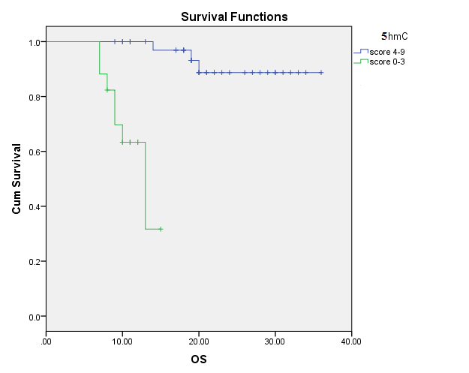

**Fig. 3: Correlation between OS and 5hmC**

There was significant correlation between OS and 5hmC level (Figure 3). The 3-year OS for patients with high 5hmC level was 88.7% compared to 31.7% for patients with low 5hmC level (**P**<0.001, **95%CI=4.8-448)**.

**Overall survival and IDH1 mutation status**

The 3-year OS for patients with IDH1 mutation was 95%, whilethe 3-year OS for patients with IDH1 wild type was34.4% (**P**<0.001, 95% **CI**= 3.9-31.6). IDH1 mutation significantly correlated with better survival (Figure 4).

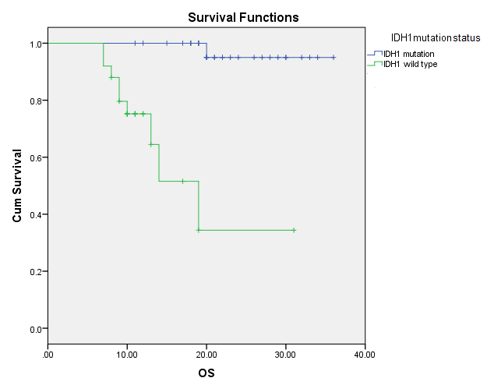

**Fig. 4: Correlation between OS and IDH1 mutation**

**Overall survivaland KI67**

The 3-year OS for patients with KI67≤4 was 89% while for patients with KI67>4, the3- year OS was 49.3% (**P**=0.004 **CI**=1.51: 23.8). KI67 label index ≤4 significantly associated with better survival (Figure 5).

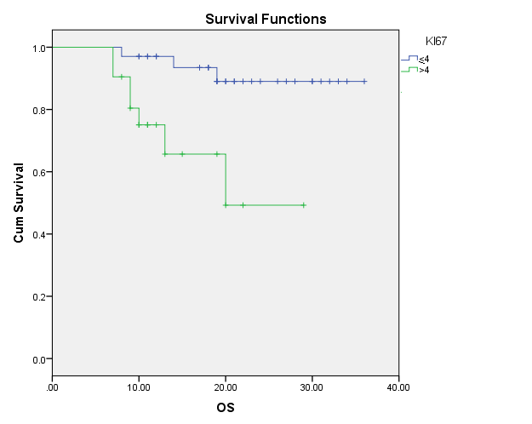

**Fig. 5: Correlation between OS and KI 67 mutation**

**Overall survival and P53**

The 3-year OS was 59.3% for patients with P53 >10 and 83% for patients with P53≤10 (**P**=0.06, **CI**=0.87-11.15). (Figure 6).

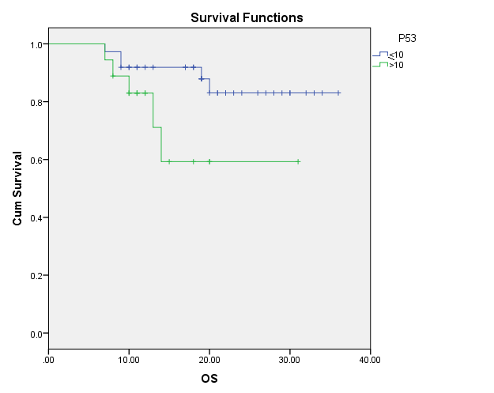

**Fig. 6: Correlation between OS and P53**

**4. Discussion**

The classification of central nervous system tumors has recently been shaped by a focus on molecular pathology rather than histopathology (9).

Diffuse gliomas are classified according to the 2016 World Health Organization (WHO) system by both histologic and molecular characteristics as isocitrate dehydrogenase (IDH)-mutant or IDH-wildtype astrocytomas; IDH-mutant and 1p19q-codeleted oligodendrogliomas; and IDH-mutant or IDH-wild type glioblastomas (10).

Isocitrate dehydrogenase (IDH) is a key factor in metabolism and catalyzes the oxidative decarboxylation of isocitrate. Mutations in IDH genes are observed in over 70% of low-grade gliomas (11), Importantly, IDH-wild type status in low-grade gliomas should be confirmed by IDH sequencing rather than relying on a negative immunohistochemical test for the most common mutant form of IDH, IDH1 R132H (12).

5-Methylcytosine (5 mC) in genomic DNA has important epigenetic functions in embryonic development and tumor biology. 5-Hydroxymethylcytosine (5 hmC) is generated from 5 mC by the action of the TET (Ten-Eleven-Translocation) enzymes and may be an intermediate to further oxidation and finally demethylation of 5 mC (13).

Maximal safe resection at the time of diagnosis for all patients with a presumed low-grade glioma, based upon reviews of the literature, have found a trend toward improved survival with this approach (13).

Currently, for patients with grade II or III gliomas who require postsurgical treatment, the preferred treatment consists of a combination of radiotherapy and chemotherapy. When deciding on the timing of postsurgical treatment with radiotherapy and chemotherapy, both clinical and molecular factors should be taken into account (15).

In the current study, we measured the level of 5-Hydroxymethylcytosine (5hm) in diffuse astrocytomas WHO grade II and analyze its relationship with other molecular markers to investigate their potential roles as a predictive indicator for astrocytoma patients and we observed that, there is significant correlation between OS and 5hmC. The 3-y OS for patients with strong 5hmc was 88.7% compared to 31.7% for patients with low 5hmc level and there is significant correlation between strong level of 5hmc and presence of IDH mutation, low level Ki 67 and low level of P 53 (P <0.001, P=0.007 and P=0.001 respectively). Consistent with our findings, Brent et al 2012 and Zhang et al 2016 used immunohistochemistry to evaluate 5hmC in a large series of gliomas and found that 5hmC reduction was closely associated with shortened survival of glioma patients (16).

The 3 y OS in the current study was 59.3% for patients with p53 >10 and 83% for patients with P53 <10 (P=0.06, CI=0.87-11.15) in contrast with Ständer et al, 2004 who did not exhibit this prognostic relevance this may be due to the difference in the WHO classification that the patients based on (17).

About 70.9% of the studied patients had mutated IDH1, this comes in concordance with Hartmann et al who found almost the same percentage among their studied patients (18).

In our study there is significant correlation between IDH1 and survival in contrast with Aibaidula et al 2017 who failed to detect this significance in low grade glioma (19). As consistent with our results the relevance of IDH1 mutations as a favorable prognostic marker has been demonstrated in several studies (20,22).

The 3-y OS for our patients with (IDH1 mutation and strong 5hmc) was 95% while 3y OS was 58.2% and 55.6% for patients (without IDH1 mutation and weak 5hmc) or other respectively (P=0.026, 95%CI=1.1-4.5). Significant correlation which agrees with other studies (22-25).

**5. Conclusion**

Low level of 5hmC was associated with reduced survival intype II astrocytoma, suggesting that the mechanisms responsible for regulating 5hmC may represent a potential future therapeutic target. Molecular classification may delineate diffuse infiltrating astrocytomas into distinct pathogenic and prognostic groups, which could aid in representing new the rapeuticstrategies.

**Funding**

This study was done by members of Tanta University Hospitals and faculty of medicine, depending on the available facilities in both institutions.

**Conflict of interest**

The authors declare that they have no conflict of interest.

**Ethical approval**

The study was approved by the Research Ethics Committee of Tanta faculty of medicine, Egypt.

**Informed consent**

Informed consent was obtained from all patients and all clinical investigations were conducted according to the ethical and legal standards.

**References**

1. Forst DA, Nahed BV, Loeffler JS, Batchelor TT. Low-grade gliomas. Oncologist. 2014 Apr; 19(4):403-13.
2. Lind-Landström T, Habberstad AH, Sundstrøm S, Torp SH. Prognostic value of histological features indiffuseastrocytomas WHO grade II. Int J Clin Exp Pathol. 2012; 5(2): 152-8.
3. Louis DN, Perry A, Reifenberger G, von Deimling A, Figarella-Branger D, Cavenee WK, Ohgaki H, Wiestler OD, Kleihues P, Ellison DW. The2016World Health Organization Classification of Tumors of the Central Nervous System: a summary. Acta Neuropathol. 2016 Jun;131(6):803-20.
4. Zhang F, Liu Y, Zhang Z, Li J, Wan Y, Zhang L, Wang Y, Li X, Xu Y, Fu X, Zhang X, Zhang M, Zhang Z, Zhang J, Yan Q, Ye J, Wang Z, Chen CD, Lin W, Li Q.5- hydroxymethylcytosine loss is associated with poor prognosis for patients with WHO grade II diffuse astrocytomas. Sci Rep. 2016 Feb 11;6:1-14.
5. Masui K, Mischel PS, Reifenberger G. Molecular classification of gliomas. Handb Clin Neurol. 2016;134:97-120.
6. Renciuk D1, Blacque O, Vorlickova M, Spingler B. Crystal structures of B-DNA dodecamer containing the epigenetic modifications 5-hydroxymethylcytosine or 5-methylcytosine. Nucleic Acids Res.2013 Nov;41(21):9891-900.
7. Sun W, Zang L, Shu Q, Li X. From development to diseases: the role of 5hmC in brain. Genomics. 2014 Nov;104(5):347-51.
8. Louis DN, Ohgaki H, Wiestler OD, Cavenee WK: WHO Classification of Tumors of the Central Nervous System, 4th edition IARC: Lyon; 2007.
9. Rogers TW, Toor G, Drummond K, Love C, Field K, Asher R, Tsui A, Buckland M, Gonzales M. The 2016 revision of the WHO Classification of Central Nervous System Tumours: retrospective application to a cohort of diffuse gliomas. J Neurooncol. 2017 Dec 7. 131(6):803-20.
10. Louis DN, Ohgaki H, Wiestler OD, Cavenee WK (WHO Classification of Tumours of the Central Nervous System, 5th edition IARC, Lyon; 2016.
11. Wang J, Zhao YY, Li JF, Guo CC, Chen FR, Su HK, Zhao HF, Long YK, Shao JY, To Ss, Chen ZP. IDH1 mutation detection by droplet digital PCR in glioma. Oncotarget. 2015 Nov 24;6(37):39651-60.
12. Kraus TF, Globisch D, Wagner M, Eigenbrod S, Widmann D, Münzel M, Müller M, Pfaffeneder T, Hackner B, Feiden W, Schüller U, Carell T, Kretzschmar HA. Low values of 5-hydroxymethylcytosine (5hmC), the "sixth base," are associated with anaplasia in human brain tumors. Int J Cancer. 2012 Oct 1;131(7):1577-90.
13. Michael J Strong, Juanita Garces, Juan Carlos Vera, Mansour Mathkour, Noah Emerson and Marcus L Ware. Brain Tumors: Epidemiology and Current Trends in Treatment Brain Tumors Neurooncol 2015, 1(1):1000-102.
14. Cohen AL, Holmen SL, Colman H. IDH1 and IDH2 mutations in gliomas. Curr Neurol Neurosci Rep. 2013 May;13(5):345-351.
15. van den Bent MJ, Smits M, Kros JM, Chang SM. Diffuse Infiltrating Oligodendroglioma and Astrocytoma. J Clin Oncol. 2017 Jul 20;35(21):2394-2401.
16. Brent A. Orr1, Michael C. Haffner, William G. Nelson, Srinivasan Yegnasubramanian. Decreased 5-Hydroxymethylcytosine Is Associated with Neural Progenitor Phenotype in Normal Brain and Shorter Survival in Malignant Glioma. Charles G. Eberhart. PLoS ONE 2012; 7(7):1-11.
17. Ständer M, Peraud A, Leroch B, Kreth FW. Prognostic impact of TP53 mutation status for adult patients with supratentorial World Health Organization Grade IIastrocytoma or oligoastrocytoma: a long-term analysis. Cancer. 2004 Sep; 1028-35.
18. Hartmann, C. et al. Type and frequency of IDH1 and IDH2 mutations are related to astrocytic and oligodendroglial differentiation and age: a study of 1,010 diffuse gliomas. Acta Neuropathol 2009; 118, 469–474.
19. Aibaidula A, Chan AK, Shi Z, Li Y, Zhang R, Yang R, Li KK, Chung NY, Yao Y, Zhou L, Wu J, Chen H, Ng HK. Adult IDH wild-type lower-grade gliomas should be further stratified. Neuro Oncol. 2017 Oct 1;19(10):1327-1337.
20. Sanson M, Marie Y, Paris S, Idbaih A, Laffaire J, Ducray F, El Hallani S, Boisselier B, Mokhtari K, Hoang-Xuan K, Delattre JY. Isocitrate Dehydrogenase 1 Codon 132 Mutation Is an Important Prognostic Biomarker in Gliomas. J Clin Oncol 2009; 27: 4150-4154.
21. Reuss DE, Sahm F, Schrimpf D, Wiestler B, Capper D, Koelsche C, Schweizer L, Korshunov A, Jones DT, Hovestadt V, Mittelbronn M, Schittenhelm J, Herold-Mende C, Unterberg A, Platten M, Weller M, Wick W, Pfister SM, von Deimling A. ATRX and IDH1-R132H immunohistochemistry with subsequent copy number analysis and IDH sequencing as a basis for an "integrated" diagnostic approach for adult astrocytoma, oligodendroglioma and glioblastoma. Acta Neuropathol. 2015 Jan;129(1):133-46.
22. Ichimura K, Narita Y, Hawkins CE. Diffusely infiltrating astrocytomas: pathology, molecular mechanisms and markers. Acta Neuropathol. 2015 Jun;129(6):789-808.
23. Kraus TF, Globisch D, Wagner M, Eigenbrod S, Widmann D, Münzel M, Müller M, Pfaffeneder T, Hackner B, Feiden W, Schüller U, Carell T, Kretzschmar HA. Low values of 5-hydroxymethylcytosine (5hmC), the "sixth base," are associated with anaplasia in human brain tumors. Int J Cancer. 2012 Oct 1;131(7):1577-90.
24. Müller T, Gessi M, Waha A, Isselstein LJ, Luxen D, Freihoff D, Freihoff J, Becker A, Simon M, Hammes J, Denkhaus D, zur Mühlen A, Pietsch T, Waha A. Nuclear exclusion of TET1 is associated with loss of 5-hydroxymethylcytosine in IDH1 wild-type gliomas. Am J Pathol. 2012 Aug;181(2):675-83.
25. Zhang F, Liu Y, Zhang Z, Li J, Wan Y, Zhang L, Wang Y, Li X, Xu Y, Fu X, Zhang X, Zhang M, Zhang Z, Zhang J, Yan Q, Ye J, Wang Z, Chen CD, Lin W, Li Q. 5-hydroxymethylcytosine loss is associated with poor prognosis for patients with WHO grade II diffuse astrocytomas. Sci Rep. 2016 Feb 11;6:20882.

9/25/2018