**Adjuvant chemotherapy for elderly (>65 years) breast cancer patients: a retrospective study**

Soha Mohammed Talima MD

Department of Clinical Oncology & Nuclear Medicine, Kaser Alainy Faculty of Medicine, Cairo University, Egypt

[soha_talima@hotmail.com](mailto:soha_talima@hotmail.com)

**Abstract: Background:** The substitution of docetaxel for doxorubicinthus creating a non-anthracycline combination for adjuvant therapy has proven its activity. However, scares data about the efficacy and toxicity of these different regimens are present in older patients with breast cancer. Therefore, we performed a retrospective analysis comparing Anthracycline based chemotherapy versus regimens with no Anthracyclines in the adjuvant chemotherapy regimens. **Patients and methods**: Charts of all consecutive elderly patients aged 65 years or more with operable BC referred to our institution between 2008 and 2015 were reviewed. Patients had stage I, II, or III breast cancer; and received adjuvant chemotherapy consisting of CMF, an Anthracycline-based regimen (FAC or FEC and TC. Data DFS, overall survival and toxicities of these regimens were calculated. **Results**: One hundred twenty patients were included, with a mean age of 69 (range 65–91); with stages: I (5%), II (27.5%), III (57.5%), unknown stage (10%). Forty-eight percent of the patients received anthracycline-based regimen, 30.8% received CMF and 20.8% received TC. The DFS was as follow 73 months for TC group,43.5 months for Anthracyclines (FAC) and 36.5 months for CMF group (p < 0.08). Five-year OS was 88% for TC, 85% for Anthracyclines, and 77% for CMF (p < 0.6). Moreneutropenia experienced more during Anthracycline based chemotherapy (22.4%) as compared TC (16%) or CMF (13.5%). Treatment delays due to myelosuppression occurred more frequently in patients receiving Anthracycline based regimens. **Conclusion:** TC was associated with a superior DFS, OS as compared with Anthracycline based chemotherapy and CMF.

[Soha Mohammed Talima. **Adjuvant chemotherapy for elderly (>65 years) breast cancer patients: a retrospective study.** *Cancer Biology* 2018;8(3):24-30]. ISSN: 2150-1041 (print); ISSN: 2150-105X (online). <http://www.cancerbio.net>. 5. doi:[10.7537/marscbj080318.05](http://www.dx.doi.org/10.7537/marscbj080318.05).

**Keywords:** Chemotherapy-elderly-Anthracycline-Taxanes

**1. Introduction**

Increasing age is one of the factors responsible for increased incidence of breast cancer (1). Every eighth female has the probability of developing breast cancer over the course of her lifetime. Furthermore, as the number of older individuals is increasing worldwide, there is an increased probability of individuals with breast cancer.

Most of the older women with breast cancer present with unfavorable stage distribution (2), large tumor size, more involvement of lymph nodes and more metastasis. This all is due to the delay in the diagnosis of breast cancer (3,4). Therefore, the systematic adjuvant therapy is necessary in the treatment of such patients which results in the improved survival rate and stops its recurrence. However, there is the limited availability of data about the feasibility along with the risks and benefits of adjuvant chemotherapy due to limited presentation of this group of people in trials. (5,6).

In the treatment of early and advanced stage breast cancer, anthracycline based combination regimens are the primary class of chemotherapy regimens. Taxanes can be added to Anthracycline based combinations to get improved long term results (7-9), But there is a need for alternative therapy as the rare but potentially fatal complications (like cardiomyopathy) are associated with the use of Anthracyclines (10-12). In the context of the US Oncology trial, the feasibility of excluding Anthracyclines from adjuvant therapy was studied. According to the most recent result of this trial, docetaxel and cyclophosphamide (TC) combination was found to be superior to doxorubicin and cyclophosphamide (AC) both in terms of overall survival (OS) and disease free survival (DFS). Till now, this is the only trial showing the superiority of regimen which is free from Anthracycline as compared to one which is based upon Anthracycline (13).

This representative study is meant to evaluate the results of different chemotherapeutic regimens used in older patients with breast cancer and to compare Anthracycline containing regimens versus taxanes based regimens without anthracyclines in this age group.

**2. Material and methods:**

This study is based upon Breast Cancer patients older than 65 years treated at Clinical Oncology Department, Cairo University during the time period from 2008 to 2013. Our study was approved by the institutional ethical committee. Inclusion criteria for this analysis were: (1) >65 years of age at diagnosis, (2) stage I, II, or III breast cancer, and (4) adjuvant chemotherapy consisting of CMF (cyclophosphamide, methotrexate, and 5-fluorouracil), FAC or FECor AC (doxorubicin and cyclophosphamide), TC (Docetaxel and cyclophosphamide). Patients who received anthracycline-taxanes based treatment were excluded from analysis.

Representative data which were reviewed includes: sex, comorbid medical problems, stage of tumor (as defined by the sixth edition of the AJCC staging system) (14), histopathological subtypes, estrogen and progesterone receptor status, HER-2 status and tumor grades.

Data were collected regarding the occurrence and type of surgery, type of chemotherapy (CMF or Anthracycline based chemotherapy or taxanes based chemotherapy) and complications which occurred after their implementation. Treatment delay, reduction in dose and discontinuity in treatment were also reported.

**Statistical analysis:**

Data were described as number and percentages or means ± standard deviation. Disease free survival (DFS) was calculated from the date of diagnosis to the date of recurrence or death. Overall survival (OS) was calculated from the date of diagnosis to the date of death. Kaplan Meier method was used to calculate DFS and OS. Log rank test was used to compare survival between groups. A P value <.05 was considered significant. Statistical analysis was performed using SPSS, version 14.0. (SPSS Inc, Chicago, Illinois).

**3. Results:**

A total of 260 Breast Cancer patients of age 65 years and above were seen in consultation at Clinical oncology department between the time period from 2008-2015. Out of these, 120 patients were included in our analysis. The remaining patients (n=140) either didn’t receive chemotherapy or received Anthracycline- taxanes based treatment or their data were incomplete.

Patients included in this study had an average age of 69.72 years (SD 5.236; range 65–91). Their median age was 69 years. Out of these 120 patients, 57 (47.4%) were older than 70 years old. Ninety-nine percent (n=119) of the total patients were female. Fifty-eight percent (n=68) of patients were diagnosed with comorbid diseases. Almost half (49.2%) of the patients were obese.

The distribution of the stages of breast cancer was as follows: 5% Stage I (n=6), 27.5% were at Stage II (n=33), 57.5% were at Stage III (n=69) and 10% (n=12) with unknown stage. More than 71% of the tumors were positive for the receptors of estrogen while 63% were positive for the receptors of progesterone. Twenty percent (n=25) of them were HER2-neu positive tumors. For only 38 % of the total cases, KI 67 was available and it was high (more than 14%) in 23.3% of tumors. Based on this data, the distribution of the breast cancer subtypes is as follow: luminal A disease was presented in 25% (n=30), luminal B in 26.7% (n=32), luminal disease (classified as luminal disease due to either unavailability of KI 67 data or Her2 neu status) in 22.5% (n=27), triple negative in 6.7% (n=8) patients.

Sixty percent (n = 72) of patients got adjuvant chemotherapy while the neo-adjuvant chemotherapy was given to 40% (n = 48) of breast cancer patients. Anthracycline based regimens were received by fifty-eight patients (48.3%); 25 patients (20.8%) had received taxane based regimens while the CMF regimen was received by37 patients (30.8%).

Seventy-three percent (29/37) of patients receiving CMF received the standard doses which was defined as cyclophosphamide 600 mg/m2 IV, methotrexate 40 mg/m2, 5-fluorouracil 600 mg/m2 IV for 8 cycles. Empirical dose reductions were done in twenty-seven percent of patients received CMF because of concern about toxicity.

Among patients treated with FAC (or FEC) 63.8% (37/58) received standard doses defined as doxorubicin60 mg/m2 IV (or Epirubicin with a dose of 75 mg/m2) and cyclophosphamide 600 mg/m2 IV for six cycles. Dose reductions were due to Empirical dose reductions in 11 (11/21) and development of toxicity in 10 (10/21).

Of the patients who received TC, 76% (19/25) received standard doses defined as docetaxel of 75mg/m2 IV and cyclophosphamide 600 mg/m2 IV for 4 cycles. Sixteen percent (7/44) of patients required dose reductions during treatment secondary to toxicity. Eleven percent (5/44) had therapy abbreviated because of toxicity. Toxicity was the only cause of dose reductions in these patients.

The figure (1) is showing the percent of patients who did not complete the planned number of chemotherapy cycles. Fifty-five percent (n = 66/120) of the total patients had therapy abbreviated (figure 2),45.5% (n = 30/66) during the FAC or FEC group and 33.3% (n =22/66) during the CMF and 21.2% (14/66) during TC treatment. Patient preference, grade 3 neutropenic fever, and grade 3 fatigue were the three most common reasons for treatment discontinuation.

In 57.5% (n=69/120) of patients, side effects related to Chemotherapy were detected. Table (2) is showing the common toxicities experienced during the treatment. Grade 3 or 4 toxicity constituted the majority which was present in 57.9% (n= 40/69)) of patients. Hematological toxicities were the most common (57.9%, n=40/69) in the form of neutropenia, thrombocytopenia and anemia. Other common grade 3 or 4 non hematological toxicities included fatigue and nausea.

Of the total group of patients, neutropenia experienced more during Anthracyclinebased chemotherapy (22.4%,13/58) as compared to patients received TC (16%, 4/25) or CMF (13.5, 5/37). Primary prophlaxis with growth factors were used in 8 (n=32%) patients receiving TC. Secondary prophylaxis with Filgrastim was given for patients developed febrile neutropenia, or in case of treatment delays due to neutropenia.

Table (1) Patient’s characteristics

|  |  |
| --- | --- |
| **Patient’s characteristics** | **Total No. = 120** |
| **Age**  Mean±SD  Median  Range | 69.72 **±** 5.23  69  65-91 |
| **Sex**  Female  Male | 118 (96.5%)  2 (3.4%) |
| **Body mass index**  Normal  Overweight  Obese I  Obese II  Obese III | 9 (7.5%)  30 (25%)  24 (20%)  18 (15%)  17 (14.2) |
| **Comorbidities**  DM  HTN  DM+HTN  Cardiac  No | 12 (27.5%)  29 (40%)  20 (17.2%)  11 (9.2%)  32 (55.2%) |
| **Stage**  I  II  III  unknown | 27 (22.5%)  12 (10%)  69 (57.5%)  12 (10%) |
| **Histology**  IDC  ILC  Other (medullary) | 105 (87.5%)  5 (4.2%)  2 (1.7%) |
| **Immunohistochemistry**  **ER status**  Positive  Negative  Unknown  **PR status**  Positive  Negative  Unknown  **HER2-NEU**  Positive  Negative  Unknown  **KI 67**  High  Low  Unknown | 86 (71.7%)  27 (22.5%)  7 (5.8%)  76 (63.3%)  36 (30%)  8 (6.7%)  25 (20.8%)  64 (53.3%)  31 (25.8%)  28 (23.3%)  18 (15%)  74 (61.7%) |
| **Molecular subtype**  Luminal A  Luminal B  Luminal (undefined)  Her2 positive disease  Triple negative disease  Unknown | 30 (25%)  32 (26.7%)  27 (22.5%)  8 (6.7%)  8 (6.7%)  15 (12.5%) |
| **Chemotherapy regimens**  Anthracyclines based regimens  Taxanes based regimens (TC)  CMF | 58 (48.3%)  25 (20.8%)  37 (30.8%) |
| **Relapse (systemic and/or local)**  Yes  No | 39 (32.5%)  81 (67.5%) |

**Survival outcomes**

The median follow up period was23 months (1–109 months). Relapse developed in 32.5% (n= 39/120). The progression developed during this follow up period was as follows: 2 patients (6.3%) suffered from local relapse, 1 (3.1%) patient developed contralateral disease (confirmed to be metastatic from the primary disease) and 36 patients (25%) experienced distant metastasis. The distribution of most common metastatic sites was as follows: bone in 16 patients, liver in 10 patients, lung in 6 patients, pleura in 3 patients and central nervous system in 1 patient.

The median disease-free survival (DFS) was as follow 73 months for TC group,43.5 months for Anthracyclines (FAC) and 36.5 months for CMF group (p < 0.08) (Fig. 2). Five-year overall survival (OS) was 88% for TC, 85% for Anthracyclines, and 77% for CMF (p < 0.6) (Fig. 3).

Two patients in the Anthracycline group had congestive heart failure. No patients experienced this complication in other groups.

**Table (2) Toxicities of different chemotherapeutic regimens**

|  |  |  |  |
| --- | --- | --- | --- |
| **Total number of toxicities** | N= 69/120 | | |
| **Chemotherapy regimens** | TC* | Anthracyclines | CMF# |
| **Number and Percent of Toxicity** | 14/25 (56%) | 35/58 (60.3%) | 20/37 (54%) |
| **Hematological:** | **10 (40%)** | **20 (34.4%)** | **10 (27%)** |
| Anemia | 4 (16%) | 4 (6.8%) | 5 (13.5%) |
| Neutropenia | 4 (16%) | 13 (22.4%) | 5 (13.5%) |
| Thrombocytopenia | 2 (8%) | 3 (5.1%) | 0 (0%) |
| **Non-hematological** | **4 (16%)** | **15 (25.8%)** | **10 (27%)** |
| Fatigue | 1 (4%) | 10 (17.2%) | 8 (21.8%) |
| Nausea | 2 (8%) | 3 (5.1%) | 1 (2.7%) |
| Diarrhea | 1 (4%) | 2 (3.4%) | 1 (2.7%) |

*TC= Taxotere (Docetaxel), Cyclophosphamide

#CMF= Cyclophosphamide, Methotrexate, Fluorouracil

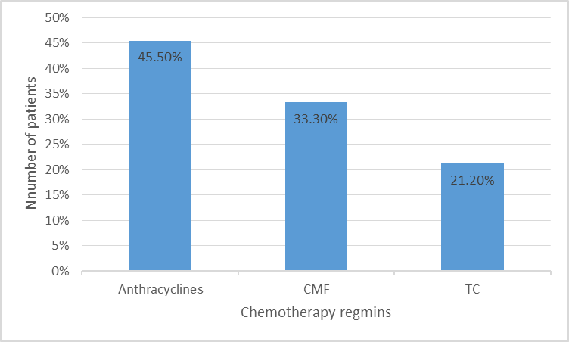Figure (1) the percent of patients who did not complete the planned number of chemotherapy cycles.

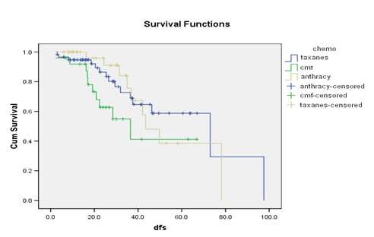

Figure (2). Disease-free survival (DFS). TC, docetaxel/cyclophosphamide; CMF, cyclophosphamide / methotrexate/fluorouracil.

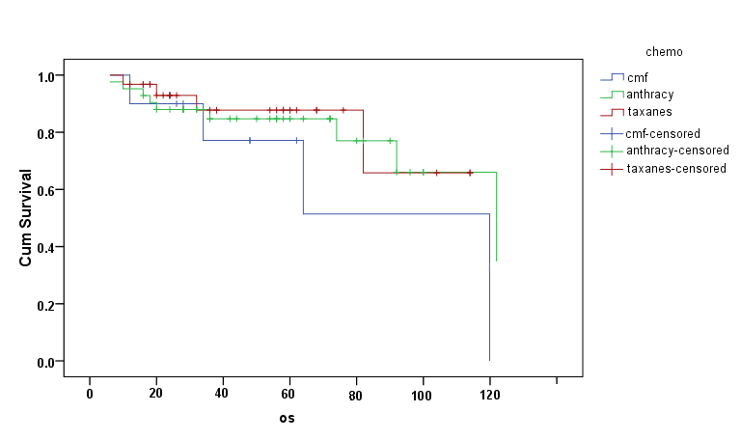

Figure (3). Overall survival (OS). TC, docetaxel/cyclophosphamide; CMF, cyclophosphamide/methotrexate/fluorouracil.

**4. Discussion**

Improved adjuvant regimens which are considered better than the four cycles of AC (Anthracycline) have either added the taxane to AC or the taxane has been given after AC (15,16). Thus the Anthracycline remains the backbone of the adjuvant chemotherapy in breast cancer. However, attempts towards replacing Anthracyclines with Taxanes have proven its effectiveness.

In our study, we evaluated TC regimen with Anthracycline based chemotherapy and CMF chemotherapy. A significant improvement in DFS for TC (73 months for TC group, 43.5 months for Anthracyclines (FAC) and 36.5 months for CMF group (p < 0.08) as compared to Anthracycline based chemotherapy (FAC or FEC) and CMF chemotherapy was observed. Moreover, patients received TC had non-statistically significant improvement in overall survival (88% for TC, 85% for Anthracyclines, and 77% for CMF (p < 0.6) when compared to Anthracyclines and CMF.

The docetaxel substitution for doxorubicin was studied previously in a study by US intergroup. The older age constituted 16% (n=160) of cases of this trial. Their results demonstrated that in patients of breast cancer, the four cycles of TC regimen have been shown to be more effective than the four cycles of AC regimen. It showed that TC is equally effective for hormone receptor positive as well as negative disease. In the same trial, during an exploratory analysis, it was seen that TC was equally effective in HER2-Postive as well as HER2-Negative disease. This result was consistent with the observations made during BCIRG 001 trial (7).

The toxicity profile of various adjuvant therapies was also given in our study. Hematological toxicities were more common than other toxicities. Neutropenia was more common during Anthracycline treatment than during TC treatments, this may be due to primary prophylaxis with Filgistrim in the TC patient group. Prophylactic antibiotics were not used routinely during this trial. In a prospective pharmacological study of patients receiving AC, an age-related decrease in nadir absolute neutrophil count was observed. After 4 cycles of AC, patients aged 65 years or older had significantly lower nadir absolute neutrophil count than those younger than age 65 (p=0.01) (17). So, consideration of empiric growth factor in older patients receiving AC is warranted.

Coinciding with our results, a study by Karavasilis, et al found that elderly patients received Anthracycline chemotherapy developed high incidence of grade 3and 4 hematological toxicity (32%), although this did not result in increased mortality (18). Similarly, older patients (>65 years old) were more likely to develop grade 3 and 4 non-hematological toxicity in the form of fatigue, mucositis, and sensory neuropathy. It was seen that the discontinuation rates of chemotherapy were higher in the Anthracycline group as compared to CMF and TC chemotherapy because of increased toxicity (neutropenia and fatigue). So, as we mentioned above the use of growth factors may decrease hematological complications and increases tolerance of older patients receiving chemotherapy.

The two patients who were on FAC regimen had congestive heart failure while nothing like this happened in the patients who were on TC or CMF regimen. There is a probability of 1% of the incidence of cardio toxicity in the patients who had four cycles of AC while TC is not known to be cardiotoxic. Older women are at increase drisk to develop cardiac toxicity when compared to younger patients. In a retrospective study of 12500 womenwith invasive breast cancer showing a 6 percent 5-year cumulative incidence of congestive heart failure (CHF) along women aged 65to 74 and 11 percent among women aged ≥ 75 years. In the other hand, younger women had acumulative incidence of 1-2 percent of CHF (19).

**Conclusions**

It is very difficult to take a decision about offering chemotherapy to older patients and one must consider the toxicity which develops as a result of it. In our study, although the biology of breast cancer in older people is more favorable but their presentation with advanced stage of the disease counterbalances this favor. About 54.5% of the patients were presented with stage III disease which indicates that the need of chemotherapy is of main importance.

Our study confirms that TC regimen as an adjuvant chemotherapy in elderly patients with breast cancer is more effective than anthracycline or CMF combination chemotherapy with less toxicity and that anthracyclines are not required for superior antitumor efficacy.

**List of abbreviations**

TC: Docetaxel and cyclophosphamide; AC: Doxorubicin and cyclophosphamide; OS: Overall survival DFS: Disease free survival; FAC: Fluorouracil, doxorubicin and cyclophosphamide; FEC: Fluorouracil, epirubicin and cyclophosphamide; CHF: Congestive heart failure

**Acknowledgements**:

We would like to thank our dear patients, as well as, our dep. IT employees.

**Conflicts of interest:**

Author declared no conflicts of interest

**References**

* 1. Armstrong K, Eisen A, Weber B: Assessing the risk of breast cancer. N Engl J Med. 2000; 342(8): 564–571.
  2. Bergman L, Kluck HM, van Leeuwen FE, et al. The influence of age on treatment choice and survival of elderly breast cancer patients in south-eastern Netherlands: a population-based study. Eur J Cancer. 1992;28A (8–9):1475–1480.
  3. Botteri E, Bagnardi V, Goldhirsch A, Viale G, Rotmensz N. Axillary lymph node involvement in women with breast cancer: does it depend on age? Clin Breast Cancer. 2010;10(4):318–321.
  4. Greer LT, Rosman M, Charles Mylander W, et al. A prediction model for the presence of axillary lymph node involvement in women with invasive breast cancer: a focus on older women. Breast J. 2014;20(2): 147–153.
  5. Hutchins LF, Unger JM, Crowley JJ, Coltman CA Jr, Albain KS. Underrepresentation of patients 65 years of age or older in cancer-treatment trials. N Engl J Med. 1999; 341(27):2061–2067.
  6. Muss HB, Woolf S, Berry D, et al. Adjuvant chemotherapy in older and younger women with lymph node-positive breast cancer. JAMA. 2005; 293(9):1073–1081.
  7. Martin M, Pienkowski T, Mackey J, et al: Adjuvant docetaxel for node positive breast cancer. N Engl J Med. 2005; 352:2301-2313.
  8. Citron ML, Berry DA, Cirrincione C, et al: Randomized trial of dose-dense versus conventionally scheduled and sequential versus concurrent combination chemotherapy as postoperative adjuvant treatment of node-positive primary breast cancer: First report of Intergroup trial C9741/Cancer and Leukemia Group B trial 9741. J Clin Oncol. 2003; 21:1431- 1439.
  9. Hudis C, Citron M, Berry D, et al: Five-year follow-up of INT C9741: Dose-dense (DD) chemotherapy (CRx) is safe and effective. Presented at the 2005 San Antonio Breast Cancer Symposium December 8-11, San Antonio, TX (abstract 41).
  10. Von Hoff DD, Layard MW, Basa P, et al: Risk factors for doxorubicin-induced congestive heart failure. Ann Intern Med. 1979; 91:710-717.
  11. Ibrahim NK, Buzdar AU, Asmar L, et al: Doxorubicin-based adjuvant chemotherapy in elderly breast cancer patients: The M.D. Anderson experience, with long-term follow-up. Ann Oncol. 2000; 11:1597-1601.
  12. Fumoleau P, Roche´ H, Kerbrat P, et al: Long term. cardiac toxicity after adjuvant epirubicin-based chemotherapy in early breast cancer: French Adjuvant Study Group results.2006; Ann Oncol 17:85-92.
  13. Jones S, Holmes FA, O'Shaughnessy J, Blum JL, et al. Docetaxel with Cyclophosphamide Is Associated with an Overall Survival Benefit Compared with Doxorubicin and Cyclophosphamide: 7-Year Follow-Up of US Oncology Research Trial 9735. J Clin Oncol. 2009; Mar 10;27(8):1177-83.
  14. AJCC
  15. Roche´ H, Fumoleau P, Spielmann M, et al. Sequential adjuvant epirubicin-based and docetaxel chemotherapy for node-positive breast cancer patients: The FNCLCC PACS 01 trial. J Clin Oncol. 2006; 24:24:5664-5671.
  16. Mamounas EP, Bryant J, Lembersky B, et al: Paclitaxel after doxorubicin plus cyclophosphamide as adjuvant chemotherapy for node-positive breast cancer: Results from NSABP B-28. J Clin Oncol; 2005; 23:3686-3696.
  17. Dees EC, O’Reilly S, Goodman SN, Sartorius S, Levine MA, Jones RJ, Grochow LB, Donehower RC, Fetting JH: A prospective pharmacologic evaluation of age-related toxicity of adjuvant chemotherapy in women with breast cancer. Cancer Invest. 2000; 18(6): 521–529.
  18. Karavasilis V, Papadimitriou C, Gogas H, Kouvatseas G, Pentheroudakis G, Koutras A, Christodoulou C, et al. Safety and Tolerability of Anthracycline-Containing Adjuvant Chemotherapy in Elderly High-Risk Breast Cancer Patients. Clin Breast Cancer. 2016; Aug;16(4):291-298.e3.
  19. Bowles EJ, Wellman R, Feigelson HS, Onitilo AA, Freedman AN, Delate T, Allen LA, Nekhlyudov L, Goddard KA, Davis RL, et al. Risk of heart failure in breast cancer patients after anthracycline and trastuzumab treatment: a retrospective cohort study. J Natl Cancer Inst 2012; 104: 1293-1305.

8/4/2018