Prognostic Impact of EGFR and CK5/6 as Basal-Markers in Triple-Negative breast Cancers

Rasha Abd El-Ghany Khedr¹, Emad Sadaka¹, Khairia Gawish¹and Safinaz H. El-Shorbagy²

¹Histopathology Department, Faculty of Medicine, Tanta University, Egypt
²Clinical Oncology Department, Faculty of Medicine, Tanta University, Egypt.
khedr_rasha@yahoo.com

Abstract: Background: Triple-negative breast cancer (TNBC) is defined by the loss of expression of estrogen receptor (ER), progesterone receptor (PR), and human epidermal growth factor 2 (HER2neu). It is a high risk group of breast cancer that lacks the benefit of specific therapies and is classified into aggressive basal subtype and less aggressive non-basal subtype. Objective: To examine the expression of basal markers; including epidermal growth factor receptor (EGFR), cytokeratin 5/6 (CK5/6) among triple-negative breast cancer cases and correlate the results with those of Ki-67expression and with the clinic pathological parameters and survival for determining prognosis and therapeutic strategies Materials and Methods: A total of 97 TNBC cases from January 2012 to July 2015based on ER, PR, and the HER2neu negativities were included in the study. The tissue specimens were stained by immune histochemistry for detection of EGFR, CK5/6 and Ki-67. Statistical analysis was done using the SPSS software version 21 for comparison between basal and non-basal TNBC. Results: About 75out of the whole cohort (77.3%) of studied TNBC specimens showed positive basal markers EGFR and or CK5/6 together with high proliferation rate detected by Ki-67 and poor prognostic parameters including overall survival (OS) and progression free survival (PFS). Conclusion: The “Triple-negative” status cannot be used alone as a surrogate for the “basal expression”. Basal subtypes of TNBC show more aggressive behavior and could better predict breast cancer survival.
[Rasha Abd El-Ghany Khedr, Emad Sadaka, Khairia Gawish and Safinaz H. El-Shorbagy, Prognostic Impact of EGFR and CK5/6 as Basal-Markers in Triple-Negative breast Cancers Cancer Biology 2017;7(X)]. ISSN: 2150-1041 (print); ISSN: 2150-105X (online). http://www.cancerbio.net.
[Rasha Abd El-Ghany Khedr, Emad Sadaka, Khairia Gawish and Safinaz H. El-Shorbagy. Prognostic Impact of EGFR and CK5/6 as Basal-Markers in Triple-Negative breast Cancers. Cancer Biology 2018;8(2):102-109. ISSN: 2150-1041 (print); ISSN: 2150-105X (online). http://www.cancerbio.net. 14. doi:10.7537/marscbj080218.14.

Key words: TNBC, EGFR, CK5/6, Ki-67, Basal markers

1. Introduction
The most common malignancy among women is breast cancer (1). Based on histopathological characteristics, a various range of invasive breast cancer types has been defined. (2). Unfortunately, this way of categorizing breast tumors fails to predict prognosis and treatment possibilities (3).
Further studies using receptor tatus of breast cancers dentified by immunohistochemistry IHC), which categorized patients according to strogen receptors ER),progesterone receptors PR) and human epidermal growth factor 2 receptor (HER2), allowed the classification of breast cancer into five main groups. Luminal A and B, HER2 rich, normal breast-like and basal like breast carcinoma (4, 5). Basal like breast carcinomas had a more aggressive clinical behavior and had received considerable attention over the last few years (6).
Triple-negative breast cancers (TNBCs) lack expression of the estrogen receptor, progesterone receptor and do not over express human epidermal growth factor 2 receptor, accounts for about 15% of breast cancers (7). They are biologically aggressive neoplasms with poor prognosis, frequent relapses and visceral metastasis (8), often occur at a younger age group (9) and are of two subtypes, basal and non-basal (10).
Although the triple-negative phenotype has been considered for long time as sufficient to identify the ‘basal-like’ tumors, increasing evidence has shown that the terms ‘basal-like’ and ‘triple-negative’ are not synonymous (4, 11).
Immunohistochemical marker panels that have been proposed to define basal-like breast cancers include beside loss expression of all ER, PR, and HER2 (‘triple-negative’ phenotype); in addition to expression of EGFR and/or CK5/6 (12), the non-basal phenotype was defined as lacking expression of these two markers (10).
Epidermal growth factor receptor also known as HER1 plays roles in cell proliferation, migration, and protection against apoptosis (13). Its over expression appears to be a later event in tumorigenesis (14) and is frequently observed in TNBC where it occurs in up to 80 % of all cases (15). Many studies had found significant correlations between EGFR immunoreactivity and worse prognosis (16, 17).
It is clearly obvious that triple-negative cancers must be accurately classified in clinical practice for the purposes of determining prognosis and therapeutic strategies for pathologists and oncologists.
Therefore, there is still a need for new clinically applicable biologic markers for TNBC in order to identify the patients with poor prognosis, and alternative treatment options needed (18).
The proliferation marker Ki-67 has been confirmed by Urruticoechea et al. (19), as an independent predictive and prognostic factor in early breast cancer. It had been detected that breast cancer with high expression of Ki-67 experience a better response to chemotherapy (20, 21), but is associated with poor prognosis (22, 23).
The objective of this work was to discuss the differentiation between basalandnon-basalsubtypes of triple-negative breast cancers, depending on EGFR and CK5/6by immunohistochemical analysis and to clarifypractical implications of these diagnoses in correlation with Ki67 expression and clinico-pathological parameters, OS and PFS.

2. Materials and Methods
Between January 2012 and July 2015, 97 patients with TNBC in Clinical Oncology Department, Tanta University Hospital and Tanta Cancer Institute were enrolled. Eligible patients were followed up until March2016. At the time of analysis, the median follow up duration was 29months (Range; 6–42 months).
Patients fulfilled the following criteria:- age older than 18 years, Eastern Co-operative Oncology Group (ECOG) of ≥ 1, average bone marrow reserve (WBC count 3.5 x 10⁹/L, neutrophil count 1.5 x10⁹/L, platelets 100 x 10⁹/L, and HG 9.5 g/dL), adequate renal function (creatinine clearance level 60 mL/min, serum creatinine ≤ 1.5mg/dl and blood urea ≥ 25mg/dl ) and average liver function (transaminases less than 3 folds upper normal limit, and serum bilirubin level below 1.5 mg/dL).
Patients were ineligible for this study if they received neoadjuvant chemotherapy or tumors more than 5 cm and those had metastases to distant sites, or patients who were pregnant or had dementia, altered mental status, or any psychiatric condition that would prohibit the understanding or signing of informed consent. Also, patients presented with secondary malignancy or uncontrolled medical illness (e.g. persistent immune-compromised states, uncontrolled infection, and clinically significant cardiac disease) were noteligible.
After the approval of the Research Ethics Committee of Tanta University, Faculty of medicine rendering of a singed informed consent from all patients before treatment initiation.
After initial diagnosis of breast carcinoma, we assigned eligible patients for initiation of chemotherapy 2-4 weeks post-surgery, after confirmation of ER, PR and HER/2 negativity paraffin blocks were collected.
Surgery:
All patients underwent surgery either breast conservative or modified radical mastectomy with submission of a tumor tissue block with a minimum of 1 cm² of tumor for immunohistochemical analysis.
Chemotherapy:
Doxirubcin at a dose of 60 mg/m²; cyclophosphamide at a dose of 600 mg/m2every 21 days for four cycles followed by taxanes for another four cycles in the form of weekly paclitaxel 80mg/m2 or three weekly docitaxel 100mg/m2.
Radiotherapy:
Radiotherapy consisted of fractionated, conformal, conventional radiation given at a total dose of 50 Gy with daily dose of 2 Gy. Treatment was delivered 5 days a week for a total of 5 weeks. Followed by a boost to the lumpectomy cavity of 10Gy in five fractions for breast conservative patients. Radiation therapy was delivered to all patients operated by breast conservative surgery and node positive patients who were operated by modified radical mastectomy.
Paraffin blocks collection:
Paraffin blocks of the eligible patients were retrieved from the archives of Pathology Department, Faculty of Medicine, Tanta University and Tanta Cancer Institute. Hematoxylin and eosin (H & E) sections were prepared from all blocks to confirm their histological diagnosis. Histological type and pathological stage were determined according to World Health Organization (WHO) classification (24). Grading was performed according to Ellis modification of Scarff-Bloom and Richardson grading system (25). Informed consents for the investigational research using the patient's paraffin blocks were obtained.
Immunohistochemistry
Immunohistochemistry was operated on formalin-fixed paraffin-embedded with optimal thickness 4 mm, sections mounted on positively charged slides. The slides were stained for EGFR, CK5/6and Ki-67.
Tissue sections were deparaffinized and rehydrated in gradedalcohols to distilled water, next they were incubated in 3% hydrogen peroxide for 10 min to block the endogenous peroxidase. Slides were immersed in acetic acid and heated in microwave at 95˚ C for 30 min for antigen retrieval then left to cool down at room temperature and washed with phosphate buffered saline (PBS) then they were incubated overnight at room temperature with the following primary antibodies: EGFR (Diagnostic Bio Systems: Species rabbit, clone SP9, Isotype IgG1/kappa), CK5/6 (BioGenex: Species rabbit, clone EPR1600Y, Isotype IgG), and Ki-67 (BioGenex: Species mouse, clone Ki-88, Isotype IgG1/kappa). The staining was completed using the streptavidin–biotin complex detection method. D.A.B. was applied for 10 to 15 minutes and reaction was aborted by application of distilled water. Counter stain Hematoxylin was applied for 2 minutes and washed with distilled water. The slides of negative controls prepared by excluding the primary antibody and replacing it with phosphate buffer solution (PBS) were included in each run (26).
Ten randomly chosen fields of each slide were scored for the percentage of immunopositivity for EGFR, CK 5/6 and Ki– 67.
EGFR was scored as positive if more than 1% of the tumor cells showed membrane reactivity and CK 5/6 was scored as positive if any cytoplasmic and /or membranous staining was observed (27). Tenpercent was used as cut off Ki – 67nuclear positivity, therefore nuclear positivity more than 10% of tumor cells was considered as high proliferative rate (28).
Statistical Analysis
SPSS 21.0 software version (SPSS, Inc.) was used for data analysis. Baseline characteristics of the 2 patient groups were compared using chi-square/ Fischer exact tests. Rates of overall-survival (OS) were calculated from the time of initial treatment (date of surgery) to the date of the last follow-up or death. While Progression-free survival (PFS) was the time lapsed from the date of initiation of treatment to the date of first evidence of any disease progression or death in the absence of disease progression. Kaplan–Meier method was used for estimating survival and logranktest was used to compare between the different prognostic factors. Mean and standard deviation were used to estimate the quantitative data. Statistical tests used were two sided and the significance was considered at values of P ≤ 0.05.

3. Results
According to the frequency of the basal markers (EGFR and or CK 5/6) expression; 75 (77.3%) out ofthe97 triple negative breast cancers studied were of basal subtype. These cases were positive for either EGFR or CK 5/6 or both. Twenty two cases (22.7 %) were negative for both markers (Table1).
The tumor characteristics of the studied triple negative breast cancer patients have been demonstrated in (Table2, Figs.1, 2).
Concerning treatment protocol: all patient received the same high risk chemotherapy protocol, only 4 cases didn’t complete there 8 cycles (3 cases received 6 cycles and one case received 7 cycles) due to hematologic manifestations in 2 cases, 1 case due to elevated liver enzymes and the other case due to neurological toxicity. As regard surgery 45 cases operated by breast conservative surgery while other cases operated by modified radical mastectomy and hence radiation therapy has received to 91 cases without interruption of radiation therapy course, the other 9 cases wasn’t indicated to radiotherapy
The mean age was 49.1 years (range 24 – 68years) for all TNBC cases examined. It was 47.97 years for basal subtype and 53.04 years for non-basal cases. The predominant histopathological type was invasive carcinoma (83/ 97, 86.6%). Sixty four of these cases were basal and 19 were non-basal. Tumor sizes ranging from 1 to 5cm (mean2.9cm). There wasn’t statistically significant difference (p=0.96) as regard size between basal (mean 2.97cm) and non-basal (mean 2.75) subtypes. The commonest histological grade was grade 3 (65/97, 67 %) followed by grade 2 (30/97, 30.9%) and lastly grade 1 (2/97, 2.1%).
Most of basal cases were of grade 3 (56/75 cases), while nearly 60% of non-basal cases were of grades1 and 2 (13/22 cases), with significant difference between basal and non-basal cases (p=0.001). Lympho-vascular invasion was detected in 33 cases (34%) with prevalence in basal subtype (25/33- 75.8%), compared to non-basal cases (8/33-24.2%). Lymph node metastases were noted in 92cases (94.8%), with significant statistical difference between basal and non-basal tumors (p=0.006). Distant metastases and local recurrences occurred in 29 cases (29.9%). Most of events were basal (27/75cases) (p=0.03), total number of deaths were 21 cases (21.6%), whereas the majority were basal-like breast cancer (20/75) (p=0.04).
High proliferative rate detected by Ki-67 nuclear immunostaining was found in 77 out of the 97examined cases (79.4%). Sixty three of them were basal and14 were non-basal subtype; which showed also significant statistical difference (p=0.04) (Table2).
Overall survival and progression free survival of whole patient series were illustrated in Figs 3 and 5.OS and PFS in basal compared to non- basal cases showed significant statistical difference (p=0.04 and 0.03 respectively) as illustrated in Figs 4 and 6.

Table 1: Immunohistochemical expression of basal markers in Triple-negative breast cancer cases.
Immunohistochemical basal marker | Number (%)
EGFR+ and/or CK 5/6 + | 75 (77.3)
- EGFR + CK 5/6 +  - EGFR + CK 5/6 –  - EGFR - CK 5/6 + | 37 (38.1)  13 (13.4)  25 (25.8)
EGFR - CK 5/6 - | 22 (22.7%)

Table 2: Clinicopathological characteristics of Triple-negative breast cancer cases.
Parameters | Basal subtype  EGFR and/or CK 5/6 | Non-basal subtype  -ve for both | P value
Age (years)  <50 (N 44)  >50 (N 53) | 40(41.2)  35(36.1) | 4(4.1)  18(18.6) | 0.004*
Histopathological diagnosis  Invasive duct carcinoma (N83)  others (N14) | 64(66)  11(11.3) | 19(19.6)  3(3.1) | 0.90
Tumor size (cm)  <2 (N 18)  ≥2(N 79) | 14(14.4)  61(62.9) | 4(4.1)  18(18.6) | 0.96
Tumor grade  G1 (N2)  G2 (N30)  G3 (N65) | -  19(19.6)  56(57.7) | 2(2.1)  11(11.3)  9(9.3) | 0.001*
Lympho-vascular invation (LVI)  Present (N33)  Absent (N64) | 25(25.8)  50(51.5) | 8(8.2)  14(14.4) | 0. 49
Lymph node metastasis  Absent (N18)  1-3 (N31)  ≥4 (N48) | 7(7.2)  23(23.7)  45(46.4) | 11(11.3)  8(8.2)  3(3.1) | 0.04*
Ki-67  >10% (N77)  ≤10% (N20) | 63(64.9)  12(12.4) | 14(14.4)  8(8.2) | 0.04*
N=Number; *P value ≤ 0.05 significant; NST= no special type; G= grade.
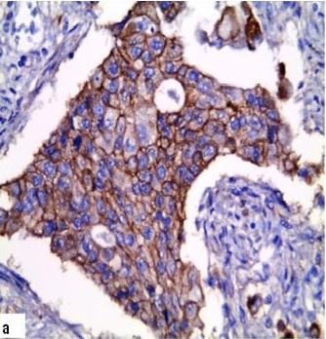 | 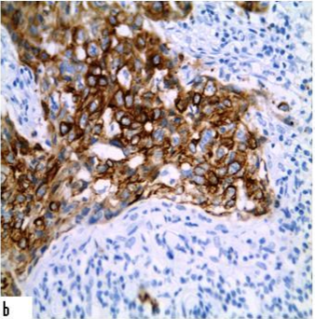 | 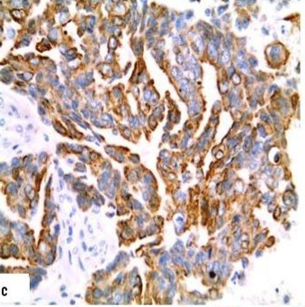
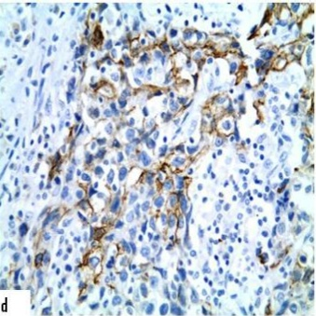 | 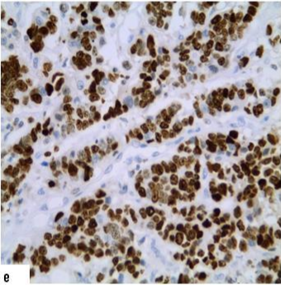
Fig. (1): Immunohistochemical expression of basal tumors x400: (a) Prominent membranous expression of EGFR in invasive carcinoma of NST G3; (b) Prominent membranous expression of EGFR in medullary carcinoma G3; (c) Strong cytoplasmic and membranous CK5/6expression in invasive carcinoma of NST G3; (d) Positive cytoplasmic and membranous CK5/6immunostainingin medullary carcinoma G2; (e) High (nearly95%) positive nuclear expression of Ki – 67 in invasive carcinoma of NST G3.
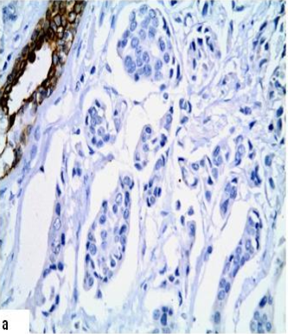 | 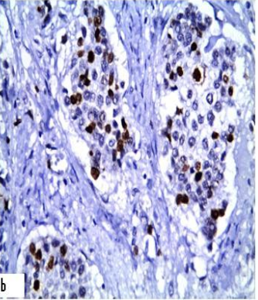
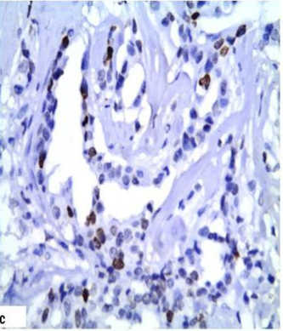
Fig. (2): Immunohistochemical expression of non-basal tumors x400: (a) Negative CK5/6 expression in invasive carcinoma of NST G2, while positive expression is found nearby breast duct (internal positive control); (b) High (about 40%) positive nuclear expression of Ki – 67 in invasive carcinoma of NST G2; (c) Low nuclear expression of Ki – 67 (<10%) in tubular carcinoma.

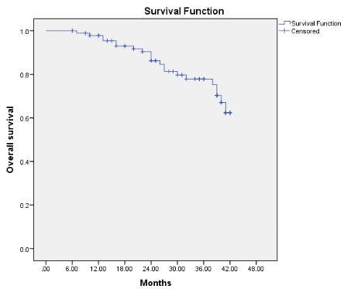
Fig. 3: Overall survival analysis among 97 TNBC cases.
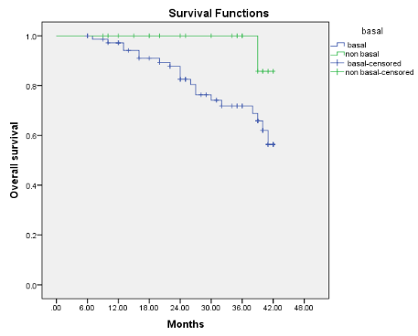
Fig. 4: Log rank test comparing overall survival of basal cases expressing EGFR expressing none of these markers (p=0.04andor CK5/6and non- basal cases)

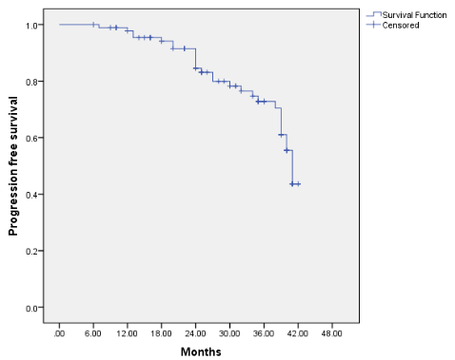
Fig. 5: Progression free survival analysis among 97 TNBC cases.
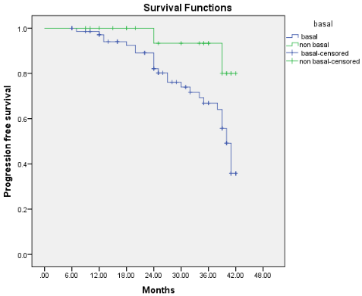
Fig. 6: Log rank test among 97 TNBC cases comparing progression free survival of basal cases expressing EGFR and or CK5/6 and non-basal cases expressing none of these markers (p=0.03).

4. Discussion
TNBCs defined as ER, PR and HER2negativity they are heterogeneous group of breast tumors that possess distinctive pathological, clinical features, prognosis and response to treatment (29, 30).
There are 2 subtypes of TNBCs an aggressive basal-like and a less aggressive nonbasal-likesubtype (31, 32).
Most of triple negative cancers are of basal-like phenotype (33) and the majority of tumors expressing ‘basal’ markers are triple-negative (34, 35). However, Bertucci et al (34) showed that only 71% of triple-negative cancers were of basal-like subtype by gene expression profiling and concerning molecular basal- like tumors 77% were triple-negative.
In the present study, 75out of97 examined cases (77.3%) of TNBCs were basal subtype (i.e. positive for either EGFR (13) or CK 5/6 (25) or both (37), with prevalence of CK 5/6. This is in contrast to the findings of Rao et al. (28) who showed that the majority of the “triple negative” patients have tumors of the basal subtype with prominent EGFR expression. However, this subtype of breast carcinomas could potentially benefit from the novel EGFR-targeted therapeutic strategies (36).
The present study showed that triple-negative breast cancer cases were correlated with age, histopathological type, tumor size, tumor grades, lympho-vascular invasion, lymph node metastases, basal markers and Ki-67 expression. The commonest age group in the present study was >50 years (53/97) followed by <50 years (44/97) and the mean age for TNBC was 51 years; similarly, the common age in TNBC observed by Tan et al (37) was >40 years and the mean age of TNBC observed by Rao et al (28 ) was 46.8 years.
The majority of the triple – negative breast cancers were of invasive ductal carcinomas (83/97- 85.6%) and the remaining were twelve medullary carcinomas (12.3%) and two tubular carcinomas (2.1%), while previous researchers showed that the triple negative tumors can occur in any histological subtypes of breast cancers, with possible implications on their pathogeneses, progressions and prognoses (38, 39).
The commonest tumor size in the present study ranged from 1 to 5 cm (79/97) and did not significantly correlate with basal markers as observed by other investigators 28, 37). In the present study EGFR and CK5/6 didn't show significant correlation with age as observed by other studies (28).
Most of the TNBCs in the present study, were grade 3 (65/97) and significantly correlated with basal subtype, similar to Rao et al. (28) who showed that grade 3 was the commonest grade among their studied cases. This possibly due to higher grades and invasive pattern. Grade 2 TNBCs have also been observed in the present study in both subtypes basal and non-basal as observed by others (41). On the other hand there was no positive association with lympho-vascular invasion.
Lymph node metastases were noted in 79 cases (81.4%), which was statistically correlated with EGFR and or CK5/6 (p=0.04). some authers (28, 40, 42) claimed that axillary lymph node metastases has no significant statistical correlation with basal markers (28).
Distant metastases and local recurrences were detected in 29 patients. The majority of distant metastasis cases was basal and showed high expression of Ki-67 with worse outcome. We detected high expression of Ki-67 in 77/97 (79.4%) of TNBC cases; of them 63 (64.9%) were of basal subtype similar to Rao et al. (28) findings. Kaem et al. (43) found that TNBC with high Ki-67 demonstrated a pattern of early recurrence, whereas the low Ki-67 subgroup did not didn’t experience this patternat all. This suggests that an early recurrence pattern of TNBC may be attributed to high Ki-67 expression which means a high proliferation potential.
Overall survival and progression free survival was significantly worse in basal subtype patients when compared to non-basal subtype. This is in co-ordinance with Cheang et al (35) who reported high rate of relapse among basal like subtype of their TNBC cases which explain poor prognosis of this group despite aggressive chemotherapy.
Foulkes et al. (44) observed also that TNBC which expresses EGFR, CK5/6, or both may have a worse outcome than the TNBCs that are negative for both of these markers. Furthermore, Conforti et al. (45) noticed that true basal group defined as HER-2negative, ER and PR negative and either EGFR and/or CK5/6 positive experienced less benefit from chemotherapy than the group negative for all these markers.
From the forgoing, TNBC cases which express basal markers (EGFR and or CK5/6) and high expression of Ki-67 were associated with poor outcome and worse OS and PFS. Therefore, TNBC should be identified by basal markers in clinical practice. However, there is still no final definition for basal-like cancers and still no clear clinical indication for the routine identification of these tumors (46).
Thus, TNBC patients with positive basal markers and high expression of Ki-67should be followed-up more frequently to guard for any recurrence.

References
- Jemal A, Siegel R, Ward E, et al: Cancer statistics. CA Cancer J Clin, 2007; 57: 43-66.
- Tavassoli FA and Devilee P: World health organization of tumors. Pathology and genetics of tumors of the breast and female genital organs.2003; Lyon, IARC press. Quoted from: Asian Pacific Journal of Cancer Prevention, 2013; 14: 1037-1041.
- de Ruijter TC, Veeck J, de Hoon JPJ, et al: Characteristics of triple-negative breast cancer. J Cancer Res ClinOncol, 2011;137: 183-92.
- Rouzier R, Perou CM, Symmans WF, et al.: Breast cancer molecular subtypes respond differently to preoperative chemotherapy. Clin Cancer Res, 2005; 11: 5678–5685.
- Reis-Filho JS, Westbury C, Pierga JY: The impact of expression profiling on prognostic and predictive testing in breast cancer. J ClinPathol, 2005; 59: 225-231.
- Brenton JD, Carey LA, Ahmed AA, et al: Molecular classification and molecular forecasting of breast cancer: ready for clinical application? J ClinOncol, 2005, 23 (29): 7350–60.
- Kaplan HG, Malmgren JA, Atwood MK: Impact of triple negative phenotype on breast cancer prognosis. Poster presented at: 29th Annual San Antonio Breast Cancer Symposium; 2006; December 14-17, San Antonio, TX.
- Ismail-Khan R and Bui MM: A review of triple-negative breast cancer. Cancer Control, 2010; 17: 173-6.
- Brouckaert O, Wildiers H, Floris G et al: Update on triple-negative breast cancer: prognosis and management strategies. Int J Womens Health 2012; 4: 511–520.
- Kutomi G, Ohmura T, Suzuki1 Y et al: “Clinicopathological characteristics of basal type breast cancer in triple-negative breast cancer.” Journal of Cancer Therapy, 2012; 3: 836–840.
- Badve S, Dabbas DJ, Schnitt SJ, et al: Basal-like and triple-negative breast cancers: a critical review with an emphasis on the implications for pathologists and oncologists. Mod Pathol. 2011; 24:157-67.
- Cheang MC, Voduc D, Bajdik C, et al: Basal-like breast cancer defined by five biomarkers has superior prognostic value than triple-negative phenotype. Clin Cancer Res 2008;14:1368–1376.
- Hynes NE, Lane HA.: ERBB receptors and cancer: the complexity of targeted inhibitors. Nat Rev Cancer.2005;5:341–54.
- Hobday TJ, Perez EA: Molecularly targeted therapies for breast cancer. Cancer Control.2005;12:73–81.
- Bouchalova K, Cizkova M, Cwiertka K, et al: Triple negative breast cancer–current status and prospective targeted treatment based on HER1 (EGFR), TOP2A and C-MYC gene assessment. Biomed Pap Med Fac Univ Palacky Olomouc Czech Repub. 2009;153:13–7.
- Viale G, Rotmensz N, Maisonneuve P, et al: Invasive ductal carcinoma of the breast with the “triplenegative” phenotype: prognostic implications of EGFR immunoreactivity. Breast Cancer Res Treat. 2009;116:317–28.
- Liu D, He J, Yuan Z, et al: EGFR expression correlates with decreased disease-free survival in triple-negative breast cancer: a retrospective analysis based on a tissue microarray. Med Oncol.2012;29:401–5.17.
- Gluz O, Liedtke C, Gottschalk N, et al: Triplenegative breast cancer–current status and future directions. Ann Oncol, 2009;20:1913-1927.
- Urruticoechea A, Smith IE, Dowsett M: Proliferation marker Ki-67 in early breast cancer. J ClinOncol, 2005; 23:7212-7220.
- Petit T, Wilt M, Velten M, et al: Comparative value of tumour grade, hormonal receptors, Ki-67, HER-2 and topoisomerase II alpha status as predictive markers in breast cancer patients treated with neoadjuvantanthracycline-based chemotherapy. Eur J Cancer 2004, 40:205-211.
- Jones RL, Salter J, A’Hern R, et al: Relationship between oestrogen receptor status and proliferation in predicting response and long-term outcome to neoadjuvant chemotherapy for breast cancer. Breast Cancer Res Treat 2010, 119:315-323.
- Brown RW, Allred CD, Clark GM, et al: Prognostic value of Ki-67 compared to S-phase fraction in axillary node-negative breast cancer. Clin Cancer Res 1996, 2:585-592.
- Jung SY, Han W, Lee JW, Ko E, et al: Ki-67 expression gives additional prognostic information on St. Gallen2007 and Adjuvant! Online risk categories in early breast cancer. Ann Surg Oncol 2009, 16:1112-1121.
- Lakhani S, Ellis I, Schnitt S, et al.: WHO Classification of Tumors of the Breast, 4th ed. Lyon, IARC Press, 2012.
- Elston CW, Ellis IO: Pathological prognostic factors in breast cancer. The value of histological grade in breast cancer: Experience from a large study with long-term follow-up. Histopathology. 1991, 19: 403-10.
- Sood N and Nigam JS: Correlation of CK5 and EGFR with Clinicopathological Profile of Triple-Negative Breast Cancer. Pathology Research International. Volume 2014, Article ID 141864, 6 pages http://dx.doi.org/10.1155/2014/141864.
- Choccalingam C, Rao L, Rao S: Clinico-pathological characteristics of triple negative and non-triple negative high grade breast carcinomas with and without basal marker (CK5/6 and EGFR) expression at a rural tertiary hospital in India. Breast cancer (Auckl). 2012; 6:21-9.
- Rao C, Shetty J, Kishan Prasad HL: “Immunohistochemical profile and morphology in triple—negative breast cancers,” Journal of Clinical and Diagnostic Research, 2013;7(7): 1361–1365.
- Prat A, Parker J, Karginova O, et al: Phenotypic and molecular characterization of the claudin-low intrinsic subtype of breast cancer. Breast Cancer Res 2010, 12: R68.
- Prat A and Perou CM: Deconstructing the molecular portraits of breast cancer. Mol Oncol 2011, 5:5-23.
- Rakha EA, El-Rehim DA, Paish C, et al: Basal phenotype identifies a poor prognostic subgroup of breast cancer of clinical importance. Eur J Cancer, 2006; 42:3149-3156.
- Yamamoto Y, Ibusuki M, Nakano M, et al: Clinical significance of basal-like subtype in triple-negative breast cancer. Breast Cancer, 2009; 16:260-267.
- Banerjee S, Reis-Filho JS, Ashley S, et al: Basal-like breast carcinomas: clinical outcome and response to chemotherapy. J ClinPathol2006; 59:729–735.
- Bertucci F, Finetti P, Cervera N, et al: How basal are triple-negative breast cancers? Int J Cancer, 2008; 123:236–240.
- Cheang MC, Voduc D, Bajdik C, et al: Basal-like breast cancer defined by five biomarkers has superior prognostic value than triple-negative phenotype. Clin Cancer Res, 2008;14:1368–1376.
- Zhou X and Liu Q: Clinicopathological characteristics of Triple-negative breast cancer. Chin J Cancer Res, 2010;22:17-20.
- Tan G H, Taib N A, Choo W Y, et al: “Clinical characteristics of triple-negative breast cancer: experience in an Asian developing country,” Asian Pacific Journal of Cancer Prevention, 2009; 10 (3): 395–398.
- Reis-Filho JS and Tutt AN: Triple negative tumors: a critical review. Histopatholgy, 2008; 52:108-18.
- Thike AA, Cheok Py, Jara-Lazaro AR, et al: Triple-negative breast cancer: clinicopathological characteristics and relationship with basal-like breast cancer. Modern Pathol, 2010;23:123-33.
- Kutomi G, Ohmura T, Suzuki1 Y, et al.: “Clinicopathological characteristics of basal type breast cancer in triple-negative breast cancer,” Journal of Cancer Therapy, 2012; 3: 836–840.
- Rakha E and Reis-Filho J S: “Basal-like breast carcinoma: from expression profiling to routine practice,” Archives of Pathology & Laboratory Medicine, 2009; 133(6): 860–867.
- Thike AA, Iqbal J, Cheok PY, et al.: “Triple negative breast cancer: outcome correlation with immunohistochemical detection of basal markers,” American Journal of Surgical Pathology, 2010; 34(7): 956–964.
- Foulkes WD, Smith I E, Reis-Filho JS: “Triple-negative breast cancer,” The New England Journal of Medicine, 2010; 363(20): 1938–1948.
- Conforti R, Boulet T, Tomasic G, et al: Breast cancer molecular subclassification and estrogen receptor expression to predict efficacy of adjuvant anthracyclines-based chemotherapy: a biomarker study from two randomized trials. Ann Oncol2007; 18:1477-83.
- Gusterson B. Do: basal-like’ breast cancers really exist? Nat Rev Cancer, 2009; 9:128–134.

6/25/2018

