Double primary malignant colonic lesions, report of a case.

Wael Al Shelfa ⁽¹⁾, shymaa yahia ⁽²⁾, Amal farid ⁽³⁾

- Ass. Professor, Zagazig university, Egypt. SGH Jeddah, KSA.
- Lecturer of microbiology, Zagazig university, Egypt.
- Lecturer of pathology, Monofia university, Egypt.
Wael Al sheaf, waelshel74@yahoo.com

Abstract: Neuro-endocrinal tumors ore found in the wall of gastrointestinal tract and arises from Kulchitsky cells located in the crypts of Lieberkuhn, historically have been referred to as ( amine precursor uptake and decarboxylation) or APUD cells. Primary lymphoma of the colon is a rare malignant tumor of gastrointestinal tract, and comprises only 0.2-1.2% only of colonic malignancies. 76 years old male patient from Yemen was treated after his complaints with abdominal distension, pain, and vomiting. The histological diagnosis of double lesions affecting hepatic flexure; neuro-endocrine tumor and lymphoma was determined after surgery, with exclusion of any other malignant lesion affecting gastrointestinal tract, oncological resection was performed. No carcinoid features were found, and the prognosis seems to be favorable.
[Wael Al Shelfa, shymaa yahia, Amal farid. Double primary malignant colonic lesions, report of a case.. Cancer Biology 2018;8(2):87-89]. ISSN: 2150-1041 (print); ISSN: 2150-105X (online). http://www.cancerbio.net. 11. doi:10.7537/marscbj080218.11.

Keywords: Double; primary; malignant; colonic lesions; report; case.

Introduction

Langhans was the first who describe intestinal carcinoid tumor in 1867 ⁽¹⁾. Lubarsch described histological features and classified as carcinoma in 1888 ⁽²⁾. Lymphoma of the colon is uncommon, observed in elderly patients, and can be primary or secondary: primary lymphoma first involves colon and can affect lymph nodes and bone marrow, secondary lymphoma affects other organs then affects colon ⁽³⁾. Adenocarcinoma of represents more than 90% of colorectal malignancies ⁽⁴⁾. Neuro-endocrine tumors tend to present as large mass, larger than 2 cm, as it is presented late, with regional metastases to lymph nodes, however, treated as colon adenocarcinoma by colectomy and regional lymph node resection ⁽⁵⁾.

Case Report

A 76 years old male patient underwent surgical operation for extended right hemicoloectomy for hepatic flexure cancer in January 2018. Patient was presented to Saudi-German hospital, Jeddah, with anorexia, abdominal pain, distension, and repeated vomiting. At examination: a mass is felt at upper right abdomen, with mild tenderness and mild distension. A colonoscopy was done and a biopsy was taken, histopathological examination shows diffuse poorly differentiated carcinoma. Abdominal computed tomography (CT) showed a 8 cm by 6 cm mass involving hepatic flexure, with enlarged superior mesenteric lymph nodes, (fig. 1). Metastatic work up was done, the tumor was only identified in hepatic flexure. Therefore, we concluded that the hepatic flexure is the primary lesion site. Extended right hemicolectomy was performed with excision of the ilio-colic, right colic, and right branch of middle colic vessels and their accompanied lymph nodes, isoperistaltic side to side ilio-transverse anastomosis is carried out. Histopathological examination stated that there is double malignancy; grade II neuro-endocrine carcinoma, and anaplastic large cell lymphoma (fig. 2-5). Prophylactic antibiotic for chronic colonic obstruction was determined by a microbiologist to be Ertapenem 1 gm IV Q 24 H, and she advised medication for 48 hours.

Discussion:
Neuro-endocrine carcinoma accounts for less than 2% of colorectal cancer, unfortunately, unlike other colorectal cancers, prognosis still the same. Based on the aggressiveness of the tumor, neuro-endocrine tumors are further divided into two main categories: 1- high grade large and small cell neuro-endocrine tumors, characterized by being aggressive, grows rapidly, and invades other tissues, 2- carcinoid tumors, characterized by being less invasive, indolent, and slowly growing. Differentiation between aggressive and indolent types is important for optimal management, and the prognosis differs considerably ⁽⁶⁾.
Gastro-intestinal tract is the most common site for extra-nodal lymphoma, accounts for 30%-40% of Non Hodgkin’s lymphoma. Primary lymphoma of the colon is a rare tumor of the colon, accounts for only 0.2% to 1.2% of colon cancers, primary lymphoma of the colon is Non Hodgkin’s lymphoma. Radical tumor resection (hemicolectomy), followed by multi-agent chemotherapy ⁽⁷⁾.

Conclusion:
In our study a hepatic flexure double lesions was seen, which is diagnosed post operative for extended right hemicolectomy, with superior mesenteric lymphadenectomy, a lesion which is not met with in the literature, however, each of both lesions is familiar to surgeons.
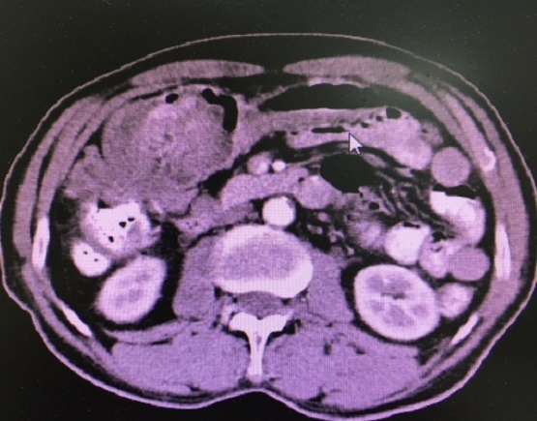

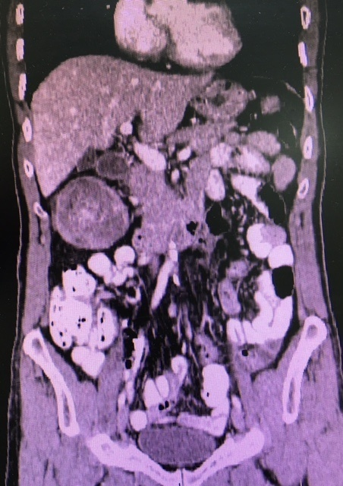

(fig. 1): Abdominal computed tomography (CT) showed a 8 cm by 6 cm mass involving hepatic flexure, with enlarged superior mesenteric lymph nodes.

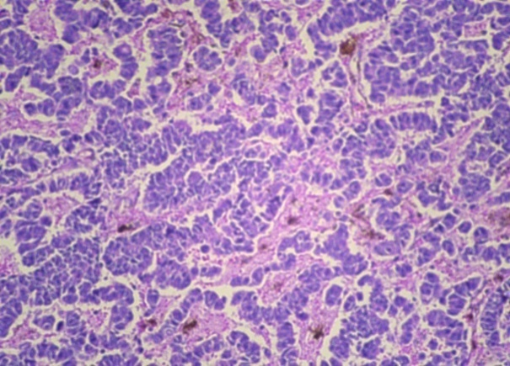

(Fig.2): H & E (40HPF): Insular and trabecular pattern of neuro-endocrine carcinoma.

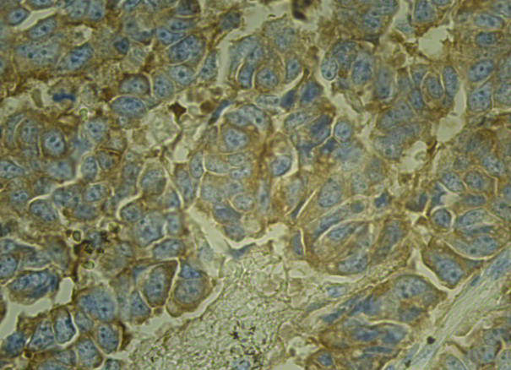

(Fig. 3): Synaptophysin immunostaining (40HPF): showed diffuse cytoplasmic positivity.

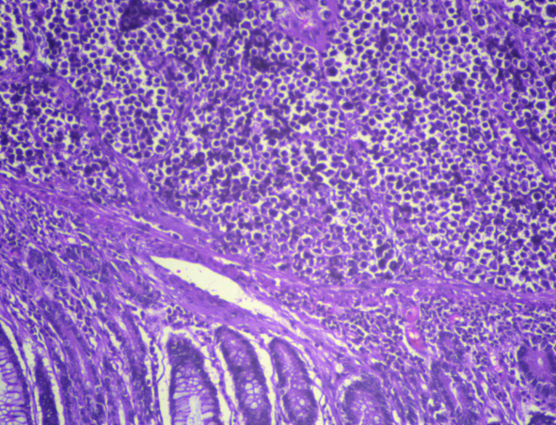
(Fig. 4): H & E (20 HPF): Diffuse infiltrate by lymphomatous deposits.

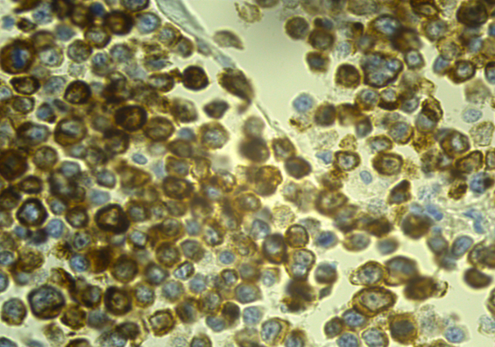
(Fig. 5): CD20 Immunostaining in the lymphomatous deposits.

References:
- Langhans T, Ueber einen drusenpolyp im ileum. Virchows Arch Pathol Anat Physiol Klin Med. 1867; 38: 559-560.
- Lubarsch O. Uber den ptimaren Kreps des ileum nebst Bemerkungen uber das gleichzeitige Vorkommen von Krebs und Tuberkulose. Virchows Arch. 1888; 3: 280-317.
- Lennert K. Histopathology of non hodgkins lymphomas: based on the Kiel classification. 2013; Springer-Verlag.
- Morson BC, Sobin LH. Histologic typing of intestinal tumors: WHO technical report 15. Geneva: 1976.
- Boudreaux J P, Klimstra D S, Hannan M M. North American Neuroendocrine Tumor Society. Guide lines for the diagnosis and management of neuroendocrine tumors. 2010; 39(6): 753-766.
- Conte B, George B, Overman M. High grade Neuroendocrine colorectal carcinoma. Clinical Colorectal Cancer. 2016; 15(2): 41-7.
- Wong MT, Eu KW. Primary colorectal lymphoma. Colorectal Dis. 2006; 8: 586-91.

6/25/2018

