A Dosimetric Analysis Study of Coplanar vs. Non Coplanar field Intensity Modulated Radiotherapy for Maxillary Sinus tumors

Rabab Abdel Moneim¹, Moustafa Abdul Moez², Maha Kamal²

Department of Clinical Oncology¹ and Physics Unit², Faculty of Medicine, Cairo University, Egypt
dr.rababahmed2014@hotmail.com

Abstract: Background and Purpose: Proximity of critical organs and Radiosensitive structures in planning maxillary cancers is challenging. This can be done using the intensity modulated radiation therapy (IMRT) technique with better achieving isodose distribution in the paranasal sinus area, while sparing adjacent critical organs. The aim of the current dosimetric study was to compare coplanar field (CF) with non coplanar field (NCF) - IMRT planning for cancer maxilla as regards target dose distribution, dose homogeneity and doses received by organs at risk (OAR). Patients and Methods: Twelve patients with histologically proven tumors of the maxillary sinuses were planned using NCF and CF intensity modulated radiotherapy techniques using the same optimization constraints template. Dose volume histograms (DVHs) were calculated for the targets and OAR. The distribution of the dose in the target volume and in the critical structures were compared between the two techniques, as well as the homogeneity Index (HI) in the target volume. The total monitor units and the total number of segments for each plan were also revised. Results: Higher doses delivered to the optic pathway, tempromandibular joint, cochlea, parotid and skull base with the CF technique than NCF The average maximum dose delivered to the brain stem for the CF and NCF plans were the same. Furthermore, the contralateral OAR received higher doses with CF technique. For the PTV, the average mean dose delivered was almost the same. The homogeneity index reveals no difference between both techniques (0.23 and 0.24 for the CF plans and NCF plans, respectively). Comparison of dose distribution in OAR for the CF and NCF techniques showed no significant difference. Conclusion: IMRT is one of the treatment options for cancer maxilla. The PTV coverage is optimal without compromising the protection of the OPS. The impact of non coplanar versus coplanar set up is very slight with no statistical significant.
[Rabab Abdel Moneim, Moustafa Abdul Moez, Maha Kamal. A Dosimetric Analysis Study of Coplanar vs. Non Coplanar field Intensity Modulated Radiotherapy for Maxillary Sinus tumors. Cancer Biology 2018;8(2):51-55]. ISSN: 2150-1041 (print); ISSN: 2150-105X (online). http://www.cancerbio.net. 6. doi:10.7537/marscbj080218.06.

Key Words: Maxillary Sinus Cancer, IMRT, non coplanar field, coplanar field.

1. Introduction:
Maxillary sinuses tumors are the most common subset of the paranasal sinuses. Symptoms often arise after the tumor reaches a considerable size, this is due to the presence of air filled spaces that permits silent growth. Therefore, the most of the patients presents to the clinic with locally advanced tumors with extensions into the nearby critical structures such as optic chiasm, nerves, and brain stem [1]. The corner stone for cure at this site is surgical resection or debulking followed by radiotherapy (RT) [2-3].
The proximity of these tumors to critical structures often raises radical surgery not possible [4-5]. In addition, two dimension radiation therapy is associated with very high toxicity to normal critical structures [6]. Use of intensity modulated radiotherapy (IMRT) for this site offers better preservation of organs function and quality of life subsequently. Furthermore, it improves dose conformality to the target volume and increases propably the therapeutic ratio in comparison with the conformal RT techniques. Nevertheless, proper coverage of the target volume may depend on the near by normal risk structures dose delivered. Treating team has to take their decision based on the possibility of locoregional control of tumor with preserving organs at risk functions. [7]
The aim of the current dosimetric study was to compare coplanar field with non coplanar field intensity modulated radiotherapy planning for tumors of maxilla as regards target dose distribution, dose homogeneity and doses delivered to organs at risk (OAR).

2. Patients and Methods:
The current dosimetric study included 12 patients with histologically proven squamous cell carcinoma of the maxillary sinuses. Patients had been treated with Conformal RT during initial therapy after primary diagnosis, and IMRT was performed for comparison as a dosimetric study.
CT imaging and volumes definitions:
Patients were immobilized in supine position with a customized cushion and a thermoplastic face mask. CT cuts were taken from the vertex to the sternum spaced every 3 mm with zero angulations. All cuts were transferred to treatment planning system (XIO) and the isocenter, located in the clinical target volume (CTV), was defined directly after the CT scan acquisition. This reference point was marked on the patient face mask using mobile lasers. Delineation the Gross Target Volume (GTV), Planning Target Volume (PTV) as well as Organs At Risk (OAR) was performed. The OAR included the eyes, lenses, optic nerves, optic chaisma, cochlea, brain stem, frontal and parietal lobes, pituitary gland, parotids and tempromandibular joints.

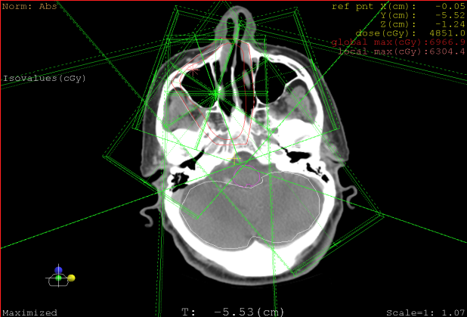
Figure (1): an axial CT cut show beam orientation for the coplanar field plan

IMRT planning with coplanar fields:
Twelve patients were planned for inverse IMRT with the modality of step and shoot. The IMRT plans were created using commercial planning system (XIO version 4.6 from CMS). Five isocentric coplanar fields with gantry angles orientation of half arc starting from 95º to 265 º equi-spaced are used Figure (2.2). A set of dose constrains were defined for the PTV and the OAR structures. The treatment goal for each patient is to deliver 60Gy to ≥ 95%of the PTV. Maximum dose limits prescribed for spinal cord, Brian stem, optic chiasma and cochlea as 45Gy, 54Gy, 50Gy and 55Gy respectively. Mean dose of 26Gy was defined to both parotid, 35Gy for both Nuchal tissue and Mucosa and 45Gy for cochlea. Our optimization constraints template is listed in figure (2). Calculation grid size adjusted to be 2mm and dose fluencies optimization run on criteria of 0.001 value of the objective function. Segmentation parameters was set to minimum segment size 2cm and maximum intensity level 10. Isodose distributions in three planes (axial, sagittal, and coronal) and dose–volume histograms of PTV and OAR were used to guide the optimization of IMRT plans. Sometimes editing of intensity map before segmentation was required to obtain better results.
IMRT planning with non-coplaner fields:
Same patients were planned with 5 non-coplanar fields: two fields with 95° and 265° gantry angulations without table rotation and three non- coplanar fields with 35°, 320° and 345° gantry angulations with 90° table rotation figure (3). Dose constrains and optimization criteria were set the same as that for the coplanar plans.

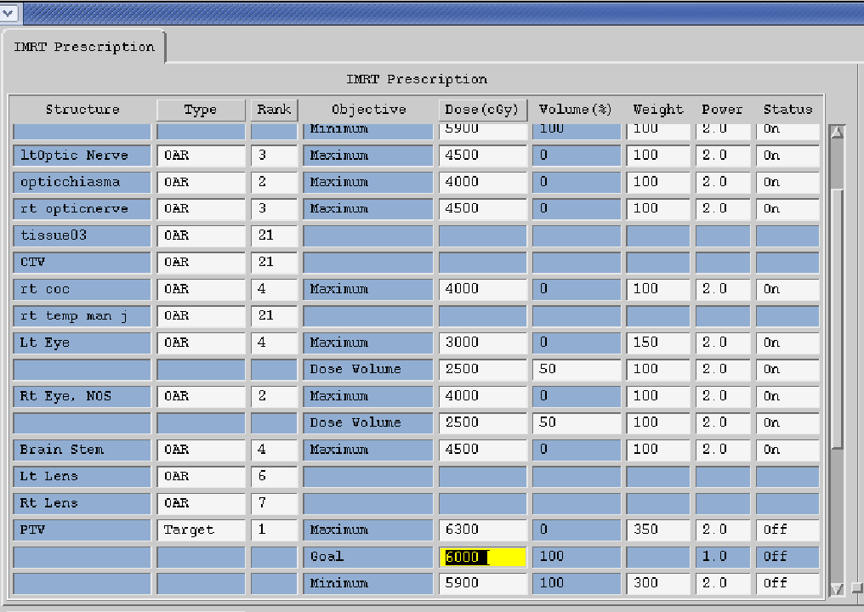
Figure (2) optimization constrains template for PTV and OAR

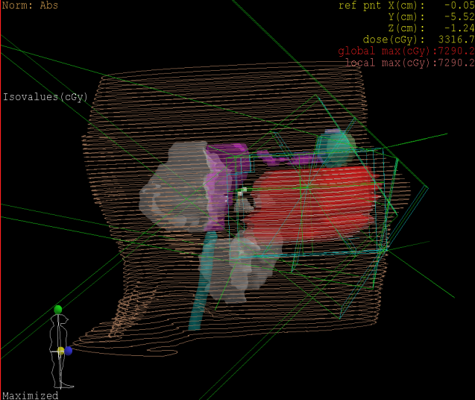
Figure (3) Beams orientation for the non-coplanar plan

Comparative study between coplanar and non-coplanar plans:
The comparative study consisted of performing a treatment plan evaluation for each patient for the co-planar and non-coplanar plan. DVHs were calculated for the targets and OAR. Dose distributions within the PTV were analyzed with regard to the minimum dose (D98%), maximum dose (D2%) and 95% coverage. Dose inhomogeneities within the PTV were defined as (D2% _ D98%)/D2% (ICRU2010). Maximum dose to serial organ and mean dose to parallel organ were also assessed. The total monitor units and the total number of segments for each plan were also revised. Homogeneity index (HI) is defined by the difference between D1 and D99% divided by the prescribed dose

Statistical analysis:

Data were statistically described in terms of range, mean, standard deviation, frequencies (number of cases) and relative frequencies (percentages) when appropriate. Comparison of quantitative variables between the study groups was done using T.Test for paired samples. A probability value (p value) less than 0.05 was considered statistically significant. All statistical calculations were done using computer package SPSS version 16 (Statistical Package for the Social Science; SPSS Inc., Chicago, IL, USA) statistical program for Microsoft Windows.

3. Results:
Plan evaluation based on compromising between target volume coverage and dose to OAR through DVH and dose distribution on axial, sagittal and coronal planes. The average number of segments was nearly the same (73 segments) for both CF and NCF plans with maximum number of segments 91 and 93 respectively. The average total number of monitor units showed a small difference, 466 for the CF plans and 477 for the NCF plans with maximum monitor units of 630 and 570, respectively.

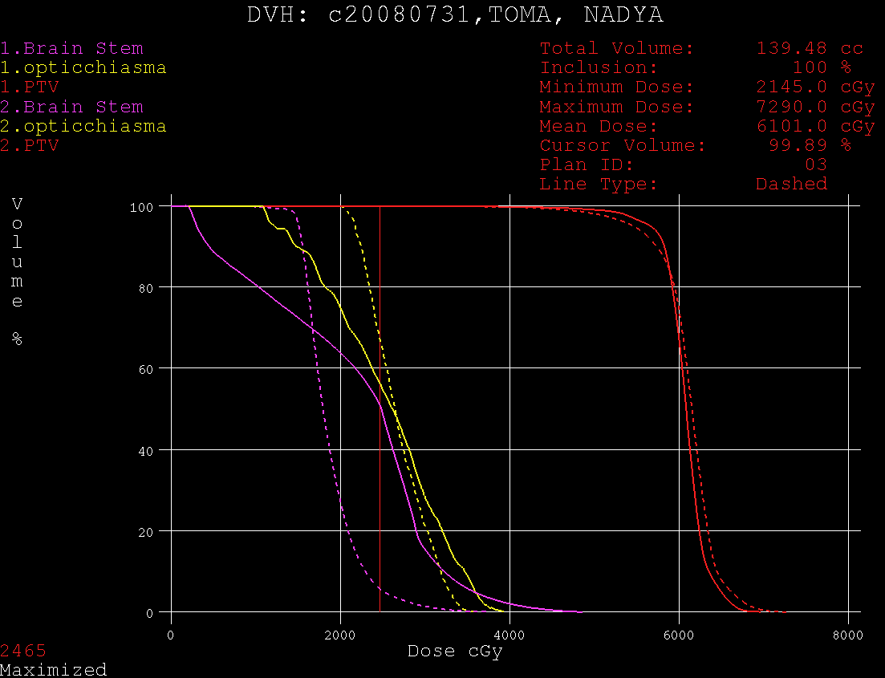
(a)

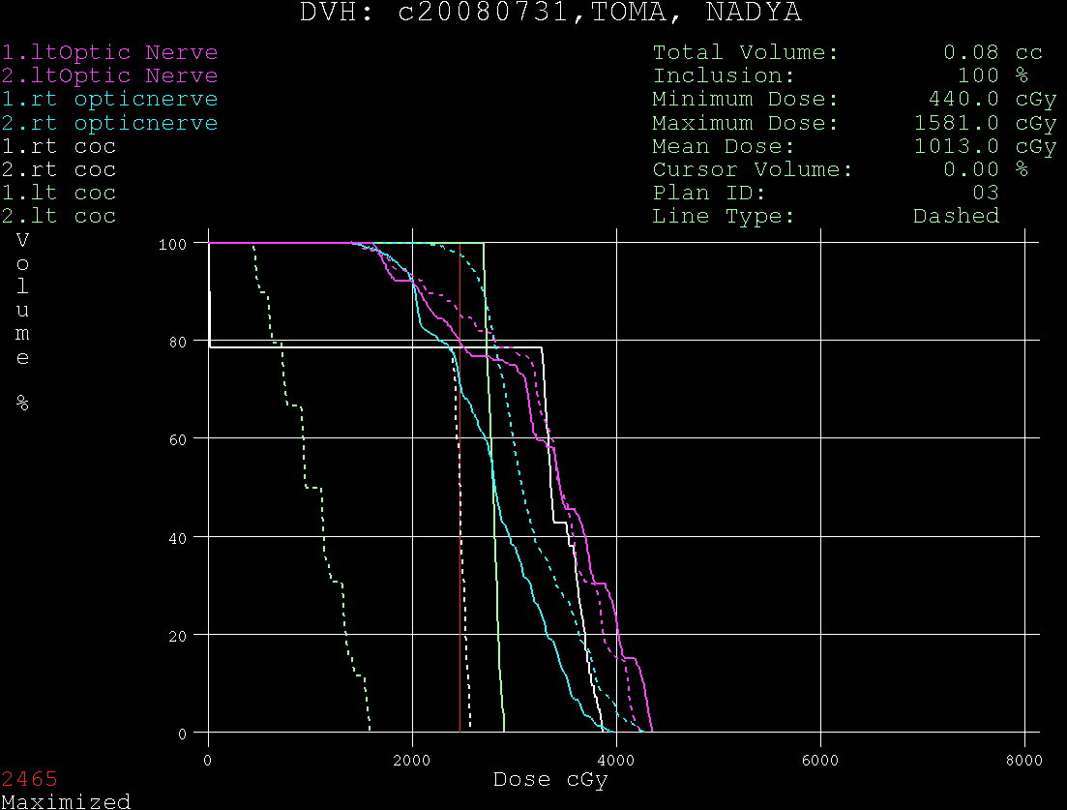
(b)

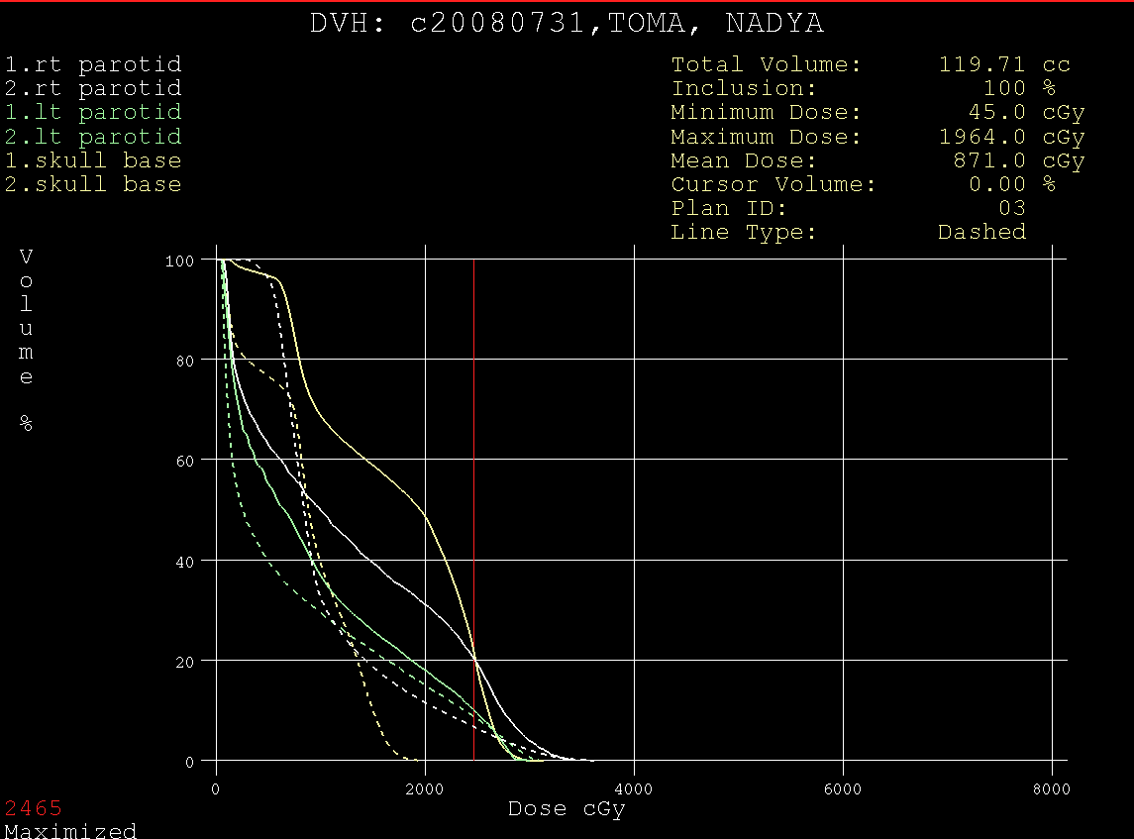
(c)
Figure (4) Comparative DVH between CF plan and NCF plan
(a) Brain stem & optic chiasma
(b) Optic nerve & cochlea
(c) Parotid & skull base

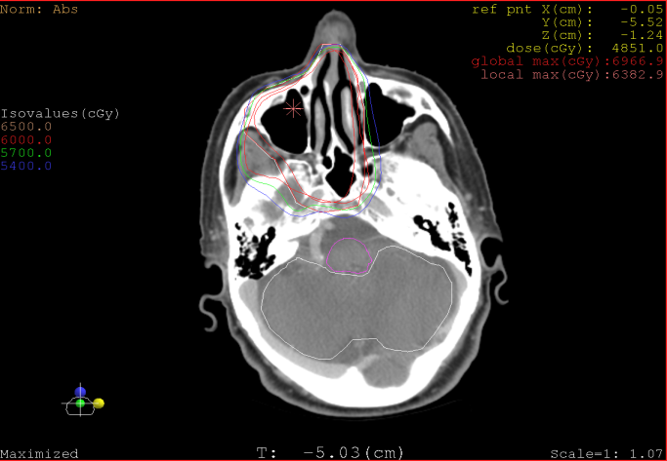
Figure (5): An axial CT cut show the dose distribution for the CF plan

For the PTV, the average mean dose delivered was 6050cGy and 6125cGy for the CF plans and the NCF plans respectively, figure (4). The 95% of PTV coverage was the same. The average maximum and minimum dose for all patients was 6677cGy and 5200cGy for the CF plans compared to 6950cGy and 5250cGy for the NCF plans. The dose distribution within the PTV assessed through the axial cut is shown in figure (5).
The homogeneity index reveals no difference between both techniques (0.23 and 0.24 for the CF plans and NCF plans, respectively). Homogeneity index for each patient was demonstrated in Figure (6).

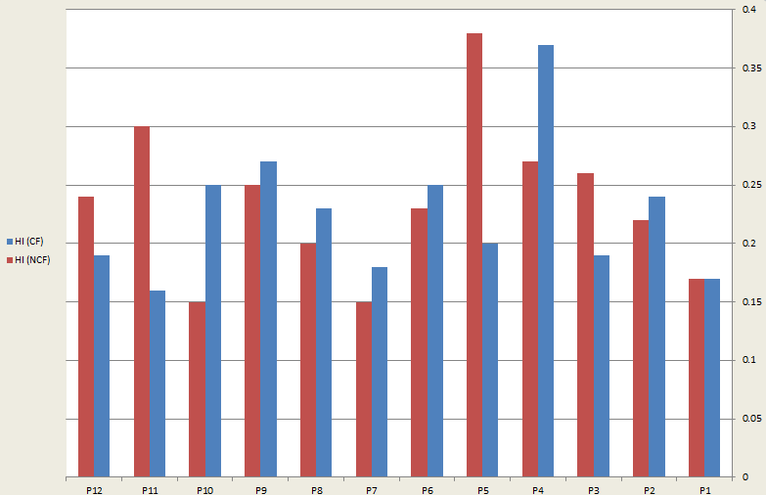
Figure (6) Homogeneity index (HI) for each patient in the CF technique (blue) and NCF technique (red)

For the optic pathway, the maximum dose in the optic chiasma was 4400cGy for the CF plans and 4200cGy for NCF plans, while the same maximum dose delivered to the ipsilateral optic nerve in both plans (5100cGy). The contralateral optic nerve had a maximum dose of 4700cGy and 4500cGy for the CF and NCF plans respectively. The mean dose delivered to the ipsilateral and contralateral eye was 2800cGy and 2200cGy for the CF plan compared to 2700cGy and 1900cGy for the NCF plan. The average maximum dose delivered to the brain stem for the CF and NCF plans were the same (2200cGy). Comparison of dose distribution in OAR for the CF (blue) and NCF (red) techniques demonstrated in figure (7) showed no significant difference. However, contralateral OAR (tempromandibular joint, cochlea, parotid) received higher maximum point doses in CF than NCF, while epsilateral OAR had a higher maximum point doses in NCF. The tolerance dose for each organ at risk is represented by D mean.

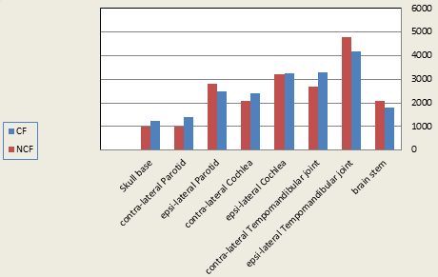
Figure (7) Comparison of mean dose in organs at risk for the CF technique (blue) and NCF technique (red)

4. Discussion:
Paranasal sinuses tumors (PNS) are rare, and are often asymptomatic until they are in the late course of the disease. They account about 3% of head and neck cancers. The maxillary with squamous cell carcinoma pathology, are the most common (8). IMRT over last years has been implemented widely into routine clinical practice in treating maxillary sinus tumors due to its close vicinity to sensitive normal tissues; its main goal was optimal sparing of these risk structures as optic tract and the brain stem, without affecting dose conformality to CTV or PTV.
Only a small number of groups until now, have reported their results using IMRT in patients with paranasal sinus tumors ( PNS). With conformal radiation therapy techniques, the target volume doses is limited by the OAR tolerated doses in order to decrease or avoid the high dose rates of treatment-related toxicity (9).
M. D. Anderson Cancer Center published a study recording a maximum point dose for optic nerve at controlateral side that was reduced significantly by using IMRT five-non coplanar fields rather than that of coplanar field method with no difference significantly recorded for ipsilateral nerve (10). In our experience, we did not observe any advantage to the optic pathway with the non coplanar fields when using the same maximum dose for both techniques, the difference did not exceed 2Gy.
For each organ at risk (OAR) a study done by Serre et al on ethmoid sinus tumors, showed no difference in dose distribution between 5-beam coplanar & non-coplanar IMRT for the ipsilateral nor the controlateral side, in addition to, inner ears nor parotids, nor temporo-mandibular joints and brainstem. Moreover, the maximum point dose for each OAR was almost the same in either of techniques in the same study (11). This was comparable with the presented study for dose distribution in OAR with no significant difference, but different in the maximum point doses which was higher in contralateral OAR (tempromandibular joint, cochlea, parotid) for CF than NCF, while ipsilateral OAR had a higher maximum point doses in NCF. This difference between two studies in maximum point dose can be due to difference in anatomical extensions of ethmoid sinus in Serre study and maxillary sinus in our study.
In the publication of Adams et al, the homogeneity index was much better with IMRT than with that recorded by conformal technique (12). Interestingly, no dosimetric benefits for the target volume were noted with IMRT over conformal treatment planning in the maxillary sinus, probably due to the distance from the optic pathway and the lack of concave organs.
The MD Anderson Cancer Center experience did not directly compare coplanar and non coplanar field IMRT; however, they used a parallelized multi-resolution beam angle optimization (PMBAO) which included non coplanar fields and obtained thus better dose homogeneity without a real impact on the conformity index. Their results could be explained by the use of only two non coplanar beams in a 5-beam configuration. The impact noted on the homogeneity in the target volume is in agreement with our results and seems to be due to non coplanar fields rather than the PMBAO (10).

Conclusion
Plan evaluation based on compromising between target volume coverage and dose to OAR through DVH and dose distribution on axial, sagittal and coronal planes and the HI were similar between the two techniques. No available data demonstrating the superiority of non coplanar over coplanar fields on the target volume has been published.

References:
  - Claus F, Boterberg T, Ost P, De Neve W: Short term toxicity profile for 32 sinonasal cancer patients treated with IMRT. Can we avoid dry eye syndrome? Radiother Oncol 2002, 64:205-8.
  - Dulguerov P, Jacobsen MS, Allal AS, Lehmann W, Calcaterra T: Nasal and paranasal sinus carcinoma: are we making progress? A series of 220 patients and a systematic review. Cancer 2001, 92:3012-29.
  - Jansen EP, Keus RB, Hilgers FJ, Haas RL, Tan IB, Bartelink H: Does the combination of radiotherapy and debulking surgery favor survival in paranasal sinus carcinoma? Int J Radiat Oncol Biol Phys 2000, 48:27-35.
  - Donald PJ, Boggan J: Sphenoidal and cavernous sinus resection for tumor. J Otolaryngol 1990, 19:122-9.
  - Parsons JT, Kimsey FC, Mendenhall WM, Million RR, Cassisi NJ, Stringer SP: Radiation therapy for sinus malignancies. Otolaryngol Clin North Am 1995, 28:1259-68.
  - Takeda A, Shigematsu N, Suzuki S, Fujii M, Kawata T, Kawaguchi O, et al.: Late retinal complications of radiation therapy for nasal and paranasal malignancies: relationship between irradiated-dose area and severity. Int J Radiat Oncol Biol Phys 1999, 44:599-605.
  - Radiation therapy (IMRT) for locally advanced paranasal sinus tumors: incorporating clinical decisions in the optimization process. Int J Radiat Oncol Biol Phys 2003, 55:776-784.
  - LIorente JL, Lopez F, Saurez C, Hermsen MA, Sinonasal carcinoma: Clinical, payhological, genetic and therapeutic advances. Nat Rev Clin Oncol 2014;11:460.
  - Claus F, Mijnheer B, Rasch C, Bortfeld T, Fraass B, De Gersem W, et al.: Report of a study on IMRT planning strategies for ethmoid sinus cancer. Strahlenther Onkol 2002, 178:572-6.
  - Wang X, Zhang X, Dong L, Liu H, Gillin M, Ahamad A, Ang K, Mohan R: Effectiveness of noncoplanar IMRT planning using a parallelized multiresolution beam angle optimization method for paranasal sinus carcinoma. Int J Radiat Oncol Biol Phys 2005, 63:594-601.
  - Serre A, Idri K, Fenoglietto P, et al: Dosimetric comparison between coplanar and non coplanar field radiotherapy for ethmoid sinus cancer. Radiat Oncol 2007, 2:35.
  - Adams EJ, Nutting CM, Convery DJ, Cosgrove VP, Henk JM, Dearnaley DP, Webb S: Potential role of intensity-modulated radiotherapy in the treatment of tumors of the maxillary sinus. Int J Radiat Oncol Biol Phys 2001, 51:579-588.

6/10/2018

