The Role Of Stat3 As A Prognostic And A Predictive Factor In The Management Of Anaplastic Large Cell Lymphomabased On ALK Exepression

Nessren Sabery¹, Dareen A. Mohammed², Duaa S. Helal²

¹Oncology Department, Faculty of Medicine, Tanta University, Egypt
²Pathology Department, Faculty of Medicine, Tanta University, Egypt
nesreensabry1eg@yahoo.com

Abstract: Purpose: The aim of this study is to investigate the role of STAT3 as a prignostic factor in ALCL and the predictive role in survival based on ALK expression. Patients and Methods: Between January 2014 and January 2017, 55 patients with patholigically prived ALCL, received their treatment in Clinical Oncology Department, Tanta University Hospital, and Tanta Insurance Hospital, were included. ALL the patients received CHOP. Assesment was done before and after 3 cycles chemotherapy and after finishing treatment, then every 3 months. Results: Thirty-nine cases (70%) were positive for STAT3( among them 36 cases (92%) were ALK +ve), while 16(30%) of cases were negative ( among them there were 8 cases (50%) were ALK -ve), with sig p value. Forty four percent patients in STAT3 +ve group achieved CR, while 62% of patients in STAT3 –ve group achieved CR. 48%, 8 % achieved PR and SD in group A respectively, while 25%, 12% achieved PR and SD in group B respectively. p value not sig. The two years OS s were 84% for the STAT3+ve group and 94 % for the STAT3 –ve. P value sig. The two years DFS were 54% and 85% for both groups respectively. P valuesig. We also asses the relation between the ALK and the STAT3, patients with ALK -ve STAT3 -ve shows 2 years OS better than ALK -ve STAT3 +ve with 88% versus 67%. While the 2 years OS in ALK +ve patients with STAT3 -ve, and ALK +ve STAT3 +ve was 100% versus 86%. with non sig P value. Conclousion: In our study STAT3 was a prognostic marker for patients with ALCL, and has apredictive rule in response and survival, irrespective to ALK, to confirm the data, a multicenter, meta-analysis and a randomized trial with a large number of patients are required in the near future.
[Nessren Sabery, Dareen A. Mohammed, Duaa S. Helal. The Role Of Stat3 As A Prognostic And A Predictive Factor In The Management Of Anaplastic Large Cell Lymphomabased On ALK Exepression. Cancer Biology 2018;8(2):42-50]. ISSN: 2150-1041 (print); ISSN: 2150-105X (online). http://www.cancerbio.net. 5. doi:10.7537/marscbj080218.05.

Keywords: Role; Stat3; Prognostic; Predictive Factor; Management; Anaplastic Large Cell; Lymphomabase; ALK Exepression

1. Introduction:
In adult anaplastic large-cell lymphoma (ALCL) represent 3%, while it represents 10% to 30% of non-Hodgkin’s lymphomas in children.¹ ALK overexpression in ALCLs is due tot (2;5) (p23; q35) or variant translocations involving the 2p23 locus.^{2,3}
There are two types of T-cell tumors (ALK+ALCL and ALK-ALCL) asdescribed Inthe 2008 World Health Organization classification. However, the questions about the biology of the ALK+and ALK-groups and theirrelationship to one another remain unclear.^{4,5,6}
Despite Correlation of clinicalsamples and moleculargenetic in vitro studies, it is difficult to unfold and to understand the mechanismsof chromosomal translocation, pathways of anoncogene, and the novel therapies fortreating thistype of lymphoma and other tumors with ALK dysregulation^{.7,8,9}
There are several pathways are suggested to be involved in ALCL oncogenesis, including PLC-gamma, PI-3-kinase pathways, andtheras, resulting indecreasedapoptosis and cell proliferation. Although C-ALCL and ALK +ALCL are characterized, diagnostic pitfalls are still present. Especially distinction of variant histologic pictures of ALCA and differentiate between C-ALCL from lymphomatoidpapulosis (LyP) and from systemic ALCL. As well as ALK dysregulation could be detectedalso inother carcinoma, tumors of neural origin inflammatory myofibroblastic tumors, and inthe blood cells of people by reversetranscription–polymerase chain reaction.¹⁰
ALCL are closely related to each other than toperipheral T-celllymphoma, not otherwise specified. ALK+or ALK-ALCL could be distinguished from PTCL-NOS by Limited numbers (as few as 14) of genes.¹¹ ALK+ ALCL is considered to be a distinct subtype of ALCL which occur in younger age group and have favorable prognosis.^{12,13,14}
Anaplastic lymphoma kinase (ALK) phosphorylates signaltransducer and activator oftranscription 3 (STAT3) with cytoplasmic expression. Despite the biologic mechanisms of the oncogenic potential of ALK remain unclear, it is proved that ALK promotestumorigenesis byactivating cell signaling pathways whichinclude STAT3 pathway.^{15,16}
Activated STAT3 could inhibit apoptosis by up-regulation of multipledownstream targets including surviving and tissue inhibitor ofmetalloprotease 1.¹⁷
Some studies proved that disease-free survival orprogression-free survival at5 yearswas lessthan 50% in ALK+ ALCL with cytoplasmicsurvivin or tissue inhibitor of metalloprotease 1.^{18,19} also CD56 is a negativeprognostic marker in ALK+ and ALK– ALCL²⁰
The aim of this study is to investigate the expression of STAT 3 in the relationto state in ALK in ALCL and to study its predictive and prognostic significance

2. Patients and methods:
Patient eligibility criteria
Fifty five patientswith pathologically proven anaplastic large cell lymphoma were included in this study and examined between January 2014 and January 2017, in Clinical Oncology Department, Tanta University Hospital, and Tanta Insurance Hospital. Patients were followed up until March2018.
Patients fulfilled the following criteria:- age range from 14 to 55 median 31.6, Eastern Cooperative Oncology Group (ECOG) performance status (PS) of ≤ 2, adequate bone marrow reserve (WBC count 3.5 x 10⁹/L, ANC count1.5 x10⁹/L, platelets 100 x 10⁹/L, and hemoglobin 10 g/dL), adequate renal function (measured creatinine clearance 60 mL/min) and adequate liver function (transaminases less than 2 x upper normal limit, and serum bilirubin concentrations below 1.5 mg/dL). Patients wereexcluded from this study if they had dementia, second malignancy, pregnant or have any psychiatric condition that would decrease the understanding or rendering of informed consent. Also, patients complaining fromuncontrolled medical illness,extensive symptomatic visceral disease, and current central nervous system metastasis werealso excluded.
Design of the Study
This study is a prospective double-arm study. Before the initiation of any treatment The Ethics Committee in Faculty of Medicine, Tanta University, granted protocol approval and an informed consent were signed by all patients
Careful clinical examination of all lymph node areas and waldeyer's ring, the performance status were assessed to ECOG performance status score.
Review and confirmation of the histopathologic diagnosis of ALCL, thenreview and confirmation of positivity for T-cell markers (CD3, CD43, and/or CD45RO), CD30and negativity of B-cell (CD20) antigens. According to ALK protein positivity cases were divided into 44cases were ALK+ while 11 were ALK–.
Immunohistochemically analysis was performed on previouslyprepared unstained slides using standard techniques. Heat-induced epitope retrieval was performed for all immunostains. the monoclonal antibody of STAT3 (pSTAT3tyr705) (clone B-7, dilution1:100; Santa Cruz Biotechnology, Santa Cruz, CA) were used, The chromogenwas 3,3'-diaminobenzidine/H2O (BioGenex, San Ramon, CA) and hematoxylin for counterstain.
Assessment of positivity for pSTAT3 was done for each casewhen more than
20% of the neoplastic cells showed unequivocal, nuclear pSTAT3tyr705 immunostaining, regardless of the staining intensity. Positive control samples for pSTAT3was blocked for Hodgkin lymphoma.²¹
Computed Tomography (CT scan) for radiological assessmentof the neck, thorax, Abdomen, and pelvis and according to the site of involvement, echocardiographyand PET CT (in some cases).
Complete laboratory investigation: liver function tests, serum uric acid, LDH Complete blood pictures, and kidney function tests. Bone marrow aspiration cytology when indicated.
Staging:
According to Ann Arbor staging system, Staging was done and risk factors evaluation according to International Prognostic Index (IPI) recommended by International Non-Hodgkin's Lymphoma Prognostic Factors Project was done. ^{22,23}
Treatmentprotocol:
Allthe 55Patients have received 6 cycles CHOP 21as thefollowings: (Cyclophosphamide750mg/m², Doxorubicin 50mg/m², Oncovin1. 4mg/m², Prednisone 100 mg/m²), cycle every 21 days, with or without IFRT (Involved Field Radiotherapy) as consolidation in stage I and stage II or cases with bulky lymph nodes, or residualafter 6 cycles chemotherapy, or for an extra-nodal site. The radiation dose ranged from 3000 to 3600 cGy.180 to 200 cGy/Fr. All the patients wereassessed by lab investigation before each cycle. The radiological assessment has been done before the start of treatment and after 3 cycles and at the end of treatment.
Tumor response:
After every three cycles of treatment, A tumor response assessment was performed. monitoring Pre- and on-treatment consisted of assessment of performance status, medical history, body weight and vital signs, neurological and physical examination, laboratory analyses, CT-scan of the chest, abdomen, and pelvis, PET CT if indicated.
Criteria for complete response (CR), partial response (PR), stable disease (SD) and progressive disease (PD) were based on the standard definitions according to RECIST 1.0 criteria.²⁴
Primary and secondary endpoints
The primary endpoints of the study assessing the prognostic value of STAT3. The secondaryendpointwas overall survival and progression-free survival.
Statistical analyses
Overall-survival (OS) rates were calculated from the date of start of intravenous treatmentto the time of the last follow-up visit or death using the Kaplan-Meier method.²⁵ with SPSS [Statistical package] (version 12.0). Progression-free survival (PFS) was the time elapsed from the date of initiation of intravenous therapy to the date of first evidence of disease progression or death in the absence of disease progression. Kaplan Meier²⁵methods used for estimating survival. The 95% confidence intervals (95% CIs) were calculated with the exact method. All P values were two-tailed; a value of 0.05 was considered significant.

3. Results:
Histopathological and immunohistochemical results [ fig 1(a, b, c, d, e, f, g, h)]:
ALCL showed histologically clusters of pleomorphic large cells with a highmitotic rate with largeeccentricnuclei have characteristically indented, horseshoe, kidney-shaped, features and havebeen called hallmark cells, The nuclear chromatin is partially dispersedwith small basophilic nuclei.
On examination of pSTAT3 expression, there were Thirty-nine cases (70%) were positive for STAT3 [ among them 36 cases (92%) were positive for ALK expression ] while 16(30%) of cases were negative [ among them there were 8 cases (50%) were positive for ALK expression ]. there were significant differences between pSTAT3 expression and ALK expression in ALCL.

Table1: relation between STAT3 expression and ALK expression
 | Patients with positive STAT-3 expression ( N 39 patients) | Patients with negative STAT-3 expression ( N 16 patients) | P-value
ALK positive expression | 36(92%) | 8(50%) | 0.001*
ALK negative expression | 3(8%) | 8(50%)

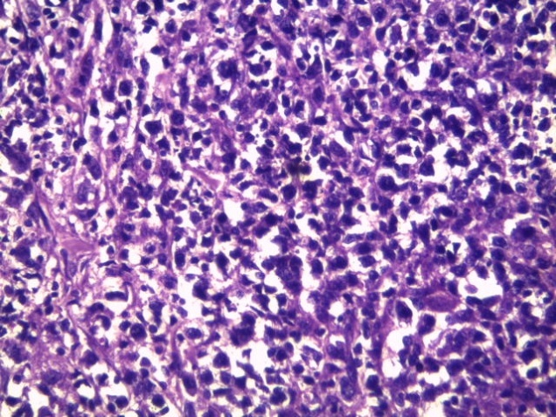
Fig1a: ALCL showed diffuse infiltration by pleomorphic large malignant lymphoid cells [H & E x200]

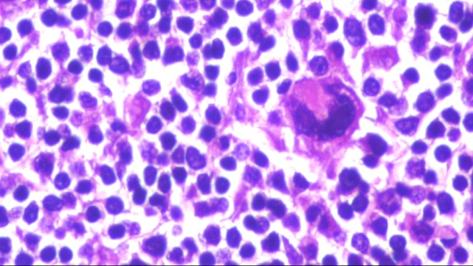
Fig1b: ALCL showed characteristic horseshoe shaped nuclei [H & E x400]

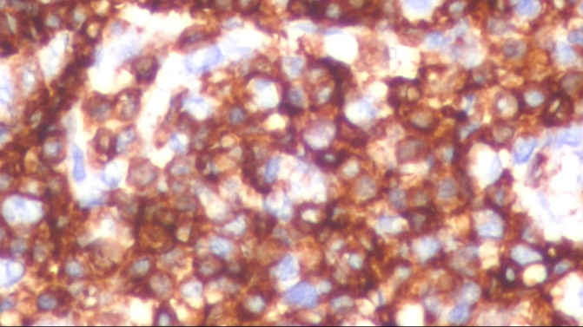
Fig 1c: CD3 immunostaining showed positive expression in ALCL [X400]

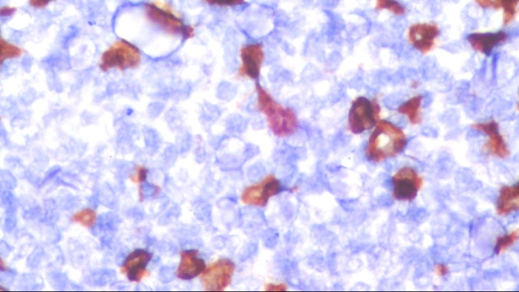
Fig 1d: CD30 immunostaining showed positive expression in ALCL [X 400]

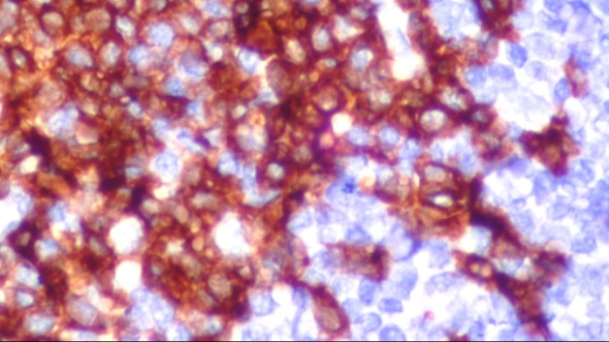
Fig 1e: ALK immunostaining showed positive expression in ALCL [X 400]

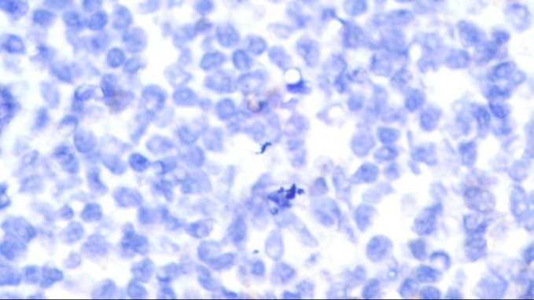
Fig 1f: ALK immunostaining showed negative expression in ALCL [X400]

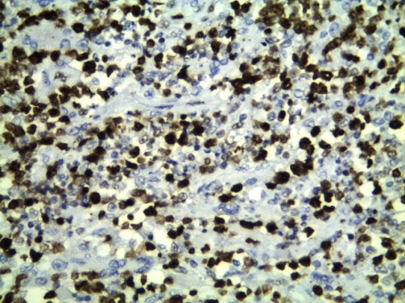
Fig 1g: pSTAT3 immunostaining showed positive nuclear expression in ALCL [x200]

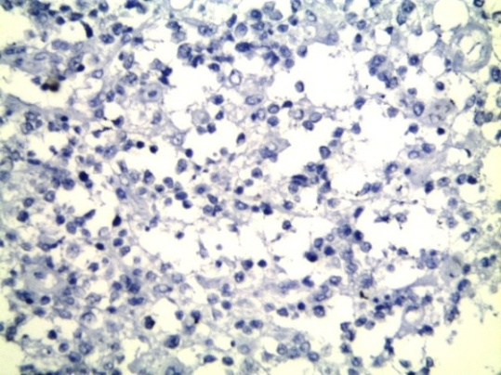
Fig 1h: pSTAT3 immunostaining showed negative expression in ALCL [x200]

Table 2: relation between STAT-3 expression with theclinical characteristics of the patient
Clinicopathological features | Patients with positive STAT-3 expression ( N 39 patients) | Patients with negative STAT-3 expression ( N 16 patients) | P-value
Age  <40years  >40 years | 20 (51%)  19 (49%) | 10 (63%)  6 (37%) | 0.448
Gender  Male  Female | 34 (87%)  5 (13%) | 11(69%)  5 (31%) | 0.108
Extranodal Site  0 or 1  2 or more | 18 (46%)  21 (54%) | 8 (50%)  8 (50%) | 0.795
Stage  I  II  III  IV | 14 (36%)  13 (33%)  10 (26%)  2 (5%) | 6 (38%)  5 (31%)  2 (13%)  3 (18%) | 0.357
IPI  Low  Low intermediate  Intermediate high  High | 12(31%)  6 (15%)  14 (36%)  7 (18%) | 6 (38%)  7 (43%)  2 (13%)  1 (6%) | 0.065

The two years over all survival of both groups were 84% for the STAT3+ve group and 94 % for the STAT3–ve. Pvalues=0.460. (Mean22.2, CI 95%22.98 – 24.86 ). Figures (1).
The association of STAT-3 expression with theclinical characteristics of the patient (regarding age, gender, site, stage, and IPI) was furtherevaluated and is summarized in Table 2.
As regards the comparison between both groups according to the treatment response, only 44% patients in STAT3 +ve group achieved CR, while 62% of patients in STAT3 –ve group achieved CR.48%, 8 % achieved PR and SD in group A respectively, while 25%, 12% achieved PR and SD in group B respectively. pvalue= 0,422, The correlation between the treatment response and the STAT3 marker is shown in table (3).

Table 3: The correlation between the treatment response and the STAT3 marker
 | Patients with positive STAT-3 expression ( N 39 patients) | Patients with negative STAT-3 expression ( N 16 patients) | X2 | P value
CR PR SD | 19(48%) 17(43.75%)) 3(8.3%) | 10(62.5%) 4(25%) 2(12.5%) | 1.723 | 0.422

As regards the relation between the treatment response and the tumor stage according to STAT3 status, patients with stage I, II, III and IV who achieved CR in group A were 54%, 55%, 43% and 10% respectively. While in group B the patients who achieved CR were 83%,67%,100% and 0% of stage I, II, III and IV respectively. pvalue=0.008 The correlation between the treatment response and the tumor stageaccording to STAT3 status is shown in table 4.

.
Table 4: The correlation between the treatment response and the tumor stage according to the STAT3 status
 | Patients with positive STAT-3 expression ( N 39 patients |  |  |  | Patients with negative STAT-3 expression ( N 16 patients) |  |  |  | X² | P value
stage | I | II | III | IV | I | II | III | IV
CR | 8(54%) | 7(54%) | 4(40%) | 0 | 5(83%) | 3(60%) | 2(100%) | 0 | 9.662 | 0.008*
PR | 6(46%) | 6(46%) | 3(30%) | 2(100%) | 1(17%) | 2(40%) | 0 | 1(33% | 26.402 | 0.001*
SD | 0 | 0 | 3(30%) | 0 | 0 | 0 | 0 | 2(67%) | 27.021 | 0.001*
 | 12.012 |  |  |  | 12.932
 | 0.062 |  |  |  | 0.048*

As regards thecorrelation between the treatment response and the IPI index in both groups according to the STAT3 status, 67%, 19% of patients who achieved CR in group A were IPI low and low intermediate, while all the patients in group B who achieved CR were IPI low and low intermediate. Pvalues=0.012 in group B. Thecorrelation between the treatment response and the IPI index in both groups according to the STAT3 status is shown in the table (5).

Table 5: The correlation between the treatment response and the IPI index in both groups according to the STAT3 status.
IPI | Group A  Patients with positive STAT-3 expression ( N 39 patients |  |  | Group B  Patients with negative STAT-3 expression ( N 16 patients) |  |  | X² | P value
 | CR  No 19 | PR  No 17 | SD  No 3 | CR  No 10 | PR  No 4 | SD  No 2
Low 12 | 8(42%) | 2 (12%) | 2 (67%) | 6 (60%) | 0 | 0 | 35.262 | 0.001*
Low intermediate 6 | 4(21%) | 2 (12%) | 0 | 4 (40%) | 3(75%) | 0 | 3.812 | 0.125
High intermediate 14 | 7(37%) | 6 (35%) | 1(33%) | 0 | 1 (25%) | 1 (50%) | 22.214 | 0.001*
High 7 | 0 | 7 (41%) | 0 | 0 | 0 | 1(50%) | 31.698 | 0.001*
 | 3.113 |  |  | 16.402
 | 0.539 |  |  | 0.012*

Survival:
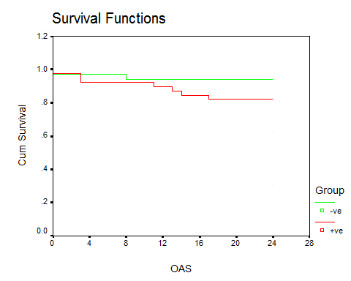
Figure (2): The two years overall survival in STAT3 +ve and -ve

The two years disease free survival were 54% and 85% for both groups respectively. P value 0.013 (Mean 20.57, CI 95% 23.11 – 24.09). Figures (2).
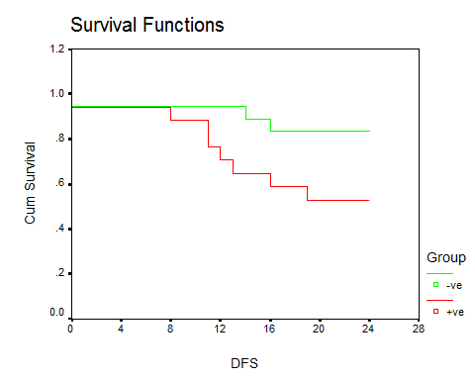
Figuer (3): The two years DFS in STAT3 +ve and -ve

 | PFS | OS
Mean | 20.57 | 22.2
Median | 24 | 24
CI 95% | 23.11 – 24.09 | 22.98 – 24.86
P value | 0.013* | 0.460
As regard the relation between the ALK and the STAT3, patients with ALK -ve STAT3 -ve shows 2 years OS better than ALK -ve STAT3 +ve with 88% versus 67%. While the 2 years OS in ALK +ve patients with STAT3 -ve, and ALK +ve STAT3 +ve was 100% versus 86%. with non sig P value. Figure (3) and (4).
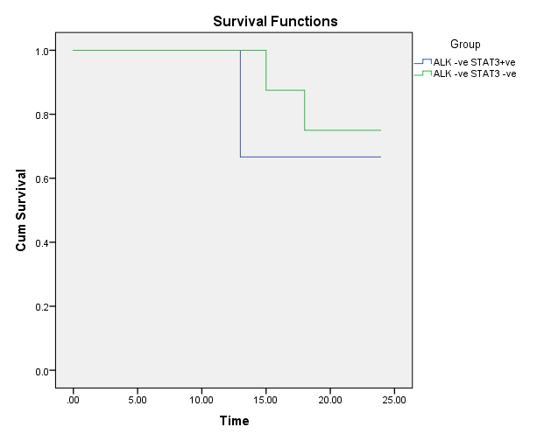
Figuer (4): The two years os in ALK-ve STAT3 +veand -ve.

 | PFS
Mean | 22.13
Median | 24
CI 95% | 19.66 – 24.59
P value | 0.676

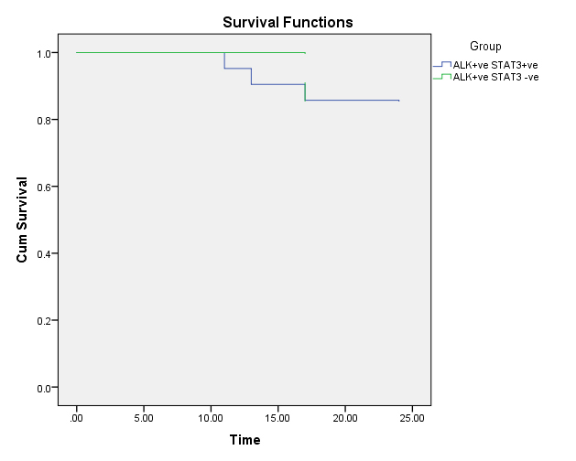
Figuer (5): The two years os in ALK+ve STAT3 +ve and -ve.

 | PFS
Mean | 23.5
Median | 24
CI 95% | 24 – 24
P value | 0.273

Conclusion:
In our study STAT3 was a prognostic marker for patients with ALCL, and has apredictive rule in response and survival, irrespective to ALK, to confirm the data, a multicenter, meta-analysis and a randomized trial with a large number of patients are required in the near future.

4. Discussion
Anaplastic large cell lymphoma has a mechanism of lymphogenesisinvolves deregulation of several signal pathway which are activated by triggering the tyrosine kinase NPM ALK.²⁶
ALK is a member of insulin receptor family of protein tyrosine kinase whose expression is normally confined to the cells of the central nervous system.²⁷
Recently it has been demonstrated thatthe tyrosine kinase NPM ALK cause constitutive activation of STAT3. Activated STAT3 contributes to the pathogenic mechanism of ALK +ALCL by regulating the expression of several downstream targets that are involved in the control of apoptosis and cell proliferation.²⁸
In our study 36(92%) of the patients with STAT3 + are ALK + with a significant correlation between them. Our findings are consistent with the result of Khoury JD et al who stated that there was a significant correlation between STAT3 and ALK positivity.²⁹
In our study we study the tumor responsein accordance to the STAT3 expression, 19(48%) of the patients with STAT3 positive expression achieved CR while 10(62,5%) patients achieved CR in STAT3 negative group, the patients who achieve PR were 17(43.75%), and 4(25%) in both groups respectively. Withnonsignificantpvalue.
In our study, we further analyze the relation of tumor response and STAT3 status according to the tumor stage, patients with stage I, II, III and IV who achieved CR in the pSTAT3 positive group were 54%, 55%, 43% and 10% respectively. While in p STAT3 negative group, the patients who achieved CR were 83%, 67%, 100% and 0% of stage I, II, III and IV respectively, with significant p-value, these results may attributed to that the STAT3 increase the cellular resistance to chemotherapy, and STAT3 positivity increase in the higher tumor stage.¹⁶
We further analyze the relationship between the tumor response and the IPI index in both groups according to the STAT3 status,67%,19% of patients who achieved CR in pSTAT3 positive group were IPI low and low intermediate, while all the patients in pSTAT3 negative group who achieved CR were IPI low and low intermediatewith significant p-value. These results are also attributed to the predominance expression of STAT3 positivity inthe higher IPI index, with poor response to treatment. ¹⁵
As regards the comparison in the overall and disease-free survival between bothgroups. The two years overall survival were 84% for the STAT3+ve group and 94% for the STAT3 – ve. P-valueis non significant, our results were in agreement with Zamo et al and Zhang et al results of other studies in which the 5 years OS of STAT3 +were less than that of the STAT3 - ve butwith significant p-value.^{28,30}. The explanation of the nonsignificance in our study may be attributed to the other studies OS was for five years, and also the no of patients in our study is less than the other.
In our study we also compare between the STAT3 + and STAT3 – groups in DFS, the 2 years DFS was 54% versus 85% respectively with significant P-value, Zamo et al in their study there were nosignificant differences, this is may be attributed to larger number of patients in their study as well as they studied the 5 years survival.²⁸
As regards the relation between STAT3 and ALK expression 36(92%) of STAT3 +ve are ALK +ve and only 3(8%) were ALK -ve, p- value was highly significant, our results were similar to other studies such as published by Zamo A et al, Eriksen K. W. et al, Garcia A et al, and Mora L et al.^{28,31,32,33} The explanation of these findings is that ALK activates STAT3.²⁸
We also study the relationship between the STAT3 and ALK and their effect on overall survival, the 2 years OS in ALK -patients with STAT3 -ve was 88% which was better than that with STAT3 +ve67 %, witha significantp-value. The patients with ALK+ STAT3 – achieved 100% 2 years OS, while those with ALK+STAT3 + has 86% 2years OS. Our results were matched with the results of other studies.^{34,30}The explanation is STAT3 has oncogenic potential and may act as a mediator of the oncogenic effect of ALK in ALK+ ALCL leading to promotion of cell growth.

References:
  - Delsol G, Ralfkiaer E, Stein H, Wright D, Jaffe S. Anaplastic large cell lymphoma. In: Jaffe ES, Harris NL, Stein H, Vardiman JW, eds. WHO Classification of Tumors of Haematopoietic and Lymphoid Tissue: Pathology & Genetics. Lyon: IARC Press, 2001: 230–5
  - Morris SW, Kirstein MN, Valentine MB, Dittmer KG, Shapiro DN, Saltman DL, Look AT. Fusion of a kinase gene, ALK, to a nucleolar protein gene, NPM, in non-Hodgkin’s lymphoma. Science1994; 263:1281-1284.
  - Duyster J, Bai RY, Morris SW: Translocations involving anaplastic lymphoma kinase (ALK). Oncogene 2001; 20:5623-5637.
  - Delsol G, Falini B, Muller-Hermelink HK, Campo E, Jaffe ES, Gascoyne RD, et al. Anaplastic large cell lymphoma, ALK-positive. In: Swerdlow SH, Campo E, Harris NL, Jaffe ES, Pileri SA, Stein H, editors. WHO classification of tumours of haematopoietic and lymphoid tissues. Lyon: International Agency for Research on Cancer Press; 2008; 312–316.
  - Mason DY, Harris NL, Delsol G, Stein H. Anaplastic large cell lymphoma, ALK-negative. In: Swerdlow SH, Campo E, Harris NL, et al, eds. Tumours of Haematopoietic and Lymphoid Tissues. Lyon, France: IARC Press; 2008:317– 319.
  - Ralfkiaer E, Willemze R, Pauli M, Kadin ME. Primary cutaneous CD30- positive T-cell lymphoproliferative disorders. In: Swerdlow SH, Campo E, Harris NL, et al, eds. Tumours of Haematopoietic and Lymphoid Tissues. Lyon, France: IARC Press; 2008300–301.
  - Savage KJ, Harris NL, Vose JM, Savage KJ1, Harris NL, Vose JM, Ullrich F, Jaffe ES, Connors JM, et al. ALK2 anaplastic large-celllymphoma is clinically and immunophenotypically different from both ALK+ALCL and peripheral T-cell lymphoma, not otherwise specified: report from the International Peripheral T-Cell Lymphoma Project. Blood. 2008;111(12):5496–5504.
  - Campo E, Chott A, Kinney MC, Leoncini L, Meijer CJ, Papadimitriou CS, Piris MA, Stein H, Swerdlow SH. Update on extranodal lymphomas: conclusions of the Workshop held by the EAHP and the SH in Thessaloniki, Greece. Histopathology. 2006; 48(5):481–504.
  - Eckerle S, Brune V, Doring C, Eckerle S1, Brune V, Döring C, Tiacci E, Bohle V, Sundström C,, et al. Gene expression profiling of isolatedtumour cells from anaplastic large cell lymphomas: insights into its cellularorigin, pathogenesis and relation to Hodgkin lymphoma. Leukemia. 2009;23(11):2129–2138.
  - Trumper L, Pfreundschuh M, Bonin FV, Daus H. Detection of the t (2;5)- associated NPM/ALK fusion cDNA in peripheral blood cells of healthy individuals. Br J Haematol. 1998;103(4):1138–1144.
  - Piva R, Agnelli L, Pellegrino E, Piva R1, Agnelli L, Pellegrino E, Todoerti K, Grosso V, Tamagno I, et al. Gene expression profiling uncoversmolecular classifiers for the recognition of anaplastic large-cell lymphoma withinperipheral T-cell neoplasms. J ClinOncol. 2010;28(9):1583–1590.
  - Falini B, Bigerna B, Fizzotti M, Pulford K, Pileri SA, Delsol G et al. ALK expression defines adistinct group of T/null lymphomas (“ALK lymphomas”) witha wide morphological spectrum. Am J Pathol. 1998;153:875-886.
  - Nakamura S, Shiota M, Nakagawa A, Yatabe Y, Kojima M, Motoori T, Suzuki R et al. Anaplastic largecell lymphoma: a distinct molecular pathologic entity: areappraisal with special reference to p80NPM/ALK expression. Am J Surg Pathol. 1997;21:1420-1432.
  - Benharroch D, Meguerian-Bedoyan Z, Lamant L, Amin C, Brugières L, Terrier-Lacombe MJ, et al. ALKpositivelymphoma: a single disease with a broad spectrum ofmorphology. Blood. 1998;91:2076-2084.
  - Zamo A, Chiarle R, Piva R, Howes J, Fan Y, Chilosi M, et al. Anaplastic lymphomakinase (ALK) activates Stat3 and protects hematopoietic cellsfrom cell death. Oncogene. 2002;21:1038-1047.
  - Marzec M, Kasprzycka M, Ptasznik A, Wlodarski P, Zhang Q, Odum N et al. Inhibition of ALK enzymatic activity in T-cell lymphoma cells induces apoptosis and suppresses proliferationand STAT3 phosphorylation independently of Jak3. Lab Invest. 2005;85(12):1544–1554.
  - Bai RY, Ouyang T, Miething C, Morris SW, Peschel C, Duyster J. Nucleophosminanaplasticlymphoma kinase associated with anaplastic largecelllymphoma activates the phosphatidylinositol 3-kinase/Aktantiapoptotic signaling pathway. Blood. 2000;96:4319-4327.
  - Amin HM, McDonnell TJ, Ma Y, Lin Q, Fujio Y, Kunisada K et al. Selective inhibitionof STAT3 induces apoptosis and G (1) cell cycle arrest in ALK-positive anaplastic large cell lymphoma. Oncogene.2004;23:5426-5434.
  - Lai R, Rassidakis GZ, Medeiros LJ, Ramdas L, Goy AH, Cutler C, et al. Signal transducer andactivator of transcription-3 activation contributes to hightissue inhibitor of metalloproteinase-1 expression in anaplasticlymphoma kinase–positive anaplastic large cell lymphoma. Am J Pathol. 2004;164:2251-2258.
  - Schlette EJ, Medeiros LJ, Goy A, Lai R, Rassidakis GZ. Survivin expressionpredicts poorer prognosis in anaplastic large-cell lymphoma. J ClinOncol. 2004;22:1682-1688.
  - Suzuki R, Kagami Y, Takeuchi K, Kami M, Okamoto M, Ichinohasama R, et al. Prognostic significanceof CD56 expression for ALK-positive and ALK-negativeanaplastic large-cell lymphoma of T/null cell phenotype. Blood. 2000;96:2993-3000.
  - Michel R. Nasr, Joseph H. Laver, Myron Chang, Robert E. Hutchison. Expression of Anaplastic Lymphoma Kinase, Tyrosine-Phosphorylated STAT3, and Associated Factorsin Pediatric Anaplastic Large Cell Lymphoma Am J Clin Pathol 2007;127:770-778.
  - Lister TA, Crowther D, Sutcliffe SB. Glatstein E, Canellos GP, Young RC, et al. Staging of Hodgkinsdisesas. JClinonc 1989;7:1630-1636.
  - The predictive model for prognosis of aggressive non hodgkins lymphoma NEngel J Med 1993;329:987-994.
  - Cheson BD, Pfistner P, Jweuid. Revised response criteria of malignant lymphoma. J Clin ONC 2007;25:579-586.
  - Berwick V, Cheek L, Ball J. Statistics and survival analysis. Crit Care 2004;8:389-94.
  - Amin HM (1), McDonnell TJ, Ma Y, Lin Q, Fujio Y, Kunisada K, et al; Selective inhibition of STAT3 induces apoptosis and G (1) cell cycle arrest in ALK positive anaplastic large celllymphoma. Oncogene.2004;23:5426-5434.

Iwahara T, Fujimoto J, Wen D, Cupples R, Bucay N, Arakawa Tet al; Molecular characterization of ALK, a receptor tyrosine kinase expressed specifically in the nervous system 1997;14:439-449.
  - Zamo A, Chiarle R, Piva R, Howes J, Fan Y, Chilosi M, et al. Anaplastic lymphomakinase (ALK) activates Stat3 and protects hematopoietic cellsfrom cell death. Oncogene. 2002;21:1038-1047.
  - Khoury JD, Medeiros LJ, Rassidakis GZ, Yared MA, Tsioli P, Leventaki Vet al; Differential expression and clinical significance of tyrosinephosphorylated STAT3 in ALK+ and ALK -anaplastic large cell lymphoma. Clim Cancer res 2003;9:3692-3699.
  - Zhang Q, Raghunath, P. N, Xue L, Majewski M, Carpentieri DF, Odum N et al; Multilevel dysregulation of STAT3 activation in anaplastic lymphoma. J Immunol,2002;168:466-474.
  - Eriksen, K, W., Kaltoft K., Mekkilsen G, Nielsen M, Zhang Q, Geisler Cet al; Constitutive STAT3 activation in sizary syndrome. Leukemia (Baltimore).2001;15:787-793.
  - Garcia R1, Bowman TL, Niu G, Yu H, Minton S, Muro-Cacho CA, et al; Constitutive STAT3 activation by tyrosine kinase participates in growth regulation in cancer cells. Oncogene 2001;20:2499-2513.
  - Mora LB, Buettner R, Seigne J, Diaz J, Ahmad N, Garcia R, et al Constitutive activation of Stat3 in human prostate tumors and cell lines: direct inhibition of Stat3 signaling induces apoptosis of prostate cancer cells. Cancer researche 2002;62: 6659-6666.
  - Darnell JE Jr, Kerr IM, Stark GR. Jak-STAT pathways and transcriptional activation in response to IFNs and other extracellular signaling proteins. Science 1994;264:1415-1412.

5/10/2018

