**Totally laparoscopic versus open radical gastrectomy for gastric cancer; a comparative study**

Mahmoud H. Elshoieby; M. D1; Mostafa M. Sayed2, Ayman Kamal2, Abdallah M. Taha3, Zainelabdeen M. Sayed MD4 and Mohamed El-Masry4

1Assis. Prof. of Surgical Oncology at Surgical Department South Egypt Cancer Institute Assuit University, Egypt

2General Surgery at General Surgery Department Assuit University, Egypt

3General Surgery, General Surgery Department, Faculty of Medicine, South Valley University, Egypt

4 Internal Medicine Department Assuit University**,** Egypt

elshoieby@live.co.uk

**Abstract:** cancer stomach is the fifth killer cancer worldwide. Radical gastrectomy for tumor resection is the gold standard for potential cure of resectable gastric cancer. Recent advances in laparoscopy especially high resolution of imaging and energy dissection/vessel sealing devices have allowed laparoscopy to have a role in gastrectomy even radical ones that necessitate lymph nodes dissection. This gives advantages of minimal invasiveness but shouldn’t be on expense of safety and oncologic efficiency of the resection. Several recent studies have discussed the role of laparoscopy in radical gastric resection for cancer. Still further studies are needed in this field.

**Objective:** retrospective comparison between laparoscopic and open radical gastrectomy for resectable gastric cancer, regarding oncologic efficiency (safety margin, number of LNs, tumor free survival, and overall survival) and safety (operative blood loss, viscus or organ injury, anastomotic leakage, wound infection, incisional hernia, and operative and early postoperative mortality) for patients operated upon in the Surgery Department, Assuit University Hospital. **Patients and methods:** This retrospective study involved 47 consecutive patients who had radical gastrectomy for gastric adenocarcinoma. All patients were admitted to the Surgery Department Assuit university Hospital between January 1st, 2014 and December 31st 2016. Patients were divided into 2 groups. Group A; included patients who had totally laparoscopic radical gastrectomy (No 13) and group B; included patients who had open radical gastrectomy (No 34). The two groups were compared regarding pathologic safety margin from the excised tumor, number of LNs, tumor free survival, and overall survival. Also, they were compared regarding operative blood loss, viscus or organ injury, anastomotic leakage, wound infection, incisional hernia, and operative and early postoperative mortality, and postoperative hospital stay. **Results:** in **group A** (n= 13) all operations were completed laparoscopicaly. There were 7 females and 6 males. Mean age was 49 years old (range 38-59). The clinical TNM stages were stage II in 8 patients (8/13) and stage III in 5 (5/13). Negative safety margin was achieved in 10 (10/13) patients, while margin was close (<1 cm) in 3 (3/13) patients. A mean of 19 LNs was harvested (range 11-26). During the follow up period 10-34 months (mean 19) the tumor recurred in 5 patients with a mean tumor free survival of 15 months (range 8-24 months). One year survival was 11/13. Mean operative time was 250 minutes (180-320). Mean blood loss was 230 mL. Postoperative leakage occurred in 2 patients where the leakage trickled out through the tubal drains. In the two patients no operative intervention was needed. No other operative complications had occurred, nor wound infection or incisional hernia. No operative or early postoperative mortality had occurred. In group B (n=34), there were 19 females and 15 males. Mean age was 58 years (range 37-71). The clinical TNM stages were stage II in 19 patients (18/34) and III in 16 (16/34). Negative safety margin was achieved in 29 (29/34) patients, while margin was close (<1 cm) in 5 (5/34) patients. A mean of 26 lymph nodes was harvested. During the follow up period (12-31, mean 20 months) the tumor recurred in 9 patients with a mean tumor free survival of 14 months (range 10-24 months). One year survival was 30/34. Mean operative time was 160 minutes. Mean blood loss was 540 mL. No postoperative leakage had occurred. Total number of postoperative complications was 14, and occurred in 6 (6/34) patients. Postoperative bleeding through the drain that stopped spontaneously occurred in 3 patients. Wound infection occurred in 4 patients and incisional hernia occurred in 7 patients. No operative or early postoperative mortality had occurred. **Conclusions:** the absence of mortality or major complications that necessitate surgical intervention together with the accepted oncologic results regarding safety margin, number of LNs removed, and tumor free survival indicate that totally laparoscopic radical gastrectomy is not only feasible and safe, but it is also oncologically efficient. However, still larger randomized controlled studies are needed for more solid conclusions.

**[**Mahmoud H. Elshoieby; M. D; Mostafa M. Sayed, Ayman Kamal, Abdallah M. Taha, Zainelabdeen M. Sayed MDand Mohamed El-Masry. **Totally laparoscopic versus open radical gastrectomy for gastric cancer; a comparative study.** *Cancer Biology* 2018;8(2):27-33]. ISSN: 2150-1041 (print); ISSN: 2150-105X (online). <http://www.cancerbio.net>. 3. doi:[10.7537/marscbj080218.03](http://www.dx.doi.org/10.7537/marscbj080218.03).

**Keywords:** laparoscopic versus, open radical gastrectomy, gastric cancer;

**1. Introduction:**

Gastric cancer is one of the most killer cancers worldwide. It usually presents late whether with locally advanced non-resectable tumor that had infiltrated surrounding vital vessels or structures or with metastatic disease either disseminated to the peritoneum or with liver or more distant metastases. When resectable the only treatment that carries a chance for cure is the radical gastric resection with sufficient safety margin and lymphadenectomy. Also, gastrectomy has a palliative role for gastric cancers complicated by gastric obstruction or bleeding not responding to other lines of treatment [1, 2]

Currently, open gastrectomy is the standard surgical technique for gastric cancer in most centers all over the world. Nevertheless, the recent advances and accumulating experience in laparoscopy and the development of efficient safe laparoscopic tissue dissecting and vessel sealing devices has allowed many centers to challenge this concept. Even some centers have changed to routine laparoscopic gastric resection for gastric cancers. Laparoscopy has many advantages that include much less postoperative pain, wound complications and early return to normal life. Also, the rarity of wound complications allows the patient to have his adjuvant chemotherapy if scheduled on time. The debate is whether laparoscopic gastric resection for cancer has the same or better operative safety and oncologic result as the open surgery or not. Several studies have discussed this issue but most of them are small, nonrandomized or not controlled. Thus, more studies are needed in this issue [3-5]

Patients and Methods: This study involved 47 patients who underwent radical gastrectomy for gastric adenocarcinoma in the Surgery Department, Assuit University Hospital. Operations were done between the 1st of January 2014 and the 31st of December 2016. Patients were divided into two groups. We excluded patients who had palliative resection with a visible tumor residue left behind in the dissected field and those who had gastric resection for gastric gastrointestinal stromal cell tumors.

All patients had signed an informed consent after full explanation of the risks and benefits of the surgery being planned for them.

Demographic details, peri-operative data such as operative time, estimated intra-operative blood loss, postoperative complications, length of hospital stay, clinico-pathological TNM stage (according to the International Union Against Cancer staging 10), and follow-up data were evaluated.

**Technique of totally laparoscopic gastrectomy**

Surgery was done in the supine position under general anesthesia with cuffed endotracheal intubation. Patient legs were spread apart (French position).

The laparoscopy tower was placed at 12 O’clock position at the patient’s head. The main surgeon stands between the separated patient legs, the camera man on the patient right side and the second assistant on the patient left side.

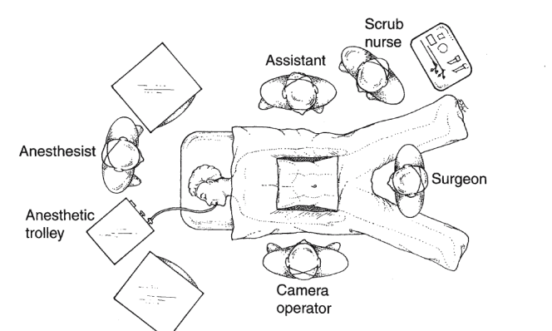

Operating room setup for laparoscopic gastrectomy

The 1st trocar (12 mm) for the scope was inserted “by Hasson’s or Visiport technique” just above the umbilicus, and the table was then changed into the steep reverse-Trendlenberg position. 2nd trocar was inserted above the level of the umbilicus on the left mid-clavicular line, while the 3rd trocar was inserted above the level of the umbilicus on the right mid-clavicular line. A 4th trocar was inserted just below the xyphoid process to apply liver retraction and a 5th port was inserted just below the level of the umbilicus on the left anterior axillary line. The trocars 2-5 were all 5 mm.



Trocar placement for laparoscopic Heller cardiomyotomy

After routine abdominal exploration, a pars flaccida approach to dissect the phrenoesophageal ligament from the anterior surface of the esophagus was carried out. Dissection clarifies the anterior vagus nerve and the thickened narrowed area of the diseased lower esophageal sphincter and part of the dilated esophagus above and the anterior surface of the cardia and upper stomach below.

Pneumoperitoneum was established and intra-abdominal pressure was set to be 14 mm Hg. Then the peritoneal cavity was carefully explored for disseminated malignancy and peritoneal lavage with fluid collected sent for cytologic examination for detection of microscopic tumor dissemination.

We used to start with dissecting the greater curvature of the stomach. We used to begin at a point midway on the greater curvature of the stomach, as it usually has an avascular window in the gastrocolic ligament with minimal fat even in obese patients. Then dissection proceeded toward the lower pole of the spleen where it stops (for distal gastrectomies) or completed by dissecting the short gastric vessels until the angle of His between the esophagus and stomach is cleared and lower esophagus mobilized for at least 6 cm (for total and proximal gastrectomy), then dissection was completed distally until the proximal 2 cm of the first part of the duodenum (for distal and total gastrectomy) or the prepyloric vein of Mayo (for proximal gastrectomy). The right gastroepiploic vessels were dissected clipped and then divided at their origin. All lymph nodes along the gastro-epiploic vessels (stations 4d and 4sb) were dissected. Then the infrapyloric LNs (station 6) were dissected from the pyloric head.

The lesser sac was then opened at the pars flaccid the descending branch of the left gastric artery was divided and mobilized with the lesser curve of the stomach downwards this is followed by flipping the stomach upwards and to the right completing dissection until the origin of the left gastric artery from the celiac trunks is reached and the artery divided at its origin (station 7). Then LNs around the celiac artery were dissected (station9). For distal and total gastrectomy, the duodenum was then transected with a linear endo-GIA stapler, 60 mm, blue cartridge, 2 cm distal to the pylorus. For proximal and total gastrectomy the mobilized esophagus was transected with a linear endo-GIA stapler, 45 mm, blue cartridge, 2 cm above the cardia.

For both distal and proximal gastrectomy the stomach was transected with multiple a linear endo-GIA stapler, 60 mm, blue or green cartridge (according to gastric wall thickening, at least 6 cm far from the palpable tumor edge.

After resecting the gastric specimen, the peritoneum on the anterior surface of the pancreas was dissected until the splenic artery was exposed and LNs around it dissected completely (station 11).

Then the hepatoduodenal ligament was dissected, and the right gastric artery was divided at origin for dissection of suprapyloric lymph nodes (station 5). The LNs along the common hepatic (station 8a) and proper hepatic (station 12a) arteries were also removed. Finally, the resected specimens were placed in a sterile plastic bag that was ligated to prevent dissemination of malignancy from resected specimens.

At this stage, when splenectomy was needed, the splenic artery and vein was dissected, clipped then divided just distal to the tail of the pancreas, and the spleen mobilized and removed from its bed.

Dissection was carried out by the Harmonic shear or the Force Triad curved tip Ligasure.

After the dissection phase is completed GI continuity was restored with Roux-en-Y gastro-jejunostomy for distal gastrectomy, with esophago-gastrostomy for proximal gastrectomy, and with esophago-jejunostomy for total gastrectomy. This was performed using side-to-side anastomosis using linear endo-GIA staplers, 60 mm, blue cartridge. As shown in the following live photos.

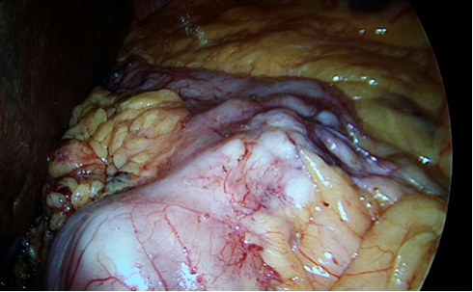

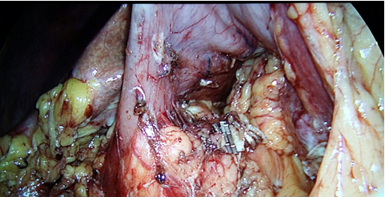

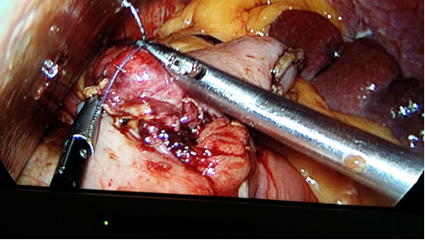

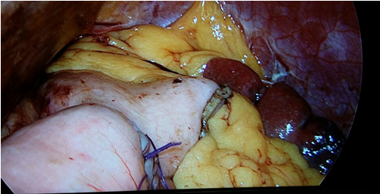

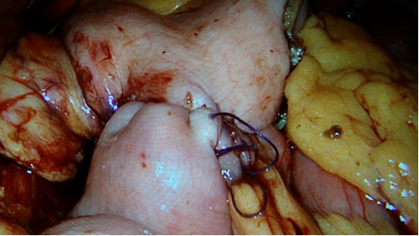

A nasogastric tube inserted at the beginning of the operation was then advanced to cross the anastomosis, just before hand sewing the opening left after the side-to-side stapling.

Finally the resected bagged specimens were extracted through a 6 cm vertical supra-umbilical incision that starts at the umbilicus.

Two large tubal drains were usually placed, one in the left subphrenic space and the other near the anastomosis through separate bilateral ports, and left until the patient starts semisolid meals without evidence of anastomotic leaks or bleeding, usually for 3-5 days.

Usually patients started mobilization a few hours after laparoscopic gastrectomy, nasogastric tube removed and oral fluids started 48 hours when there was no evidence of anastomotic leak.

**3. Results:**

The 47 patients included in the study had radical gastrectomy for gastric adenocarcinoma. The tumor was confirmed to be adenocarcinoma by postoperative specimen pathologic examination. Patients were divided into two groups; A and B.

**Group A** included 13 patients who had totally laparoscopic radical gastrectomy (LG). No conversion to open gastrectomy was needed. Patients were 7 females and 6 males with mean age 49 years (range 38-59). The clinical TNM stage was stage II in 8 patients and stage III in 5 patients. Tumor distribution within the stomach was 8 tumors in the distal stomach and had distal radical gastrectomy, 4 tumors in the proximal stomach and had proximal radical gastrectomy and 1 tumor involving large part of the stomach and necessitated total radical gastrectomy with splenectomy. As in the open surgery the safety resection margin was considered 6 cm from the felt tumor edge. The D2 LN dissection was done in all cases. Negative pathologic safety margin (>1 cm) was achieved in 10 patients, while the margin was close (< 1cm) in 3 patients. Dissected LNs confirmed by pathologic analysis of specimens ranged from 11-26 LNs (mean 19 LNs). Mean operative time was 250 minutes (range 180-320). Mean blood loss was 230 mL (range 130-480). No operative complications had occurred. Postoperative limited anastomotic leakage occurred in 2 patients. Leakage trickled out through the tubal drains and stopped spontaneously over a few days. No other operative or postoperative complications had occurred. No operative or early postoperative mortality has occurred. Mean hospital stay was 6 days (4-21).

Mean follow up was 19 months (10-34). Tumor recurrence occurred in 5 patients (5/13). Mean tumor free survival was 15 months (8-24) and overall survival at one year was 12/13.

**Group B** included 34 patients who had open radical gastrictomy (OG) for gastric adenocarcinoma. Patients were 19 females and 15 males with a mean age of 58 years (range 37-71) the clinical TNM stages were, stage II in 18 patients and stage III in 16 patients.

Tumor distribution within the stomach was 16 tumors in the distal stomach and had distal radical gastrectomy, 13 tumors in the proximal stomach and had proximal radical gastrectomy and 5 tumors involving large part of the stomach and necessitated total radical gastrectomy with splenectomy, one of them had distal pancreatectomy as well. Mean operative time was 160 minutes (130-235). Mean blood loss was 540 mL (340-750). Total number of postoperative complications was 14 and occurred in 6 patients (6/34). Postoperative bleeding through the drain that stopped spontaneously occurred in 3 patients. Wound infection occurred in 4 patients and incisional hernia occurred in 7 patients. No operative or early postoperative mortality had occurred. Negative safety margin was achieved in 29 patients, while margin was close (<1 cm) in the remaining 5 (5/34) patients. A mean of 26 lymph nodes were harvested (range 18-32). Mean hospital stay time was 7 days (4-17).

Mean follow up was 20 months (12-31). Tumor recurred in 9 patients with a mean tumor free survival of 16 months (range 10-27 months). One year survival was 31/34.

**4. Discussion:**

Since the first laparoscopic gastrectomy for gastric caner was performed by Japanese surgeons in 1991, laparoscopic distal gastrectomy **(LDG)** for early gastric cancer has gained widely acceptance for its minimal invasion compared with open distal gastrectomy **(****ODG)**[6].

Recently, a meta-analysis published by Haverkamp et al. and Shinohara et al demonstrated the better not only short-term outcomes but also acceptable long-term oncologic safety of **LTG** compared with **OTG**. It was also demonstrated that the functional recovery was faster for LTGpatients than for OTG patients. This most probably results from less surgically induced trauma and subsequently reduced inflammation. The lower levels of white blood cell counts and C reactive protein found in the LTG group during the early postoperative phase support [7] [8].

**Table 1 Patient demographics**

|  |  |  |  |
| --- | --- | --- | --- |
| **Variables** | **LG**  **(n = 13)** | **OG**  **(n = 34)** | **Total**  **(n = 47)** |
| **Sex**  **(females: males)** | **7: 6** | **19:15** | **26: 21** |
| **Age**  **(mean, range) in years** | **49, 38-59** | **58, 37-71** | **52, 37-71** |
| **TNM stage** |  |  |  |
| **II** | **8** | **18** | **26** |
| **III** | **5** | **16** | **21** |
| **Total** | **13/13** | **34/34** | **47/47** |
| **(LG) Totally laparoscopic radical gastrectomy, (OG) Open radical gastrictomy** | | | |

At present, LG is usually considered unsuitable for T4a cases because of the potential for inadequate lymph node dissection and a higher incidence of regional or peritoneal recurrence of gas insufflation during the LG procedure [9]

In our hospital, with a volume of 47 patients who underwent radical gastrectomy (**LG** 13 vs **OG** 34) were done in three years. In our study the postoperative hospital stay relatively accepted With mean, (range) of 7, (7-21) days [6, (4-21) days vs 7, (4-17) days] LG vs OG respectively, table 1.

Ten out of twelve studies described the length of hospital stay, was significantly shorter in the LG group. Two studies showed a mean shorter hospital stay in the OG group in comparison with the LG group with weighted mean difference of -2.43 days [10].

Although laparoscopic surgery has a clear benefit regarding postoperative hospital stay, in our series the hospital stay was with a mean, (range) of 6, (4-21) days 7, (4-17) days vs 7, (4-21) days LG vs OG respectively. In fact, a publication from Japan also reported postoperative hospital stays similar to ours (16.7 ± 5.6 days with LADG versus 21 ± 11.4 days with ODG), so our hospital stay was significantly low and comparable with previous studies [11].

In this study, we observed longer operative time (250, 180-320 min versus 160, 130-235min) and similar blood loss (230, 130-480 mL versus 540, 340-750 mL) in the LG group compared with the OG group. The longer hospital stay may be attributed to the trend of not discharging patients until they have fully recovered from the surgery.

One of the major concerns in conducting laparoscopic total gastrectomy with D2 lymphadenectomy was the prolonged operation time, which may increase morbidity, D2 lymphadenectomy was done in all of our study, however the hospital mortality rate was zero and there was acceptable morbidity rate [8].

**Table 2 Operative Results**

|  |  |  |  |
| --- | --- | --- | --- |
| **Variables** | **LG**  **(n = 13)** | **OG**  **(n = 34)** | **Total**  **(n = 47)** |
| **Post-operative day**  **(mean (range)) (d))** | **6, 4-21** | **7, 4-17** | **7, 4-21** |
| **Curative rate**  **R0, R1, R2** | **10: 3: 0** | **29: 5: 0** | **39:8: 0** |
| **Harvested LN** | **19, 11-26** | **26, 18-32** | **24, 11-32** |
| **Gastrectomy** |  |  |  |
| **Distal** | **8** | **16** | **24** |
| **Proximal** | **4** | **13** | **17** |
| **Total** | **1** | **5** | **6** |
| **Operative blood loss**  **(mean, range) in mL** | **230, 130-480** | **540, 340-750** | **380, 130-750** |
| **Operative time**  **(mean, range) in min.** | **250, 180-320** | **160, 130-235** | **190, 130-320** |
| **(LG) Totally laparoscopic radical gastrectomy, (OG) Open radical gastrictomy** | | | |

Our data showed that the numbers of harvested lymph nodes were not significant between the LG and OG groups (11-26 LNs (mean 19 LNs) versus 18-32LNs (mean 26 LNs)), respectively), which were comparable with the results in the previous reports [12], table 2.

Post-operative morbidity after OG are more than LG totally 16 (34%) (14 (41%) vs 2 (15%) respectively) in form of Wound infection (4), Post-op. bleeding (4), Incisional hernia (7), while 2 patient with LG had leakage.

In the study by **Topal et al**, the overall morbidity rate was 39.5%. **Huscher et al** reported an 18.2% mortality rate and a 45.4% morbidity rate. In the present study, mortality (death within 30 d after operation) and morbidity of patients with LG vs OG was 0% and 15.3% vs 0% and 20%, respectively. No significant differences between LG and OG were found with regard to mortality or morbidity rates. In addition, these scores were comparable to rates reported in other studies [4, 13].

The previous studies from Western centers have reported operative mortality rates ranging from 4.4% to 16.8% in regard was zero in our study [13], table 3.

**Table 3 Post-operative Morbidity and Mortality**

|  |  |  |  |
| --- | --- | --- | --- |
| **Variables** | **LG**  **(n = 13)** | **OG**  **(n = 34)** | **Total**  **(n = 47)** |
| **Post-operative Morbidity** |  |  |  |
| **Viscus injury** | **No** | **No** | **No** |
| **Leakage** | **2** | **No** | **2** |
| **Wound infection** | **No** | **4** | **4** |
| **Post-op. bleeding** | **No** | **4** | **4** |
| **Incisional hernia** | **No** | **7** | **7** |
| **Total** | **2/13** | **6/34** | **8/47** |
| **Post-operative Mortality** |  |  |  |
| **Total** | **No** | **No** | **No** |
| **(LG) Totally laparoscopic radical gastrectomy, (OG) Open radical gastrictomy** | | | |

After a mean follow-up period of 19 months (range 10-34months) and 20 months (range 12-31months) for LG vs OG, the one year overall survival rate in the laparoscopic group was 92.3%, compared to 91.1% in the open group which was comparable with previous studies. The recurrence-free survival rate for one year was 61.6% in the LG group and 73.6%in the OG group, respectively, with significant differences between the 2 groups. Recurrences occurred in 5 (38.4%) patients in the LG group compared to 9 (26.4%) patients in the OG group, no significant differences in recurrence were observed [14], table 4.

**Table 4 Recurrence Free Survival and Over All Survival**

|  |  |  |  |
| --- | --- | --- | --- |
| **Surgical**  **Approach** | **Recurrence** | **One Year**  **Recurrence Free Survival (%)** | **One Year**  **Over All Survival (%)** |
| **LG**  **(n=13)** | **5 (38.4%)** | **61.6%** | **92.3%** |
| **OG**  **(n=34)** | **9 (26.4%)** | **73.6%** | **91.1%** |
| **Total** | **14** |  |  |
| **(LG) Totally laparoscopic radical gastrectomy, (OG) Open radical gastrictomy** | | | |

**Conclusion**:

The absence of mortality or major complications that necessitate surgical intervention together with the accepted oncologic results regarding safety margin, number of LNs removed, and tumor free survival indicate that totally laparoscopic radical gastrectomy is not only feasible and safe, but it is also oncologically efficient. However, still larger randomized controlled studies are needed for more solid conclusions.

**References:**

1. Kim, M. C., et al., Comparison of laparoscopy‐assisted by conventional open distal gastrectomy and extraperigastric lymph node dissection in early gastric cancer. Journal of surgical oncology, 2005. 91(1): p. 90-94.
2. Uyama, I., et al., Laparoscopic gastrectomy with preservation of the vagus nerve accompanied by lymph node dissection for early gastric carcinoma. Journal of the American College of Surgeons, 2005. 200(1): p. 140-145.
3. Usui, S., et al., Laparoscopy-assisted total gastrectomy for early gastric cancer: comparison with conventional open total gastrectomy. Surgical Laparoscopy Endoscopy & Percutaneous Techniques, 2005. 15(6): p. 309-314.
4. Topal, B., et al., Determinants of complications and adequacy of surgical resection in laparoscopic versus open total gastrectomy for adenocarcinoma. Surgical endoscopy, 2008. 22(4): p. 980-984.
5. Kitano, S., et al., A multicenter study on oncologic outcome of laparoscopic gastrectomy for early cancer in Japan. Annals of surgery, 2007. 245(1): p. 68.
6. Wang, W., et al., Laparoscopic versus open total gastrectomy for gastric cancer: an updated meta-analysis. PloS one, 2014. 9(2): p. e88753.
7. Haverkamp, L., et al., Laparoscopic total gastrectomy versus open total gastrectomy for cancer: a systematic review and meta-analysis. Surgical endoscopy, 2013. 27(5): p. 1509-1520.
8. Shinohara, T., et al., Laparoscopic total gastrectomy with D2 lymph node dissection for gastric cancer. Archives of surgery, 2009. 144(12): p. 1138-1142.
9. Xu, Y., et al., Laparoscopic versus open gastrectomy for gastric cancer with serous invasion: long-term outcomes. journal of surgical research, 2017. 215(July 2017 p1-268): p. 190-195.
10. Straatman, J., et al., Minimally invasive versus open total gastrectomy for gastric cancer: a systematic review and meta-analysis of short-term outcomes and completeness of resection. World journal of surgery, 2016. 40(1): p. 148-157.
11. Hamabe, A., et al., Comparison of long-term results between laparoscopy-assisted gastrectomy and open gastrectomy with D2 lymph node dissection for advanced gastric cancer. Surgical endoscopy, 2012. 26(6): p. 1702-1709.
12. Lee, S. R., et al., Laparoscopic-assisted total gastrectomy versus open total gastrectomy for upper and middle gastric cancer in short-term and long-term outcomes. Surgical Laparoscopy Endoscopy & Percutaneous Techniques, 2014. 24(3): p. 277-282.
13. Huscher, C. G., et al., Totally laparoscopic total and subtotal gastrectomy with extended lymph node dissection for early and advanced gastric cancer: early and long-term results of a 100-patient series. The American Journal of Surgery, 2007. 194(6): p. 839-844.
14. Fang, C., et al., Comparison of long-term results between laparoscopy-assisted gastrectomy and open gastrectomy with D2 lymphadenectomy for advanced gastric cancer. The American Journal of Surgery, 2014. 208(3): p. 391-396.

4/16/2018