Potential protective effect of Colostrum or Coenzyme Q10 against experimentally induced carcinogenesis

Gamal Mohamed Fathy Edrees; Maher Amer Ali Amer, Mona Sami Gouida, Alaa El-Din L. Firgany, Mostafa Ismail Abd Al-Halium Al-Tonbary.

Zoology Department, Faculty of Science, Mansoura University, Egypt. mostafaaltonbary@gmail.com

Abstract: The role of Colostrum (50 mg/kg) or Coenzyme Q10 (100 mg/kg) on oxidative stress induced by Erlich ascites carcinoma [EAC] (0.2X10⁶ cells) and CCL₄ (1.5 ml / kg) in female mice were evaluated. Viability, arginase activity, α L-fucosidase and Bcl₂ were significantly exceeded in EAC + CCL₄ treated mice. In addition P53 level significantly decreased. These abnormalities are accompanied by increased the lipid peroxidation product (MDA), protein carbonyl PC and decline in antioxidant enzyme activity as well as GSH, CAT, SOD, GST level. It seems that mice pretreated with Colostrum or Coenzyme Q10 then with EAC + CCL₄ reveal marked protection as antitumor substance.
[Gamal Mohamed Fathy Edrees; Maher Amer Ali Amer, Mona Sami Gouida, Alaa El-Din L. Firgany, Mostafa Ismail Abd Al-Halium Al-Tonbary. Potential protective effect of Colostrum or Coenzyme Q10 against experimentally induced carcinogenesis. Cancer Biology 2018;8(1):122-128]. ISSN: 2150-1041 (print); ISSN: 2150-105X (online). http://www.cancerbio.net. 7. doi:10.7537/marscbj080118.07.

Key words: Colostrum, Coenzyme Q10, Ehrlich ascites carcinoma, CCL₄, Antioxidant.

1. Introduction
Cancer continuous to represent the largest cause of mortality in the world and claims over 6 million lives every year (Abdullaev et al., 2000). An extremely promising strategy for cancer prevention is chemoprevention, which is defined as the use of synthetic or natural agents (alone or combination) to prevent the development of cancer in humans (Gupta et al., 2004).
Colostrum also known colloquially as beestings, bisnings or first milk, Colostrum is a form of milk produced by the mammary glands of mammals (including humans) in late pregnancy. Most species will generate colostrum just prior to giving birth. Colostrum contains antibodies to protect the newborn against disease, as well as being lower in fat, and higher in protein than ordinary milk (Hibbeln et al., 2006; Sakai et al., 2010).
Colostrum shows promise in the treatment or prevention of a variety of diseases, Ateb and ErdoUrul (2003) and Arokiyaraj et al. (2008) CoQ10 is found in the membranes of many organelles. Since its primary function in cells is in generating energy, the highest concentration is found on the inner membrane of the mitochondrion. Some other organelles that contain CoQ10 include endoplasmic reticulum, peroxisomes, lysosomes, and vesicles.
The antioxidant nature of CoQ10 derives from its energy carrier function. As an energy carrier, the CoQ10 molecule continuously goes through oxidation-reduction cycle. As it accepts electrons, it becomes reduced. As it gives up electrons, it becomes oxidized. In its reduced form, the CoQ10 molecule holds electrons rather loosely, so this CoQ molecule will quite easily give up one or both electrons and, thus, act as an antioxidant. CoQ10 inhibits lipid peroxidation by preventing the production of lipid peroxyl radicals (LOO). Moreover, CoQH₂ reduces the initial perferryl radical and singlet oxygen, with concomitant formation of ubisemiquinone and H₂O₂. This quenching of the initiating perferryl radicals, which prevent propagation of lipid peroxidation, protects not only lipids, but also proteins from oxidation. In addition, the reduced form of CoQ effectively regenerates vitamin E from the a-tocopheroxyl radical, thereby interfering with the propagation step (McConnell et al., 2001).
The goal of this study is to test whether Colostrum or Coenzyme Q10 inhibit the proliferation of tumour cells without damaging the normal cells, in experimentally liquid tumour induced by Erlich ascites and CCL₄ in female mice.

2. Materials and Methods
Materials:
Corn oil is oil extracted from the germ of corn (maize), 100% pure donated from supermarket. Cows Bovine Colostrum is a milky fluid that comes from the breasts of the first few days after giving birth, before true milk appears. Coenzyme Q10 is donated from Sigma Aldrich. Ehrlish ascites carcinoma cells were purchased from National Institute of Cancer, Cairo, Egypt. Carbon tetra chloride (CCL₄) is donated from Sigma Aldrich.
Animals and Diets:
Female Swiss albino mice weighing 23 ±3 g were purchased from animal house of National institute of cancer for experimental animals, Cairo, Egypt. They were raired in the animal house of Zoology Department, Faculty of science, Mansoura University, Egypt.
The animals were housed in cages in groups, 12 mouse per cage, in a controlled environment (25±2 ºC, 50-60% relative humidity and 12- hour light-dark cycle).
The animals were fed standard rodent diet and allowed water ad libitum for a week, and were then randomly assigned to 7 groups: control untreated group, corn oil group (corn oil orally administred at adose of 1.5 ml / kg from the first day to the last day), colostrum group (colostrum orally administred at a dose of 50 mg / kg from the first day to the last day), coenzyme Q10 group (coenzyme Q10 orally administred at adose of 100 mg / kg from the first day to the last day), colostrum+EAC+CCL₄ group (colostrum administred orally at adose of 50 mg / kg and CCL₄ administred orally at a dose of 1.5 ml / kg from the first day to the last day, while EAC were injected intradermal in the 21th day only at a dose (0.02x10⁷ cells)), coenzyme Q10 +EAC+CCL₄ group (coenzyme Q10 administred orally at a dose of 100 mg / kg and CCL₄ administred orally at a dose of 1.5 ml / kg from the first day to the last day, while EAC were injected pretonial in the 21 th day only by dose (0.02x10⁷ cells)), EAC+CCL₄ group (Erlich ascites carcinoma cells where injected pretonial in the 21 th day only by dose (0.02x10⁷ cells) while CCL₄ administrated orally at a dose of 1.5 ml / kg from the first day to the last day ).
After 21 th day from CCL₄ adminstration, EAC was injected, then after 12 day mice were scarificed by cervical decapitation and viliability was assessed. Blood samples were collected in heparinized tubes and tissue samples (liver & kidney) were quickly separeted and weighed, stored at -20° C for future analysis.
Viability of EAC:
The fresh cells were stained with trypan blue dye according to the method of, (Boyse -Wetzel et al., 1964) the cells that did not stained were viable and non viable cells were counted. The percentage of residual cell viability was calculated using the following formula:

Tumour markers
Arginase activity was determined by colorimetric kit described by Marsch et al., 1965 (Biodiagnostic company, 29 Tahreer St., Dokki, Giza, Egypt). α L Fucosidase activity was determined using the method of El-Houseini et al., 2005 ( Biodiagnostic company, 29 Tahreer St., Dokki, Giza, Egypt ). P53 was assessed in cell suspension using the method Descripied by Sironi et al., (1999) Bcl2 was estimated in cell suspension using the method of pezzella et al., (1990).
Oxidative stress biomarkers
Malondialdehyde was assessed as described by Ohkawa, et al. (1979) by using Colorimetric kit purchased from (Biodiagnostic company, 29 Tahreer St., Dokki, Giza, Egypt). Protein carbonyl content was measured by first forming labelled protein hydrazone derivatives using 2, 4- dinitrophenylhydrazide Smith et al., (1991). GSH was assessed as described by Beutler et.al, (1963) using Colorimetric kit purchased from (Biodiagnostic company, 29 Tahreer St., Dokki, Giza, Egypt). Super oxide was assessed as described by Nishikimi et al., (1986) using Colorimetric kit purchased from (Biodiagnostic company, 29 Tahreer St., Dokki, Giza, Egypt). Catalase was assessed as described by Aebi, (1984) using Colorimetric kit purchased from (Biodiagnostic company, 29 Tahreer St., Dokki, Giza, Egypt). Glutathione-S-transefrase was assessed as described by Habig and Pabst (1974) using Colorimetric kit purchased from (Biodiagnostic company, 29 Tahreer St., Dokki, Giza, Egypt).
Histological technique
Mice were sacrificed by decapitation under light isoflurane anesthesia. Kidneys and liver were rapidly dissected out, tiny pieces from both organs were immediately fixed in 10% formol saline for paraffin sections (5 µ thickness) stained with H & E and Masson’strichrome stains (Bancroft and Layton, 2013).
Statistical Analysis:
The results were analysed by One Way ANOVA (analysis of variance) test and comparied using Tukey test. The results were expressed as mean ± standard error (SE). The values of p≤0.05 were considered statistically significant (Snedecor and Cochran, 1982).

3. Results
Administration Colostrum or Coenzyme Q10, prior to EAC+ CCl₄ inoculation resulted a significant decrease (P<0.05) in the viability as compared to EAC+ CCl₄ group (Table1). EAC implantation and CCl₄ administration causes significant increase (P<0.05) in the serum arginase and α L-fucosidase activities as compared to their activates in control group. Administration Colostrum or Coenzyme Q10, prior to EAC+ CCl₄ inoculation produced significant amelioration (P<0.05) in the serum arginase, L-fucosidase and in Bcl2 and proliferation in P53 activities as compared to that of EAC control group.
Table (2) showed that EAC+ CCl₄ induces significant increase (P<0.05) in MDA and PC and significant decrease (P<0.05) in GSH, CAT, SOD and GST as compared to that of the normal control group. Administration of Colostrum or Coenzyme Q10 prior to EAC + CCl₄ inoculation produced significant decrease (P<0.05) in MDA and PC and significant increase in GSH, CAT, SOD and GST as compared to that of EAC+ CCl₄ group.

Table (1) Protective effect of Colostrum or Cooenzyme Q10 on vailability, serum arginase and alpha L fucosidase activities as a tumour marker as well as Bcl2 % as antiapoptotic marker, P53 as apoptoic and oncogenic markers in control and different treated mice groups
Animal groups | Control | Corn Oil | Colostrum | Coenzyme Q10 | Erlich+ccl4 | Colostrum+ Erlich+ccl4 | Coenzyme Q10+ Erlich+ccl4
Vailability % |  |  |  |  | 25.6±0.4 | 10.5±0.1^{b} | 20.2±0.3^{b}
Arginase (U/L) | 145.5±9.3 | 145.1±6.5 | 143.2±6.9 | 142.2±5.9 | 318.2±7.4 ^{ab} | 203.7±7.4 ^{ab} | 249.7±8.8^{ab}
alpha L fucosidase (U/L) | 2.76±0.04 | 2.81±0.04 | 2.83±0.05 | 2.85±0.03 | 8.41±0.2 ^{ab} | 5.14±0.1 ^{ab} | 5.99±0.3 ^{ab}
BCL-2 (liver) % | 46.7±0.5 | 46.4±0.9 | 49.8±0.7 | 46.2±1.4 | 63.6±0.9ª | 54.03±1.3^{ab} | 60.7±2.4ª
BCL-2 (kidney)% | 46.6±0.5 | 47.7±0.6 | 47.0±0.6 | 43.7±1.2 | 66.7±0.5ª | 54.7±1.2^{ab} | 57.6±0.8^{ab}
P53 (liver) % | 42.8±0.7 | 47.4±0.7ª | 44.9±1.2 | 45.5±0.5 | 25.7±0.8ª | 38.3±1.2^{ab} | 33.1±0.9^{ab}
P53 (kidney) % | 43.5±0.7 | 44.4±0.9 | 46.5±0.5 | 47.9±0.5ª | 26.5±0.9ª | 36.9±1.1^{ab} | 34.2±1.2^{ab}
ª significant against control group p≤ 0.05; ^{b} significant against Ehrlich + CCl4 group group p≤ 0.05.

Table (2): The antioxidant effect of Colostrum or Coenzyme Q10 in MDA, GSH, CAT, SOD, GST and PC in control and different treated mice groups.
Animal groups | Control | Corn Oil | Colostrum | Coenzyme Q10 | Erlich+ccl4 | Colostrum+ Erlich+ccl4 | Coenzyme Q10+ Erlich+ccl4
MDA (liver) (nmol / g.tissue) | 70.7±0.5 | 71.1±0.5 | 31.5±0.4 ª | 42.1±0.4 ª | 158.5±0.6 ª | 132.9±0.5 ^{ab} | 140.1±0.4 ^{ab}
MDA (kidney) (nmol / g.tissue) | 67.6±0.5 | 67.2±0.5 | 27.6±0.5 ª | 38.1±0.4 ª | 154.6±0.4 ª | 134.7±0.5 ^{ab} | 139.9±0.5 ^{ab}
PC (liver) (µmol DNPH / mg. wet tissue) | 8.9±0.7 | 8.9±0.6 | 6.4±0.1 ª | 7.4±0.1 | 16.9±0.2 ª | 12.9±0.1 ^{ab} | 13.9±0.2 ^{ab}
PC (kidney) (µmol DNPH / mg. wet tissue) | 7.5±0.1 | 7.4±0.2 | 6.5±0.2 ª | 7.3±0.2 | 15.7±0.3 ª | 12.2±0.2 ^{ab} | 13.2±0.1 ^{ab}
GSH (liver) (mg / g. tissue) | 49.5±0.8 | 51.7±0.6 | 57.1±1.8 ª | 56.9±0.3 ª | 25.1±0.5 ª | 35.7±0.6 ^{ab} | 30.8±0.8 ^{ab}
GSH (kidney) (mg / g. tissue) | 39.6±0.3 | 41.4±0.4 | 49.5±0.4 ª | 46.8±0.4 ª | 14.9±0.3 ª | 25.4±0.3 ^{ab} | 20.2±0.4 ^{ab}
SOD (liver) (U / g. tissue) | 27.8±0.2 | 28.8±0.1 | 25.6±0.3 | 24.6±0.6 | 20.5±0.4 ª | 22.8±0.7 ª | 21.4±0.9 ª
SOD (kidney) (U / g. tissue) | 25.6±0.2 | 28.2±0.2 | 23.6±0.9 | 22.1±0.9 | 17.2±2.8ª | 20.6±1.5 | 18.4±2.2ª
CAT (liver) (U / g. tissue) | 116.9±0.3 | 118.1±0.3 ª | 115.3±0.2 ª | 114.4±0.4 ª | 32.7.±0.2 ª | 81.7±0.2 ^{ab} | 57.1±0.2 ^{ab}
CAT (kidney) (U / g. tissue) | 114.9±0.2 | 115.8±0.2 | 113.2±0.2 ª | 111.8±0.3 ª | 30.7±0.2 ª | 79.5±0.2 ^{ab} | 55.1±0.2 ^{ab}
GST (liver) (U / g. tissue) | 7.1±0.1 | 7.6±0.1 ª | 8.8±0.1 ª | 8.2±0.1 ª | 3.7±0.1 ª | 4.8±0.1 ^{ab} | 4.3±0.1 ^{ab}
GST (kidney) (U / g. tissue) | 6.4±0.1 | 7.1±0.1 ª | 8.2±0.1 ª | 7.6±0.1 ª | 3.1±0.1 ª | 4.3±0.1 ^{ab} | 3.6±0.1 ^{ab}
ª significant against control group p≤ 0.05; ^{b} significant against Ehrlich + CCl4 group group p≤ 0.05.

4. Discussion
In this study, Administration of both Colostrum and Coenzyme Q10 to the normal animals for 33 day did not produce any significant modification in the animal's body weight gain by the end of the experimental period, compared to the normal control, this result indicate that both Colostrum and Coenzyme Q10, have produced no toxic biocompatible, biodegradable effect or afavorable effect on the growth rate of the animal used, a view which in agreements with Vinsova and Vavrikova (2008).
In the present results, EACc inoculation and CCL₄ induces significant increase in Availability of EAC cells %; this result agree with Bergamini-santos et al. (2004) that may lead to the neutrophilic inflammatory response which is essential to Ehrlich tumor controlling. The administration of Colostrum or Coenzyme Q10 to Ehrlich ascites and CCl₄ mice treated group showed significant decrease in Availability when compared with the mice loaded with EAC-CCL₄, this result may be attributed to the anti-inflammatory action of bovine colostrum lactoferrin (Nishino et al., 2002) and antioxidant acivity of coenzyme Q10 (Folkers et al., 1993).
The present data showed that, EACc inoculation and CCL₄ induces significant increase in serum arginase activity compared to that of the normal control, this result agree with Erbas et al. (2007) who observed that, in the tumor induced by Ehrlich ascites in female mice there was a significant increase in serum arginase activity. The administration of colostrum or coenzyme Q10 showed significant decrease serum arginase activity when compared with the mice loaded with EAC-CCL₄, this result may be attributed to the anti-inflammatory action of bovine colostrum lactoferrin (Wakabayashi, 2000) and antioxidant activity of coenzyme Q10 (Littarru and Tiano, 2007).
EACc inoculation and CCL₄ induces significant increase in Serum α L fucosidase (AFU) activity as compared to that of the normal control, this result agree with Grizzi et al. (2007) who noted that, in the tumor induced by Ehrlich ascites in female mice there was a significant increase in AFU activity which indicate the appearance of cancer. The administration of colostrum or coenzyme Q10 showed decrease in AFU activity when compared with the mice loaded with liquid tumor, this result agree with Kawamori et al. (1999) and may be due to the anti-inflammatory action of bovine colostrum lactoferrin, while Coenzyme Q10 exhibited significant antitumor and might be show oxidative metabolism, an explantion which in accordance with Overvad et al. (1999).
The present data showed that in the liquid tumor induced by Ehrlich ascites and CCL₄ in female mice, there was a significant increase in Bcl₂ % when compared with normal one, this result agree with the previous study of Tsujimoto et al. (1985) who noted that, BcL₂, is as a proto-oncogene exceed in a follicular B-cell lymphoma as a proto-oncogene. The administration of colostrum or coenzyme Q₁₀ pre EACc and CCL₄ showed decrease in Bcl₂ % when compared with the mice loaded with liquid tumor only, These results agree with Tsuda et al. (2002) who noted that, the mechanism of bovine colostrum lactoferrin cellular defense and coenzyme Q10 against ROS generation as reported by Beyer, (1996).

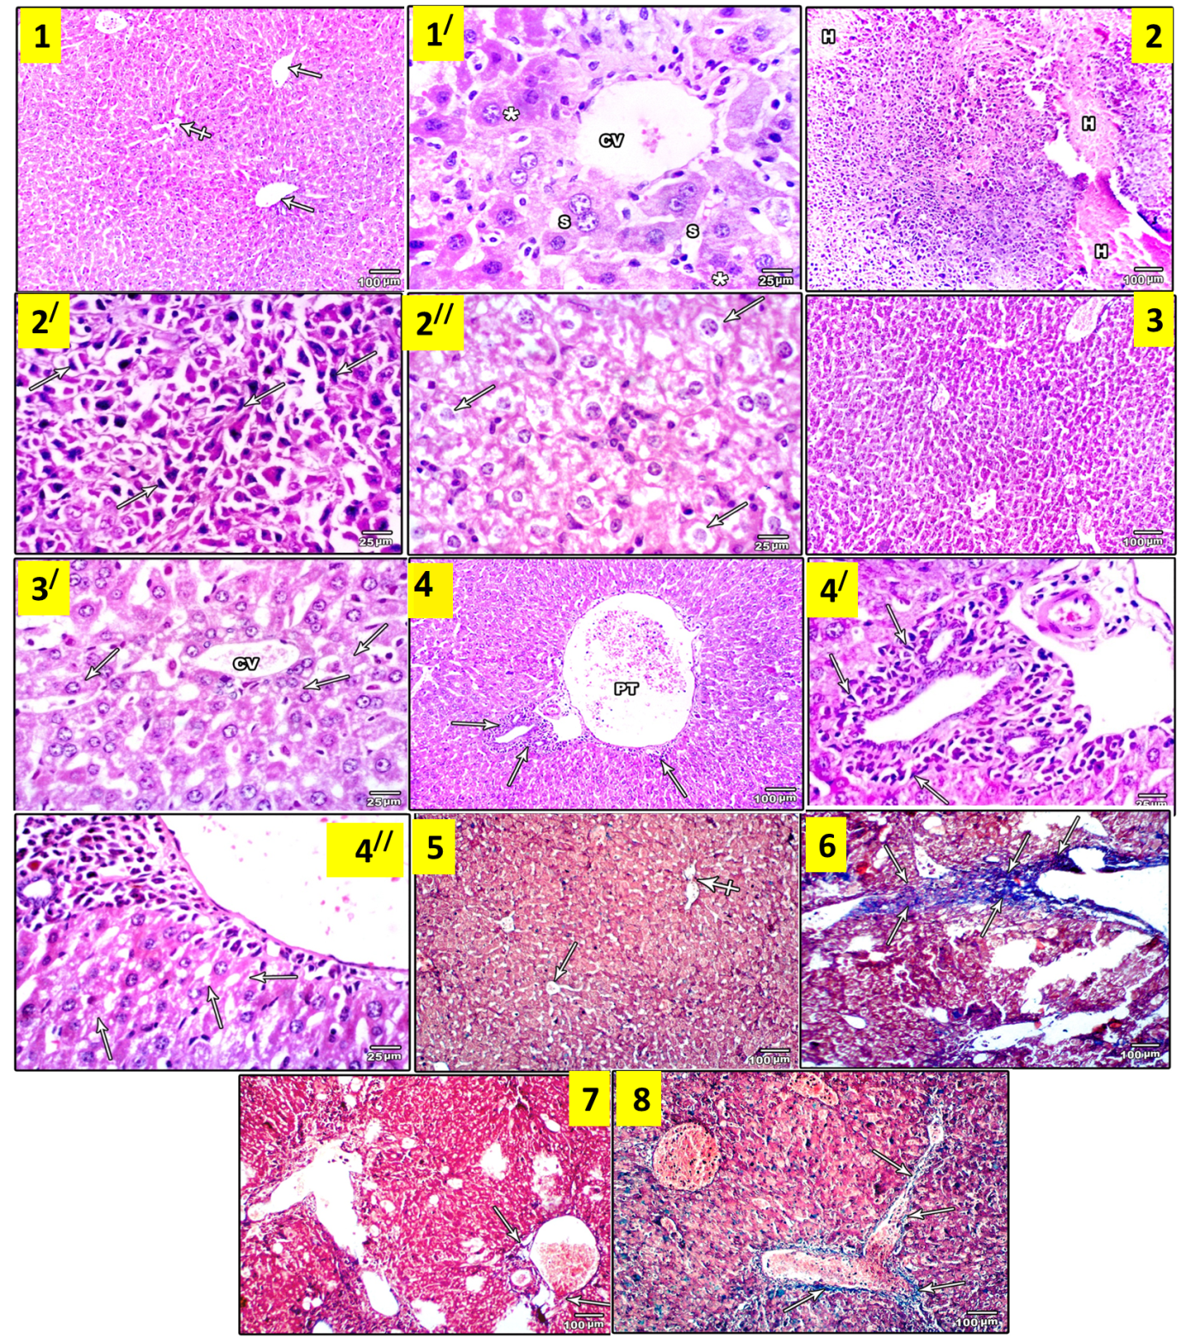
Fig. a. Photomicrographs of liver of all groups stained with H & E (1-4//) and Masson’s trichrome (5-8). Portal tracts (arrows) and a central vein (crossed arrow) are seen in the control group (1). A higher magnification (1/) showing the central vein (CV) and hepatocytes (*) separated by blood sinusoids (S). EAC + CCL₄ group (2) demonstrates massive infiltration with Erlichs cells and wide areas of haemorrhage inbetween (H). A higher magnification showing Erlichs cells (arrows) (2/) and marked vacuolation of the majority of hepatocytes (arrows) (2//). Note the absence of infiltrating Erlichs cells in Colostrum + EAC + CCL₄ group (3). The higher magnification (3/) shows hepatocytes with minimal cytoplasmic vacuolation (arrows). Coenzyme Q10 + EAC + CCL₄ group demonstrates small areas of focal infiltration (arrows) around portal tract (PT) (4 & 4/) and minimal cytoplasmic vacuolation (arrows) in the hepatocytes (4//). Masson’s trichrome of control group (5) demonstrates thin connective tissue at the areas of portal tracts (crossed arrow) and in the wall of central vein (arrow). EAC + CCL₄ group liver shows extensive fibrosis (arrow) in liver parenchyma (6). Colostrum + EAC + CCL₄ group (7) displays slightly larger amount of connective tissue (arrows) as compared to the control group. Coenzyme Q10 + EAC + CCL₄ group (8) illustrates moderate amount of fibrous tissue (arrows). (1,2,3, 4,5,6,7,8): ×100, scale bar = 100 µm). (1/,2/,2//,3/,4/,4//: ×400, scale bar = 25 µm).

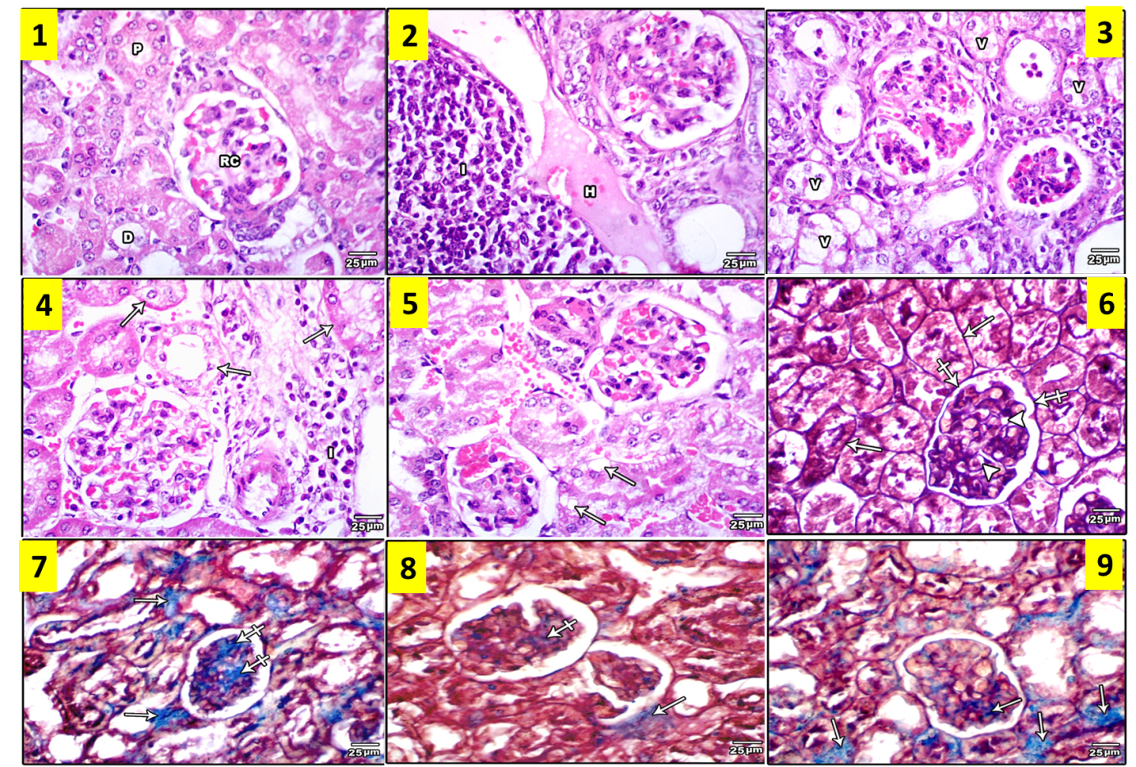
Fig. b. Photomicrographs of the renal cortex of all groups stained with H & E (1-5) and Masson’s trichrome (6-9). Renal corpuscles (RC) proximal (P) and distal (D) convoluted tubules are seen in the control group (1). Erlich+CCl₄ group displays severe interstitial nephritis (I) haemorrhage (H) and marked vacuolation of renal tubules lining cells (2 and 3). Coenzyme Q10+ Erlich+CCL₄ group shows minimal vacuolation (arrows) and interstitial nephritis (I) (4). Colostrum + EAC + CCL₄ group displays minimal cytoplasmic vacuolation (arrows) (5). Masson’s trichrome of control group (6) demonstrates thin connective tissue around renal tubules (arrows), around renal corpuscles (crossed arrows) and in the renal glomerulus (head arrows). EAC + CCL₄ group (7) kidney shows massive interstitial (arrows) and glomerular fibrosis (crossed arrows). Colostrum + EAC + CCL₄ group (8) illustrates minimal amount of interstitial (arrow) and glomerular (crossed arrow). Coenzyme Q10 + EAC + CCL₄ group (9) shows slightly less amount of fibrosis (arrows) as compared to EAC + CCL₄ group (7). (×400, scale bar = 25 µm).

The reduced P53 in tumor loaded group is not unexpected, and agree with Wilson et al. (1997) and may be as a result of the tumor suppressor function of P53 as mentioned by Irani et al. (2011). The tumor-suppressor protein p53 accumulates when DNA is damaged due to a chain of biochemical factors. Part of this pathway includes alpha-interferon and beta-interferon, which induce transcription of the p53 gene, resulting in the increase of P53 protein level and enhancement of cancer cell-apoptosis. P53 prevents the cell from replicating by stopping the cell cycle at G1, or interphase, to give the cell time to repair, however it will induce apoptosis if damage is extensive and repair efforts fail. Any disruption to the regulation of the p53 or interferon genes will result in impaired apoptosis and the possible formation of tumors (Takaoka et al., 2003). This apoptosis may be attributed due to the activation of P53 leading to DNA damage as reported by Wilson et al. (1997), the administration of colostrum or coenzyme Q10 showed significant increase in P53 % when compared with that in the mice loaded with liquid tumor only, these results may be attributed to the potant antioxidant acivity of bovine colostrum lactoferrin (Owour and Kong, 2002); Folkers et al., 1993) respectively.
The present data showed that EAC inoculation induces significant increase in liver and kidney tissues malondealdehyde (MDA) and protein carbonyl (PC) levels as compared to that of the normal control. The increased MDA level in tumor loaded group may be as a result of the excessive free radical production as reported by Gupta et al. (2004). The administration of colostrum or coenzyme Q10 showed significant reduction in hepatic and tumor tissues malondialdehyde (MDA) and protein carbonyl (PC) levels when compared with the mice loaded with EAC-CCL₄, a result which may be attributed to the antioxidant activity of colostrum or may be attributed to the bovine colostrum lactoferrin enhancement of the cell killing activity of cytotoxic T and natural killer cells as reported by Tsuda et al. (2006) and antioxidant activity of coenzyme Q₁₀, a view which in accordance with Beyer et al. (1992).
In the present study, the significant decreases of GSH, SOD, CAT and GST, upon EAC-CCL₄ administration, indicated that EAC-CCL₄ destroyed antioxidant defense system in mice, these free radicals also attack antioxidant defense system, leading to the loss of antioxidant components such as GSH, SOD, CAT and GST (Cheshchevik et al., 2012). Administration of colostrum and Coenzyme Q₁₀ improve the antioxidant defense system and protect the Liver and kidney tissue cells from damaging induced by EAC-CCL₄ through decreasing the oxidative stress and support the antioxidant defense system (Black, 2002; Conklin; 2005).
In conclusion, the present study provided obvious evidence on the beneficial effects of colostrum and coenzyme Q10 in reducing tumor growth and counteracting the metabolic disorders associated with female mice inoculated with liquid tumour model and may offer novel approaches to cancer therapy.

References
- Abdullaev F, Rivera-Luna R, Roitenburd-Belacortu V, Espinosa-Aguirre J. 2000. Pattern of childhood cancer mortality in mexico. Arch. Med. Res. 31: 526-531.
- Arokiyaraj, S., S. Martin, K. Perinbam, P. Marie Arockianathan and V. Beatrice, (2008): Free radical scavenging activity and HPTLC finger print of Pterocarpus santalinus L.-an in vitro study. Int. J. Sci. Tech., 1: 1-7.
- Ateb, D.A. and O.T. ErdoUrul, (2003): Antimicrobial activities of various medicinal and commercial plant extracts. Turk. J. Biol., 27: 157-162.
- Bergamini-santos, P.C.; Mariano, M. and Barbuto, J.A. (2004): Dual role of polymorphonuclear neutrophils on the growth of Ehrlich ascites tumor (EAT) in mice. Life Sci. 75(2): 245-255.
- Boyse -Wetzel E1, Schwarzenbacher R, Lipton SA. (1964): Molecular pathways to neurodegeneration. 10: S2-9.
- Beyer R.E., Segura-Aguilar J., Di Bernardo S., Cavazzoni M., Fato R., Fiorentini D., Galli M.C., Setti M., Landi L., Lenaz G (1996): The role of DT-diaphorase in the maintenance of the reduced antioxidant form of coenzyme Q in membrane systems. Proc. Natl. Acad. Sci. USA. 93:2528–2532.
- Beyer, R. E. (1992): An analysis of the role of coenzyme Q in free radical generation and as an antioxidant. Biochem. Cell Biol. 70:390–403.
- Cheshchevik, V; Lapshina, E; Dremza, I; Zabrodskaya, S; Reiter, R; Prokopchik, N; Zavodnik, I (2012): Rat liver mitochondrial damage under acute or chronic carbon tetrachloride-induced intoxication: Protection by melatonin and cranberry flavonoids. Toxic appl. pharm. 261: 271-279.
- Conklin KA (2005): Coenzyme q10 for prevention of anthracycline-induced cardiotoxicity Integr Cancer Ther. 4(2):110-30.
- Erbas H.; Aydogdu, N.; Usta, U. and Erten, O. (2007): Protective role of carnitine in breast cancer via decreasing arginase activity and increasing nitric oxide. Cell Biol. Int. 31: 1414-1419.
- Folkers K1, Morita M, McRee J Jr. (1993): The activities of coenzyme Q10 and vitamin B6 for immune responses. Biochem Biophys Res Commun.193(1):88-92.
- Grizzi F.; Franceschini, B.; Hamrick, C.; Frezza, E.E.; Cobos, E. and Chiriva-Internati, M. (2007): Usefulness of cancer-testis antigens as biomarkers for the diagnosis and treatment of hepatocellular carcinoma. J. Transl. Med. 5: 3.
- Gupta S, Adhami V, Subbarayan M, MacLennan G, Lewin J, Hafeli U, Fu P, Mukhtar H. 2004. Suppression of prostate carcinogenesis by dietary supplementation of celecoxib in transgenic adenocarcinoma of the mouse prostate model. Cancer Res., 64: 3334-3343.
- Hibbeln Joseph R , Levi RG Nieminen, Tanya L Blasbalg, Jessica A Riggs, and William EM Lands (2006): Healthy intakes of n−3 and n−6 fatty acids: estimations considering worldwide diversity. Am. J. Clin. l Nutrit. 83 (6 Suppl): 1483S–1493S.
- Irani, S.; Atyabi, S.M.; Mivehchi, H.; Siadat, S.D.; Aghasadeghi, M.R. and Farhangi, A. (2011): Solvent effects on structural and thermochemical properties of p53 tumor-suppressor gene: A molecular modeling approach in drug design. Int. J. Nanomedicine. 6: 2063-2069.
- Kawamori T., Lubet R., Steele V. E., Kelloff G. J., Kaskey R. B., Rao C. V., and Reddy B. S. (1999): Chemopreventive effect of curcumin, a naturally occurring anti-inflammatory agent, during the promotion/progression stages of colon cancer. Cancer. Res. 59, 597–601.

McConnell JR1, Emery J, Eshed Y, Bao N, Bowman J, Barton MK. (2001): Role of PHABULOSA and PHAVOLUTA in determining radial patterning in shoots. Nature 411: 709–713.
- Owour E. D., and Kong A. N. (2002): Antioxidants and oxidants regulated signal transduction pathways Biochem. Pharmacol. 64: 765–770.
- Sakai H; Nagahama K; Taguchi H; Akamatsu T; Morimura S; Kida K; Matsuoka M. (2010): Functional replacement of yeast flavocytochrome b (2) with bacterial l-lactate dehydrogenase. J Biosci Bioeng 110(3):269-27.
- Snedecor, G.W. and Cochran, W.G. (1982): Statistical Methods. 6th Edn., Iowa State University Press, Ames, USA., P. 593.
- Takaoka A1, Hayakawa S, Yanai H, Stoiber D, Negishi H, Kikuchi H, Sasaki S, Imai K, Shibue T, Honda K, Taniguchi T. (2003): Integration of interferon-alpha/beta signalling to p53 responses in tumour suppression and antiviral defence. Nature. 424(6948):516-23.

Tsuda Hiroyuki, Katsumi Fukamachi, Jiegou Xu, Kazunori Sekine, Shigetoshi Ohkubo, Nobuo Takasuka, and Masaaki Iigo (2006): Prevention of carcinogenesis and cancer metastasis by bovine lactoferrin Proc Jpn Acad Ser B Phys Biol Sci. 82(7): 208–215.

Tsuda H, Sekine K, Fujita K, Ligo M (2002): Cancer prevention by bovine lactoferrin and underlying mechanisms--a review of experimental and clinical studies. Biochem Cell Biol. 80(1):131-136.
- Vinsova J1, Vavrikova E (2008): Recent advances in drugs and prodrugs design of chitosan. Curr Pharmaceut. Design. 14(13):1311-26.
- Wilson, W.H.; Teruya-Feldstein, J.; Fest, T.; Harris, C.; Steinberg, S.M.; Jaffe, E.S. and Raffeld, M. (1997): Relationship of p53, Bcl-2, and tumor proliferation to clinical drug resistance in non-hodgkin's lymphomas. Blood. 89: 601-609.
- Wakabayashi H, Yamauchi K, Kobayashi T, Yaeshima T, Iwatsuki K, Yoshie H. (2009): Inhibitory effects of lactoferrin on growth and biofilm formation of Porphyromonas gingivalis and Prevotella ntermedia. Antimicrob Agents Chemother 53: 3308–3316.

3/25/2018

