Results of Low Grade Gliomas Single Institute Experience

Radwa H. Azab, MSc¹, Karim Mashhour, M.D¹, Mohamed Abdalla, MD¹, Hanan Darwish, MD¹, Hoda Abdelghany, MSc², Shawky El-Haddad, FRCR, MD¹.

¹Department of Clinical Oncology, Kasr Al-Ainy School of Medicine, Cairo University, Egypt
² Department of Medical Physics, Kasr Al-Ainy Hospital, Cairo University, Egypt
drradwahamdy@gmail.com

Abstract: Aim of the study: The aim of the study is to correlate the progression free survival (PFS) and the overall survival (os) in low grade gliomas with age, performance status, sex, pathological type, grade, tumor volume, biopsy size, laterality of tumor of the patients. Background: Low-grade gliomas (LGG) comprise a rare and clinically challenging group of central nervous system tumors to manage ⁽¹⁾⁾. The median survival time for patients with low-grade glioma has been shown to be between 4.7 and 9.8 years with a range of up to 13 years for certain subtypes (3) 102 Patients was low grade astrocytoma at NEMROCK, 67% was supratentorial, astrocytoma grade II represent 66 % more than grade I. 5 years survival rate was 66 % for the study, the size of the tumor, extent of the surgery, degree of immediate response of irradiation significantly affected the Relapse rate. ⁽⁵⁾ Approximately 2,000 to 3,000 LGGs are diagnosed in the United States every year, accounting for nearly 15% of all primary brain tumors. Peak incidence occurs in people between 35 and 44 years of age, and there is an increased prevalence among white people and men. ⁽¹⁴⁾ Material & Methods: patients with a pathological diagnosis of low grade gliomas (WHO grade I-II) were referred to our center for postoperative irradiation we are going to correlate which will affect overall survival (os) and progression free survival (PFS) of the patients the performance status, young age (equal or less than 40 years old), sex, pathological type, grade, tumor volume, biopsy size, laterality of tumor. Results: Patients in our study with PS 1 the mean value SD± was (36 ± 6.5) and PS 2,3 the mean value SD± (15.6±4.1) with statistical significance (p value<0.009) so better PFS seen in ps 1. Patients in our study with PS 1 the mean value SD± was (43.6 ± 2.29) and PS 2,3 the mean value SD± (36.9±4.16) with no statistical significance (p value<0.156) regarding the overall survival (os), Patients in our study with age equal or less than 40 years has better survival than patients above 40 with statistical significance (p value <0.000). While sex, pathological type, grade, tumor volume, biopsy size, laterality of tumor donot affect theoverall survival or progression free survival of the patients with no statistical significance. Conclusion: In our study only performance status affect PFS and young age (equal or less than 40 years old ) affect overall survival of the patients while sex, pathological type, grade, tumor volume, biopsy size, laterality of tumor donot affect the survival of the patients.
[Radwa H. Azab, Karim Mashhour, Mohamed Abdalla, Hanan Darwish, Hoda Abdelghany, Shawky El-Haddad. Results of Low Grade Gliomas Single Institute Experience. Cancer Biology 2018; 8(1):24-29]. ISSN: 2150-1041 (print); ISSN: 2150-105X (online). http://www.cancerbio.net. 4. doi:10.7537/marscbj080118.04.

Keywords: Low grade gliomas, OS, PFS, age, performance status.

1. Introduction
Low-grade gliomas (LGG) comprise a rare and clinically challenging group of central nervous system tumors to manage ⁽¹⁾. They accounts for approximately 15 % of all primary brain tumors ⁽²⁾.
The median survival time for patients with low-grade glioma has been shown to be between 4.7 and 9.8 years with a range of up to 13 years for certain subtypes ⁽³⁾
In Egypt the incidence of brain tumors based upon results of National Cancer Registry Program (NCRP) from 2008 till 2011, the brain tumors incidence was 5.29% of cancer in Egypt, (male 5.48% and female 5.18%) ⁽⁴⁾
102 Patients was low grade astrocytoma at NEMROCK, 67% was supratentorial, astrocytoma grade II represent 66 % more than grade I. 5 years survival rate was 66 % for the study, the size of the tumor, extent of the surgery, degree of immediate response of irradiation significantly affected the Relapse rate. ⁽⁵⁾
The Surgical resection (versus biopsy alone) gives a better opportunity to characterize, grade, proper diagnosis, treatment, and prognosis. Despite the lack of a randomized controlled trial, the evidence for the benefits of extensive surgical resection is growing. ⁽⁶⁾
Radiation therapy (RT) has traditionally been the mainstay in the treatment of LGGs. Clearly, early postoperative RT has been shown to have benefits with regards to progression free survival but no difference in OS was noted ⁽⁷⁾

2. Methods and Materials
- Patient selection & eligibility:
Patients with a pathological diagnosis of low grade gliomas (WHO grade I-II) were referred to our center for postoperative) in a period June 2014 till July 2016. Table 1 Shows patients demographic data tumor characteristics.

Table 1: Patients and tumor characteristics
 | No | %
Age
< 40 years | 12 | 60
>40 years | 8 | 40
Sex
Male | 7 | 35
Female | 13 | 65
Performance status
1 | 11 | 55
2 | 6 | 30
3 | 3 | 15
Clinical presentation
Convulsions | 4 | 20
Diminution of vision | 1 | 5
Headache | 11 | 55
Weakness | 4 | 20
Pathological type
Astrocytoma | 18 | 90
Oligodendroglioma | 2 | 10
Pathological grade (WHO)
I | 5 | 25
II | 15 | 75
Tumor Site
Corpus callosal | 2 | 10
Frontal | 2 | 10
Temporal | 1 | 5
Intraventricular | 2 | 10
Thalamic | 1 | 5
Parietal | 4 | 20
Parieto-occipital | 2 | 10
Temporal | 4 | 20
Tempero-parietal | 2 | 10
Laterality
Left | 9 | 45
Right | 3 | 15
Midline | 8 | 40
Abbreviations: No: Number of patient; WHO: world health organization

2. Correlation survival with demographic and pathological data and the technique:
In our study we are going to correlate which will affect overall survival (os) or and progression free survival (PFS) of the patients performance status, young age (equal or less than 40 years old ), sex, pathological type, grade, tumor volume, biopsy size, laterality of tumor.
3. Statistical analysis:
Data were statistically described in terms of range, mean, standarddeviation (SD), median, frequencies (number of cases) and relativefrequencies (percentages) when appropriate. Comparison of quantitativevariables between the study groups was done using Mann Whitney U testfor independent samples. A probability value (p value) less than 0.05 was considered statistically significant. All statistical calculations were done using computer programs Microsoft Excel version 7 (Microsoft Corporation, NY, USA) and SPSS (Statistical Package for the Social Science; SPSS Inc., Chicago, IL, USA) statistical program for Microsoft Windows.

3. Results
PFS in relation to performance status (ps):
Patients in our study with PS 1 the mean value SD± was (36 ± 6.5) and PS 2,3 the mean value SD± (15.6±4.1) with statistical significance (p value<0.009) so better PFS seen in ps 1.

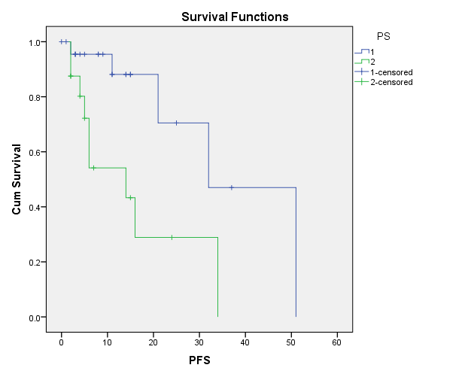
Fig. 1: Blue curve represents patients with ps 1 and green curve represents patients with ps 2 and 3 in correlation with PFS.

OS in relation to performance status (ps):
Patients in our study with PS 1 the mean value SD± was (43.6 ± 2.29) and PS 2,3 the mean value SD± (36.9±4.16) with no statistical significance (p value<0.156).

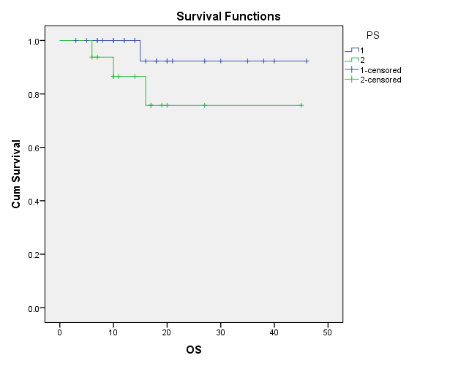
Fig. 2: Blue curve represents patients with ps 1 and green curve represents patients with ps 2 and 3 in correlation with os.
OS in relation to Age:
Patients in our study with age equal or less than 40 years has better survival than patients above 40 with statistical significance (p value <0.000).

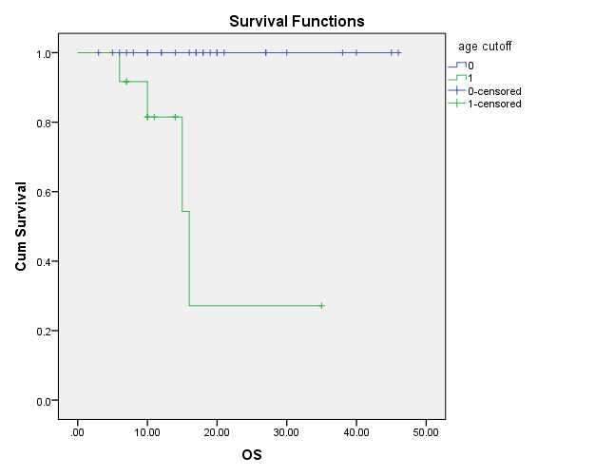
Fig. 3: Blue curve represents patients with age less than or equal 40 years while green curve represents the age above 40 years in correlation with the survival.

OS in relation to sex:
In our study there is no statistical difference between males with mean value SD± (42.5± 3.24) and females with mean value SD± (34.9 ±2.65) regarding the overall survival ( p value<0.471).
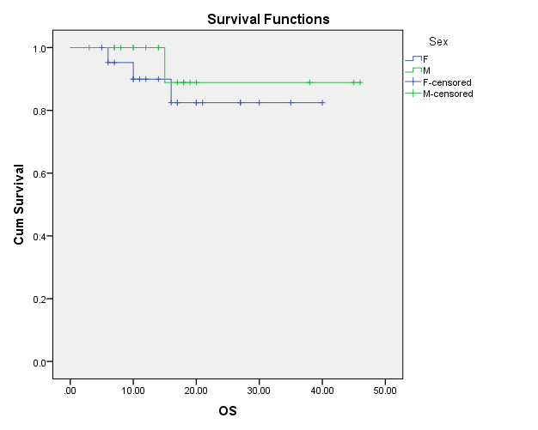
Fig. 4: Blue curve represents females while green curve represents males in correlation with 0S

OS in relation to tumor laterality:
In our study the tumors which are midline in images with mean value SD± (36.6 ± 3.1) while tumors which are on one side either left or right mean value SD± (40.6±2.89) there is no statistical difference regarding the overall survival ( p value<0.863).

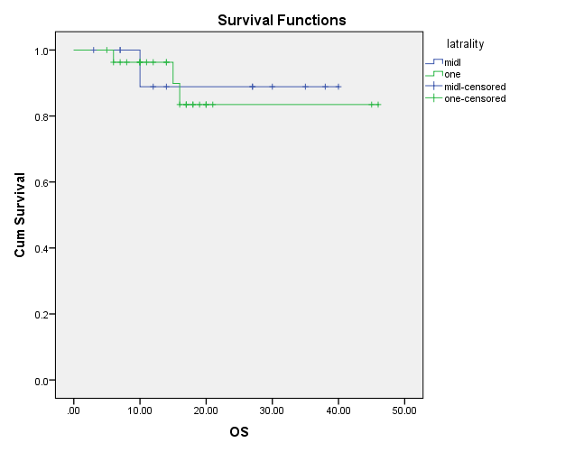
Fig. 5: Blue curve represents midline tumors while green curve represents tumors related to left or right side in correlation with 0S

OS in relation to pathological type:
In our study there is no statistical difference regarding the overall survival between astrocytomas and oligdendrogliomas and mixed gliomas (p value<0.508).

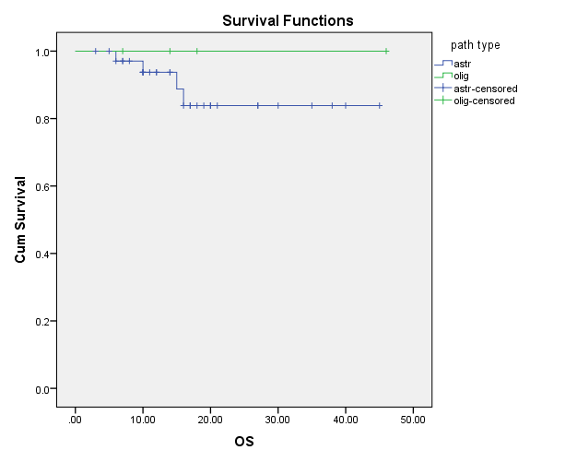
Fig. 6: Blue curve represents astrocytomas while green curve represents oligodendrogliomas and mixed gliomas in correlation with 0S

OS in relation to pathological grade:
In our study patients with pathological grade I with mean value SD± (32 ± 6.5) while patients with pathological grade II with mean value SD± (41.9± 2.2) with no statistical difference regarding overall survival (p value<0.479).

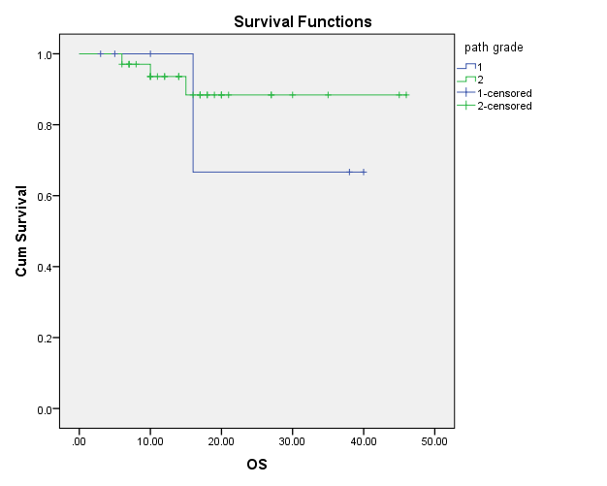
Fig. 7: Blue curve represents patients with pathological grade I while green curve represents with pathological grade II in correlation with 0S.

OS in relation to tumor size:
In our study there is no statistical difference regarding the os with tumors more than 100 cm3 or less than 100 cm3 with (p value<0.128).

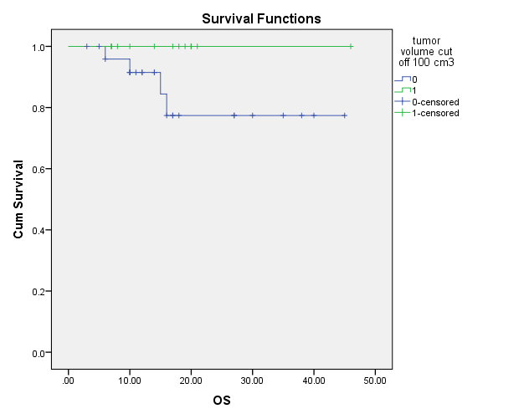

Fig. 8: Blue curve represents tumors less than 100 cm3 while green curve tumors more than 100 cm3 in correlation with 0S.

OS in relation to biopsy resection:
In our study patients with biopsy size less than or equal 0.5 cm with mean value SD± (40.27 ± 3.05) while patients with biopsy size more than 0.5 cm with mean value SD± (25.5 ±1.35) with no statistical difference regarding overall survival ( p value<0.693).

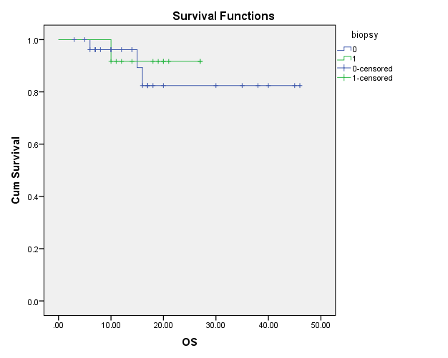
Fig. 9: Blue curve represents biopsy size less than or equal 0.5 cm while green curve represents biopsy size more than 0.5 cm in correlation with 0S.

In our study only performance status affect PFS and young age (equal or less than 40 years old ) affect overall survival of the patients while sex, pathological type, grade, tumor volume, biopsy size, laterality of tumor do not affect the survival of the patients.

4. Discussion
LGGs are generally slower growing and account for approximately 10–20 % of all primary brain tumors. The median survival time for patients with low-grade glioma has been shown to be between 4.7 and 9.8 years with a range of up to 13 years for certain subtypes ⁽³⁾.
Prognosis of LGGs is assessed utilizing parameters of progression free survival (PFS) and overall survival (OS). Factors such as tumor size >6.0 cm, astrocytoma histology, and partial resection surgery are poor prognostic indicators for both PFS and OS ⁽⁸⁾.
Pignatti et al analyzed the EORTC 22845 randomized trial data and developed a prognostic scoring system based upon unfavorable prognostic factors. In their scoring system, age greater than 40 years, tumor diameter greater than 6 cm, tumors crossing midline, astrocytoma histology, and baseline neurologic deficit were all considered unfavorable prognostic variables. Their analysis revealed that low-risk patients with two or fewer risk factors had an expected median survival of more than 7 years. Three or more risk factors was deemed higher risk and correlated with a much lower median survival ⁽⁹⁾.
In our study Patients with age equal or less than 40 years has better survival than patients above 40 with statistical significance (p value <0.000), In our study the tumors which are midline in images with mean value SD± (36.6 ± 3.1) while tumors which are on one side either left or right mean value SD± (40.6±2.89) there is no statistical difference regarding the overall survival ( p value<0.863).
The University of California, San Francisco (UCSF) group introduced a new LGG scoring system that uses a four-point scoring system to predict OS and PFS, assigning one point each for age greater than 50 years, Karnofsky performance score (KPS) ≤80, maximum tumor diameter greater than 4 cm, and eloquent involvement of the tumor. When stratified according to low-risk (scores 0–1), medium-risk (score 2), and high-risk (scores 3–4) groups, 5-year OS was 97%, 81%, and 56%, respectively, and 5-year PFS was 76%, 49%, and 18%, respectively ⁽¹⁰⁾, In our study Patients with PS 1 the mean value SD± was (43.6 ± 2.29) and PS 2,3 the mean value SD± (36.9±4.16) with no statistical significance (p value<0.156) regarding the overall survival (os), Patients with PS 1 the mean value SD± was ( 36 ± 6.5) and PS 2,3 the mean value SD± (15.6±4.1) with statistical significance (p value<0.009) regarding progression free survival (PFS) so better PFS seen in ps 1.
A recent meta-analysis on the 4 large randomized trials from the pre-molecular era (including RTOG 9802) showed 4 factors related to worse OS: the presence of baseline neurological deficits, a shorter time since first symptoms (30 weeks), an astrocytic tumor type, and tumors larger than 5 cm in diameter. ⁽¹¹⁾
In a study investigated the clinical prognostic factors for low-grade gliomas. In which the Patients diagnosed with histopathologically confirmed low-grade glioma, It was found that Fifty-five patients were included in the study. The mean follow-up period was determined as 60 ± 57 (4.5-168.1) months. Five-year overall survival was determined as 69% and 10-year overall survival was determined as 40%, pre-radiotherapy age below 40 and gross-total excision were determined as good prognostic factors. So they demonstrated that the aggressive surgical resection provided a better survival advantage both in single variable analyses and multivariate analyses, although the low number of patients was the most important limitation in the study, they consider that patient age and extent of resection are the most important clinical prognostic factors in low-grade gliomas ⁽¹²⁾.
In a study including 86 patients with low-grade gliomas (LGGs), they analyzed the prognostic factors for progression-free survival (PFS), overall survival (OS), and malignant transformation. They concluded that, non-critical location, gross total removal, and oligodendroglial pathology statistically correlated with improved PFS and OS., gross total removal correlated with longer PFS and gemistocytic astrocytoma had a poor PFS. Younger age and non-critical area showed an improved OS and astrocytic pathology showed a poor OS). Malignant transformation was pathologically diagnosed in 13 out of 86 patients (15%). Gemistocytic astrocytoma correlated independently with malignant transformation In LGGs. ⁽¹³⁾ In our study there is no statistical difference regarding the overall survival between astrocytomas and oligdendrogliomas and mixed gliomas (p value<0.508), In our study patients with biopsy size less than or equal 0.5 cm with mean value SD± (40.27 ± 3.05) while patients with biopsy size more than 0.5 cm with mean value SD± (25.5 ±1.35) with no statistical difference regarding overall survival (p value<0.693), In our study there is no statistical difference regarding the os with tumors more than 100 cm3 or less than 100 cm3 with ( p value<0.128).

Conclusion
In our study only performance status affect PFS and young age (equal or less than 40 years old ) affect overall survival of the patients while sex, pathological type, grade, tumor volume, biopsy size, laterality of tumor do not affect the survival of the patients.

References
- Kaloshi G, Psimaras D, Mokhtari K, Dehais C, et al. Supratentorial low-grade gliomas in older patients. Neurology, 2009; 73 (24).
- Ostrom QT, Gittleman H, Farah P, Ondracek A, Chen Y, Wolinsky Y, et al.: CBTRUS statistical report: primary brain and central nervous system tumors diagnosed in the United States in 2006-2010. Neuro Oncol. 2013 Nov;15 Suppl 2:ii1-56.
- Omuro A, De Angelis LM.: Glioblastoma and other malignant gliomas: a clinical review. JAMA, 2013; 310(17):1842–1850.
- Ibrahim AS, Khaled HM, Mikhail NN, Baraka H, Kamel H.: Cancer Incidence in Egypt: Results of the National Population-Based Cancer Registry Program. J Cancer Epidemiol. 2014; 2014:437971.
- El Haddad. SH, El-Ghoneimy E, Nayel, Moustafa H, et al.: Prognostic factors low grade Astrocytoma The Egyptian journal of radiology and nuclear medicine. june 1990, Volume XXI, No 1.
- Keles GE, Lamborn KR, Berger MS: Low-grade hemispheric gliomas in adults: a critical review of extent of resection as a factor influencing outcome. J Neurosurg 2001, 95:735–745.
- Claus EB, Black PM: Survival rates and patterns of care for patients diagnosed with supratentorial low-grade gliomas: data from the SEER program, 1973–2001. Cancer 2006; 106:1358–1363.
- Karim AB, Afra D, Cornu P, Bleehan N, Schraub S, De Witte O, et al.: Randomized trial on the efficacy of radiotherapy for cerebral low-grade glioma in the adult: European Organization for Research and Treatment of Cancer Study 22845 with the Medical Research Council study BRO4: an interim analysis. Int J Radiat Oncol Biol Phys. 2002; 52:316–24.
- Pignatti F, van den Bent M, Curran D, et al.: Prognostic factors for survival in adult patients with cerebral low-grade glioma. J Clin Oncol 2002, 20:2076–2084.
- Chang EF, Smith JS, Chang SM, et al.: Preoperative prognostic classification system for hemispheric low-grade gliomas in adults. J Neurosurg 2008, 109:817–824.
- Gorlia T, Wu W, Wang M, et al.: New validated prognostic models and prognostic calculators in patients with low-grade gliomas diagnosed by central pathology review: a pooled analysis of EORTC/RTOG/ NCCTG phase III clinical trials. Neuro Oncol. 2013;15(11):1568–1579.
- Kaya V, Gamze Aksu M, Korcum A, et al.: Clinical prognostic factors of adjuvant radiation therapy for low-grade gliomas: results of 10 years survival, Int J Clin Exp Med 2014;7(5):1336-1343.
- Tae-Young J, Shin J, Jung-Ho M, et al: Early prognostic factors related to progression and malignant transformation of low-grade gliomas. Clin Neurol Neurosurg. 2011 Nov; 113(9):752-7.
- Central Brain Tumor Registry of the United States: Statistical Report: Primary Brain Tumors in the United States, 2000–2004. Available at http://www.cbtrus.org/reports//2007-2008/2007report.pdf.

