Comparisons between Three Algorithms in Left-Side Breast Cancers Using Three-Dimensional Conformal Radiotherapy Technique

E. A. Hegazy¹, E. O. Abdel-Muttalib², M. T. Ahmed³, M. I. Abdel-Hamid³, M. A. Elnaggar⁴, M. M. Ghozlan⁴

¹ Delta University for Science and Technology, Faculty of Pharmacy, Dakahlia, Egypt.
²Mansoura General Hospital, Department of Medical Analysis, Mansoura, Egypt.
³Mansoura University, Faculty of Science, Department of Physics, Mansoura, Egypt.
⁴Alexandria Clinical Oncology Center “Ayadi-Almostakbal” (ACOCAA), Department of Radiotherapy, Alexandria, Egypt.
emadomar78@yahoo.com

Abstract: We aimed to compare between three dose calculations algorithms (convolution (CON), fast superposition (FSUP), and superposition (SUP)) in three-dimensional conformal radiotherapy (3D-CRT) treatment planning technique for breast cancer patients. Ten patients with left-side breast cancer were selected for this study. Dose of 5000 cGy was prescribed to planning target volume (PTV). For each patient, 3D-CRT plans were created with non-coplanar and non-opposing photon beams of 6 MV quality. CMS XiO system of treatment planning (TPS) was the system for the process of planning. The percent of maximum variation observed between the three algorithms for PTV was 2.72% for average conformity index (CI), and for OARs was 11.47% in average D_{mean} in case of contralateral breast. Significant variations between three algorithms were observed. From our study, as the results of the three different algorithms showed clear difference in some cases, considerable precaution unavoidable in evaluation of treatment plans, because the selection of dose calculation algorithm could effect on the process of treatment planning (TP) as well as the end medical results.
[E. A. Hegazy, E. O. Abdel-Muttalib, M. T. Ahmed, M. I. Abdel-Hamid, M. A. Elnaggar, M. M. Ghozlan. Comparisons between Three Algorithms in Left-Side Breast Cancers Using Three-Dimensional Conformal Radiotherapy Technique. Cancer Biology 2018;8(1):9-17]. ISSN: 2150-1041 (print); ISSN: 2150-105X (online). http://www.cancerbio.net. 2. doi:10.7537/marscbj080118.02.

Keywords: Comparison; Algorithm; Breast Cancer; Radiotherapy; Technique

1. Introduction:
Many tumors have been demonstrated to be dominatable, if not healable, by the usage of radiation. Ionizing radiation either deaths cancer cells directly or might hurts them quite so that they cannot split again, making it unattainable for the cancer to keep to grow [1]. Three-dimensional conformal radiotherapy (3D-CRT) is a radiotherapy delivery technique that utilizes treatment systems and computer planning to suture the shape and size of the dose extent to the perfect target volume, with most insularity of the surrounding healthy tissues [2].
The dose calculation accuracy and the rigorous program of quality assurance is fundamental so as to make certain that delivery of dose to the tumor is 100% or near 100% of the intended dose [3]. The radiotherapy dose calculation algorithm has been developing quickly since the 1950s, fundamentally attributed to the fast evolution in the computer science and particle/nuclear physics domains which make us able to superiorly understand the processes involved in the interaction of beam particle-media and to calculate and simulate doses for a complicated system in a shortened period of time. A good algorithm is the dose calculation algorithm which not only consider the accuracy of all the physical operations involved in the interaction of beam particle-media so that the calculated dose is precise, but also is rapid sufficient to be applied in clinic. Thus, speed and accuracy are the two main factors for an algorithm [4].
Three different dose computation algorithms (convolution (CON), superposition (SUP), and fast superposition (FSUP)) were utilized to calculate the dose for the plans that were created during this study. Both the superposition (Wiesmeyer and Miften) algorithm of the XiO system and the convolution algorithm calculate the dose via convolving the total energy with Monte Carlo-kernels, reported by Mackie et al. [5]. Kernel is the matrix of dose deposited for unit TERMA (total energy released per unit mass) at the interaction site. TERMA is defined as the product of the primary energy fluence and the mass attenuation coefficient [6]. The algorithm selection is an important task when utilizing high ended planning techniques and compare between them [7-9]. This study aimed to evaluate and compare between CON, SUP, and FSUP algorithms for breast cancer patients using 3D-CRT TP technique.

2. Materials and Methods:
Ten left-side breast cancer patients were chosen for this study. The prescribed dose to PTV was 5000 cGy. The patients' mean age was 52 years. The heart, contralateral breast, and ipsilateral lung were the OARs. For each patient, 3D-CRT plans were created with two non-coplanar and non-opposing photon beams having 6 MV energy using CON, SUP, and FSUP algorithms. CMS XiO TPS was the system for the planning process. Siemens artiste linear accelerator (linac; ART L4) treatment system was used in this study.
The radiation therapy oncology group (RTOG) was recommended to use the conformity index_{RTOG} in 3D-CRT guidelines. The CI was defined as:
Eq. (1)
Where,
• V_{RI}: Volume of the reference isodose (e.g. 95% isodose);
• TV: Target volume (volume of the PTV; V_{PTV}).
The RTOG guidelines defined a ratio is situated between 1.0 and 2.0, treatment is considered to comply with the treatment plan, with values nearest to one mean the better conformation [10].
The homogeneity index (HI) is defined as the ratio of the maximum dose in PTV to reference isodose according to RTOG [11], with values nearest to one mean the best homogeneity. HI was defined as:
Eq. (2)
Where,
• D_{max}: Maximum isodose in the PTV;
• RI: Reference isodose (e.g. 95% isodose).
For each plan, dose-volume histogram (DVH) was generated using CMS XiO TPS. D_{mean}, D_{max}, and D_{min} were recorded for OARs and PTV. HI and CI were computed for PTV in all patients.Maximum variations of D_{min}, D_{max} and D_{mean}were tabulated. The percent of maximum variations between the different algorithms were evaluated for OARs and PTV. To evaluate the doses to OARs, D_{max} was used.
All treatment plans were evaluated with the evaluation parameters of the ICRU (International Commission on Radiation Units and Measurements) [12, 13].

3. Results and Discussions:
- Comparisons between CON, SUP and FSUP algorithms for PTV:
Figure (1) shows DVHs for breast cancer patient number one with 3D-CRT technique using CON, SUP, and FSUP algorithms.
Figure (2) shows treatment plans of patient number one with 3D-CRT technique using three different algorithms.

Figure (3) shows a comparison between CON, SUP and FSUP according to D_{max} as percent of prescription dose for PTV in ten patients. The RTOG constraints for D_{max} for breast is that, D_{max} ≤ 110% of prescription dose [14]. It is clear that, D_{max} of nine cases in three algorithms not exceed than 110%. Only one case in three algorithms is more than 110%, but the increment is not too large to refuse the plans. In some cases, small increases of D_{max} than the RTOG limits is acceptable and satisfied the constraints in order to achieve the main and uppermost objective of the plan which is to deliver 95% or more of the prescribed dose to 100% of the tumor volume while sparing healthy tissues and OARs [15, 16]. Thus, all the plans for ten patients in three different algorithms are accepted and satisfied the RTOG constraints for D_{max}. Figure (4) shows a comparison between three algorithms according to D₉₅ as percent of prescription dose for PTV in ten patients. The RTOG constraints for D₉₅ is D₉₅ ≥ 95% (> 90% accepted). It is clear that D₉₅ of ten patients in CON, SUP and FUP are more than 90%. So, all the plans for ten patients in three algorithms are accepted and satisfied the RTOG constraints.

(a) (b)
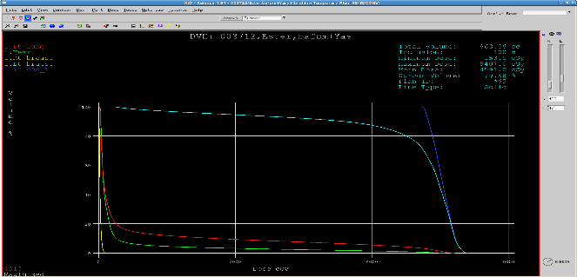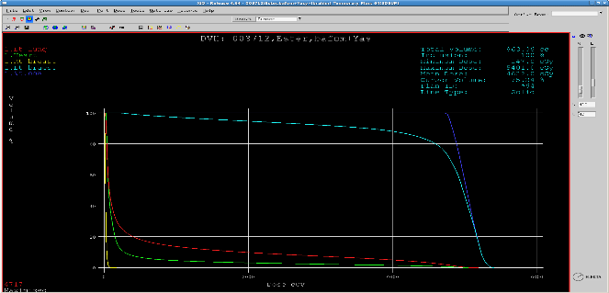
(c)

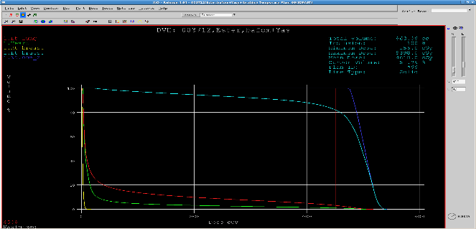
Figure (1): 3D-CRT DVHs for breast cancer patient number one using (a) CON; (b) SUP; (c) FSUP algorithms.

(a) (b)
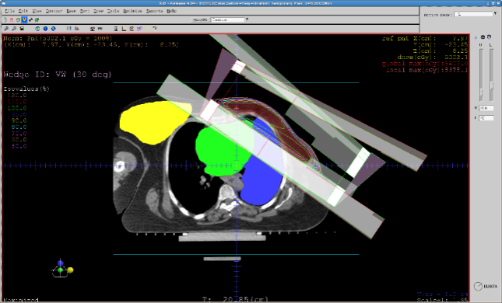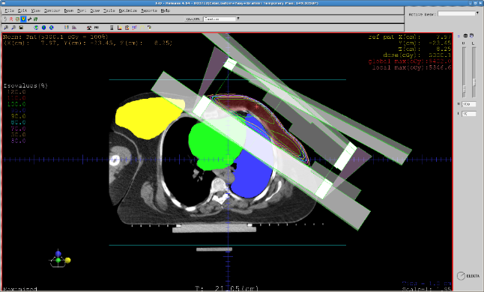

(c)
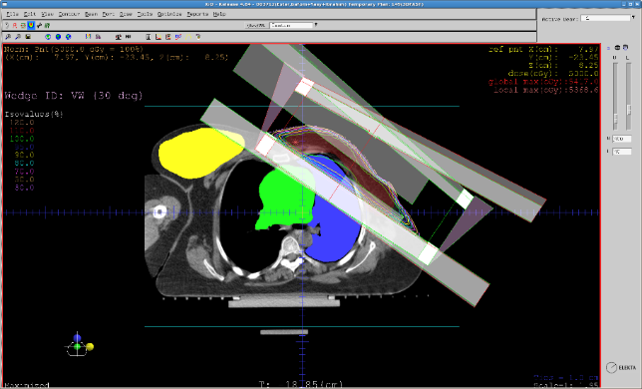
Figure (2): 3D-CRT plans for breast cancer patient number one using (a) CON; (b) SUP; (c) FSUP algorithms.

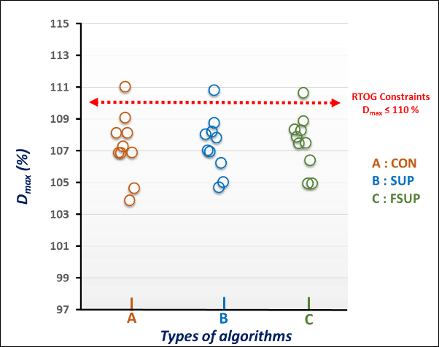
Figure (3): Comparison between three algorithms according to D_{max}for breast PTV with 3D-CRT in ten patients.
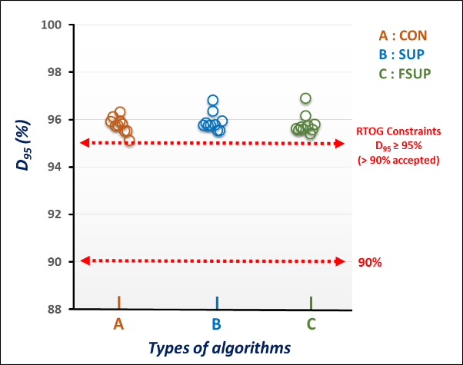
Figure (4): Comparison between three algorithms according to D₉₅ for breast PTV with 3D-CRT in ten patients.

1.1. Comparison between the three algorithms according to D_{mean} relative differences with prescribed dose:
Figure (5) shows a comparison between three algorithms according to average D_{mean} relative differences with prescribed dose for PTV of breast cancer patients with 3D-CRT technique. The percent of maximum variation between the three algorithms was 0.40%. CON algorithm gave the minimum value of average D_{mean} relative difference with prescribed dose (0.19%). Thus, CON algorithm gives the minimum percent of deviation with the prescribed dose. So, CON algorithm is better algorithm in 3D-CRT for PTV of breast cancer patients when comparing the three algorithms according to the D_{mean} relative difference with prescribed dose.
1.2. Comparison between the three algorithms according to the homogeneity index (HI):
A comparison between CON, SUP and FSUP dose calculation algorithms according to the average HIs for PTV of breast cancer patients with 3D-CRT technique is shown in figure (6). CON algorithm shows the minimum value of average HI (closer value to one). So that, CON is better algorithm in 3D-CRT technique for PTV of breast cancer patients when comparing the three algorithms according to the HI. The differences between the three algorithms is not large. Maximum percentage of variation between three algorithms is 0.27%.
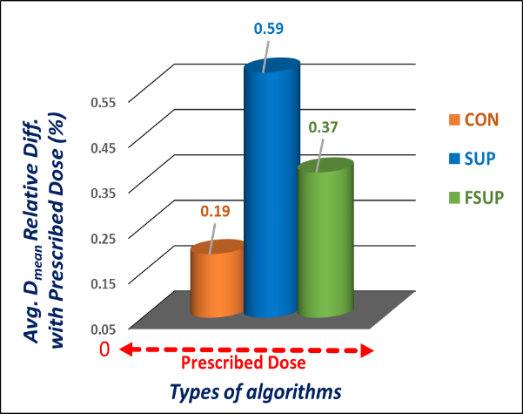
Figure (5): Comparison between three algorithms according to the average D_{mean} relative differences with prescribed dose for breast PTV with 3D-CRT.

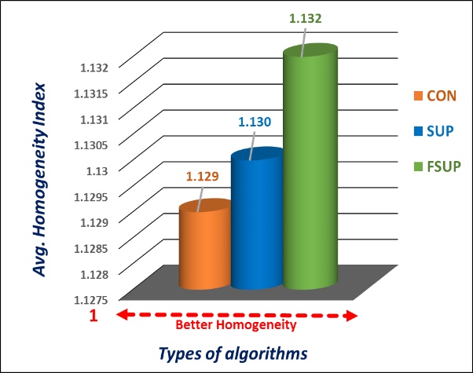
Figure (6): Comparison between three algorithms according to the average homogeneity indexes for breast PTV with 3D-CRT.

1.3. Comparison between the three algorithms according to the
conformity index (CI):
Figure (7) shows a comparison between three different algorithms according to the average CIs for PTV of breast cancer patients with 3D-CRT technique. CON algorithm shows the minimum value (1.214) of average CI. When the value of CI is one, this means that the conformity of the prescription isodose to the PTV is 100%. So, CON algorithm is better algorithm in 3D-CRT technique for PTV of breast cancer patients when comparing the three algorithms according to the CI. Maximum percentage of variation between the three algorithms is 2.72%.
- Comparisons between CON, SUP and FSUP algorithms for OARs:
2.1. Comparison between three algorithms in ipsilateral lung:
A comparison between CON, SUP and FSUP algorithms according to D₃₀ for ipsilateral lung with 3D-CRT technique in ten breast cancer patients is presented in figure (8). Figure (9) shows a comparison between three different algorithms according to average D₃₀ for ipsilateral lung. The RTOG had defined the dose constraints of ipsilateral lung as an organ at risk in TP of breast as, D₃₀ ≤ 2000 cGy (which equal to 40% of the prescription dose; 5000 cGy) [14]. It is clear that all the values of D₃₀ and average D₃₀ in ten patients are under the RTOG constraints, and thus all the treatment plans are accepted and satisfied the RTOG constraints due to the dose received by the ipsilateral lung.
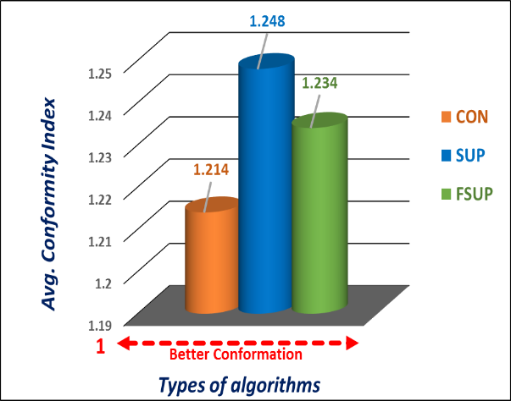
Figure (7): Comparison between three algorithms according to the average conformity indexes for breast PTV with 3D-CRT.

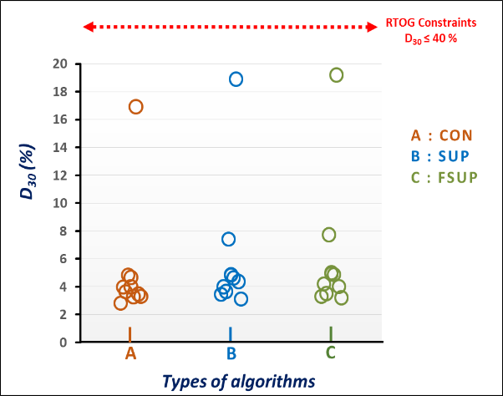
Figure (8): Comparison between three algorithms according to D₃₀ for ipsilateral lung with 3D-CRT in ten patients.

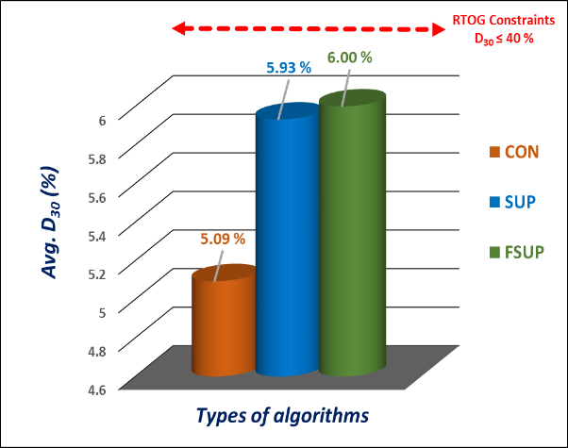
Figure (9): Comparison between three algorithms according to average D₃₀ for ipsilateral lung with 3D-CRT.

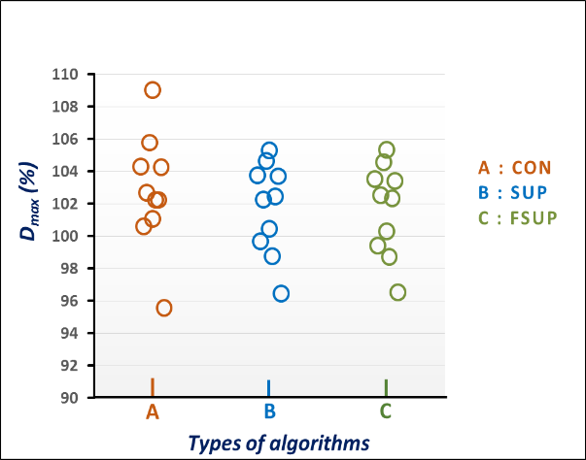
Figure (10): Comparison between three algorithms according to D_{max} for ipsilateral lung with 3D-CRT in ten patients.

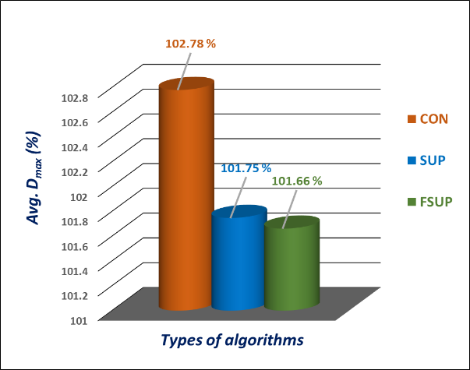
Figure (11): Comparison between three algorithms according to average D_{max} for ipsilateral lung with 3D-CRT.

Figure (10) shows a comparison between three algorithms according to D_{max} for ipsilateral lung in ten patients. Figure (11) shows a comparison between three algorithms according to the average D_{max}. It can be noticed that the maximum value of average D_{max} is with CON (102.78%) and the minimum value is with FSUP (101.66%). This means that, ipsilateral lung gets the highest doses with CON and gets the lowest doses with FSUP algorithm. So that, FSUP is better algorithm in 3D-CRT TP for breast cancer patients when comparing the three algorithms according to the maximum dose received by the ipsilateral lung. The difference between FSUP and SUP algorithms is not large.
2.2. Comparison between three algorithms in heart:
A comparison between CON, SUP and FSUP algorithms according to D₁₀ for heart in ten patients is presented in figure (12). Figure (13) shows a comparison between three algorithms according to average D₁₀. The RTOG dose constraints of heart is D₁₀ ≤ 2500 cGy (50% of the prescription dose) [14]. All the plans are accepted and satisfied the RTOG constraints.

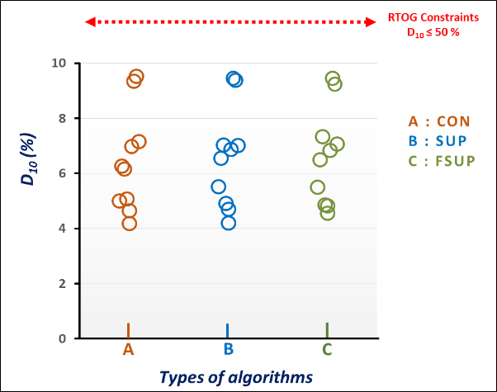
Figure (12): Comparison between three algorithms according to D₁₀ for heart with 3D-CRT in ten patients.

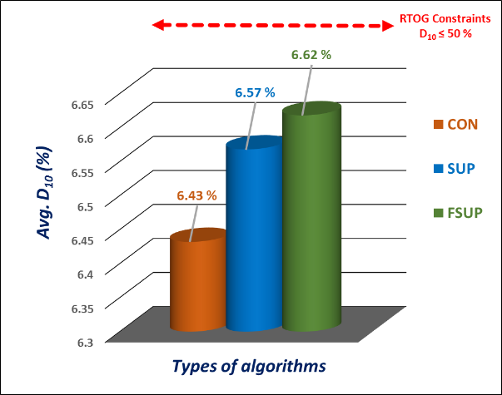
Figure (13): Comparison between three algorithms according to average D₁₀ for heart with 3D-CRT.

Figure (14) shows a comparison between three algorithms according to D_{max}. Figure (15) shows a comparison between three algorithms according to average D_{max}. The maximum value of average D_{max} is with SUP (97.43%) and the minimum is with FSUP (97.27%). So, FSUP is better algorithm in 3D-CRT TP for breast when comparing three algorithms according to maximum dose received by heart. The difference between the FSUP and the CON algorithms is not large.

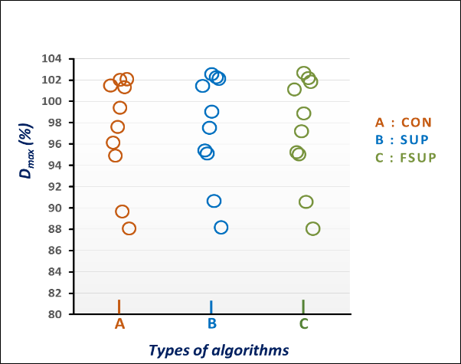
Figure (14): Comparison between three algorithms according to D_{max} for heart with 3D-CRT in ten patients.

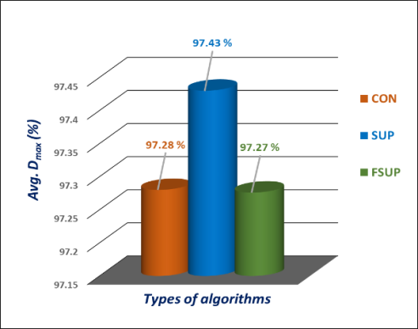
Figure (15): Comparison between three algorithms according to average D_{max} for heart with 3D-CRT.

  - Comparison between three algorithms in contralateral breast:
Figure (16) shows a comparison between three algorithms according to D_{max} for contralateral breast in ten patients. Figure (17) shows a comparison between three algorithms according to the average D_{max}. The RTOG constraints of contralateral breast isD_{max} ˂ 496 cGy (9.92 % of the prescription dose) [14]. All the values of D_{max} are less than the constraints, and thus all the plans are accepted and satisfied the RTOG constraints. The maximum value of average D_{max} is with FSUP (4.22%) and the minimum value is with CON algorithm (4.08%). Thus, the contralateral breast gets the highest doses with FSUP and gets the lowest doses with CON algorithm. So that, CON algorithm is better algorithm in 3D-CRT TP for breast cancer patients.

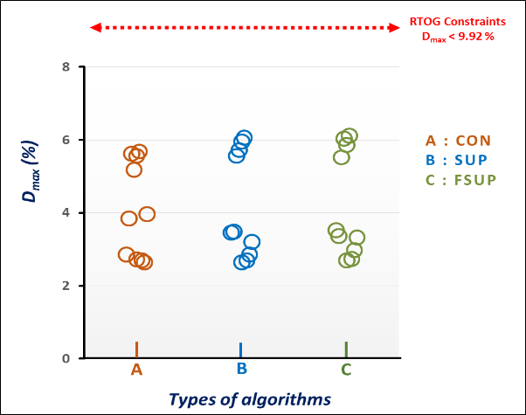
Figure (16): Comparison between three algorithms according to D_{max} for contralateral breast with 3D-CRT in ten patients.

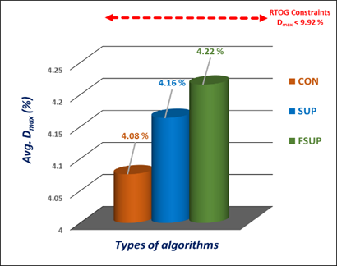
Figure (17): Comparison between three algorithms according to average D_{max} for contralateral breast with 3D-CRT.

- Summary of the results:
Table (1) shows a summary of the percent of maximum differences between three algorithms in average D_{mean}, D_{max}, and D_{min} of PTV and OARs. The minimum value of maximum percentage of difference between three algorithms is 0.23% in average D_{max}in case of PTV, while the maximum value is 11.47% in average D_{mean} in case of contralateral breast. Significant variations between the three algorithms can be observed from the table.

Table (1): Summary of maximum differences (%) between three algorithms in average D_{min}, D_{max}, and D_{mean} of PTV and OARs.
Organ |  | Breast
 |  | 3D-CRT
PTV | Maximum % of difference in avg. D_{mean} | 0.40
 | Maximum % of difference in avg. D_{max} | 0.23
 | Maximum % of difference in avg. D_{min} | 0.34
 | Minimum avg. D_{mean} relative difference is with | CON
 | Maximum Avg. D_{max} is in | FSUP
 | Minimum Avg. D_{max}is in | CON
OAR 1 |  | Ipsilateral Lung
 | Maximum % of difference in avg. D_{mean} | 0.30
 | Minimum avg. D_{mean} is with | CON
 | Maximum Avg. D_{max} is in | CON
 | Minimum Avg. Dmax is in | FSUP
OAR 2 |  | Heart
 | Maximum % of difference in avg. D_{mean} | 1.15
 | Minimum avg. D_{mean} is with | FSUP
 | Maximum Avg. D_{max} is in | SUP
 | Minimum Avg. Dmax is in | FSUP
OAR 3 |  | Contralateral Breast
 | Maximum % of difference in avg. D_{mean} | 11.47
 | Minimum avg. D_{mean} is with | SUP
 | Maximum Avg. D_{max} is in | FSUP
 | Minimum Avg. Dmax is in | CON

Table (2) shows a summary of minimum average D_{max} for OARs. The organs get the lowest doses with the algorithms shown in the table. So, these algorithms is the most suitable with respect to the breast and 3D-CRT due to minimum D_{max}.

Table (2): Summary of algorithms suitability to the breast and the 3D-CRT technique according to the minimum average D_{max} for OARs.
Site | OAR | Technique | Algorithm
Breast | Ipsilateral Lung | 3D-CRT | FSUP
 | Heart |  | FSUP
 | ContralateralBreast |  | CON

Table (3) shows a summary of the algorithms suitability to the breast and 3D-CRTtechnique. The algorithms in the table showed the minimum values of average D_{mean} relative difference with the prescription dose and the minimum values of CI and HI. So that, these algorithms are the most suitable and the better than the other algorithms.

Table (3): Summary of algorithms suitability to the breast and the 3D-CRT treatment planning technique according to the PTV.
Comparisons | Technique | Site
 |  | Breast
D_{mean} relative difference with prescription dose | 3D-CRT | CON
CI |  | CON
HI |  | CON

Conclusions:
      - The percent of maximum variation observed between the three algorithms for the PTV was 2.72% in average CI, and for the OARs was 11.47% in average D_{mean} in case of contralateral breast.
- Significant variations between the three algorithms were observed according to the dosimetric results obtained from this study.
- From our study, because the results of the three different algorithms show clear difference in some comparisons, considerable precaution unavoidable in treatment plans evaluation, because the dose calculation algorithm selection could effect on the process of TP and also on the end medical results.
- We recommend to use the CON algorithm with 3D-CRT technique in treatment planning of the left side breast. This recommendation is based on the better conformation of the prescription isodose to the tumor volume and the sparing of OARs which were achieved by this algorithm.

References
- Akpochafor MO, Madu CB, Habeebu MY, Omojola AD, Adeneye SO, Aweda MA. Development of pelvis phantom for verification of treatment planning system using convolution, fast superposition, and superposition algorithms. J. Clin. Sci. 2017; 14(2).
- Gazda MJ, Coia LR. Principles of radiation therapy. J. Radiat. Ther. 2012; 9-19.
- Mohammadi K, Hassani M, Ghorbani M, Farhood B, Knaup C. Evaluation of the accuracy of various dose calculation algorithms of a commercial treatment planning system in the presence of hip prosthesis and comparison with Monte Carlo. J. Cancer Res. Ther. 2017; 13(3): 501-509.
- Lu L. Dose calculation algorithms in external beam photon radiation therapy. Int. J. Cancer Ther. Oncol. 2013; 1(2): 01025.
- Muralidhar KR, Murthy NP, Raju AK, Sresty N. Comparative study of convolution, superposition, and fast superposition algorithms in conventional radiotherapy, three-dimensional conformal radiotherapy, and intensity modulated radiotherapy techniques for various sites, done on CMS XiO planning system. J. Med. Phys. 2009; 34(1): 12-22.
- Khan FM. The physics of radiation therapy. 4th ed., Philadelphia, Pa: Lippincott, Williams & Wilkins, 2010.
- Reinhart AM, Fast MF, Ziegenhein P, Nill S, Oelfke U. A kernel-based dose calculation algorithm for kV photon beams with explicit handling of energy and material dependencies. Br. J. Radiol. 2017; 90(1069), 20160426.
- Verma T, Painuly NK, Mishra SP, Shajahan M, Singh N, Bhatt ML, Jamal N, Pant MC. Performance evaluation of algorithms in lung IMRT: A comparison of Monte Carlo, pencil beam, superposition, fast superposition and convolution algorithms. J. Biomed. Phys. Eng. 2016; 6(3): 127-138.
- Golestani A, Houshyari M, Mostaar A, Arfaie AJ. Evaluation of dose calculation algorithms of Isogray treatment planning system using measurement in heterogeneous phantom. Rep. Radiother. Oncol. 2015; 2(3), e5320.
- Shaw E, Scott C, Souhami L. Single dose radiosurgical treatment of recurrent previously irradiated primary brain tumors and brain metastases: Final report of RTOG protocol 90-05. Int. J. Radiat. Oncol. Biol. Phys. 2000; 47: 291-298.
- Feuvret L. " Conformity index: A review". Int. J. Radiat. Oncol. Biol. Phys. 2006; 64(2): 333-342.
- International Commission on Radiation Units and Measurements. "Prescribing, Recording, and Reporting Photon-Beam Intensity-Modulated Radiation Therapy (IMRT)". J. ICRU, ICRU Report 83, 2010; 10(1).
- Wu VW, Sham JS, Kwong DL. Inverse planning in three-dimensional conformal and intensity modulated radiotherapy of mid-thoracic esophageal cancer. Br. J. Radiol. 2004; 77: 568-572.
- Mhtml: file://IN:\Radiation Oncology-Toxicity-RTOG – Wikibooks, open books for an open world, 2013.
- Khan FM. The Physics of Radiation Therapy. 3rd ed., Baltimore, MA: Lippincott Williams & Wilkins, 2003.
- Khan FM. The Physics of Radiation Therapy. 5th ed., Baltimore, MD: Williams & Wilkins, 2014.

1/20/2018

