**Use of immobilized *Bacillus subtilis natto* cells in calcium alginatematriceson MK-7 production**

Raja Mahanama, Aydin Berenjian, John Kavanagh, Fariba Dehghani

School of Chemical and Bimolecular Engineering, The University of Sydney, Sydney, NSW 2006, Australia

[aydin.berenjian@sydney.edu.au](mailto:geetakh@gmail.com)

**Abstract:** Menaquinone-7 (MK-7) a K vitamer has shown significant effects on preventing cardiovascular and osteoporosis, and hence is of industrial/pharmaceutical interest. Bacillus subtilis natto is known to produce via free floating fermentation. On the other hand, cell immobilization technique due to its high stability against contamination, easier product recovery and high productivity attracted attention for producing many fermentation processes. Therefore, to optimize MK-7 production it is critical to understand the effect of immobilization on MK-7 formation.

**[**Raja Mahanama, Aydin Berenjian, John Kavanagh, Fariba Dehghani. **Use of immobilized *Bacillus subtilis natto* cells in calcium alginatematriceson MK-7 production.** *Cancer Biology* 2017;7(4):39-41]. ISSN: 2150-1041 (print); ISSN: 2150-105X (online). <http://www.cancerbio.net>. 5. doi:[10.7537/marscbj070417.05](http://www.dx.doi.org/10.7537/marscbj070417.05).

**Keywords:** Menaquinone-7, *Bacillus subtilis natto,* immobilization.

**1. Introduction**

Menaquinone-7 (MK-7) a category of vitamin K has shown a significant effect on preventing cardiovascular and osteoporosis which are the major health issues [1-2]. The rate of suffers from these diseases is rising rapidly [3], urging the need for production of highly concentrated MK-7 supplements. MK-7 can be produced mainly by the liquid fermentation of *Bacillus subtilis natto* [4-6]*.* Cell immobilization technique due to its high stability against contamination, easier product recovery and high productivity attracted attention for producing many fermentation processes [7-8]. In this study, the possibility of immobilization of *Bacillus subtilis natto* cells for MK-7 production was compared to un-immobilized system.

**2. Material and Methods**

*Bacillus subtilis natto* strains were isolated from various brands of natto available in the Australian market. The strain producing the highest concentration of MK-7 was used for the remainder of the work. Pure MK-7 (99.3%) was purchased from ChromaDex (USA). Soy peptone and green pea peptone were purchased from Oxoid (UK). Yeast extract was purchased from BD (USA). NaNO3, glycerol and K2HPO4 were purchased from Chem-Supply (Australia). Starch and glucose were purchased from a commercial domestic supplier. Methanol, dichloromethane, 2-propanol, n-hexane and sucrose were obtained from Sigma-Aldrich (USA). Fermentation was carried out at 40 °C for a period of 3 days in 25 mL round bottles. In previous report, fermentation media consisting of 5% (w/*v)* yeast extract, 18.9% (w/v) soy peptone; 5% (w/v) glycerol and 0.06% (w/v) K2HPO4 found to be optimum on MK-7 production [4].  Cell immobilization was performed by using sodium alginate. A 2% (w/v) of the sterilized sodium alginate solution were thoroughly mixed with the Bacillus subtilis natto cells. Beads were prepared by droplet from a pipette about 5 mm diameter in a sterilized 6% (w/v) calcium chloride solution. A mixture of 2-propanol and n-hexane (2:1, v/v) was used to extract MK-7 from each. In each run the mixture was stirred well then centrifuged at 3000 rpm for 10 min to separate organic and aqueous layers. The organic layer was then separated and evaporated under vacuum to recover the extracted MK-7 fermentation media with 1:4 (aqueous: organic, v/v). High performance liquid chromatography (HP 1050, USA) equipped with a UV detector and C18 Gemini column at 40°C (5 μm, 250 × 4.6 mm, Phenomenex, USA) was used for measuring MK-7 concentration. Mobile phase was consisted of methanol: dichloromethane (9:1, v/v) with the flow rate of 1 mL/min [4].

**3. Results and Discussion**

The amount of MK-7 increased gradually in both immobilized and un-immobilized systems during the fermentation period. The results are shown in Figure 1 and the data indicated that MK-7 production reached a maximum level after six days of fermentation. It was observed that the MK-7 production with immobilized cells in calcium alginate was less than the un-immobilized cells. In un-immobilized cell condition, MK-7 concentration obtained was 56 mg/L after 6 days, while in the immobilized system 48 mg/L MK-7 was produced at the end of the fermentation period.

There was a slight difference in pH profile of immobilized and un-immobilized cells (Figure 2). This difference in pH profiles can be due to different metabolic activities of cells within the calcium alginate matrix and un-immobilized condition. The cell leakage from the matrix was gradually increased with increase of fermentation time. Increase in cell leakage can be related to cell growth within the beads which has been reported as one of the major challenges in cell immobilization technology [8]. However, the beads were not disintegrated during the operation batch.

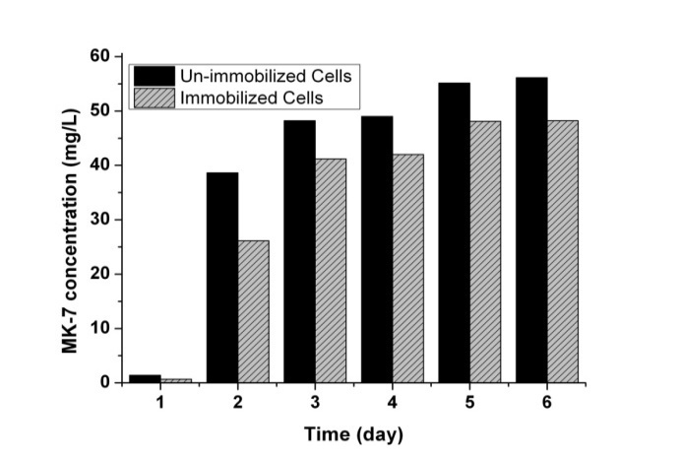

Figure 1: Effect of immobilized and un-immobilized *Bacillus subtilis natto* cells on MK-7 production at 40°C.

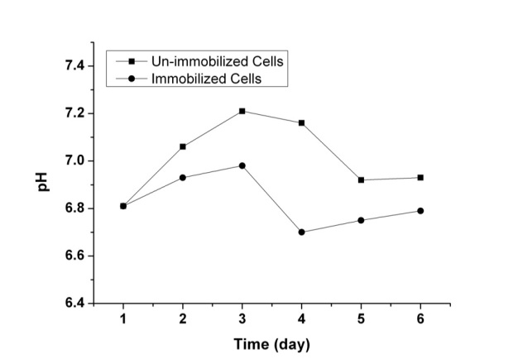

Figure 2: pH profile by immobilized and un-immobilized *Bacillus subtilis natto* cells during MK-7 fermentation period.

Based on the achieved results, alginate-entrapped cells showed the ability to produce considerable amounts of MK-7. This finding eases of conversion of batch fermentation on continuous mode without cell washout. Slightly lower MK-7 level during the fermentation period in immobilized system can be due to the small pore size of the beads which inhibited the substrate diffusion toward the cells and hindered the release of MK-7 during the batch fermentation. For the embedded cells, the substrates have to migrate through the matrix between the cells in order to maintain the optimum growth and MK-7 formation. Therefore, further investigation need to be carryout on intraparticle diffusion on the activity of immobilized *Bacillus subtilis natto* cells for MK-7 production.

**4. Discussions**

The static fermentation of *Bacillus subtilis natto* *Bacillus subtilis natto* showed the ability to produce MK-7 in both immobilized and unimmobilized systems. Slightly lower MK-7 level during the fermentation period in immobilized system can be justify by the small pore size of the beads which inhibited the substrate diffusion toward the cells and hindered the release of MK-7 during the batch fermentation. However, immobilization can be a desirable choice for commercial MK-7 production as it leads to easier product recovery and maintenance.

**Corresponding Author:**

Aydin Berenjian

School of Chemical and Bimolecular Engineering, The University of Sydney, Sydney, NSW 2006, Australia

E-mail: [aydin.berenjian@sydney.edu.au](mailto:aydin.berenjian@sydney.edu.au)

**References**

1. Eddy, D.M., et al., Osteoporosis: Review of the evidence for prevention, diagnosis, and treatment and cost-effectiveness analysis. Status report. Osteoporosis International, 1998. 8(SUPPL. 4).
2. Tsukamoto, Y., M. Kasai, and H. Kakuda, Construction of a Bacillus subtilis (natto) with high productivity of vitamin K2 (menaquinone-7) by analog resistance. Biosci-Biotechnol-Biochem., 2001. 65(9): p. 2007-2015.
3. Gast, G.C.M., et al., A high menaquinone intake reduces the incidence of coronary heart disease. Nutrition, Metabolism and Cardiovascular Diseases, 2009. 19(7): p. 504-510.
4. Berenjian, A., et al., Efficient media for high menaquinone-7 production: response surface methodology approach. New Biotechnology, 2011. 28(6): p. 665-672.
5. Mahanama, R., et al., Enhanced Production of Menaquinone 7 via Solid Substrate Fermentation from Bacillus subtilis. International Journal of Food Engineering, 2011. 7(5): p. Article 17.
6. Sato, T., et al., Production of Menaquinone (vitamin K2)-7 by Bacillus subtilis. Journal of Bioscience and Bioengineering, 2001. 91(1): p. 16-20.
7. Atia, K.S., et al., Use of Co-immobilized β-amylase and pullulanase in reduction of saccharification time of starch and increase in maltose yield. Biotechnology Progress, 2003. 19(3): p. 853-857.
8. Cheng, K.C., A. Demirci, and J.M. Catchmark, Advances in biofilm reactors for production of value-added products. Applied Microbiology and Biotechnology, 2010. 87(2): p. 445-456.

12/25/2017