**Comparison of the anticancer effects of Panobinostat with doxorubicin on diethylnitrosamine induced hepatocellular carcinoma**

Neimat A Yassin1, Aml A Mahmoud 2, Asmaa M Elhoseiny3

1Assistant lecturer in Clinical Pharmacology Department, Faculty of Medicine, Mansoura University, Mansoura, Egypt

2Veterinarian in Mansoura Experimental and Research Center, Mansoura, Egypt

3 Assistant lecturers in Histology Department, Faculty of Medicine, Mansoura University, Mansoura, Egypt

[dr\_nona82@yahoo.com](mailto:dr_nona82@yahoo.com)

**Abstract**: Panobinostat is the most recent histone deacetylase inhibitor approved for treatment of relapsed and recurrent multiple myeloma. In this study we compare its effects with doxorubicin which is already used for trans-arterial chemoembolization of hepatocellular carcinoma (HCC). ***Methods***: anti-cancer effects of panobinostat and doxorubicin are tested in DENA induced HCC in rats by pathological examination of liver sections and measuring liver enzymes ***Results***: Panobinostat was found to highly significantly inhibit Heppar-1 and VEGF levels and both drugs decrease ALT levels while AST was increased in panobinostat groups. ***Conclusion***: These results suggest that panobinostat may be a potent alternative to doxorubicin for treatment of HCC.

**[**Neimat A Yassin, Aml A Mahmoud, Asmaa M Elhoseiny. **Comparison of the anticancer effects of Panobinostat with doxorubicin on diethylnitrosamine induced hepatocellular carcinoma.** *Cancer Biology* 2017;7(4):19-28]. ISSN: 2150-1041 (print); ISSN: 2150-105X (online). <http://www.cancerbio.net>. 3. doi:[10.7537/marscbj070417.03](http://www.dx.doi.org/10.7537/marscbj070417.03).

**Keywords:** Panobinostat, Hepatocellular carcinoma, Doxorubicin, Diethylnitrosamine

**1. Introduction**

Hepatocellular carcinoma (HCC) is the sixth most common cancer in the world, and third cause of cancer related mortality ***(El Serag, 2011).*** Egypt has a very high and rising rate of HCC and is the highest in prevalence of HCV worldwide ***(Baghdady et al, 2013).*** HCV is the main risk factor for development of HCC in Egypt followed by HBV. The risk increases in smokers and diabetic patients ***(Atti, 2015).*** In HCC chemotherapy, doxorubicin is given by the hepatic artery route associated with some form of hepatic artery occluding agent, resulting in partial responses and tumour shrinkage ***(Llovet et al, 2002).*** Histone deacetylase (HDAC) inhibitors are promising anticancer agents ***(Inche and La Thangue, 2006).*** HDAC was found to be greatly concerned with regulation of many physiological processes of cell proliferation, differentiation and apoptosis by controlling gene transcription ***(Lee et al, 2004).***

This work aims at studying the anticancer effects of the recently developed HDAC inhibitor panobinostat in DENA induced HCC in rats and comparing it with the currently used drug Doxorubicin.

**2. Materials and methods**

**Drugs and chemicals**

* Diethylnitrosamine (DENA), purchased from Sigma Aldrich.
* Panobinostat (Purchased from Selleck Chemicals) in the form of brownish powder dissolved in DMSO ([Dimethyl sulfoxide 2%)](http://en.wikipedia.org/wiki/Dimethyl_sulfoxide)
* Doxorubicin in the form of adricin vial (10mg/5ml).

**Animals**

40 Adult male Sprague Dawley rats (200-250 gm) were used in this study. Rats were housed four per cage and they had free access to food (in the form of standard rat chow) and water in an animal room maintained at 22 ± 3°C on a twelve/ twelve hours light–dark cycle in Mansoura experimental and research center. The protocols used for handling the rats were approved by The Mansoura ethical committee.

**Induction of hepatocellular carcinoma**

HCC was induced in rats by DENA given by once intra-peritoneal injection in a dose of 100mg/kg ***(Gonzalez de Mejıa et al, 2004).*** After 8 months rats were treated before being sacrificed three weeks later.

**Animal grouping**

Male albino rats were divided into 5 groups each group include 8 animals

1. Group 1: Normal control group: Include normal control untreated animals.
2. Group 2 (DENA group): Include diseased animals with DENA induced HCC that receive no treatment.
3. Group 3: Treated animals were divided into 3 subgroups:

* Intraportal panobinostat group: Animals treated with intraportal Panobinostat once in a dose of 7.5 mg/kg
* Doxorubicin group: Animals treated with intraportal Doxorubicin once in a dose of 7.5 mg/kg.
* Intraperitoneal panobinostat group: Animals treated with I.P Panobinostat 7.5 mg/kg once/week for 3 weeks.

**Experimental design:**

For intrahepatic administration of drugs rats were anaesthetized by 80 mg/kg Ketamine and 10 mg/kg Xylazine, the abdomen is then opened by about 4cm midline incision below the xyphoid process, the liver is exposed and drugs injected into the portal vein. After the 3 weeks treatment period animals were sacrificed under deep anesthesia. All groups were assessed by:

**Pathological examination:**

**Hematoxylin and eosin**

Liver samples were fixed in 10% formalin, embedded in paraffin and routinely stained with hematoxylin and eosin (H & E). To verify whether preneoplastic and neoplastic foci are induced by DENA treatment.

**Hepatocyte paraffin -1**

Hepatocyte paraffin-1 (Heppar-1) is a monoclonal antibody developed from failed liver allograft. It has emerged as a most specific and sensitive immunohistochemical marker used for diagnosis of HCC ***(Lugli et al, 2004).***

**Vascular endothelial growth factor (VEGF)**

To asses blood vessel density and neo-vessel formation, which is considered a pathognomonic feature for neoplastic tissues, vascular endothelial growth factor (VEGF) expression has been examined using immunohistochemistry by rabbit Histofine streptoavidin biotin kits. The primary antibody Anti-VEGF antibody (1.0 μg/mL; Santa Cruz Biotechnology).

The result images were analyzed on Intel® Core I3® based computer using Video Test® Morphology® software (Russia) with a specific built-in routine for area measurement.

**Serum level of AST and ALT**

Serum level of AST and ALTwere determined byspectrophotometer. Blood samples were allowed to clot at room temperature then serum was separated by centrifugation of blood at 2000 rpm for 10 minutes. Aspartate and alanin aminotransferase (AST and ALT) were determined according to the manufacturer's instructions, using reagent kits obtained from Spinreact.

**3. Results**

1. **Pathology and immunohistochemistry**
2. **Pathology**

**Gross picture**

The liver of diseased animals is enlarged in comparison with normal rats. Hepatic lesions in DENA treated animals appeared as multiple soft masses different in size with the largest reaching 1 cm. The masses are polychrome, dark and pale, with foci of hemorrhage and necrosis. The liver of doxorubicin and panobinostat treated animals appeared smaller with more homogenous surface (Figure 1).

**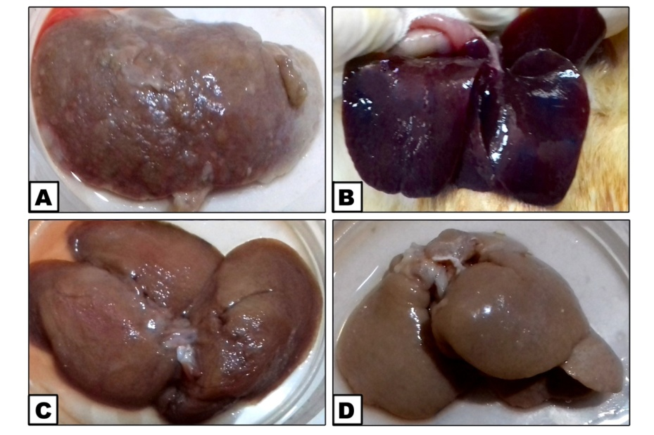**

**Figure 1 A & B: liver of rats in DENA group. C: liver of rat treated with intraportal panobinostat. D: liver of rat treated with doxorubicin.**

|  |  |  |
| --- | --- | --- |
| **getIT_17.tif** | |  |
| Figure 2: a photomicrograph of paraffin section in the liver of normal rat showing normal hepatocytes radiating from central vein (H & E X400) | | **Figure 3 a photomicrograph of paraffin section in the liver of DENA group showing pathologic hepatic nodules separated by degenerated hepatic tissue (H & E X100)** |
|  | |  |
| Figure 4 a photomicrograph of paraffin section in the liver of DENA group showing loss of normal hepatic architecture with invasion of the dilated central vein by various atypical cells with signet ring appearance (H & E X400) | | Figure 5 a photomicrograph of paraffin section in the liver of doxorubicin group showing well defined lesion with hepatocytes appeared as clear cells with eccentric nuclei (H & E X 400) |
|  |  | |
| Figure 6 a photomicrograph of paraffin section in the liver of panobinostat group showing hepatocyte degeneration with loss of normal hepatic architecture (H & E X400) | Figure 7 a photomicrograph of paraffin section in the liver of i.p panobinostat group showing clear distinction between the abnormally enlarged hepatocytes and the normal compressed hepatic cords (H & E X400) | |

**Microscopic examination**

At histological examination by Hx and E, the liver sections of normal rats showed normal hepatocytes with acidophilic cytoplasm with one or two nuclei. The hepatocytes are arranged as cords of one or two cell thickness radiating from central vein (Figure 2). DENA treated animals showed loss of normal hepatic architecture and numerous foci of altered hepatocytes. Foci and micronodules were mostly formed by large acidophilic hepatocytes showing cellular and nuclear atypias suggestive of malignant progression with blood vessels proliferation and sever inflammatory invasion. There were also other foci of clear cell masses which contain fat or glycogen. Some section showed megalocytosis, increased nucleocytoplasmic ratio, hyperchromatic nuclei as well as nuclear vacuolation, ballooning degeneration of hepatic cells and infiltration of portal tracts by inflammatory and atypical cells (Figure 3, 4).

Liver sections from doxorubicin treated rats show multiple lesions of clear cell type. The surrounding tissues exhibited degeneration of hepatic cells, severe infiltration of portal tract by inflammatory cells, excessive nuclear hyperchromatosis and abnormal mitosis with irregular hepatic surface and thickened capsule (Figure 5).

Liver sections from intra portal and i.p panobinostat treated rats showed less degree of nuclear hyperchromatosis with very minimal inflammatory invasion (Figure 6,7). Neoangiogenesis was assessed by abnormal vessels proliferation and new vessel formation and it was found to be the highest in DENA treated animals in comparison with doxorubicin and panobinostat treated animals and was the least in intraportal panobinostat treated animals.

1. **Immunohistochemistry**

**Heppar-1 staining**

|  |
| --- |
| **A Normal** **B DENA** |
| D:\د نعمت فارما\Heppar 1\Control Normal\getIT_100\JPEG\getIT_100.jpg |
| **C Doxorubicin D Panobinostat** |
|  |

|  |
| --- |
| **E i.p Panobinostat** |
| **Figure 8 photomicrographs of paraffin section in the liver of different groups (Heppar-1 X100)** |

Light microscopic examination of liver sections stained with the tumour marker heppar-1, expressed as brown patchy deposits, revealed the percentage area of hepatic expression of heppar-1 was significantly low in the normal control group (0.474%) in comparison with DENA, doxorubicin and panobinostat groups. DENA treated rats displayed a remarkable increase in the hepatic expression of heppar-1 relative to the normal control group. Treatment of the rats given DENA with intraportal panobinostat significantly reduced the hepatic expression of heppar-1 relative to DENA group (3.727% and 8.385% respectively). But this effect was not the same with doxorubicin and i.p panobinostat treated rats that exhibited a more expression of heppar-1 (6.575% and 6.960% respectively) than the intraportal panobinostat treated group. They are non significant from each other. Heppar-1 intake in doxorubicin group is significantly low in comparison with the DENA group but the stain percentage in i.p panobinostat group is not significantly different from DENA group. (Table 1) (Figure 8,10).

**VEGF staining**

Light microscopic examination of liver sections stained with VEGF revealed that percentage area of VEGF expression was significantly high in DENA treated animals (15.733%) in comparison with normal, doxorubicin and panobinostat groups and was significantly low in normal control animals in comparison with other groups (0.243%). In intraportal panobinostat treated animals the expression of VEGF was significantly low as compared to doxorubicin and i.p panobinostat treated groups (7.641%, 12.103% and 12.363% respectively). There is no statistically significant difference between doxorubicin and i.p panobinostat group. The intensity of VEGF staining tended to be stronger in cells adjacent to the nodular margins and portal tracts compared with the expression level in the central area of each nodule (Table 1) (Figure 9,11).

**Table 1:** Hepper-1 stain % and VEGF stain % and Serum ALT (SGPT) and AST (SGOT) level in Normal, DENA, Doxorubicin, Panobinostat and i.p Panobinostat group. Data expressed as mean ± SD

|  |  |  |  |  |
| --- | --- | --- | --- | --- |
| Group | Heppar-1% | VEGF% | ALT (SGPT) (IU/L) | AST (SGOT) (IU/L) |
| Normal control | 0.474± 0.069 | 0.243±0.074 | 21.97 ± 2.16 | 59.19 ± 6.5 |
| DENA | 8.385±2.26 | 15.733±1.93 | 107.87 ± 6.1 | 175.5 ± 10.4 |
| DENA + Doxorubicin | 6.575±0.89 | 12.103±1.9 | 72.08 ± 8.8 | 94.13 ± 7.6 |
| DENA+ Panobinostat | 3.727±1.01 | 7.641±1.8 | 63.75 ± 3.02 | 201.83 ± 13.3 |
| DENA+ Panobinostat i.p | 6.960±1.6 | 12.363±1.5 | 70.4 ± 6.35 | 119.6 ± 10.05 |

1. **Effect of DENA, Doxorubicin and Panobinostat on serum ALT and AST levels**

DENA-treated rats showed significant increase in serum levels of ALT and AST in comparison to normal control group (107.87 and 21.97 respectively for ALT and 175.5 and 59.19 respectively for AST). Serum ALT levels in doxorubicin, panobinostat and i.p panobinostat groups are not significantly different from each other (72.08, 63.75 and 70.4 respectively). They are all significantly low as compared to DENA group and are significantly high as compared to normal control group (Table 1) (Figure 12). Serum AST level in panobinostat group is significantly high in comparison with doxorubicin and i.p panobinostat group (201.83, 94.13 and 119.6 respectively). Serum AST level in doxorubicin group is significantly low as compared to DENA, panobinostat and i.p panobinostat groups and significantly high as compared to normal control group. Serum AST level in i.p panobinostat group is significantly high in comparison with normal, DENA and doxorubicin group and significantly low as compared to panobinostat group (Figure 13).

**A Normal B DENA**

**C:\Users\Compu1-A\AppData\Local\Microsoft\Windows\Temporary Internet Files\Content.Word\getIT_61.tif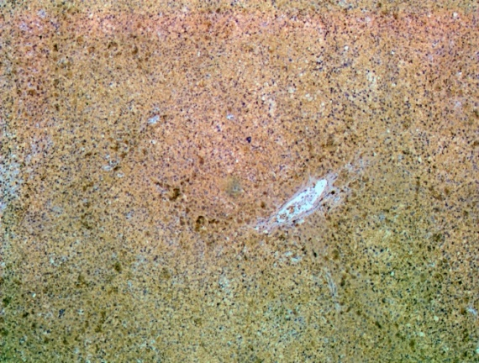**

**C Doxorubicin D Panobinostat**

**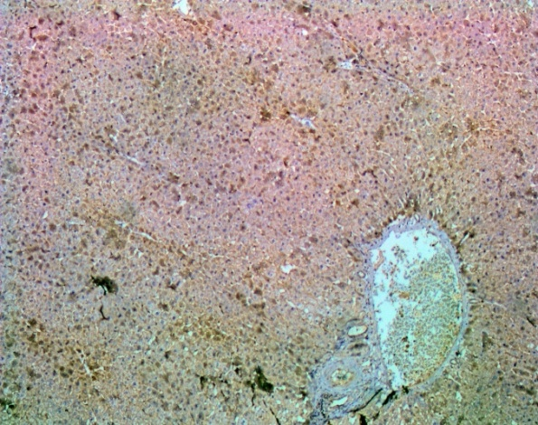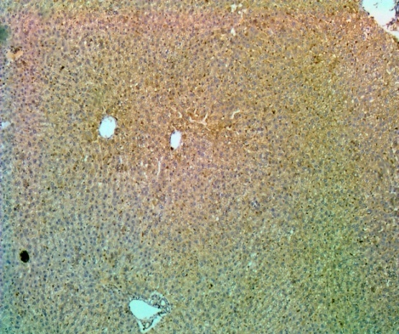**

**E i.p Panobinostat**

**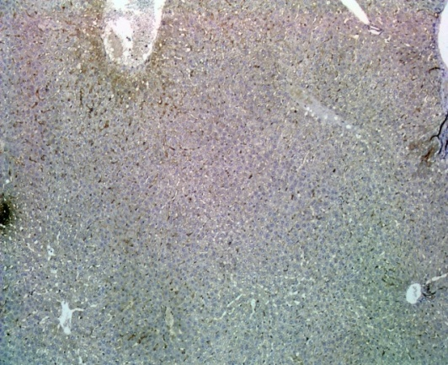**

**Figure 9 photomicrographs of paraffin section in the liver of different groups (VEGF X100)**

|  |  |
| --- | --- |
|  |  |
| **Figure 10 Heppar-1 % area in Normal, DENA, Doxorubicin, Panobinostat** **and i.p Panobinostat group.** | **Figure 10 Heppar-1 % area in Normal, DENA, Doxorubicin, Panobinostat** **and i.p Panobinostat group.** |
| D:\MD\fainal\ALT.jpg | D:\MD\fainal\AST.jpg |
| **Figure 12 Serum ALT (SGPT) level in Normal, DENA, Doxorubicin, Panobinostat and i.p Panobinostat group.** | **Figure 13 Serum AST (SGOT) level in Normal, DENA, Doxorubicin, Panobinostat and i.p Panobinostat group.** |

**4. Discussion**

Liver is the main site of DENA metabolism. The generation of reactive oxygen species (ROS) in the liver is an important contributor in DENA-induced carcinogenic effects ***(Shaarawy et al., 2009).*** ROS produce oxidative stress that seriously damage the biological systems by altering biochemical compounds, eroding cell membranes, producing chromosomal instability and mutation, which are involved in all steps of carcinogenesis, i.e. initiation, promotion and progression ***(Karbownik et al., 2001).*** In this study, upon DENA treatment, several changes were noticed in the hepatocytes and liver tissue. These changes are similar to various findings observed in previous studies. On a study carried out by ***Fiume et al. in 2005***, the neoplastic tissue was grossly appeared as multiple pale nodules. The neoplastic hepatocytes were much larger and irregular compared to the smaller and darker normal hepatocytes with distortion of normal architecture, increased fibrosis and bile duct proliferation. This study stated that doxorubicin decreased the number of tumor nodules but the result is insignificant from control***.*** In the present study the gross effects of both doxorubicin and panobinostat are not extremely different from each other but were significantly different from control animals which had multiple surface lesions.

The cellular effects of damage, hyperchromatosis and inflammatory invasion are in consistence with many other studies that reported dysplastic changes in the form of enlarged nuclei with increased nuclear/cytoplasmic ratio, polymorphic cells with different shapes and sizes ***(Jo et al, 2016, Ahmedy et al, 2016).***

In the field of human studies, data reported that the most common type of primary HCC arising on top of normal liver is the clear cell type where tumor cells are composed of large cells with dark small nuclei and vaculated cytoplasm containing fat or glycogen vacuoles ***(Clayton et al, 2012).***

Some studies suggested correlation between Heppar-1 positivity and degree of hepatocyte differentiation ***(Lee et al, 2003).*** But, the result of some other studies has established that the antigen expression has no correlation to the degree of hepatocyte differentiation ***(Lugli et al, 2004).*** In a study performed by Hanif and Mansour on patients with HCC, among 6 cases with 90% tumour cells staining, two were poorly differentiated HCC and among 14 cases of HCC with strong staining results, 5 cases were of poorly differentiated HCC. This confirms that no relationship exist between antigen expression and degree of hepatocyte differentiation ***(Hanif and Mansoor, 2014).***

In some studies the hepatic expression of the tumour marker hepPar-1 was not detectable in the normal hepatic tissue while DENA-induced hepatocellular carcinoma showing significant increase in hepPar-1 immunoreactivity in the cytoplasm of hepatocytes ***(Ahmedy et al, 2016).***

In the present study there was high hepPar-1 staining percentage in DENA treated animals more than other groups indicating higher mitochondrial activity of hepatocytes indicating higher rate of division and excess metabolic activity. The abnormal patchy staining of Heppar-1 was significantly lower with intra-portal panobinostat group than with doxorubicin and systemic panobinostat administration. This roughly indicates that panobinostat is more potent than doxorubicin in suppression of proliferation in highly active and rapidly dividing cells. The systemic use of panobinostat was not significantly different from intra-portal doxorubicin as the bioavailability in this situation is lower than its topical administration into the liver via the portal vein.

Uncontrolled proliferation of hepatocytes generates hypoxic hepatic nodules that promote the stimulation of mechanisms that mediate the angiogenic switch. Endothelial cells proliferate in response to growth factors secreted by themselves or by surrounding cells, such as hepatic stellate cells, leukocytes, hepatocytes and Kupffer cells. The most thoroughly characterized of these growth factors is VEGF, which is a multifunctional protein that binds to two tyrosine kinase receptors ***(Ferrara et al, 2003).*** Drugs directed against the VEGF pathway, such as bevacizumab, are formerly introduced into clinical utilization ***(Semela and Dufour, 2004).*** However, many data have suggested that other anticancer chemotherapeutic drugs may also have suppressing effects on angiogenesis and tumor vasculature function ***(Sanz-Cameno et al, 2010).***

On a study of the effects of doxorubicin and other anticancer drugs on the tumor vasculature in orthotopic and subcutaneous human cancer xenograts, it demonstrated insignificant changes in the total endothelial cell marker (CD31) or in the functional vasculature perfusion marker (DiOC7) in the breast carcinoma cell line (MCF-7) either ectopic tumors or orthotopic models following treatment with doxorubicin ***(Fung et al, 2015).***

In palliative treatment of HCC several studies have reported that TACE inhibits tumor angiogenesis and induces tumor cell apoptosis, while other studies have found that TACE stimulates tumor angiogenesis and thus increases the proliferative activity of the tumor cells to some degree ***(Detmar et al, 1997 and Sumie et al, 2003).*** A further study carried out by Wang et al. indicates that the residual surviving cancerous tissue in HCC after TACE has a rich vascularity. TACE increases VEGF expression in the residual surviving cancerous tissue possibly as a result of hypoxia resulting from vascular ischemia ***(Wang et al, 2008).***

The study carried out by ***Lachenmayer et al, 2012,***) comparing vascular effects of panobinostat with sorafenib in xenograft mouse model of HCC have stated that panobinostat significantly decreased tumor vessel density in comparison to sorafenib***).*** This may be explained by their different mechanisms of action. While sorafenib as a multikinase inhibitor targets neo-angiogenesis through the VEGF pathway, panobinostat as a histone deacetylase inhibitor targeting gene transcription reduces angiogenesis by inhibition of endothelial cell formation via suppression of synthesis of several growth factors including VEGF ***(Qian et al, 2006).***

In the present study panobinostat exhibited more suppression of VEGF in comparison to doxorubicin. This indicates a more targeted tumor cytotoxicity of panobinostat than doxorubicin.

The aminotransferases (formerly transaminases) are the most frequently utilized and specific indicators of hepatocellular necrosis. ALT is primarily localized to the liver but the AST is present in a wide variety of tissues like the heart, skeletal muscle, kidney, brain and liver ***(Rosen and Keefe, 2000).***

Whereas the AST is present in both the mitochondria and cytosol of hepatocytes, ALT is localized to the cytosol. About 80% of AST activity in human liver is contributed by the mitochondrial isoenzyme, whereas most of the circulating AST activity in normal people is derived from the cytosolic isoenzyme. Large increases in mitochondrial AST occur in serum after extensive tissue necrosis. Mitochondrial AST is also increased in chronic liver disease***.*** Although enzyme levels may reflect the extent of hepatocellular necrosis they do not correlate with eventual outcome ***(Thapa and Anuj Walia, 2007).***

In this study The ALT level is significantly lower in doxorubicin and Panobinostat treated animals than in DENA treated animals. This indicates the hepatoprotective effect of drugs on rats having chemically induced hepatocellular carcinoma upon nitrosamine induction. These results are in agreement with the previous studies that states the hepatoprotective effects of doxorubicin and Panobinostat ***(Slingerland et al, 2014).***

On the other hand some experimental studies stated that doxorubicin may induce hepatocellular damage in normal rats ***(Kalende et al, 2005)*** and is so contraindicated in patients with impaired liver functions, while panobinostat was found to be safe ***(Slingerland et al, 2014).*** This hazardous effect of doxorubicin may be explained by its free radical generating ability that produces most of its toxic effects like cardiac and hepatic toxicity. Doxorubicin causes increase in the levels of superoxide dismutase (SOD), catalase (CAT) and glutathione peroxidase (GSHPx) enzyme in liver tissue of guinea pigs ***(Durak et al., 1998).*** But, unlike the previous study on normal rats, the rats in our study already had chemically induced hepatic damage by DENA that is more toxic than doxorubicin and generate more free radicals ***(Karbownik et al. 2001).***

Unlike ALT, AST was found significantly higher in panobinostat treated animals than in DENA or doxorubicin group. This paradoxical finding is not consistent with the previously mentioned studies that detect safety of panobinostat in patients with abnormal liver functions ***(Slingerland et al, 2014).*** However, there is a major difference between this study and our study in that patients in the previous study did not have hepatocellular carcinoma like the case in our animals. So, the increase in AST observed with panobinostat treated animals may be explained by its pro-apoptotic effect and induction of necrosis not in normal but in hyperplastic cells that have higher rate of proliferation and higher mitochondrial activity ***(Thapa and Anuj Walia, 2007).***

**References**

1. Atti, E. A. (2015). HCC burden in Egypt. *Gastroenterol Hepatol*, *2*(3), 00045.
2. Ahmedy O, El-sayed M, Shoka A., et al. (2016). Chemotherapeutic effect of celery seed oil against hepatocellular carcinoma induced by diethylnitrosamine in rats. *International Journal of Development Research*, 6(5).
3. Baghdady I, EI-Kaffrawy N, Abd EI-Atti E et al. (2013). Study of the risk factors for hepatocellular carcinoma: effect of their synergism. *Journal of American Science* 9(4): 211-217.
4. Clayton, E. F., Furth, E. E., Ziober, A., et al. (2012). A case of primary clear cell hepatocellular carcinoma in a non-cirrhotic liver: an immunohistochemical and ultrastructural study. *Rare tumors*, *4*(2).
5. Detmar M, Brown LF, Berse B, et al. (1997). Hypoxia regulates the expression of vascular permeability factor/vascular endothelial growth factor (VPF/VEGF) and its receptors in human skin. J Invest Dermatol;/108:/263-8.
6. Durak, I., Ozturk, H.S., Kavutcu, M., et al. (1998). Protective role of antioxidant vitamins on adriamycin-induced free radical production and cardiotoxicity in guinea pigs. *Cancer Res. Ther. Cont*. 5, 133–141.
7. El-Serag, H. (2011). Hepatocellular carcinoma. N. Engl. J Med. 365(12), pp. 1118-1127.
8. Ferrara N., Gerber H.-P., and LeCouter J. (2003). The biology of VEGF and its receptors. *Nature Medicine*, 9(6):669–676.
9. Fiume, L., Bolondi, L., Busi, C., et al. (2005). Doxorubicin coupled to lactosaminated albumin inhibits the growth of hepatocellular carcinomas induced in rats by diethylnitrosamine. *Journal of hepatology*, 43(4), 645-652.
10. Fung, A. S., Lee, C., Yu, M., et al. (2015). The effect of chemotherapeutic agents on tumor vasculature in subcutaneous and orthotopic human tumor xenografts. BMC cancer, 15(1), 112.
11. Gonzalez de Mejıaa E., Ramı´rez-Maresa M.V., and Arce-Popocab E. (2004). Inhibition of liver carcinogenesis in Wistar rats by consumption of an aqueous extract from leaves of Ardisia compressa. *Food and Chemical Toxicology*. 42: 509–516.
12. Hanif R. and Mansoor S. (2014). Heppar-1 A novel immunohistochemical marker for differentiating hepatocellular carcinoma from metastatic carcinoma. *Journal of the College of Physicians and Surgeons Pakistan*. 24 (3): 186-189.
13. Inche AG and La Thangue NB. (2006). Chromatin control and cancer–drug discovery: realizing the promise. *Drug Discovery Today*. 11:97–109.
14. Jo, W., Yu, E. S., Chang, M, et al. (2016). Metformin inhibits early stage diethylnitrosamine‑induced hepatocarcinogenesis in rats. *Molecular medicine reports*. 13(1): 146-152.
15. Kalende Y, Mustafa Y, Kalender S. (2005). Doxorubicin hepatotoxicity and hepatic free radical metabolism in rats. The effects of vitamin E and catechin. *Toxicology*. 209:39–45.
16. Karbownik, M., Lewinski, A. and Reiter, R. J. (2001). Anticarcinogenic actions of melatonin which involve antioxidative processes: comparison with other antioxidants. *Int. J Biochem. Cell Biol*.33(8), pp. 735-753.
17. Lachenmayer, A., Toffanin, S., Cabellos, L et al. (2012). Combination therapy for hepatocellular carcinoma: additive preclinical efficacy of the HDAC inhibitor panobinostat with sorafenib. *J. Hepatol*. 56, 1343e1350.
18. Lee HS, Kim WH, Kang GH et al. (2003). Hepatocyte expressions in hepatocellular carcinomas, gastrointestinal neoplasms, and non-neoplastic gastrointestinal mucosa: its role as a diagnostic marker. *J Korean Med Sci*. 18:842-8.
19. Lee NK, Kim TY, Kim YJ, et al. (2004). Class I histone deacetylaseselective novel synthetic inhibitors potently inhibit human tumour proliferation. *Clinical Cancer Research*. 10:5271–5281.
20. Llovet JM, Real MI, Montana X, et al. (2002). Arterial embolisation versus symptomatic treatment in patients with unresectable hepatocellular carcinoma: a randomized controlled trial. *Lancet*. 359:1734-1739.
21. ugli A, Tornillo L, Mirlacher M, et al. (2004). Hepatocyte paraffin-1 expression in human normal and neoplastic tissues: tissue microarray analysis on 3,940 samples. *Am J Clin Pathol*. 122:721-7.
22. Qian D.Z., Kato Y., Shabbeer S., et al. (2006). Targeting tumor angiogenesis with histone deacetylase inhibitors: the hydroxamic acid derivative LBH589, *Clin. Cancer Res*. 12:634–642.
23. Rosen HR and Keefe EB. (2000). Evaluation of abnormal liver enzymes, use of liver tests and the serology of viral hepatitis: *Liver disease, diagnosis and anagement.* 1st ed. New York; Churchill living stone publishers. 24-35.
24. Sanz-Cameno, P., Trapero-Marugán, M., Chaparro, M., et al. (2010). Angiogenesis: from chronic liver inflammation to hepatocellular carcinoma. *Journal of oncology*. 27:21-7.
25. Semela D and Dufour J F. (2004). Angiogenesis and hepatocellular carcinoma. *Journal of Hepatology*. 41(5):864–880.
26. Shaarawy, S. M., Tohamy, A. A., Elgendy, S. M., et al. (2009). Protective effects of garlic and silymarin on NDEA-induced rats hepatotoxicity. *Int. J Biol. Sci*.5(6):549-557.
27. Slingerland M, Hess D, Clive S et al. (2014). A phase I, open-label, multicenter study to evaluate the pharmacokinetics and safety of oral panobinostat in patients with advanced solid tumors and various degrees of hepatic function. *Cancer Chemother Pharmacol*. 74:1089–1098.
28. Sumie S, Yamashita F, Ando E, et al. (2003). Interventional radiology for advanced hepatocellular carcinoma: comparison of hepatic artery infusion chemotherapy and transcatheter arterial lipiodol chemoembolization. *Am J Roentgenol*. 181:/1327-34.
29. Thapa B.R. and Anuj Walia. (2007). Liver Function Tests and their Interpretation. *Indian Journal of Pediatrics*. 74 .
30. Wang, B., Xu, H., Gao, Z. Q. et al. (2008). Increased expression of vascular endothelial growth factor in hepatocellular carcinoma after transcatheter arterial chemoembolization. *Acta Radiologica*. 49(5):523-529.

12/25/2017