**Anti-cancer activity of *Crinum defixum* Ker-Gawler medicinal plant leaves using KB cells**

*A. Elaiyaraja, G. Chandramohan

Department of Chemistry, A.V.V.M. Sri Pushpam College, Poondi, Thanjavur-613 503, Tamilnadu, India.

Emails: [raja_mscchem@rediffmail.com](mailto:raja_mscchem@rediffmail.com), Mobile: 9043571103

**Abstract:** *Crinum defixum* Ker-Gawler is a well-known herb used in ethnomedicine. Alakaloids and flavonoids are major constituents of *C.defixum*. In this study, we investigated the anticancer activity of KB and normal HGF-1 cells. We demonstrated the effects of ethanolic extract of *C.defixum* on the cell growth and apoptosis in KB and normal HGF-1 cells were analyzed by the generation of reactive oxygen species (ROS), the level of mitochondrial membrane potential (*∆*ψ*M*) and apoptotic morphological changes were analyzed by AO/EtBr, AO and Hoechst staining. Our results indicated that the ethanolic extracts of *C.defixum* shows better anticancer activity through it’s induces increased cell death, ROS generation, alteration of mitochondria membrane potential and apoptosis.

**[**A. Elaiyaraja, G. Chandramohan. **Anti-cancer activity of *Crinum defixum* Ker-Gawler medicinal plant leaves using KB cells.** *Cancer Biology* 2017;7(3):8-13]. ISSN: 2150-1041 (print); ISSN: 2150-105X (online). <http://www.cancerbio.net>. 2. doi:[10.7537/marscbj070317.02](http://www.dx.doi.org/10.7537/marscbj070317.02).

**Keywords:** *Crinum defixum* Ker-Gawler, Anticancer activity, KB, normal HGF-1 cell, ROS generation, Mitochondria membrane potential.

**1. Introduction**

The plants of the genus *Crinum* (Amaryllidaceae) has used in Asian folk and traditional medicine as rubefacient, tonic and for treatment of allergic disorders and tumor diseases [1]. The genus of *Crinum* (Amaryllidaceae) is a big family and contains about 160 species, many of which have vanished [2]. Most of the *Crinum* species are common emetic, laxative, expectorant, diaphoretic, anti-asthmatic, analgesic, anti-inflammatory, anti-microbial and anti-tumor remedies in various folkloric medicines [3]. Already the *Crinum* genus has yielded more than 170 different compounds, most of which are alkaloids. These have shown significant analgesic, antitumor and antiviral activities [4]. Phytochemical investigations have resulted in isolation of several classes of compounds and have been focused predominantly on alkaloids whereas the non-alkaloid constituents are much less attention [5].

*C.defixum* Ker-Gawler (Amaryllidaceae) has abundantly growing on rivers and canals side’s in wet conditions. The *C.defixum* has commercial, economical and medicinal importance. The *C.defixum* Ker-Gawler is one of the *Crinum* genuses [6]. It is commonly known as Bon-naharu (Meaning wild garlic) and this plant genus having lot of medicinal activities. The leave extracts are used to treat pimples, body-ache, leprosy, paronychia itching, and otitis. The crushed bulbs are used to treating nauseant, emetic, emollient, diaphoretic, burns, whitlow and carbuncle [7]. The bulbs of this plant is fusiform, flowers are sessile, fragment at night and tinged with red [8].

The *C.defixum* is reported to contain the active constituents such as caranine, crinamine, crinine, galanthamine, galanthine, haemanthamine and hippestrine. The new alkaloid 5 α-hydroxyhomolycorine has also been reported in the recent years [9]. The ethanol and methanol extracts of the *C.defixum* Ker-Gawler have been reported to free radical scavenging, antianalgesic and antigenotoxic properties [10]. In this study, the anticancer activity of ethanolic extracts of *C.defixum* in KB cells analyzed by cytotoxicity, ROS measurement, mitochondrial membrane potential and apoptotic morphological changes.

**2. Materials And Methods**

**2.1. Collection of plant materials**

The leaves of *C.defixum* Ker - Gawler were collected from Poondi village, Thanjavur District, Tamilnadu. The botanical identity (Voucher No: A.A.R 003 on 04-02-2013) of the plant of was confirmed by Dr. S.John Britto, Rapinat Herbarium, St. Joseph’s College, Tiruchirappalli.

**2.2. Preparation of Extracts**

The fine powder (5 kg) was extracted with 95% ethanol at room temperature for ten days. The extract were filtered and concentrated under reduced pressure in a rotary evaporator and extracted for various solvents in increasing order of polarity from using n-hexane, chloroform, ethyl acetate, acetone, ethanol, butanol and methanol. After that the extract was taken in a beaker and kept in a water bath and heated at 30-40 ºC till all the solvent got evaporated. All the extracts were tested for the presence bioactive compounds by using standard methods. The dried extracts were subjected to preliminary phytochemicals. The preliminary phytochemical analysis of various extract of *C.defixum* Ker-Gawler plant leaves revealed the following phytochemicals (Table.1).

The dried ethanolic extracts of *C.defixum* Ker-Gawler plant leaves extract were weighed (10 mg/mL) and dissolved in sterile distilled to prepare appropriate dilution to get required concentrations of 45 and 60 (µg/mL) of *C.defixum* were used for the anticancer activity experiment.

**2.3. Chemicals:**

1. Dulbecco’s Modiﬁed Eagles Medium (DMEM),
2. Phosphate Buffered Saline (PBS),
3. Fetal bovine serum (FBS),
4. 0.25% trypsin EDTA,
5. Antibiotics (penicillin, streptomycin),
6. Dimethyl sulfoxide (DMSO),
7. 3-(4,5-dimethylthiazol-2-yl)-2,5-diphenyl tetrazolium bromide (MTT),
8. 2,7-diacetyldichloro ﬂuorescein (DCFH-DA),
9. Ethidium Bromide (EtBr),
10. Rhodamine 123,
11. Acridine Orange (AO).

**2.4. Cell culture**

The oral carcinoma (KB) cell lines were obtained from NCCS, Pune, India. Cells were cultured in Dulbecco’s Modiﬁed Eagles Medium (DMEM) and maintained at 37ᵒ C in a humidiﬁed atmosphere containing 5% CO2 and 95% air incubation.

**3. Experimental Work**

**3.1. MTT ASSAY**

MTT assay is the standard colorimetric assay for detecting cytotoxicity, cell viability, and anticancer activity trialed drugs/compounds. The effect of ethanolic extracts of *C.defixum* on the cell proliferation of KB cells was determined by MTT assay based on the detection of mitochondrial dehydrogenase activity in healthy cells following the method of Arora *et al* [11]. KB cells were seeded in 96- well plates at a density of 5-103 cells / well in a ﬁnal volume of 100 μL with DMEM an incubated up to 24h. The cells were treated with different concentrations (10-100 μL) of ethanolic extracts of *C.defixum*. After 24h, the cells were incubated with 100 μL of MTT solution (1mg/mL) for 2h at 37ºC. The MTT solution was removed and added 100 μL of DMSO to dissolve the formazan crystals. The plate was read at 570 nm in a Read well touch, ELISA plate reader (Robonic, India).

**3.2. Measurement of intracellular ROS generation**

Intracellular ROS was measured by using a non-ﬂuorescent probe, DCFH-DA that can freely penetrate into the intracellular matrix of cells where it is oxidized by ROS to ﬂuorescent dichloro ﬂuorescein (DCF). Thus, the ﬂuorescence intensity is directly proportional to the amount of ROS generation [12]. Cells were seeded (1x106 cells/well) in 6-well plate treated with ethanolic extracts of *C.defixum* different concentrations and kept in a CO2 incubator for 24 h. After 24 h incubation 1mL of cells were incubated with 100µL DCFH-DA for 10 min at 37ºC. Fluorescent intensity was measured with excitation and emission ﬁlters set at 485 ± 10 and 530 ± 12.5 nm, respectively (Shimadzu RF-5301 PC spectroflurometer). The results were articulated as the percentage increase in the % of fluorescence intensity.

**3.3. Determination of mitochondrial membrane potential**

Alteration of mitochondrial membrane potential has considered being an early sign of cell death or apoptosis. Mitochondrial membrane potential (∆ψ*M*) was measured by Rhodamine-123 (Rh-123), lipophilic cationic dye [13]. Cells were cultured in 6 wells plate (1 X 106 cells/well) and treated with ethanolic extracts of *C.defixum*. After the 24 h treatment, the cells were incubated with Rh-123 dye for 30 min. The *∆*ψ*M* was evaluated qualitatively under a floid cell imaging station (Invitrogen, USA). Consequently, cells were trypsinaized and fluorescence intensity was measured at 485/530 nm under Spectrofluorometer (Schimadzu, USA). The graphical results were compared with positive control.

**3.4. Determination of apoptotic morphological changes**

Acridine orange (AO) and ethidium bromide (EtBr) staining were used to detect apoptotic cells affirmation [14]. The cells were cultured in 6-well plate (3 X 104 /well) treated with different concentrations of ethanolic extracts of *C.defixum* for 24 h. The cells were fixed in methanol: glacial acetic acid (3:1) for 30 min at 4ºC. The cells were washed in PBS, and stained with 1:1 ratio of AO/EtBr for 30 min at 37º C. Stained cells were washed with PBS and viewed under a fluorescence microscope. The number of cells showing features of apoptosis was counted as a function of the total number of cells present in the field.

**3.5. Statistical analysis**

The results were expressed as the mean ± SD. The statistical analyses were performed using SPSS 11.0 software package. Statistical variances were assessed using ANOVAs. Significant differences (p < 0.05) between the means were identified by Duncan’s Multiple Range Test (DMRT).

**Table 1. Preliminary phytochemical constituents of *C.defixum* Ker-Gawler leaves.**

|  |  |  |  |  |  |  |  |  |
| --- | --- | --- | --- | --- | --- | --- | --- | --- |
| S.N | Phytochemicals | Hexane Extract | Chloroform  Extract | Ethyl acetate Extract | Acetone  Extract | Ethanol  Extract | Butanol  Extract | Methanol  Extract |
| 1. | Alkaloids | - | Present | Present | Present | Present | - | Present |
| 2. | Flavonoids | - | Present | - | - | - | Present | Present |
| 3. | Terpenoids | Present | Present | Present | - | - | - | - |
| 4. | Glycosides | - | - | - | - | - | - | - |
| 5. | Saponins | - | Present | Present | Present | Present | - | - |
| 6. | Steroids | Present | - | - | Present | - | - | - |
| 7. | Carbohydrates | - | - | - | - | - | - | - |
| 8. | Phenolic Compounds | Present | Present | Present | Present | Present | Present | - |
| 9. | Tannins | - | - | - | - | - | - | - |
| 10 | Amino acids | Present | - | - | Present | Present | Present | Present |

**4. Results and Discussion**

**4.1. Cell proliferation inhibition effect of ethanolic extracts of *C.defixum* on KB cells**

The cytotoxic effect of ethanolic extracts of *C.defixum* on KB cells was determined by MTT assay. Cells were treated with different concentrations (45 µL and 60 µL) of ethanolic extracts of *C.defixum* for 24 h incubation, which revealed a dose-dependent inhibition of cell proliferation. Maximum cell death was observed at 70µg/mL concentration. Hence, the inhibitory concentration 50 (IC50) of ethanolic extracts of *C.defixum* for KB cells 40 µg/mL apparent from growth inhibition curve, Hence the (IC50) value shown to be 45 µg/mL. Therefore 45 and 60 µg/mL doses of ethanolic extracts of *C.defixum* were treated with KB cells for further studies.

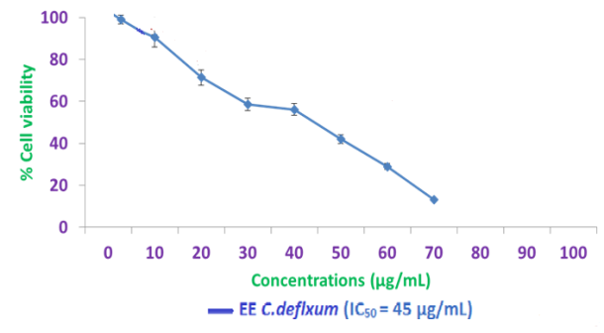

**Fig. 1. Cell proliferation inhibition effect of ethanolic extracts of *C.defixum* on KB cells**

**4.2. Intracellular ROS generation by DCFH-DA staining of *C.defixum* on KB cells**

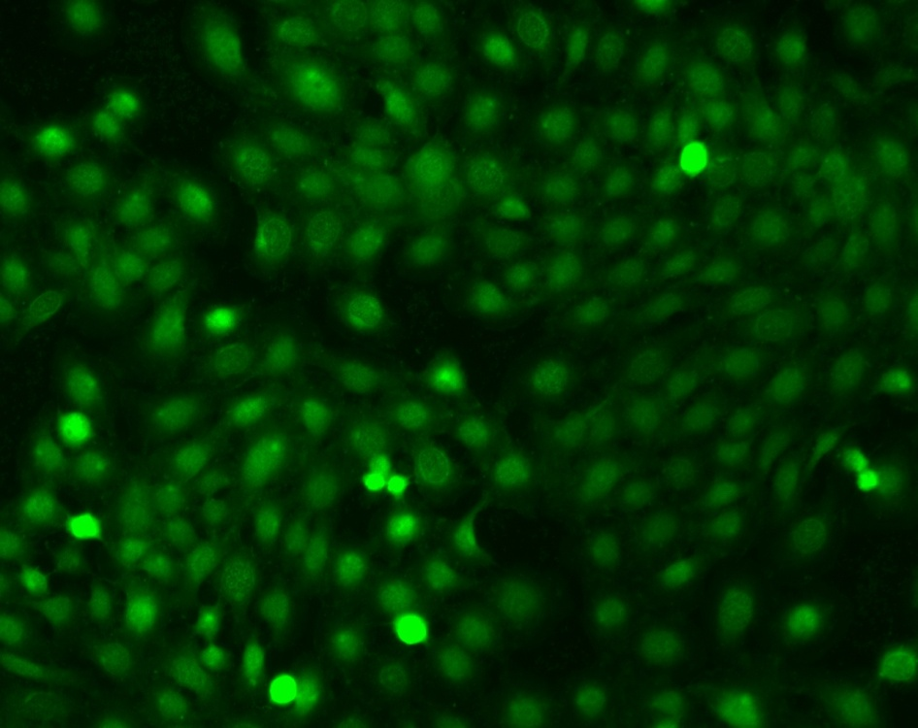 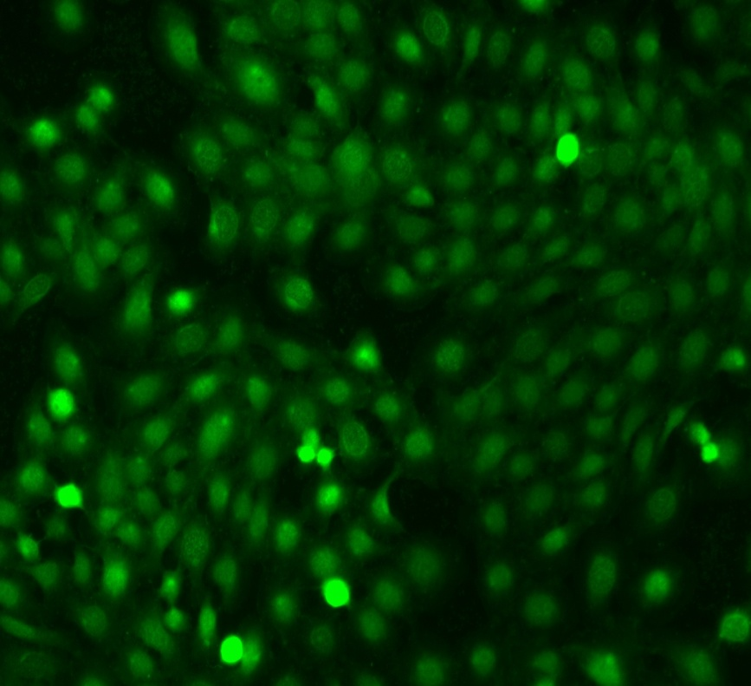 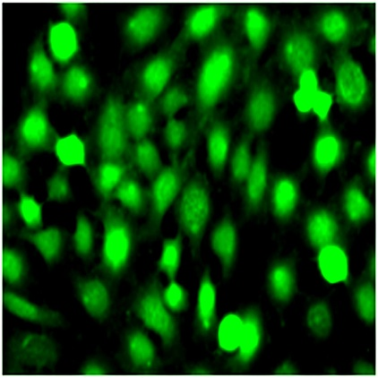

**i. Controlii. EE *C.D* (45 µg/mL) iii. EE *C.D* (60 µg/mL)**

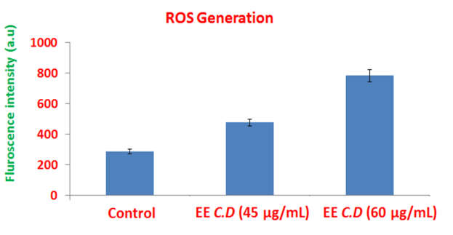

**Fig.2. The levels of ROS generation in control and ethanolic extracts of *C.defixum* treated cells.**

Fig.2 the effect of ethanolic extracts of *C.defixum* on intracellular ROS generation was evaluated with KB cells by using DCFH-DA staining. The ethanolic extracts of *C.defixum* treated KB cell shows increased ROS generation was indicated by deep DCF fluorescence intensity (images ii and iii). The images were acquired by fluroscence microscope. Cells were treated with different concentrations of ethanolic extracts of *C.defixum* (45 and 60 µg/mL) for 24 h incubation, which revealed a dose-dependent inhibition of cell proliferation. Percentage of ROS generation was detected by spectrofluorometer. All experiments were performed in triplicate and all the values were expressed as mean ± standard deviation of the mean. Statistical significance was determined by a one way ANOVA followed DMRT.

**4.3. Mitochondrial membrane potential by Rhodamine 123 staining of *C.defixum* on KB cells.**

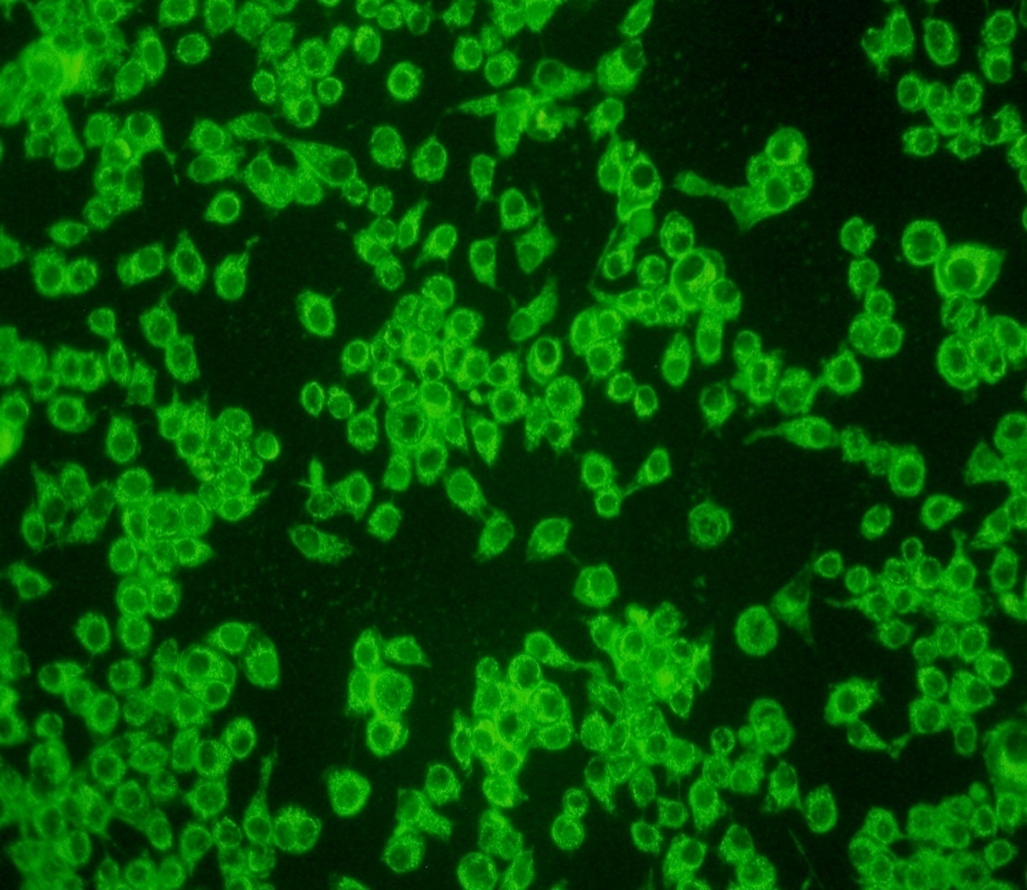 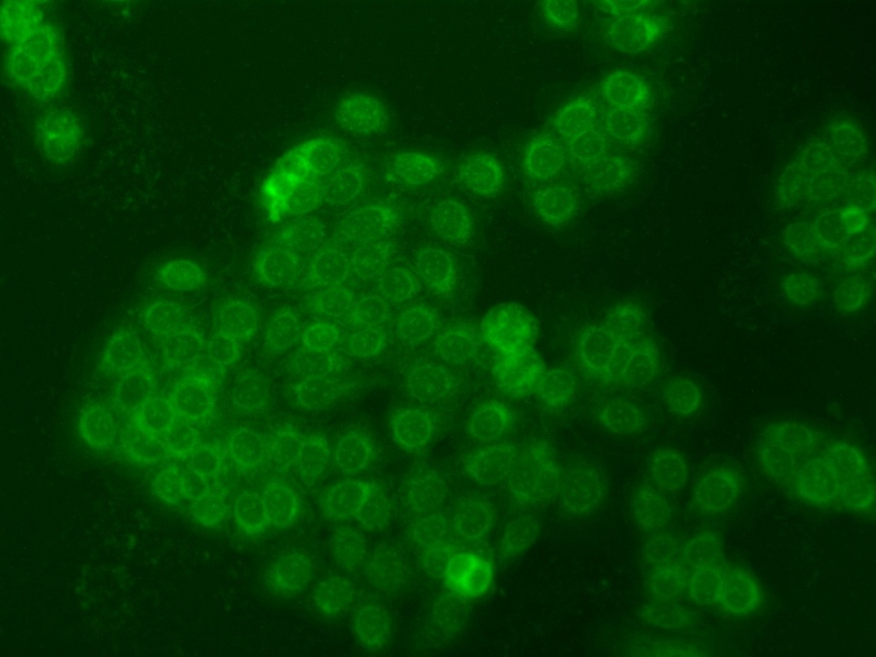 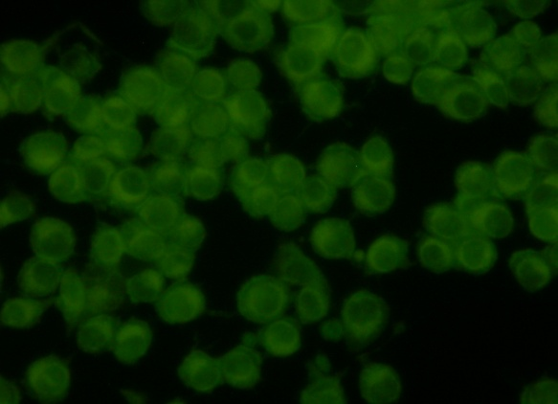

**i. Control ii. EE *C.D* (45 µg/mL) iii. EE *C.D* (60 µg/mL)**

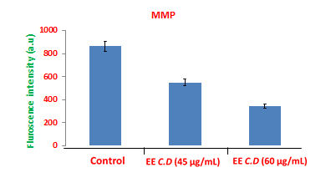

**Fig. 3. The levels of MMP in control and ethanolic extracts of *C.defixum* treated cells.**

Early stage of apoptosis is triggered by alteration of mitochondrial membrane potential were assessed by lipophillic cationic dye, Rhodamine-123. The effect of ethanolic extracts of *C.defixum* on mitochondria membrane potential (*∆ψM*) damage was evaluated with KB cells using the Rhodamine 123. Untreated KB (control) cells show high fluorescence which indicate polarized mitochondria membrane (imge. i). The image (ii and iii) shows KB cells were treated with different concentrations of ethanolic extracts of *C.defixum* (45 and 60 µg/mL) for 24 h and fluorescence intensity was decreased as indicated by collapsed mitochondria matrix. The images were acquired by floid cell imaging station. The depicted fluorescence intensity was detected by spectrofluorometer. All experiments were performed in triplicate and all values were expressed as mean ± standard deviation of the mean. Statistical significance was determined by a one way ANOVA followed DMRT.

**4.4. Apoptotic Morphological changes by Acridine orange and ethidium bromide staining of *C.defixum* on KB cells**

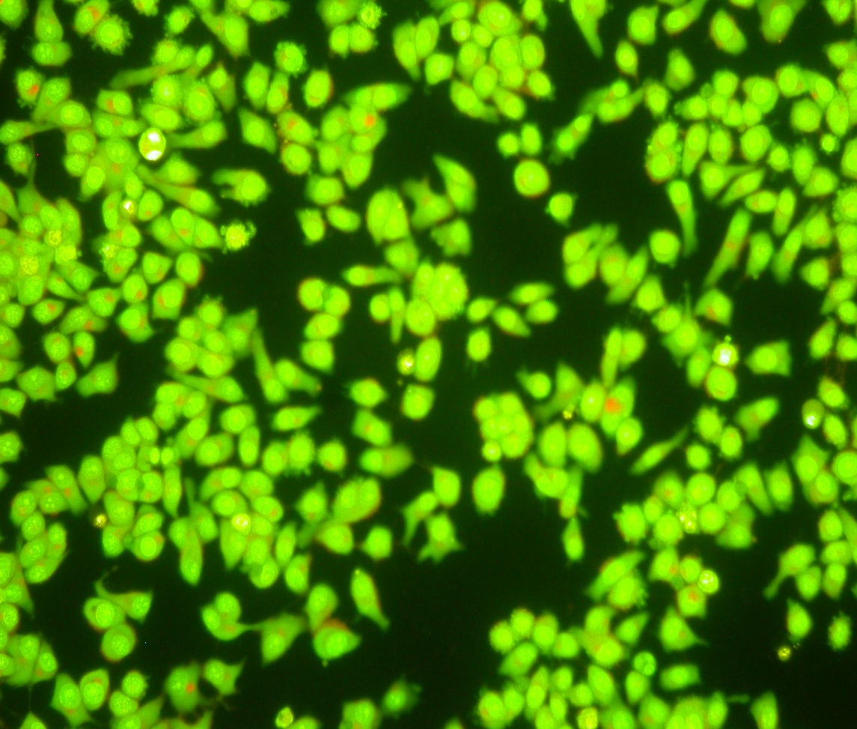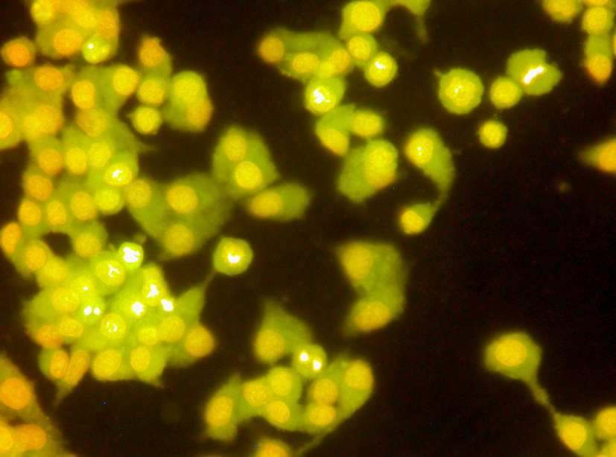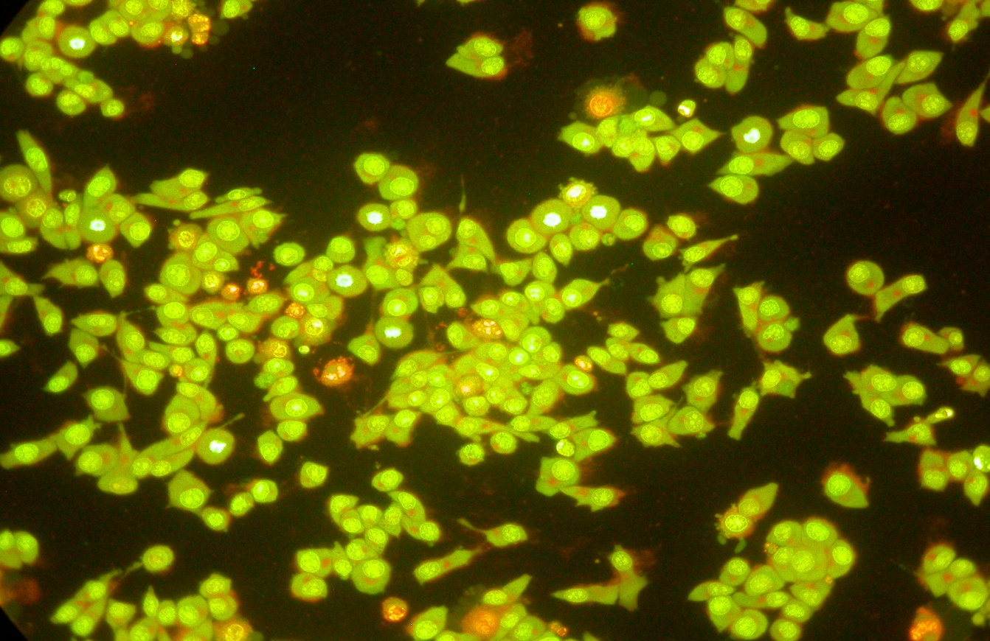

**i. Control ii. EE *C.D* (45 µg/mL) iii. EE *C.D* (60 µg/mL)**

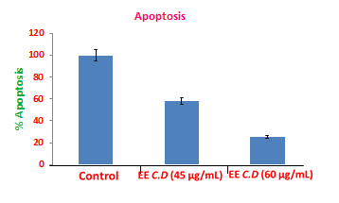

**Fig 4. The levels of Apoptosis in control and ethanolic extracts of *C.defixum* treated cells**

Fig. 4 Illustrated fluorescence microscopy images of apoptotic morphology by dual staining (AO/EtBr). Image i, untreated KB (Control) cells. Images (ii, iii) show different concentrations of ethanolic extracts of *C.defixum* (45 and 60 µg/mL) treated KB cells which shows increased % of apoptotic cells in a concentration dependent manner. The red fluorescence dye of EtBr was selectively penetrated into condensed nuclei of apoptotic cells, while the AO (green) had only taken up healthy cells. The observed results show untreated KB (control) cells which has highly green fluorescence nucleus that indicates live cells (image. i). The ethanolic extracts of *C.defixum* (45 and 60 µg/mL) treated cells showed orange color pointed out early apoptotic and red stained fragmented nuclei which indicates late apoptosis at concentration depended manner for 24 h represented in (image ii and iii).

**5. Conclusion**

The preliminary phytochemical analysis of various extract of *Crinum defixum* Ker-Gawler leaves contains many bioactive chemicals like alkaloids, flavonoids, saponins, terpenoids, amino acids and phenolic compounds (table-1). The *Crinum defixum* Ker-Gawler has rich in (Amaryllidaceae) alkaloids content in both bulb and leaves. The Amaryllidaceae alkaloids exhibit a range of biological activity, both pharmacological and microbiological. Among the most noted effects are: analgesic, central nervous system, anti-tumor, antiviral and anticholinergic. Hence the medicinal plant *Crinum defixum* Ker-Gawler leaves has a Phytochemically potent one.

The cytotoxicity effect of ethanolic extract of *C.defixum* on KB and normal HGF-1 cells measured by MTT assay, the inhibitory concentration 50 (IC50) of *C.defixum* is 45 µg/mL. The ethanolic extract of *C.defixum* shows better anticancer activity through it’s induces increased cell death, ROS generation, alteration of mitochondria membrane potential and apoptosis. The anticancer activity of *C.defixum* might be oxidative damage through proxidant mechanisms. These results indicated that we concluded that ethanolic extract of *C.defixum* could be used as a novel therapeutic agent for the prevention of cancer.

**6. Acknowledgement**

I wish to express my deep sense of gratitude and most sincere thanks to my family for providing support to finish my research work.

**Corresponding author**

A. Elaiyaraja

Department of Chemistry,

A.V.V.M. Sri Pushpam College, Poondi,

Thanjavur -613 503,Tamilnadu, India.

Email: [raja_mscchem@rediffmail.com](mailto:raja_mscchem@rediffmail.com)

Mobile: 9043571103

**References**

1. Ghosal Sh., Saini K. S. and Razdan S. (1985), *Crinum* alkaloids: their chemistry and biology. Phytochemistry 24, 2141D2156.
2. Benson, L., Handbook of Plant Classification, (Oxford and I.B.H publishing Co., New Delhi, Bombay, 1970) 793.
3. Fennell CW and Van Staden J: Crinum species in traditional and modern medicine. Journal of Ethnopharmacology 2001; 78(1):15-26.
4. Fangan, B.M., Nordal, I., 1993. A comparitive analysis of morphology, chloroplast-DNA and distribution within the genus *Crinum* (Amaryllidaceae). Journal of Biogeography 20, 55-61.
5. Wildman WC: The Alkaloids: Chemistry and Physiology. Edited by R.H.F. Manske, Academic Press, New York, London, Vol. VI, 1960.
6. Fennell CW and Van Staden J: *Crinum* species in traditional and modern medicine. Journal of Ethnopharmacology 2001; 78(1):15-26.
7. K.R. Kirtikar, B,D. Basu, Indian Medicinal Plants,vol. IV (1975) Published by M/S Bishen Singh Mohendra Pal Sing, New Connaught Place, Dehradun, PP. 2473-2474.
8. Hooker JD, Flora of British India, Published under the authority of the Secretary of state for India in Council, 1954.
9. Nguyen TNT, Titorenkovab TV, Bankovab V, Handjievab NV, Popovb SS. *Crinum* L.*Amaryllidaceae*. Fitoterpia, 2002; 73: 183-208.
10. Jeffs PW, Abou-Donia A, Campau D, Staiger D. Structures of 9-*O*-dimethyl-homolycorine and 5 α-hydroxyhomolycorine alkaloids of *crinum defixum*, C. *latifolium* Assignment of aromatic substitution patterns from **1**H-coupled **13**C spectra, J Org Chem. 1985; 50: 1732-1737.
11. A. Arora, K. Seth, N. Kalra, Y. Shukla, Modulation of P-glycoprotein-mediated multidrug resistance in K562 leukemic cells by indole-3-carbinol, Toxicol. Appl. Pharmacol. 202 (2005) 237–243.
12. E.P. Jesudason, E.G. Masilamoni, E.J. Charles Jebaraj, F.D. Solomon, R.P. Jayakumar, Efficacy of DL-a lipoic acid against systemic inflammation induced mice: antioxidant defense system, Mol. Cell. Biochem. 313 (2008) 113–123.
13. L.V. Johnson, M.L. Walsh, L.B. Chen, Localization of mitochondria in living cells with rhodamine 123, Proc. Natl. Acad. Sci. U. S. A. 77 (1980) 990–994.
14. S. Karthikeyan, G. Kanimozhi, N.R. Prasad, R. Mahalakshmi, Radiosensitizing effect of ferulic acid on human cervical carcinoma cells in vitro, Toxicol. In Vitro 25 (7) (2011) 1366–1375.

8/15/2017