The role of c-Met and c-Src in radiotherapy of non-small cell lung cancer cell line A549

Xing Xin, Yusi Liang, Huawei Zou

Department Of Oncology, Shengjing Hospital Of China Medical University, No.36, Shanhao RD, Heping District, Shenyang 110004, China.
Tel.:+86-8624-96615; Fax:+86-8624-96615; Email: huawei_zou@163.com

Abstract: Objective: To detect the change of c-Met and c-Src expression and activity in human lung cancer cells after radiation in order to explore the efficacy of them and the mechanism. Methods: We used human lung cancer cell lines A549 in vitro as research object. Western Blot assay was used to evaluate the change of c-Met and c-Src expression and activity in human lung cancer cells in different time point after 8Gy irradiation and before. Results: Western Blot results showed that the phosphorylation-c-Met reach the peak after 8Gy X-ray acting on A549 cell lines 2 hours. It’s 4.41times as many as the expression of before irradiation. It marked increased the activation of c-Met. The expression of non-phosphorylation c-Met is undifferentiated. The phosphorylation-c-Src reach the peak after 8Gy X-ray acting on A549 cell lines 4 hours. It has increased 2.99 times than those who not receive irradiation. The expression of non-phosphorylation c-Src is undifferentiated. Conclusion: The results of this research provide foundation for further exploring the mechanism of radiosensitizing effect in non small cell lung cancer and reference for whether c-Met or c-Src inhibitor can be used to prevent the radiosensitizing effect in clinical application for the patients who have non small cell lung cancer.
[Xing Xin, Yusi Liang, Huawei Zou. The role of c-Met and c-Src in radiotherapy of non-small cell lung cancer cell line A549. Cancer Biology 2017;7(2):104-108]. ISSN: 2150-1041 (print); ISSN: 2150-105X (online). http://www.cancerbio.net. 14. doi:10.7537/marscbj070217.14.

Key words: Carcinoma; Non-Small-Cell Lung; Radiotherapy; Proto-Oncogene Proteins c-met; Proto-Oncogene Proteins pp60 (c-src)

1. Introduction
Lung cancer is the tumor with the highest morbidity and mortality, which is divided into small cell lung cancer and non-small cell lung cancer (NSCLC). NSCLC accounted for about 80% of lung cancer. Most patients with NSCLC were diagnosed at an advanced stage, who lost the opportunity of surgery; therefore, the radiotherapy was the major treatment method. However, the efficacy of radiotherapy on NSCLC was limited by its resistance to radiotherapy. Currently, the resistance mechanism of NSCLC radiotherapy mainly focuses on growth factors and related signaling pathways. As a specific receptor of hepatocyte growth factor (HGF), c-Met is a transmembrane tyrosine kinase receptor encoded by oncogene, activation of c-Met can produce a variety of biological effects, such as promote the dissociation of adhesion between cells to enhance cell migration and invasion. The over-expression of c-Met occurs in a variety of solid tumors including NSCLC. In previous clinical studies, c-Met was positively expressed in about 40% NSCLC patients (Han et al.,2012), which was an independent adverse prognostic factor of NSCLC (Han et al.,2012; Masuya et al.,2004).
The c-Src is a type of non-receptor tyrosine kinase, which is involved in the activation of cell membrane signal and signal transmission. The c-src gene is rarely mutated in tumor cells as a oncogene, and over-expression of c-src is almost no carcinogenicity in normal cells. Therefore, it is controversial that whether c-src is involved in the occurrence and progression of tumor. However, recent studies have shown that the expression of c-src protein and the activity was increased as a non-receptor tyrosine kinase, and clinical studies have shown that the abnormal activation of c-src was correlated with the progress and poor prognosis of tumor (Irby et al.,2000; Alvarez et al., 2006; Summy et al., 2003; Summy et al., 2006).
In the studies of colorectal cancer (Herynk et al.,2007), bile duct cancer (Urai et al.,2005) and breast cancer cells (Stephen et al.,2006) with drug resistances, the phosphorylation of c-Src was enhanced with the phosphorylation of c-Met; the expression of c-Met in the resistant cells significantly affected their biological behavior. In this study, we detected the expression and phosphorylation of c-Met and c-Src in human NSCLC A549 cells treating with radiotherapy, and detected the related signaling pathways of c-Met and c-Src after radiotherapy.

2. Materials and methods
2.1 Experimental materials
Lung cancer cell line A549 cells were provided by Cancer Research Institute, China Medical University; the ray source was form linear accelerator produced by Varian, USA; MTT and TEMED were purchased from Sigma, USA; 1640 medium was purchased from Gibico, USA; fetal bovine serum was purchased from Sijiqing company, Hangzhou; NP40 lysis buffer, PMSF, BCA protein concentration assay kit and goat-anti-rabbit IgG-HRP were purchased from Beyotime Institute of Biotechnology, Shanghai; pre-stained protein marker was purchased from Fermentas, Canada; PVDF membrane was purchased from Millipore, USA; ECL luminescent liquid was purchased from Qihai Fu Tai Biotechnology Company, Shanghai; BSA was purchased from AMRESCO, USA; the Src antibody, phosphor-Src family (Tyr416) antibody, phosphor-Met (Tyr1234/1235) antibody, Met antibody were purchased from Cell Signaling Technology, USA.
2.2 Cell culture
The human lung cancer cell line A549 cells were recovered from our lab, and cultured in RPMI 1640 medium with 10% fetal bovine serum, 100 U/ml penicillin and 25 μg/ml streptomycin. The cells were placed in 37℃, 5% CO₂ incubator, and cells of exponential growth phase were used for experiments.
2.3 Western blot
210⁶ cells were seeded in 50 mm petri dishes and cultured in 37℃, 5% CO₂ incubator. After 24 h, the medium was changed by serum-free medium for another 24 h, and then the cells were irradiated by 8 Gy X-ray for 2 h, 4 h, 8 h and 24 h; and the cells without irradiation were set as control. Next, the proteins were extracted from cells for western blot; the expression and activation of phosphorylation of c-Met and c-Src were determined by western blot. The net optical density values were analyzed with Gel Pro gel image analysis software to calculate the relative expression of target proteins.
2.4 Statistical analysis
All data were expressed as meanstandard deviation (s) and analyzed by SPSS software. The comparisons used paired t test, a P<0.05 was considered as statistically significant.

3. Results
3.1 The expression levels of c-Met in A549 cells before and after radiotherapy

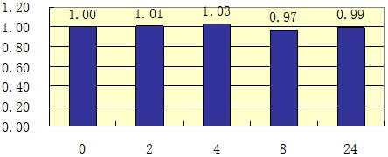
Figure 1. The relative expression levels of c-Met in A549 cells before and after radiotherapy.

After 8 Gy X-ray irradiation to A549 cells, the net optical density values of c-Met were 4682.03±15.18, 4686±39.88, 4734.1±39.51, 4625.1±25.35 and 4057.5±711.00 at 0 h, 2 h, 4 h, 8 h and 24 h, respectively. Compared with cells without radiotherapy, there was no significant difference (P>0.05). The results suggested that there was no significant difference in expression of non-phosphorylated c-Met before and after radiotherapy. The relative expression levels of c-Met were calculated based on cells without radiotherapy as a standard (Figures 1 and 2).

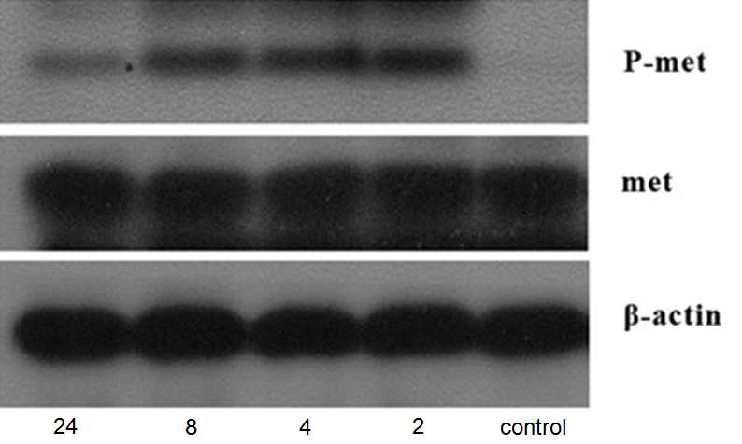
Figure 2. The expression levels of phosphorylated and non-phosphorylated c-Met before and after radiotherapy.

3.2 The expression levels of phosphorylated c-Met before and after radiotherapy
The net optical density values of phosphorylated/activated c-Met of A549 cells were 416.06±3.18, 1710.07±93.23, 1595.53±135.92, 1554.33±36.31 and 993.27±24.18 at 0 h, 2 h, 4 h, 8 h and 24 h after radiotherapy. The expression of activated c-Met reached the peak at 2 h, and then gradually decreased. There was significant difference in the phosphorylated c-Met before and after radiotherapy (P<0.05), suggesting the activation of c-Met after radiotherapy was increased. The relative expression levels of phosphorylated c-Met were calculated based on cells without radiotherapy as a standard (Figures 2 and 3).

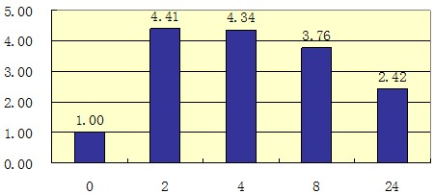
Figure 3. The relative expression levels of phosphorylated c-Met in A549 cells before and after radiotherapy.

3.3 The expression levels of c-Src before and after radiotherapy
After the A549 cells received 8 Gy X-ray irradiation, the net optical density values of c-Met were 3630.8±2.97, 3715.57±90.40, 3714.17±100.24, 3790.37±24.82 and 3742.1±8.31 at 0 h, 2 h, 4 h, 8 h and 24 h, respectively. Compared with cells without radiotherapy, there was no significant difference at any time points (P>0.05). The results suggested that there was no significant difference in expression of non-phosphorylated c-Src before and after radiotherapy. The relative expression levels of c-Src were calculated based on cells without radiotherapy as a standard (Figures 4 and 5).

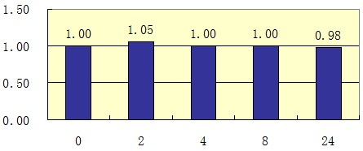
Figure 4. The relative expression levels of c-Src in A549 cells before and after radiotherapy.

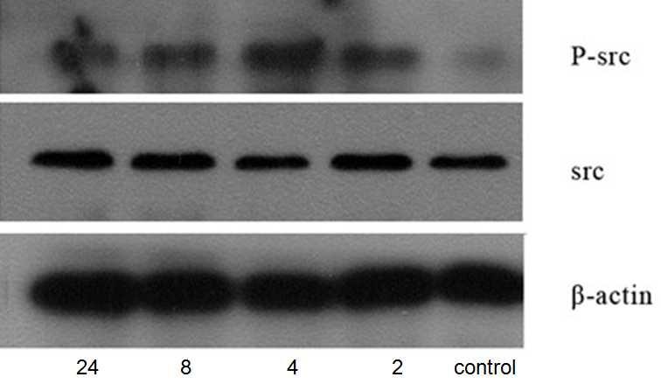
Figure 5. The expression levels of phosphorylated and non-phosphorylated c-Src before and after radiotherapy.

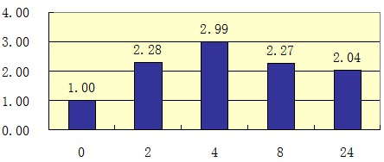
Figure 6. The relative expression levels of phosphorylated c-Src in A549 cells before and after radiotherapy.

3.4 The expression levels of phosphorylated c-Src before and after radiotherapy
The net optical density values of phosphorylated c-Src of A549 cells were 1066.63±0.01, 2452.53±1.67, 3052.67±169.23, 2582.67±56.12 and 2239.1±23.26 at 0 h, 2 h, 4 h, 8 h and 24 h after radiotherapy. The expression of activated c-Met was gradually increased after radiotherapy and reached the peak at 4 h, and then gradually decreased. There was significant difference in the phosphorylated c-Src before and after radiotherapy (P<0.05), suggesting the activation of c-Src after radiotherapy was increased. The relative expression levels of phosphorylated c-Src were shown in Figures 5 and 6.

4. Discussion
The concurrent chemoradiotherapy is the main treatment method for locally advanced or advanced NSCLC; however, the clinical effect is not satisfactory. Therefore, to explore how to enhance the radiosensitivity and its mechanism has important significance for treatment of NSCLC.
With the development of molecular target therapy, the EGFR has become the important target for cancer therapy (Herynk et a l., 2007). EGFR is a growth factor receptor with tyrosine kinase activity, which is over-expressed in a variety of tumor cells (Urai et al.,2005). When the tumor cells received irradiation, EGFR inhibited tumor cell apoptosis, induce tumor angiogenesis and cell regrowth, which could promote the repair of potentially lethal damage and sublethal damage (Stephen et al.,2006;Carney et al.,2002;Chute et al., 1999; Begg et al.,2011), thereby reducing the radiosensitivity of tumor cells. Clinically, EGFR inhibitors combined with radiotherapy achieved encouraging efficacy (Birchmeier et al.,2003). In this study, we combined radiotherapy with the EGFR humanized monoclonal antibody, Nimotuzumab, to induce A549 cell apoptosis and observed the cell cycle distribution; to investigate the mechanism of lung cancer cell apoptosis by combination of radiotherapy and Nimotuzumab, which provides a theoretical basis for rational chemoradiotherapy program in clinic.
In our study, we detected the growth inhibition rate of A549 cells treated with different concentrations of Nimotuzumab by MTT assay, the results showed that the growth inhibition rate was gradually increased with the concentration of Nimotuzumab, suggesting that Nimotuzumab could inhibit the growth of A549 cells. Meanwhile, the radiosensitivity assay was performed on A549 cells treated with low cytotoxic Nimotuzumab (20 μg/ml).
The time of adding Nimotuzumab as radiation sensitizer was 24 h before radiation, the previous studies have shown that the sensitization effect was better at 24 h before radiation than during radiation and at 24 h after radiation (Rabkin et al.,2001). The reason was that Nimotuzumab could induce G1 phase cell arrest to make cell synchronization, and then the cell cycle was back to normal and went into G2/M phase during radiation (Shimizu et al.,1991), thereby the radiation-sensitive cells were prone to necrosis or apoptosis.
The clone forming assay is considered as the most reliable method for determination of cell survival, and the gold standard for detection of cell radiosensitivity. In this study, we detected the radiosensitivity of A549 cells treated Nimotuzumab by clone forming assay and multitarget-single hitting model, and the results showed that the dose-survival curve had the narrower shoulder area and higher slope in combination of radiotherapy and Nimotuzumab group than that in radiotherapy alone group and Nimotuzumab alone group. Do was the reciprocal of the slope, which represented the average lethal dose to kill 63% cells; the Do value of combination group was decreased, indicating that cells had higher sensitivity to radiation at greater dose region (Noji et al.,1990). Dq represented the sublethal damage repair capacity, the Dq value of combination group became small, and suggesting that the capacity of sublethal damage repair was diminished (Noji et al.,1990). SF2 was used to evaluate the radiosensitivity of tumor cells, the higher SF2 value, the lower radiosensitivity; the SF2 was significantly decreased in combination group, suggesting that Nimotuzumab could induce more A549 cells apoptosis at early period with increasing radiation dose, and reduce the sublethal damage repair capacity of A549 cells, so as to increase the radiosensitivity of A549 cells.
The flow cytometry results showed that the number of apoptotic cells was significantly increased in combination group, Nimotuzumab played the radiosensitizing effect, and the sensitizing mechanism was involved in cell cycle regulation. Our study observed that Nimotuzumab could induce G1 phase cell arrest to make cell synchronization, and then the cell cycle was back to normal and went into G2/M phase during radiation, thereby the radiation-sensitive cells were prone to necrosis or apoptosis.
Our results showed that Nimotuzumab could promote radiosensitization of lung cancer cells, which provide the experimental basis for application of Nimotuzumab in radiation and explore the optimization of radiosensitization effect.

Correspond to: Huawei Zou
Department Of Oncology, Shengjing Hospital Of China Medical University, No.36, shanhao RD, Heping District, Shenyang 110004, China.
Tel.:+86-8624-96615;
Fax:+86-8624-96615;
Email: huawei_zou@163.com
References
- Han CB, Ma JT, Li F. EGFR and KRAS mutations and altered c-Met gene copy numbers in primary non-small cell lung cancer and associated stage N2 lymph node-metastasis. Cancer Lett 2012;314:63-72.
- Masuya D, Huang C, Liu D, et al. The tumour-stromal interaction between intratumoral c-Met and stromal hepatocyte growth factor associated with tumour growth and prognosis in non-small-cell lung cancer patients.Br J Cancer 2004;90:1555-62.
- Irby RB, Yeatman TJ. Role of Src expression and activation in human cancer. Oncogene 2000;19:5636–42.
- Alvarez RH, Kantarjian HM, Cortes JE. The role of Src in solid and hematologic malignancies: development of new-generation Src inhibitors. Cancer 2006; 107: 1918–29.
- Summy JM, Gallick GE. Src family kinases in tumor progression and metastasis. Cancer Metastasis Rev 2003; 22: 337–58.
- Summy JM, Gallick GE. Treatment for advanced tumors: SRC reclaims center stage. Clin Cancer Res 2006; 12: 1398–401.
- Herynk MH, Zhang J, Parikh NU, Gallick GE. Activation of Src by c-Met overexpression mediates metastatic properties of colorectal carcinoma cells.Journal of Experimental Therapeutics & Oncology 2007; 6:205-17.
- Urai Pongchairerk, Jun-Lin Guan, Vijittra Leardkamolkarn. Focal adhesion kinase and Src phosphorylations in HGF-induced proliferation and invasion of human cholangiocarcinoma cell line, Hu CCA-1. World J Gastroenterol 2005;11:5845-52.
- Stephen Hiscox, Nicola J Jordan, Wen Jiang, Maureen Harper, Richard McClelland, Chris Smith, Robert I Nicholson. Chronic exposure to fulvestrant promotes overexpression of the c-Met receptor in breast cancer cells: implications for tumour–stroma interactions. Endocri Relat Cancer 2006;13:1085–99.
- Carney DN. Lung cancer--time to move on from chemotherapy. N 2002;346:126-8.
- Chute JP, Chen T, Feigal E, Simon R, Johnson BE. Twenty years of phase III trials for patients with extensive-stage small-cell lung cancer: perceptible progress.J Clin Oncol 1999;17:1794-801.
- Begg AC, Stewart FA, Vens C. Genomic instability in cancer strategies to improve radiotherapy with targeted drugs. Nat Rev Cancer 2011;11:239-53.
- Birchmeier C, Birchmeier W, Gherardi E, Vande Woude GF. Met, metastasis, motility and more. Nat Rev Mol Cell Biol 2003; 4: 915–25.
- Rabkin R, Fervenza F, Tsao T, Sibley R, Friedlaender M, Hsu F, Lassman C, Hausmann M, Huie P, Schwall RH. Hepatocyte growth factor receptor in acute tubular necrosis. J Am Soc Nephrol 2001;12:531–40.
- Shimizu I, Ichihara A, Nakamura T. Hepatocyte growth factor in ascites from patients with cirrhosis. J Biochem 1991;109:14–8.
- Noji S, Tashiro K, Koyama E, Nohno T, Ohyama K, Taniguchi S, Nakamura T. Expression of hepatocyte growth factor gene in endothelial and Kupffer cells of damaged rat livers, as revealed by in situ hybridization. Biochem Biophys Res Commun 1990;173:42–7.

6/25/2017

