Effect Of Age And Gender On The Clinicopathological Features Of Bladder Tumor

Javed Altaf, Muhammad Adeel Mahesar, Taimur Jatoi

Department of Urology, Liaquat University of Medical and Health Sciences, Jamshoro
Corresponding Author: Javed Altaf, Assistant Professor, javed_altfdr@yahoo.com

Abstract: Objective: To objective of the present was to examine the effect of age and gender on the clinicopathological features of bladder tumors in a single institution in Hyderabad, Sindh, Pakistan. Material & Methods: From 7th January 2013 to 6th June 2013, Patient Records of bladder tumor Department of Urology, Liaquat University of Medical and Health Sciences Jamshoro was to examine the effect of age and gender on the clinicopathological features of bladder tumors in a single institution in Hyderabad, Sindh, Pakistan. A total of 95 patients were identified and enrolled for this study. The bladder specimens of all the patients were sent for histopathological examination to find out the nature and grade of the disease. History of patients and histopathological characteristics were noted in the proforma. Results: A total of 95 cases were enrolled in this study. Mean ±SD duration of disease was 2.1 ±1.3 years. Out of 95 patients, 81were male and 14 were female with 5.7: 1 male to female ratio. The average age of the patients was 60.04 ±10.3 years. Minimum age was 40 years and maximum age was 72 years. Most of the patients 57 were between 50 - 59 years. Painless macroscopic hematuria was found in 61 males and in 8 females. Dysuria was found in 31 males and in 5 females. Urine urgency was found in 19 males and in 2 females. Majority of cases with painless macroscopic hematuria had age between 50 – 59 years, 47 Majority of cases with dysuria had age between 50 – 59 years, 24, majority of cases with urine urgency had age between 50 – 59 years, 16 (28.1%), but difference is insignificant (p-value = 0.2). Conclusion: In this study painless macroscopic hematuria and histological sub-type transitional-cell carcinoma was dominant with significant male preponderance among patients. Adult aged patients have low-grade disease. Hematuria is the common presentation and greater awareness is needed not to overlook bladder cancer.
[Altaf J, Mahesar MA, Jatoi T. Effect of Age and Gender on the Clinicopathological Features of Bladder Tumor. Cancer Biology 2017;7(2):18-22]. ISSN: 2150-1041 (print); ISSN: 2150-105X (online). http://www.cancerbio.net. 3. doi:10.7537/marscbj070217.03.

Keywords: Bladder Tumor, Age, Gender

- Introduction
Bladder tumors are among the commonest urological conditions worldwide. Total of 70,980 new cases were diagnosed with an estimated 14,330 deaths in United States in 2009 ¹. Bladder cancer is primarily a disease of advanced age group ². The worldwide age standardized incidence rate (ASR) is 10.1 per 100,000 for males and 2.5 per 100,000 ³. In Pakistan, bladder cancer is 4th most common cancer with an age standardized rate of 6.8 per 100,000 ⁴. Bladder cancer is caused by genetic abnormalities and external risk factors. Smoking is one of the major perilous factors with risk, increasing with increased period of smoking ⁵. Carcinogen exposure (those working in chemical industries), inflammation, infection (Schistosoma Hematobium and chronic bacterial infections), chemotherapy (cyclophosphamide) and radiotherapy, are among the other risk factors ⁶. The study of Kong CH reported that the histopathology were transitional cell carcinoma (TCC) (90.4%), followed by adenocarcinoma (6%).⁷ For the transitional cell tumours, 58.6% were superficial tumours while 41.4% were muscle invasive. While all 5(100%) adenocarcinomas were muscle invasive.⁷ Squamous-cell and adenocarcinoma were recorded in 6.4% of the 607 cases. Among the grades; G3 was the commonest grade found in 37.9%, followed by G2 in 25.2% and G1 in 9.7% of patients.⁸ Histologically, bladder tumors are classified into Urothelial (Transitional cell type) and Non-Urothelial cancers ^{9.} The urothelial cancers are divided into Non-muscle-invasive and Muscle invasive and Metastatic bladder cancers. According to 2004 WHO Classification, Non–muscle-invasive bladder cancer (NMIBC) is sub-divided into flat, endophytic and papillary types, according to the association with the surface of the surrounding urothelial mucosa.¹⁰ Muscle invasive bladder cancer includes Lamina propria invasion and Muscularis propria (detrusor muscle) invasion. The Non-urothelial cancers of bladder include Sarcomas, Signet Ring Cell Carcinoma, Small Cell Carcinoma and Squamous Cell Carcinoma. Gross painless hematuria is the primary symptom in 78% patients with a newly diagnosed bladder tumor. ² Other lower urinary tract symptoms 42% include dysuria, polyuria or urinary urgency. The gold standard for diagnosing bladder cancer is biopsy obtained during cystoscopy. Bladder cancer can sometimes be incidentally found during cystoscopy performed for other conditions ^{11.} Other investigations like urine cytology & upper-tract imaging (primarily a CT scan of the abdomen and pelvis) are also helpful. The treatment of bladder cancer depends on how deep the tumor invades into the bladder wall. Transurethral Resection Of bladder Tumor (TURBT), Laser Therapy, Immunotherapy (in form of BCG) and Intravesical Chemotherapy are used to treat superficial tumors.¹² Patients at high risk for progression should be considered for cystectomy and urinary diversion.¹³

To objective of the present was to examine the effect of age and gender on the clinicopathological features of bladder tumors in a single institution in Hyderabad, Sindh, Pakistan.

2. Material and Methods
From 7th January 2013 to 6th June 2013, Patient Records of bladder tumor Department of Urology, Liaquat University of Medical and Health Sciences Jamshoro was to examine the effect of age and gender on the clinicopathological features of bladder tumors in a single institution in Hyderabad, Sindh, Pakistan. A total of 95 patients were identified and enrolled for this study. The bladder specimens of all the patients were sent for histopathological examination to find out the nature and grade of the disease. History of patients and histopathological characteristics were noted in the proforma.
Sample Selection:
Inclusion Criteria:-
- Age 40-75 years.
- Both gender.
- Suspected case of bladder tumor of superficial to muscle invasive of more than 3 months duration.
Exclusion Criteria:-
- Recurrent bladder tumor.
- Post treatment.
- Refused to participate in the study.
Data Collection Procedure:-
The study was performed after the permission of ethical committee of hospital, and written informed consent for the study. Patients fulfilling the inclusion criteria admitted through outpatient department of Liaquat University Hospital Hyderabad. After taking detailed history regarding age, sex, clinical presentation, duration of symptoms and physical examination was noted in the proforma. SPSS.16 was used for data analysis.

3. Results
A total of 95 suspected case of bladder tumor of more than 3 months duration were included in this study.
Mean ±SD duration of disease was 2.1 ±1.3 years. Out of 95 patients, 81(85.3%) were male and 14 (14.7%) were female with 5.7: 1 male to female ratio as presented in Figure-1. The average age of the patients was 60.04 ±10.3 years. Minimum age was 40 years and maximum age was 72 years. Most of the patients 57 (60%) were between 50 - 59 years. Distribution of age is presented in Figure-2. Figure 3 shown the clinical features of Bladder Tumor. The painless macroscopic hematuria as per gender is shown in fig 4. Painless macroscopic hematuria was found in 61 (75.3%) males and in 8 (57.1%) females (p-value = 0.16). Dysuria was found in 31 (38.3%) males and in 5 (35.7%) females (p-value = 0.9). Urine urgency was found in 19 (23.5%) males and in 2 (14.3%) females (p-value = 0.4). Painless macroscopic hematuria was found in 61 (75.3%) males and in 8 (57.1%) females (p-value = 0.16). Dysuria was found in 31 (38.3%) males and in 5 (35.7%) females (p-value = 0.9). Fig:-5 Urine urgency was found in 19 (23.5%) males and in 2 (14.3%) females (p-value = 0.4). Painless macroscopic hematuria as per age group is shown. Majority of cases with painless macroscopic hematuria had age between 50 – 59 years, 47 (82.5%), (p-value = 0.005). Majority of cases with dysuria had age between 50 – 59 years, 24 (42.1%), but difference between proportion is not significant (p-value = 0.5). Majority of cases with urine urgency had age between 50 – 59 years, 16 (28.1%), but difference is insignificant (p-value = 0.2).
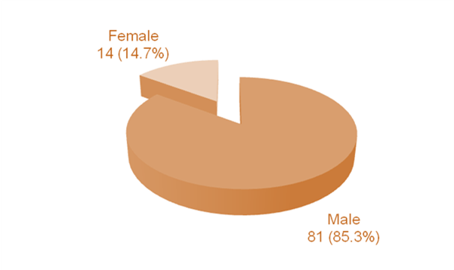
Figure-1: Gender Distribution (N = 95)
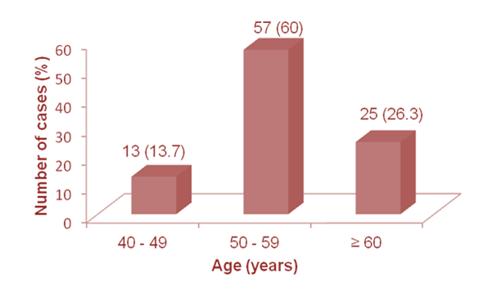
Figure-2: Age Distribution (n = 95)

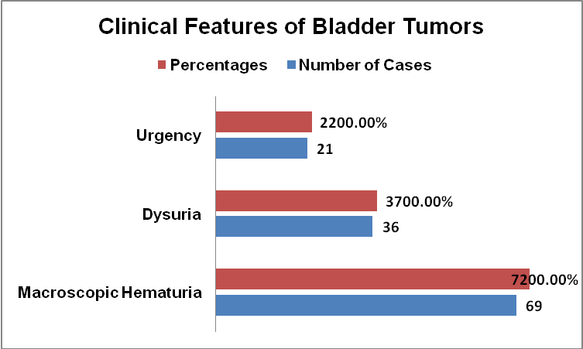
Fig: 3 Clinical Features of Bladder Tumors

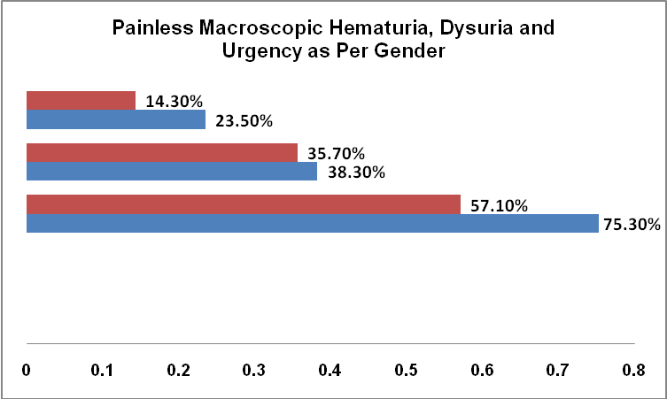
Fig 4: Painless Macroscopic Hematuria, Dysuria and Urgency as Per Gender

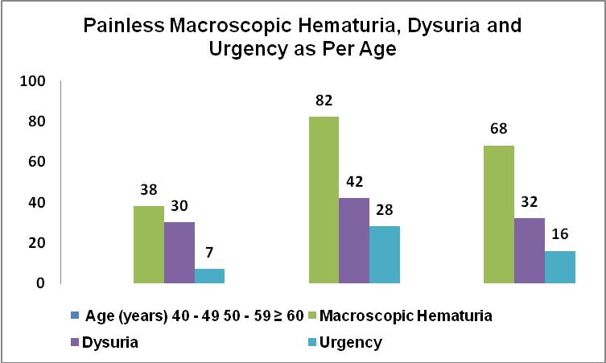
Fig: 5 Painless Macroscopic Hematuria, Dysuria and Urgency as Per Age

4. Discussions
Worldwide, bladder cancer is the fourth most common cancer in males and the ninth most common in females.^{14,15,16} It accounts for 7% of all new cancer cases in men and 2% in women.¹⁷ The overall incidence of bladder cancer has apparently increased during recent decades.^{18,19} This increasing trend cannot be attributed to technological improvements in medicine, as bladder cancer has been diagnosed by cystoscopy and biopsy for about six decades.²⁰ However, the trend might be due to the latent effects of risk factors for bladder cancer, including tobacco, non-occupational and industrial carcinogens, and population aging.²¹ According to the World Cancer Report 2008, in the Eastern Mediterranean Region the second most common cancer is bladder cancer in men, after lung cancer.²² In the most recent national cancer report in Iran, the age-specific incidence rates for bladder cancer were 13.03 in males and 3.32 in females per 100 000 population.²³ Worldwide, the male-to-female ratio in the incidence of bladder cancer varies and has been reported as 1.1:1.0 in Eastern Africa, 2.1:1.0 in South Africa, 5:1 in Northern Africa and 5.1:1.0 in several areas of southern Europe.^{23,24} In this study, this ratio (5.7:1) was similar to the figures reported in previous research in Iran and Pakistan.²⁵⁻²⁷ Globally gender-related difference in incidence with the male to female ratios being documented as 4 to 1 in the United States and 7 to 1 in Italy²⁸ and, in Spain, 6.7 to 1.²⁹ There are various possible explanations for the observed preponderance of bladder tumours in males. Among them are environment and dietary exposures not yet identified and innate sexual characteristics such as anatomic differences, urination habits or hormonal factors.^{30, 31} besides that, the lower incidence of bladder tumours in females could be attributed to the decreased exposure to the industrial carcinogens as there are fewer women working outside the home. In addition to that, there are fewer women who smoke as compared to men, which is a major predisposing factor for bladder tumours.³² Urinary bladder cancer is a disease of the elderly with most cases occurring above the age of 50 years. In this study the mean age at presentation was 60.04 ±10.3 years which is similar to with what has been recorded in other studies conducted in Pakistan.^{33, 34} The results are also comparable with studies in Kurdistan and Tehran, Iran reported mean ages of 62.5±13.0 and 61.9 years, respectively.^{35, 36} A study in Shiraz reported that the mean age of patients with bladder cancer was 61.0 ±12.7 years.³⁷

Conclusion
It is concluded that painless macroscopic hematuria and histological sub-type transitional-cell carcinoma was dominant with significant male preponderance among patients. Hematuria is the common presentation and greater awareness is needed not to overlook bladder tumor.

Corresponding Author:
Dr. Javed Altaf
Assistant Professor,
Department of Urology Liaquat University of Medical and Health Sciences Jamshoro
javed_altfdr@yahoo.com

References
- Jemal A, Siegel R, Ward E, Hao Y, Xu J, Thun MJ. Cancer statistics. CA Cancer J Clin. 2009;59:225–49.
- Taylor III JA, Kuchel GA. Bladder cancer in the elderly: clinical outcomes, basic mechanisms, and future research direction. Nature Clinical Practical Urology. 2009;6:135–44.
- Ploeg M, Aben KKH, Kiemeney LA. The present and future burden of urinary bladder cancer in the world. World J Urology. 2009;27:289–93.
- Badar F, Sattar A, Meerza F, Irfan N, Siddiqui N. Carcinoma of the urinary bladder in a tertiary care setting in a developing country. Asian Pacific J Cancer Prevention 2009;10:35-9.
- Tyczynski JE, Parkin DM. Bladder cancer in europe, european network of cancer registries. Intern Agency for Res on Cancer. 2003;3:1-3.
- Matalka I, Bani-Hani K, Shotar A, Bani-Hani O, Bani-Hani I. Transitional cell carcinoma of the urinary bladder: a clinicopathological study. Med J Singapore. 2008;49:790-4.
- Kong CH, Singam P, Hong GE, Cheok LB, Azrif M, Tamil AM, et al. Clinicopathological features of bladder tumours in a single institution in Malaysia. Asian Pac J Cancer Prev. 2010;11(1):149-52.
- Badar F, Sattar A, Meerza F, Irfan N, Siddiqui N. Carcinoma of the urinary bladder in a tertiary care setting in a developing country. Asian Pacific J Cancer Prev. 2009;10:449-52.
- Chalasani V, Chin JL, Izawa JI. Histologic variants of urothelial bladder cancer and nonurothelial histology in bladder cancer. Canadian Urological Assoc Jour 2009;3:193-8.
- Montironi R, Lopez-Beltran A, Scarpelli M, Mazzucchelli R, Cheng L. World Health Organization Classification of the Noninvasive Urothelial Neoplasms: Inherent Problems and Clinical Reflections. European Urology. 2009;8:453–7.
- Walid MS, Heaton RL. Can posthysterectomy cystoscopy be utilized as a screening test for bladder cancer?" German Med Sci. 2008;6:56-61.
- Hall MC, Chang SS, Dalbagni G, Pruthi RS, Seigne JD, Skinner EC. Guideline for the management of nonmuscle invasive bladder cancer (stages Ta, T1, and Tis):2007 update. American J Urol. 2007;178:2314-30.
- Shalhoub PJ, Quek ML. Clinical decision-making and guideline recommendations, management of bladder cancer in the elderly. Aging Health. 2010;6:607-10.
- Campbell W. Urothelial Tumors of the Bladder. In ‘Urology’. Eds Kavoussi LR, Novick AC, Partin AW, Peters CA, Wein AJ. Saunders Elsevier, Philadelphia 2007. p. 2407-46.
- Scelo G, Brennan P. The epidemiology of bladder and kidney cancer. Nat Clin Pract Urol. 2007;4:205-17.
- Yavari P, Sadrolhefazi B, Mohagheghi MA. A descriptive retrospective study of bladder cancer at a hospital in Iran (1973-2003). Asian Pac J Cancer Prev. 2009;10:681-4.
- Carel R, Levitas-Langman A, Kordysh E. Casereferent study on occupational risk factors for bladder cancer in southern Israel. Int Arch Occup Environ Health. 1999;72:304-8.
- Madeb R, Messing EM. Gender, racial and age differences in bladder cancer incidence and mortality. Urol Oncol, 2004;22:86-92.
- Villares da Costa LA, Wroclawski ML, Tobias-Machado M. Non-occupational risk factors for bladder. Einstein, 2008;6:507-10.
- Boyle P, Levin B. World Cancer Report, IARC Press; 2008. p. 444-6.
- Report of National Cancer Registration Iran (2007-2008). Islamic Republic of Iran. Ministry of Health and Medical Education, Office Health Deputy, Center for Disease Control and Prevention.
- Soofi Majidpour H, Rahimi E, Malekpour MH. The incidence rate of bladder cancer and demographic characteristics of the patients in Kurdistan province form year 1994 to 1999. Scientific Journal OF Kurdistan University of Medical Sciences, 2001;5:22-6.
- Ahmad E, Ghasemkhani O, Dastoori P. Recurrence rate and prognostic factors of superficial bladder cancer in Shiraz Shahid Faghihi Hospital during the years 1998-2001. Journal of Zanjan University of Medical Sciences & Health Services, 2003;11: 7-1.
- Schatte E, Grunenfelder J, Fradet Y, Miles BJ. Epidemiology of bladder cancer. In: Comprehensive Textbook of Genitourinary Oncology, 2nd edition. Vogelzang NJ, Scardino PT, Shipley WU, Coffey DS, editors. Philadelphia: Lippincott, Williams and Wilkins, 2000. p. 283.
- Puente D, Malats N, Cecchini L. Gender-related differences in clinical and pathological characteristics and therapy of bladder cancer. Eur Urol, 2003;43:53-62.
- Hartge P, Harvey EB, Linehan WM. Unexplained excess risk of bladder cancer in men. J Natl Cancer Inst, 1990;82:1636-40.
- Horn EP, Tucker Ma, Lambert G. A study of genderbased cytochrome P450 1A2 variability: A possible mechanism for the male excess of bladder cancer. Cancer Epidemiol Biomarkers Prev, 1995;4:529-33.
- Gupta P, Jain M, Kapoor R. Impact of age and gender on the clinicopathological characteristics of bladder cancer. Indian J Urol, 2009;25:207-10.
- Ullah R, Nusrat J, Hamdani SR, Burdy GM, Khurshid A. Cancer urinary bladder-5 year experience at CENAR, Quetta. J Ayub Med Coll Abottabad, 2001;13:14-6.
- Carrion Rafael, Seigne J: Surgical management of bladder carcinoma. Cancer Control 2002;9:284-92.
- Rafique M. Clinico-pathological features of bladder carcinoma in women in Pakistan and smokeless tobacco as a possible risk factor. World J Surg Oncol. 2005; 3: 53.
- Leung HY, Griffiths TRI, Neal DE: Bladder cancer. Post Grad Med J 1996;72:719-24.
- Van der Poel HG, Mungan NA, Witjes JA: Bladder cancer in women. Int Urogynecol J and pelvic floor dysfunction 1999;10:207-12.
- Rabbani F, Cordon-Cardo C. Mutation of cell cycle regulators and their impact on superficial bladder cancer. Urol Clin North Am, 2000;27:83-102.
- Hasan SM, Imtiaz F, Hasan SM. Frequency of transitional cell carcinoma in local suburban population of Karachi. J Liaquat Uni Med Health Sci Jan 2007;6:83-5.
- Salehi A, Khezri AA, Malekmakan L, Aminsharifi A. Epidemiologic status of bladder cancer in Shiraz, southern Iran. Asian Pac J Cancer Prev. 2011;12:1323-7.
- Johansson SL, Cohen SM. Epidemiology and etiology of bladder cancer. Semin Surg Oncol, 1997; 13:291-8.

4/27/2017

