**Correlation between hormonal receptor status and Her 2 neu expression with the age of breast cancer patients and its outcome: a single institutional study in Egypt**

Heba G.M. Mahmoud1， Marwa Nabil Abdelhafez 2, Wafaa Yousif Abdel Wahed3, Dalia Nabil Abdelhafez4

1Surgical Department, National Cancer Institute, Cairo University, Egypt

2Medical Oncology Department, National Cancer Institute, Cairo University, Egypt

3Public Health and Community medicine Department, Faculty of Medicine, Fayoum University, Egypt

4Pathology Department, Faculty of Medicine, Fayoum University, Egypt

[marwa_nabil_25@yahoo.com](mailto:marwa_nabil_25@yahoo.com)

**Abstract: Background:** Hormone receptors and Her2/ neu statuses are known to be very powerful and useful predictors of outcome. Assessment of the receptor status profile in correlation with the age of the patients allows for prediction of breast cancer outcome and hence better treatment optimization for different age groups. **Objectives:** To assess the correlation between hormone receptor and Her2/neu status and age, and its significance as a predictor of outcome in patients with breast cancer. **Patients & methods** This is a retrospective study conducted on 382 patients diagnosed with breast cancer at the national cancer institute, Cairo University. Clinicopathological data (age, tumor histology, lymph node status, stage, and hormone receptor status and her2/ neu expression, were retrieved from the files. A correlation between the age of the patients and the hormone receptor status and outcome was done statistically. **Results:** The patients age ranged from26 to 78 (mean 49.7). Significant relation between ER, PR statuses and HER 2 neu expression with the age of the patients was observed. ER positivity increased and HER-2/neu expression decreased with rising age. ER and PR expression were significantly lower in HER-2/neu positive as compared with HER-2/neu negative tumors.  In patients less than 40 years 72.2% were ER positive while in patients more than 40 years, 83.9% of cases are ER positive and the P value insignificant (0.017). While PR was positive in 74.7% of cases less than 40 years and in 84.9% of cases more than 40 years with significant p value (0.032). Her2/neu expression was positive in 34.2% of cases less than 40 years while it is positive in only 19.2% of cases more than 40 years. No relation of ER, PR, Her2neu expression with other variables(grade, tumor size, pathological type or surgery type were found. **Conclusion:** ER and PR and Her2 neu receptors statuses in the current study are significantly correlated with the patients age. Young breast cancer patients have more aggressive tumors with more negative hormone receptor status and more her2 /neu expression. Her-2/neu expression was increased in hormone receptor negative tumors.

[Heba G.M. Mahmoud, Marwa Nabil Abdelhafez, Wafaa Yousif Abdel Wahed, Dalia Nabil Abdelhafez. **Correlation between hormonal receptor status and Her 2 neu expression with the age of breast cancer patients and its outcome: a single institutional study in Egypt.** *Cancer Biology* 2017;7(1):26-33]. ISSN: 2150-1041 (print); ISSN: 2150-105X (online). <http://www.cancerbio.net>. 4. doi:[10.7537/marscbj070117.04](http://www.dx.doi.org/10.7537/marscbj070117.04).

**Keywords:** Breast cancer, hormone receptors, Her 2 neuexpression, young patients

**1. Introduction:**

Hormone receptor status and the over expression of human epidermal growth factor receptor (HER-2/neu) are very important predictors of the outcome of breast cancer patients. There are also observations among the molecular subtypes of breast cancer that point to a worse prognosis of triple negative breast cancer as well as HER-2 type breast cancer(1).

The hormone receptor status of the tumor as well as the expression of HER-2 were linked to age in previous published studies (2, 3). Young breast cancer patients are known to have more aggressive tumors and more invasiveness with more metastases at presentation(3).

In this study we are trying to find if there is a correlation between the age and the hormone receptor status (HRS) and HER-2/neu expression and the outcome in a cohort of breast cancer Egyptian patients. In this study, we will try to explain the aggressiveness of BC in the younger age group using hormone receptor status and HER-2 as a measure of aggressiveness and outcome. We will be looking at the differences in HRS (ER and PR), and HER-2 over-expression between women and the relation between the HRS and HER-2 expression in different ages.

**2. Patients and methods:**

This is a retrospective study including 385 consecutive breast cancer patients who were diagnosed and treated at the National Cancer Institute in Cairo during the year 2010.

Data was retrieved from the files of the patients. All types of histologically invasive carcinoma were included. Data included patient’s age, tumor type (ductal or other type), size (T1: <20 mm, T2: 20-50 mm, T3: >50 mm, and T4: >50 mm or fixed to chest wall), lymph node involvement (N0: no nodes, N1: <3 nodes, N2: 4-9 nodes, N3: >10 nodes), Stage (I, II, II IV), Grade (I, II, and III), ER and PR status, HER-2/neu receptor expression were determined using immunohistochemical staining, figure(1,2,3).

Hormone receptors were considered positive when the receptor concentration was greater than 10% (>30/300). The HER-2 expression was considered positive if it is present in more than 10% of tumor cells, stained +3 by immunohistochemistry. Immunoreactivity of c-erbB-2 was observed in the cell membrane and was scored semi quantitatively according to ***Jackobs et al., 1999.***

A correlation between HRS, HER-2 expression and age of the patients (above 40 years and below 40 years) was calculated. Also a correlation between ER and or PR and HER-2 expression was determined.

**Statistical methods**

Data was collected, coded; double entered and analyzed using SPSS software (Version 16) on Windows 7. Data was summarized using Mean and S.D. were calculated for quantitative variables. Number and percentages for categorical data. Differences were tested statistically by applying chi square tests for comparisons between breast cancer hormonal subtypes. Kaplan-Meier curves were constructed to describe survival by hormonal status at length 5 years time to estimate 5 year survival overall and disease free survival. Overall survival was measured from the date of diagnosis to the date of death from any cause. Disease-free survival was measured from the date of first definitive treatment to the date of first relapse or death from any cause. Survival times were censored at the dates of last contact for subjects who were lost to follow-up.

Cox-proportional hazard model was used to estimate the hazard ratios and 95% CI for overall and disease-free survival between the breast cancer hormonal subtypes. p-value of <0.05 was considered statistically significant.

**3. Results:**

This study included 382 consecutive breast cancer patients. The patients age ranged from26 to 78(mean49.7). Patients were divided into 2 age groups, namely; young women under 40 (n=81, 21.2%), and older women over 40 (n=301, 78.8%). the most common histologic subtype of the tumor was invasive duct carcinoma found in 304 cases(69,9%), also stage II was the most common stage, Most of the tumors, 348 cases (90.6%)were grade II. Most of the tumors were 2 to 5cm in size 262 cases(68.6 %).

Positive axillary lymph nodes metastases were present in 232 cases (60.7%) and negative in 122 cases (30%), patients clinicopathologica lcharacteristics are shown in table (1).

Table(1): Patients characteristics

|  |  |  |
| --- | --- | --- |
|  | N | N =382 |
| Age  ≤40  >40  Mean ±SD, range | 81  301  49.7±10.6, 26:78 | 21.2  78.8 |
| Marital status  married  single  Widow &divorced | 371  6  5 | 97.1  1.6  1.3 |
| Menopausal status  Pre  Post | 202  180 | 52.9  47.1 |
| Family history  Yes  No  Unknown | 54  260  68 | 14.2  68.1  17.8 |
| Side  RT  LT  Bilateral | 217  162  3 | 56.8  42.4  0.8 |
| Pathology  IDC  ILC  Mixed  Others | 304  30  28  20 | 79.6  7.9  6.8  5.2 |
| Surgery type  MRM  conservative breast surgery (CBS)  Metastatic | 291  88  3 | 76.2  14.7  0,3 |
| LN affection  No  1-4  ≥5  Unknown | 122  122  110  28 | 31.9  31.9  28.8  7.3 |
| Grade  1  2  3 | 2  348  34 | ,5  90.6  8.9 |
| Tumor size  <2  2-5  >5 cm  missing  Mean ±SD, range | 30  262  60  30  3.79±1.98, 1: 15 | 7.9  68.6  15.7  7.9 |
| PR  Positive  Negative  Unknown | 307  64  11 | 80.4  16.8  2.9 |
| HER2  Positive  Negative  Unknown | 76  260  46 | 19.9  68.1  12.0 |

CBS: conservative breast surgery

Significant relation between Hormone receptor statuses and HER2/NEU expression were reported (table 2). HER2 expression was inversely proportionate to ER and PR positivity.

Significant difference between young and older patients in Hormone receptor statuses and HER2/NEU expression: in patients less than 40 years 72.2% were ER positive while in patients more than 40 years, a higher percent 83.9% of cases were ER positive (P value)= (0.017), PR positivity was represented by 74.7% and 84.9% of cases less than 40 years and more than 40 years respectively with p value (0.032). The HER-2 positive-expression was seen more in younger women in comparison with older women (34.2% versus 19.2%) p value 0.006.

The most prevalent subtype was Luminal A (ER and/or PR positive, HER-2 negative), significant difference between these subtypes regarding age distribution was detected (p 0.017). Luminal A subtype was seen at a higher rate in older women > 40 years old 76.3.2% in comparison with young age 57.9%. Triple negative, was common in young age than older age 18.4% versus 9.8%. Her2 type was common in young age than older age 9.2% versus 4.9%.

**Hormonal receptor status and HER2 expression in correlation with the DFS and OS (figure 2):**

ER positivity was a prognostic factor for disease free survival HR (95% CI) = 0.44 (0.226: 0.8), nodal affection was a poor prognostic value for disease free survival (2.3(1.2: 4.6). Breast cancer subtypes in relation to age is shown in table (4).

Triple negative breast cancer subtype represented 18.4% (14 cases out of 72 cases) of patients below 40 years while it represented 9.77% of those above 40 years (26 cases out of 266 cases).

Multivariate analysis showed that significant relation between ER, PR statuses and HER 2 neu expression with the age of the patients was observed.

ER positivity increased and HER-2/neu expression decreased with rising age.

P value = ER and PR expressions were significantly lower in HER-2/neu positive as compared with HER-2/neu negative tumors.

No relation of ER, PR, Her2neu expression with other variables (grade, tumor size, pathological type or surgery type were found.

Table(2): Relation between HER2 status with ER and PR expression

|  |  |  |  |
| --- | --- | --- | --- |
|  | HER2 | | P value |
| Negative(260) | Positive(76) |
| ER  Positive(274)  Negative(62) | 227(82.8)  33(53.2) | 47(17.2)  29(46.8) | **0.000** |
| PR  Positive  Negative | 225(81.8)  35(57.4) | 50(18.2)  26(42.6) | **0.000** |

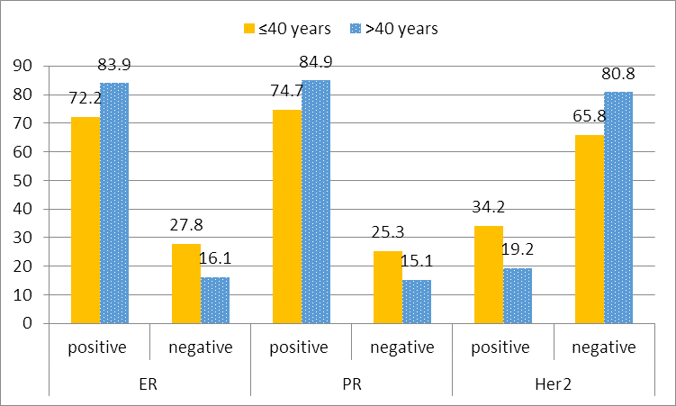

Figure (1): relation between ER, and PR and HER receptors with age

Table(3): relation between ER, and PR and HER receptors with age and outcome of patients

|  |  |  |  |  |
| --- | --- | --- | --- | --- |
|  |  | ER positive | PR Positive | HER2 Positive |
| Age | ≤40(79)  >40(292) | 57(72.2)  245(83.9) | 59(74.7)  248(84.9) | 26(34.2)  50(19.2) |
| P value | **0.017** | **0.032** | **0.006** |
| Status at last follow up | Free(312) | 261(83.7) | 264(84.6) | 61(21.6) |
| Mets(49) | 35(71.4) | 39(79.6) | 8(18.2) |
| Recurrence (10 | 6(60.0) | 4(40.0) | 7(70.0) |
| P value | **0.026** | **0.001** | **0.001** |

Table(4): Overall survival and disease free survival at 0, 1, 1nd 2, three, four years

|  |  |  |  |  |  |
| --- | --- | --- | --- | --- | --- |
|  | After 1 year | 2 y | 3y | 4y | 5 years |
| DFS | 99% | 98% | 93% | 84% | 75% |
| OS | 100% | 100% | 100% | 87% | 67% |

Table(5): Distribution of breast cancer subtypes according to age

| AGE |  | Groups | | | | P value |
| --- | --- | --- | --- | --- | --- | --- |
| ER-PR-.Her-  N=40 | ER-PR-Her+  N=20 | ER+PR+.Her 2 neu-  N=247 | ER+PR+.Her 2 neu+  N=35 |
| <40(76) | n | 14 | 7 | 44 | 11 | 0.017 |
| % | 18.4% | 9.2% | 57.9% | 14.5% |
| >=40(266) | n | 26 | 13 | 203 | 24 |
| % | 9.8% | 4.9% | 76.3% | 9.0% |

* Data available for 342 patients only

G I ER-PR-.Her-(triple negative)

G II ER-PR-./-Her+ = HER2 TYPE (ER AND PR NEGATIVE, HER2 POSITIVE)

GIII ER+PR+Her- = Luminal A subtype (ER and/or PR positive, HER-2 negative)

G IV ER+PR+.Her 2 neu+-luminal type B(TRIPLE POSITIVE)

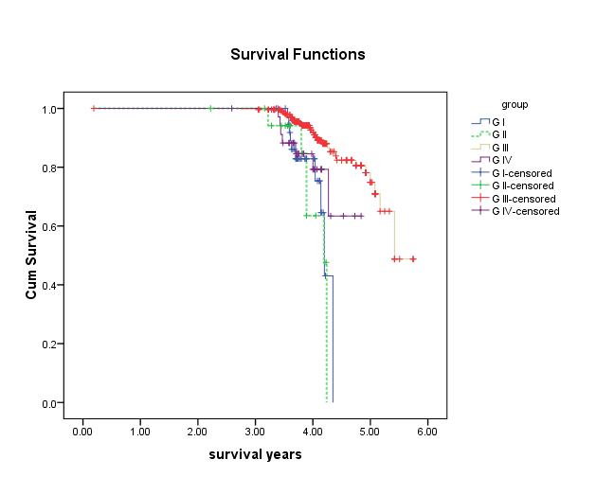

Figure (2): overall Survival in relation to the 4 groups of breast cancer subtypes based on their HRS and HER2 expression

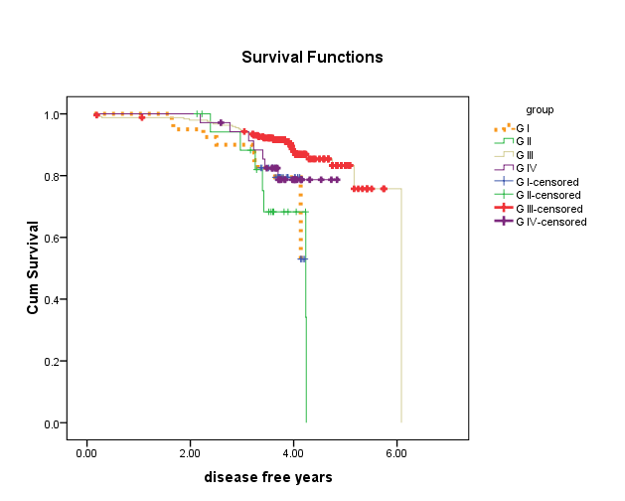

Figure(3): Cumulative survival and DFS in relation to breast cancer subtypes distribution based on the HRS and HER2 expression

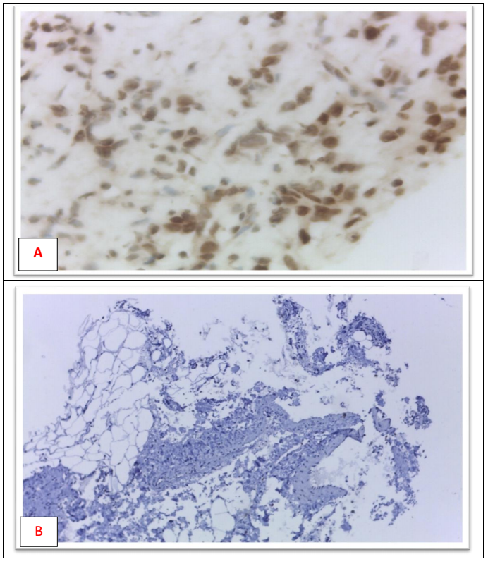

**Fig.(4):** ER immunohistochemical expression in 2 different cases of invasive duct carcinoma of the breast showing (A) strong (X400) and (B) negative expression (X200).

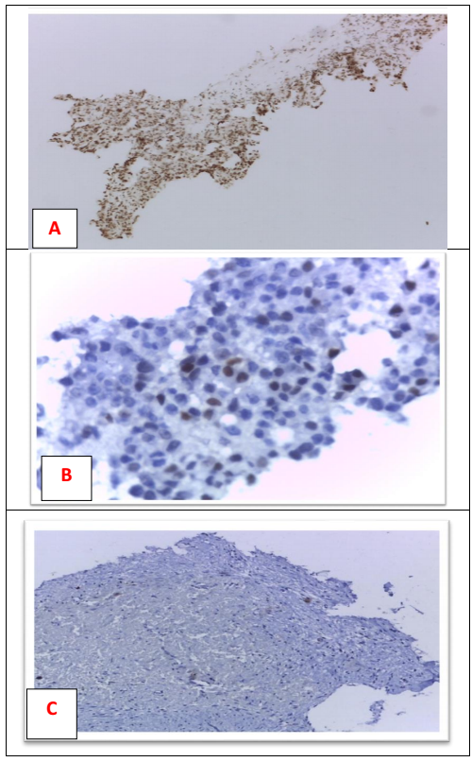

**Fig.(5):** PR immunohistochemical expression in 3 different cases of invasive duct carcinoma of the breast showing (A) strong (X200), (B) moderate (X400) and negative expression (X200).

**4. Discussion:**

Our study shows that young breast cancer patients less than 40 years old at diagnosis have more negative ER and PR receptors and more positive HER2 expression. ER and PR expression were significantly lower in HER-2 positive tumors when compared with HER-2 negative tumors.

Multivariate analysis showed that ER positivity was a good prognostic factor for disease free survival, HR= 0.44 and 95% CI (0.226: 0.8). Cumulative overall survival was not affected by the HRS or the HER-2 expression or age.

These results are in concordance with previous published studies that identify more negative ER status and more positive HER 2 in young age.

Studies correlating age with the HRS and Her2 expression have conflicting results with negative correlations found in some studies(4-6) and positive correlations similar to our study found in others(7).

ER positive tumors correlate with the outcome in terms of 5-years DFS and OS (74% and 66% respectively versus66% DFS and 82% OS in ER negative tumors (8).

Contrary to our findings where the DFS difference shown was after the 4th year of follow up, Hilsenbeck et al showed that the prognostic significance of The ER and PR positivity is only present during the first 3 years of follow up but not afterwards (9). our findings may be related to the protective effect of tamoxifen taken by the patients with positive ER and PR for 5 years in this cohort.

In this study, younger women with breast cancer have a worse hormone receptor expression with less estrogen receptor positive tumors and hence worse prognosis than do their older counterparts. Also they do much worse in terms of their disease free survival and not their overall survival when compared to older patients with more positive estrogen receptors in their tumors.

In another retrospective study, the relative risk of loco regional recurrence increased by 7% for every decreasing year of age in women younger than 40 who were ER negative and HER-2 positive. Taking the aforementioned criteria into consideration this may explain the better disease free survival in breast cancer with positive ER status.

On the other hand the less the expression of the ER and the PR, the less the use of the antiestrogen tamoxifen in the young patients which can affect the outcome.

The fact that the overall survival of patients was not dependent on their HRS or their HER-2 expression in this studied population was also shown in previous studies in different populations.

Although, other studies revealed ER-positive, HER-2/neu-positive status accompanied by poorer survival than ER-positive, HER-2/neu negative status(8). In this study we found no relationship between ER positivity and HER2 positivity and a worse outcome.

Assuming that HER-2/neu expression is a better predictor of response to hormonal therapy than ER status alone. In ER positive and HER2 positive patients, the response to tamoxifen is decreased. This fact is the same for all age groups, but the young patients in this study tend to have this biomarker profile less than their older counterparts.

Despite the fact that breast tumors are more aggressive if they were HER-2 positive (luminal B and HER-2 type), the presence of the targeted therapy trustuzumab offers a therapeutic solution for this category in the metastatic and adjuvant setting(10).

HRS and HER2 over expression are the main factors guiding therapy in both the metastatic and the localized breast cancer. Their correlation with age and with each other have its impact on the treatment level as well as the explanation of the aggressiveness and the outcome of breast cancer with a certain HRS and HER2 profile in young age groups.

BC in younger women is more aggressive than in older women with a significant proportion of younger women less than 40 years with triple negative and HER-2 type tumors(ER negative and HER2 positive) in this cohort.

These patients cannot benefit from the use of tamoxifen that has a good impact on overall survival and disease free survival. The use of trustuzumab in the adjuvant setting of Her2 positive young patients with negative HRS have been shown to increase overall survival and DFS in these patients(11).

In triple negative breast cancer which is found in young age groups, there is no use of tamoxifen and trustuzumab however some studies found benefits from the use of trustuzumab with systemic therapy in HER2 negative tumors(11).

This is particularly important in young patients since the decision of the use of tamoxifen and the anti HER2 targeted therapy as well as systemic therapy should be individualized depending on the HRS and the HER2 profile.

These findings show the importance of these biomarkers because they provide valuable prognostic information for best therapeutic decision.

Further studies should be done on the relationship between the breast cancer patients and their HRS and the type of surgery done as this may influence the local recurrence rate after breast conservative surgery especially in young women.

Our study is limited by the lack of evaluation in the differences in the genetic profile of patients, especially the genetic abnormalities like BRCA 1 and 2 genes, as these may have a significant effect on the molecular subtype of the tumors.

**Acknowledgments:**

The authors wish to thank Mr Ahmed Shaker in the statistical department in the National Cancer Institute for his help in the data collection.

Conflict of interest: The authors declare that there is no conflict of interests.

**References:**

1. Onitilo AA, Engel JM, Greenlee RT, Mukesh BN. Breast Cancer Subtypes Based on ER/PR and Her2 Expression: Comparison of Clinicopathologic Features and Survival. Clinical Medicine & Research. 2009;7(1-2):4-13.

2. AlZaman AS, Mughal SA, AlZaman YS, AlZaman ES. Correlation between hormone receptor status and age, and its prognostic implications in breast cancer patients in Bahrain. Saudi Medical Journal. 2016;37(1):37-42.

3. Cvetanovic A, Popovic L, Filipovic S, Trifunovic J, Zivkovic N, Matovina-Brko G, et al. Young age and pathological features predict breast cancer outcome - report from a dual Institution experience in Serbia. Journal of BUON: official journal of the Balkan Union of Oncology. 2015;20(6):1407-13.

4. Siadati S, Sharbatdaran M, Nikbakhsh N, Ghaemian N. Correlation of ER, PR and HER-2/Neu with other Prognostic Factors in Infiltrating Ductal Carcinoma of Breast. Iranian Journal of Pathology. 2015;10(3):221-6.

5. Biswal P, Behera S, Kar A, Pradhan D, Kumar Behera P, Burma S, et al. Correlation of Hormonal Receptors Estrogen Receptor, Progesterone Receptor and Her-2/Neu with Tumor Characteristics in Breast Carcinoma: Study of 100 Consecutive Cases. International Journal of Clinical Medicine. 2015;06(12):961-6.

6. Abdollahi A, Sheikhbahaei S, Safinejad S, Jahanzad I. Correlation of ER, PR, HER- 2 and P53 Immunoreactions with Clinico-Pathological Features in Breast Cancer. Iranian Journal of Pathology. 2013;8(3):147-52.

7. Huang HJ, Neven P, Drijkoningen M, Paridaens R, Wildiers H, Van Limbergen E, et al. Association between tumour characteristics and HER-2/neu by immunohistochemistry in 1362 women with primary operable breast cancer. Journal of clinical pathology. 2005;58(6):611-6.

8. Cianfrocca M. Prognostic and Predictive Factors in Early-Stage Breast Cancer. The oncologist. 2004;9(6):606-16.

9. Hilsenbeck SG, Ravdin PM, de Moor CA, Chamness GC, Osborne CK, Clark GM. Time-dependence of hazard ratios for prognostic factors in primary breast cancer. Breast cancer research and treatment. 1998;52(1-3):227-37.

10. Baselga J, Tripathy D, Mendelsohn J, Baughman S, Benz CC, Dantis L, et al. Phase II study of weekly intravenous recombinant humanized anti-p185HER2 monoclonal antibody in patients with HER2/neu-overexpressing metastatic breast cancer. Journal of Clinical Oncology. 1996;14(3):737-44.

11. Pinhel I, Hills M, Drury S, Salter J, Sumo G, A'Hern R, et al. ER and HER2 expression are positively correlated in HER2 non-overexpressing breast cancer. Breast Cancer Research. 2012;14(2).

3/2/2017