**Myocardial Changes in Childhood Cancer Patients Treated with Anthracyclines**

Faisal-Alkhateeb Ahmad1, Rehab F Mohamed2, Amany M Ali3, Khaled F Riad3, Ahmed M Morsy3 and Hekma S Farghaly1

1Department of Pediatrics, Faculty of Medicine, Assiut University, Assiut, Egypt.

2Department of Clinical Oncology and Nuclear Medicine, Faculty of Medicine, Assiut University, Assiut, Egypt.

3Department of Pediatric Oncology, South Egypt Cancer Institute, Assiut University, Assiut, Egypt.

[faisalalkhateeb@yahoo.com](mailto:faisalalkhateeb@yahoo.com)

**Abstract: Background:** Anthracycline-induced cardiotoxicity in survivors of childhood cancer initially presenting as sub-clinical cardiac abnormalities that, if left undetected or untreated, can lead to clinical cardiac dysfunction. The present study aimed to evaluate the early myocardial changes that develop with anthracycline therapy. **Material and Methods:** In this prospective study the preanthracycline and 6-months postanthracycline echocardiographic and electrocardiographic parameters were analyzed for cardiac dysfunction. The demographic information, including age, sex, type of anthracycline, and cumulative dose, were recorded, as well. **Results:** In this study, 115 patients with childhood cancer, including 81 males (70.4%) and 34 females (29.6%) with the mean age of 11.1±3.8 years were enrolled. Their normal baseline and 6-months postanthracycline echocardiographic and electrocardiographic parameters were compared for myocardial changes. Doxorubicin alone was used in 91 (79%) patients while daunorubicin alone in 24 (21%). Only 16 children (14%) received a high dose of anthracycline (cumulative dose > 300 mg/m2). QTc interval significantly prolonged 6-months after chemotherapy than the baseline readings (*P*<0.001). There was a significant increase in the left ventricular dimensions, and all myocardial functional parameters were significantly deteriorated in children who received anthracycline (*P*<0.001). The incidence of cardiac dysfunction found more in female patients (20/28; 71.4%). Myocardial dysfunction was significantly higher among children who received a high cumulative dose of doxorubicin (*P*<0.001). **Conclusion:** The incidence of subclinical anthracycline-related cardiac dysfunction is high. Children treated with anthracycline require a long-term follow-up to identify and establish optimal prevention and management strategies that balance oncologic efficacy with long-term safety.

**[**Faisal-Alkhateeb Ahmad, Rehab F Mohamed, Amany M Ali, Khaled F Riad, Ahmed M Morsy and Hekma S Farghaly. **Myocardial Changes in Childhood Cancer Patients Treated with Anthracyclines.** *Cancer Biology* 2017;7(1):1-8]. ISSN: 2150-1041 (print); ISSN: 2150-105X (online). <http://www.cancerbio.net>. 1. doi:[10.7537/marscbj070117.01](http://www.dx.doi.org/10.7537/marscbj070117.01).

**Keywords:** Anthracycline, cardiotoxicity, myocardial changes, childhood cancer, electrocardiography, echocardiography

**1. Introduction**

Owing to their high efficacy, anthracycline antibiotics (doxorubicin, daunorubicin) are included in numerous chemotherapeutic regimens used in treatment of solid tumors and blood malignancies, both in children and adults [1].

The toxic effect of anthracyclines on cardiovascular system leads to the direct loss of cardiomyocytes, decreased cardiac muscle contractility and damage to the microvasculature. Furthermore, by affecting cardiac progenitor cells and fibroblasts, anthracyclines make it more difficult for the already-weakened heart to recover from injuries [2]. Anthracyclines impose substantial risk of cardiotoxicity through several possible mechanisms [3]. The most commonly accepted is the oxidative stress hypothesis, which suggests that generating reactive oxygen species and lipid peroxidation of the cell membrane damage cardiomyocytes [4]. The effect of anthracycline-based chemotherapy on human heart may be manifested differently in different individuals. The most typical clinical manifestations of cardiac muscle damage are as follows: asymptomatic ECG abnormalities, mild blood hypotension, cardiac arrhythmias, electrical conduction dysfunction, myocarditis, pericarditis, acute myocardial infarction, heart failure, and chronic dilated and/or restrictive cardiomyopathy [5- 9]. Cardiotoxicity can be acute (within a month of initiation of therapy), early-onset chronic progressive (within a year after therapy) and late-onset chronic progressive (after a year of therapy) [10-12]. The recent research shows that the asymptomatic diastolic dysfunction, which is a common feature observed in many cancer survivors, is the earliest noticeable cardiac abnormality [13, 14].

Various methods have been recommended for monitoring of cardiotoxicity in oncology [15- 18]. Electrocardiography (ECG) is among recommended diagnostic methods for detection of cardiotoxicity in oncology. It is a widely available and low-cost examination [15, 18]. Transthoracic echocardiography (ECHO) is an important sensitive and non-invasive tool for evaluation of left ventricular (LV) systolic and diastolic function [15- 17, 19- 21].

The aim of this study was early detection of cardiac damage in still-reversible stage because anthrcyclinecardiotoxicity will eventually progress into irreversible phase, and detection of subclinical myocardial contractility impairment at a latent stage will allow early treatment and complete recovery.

**2. Patients and Methods**

This prospective study was conducted at Assiut University Hospitals, Assiut, Egypt, between January 2016, and December 2016. It compared preanthracycline and postanthracycline echocardiographic and electrocardiographic evaluations in children aged 1 month–15 years with various childhood malignancies. Children with normal baseline echocardiography, who received anthracycline (daunorubicin and/or doxorubicin) and had the two desired echocardiographic and electrocardiographic evaluations (prechemotherapy and 6-months postchemotherapy), were enrolled in the study. Children were excluded if they were previously diagnosed with any structural or functional cardiac abnormalities or if they had developed acute non-cardiac complications during their treatment course. A total of 115 were available for final analysis. A written informed consent was obtained from parent or guardian by the principle investigator at the time of enrolment in the study. Clinical characteristics, type of malignancy, type and cumulative dose of anthracycline and complications were recorded.

**Electrocardiography (ECG):** 12-lead resting ECG was performed to all patients included in the study. The heart rate-corrected QT (QTc) interval was calculated by the use of Bazett's formula and expressed in seconds [22]:

$$QTc=\frac{QT measured}{\sqrt{RR interval}}$$

**Echocardiography:** Echocardiographic analysis was performed using the Philips EnVisor C HD ultrasound system (Philips Medical Systems) with S4-2 Broadband Sector (4 to 2 MHz phased-array transducer) and S8-3 Broadband Sector (8 to 3 MHz phased-array transducer). An M-mode echocardiography was obtained with the ultrasonic transducer along the left sternal border and directed toward the part of the heart to be examined. On the parasternal long axis view, with the use of M-mode and conventional echocardiography, several parameters, including left ventricular (LV) dimension, LV fractional shortening (FS), and LV ejection fraction (EF), were measured [23].

Conventional mitral inflow velocities were obtained in the apical four-chamber views. The pulsed Doppler sample volume was 2 mm and it was placed at the mitral valve tip. The early peak flow velocity (E) and atrial filling velocity (A) were measured, and the E/A ratio was calculated. The interval from the early peak velocity to the zero intercept of the extrapolated deceleration slope (the early filling deceleration time "DcT") was measured. The interval between the end of the LV outflow velocity and the onset of mitral inflow (isovolumic relaxation time "IVRT") was obtained by pulsed-wave Doppler with the cursor placed in the LV outflow near the anterior leaflet of the mitral valve and was measured from the end of the LV ejection to the onset of the mitral inflow [23].

Pulsed-wave Tissue Doppler Imaging was used to record the longitudinal myocardial velocities. The sample volume was placed in the ventricular myocardium immediately adjacent to the mitral annulus. Peak early diastolic myocardial velocity (E′) was measured at the lateral corner of the mitral annulus. E/ E′ ratio assesses diastolic dysfunction [24- 26].

**Statistical analysis:** Data analysis was performed using the Statistical Package for the Social Sciences, version 16 (SPSS, Inc., Chicago, IL, USA). Descriptive statistics were calculated. Results are expressed as mean ± standard deviation and percentage. Cross tabulation was performed using chi-square for categorical data. Comparisons between the baseline and six months after chemotherapy electrocardiographic and echocardiographic parameters were performed using Student’s *t* test. Multivariate correlation analyses were performed by the linear regression technique. All *P* values lower than 0.05 were considered statistically significant.

**3. Results**

One hundred fifteen patients with childhood cancer were enrolled in our study. The study included 81 (70.4%) males and 34 (29.6%) females and their mean age was 11.1±3.8 years.

The demographic data and baseline characteristics of the study group are summarized in **table 1**. Of 115 cancer survivors who agreed to participate, hematological malignancies were predominant (n= 88; 76.5%). Acute lymphoblastic leukemia (ALL) was present in 74 (64.3%) and acute myeloid leukemia (AML) was present in 14 (12.2%). Doxorubicin alone was used in 91 (79%) patients while daunorubicin alone in 24 (21%). Only 16 children (14%) received a high dose of anthracycline (cumulative dose > 300 mg/m2).

As shown in **figure 1**, there was significant prolongation of the duration of heart rate corrected QT interval (QTc sec.) after six months of the initiation of chemotherapy than the baseline readings (0.468±0.177 versus 0.418±0.168, *P*<0.001) which represents an abnormal prolongation of ventricular repolarization among children who received anthracyclines.

The data derived from conventional echocardiographic analysis and tissue Doppler imaging are listed in **table 2**. Comparison of the echocardiographic findings prior to and after anthracycline therapy clarified that there was a significant postanthracycline increase in the left ventricular dimensions (*P*<0.001), and all myocardial functional parameters were significantly deteriorated in children who received anthracycline (*P*<0.001).

|  |  |
| --- | --- |
| Table 1. Clinical characteristics of the study group | |
| Characteristic | n= 115 (%) |
| Age by year (mean ±SD) | 11.1±3.8 |
| Males | 81 (70.4) |
| Females | 34 (29.6) |
| Weight by Kg (mean ±SD) | 44.8±12.3 |
| Height by meter (mean ±SD) | 1.51±0.09 |
| Body mass index "kg/m2" (mean ±SD) | 19.2±2.4 |
| Body surface area "m2" (mean ±SD) | 0.72±0.89 |
| Systolic blood pressure "mmHg" (mean ±SD) | 112±8 |
| Diastolic blood pressure "mmHg" (mean ±SD) | 65±7 |
| Diagnoses:  *Acute lymphoblastic leukemia (ALL)  *Acute myeloid leukemia (AML)  *Hodgkin’s Lymphoma  *Non-Hodgkin’s Lymphoma  *Other malignancies;  -Sarcoma  -Kidney tumor  -Neuroblastoma  -Bone cancer | 74 (64.3)  14 (12.2)  10 (8.7)  6 (5.21)  3 (2.61)  4 (3.5)  3 (2.61)  1 (0.87) |
| Type of anthracycline given  *Doxorubicin  *Daunorubicin | 91 (79)  24 (21) |
| Cumulative anthracycline dose (mg/m2)  <100  100-300  >300 | 21 (18.2)  78 (67.8)  16 (14) |

Continuous variables are expressed as the mean ± standard deviation

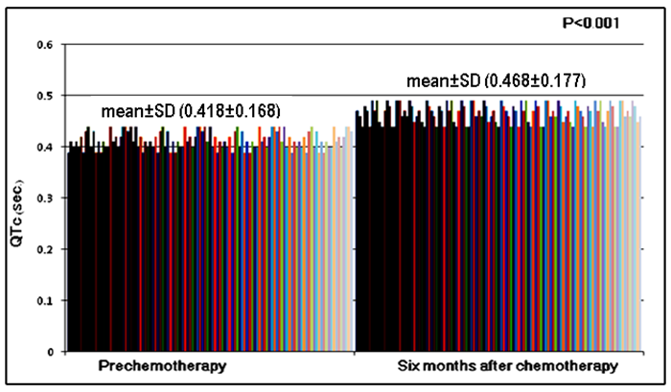

**Figure 1.** Heart rate corrected QT (QTc) interval in the study group comparing the baseline reading and six months after chemotherapy

|  |  |  |  |
| --- | --- | --- | --- |
| Table 2. Echocardiographic parameters in the study group comparing the baseline readings and six months after anthracycline chemotherapy | | | |
| Parameter | Baseline readings | Six months after the start of anthracycline chemotherapy | P-value |
| LVEDD (mm) | 41.19±4.23 | 44.59±4.28 | <0.001 |
| LVESD (mm) | 25.01±3.91 | 28.56±3.68 | <0.001 |
| IVSd (mm) | 7.41±0.53 | 7.35±0.78 | 0.73 |
| LVPWd (mm) | 4.09±0.54 | 4.08±0.56 | 0.97 |
| EF (%) | 70.10±4.65 | 63.53±4.45 | <0.001 |
| FS (%) | 39.48±3.93 | 34.70±3.68 | <0.001 |
| E (cm/s) | 111.61±15.00 | 84.5 ±6.29 | <0.001 |
| A (cm/s) | 61.66±11.20 | 59.13±8.38 | 0.33 |
| E/A ratio | 1.85±0.34 | 1.45±0.19 | <0.001 |
| E′ (cm/s) | 15.2±2.1 | 10.1±2.2 | <0.001 |
| E/ E′ ratio | 7.2±1.1 | 8.3±1.7 | <0.001 |
| DcT (ms) | 119.97±14.62 | 198.99±15.24 | <0.001 |
| IVRT (ms) | 57.26±6.47 | 86.66±8.77 | <0.001 |

All measures are expressed as the mean ± standard deviation

**LVEDD:**

Left ventricular end-diastolic diameter, LVESD: Left ventricular end-systolic diameter, IVSd: Interventricularseptal thickness in diastole, LVPWd: Posterior wall thickness in diastole, EF: Ejection fraction, FS: Fractional shortening, E: Early peak flow velocity, A: Atrial filling velocity, E′: Early peak diastolic myocardial velocity DcT: Deceleration time, IVRT: Isovolumic relaxation time.

In our study, as shown in **figure 2**, the incidence of cardiac dysfunction found more in female patients (20/28; 71.4%). Also, as shown in **table 3** and **figure 3**, we found that the incidence of cardiac dysfunction was significantly higher among children with AML (10/14; 71.4%).

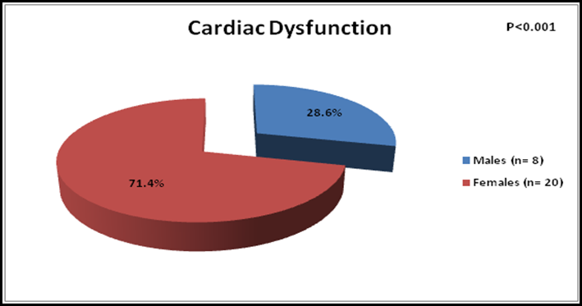

**Figure 2.** Frequency of cardiac dysfunction among children who received anthracycline chemotherapy

|  |  |
| --- | --- |
| Table 3. Frequency of anthracycline induced cardiac dysfunction in relation to the type of malignancy | |
| Malignancy | Cardiac dysfunctionn (%) |
| Acute Lymphoblastic Leukemia (n=74) | 15 (20.3) |
| Acute Myeloid Leukemia (n= 14) | 10 (71.4) |
| Hodgkin Lymphoma (n= 10) | 1 (10) |
| Non-Hodgkin Lymphoma (6) | 2 (33.3) |

**Figure 3.** Frequency of anthracycline induced cardiac dysfunction in relation to the type of malignancy.

**Table 4** clarifies that myocardial dysfunction was significantly higher among children who received a high cumulative dose of doxorubicin.

As shown in **figure 4** there was significant negative correlation between the ejection fraction and the anthracycline cumulative dose (*r*= −0.601; *P*<0.001).

**Figure 5**shows significant positive correlation between the isovolumic relaxation time (IVRT) and the anthracycline cumulative dose (*r*= 0.599; *P*= 0.002).

|  |  |  |  |  |  |  |  |
| --- | --- | --- | --- | --- | --- | --- | --- |
| Table 4. Types of anthracycline used and their relation to cardiac dysfunction | | | | | | | |
| Anthracycline | Cardiac Dysfunction | | | No Cardiac Dysfunction | | | P-value |
| n | % | Anthracycline cumulative dosage by mg/m2 (mean±SD) | n | % | Anthracycline cumulative dosage by mg/m2 (mean±SD) |
| Doxorubicin (n= 91) | 14 | 15.4 | 290±139 | 77 | 84.6 | 121±71 | <0.001 |
| Daunorubicin (n= 24) | 11 | 45.8 | 315±69 | 13 | 54.2 | 251±121 | 0.391 |

SD= standard deviation

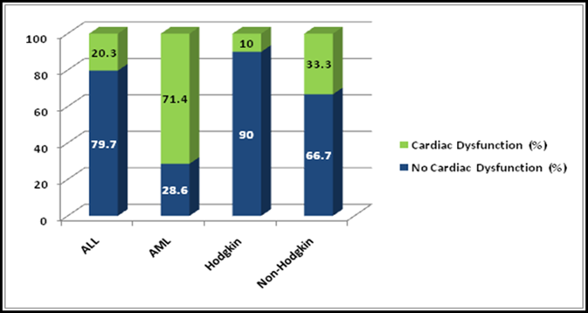

**Figure 3.** Frequency of anthracycline induced cardiac dysfunction in relation to the type of malignancy

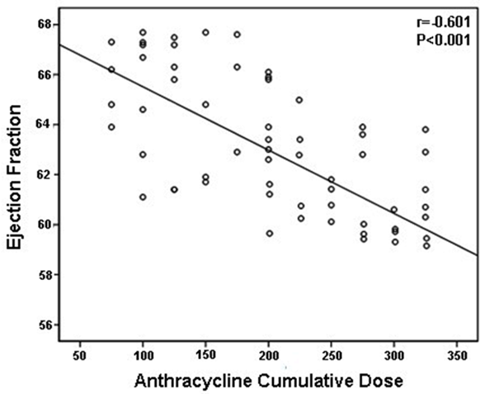

**Figure 4.** Correlation coefficient showing the negative relation between ejection fraction and anthracycline cumulative dose

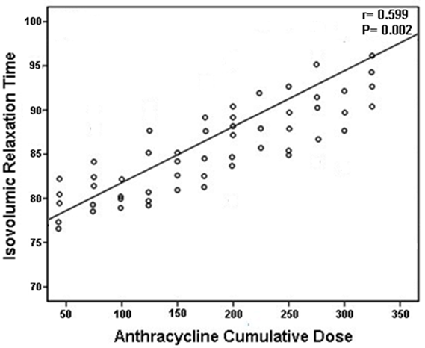

**Figure 5.** Correlation coefficient showing the positive relation between isovolumic relaxation time and anthracycline cumulative dose

**4. Discussion**

Anthracycline (doxorubicin, daunorubicin) are potent but cardiotoxic chemotherapeutic agents are essential for treating many childhood malignancies [27]. Cardiac damage may begin with the first dose of anthracycline or appear at any dose as there is no guaranteed safe dose limit. However, a higher cumulative dosage and combination therapy with different anthracycline derivatives are important risk factors [28, 29]. Anthracycline-induced early onset cardiotoxicity in our study was 24%, which is a little low compared with the data published earlier [30,31].

Generally, cumulative doses greater than 300 mg/m2 are associated with the greatest risk for cardiac injury. In our study, children receiving a cumulative dose >300 mg/m2 had shown significant toxicity and there was a significant negative correlation between decreased LV ejection fraction and increased anthracycline cumulative dose (*r*= −0.601; *P*<0.001). In our study also there was a significant positive correlation between increased isovolumic relaxation time (IVRT) and increased anthracycline cumulative dose (*r*= 0.599; *P*= 0.002).

In the present study the effect of chemotherapy on ventricular repolarization as reflected by prolongation of the duration of heart rate corrected QT interval (QTc) was statistically significant (*P*<0.001). The study by Larsen and colleagues indicated that QTc prolongation might occur in the patients on anthracyclines compared to the normal group (*P*<0.001) [32].

Anthracycline causes LV enlargement, both systolic and diastolic diameters increase, resulting in decreased fraction shortening (FS) and ejection fraction (EF). In our study baseline EF and FS changed significantly after anthracyclines(*P*<0.001), which was similar to results published in the past [33].

Anthracycline-induced cardiac damage leads to deceased interventricularseptal (IVS) and LV posterior wall thickness (PWT), thereby increasing after load and causing myocardial dysfunction. According to this study, no significant difference was found in PWT and IVS preanthracycline and postanthracycline(*P*>0.05), which might be due to the short follow-up period. In some studies, this difference was detected in more prolonged follow-up periods [34].

Systolic and diastolic myocardial velocities correlate well with systolic and diastolic ventricular functions [35, 36]. E, A and E′ velocities, E/A and E/ E′ ratios, deceleration time (DcT) and isovolumic relaxation time (IVRT) are good indicators of diastolic dysfunction [24]. In our study, sex months after initiation of therapy, there was a statically significant change in diastolic parameters like E velocity (*P*<0.001), E/A ratio (*P*<0.001), E′ velocity (*P*<0.001) and E/ E′ ratio (*P*<0.001). The DcT and IVRT also showed significant changes (*P*<0.001). These findings were consistent with the data published earlier [30, 37].

Female gender has been associated with increased risk for cardiotoxicity in several studies [38- 41], and the same was observed in our study as well. The reason female gender has been correlated with this increased risk is unknown. Lipshultz et al. hypothesized that girls tend to have more body fat than boys; therefore, this risk might be partially explained by the low clearance of anthracyclines with increased body fat and its longer persistence in higher concentrations in non-adipose tissues, including the heart [42].

Anthracycline (doxorubicin, daunorubicin) are cardiotoxic but daunorubicin is less cardiotoxicthan doxorubicin [30, 43]. In our study doxorubicin was used in 91 patients and 14/91 (15.4%) children showed cardiac dysfunction 6 months after initiation of therapy. Their cumulative dose of doxorubicin was significantly higher as compared with those without dysfunction, 290±139vs121±71 mg/m2 (*P*<0.001).

**Conclusion**

The incidence of subclinical anthracycline-related cardiac dysfunctions is high. It is highly important to understand the adverse effects of cancer treatment on the heart and their long-term consequences to identify and establish optimal prevention and management strategies that balance oncologic efficacy with long-term safety. Regardless of the type and the dose used, children treated with anthracycline require a long-term follow-up.

**References**

1. Franco VI, Henkel JM, Miller TL, Lipshultz SE. Cardiovascular effects in childhood cancer survivors treated with anthracyclines. Cardiol Res Pract. 2011;2011(10):134679.
2. Chen MH, Colan SD, Diller L. Cardiovascular disease: cause of morbidity and mortality in adult survivors of childhood cancer. Circ Res. 2011;108(5):619–628.
3. Diamond MB, Franco VI, Miller TL, *et al.* Preventing and treating anthracycline-related cardiotoxicity in survivors of childhood cancer. Curr Cancer Ther Rev 2012; 8: 141–151.
4. Sawyer DB, Peng X, Chen B, *et al.* Mechanisms of anthracycline cardiac injury: can we identify strategies for cardioprotection? ProgCardiovasc Dis 2010; 53: 105–113.
5. Adams MJ, Lipshultz SE. Pathophysiology of anthracycline- and radiation-associated cardiomyopathies: implications for screening and prevention. Pediatr Blood Cancer. 2005;44(7):600–606.
6. Barry E, Alvarez JA, Scully RE, Miller TL, Lipshultz SE. Anthracycline-induced cardiotoxicity: course, pathophysiology, prevention and management. Expert Opin Pharmacother. 2007;8(8):1039–1058.
7. Giantris A, Abdurrahman L, Hinkle A, Asselin B, Lipshultz SE. Anthracycline-induced cardiotoxicity in children and young adults. Crit Rev OncolHematol. 1998;27(1):53–68.
8. Lipshultz SE, Lipsitz SR, Mone SM, Goorin AM, Sallan SE, Sanders SP, *et al.* Female sex and drug dose as risk factors for late cardiotoxic effects of doxorubicin therapy for childhood cancer. N Engl J Med.1995;332(26):1738–1743.
9. Simbre VC, Duffy SA, Dadlani GH, Millet TL, Lipshultz SE. Cardiotoxicity of cancer chemotherapy: implications for children. Paediatr Drugs. 2005;7(3):187–202.
10. Lipshultz SE, Alvarez JA, Scully RE. Anthracycline associated cardiotoxicity in survivors of childhood cancer. Heart 2008;94:525–33.
11. Monsuez JJ, Charniot JC, Vignat N, *et al.* Cardiac side-effects of cancer chemotherapy. Int J Cardiol 2010;144:3–15.
12. Shan K, LincoffAM, Young JB. Anthracycline-induced cardiotoxicity. Ann Intern Med 1996;125:47–58.
13. Gianni L, Herman EH, Lipshultz SE, Minotti G, Sarvazyan N, Sawyer DB. Anthracyclinecardiotoxicity: from bench to bedside. J Clin Oncol. 2008;26(22):3777–3784.
14. Minotti G, Salvatorelli E, Menna P. Pharmacological foundations of cardio-oncology. J PharmacolExp Ther.2010;334(1):2–8.
15. Ganz WI, Sridhar KS, Ganz SS, *et al*. Review of tests for monitoring doxorubicin-induced cardiomyopathy. Oncology 1996; 53: 461–70.
16. Meinardi MT, van der Graaf WT, van Veldhuisen DJ, *et al*. Detection of anthracycline-induced cardiotoxicity. Cancer Treat Rev 1999; 25: 237–47.
17. Pudil R, Horacek JM, Strasova A, *et al*. Monitoring of the very early changes of left ventricular diastolic function in patients with acute leukemia treated with anthracyclines. Exp Oncol 2008; 30: 160–2.
18. Jakl M, Horacek JM, Jebavy L, *et al*. Continuous 24-h monitoring of electrocardiogram during anthracycline based therapy in acute leukemia. Leuk Res 2009; doi:10.1016/j. leukres. 2008.12.024 (article in press).
19. Bu’Lock FA, Mott MG, Martin RP. Left ventricular diastolic function in children measured by Doppler echocardiography: normal values and relation with growth. Br Heart J 1995;73:334–9.
20. Ganame J, Claus P, Uyttebroeck A, *et al.* Myocardial dysfunction late after low-dose anthracycline treatment in asymptomatic pediatric patients. J Am SocEchocardiogr 2007;20:1351–8.
21. Steinherz LJ, Graham T, Hurwitz R, *et al.* Guidelines for cardiac monitoring of children during and after anthracycline therapy: report of the Cardiology Committee of the Children Cancer Study Group. Pediatrics 1992;89:942–9.
22. Bazett HC. An analysis of the time relationships of electrocardiograms. Heart 1920;7:353-357.
23. Myung K. Park: Pediatric Cardiology for Practitioners, Textbook, 6th ed. Copyright © [2014 Mosby, An Imprint of Elsevier](mk:@MSITStore:D:\Pediatric%20Cardiology%20for%20Practitioners%20(Mosby,%202007).chm::/HTML/about/book/mosby.html)**.** Part 2– Special Tools in Evaluation of Cardiac Patients**;** Chapter 5 – Noninvasive Imaging Tools.
24. Sohn DW, Chai IH, Lee DJ, Kim HC, Kim HS, Oh BH, Lee MM, Park YB, Choi YS, Seo JD, Lee YW. Assessment of mitral annulus velocity by Doppler tissue imaging in the evaluation of left ventricular diastolic function. J Am Coll Cardiol. 1997; 30: 474–480.
25. Yamada H, Oki T, MishiroY, Tabata T, Abe M, Onose Y, Wakatsuki T, Ito S. Effect of aging on diastolic left ventricular myocardial velocities measured by pulsed tissue Doppler imaging in healthy subjects. J Am SocEchocardiogr. 1999; 12: 574–581.
26. Ommen SR, Nishimura RA, Appleton CP, Miller FA, Oh JK, Redfield MM, Tajik AJ. Clinical utility of Doppler echocardiography and tissue Doppler imaging in the estimation of left ventricular filling pressures: a comparative simultaneous Doppler-catheterization study. Circulation. 2000; 102: 1788–1794.
27. Singal PK, Iliskovic N. Doxorubicin-induced cardiomyopathy. N Engl J Med 1998;339:900–5.
28. Giantris A, Abdurrahman L, Hinkle A, *et al.* Anthracycline-induced cardiotoxicity in children and young adults. Crit Rev OncolHematol 1998;27:53–68.
29. Kremer LC, van Dalen EC, Offringa M, *et al.* Frequency and risk factors of anthracycline-induced clinical heart failure in children: a systematic review. Ann Oncol 2002;13:503–12.
30. Shaikh AS, Saleem AF, Mohsin SS, *et al.* Anthracycline-induced cardiotoxicity: prospective cohort study from Pakistan. BMJ Open 2013;3:e003663.
31. Monsuez JJ, Charniot JC, Vignat N, *et al.* Cardiac side-effects of cancer chemotherapy. Int J Cardiol 2010;144:3–15.
32. Larsen RL, Jakacki RI, Vetter VL, Meadows AT, Silber JH, Barber G. Electrocardiographic changes and arrhythmias after cancer therapy in children and young adults. Am J Cardiol. 1992;1; 70(1):73–7.
33. Lipshultz SE, Lipsitz SR, Sallan SE, *et al.* Chronic progressive cardiac dysfunction years after doxorubicin therapy for childhood acute lymphoblastic leukemia. J Clin Oncol 2005;23:2629–36.
34. Iarussi D, Galderisi M, Ratti G, *et al.* Left ventricular systolic and diastolic function after anthracycline chemotherapy in childhood. Clin Cardiol 2001;24:663–9.
35. Erdogan D, Yucel H, Alanoglu EG, *et al.* Can comprehensive echocardiographic evaluation provide an advantage to predict anthracycline-induced cardiomyopathy? Turk Kardiyol Dern Ars 2011;39:646–53.
36. Kalay N, Basar E, Ozdogru I, *et al.* Protective effects of carvedilol against anthracycline-induced cardiomyopathy. J Am Coll Cardiol 2006;48:2258–62.
37. Velensek V, Mazic U, Krzisnik C, *et al.* Cardiac damage after treatment of childhood cancer: a long-term follow-up. BMC Cancer 2008;8:141.
38. J. P. Krischer, S. Epstein, D. D. Cuthbertson, A. M. Goorin, M. L. Epstein, and S. E. Lipshultz, “Clinical cardiotoxicity following anthracycline treatment for childhood cancer: the Pediatric Oncology Group experience,” Journal of Clinical Oncology, vol. 15, no. 4, pp. 1544–1552, 1997.
39. J. Leandro, J. Dyck, D. Poppe *et al.* “Cardiac dysfunction late after cardiotoxic therapy for childhood cancer,” American Journal of Cardiology, vol. 74, no. 11, pp. 1152–1156, 1994.
40. F. G. Pinarli, A. Oǧuz, F. S. Tunaoǧlu, C. Karadeniz, N. Gökçora, and S. Elbeg, “Late cardiac evaluation of children with solid tumors after anthracyclinechemotherapy,” Pediatric Blood and Cancer, vol. 44, no. 4, pp. 370–377, 2005.
41. A. Garcia-Alvarez, X. Garcia-Albeniz, J. Esteve, M. Rovira, and X. Bosch, “Cardiotoxicity of tyrosine-kinase-targeting drugs,” Cardiovascular and Hematological Agents in Medicinal Chemistry, vol. 8, no. 1, pp. 11–21, 2010.
42. Lipshultz SE, Lipsitz SR, Mone SM, *et al.* Female sex and drug dose as risk factors for late cardiotoxic effects of doxorubicin therapy for childhood cancer. N Engl J Med 1995; 332: 1738–1743.
43. Gharib MI, Burnett AK. Chemotherapy-induced cardiotoxicity: current practice and prospects of prophylaxis. Eur J Heart Fail 2002;4:235–42.

1/15/2017