Angiogenesis in astrocytomas: An immunohistochemical study of VEGF, factor VIII, and COX-2 expression

Omnia MK Rizk¹, Eman M. Saied², Dalia ES Abd El-Maqusod³

¹Pathology Department, Faculty of Medicine, Tanta University, Egypt
²Pathology Department - Faculty of Medicine - Kafrelsheikh University, Egypt
³El-Menshawy General Hospital, Egypt
omnia_kamelrizk@outlook.com

Abstract: Background & aim: Astrocytomas are histologically classified into grades I through IV on the basis of cellularity, nuclear atypia, mitotic activity, pseudopalisading necrosis and/ or microvascular proliferation. Angiogenesis plays an important role in the growth and progression of asrtocytomas that exhibit marked and aberrant blood vessel formation indicating angiogenic endothelial cells as a potential target for tumor treatment. Materials & methods: This work was designed to study the role of angiogenesis in the growth and progression of astrocytomas, by studying the immunohistochemical expression of vascular endothelial growth factor (VEGF), factor VIII, and Cyclooxygenase-2 (COX-2) on 78 retrospective cases of astrocytoma. Results: VEGF immunoreactivity was detected 87.2% of the studied cases, while 82.1% of the studied cases showed positive COX-2 expression. The expression of both VEGF and COX-2 showed significant increase with increasing tumor grade (p < 0.05). The relationship between the tumor grade and microvascular density (MVD) increased significantly (p < 0.05). A significant positive correlation was observed between the immunoreactive scores of VEGF, COX-2, and MVD (p < 0.05). Conclusion: The increase in VEGF expression and MVD in astrocytomas indicates the significant role of angiogenesis in their development and progression. The significant positive association between VEGF expression, MVD, and COX-2 expression suggests that COX-2 contributes to angiogenesis in astrocytomas possibly by upregulation of VEGF.
[Omnia MK Rizk, Eman M. Saied, Dalia ES Abd El-Maqusod Angiogenesis in astrocytomas: An immunohistochemical study of VEGF, factor VIII, and COX-2 expression. Cancer Biology 2016;6(4):188-195]. ISSN: 2150-1041 (print); ISSN: 2150-105X (online). http://www.cancerbio.net. 12. doi:10.7537/marscbj060416.12.

Keywords: Astrocytoma, COX-2, VEGF, factor VIII

1. Introduction
Astrocytomas, derived from astrocytes or astroglial precursors, are the most common primary brain tumors; accounting for more than 60% of them and accounting for 75% of neuroepithelial tumors (Jhanwar-Uniyal et al., 2015). Angiogenesis and the production of angiogenic factors are fundamental for tumor growth, invasion and metastasis (Tirumani et al., 2015). It plays an important role in the growth and progression of astrocytomas that exhibit marked and aberrant blood vessel formation indicating angiogenic endothelial cells as a potential target for tumor treatment (Malhan et al., 2010).
Vascular endothelial growth factor (VEGF) is a potent endothelial cell mitogen and key regulator of both physiologic vasculogenesis in the embryonic circulatory system and pathologic angiogenesis leading to the growth of blood vessels from existing vasculature (Norden et al., 2009).
VEGF has also been shown to stimulate monocyte/macrophage migration, stimulate tumor cell migration, and enhance vascular permeability in tight-junction endothelial environments such as those of the intact blood-brain barrier (Peak and Levin, 2010). One of the most important pathologic criteria for the diagnosis of high grade astrocytomas, especially glioblastoma multiforme, is microvessel proliferation, particularly in the form of glomeruloid complex. It has been stated that microvascular density (MVD) is a prognostic indicator in astrocytomas, and the expression of endothelial-related markers by neoplastic cells has a direct relationship with their grades (Mahzouni et al., 2010). Factor VIII-related antigen (von Willebrand Factor; vWF), an important factor in hemostasis, is one of the endothelial-related markers that can be studied by immunohistochemistry to evaluate the microvascular density (Jonathan and Rao, 2007).
Cyclooxygenase-2 (COX-2) isoenzyme is frequently undetectable in most normal tissues, but quickly induced by cytokines, growth factors and carcinogenic agents (Guo et al., 2009). Over-expression of COX-2 is detectable in various solid malignancies, including brain tumors, and is thought to be involved in the critical steps in carcinogenesis, as well as a regulator of tumor angiogenesis; however, the potential mechanism is still unclear (Lee et al., 2011). Several studies have indicated that overexpression of COX -2 may contribute to VEGF-induced angiogenesis (El-Sayed and Taha, 2011).
The aim of this work was to study the role of angiogenesis in the growth and progression of astrocytomas by studying the immunohistochemical expression of vascular endothelial growth factor (VEGF) and factor VIII-related antigen (von Willebrand Factor- vWF), and to correlate the immunohistochemical expression of these angiogenic markers with the expression of cyclooxygenase-2 enzyme (COX-2) in order to predict the biological behavior of the studied tumors.
2. Materials and methods
This retrospective study was carried out upon 78 cases of randomly selected astrocytic tumors of different grades, obtained from the archives of Department of Pathology, Faculty of Medicine, Tanta University, Tanta Cancer Center, and from private laboratories during the period from 2012 to 2015. The study was approved by the Research Ethics Committee of the Faculty of Medicine, Tanta University.
2.1. Histopathological study
Formalin fixed paraffin embedded blocks were collected and subjected to routine hematoxylin and eosin staining for histopathological typing and grading of the studied tumors according to the 2016 WHO classification of tumors of nervous system (Louis et al., 2016).
2.2. Immunohistochemistry
Immunohistochemical staining was performed using the avidin (streptavidin)-biotin immunoperoxidase technique. The UltraVision Detection Kit (TP-015-HD, Lab Vision, USA) was used according to the manufacturer’s protocol. The used primary antibodies included: rabbit polyclonal anti-Vascular Endothelial Growth Factor (VEGF) antibody (Cat. No. RB-222-R7, Ready to use, Lab Vision, USA), rabbit polyclonal anti-Factor VIII Related Antigen/von Willebrand Factor Ab-1 antibody (Cat. No. RB-281-R7, Ready to use, Lab Vision, USA), and rabbit monoclonal anti-COX-2 antibody (Clone SP21, Cat. No. RM-9121-R7, Ready to use, Lab Vision). Each staining run included both external positive and negative control slides to confirm that the correct procedure has been followed and the staining system worked properly. As positive controls, a case of colon carcinoma known to be positive for COX-2, a case of angiosarcoma for VEGF, and a section in a tonsil for factor VIII related antigen were used. Negative controls were prepared by omission of the primary antibodies.
2.2.1. Interpretation of immunohistochemical staining

Scoring of the immunohistochemical staining of VEGF and COX-2 was performed according to the methods described by El-Sayed and Taha et al. (2011). VEGF expression was confined to the cytoplasm of tumor cells, some vascular endothelium and some necrotic areas, while COX-2 expression was confined to the cytoplasm of tumor cells and some necrotic areas. Briefly, based on the proportions of immunopositive cells, five categories were defined as follows: all negative; 1 +: < 25% positive cells; 2 +: 25–49%; 3 +: 50-74%; and 4 +: >75%. The immuno-intensity was also subclassified into four groups as follows: 0, negative; 1+, weak; 2+, moderate; and 3+, strong. Immunoreactive scores for each case were produced by multiplication of the values for the two parameters. Immunoreactive scoring was categorized as low ≤ 3 and moderate to high ≥ 4. Tumor angiogenesis can be reflected by microvascular density (MVD) in the most vascularized areas of the tumor tissues. MVD, as highlighted by factor VIII-related antigen immunostaining, which was mainly confined to the cytoplasm of vascular endothelial cells as brownish yellow granules, was assessed by using a semiquantitative scale described by Ahmed and Mohammed (2010); by identification of regions with the highest vascularization by immunohistochemical staining of the cytoplasm of the endothelial cells (ECs) “called hot spots” to restrict subsequent counting of the microvessels to these hotspots. The hotspots were selected by scanning sections at low magnification (X40), whereas the counting was performed at X100 magnification. Any highlighted ECs or EC cluster clearly separated from adjacent microvessels, tumor cells and stroma was considered as a single, countable microvessel. Branching structures were counted as a single vessel unless there was a break in the continuity of the structure. Five fields in the hot spot were counted and the mean of these five fields was considered to be the number of blood vessels for each patient.

2.3. Statistical analysis

Statistical presentation and analysis of the present study was conducted using the Statistical Package of Social Sciences (SPSS Inc., Chicago, Illinois, USA) software for windows, version V.20. The mean, standard deviation, chi-square test, analysis of variance (ANOVA) tests (F), and linear correlation coefficient (r) were calculated. Differences were considered significant when p-value was < 0.05.

3. Results
3.1. Histopathological results
The histological types of the studied 78 astrocytomas were summarized in table (1). Glioblastoma multiforme (WHO grade IV) was the most frequent type of the studied astrocytic tumors representing 39.8%, while pleomorphic xanthoastrocytoma (WHO grade II) was the least frequent type, representing 1.3% of the total cases.

Table (1): The distribution of the studied astrocytomas according to the histological type and tumor grade.
Histological type | Grade | No. | %
Pilocytic astrocytomas | I | 8 | 10.3
Diffuse astrocytomas | II | 14 | 17.9
Pleomorphic xanthoastrocytomas | II | 1 | 1.3
Pleomorphic xanthoastrocytomas  with anaplasia | III | 4 | 5.1
Anaplastic astrocytomas | III | 20 | 25.6
Glioblastoma multiforme | IV | 31 | 39.8
Total |  | 78 | 100

3.2. Immunohistochemical expression of VEGF in the studied cases
VEGF immunohistochemical expression was detected in 68/78 (87.2%) of the studied astrocytomas. There was a statistically significant increase in its expression with increasing tumor grade in the studied cases (p < 0.05), as it was detected in 70% of grades I and II, 84% of grade III, and 100% of grade IV tumors (GBM). VEGF expression in the studied astrocytomas is shown in table (2) and figures (1; A-D).

Table (2): VEGF expression in the studied astrocytomas.
Histological type |  | VEGF expression |  |  | Total
 |  | –v e | +ve
 |  |  | ≤ 3 | ≥ 4
Pilocytic astrocytomas | N | 2 | 5 | 1 | 8
 | % | 25% | 62.5% | 12.5%
Diffuse astrocytomas | N | 5 | 6 | 3 | 14
 | % | 35.7% | 42.9% | 21.4%
Pleomorphic xanthoastrocytomas | N | 0 | 1 | 0 | 1
 | % | 0% | 100% | 0%
Pleomorphic xanthoastrocytomas  with anaplasia | N | 0 | 3 | 1 | 4
 | % | 0% | 75% | 25%
Anaplastic astrocytomas | N | 3 | 13 | 4 | 20
 | % | 15% | 65% | 20%
Glioblastoma multiforme | N | 0 | 9 | 22 | 31
 | % | 0% | 30% | 70%
Total | N | 10 | 37 | 31 | 78
 | % | 13% | 48% | 39% | 100%
Chi-square | X² | 28.283
 | p-value | 0.002*
* Significant (p < 0.05)

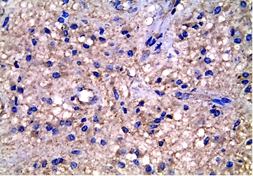
Fig. (1-A): A case of diffuse fibrillary astrocytoma showing moderate cytoplasmic VEGF expression (Immunoperoxidase X400).
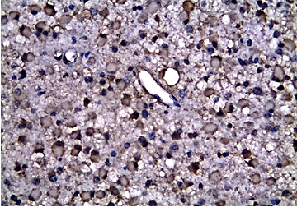
Fig. (1-B): A case of gemistocytic astrocytoma showing high cytoplasmic VEGF expression (Immunoperoxidase X400).
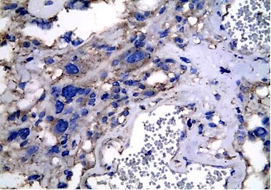
Fig. (1-C): A case of pleomorphic xanthoastrocytoma showing moderate cytoplasmic VEGF expression (Immunoperoxidase X400).
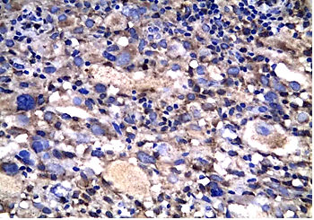
Fig. (1-D): A case of pleomorphic xanthoastrocytoma with anaplasia showing high cytoplasmic VEGF expression (Immunoperoxidase X400).

3.3. Immunohistochemical expression of factor VIII in the studied cases
Positive expression of factor VIII was detected in 68/78 (87.2%) of the studied astrocytomas. Microvessels were represented by brownish yellow capillaries or small cell clusters. Astrocytomas of high grade demonstrated greater and different pattern of vascularization than that of low grade. The relation between the MVD and the tumor grade was statistically significant (p < 0.05). Factor VIII expression in the studied astrocytomas is shown in table (3) and figures (2; A-D).

Table (3): Factor VIII expression in the studied astrocytomas.
Histological type | Pilocytic astrocytomas | Diffuse astrocytomas | Pleomorphic xanthoastrocytomas | Pleomorphic xanthoastrocytomas  with anaplasia | Anaplastic astrocytomas | Glioblastoma multiforme
Factor VIII expression
Range | 15 – 20 | 15 – 34 | 15 – 15 | 18 – 47 | 29 – 63 | 40 – 83
Mean ± SD | 17 ± 1.85 | 23 ± 5.14 | 15 ± 0 | 30.5 ± 14.8 | 44.9 ± 7.1 | 57.1 ± 12.2
F. test | 41.543
p-value | 0.001*
*Significant (p < 0.05)

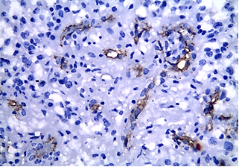
Fig. (2-A): A case of pilocytic astrocytoma showing weak factor VIII expression (Immunoperoxidase X400).

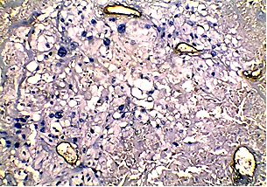
Fig. (2-B): A case of pleomorphic xanthoastrocytoma with anaplasia showing weak factor VIII expression (Immunoperoxidase X400).

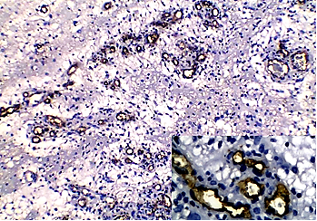
Fig. (2-C): A case of GBM showing glomeruloid microvascular pattern with factor VIII expression (Immunoperoxidase X100, with a close view X400).

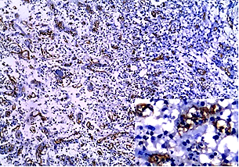
Fig. (2-D): A case of GBM showing strong factor VIII expression (Immunoperoxidase X100, with a close view X400).

Table (4) COX-2 expression in the studied astrocytomas.
Histological type |  | COX-2 expression |  |  |  | Total
 |  |  | –v e | +ve
 |  |  |  | ≤ 3 | ≥ 4
Pilocytic astrocytomas |  | N | 3 | 4 | 1 | 8
 |  | % | 37.5% | 50.0% | 12.5%
Diffuse astrocytomas |  | N | 5 | 7 | 2 | 14
 |  | % | 35.7% | 50.0% | 14.3%
Pleomorphic xanthoastrocytomas |  | N | 1 | 0 | 0 | 1
 |  | % | 100% | 0% | .0%
Pleomorphic xanthoastrocytomas  with anaplasia |  | N | 0 | 2 | 2 | 4
 |  | % | 0% | 50% | 50%
Anaplastic astrocytomas |  | N | 4 | 15 | 1 | 20
 |  | % | 20.0% | 75.0% | 5.0%
Glioblastoma multiforme |  | N | 1 | 13 | 17 | 31
 |  | % | 3.2% | 41.9% | 54.8%
Total |  | N | 14 | 41 | 23 | 78
 |  | % | 17.9% | 52.6% | 29.5% | 100.0%
Chi-square | X² |  | 26.134
 | p-value |  | 0.001*
* Significant (p < 0.05)

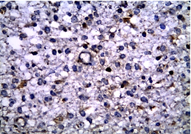
Fig. (3-A): A case of diffuse fibrillary astrocytoma showing moderate cytoplasmic COX-2 expression (Immunoperoxidase X400).
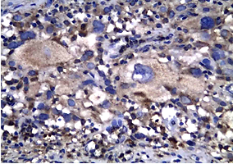
Fig. (3-B): A case of pleomorphic xanthoastrocytoma with anaplasia showing high cytoplasmic COX-2 expression (Immunoperoxidase X400).
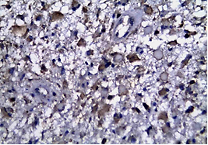
Fig. (3-C): A case of anaplastic gemistocytic astrocytoma showing high cytoplasmic COX-2 expression (Immunoperoxidase X400).

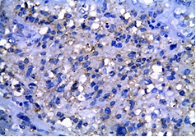
Fig. (3-D): A case of GBM showing moderate cytoplasmic COX-2 expression (Immunoperoxidase X400).

Fig. (4): Correlation between VEGF and COX-2 expression in the studied astrocytomas.

3.4. Immunohistochemical expression of COX-2 in the studied cases
COX-2 immunohistochemical expression was detected in 64/78 (82.1%) of the studied astrocytomas. There was a statistically significant increase in COX-2 expression with increasing tumor grade (p < 0.05), as it was detected in 60% of grade I and II, 83% in grade III and in 96.8% of grade IV tumors (GBM). COX-2 expression in the studied astrocytomas is shown in table (4) and figures (3; A-D).
3.5. Correlation between VEGF and COX-2 expression in the studied cases
Immunoreactive scores of VEGF expression were significantly increased in COX-2 positive tumors compared to COX-2 negative ones (p < 0.05) as shown in figure (4). Almost all COX-2 negative tumors exhibited negative staining of VEGF except in 4 cases.
3.6. Correlation between VEGF expression and MVD in the studied cases
VEGF expression was significantly correlated with MVD (p < 0.05). The mean MVD in COX-2 positive astrocytomas with immunoreactive scores ≥ 4 was significantly higher (43.8± 17.64) than that of COX-2 negative tumors (19.76 ± 2.12) or with immunoreactive scores ≤ 3 (35.7± 3.89) as shown in figure (5).

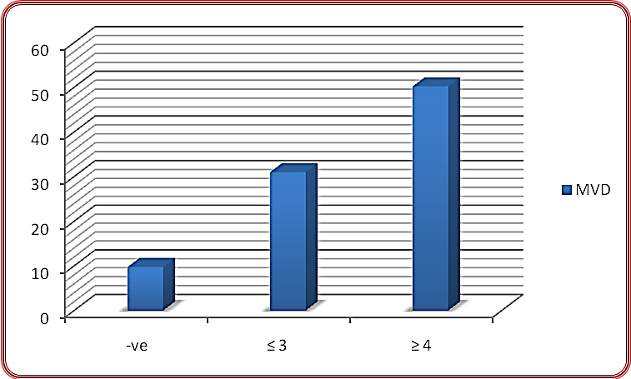
Fig. (5): Correlation between VEGF expression and MVD in the studied astrocytomas.

3.7. Correlation between COX-2 expression and MVD in the studied cases
COX-2 expression was significantly correlated with MVD (p < 0.05). The mean MVD in COX-2 positive astrocytomas with immunoreactive scores ≥ 4 was significantly higher (43.8± 17.64) than that of COX-2 negative tumors (19.76 ± 2.12) or with immunoreactive scores ≤ 3 (35.7± 3.89) as shown in figure (6).

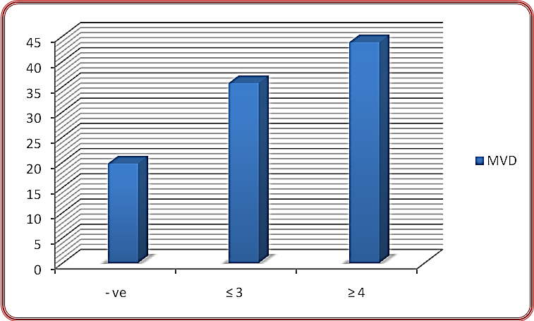
Fig. (6): Correlation between COX-2 expression and MVD in the studied astrocytomas.
4. Discussion
This work was designed to study angiogenesis in astrocytomas by evaluating the immunohistochemical expression of VEGF and microvascular density (MVD) using anti-factor VIII antibodies in relation to COX-2 expression. VEGF expression was detected in 87.2% of the studied astrocytomas, and it showed a statistically significant stepwise increase from low-grade to high grade tumors (p < 0.05). This was in accordance with Wang et al. (2016), who found significantly higher VEGF expression in high-malignancy group (grades III and IV) compared to low-malignancy group (grades I and II). The present study also revealed a greater and different pattern of vascularization in high grade astrocytomas than that of low grade tumors. The relationship between the tumor grade and MVD increased significantly (p < 0.05), whereas Mahzouni et al. (2010) demonstrated that the mean values of factor VIII were closely similar in grades I and II tumors, increased in grade III tumors, and reached the highest levels in grade IV astrocytomas. In the present study, positive COX-2 expression was detected in about 82.1% of the studied astrocytomas, moreover, COX-2 expression showed a significant increase with increasing tumor grade (p < 0.05), as it was detected in 60% of grades I and II, 83% in grade III and in 96.8% of grade IV tumors (GBM). Close to these results were the results obtained by El-Sayed and Taha (2011), as they detected positive COX-2 expression in 80.7% of astrocytomas with an increased expression in grade IV tumors (100%) compared to grades II (63.6%) and III tumors (83.3%). However, this incidence was lower than that obtained by Perdiki et al. (2007), who found COX-2 expression in 95% of their studied astrocytomas, with an increased expression in grade IV compared to grade II/III tumors. On the other hand, the detected incidence in this study was higher than that reported by Yamen and Tong-yu (2006), who observed COX-2 expression in 49% of astrocytomas. The discrepancies observed in these results may be related to population differences and nature of immunohistochemical assays. The positive association between COX-2 expression and histopathologic grade of astrocytic gliomas is also reported by other studies such as Murakami et al. (2006). These observations support the relevant role of COX-2 in malignant change during astrocytic tumorigenesis. In the present study, significant positive correlations between VEGF expression, MVD, and COX-2 expression in the studied astrocytomas were observed (p < 0.05). These results are supported by previous reports of Buccoliero et al. (2006), who evaluated the correlation between the immunohistochemical expressions of COX-2 and VEGF in glioblastomas, where they found concordance between COX-2 and VEGF in 60% of cases. Similar results were also reported by Marina et al. (2007). These findings indicate that COX-2 is widely implicated in tumorigenesis, a process to which it contributes by upregulating the expression of VEGF, with subsequent pathological neovascularization. The previous observation also indicates the significance of COX-2 as a therapeutic target for COX-2 inhibitors as a line of treatment in astrocytomas, especially with selective COX-2 inhibitors that can cross the blood brain barrier (El-Sayed and Taha, 2011).

5. Conclusion
The increase in VEGF expression and MVD in astrocytomas indicates the significant role of angiogenesis in their development and progression. The significant positive association between VEGF expression, MVD, and COX-2 expression suggests that COX-2 contributes to angiogenesis in astrocytomas possibly by upregulation of VEGF.

Conflict of interest: There is no conflict of interest or financial ties to include.

References
- Ahmed MM, Mohammed SH. Significance of intratumoral microvessel density quantification based on immunohistochemical detection of PECAM-1 and vWF in colorectal carcinoma from Iraqi patients. Indian J Pathol Microbiol 2010; 53 (3):439-46.
- Buccoliero AM, Caldarella A, Gheri CF, Taddei A, Paglierani M, Pepi M, et al. Inducible cyclooxygenase (COX-2) in glioblastoma-clinical and immunohistochemical (COX-2-VEGF) correlations. Clin Neuropathol 2006; 25(2):59-66
- El-Sayed M, Taha M. Immunohistochemical Expression of Cycloxygenase-2 in Astrocytoma: Correlation with Angiogenesis, Tumor Progression and Survival. Turkish Neurosurgery 2011; 21(1):27-35.
- Guo X, Chen Y, Xu Z, Xu Z, Qian Y, Yu X. Prognostic significance of VEGF-C expression in correlation with COX-2, lymphatic microvessel density, and clinicopathologic characteristics in human non-small cell lung cancer. Acta Biochim Biophys Sin 2009; 41: 217–222.
- Jhanwar-Uniyal M, Labagnara M, Friedman M, Kwasnicki A, Murali R. Glioblastoma: molecular pathways, stem cells and therapeutic targets. Cancers (Basel) 2015; 7(2):538-55.
- Jonathan LM, Rao AK. Blood platelets and von Willebrand disease. In: Henry clinical diagnosis and management by laboratory methods (21st ed.) 2007.New York: Saunders.pp760-9.
- Lee P, Jain S, Pincus MR, Xu R. Molecular Genetic Pathology of Solid Tumors. In: McPherson: Henry's Clinical Diagnosis and Management by Laboratory Methods; (twenty second edition) 2011; McPherson RA and Pincus MR (Eds). China: Saunders, chap.76. pp.1441-1462.
- Louis DN, Perry A, Reifenberger G, von Deimling A, Figarella‑Branger D, Cavenee WK, et al. The 2016 World Health Organization classification of Tumors of the Central Nervous System: a summary. Acta Neuropathol 2016; 131 (6):803–20.
- Mahzouni P, Mohammadizadeh F, Mougouei K, Moghaddam NA, Chehrei A, Mesbah A. Determining the relationship between "microvessel density" and different grades of astrocytoma based on immunohistochemistry for "factor VIII-related antigen" (von Willebrand factor) expression in tumor microvessels. Indian J Pathol Microbiol 2010; 53(4): 605-10.
- Malhan P, Husain N, Bhalla S, Husain M. Proliferating cell nuclear antigen, p53 and micro vessel density: Grade II vs. Grade III astrocytoma. Indian J Pathol Microbiol 2010; 53(1):20-3.
- Marina P, Penelope K, Irene T. Cyclooxygenase-2 expression in astrocytomas. Relationship with micro-vascular parameters, angiogenetic factors expression and survival. J Molecular and Cellular Biochemistry 2007; 295: 75 - 83.
- Murakami H, Sawa H, Kamada H. Expression of cyclooxygenase (COX)-2 in astrocytic tumors and antitumor effects of selective COX-2 inhibitors. Brain Nerve 2006; 58:43-9.
- Norden AD, Drappatz J, Wen PY. Angiogenic therapies for high grade glioma. Nat Rev Neurol 2009; 5 (11):610-20.
- Peak S, Levin A. Role of bevacizumab therapy in the management of glioblastoma. Cancer Management and Research 2010; 2:97–104.
- Perdiki M, Korkolopoulou P, Thymara I, Agrogiannis G, Piperi C, Boviatsis E, et al. Cyclooxygenase-2 expression in astrocytomas. Relationship with microvascular parameters, angiogenic factors expression and survival. Mol Cell Biochem 2007; 295 (1-2): 75-83.
- Tirumani SH, Fairchild A, Krajewski KM, Nishino M, Howard SA, Baheti AD, et al. Anti-VEGF Molecular Targeted Therapies in Common Solid Malignancies: Comprehensive Update for Radiologists. Radiographics 2015; 35(2):455-74.
- Wang L, Zhang L, Shen W, Liu Y, Luo Y. High expression of VEGF and PI3K in glioma stem cells provides new criteria for the grading of gliomas. Exp Ther Med 2016; 11 (2):571-6.
- Yamin R, Tong-yu C. Expression and significance of HIFa, COX-2 and VEGF proteins in glioma. Modern oncology 2006; 14 (2) “Abstract”.

12/25/2016

